**Testing result**

**the simulation results diagram**

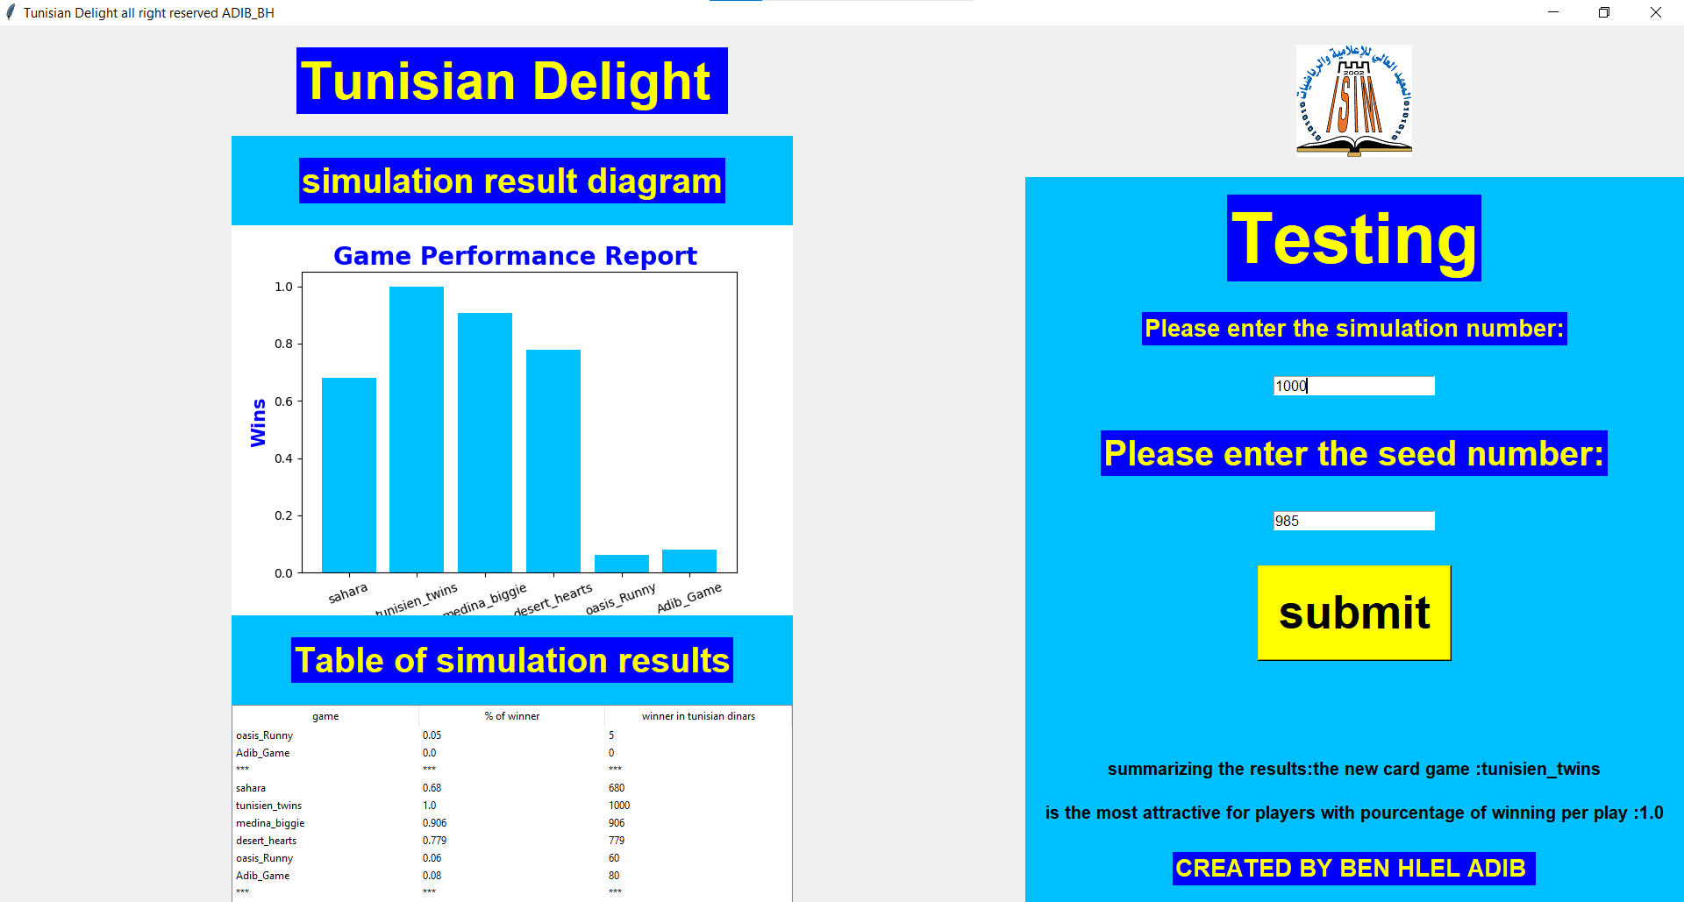

**-Table of simulation results: % of winner , winner in Tunisian dinars**

**The result in few sentences**

**Ps:**

**- there is a separator row in the table for each simulation operation.**

**-the message regenerate for each simulation operation**