Contents
LIST OF FIGURES 4
LIST OF TABLES 4
ABSTRACT 5
1.1 Background 6
1.2 Objectives 6
1.3 Scope of the System 6
1.4 Technology Stack 7
2.1 Overall Architecture Pattern 8
2.2 File Structure 8
2.3 Request-Response Flow 8
2.4 Session Management 8
2.5 Database Connectivity 9
2.6 Component Interaction Diagram 9
3.1 Database Overview 10
3.2 Table: users 10
3.3 Table: products 10
3.4 Table: cart 12
3.5 Table: wishlist 13
3.6 Entity Relationship Summary 14
3.7 SQL Schema 14
4. Module Analysis 15
4.1 Login Module (login.php) 15
4.1.1 Purpose 15
4.1.2 Functional Flow 15
4.1.3 Key Code Segment 16
4.1.4 UI Features 16
4.2 Registration Module (register.php) 16
4.2.1 Purpose 16
4.2.2 Functional Flow 17
4.2.3 Estimated Code Pattern 17
4.2.4 Observations 17
4.3 Dashboard Module (dashboard.php) 17
4.3.1 Purpose 17
4.3.2 Functional Flow 18
4.3.3 Dynamic Query Builder 18
4.3.4 buildLink() Helper Function 18
4.3.5 Product Card Features 18
4.4 Product Management Module (add.php & product.php) 19
4.4.1 Add Product (add.php) — Purpose 19
4.4.2 Add Product — Form Fields 20
4.4.3 Image Upload Logic 20
4.4.4 Product Detail View (product.php) — Purpose 20
4.5 Cart Module (cart.php) 20
4.5.1 Purpose 20
4.5.2 Estimated Functional Flow 21
4.5.3 Cart Table Query Pattern 21
4.6 Wishlist Module (wishlist.php) 21
4.6.1 Purpose 21
4.6.2 Key Differences from Cart 22
4.7 Update profile module (update_profile.php) 22
4.7.1 Purpose 22
4.8 Logout Module (logout.php) 23
4.8.1 Purpose 23
4.8.2 Implementation 23
5. User Interface Design 24
5.1 Design Philosophy 24
5.2 Color Palette 24
5.3 Layout System 24
5.3.1 Sidebar + Content Layout 24
5.3.2 Product Grid 24
5.4 Animation Effects 25
5.5 Responsive Design 25
5.6 Accessibility Considerations 25
6. Security Analysis 26
6.1 Security Overview 26
6.2 SQL Injection 26
6.2.1 Attack Scenario 26
6.3 Plaintext Password Storage 26
7. Testing & Quality Assurance 27
7.1 Testing Approach 27
7.2 Functional Test Cases — Authentication 27
7.3 Functional Test Cases — Product Management 28
7.4 Functional Test Cases — Cart & Wishlist 28
7.5 Browser Compatibility Testing 29
7.6 Responsive Design Testing 29
7.7 Input Validation Testing 29
8. Performance Evaluation 30
8.1 Performance Characteristics 30
8.2 Database Query Analysis 30
8.3 Image Performance 30
8.4 Front-End Performance 30
9. Uses and daily applications 31
9.1 Practical Uses of the System 31
9.2 Daily Life Applications 31
10. Limitations & Known Issues 32
10.1 Functional Limitations 32
10.2 Security Limitations (Summary) 32
10.3 Usability Limitations 32
11. Future Enhancements 33
11.1 Short-Term Improvements (1-3 Months) 33
11.2 Long -Term Improvements (3-6 Months) 33
12. Conclusion 34
References & Bibliography 35

LIST OF FIGURES
3.2 Table: users
3.3 Table: products
3.4 Table: cart
3.5 Table: wishlist
3.7 SQL Schema
4.1.1 Purpose
4.2.1 Purpose
4.3.1 Purpose
4.4.1 Add Product (add.php) — Purpose
4.5.1 Purpose
4.6.1 Purpose
4.7.1 Purpose

LIST OF TABLES
1.3 Scope of the System
1.4 Technology Stack
2.4 Session Management
2.5 Database Connectivity
2.6 Component Interaction Diagram
3.2 Table: users
3.3 Table: products
3.4 Table: cart
3.5 Table: wishlist
4.3.5 Product Card Features
4.4.2 Add Product — Form Fields
4.6.2 Key Differences from Cart
5.2 Color Palette
5.4 Animation Effects
6.1 Security Overview
7.2 Functional Test Cases — Authentication
7.3 Functional Test Cases — Product Management
7.4 Functional Test Cases — Cart & Wishlist
7.5 Browser Compatibility Testing
7.6 Responsive Design Testing
7.7 Input Validation Testing
8.2 Database Query Analysis
9.1 Practical Uses of the System
10.1 Functional Limitations
11.1 Short-Term Improvements (1-3 Months)

ABSTRACT

The PHP Inventory Management System is a web-based application developed to simplify and automate the process of managing inventory for small to medium-scale businesses. In traditional inventory systems, manual record-keeping often leads to errors, data inconsistency, and inefficiency. This project aims to overcome such challenges by providing a centralized and user-friendly digital platform.
The system is designed using core web technologies including PHP for server-side scripting, MySQL for database management, and HTML, CSS, and JavaScript for the user interface. It allows users to perform essential operations such as adding, updating, deleting, and viewing product records efficiently. The application also includes features like user authentication, product categorization, stock tracking, and basic shopping functionalities such as cart and wishlist management.
One of the key highlights of this system is its structured database design, which ensures data integrity and quick retrieval of information. The use of prepared statements enhances security by preventing SQL injection attacks. Additionally, the interface is designed to be visually appealing and easy to navigate, making it accessible even for users with minimal technical knowledge.
This project demonstrates the practical implementation of database management concepts and web development skills. It provides a cost-effective and scalable solution for inventory control, reducing manual workload and improving accuracy. Overall, the PHP Inventory Management System serves as a foundational step toward building more advanced enterprise-level applications.

1. Introduction & Project Overview

1.1 Background
Inventory management is a cornerstone of retail business operations. Traditionally handled through paper ledgers or desktop applications, modern businesses increasingly demand web-based solutions that offer flexibility, accessibility, and real-time data visibility. This project addresses that need by providing a lightweight, browser-accessible inventory system built entirely on open-source technologies.
The system is designed for a single-store owner or small business operator who needs to catalog their products, manage stock levels, and offer customers a basic shopping experience — all within a single unified web application.

1.2 Objectives
The primary objectives of this system are:
- To provide a secure, multi-user login and registration system
- To allow authenticated users to add, view, and delete products from their personal store inventory
- To support product categorization by type (category) and target demographic (gender section)
- To enable product search and filter functionality on the dashboard
- To support image uploads for product listings
- To offer cart and wishlist management for a complete shopping workflow
- To deliver a visually polished, responsive user interface suitable for mobile and desktop use

1.3 Scope of the System
The system operates as a single-tenant, per-user inventory store. Each registered user sees only their own products, maintaining data isolation between different store owners. The scope includes:
Feature Area | In Scope | Out of Scope
Authentication | Login, Register, Logout | OAuth, 2FA, Email Verification
Product Management | Add, View, Delete, Image Upload | Edit/Update Product, Bulk Import
Filtering | Gender, Category, Search | Price Range, Stock Alerts
Shopping | Cart, Wishlist | Checkout, Payment Gateway
Reporting | This document | In-app Analytics Dashboard
Administration | Per-user data | Super-admin Panel

1.4 Technology Stack
The application uses the following technologies:
Layer | Technology | Purpose
Back-end Language | PHP 7+ | Server-side logic and session management
Database | MySQL (via MySQLi) | Persistent data storage
Front-end | HTML5, CSS3, JavaScript | User interface and interactivity
Typography | Google Fonts (Poppins) | Professional, modern typography
Icons | Font Awesome 6.4.0 | UI icons for navigation and actions
Server | Apache (XAMPP) | HTTP request handling

2. System Architecture

2.1 Overall Architecture Pattern
The Inventory Management System follows a Page-Centric PHP Architecture, a common pattern for traditional web applications where each PHP file represents a distinct page or functional unit. Unlike MVC frameworks such as Laravel or CodeIgniter, this application does not use a formal routing layer. Instead, each file independently handles its own request processing, database interaction, and HTML output.

2.2 File Structure
The estimated project file structure is as follows:
inventory-system/
├── db.php # Database connection (shared include)
├── login.php # User authentication page
├── register.php # New user registration
├── logout.php # Session destruction
├── dashboard.php # Main product listing/store view
├── add.php # Add new product form + handler
├── delete.php # Product deletion handler
├── product.php # Single product detail view
├── cart.php # Shopping cart management
├── wishlist.php # Wishlist management
├── profile.php # User profile page
├── style.css # Global stylesheet
├── images/ # Uploaded product images
|---updateprofile.db
└── [register]

2.3 Request-Response Flow
Every user interaction follows this basic flow:
- Browser sends HTTP GET or POST request to a PHP file
- PHP script starts session (session_start()) and includes db.php
- Script checks authentication via $_SESSION['id']
- If authenticated: processes request, queries MySQL, renders HTML
- If not authenticated: redirects to login.php via header()
- HTML response is streamed back to the browser

2.4 Session Management
The application uses PHP's native session management system. Upon successful login, the following session variables are set:
Session Variable | Value Stored | Usage
$_SESSION['id'] | User's database ID | Authorization check on all protected pages
$_SESSION['user'] | User's username | Display name in sidebar profile section

Every protected page begins with a session check. If $_SESSION['id'] is not set, the user is redirected to login.php. This provides basic access control across the application.

2.5 Database Connectivity
The db.php file serves as the central database connection module. It is included by every page that requires database access using PHP's include directive. This file creates a MySQLi connection object ($conn) that is reused across all queries on that page.

<?php
$conn = new mysqli("localhost", "root", "", "inventory_system");
if ($conn->connect_error) {
die("Connection failed: " . $conn->connect_error);
}
?>

2.6 Component Interaction Diagram
The following table summarizes how the major components interact with each other:
Source Component | Interacts With | Interaction Type
login.php | db.php, users table | SQL SELECT — verify credentials
register.php | db.php, users table | SQL INSERT — create user
dashboard.php | db.php, products table | SQL SELECT with filters
add.php | db.php, products table, images/ | SQL INSERT + file upload
delete.php | db.php, products table | SQL DELETE by ID
cart.php | db.php, cart table, products table | SQL INSERT/SELECT/DELETE
wishlist.php | db.php, wishlist table, products table | SQL INSERT/SELECT/DELETE
product.php | db.php, products table | SQL SELECT by ID
logout.php | PHP Session | session_destroy()
3. Database Design

3.1 Database Overview
The system uses a MySQL relational database to store all persistent data. Based on the source code analysis, the database contains four primary tables: users, products, cart, and wishlist. The schema follows a simple, non-normalized design appropriate for a small-scale single-store application.

3.2 Table: users
The users table stores authentication and profile information for each registered account.
Column Name | Data Type | Constraints | Description
id | INT | PRIMARY KEY, AUTO_INCREMENT | Unique user identifier
username | VARCHAR(100) | NOT NULL | Display name shown in sidebar
email | VARCHAR(150) | NOT NULL, UNIQUE | Login credential (email)
password | VARCHAR(255) | NOT NULL | User password (plaintext — see Security section)
created_at | TIMESTAMP | DEFAULT NOW() | Account creation timestamp

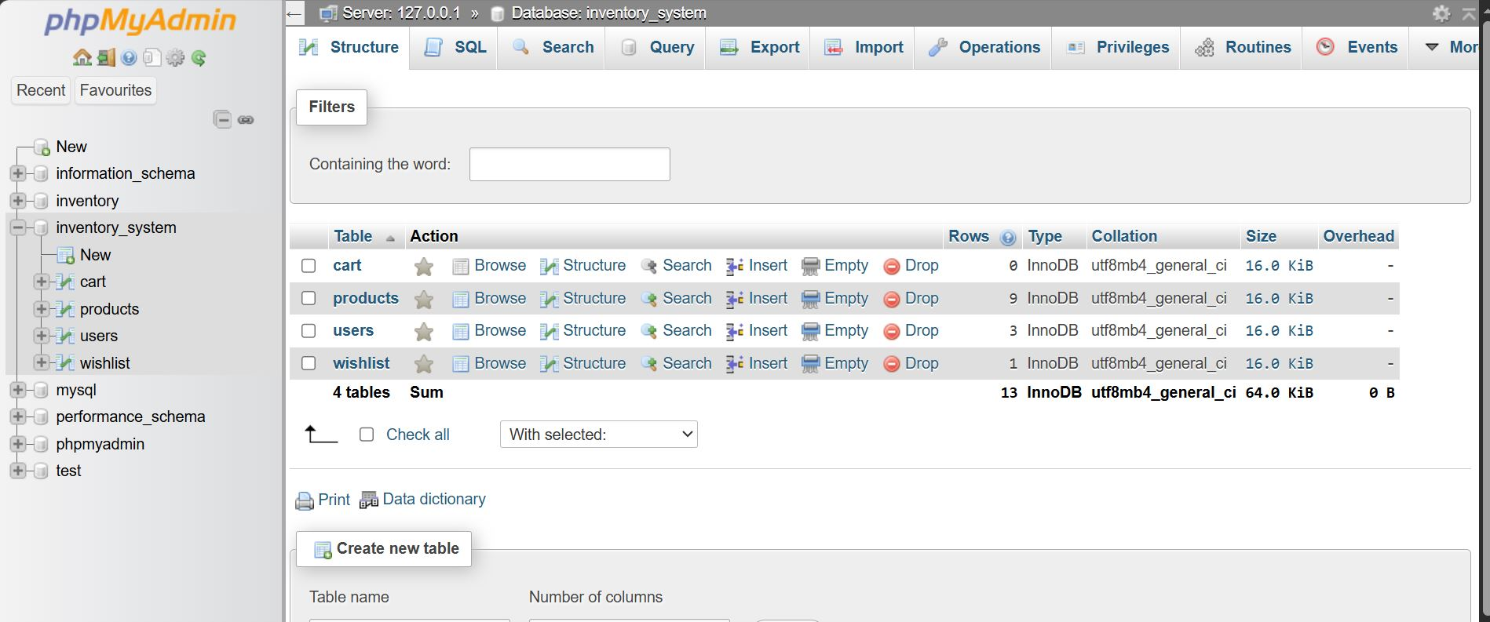

3.3 Table: products
The products table is the core table of the system, storing all product catalog data.

Column Name | Data Type | Constraints | Description
id | INT | PRIMARY KEY, AUTO_INCREMENT | Unique product identifier
user_id | INT | FOREIGN KEY → users.id | Owner of the product listing
name | VARCHAR(200) | NOT NULL | Product name
price | DECIMAL(10,2) | NOT NULL | Product selling price (INR)
quantity | INT | NOT NULL | Current stock count
category | VARCHAR(50) | NOT NULL | Product category (enum-like)
gender | VARCHAR(20) | NOT NULL | Target section: all/men/female/children
image | VARCHAR(255) | NULLABLE | Filename of uploaded product image
created_at | TIMESTAMP | DEFAULT NOW() | Date product was added

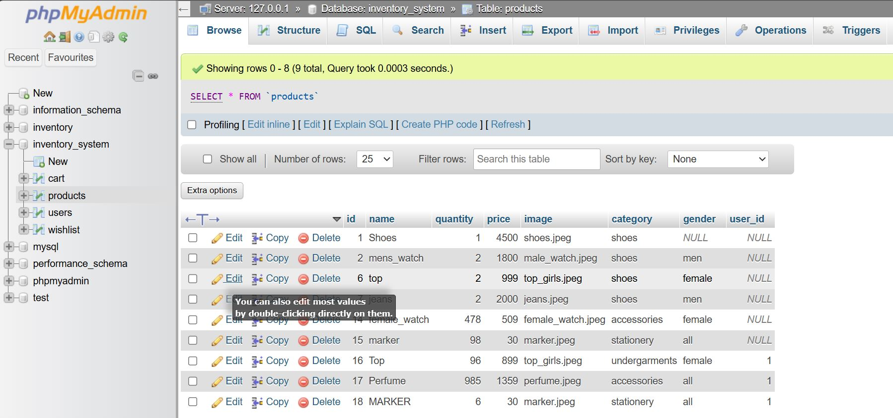

3.4 Table: cart

The cart table tracks products added to shopping carts by users.

Column Name | Data Type | Constraints | Description
id | INT | PRIMARY KEY, AUTO_INCREMENT | Unique cart entry ID
user_id | INT | FOREIGN KEY → users.id | User who added the item
product_id | INT | FOREIGN KEY → products.id | Product being added to cart
quantity | INT | DEFAULT 1 | Number of units in cart
added_at | TIMESTAMP | DEFAULT NOW() | When the item was added

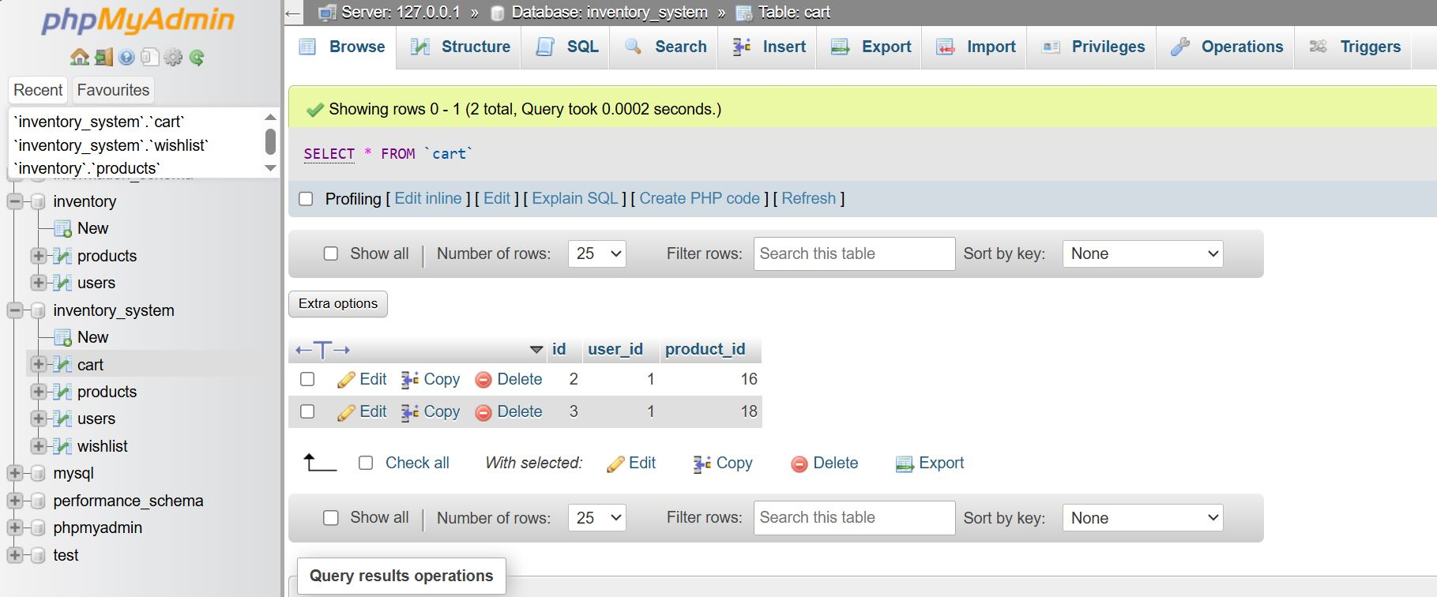

3.5 Table: wishlist
The wishlist table tracks products saved to wishlists.

Column Name | Data Type | Constraints | Description
id | INT | PRIMARY KEY, AUTO_INCREMENT | Unique wishlist entry ID
user_id | INT | FOREIGN KEY → users.id | User who wishlisted the item
product_id | INT | FOREIGN KEY → products.id | Wishlisted product
added_at | TIMESTAMP | DEFAULT NOW() | When the item was wishlisted

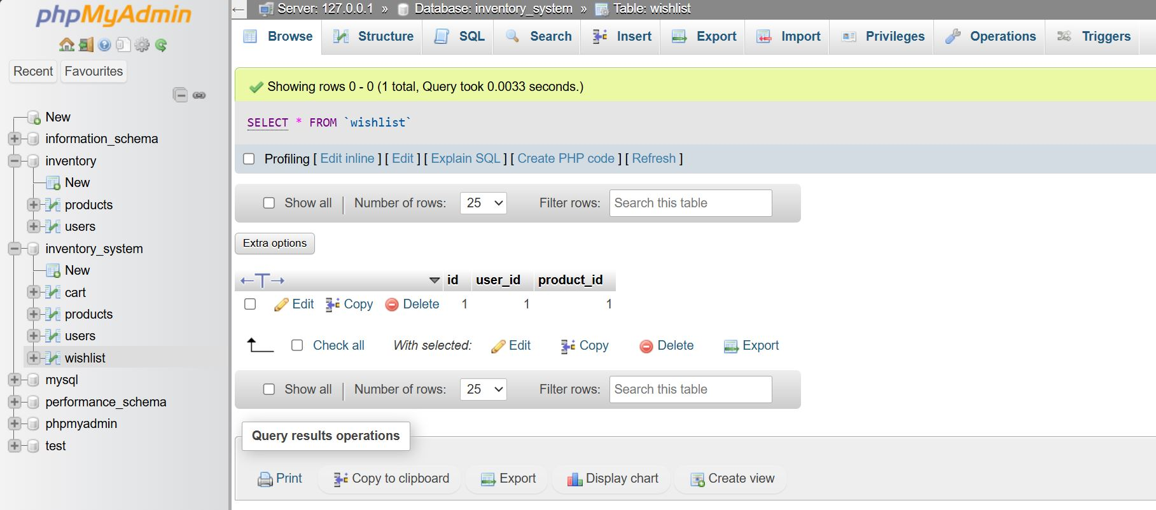

3.6 Entity Relationship Summary
The relationships between tables follow a straightforward one-to-many model:
- One user can own many products
- One user can have many cart entries
- One user can have many wishlist entries
- One product can appear in many cart entries
- One product can appear in many wishlist entries

3.7 SQL Schema

CREATE TABLE users (
id INT AUTO_INCREMENT PRIMARY KEY,
username VARCHAR(50) NOT NULL,
email VARCHAR(50) NOT NULL UNIQUE,
password VARCHAR(50) NOT NULL,
);

CREATE TABLE products (
id INT AUTO_INCREMENT PRIMARY KEY,
user_id INT NOT NULL,
name VARCHAR(200) NOT NULL,
price DECIMAL(10,2) NOT NULL,
category VARCHAR(50) NOT NULL,
gender VARCHAR(20) NOT NULL,
image VARCHAR(255),
);

4. Module Analysis
This provides a detailed analysis of each PHP module in the system, covering its purpose, logic flow, key code segments, and any notable observations.

4.1 Login Module (login.php)

4.1.1 Purpose
The login module is the entry point for all authenticated users. It presents a styled login form and validates submitted credentials against the users table in the database.



4.1.2 Functional Flow
- Page loads — checks if POST request has been submitted
- Extracts email and password from $_POST, trims whitespace
- Prepares a MySQLi prepared statement to query users table
- If a matching row exists: sets $_SESSION['id'] and $_SESSION['user'], redirects to dashboard.php
- If no match: sets $error variable and re-renders the form with error message

4.1.3 Key Code Segment
$stmt = $conn->prepare("SELECT * FROM users WHERE email=? AND password=?");
$stmt->bind_param("ss", $email, $password);
$stmt->execute();
$result = $stmt->get_result();
if ($result->num_rows > 0) {
$row = $result->fetch_assoc();
$_SESSION["id"] = $row["id"];
$_SESSION["user"] = $row["username"];
header("Location: dashboard.php");
}

4.1.4 UI Features
The login page features a split-panel layout with a gradient animated left panel
- Animated gradient background with floating particle shapes
- Bouncing Font Awesome shield icon on the image panel
- Smooth slide-in animation on page load (CSS keyframe)
- Input focus effects with elevation transform and glow
- Password visibility toggle via JavaScript event listener
- Error message with shake animation for invalid credentials
- Fully responsive — stacks vertically on mobile screens

4.2 Registration Module (register.php)

4.2.1 Purpose
The registration module allows new users to create an account. It collects a username, email, and password, then inserts a new record into the users table.
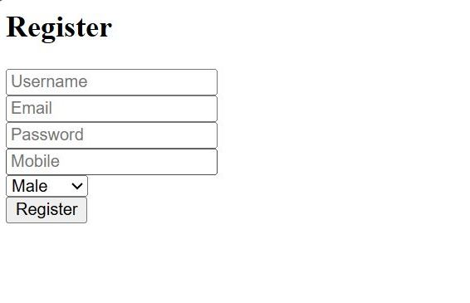

4.2.2 Functional Flow
- User fills out registration form with username, email, password
- POST request submitted to same page
- Server-side validation (basic required field checks)
- Database INSERT into users table
- On success: redirect to login.php or show confirmation

4.2.3 Estimated Code Pattern
if ($_SERVER["REQUEST_METHOD"] == "POST") {
$username = trim($_POST["username"]);
$email = trim($_POST["email"]);
$password = trim($_POST["password"]); // Should use password_hash()
$conn->query("INSERT INTO users (username, email, password)
VALUES ('$username','$email','$password')");
header("Location: login.php");
}

4.2.4 Observations
- No duplicate email validation is visible in current implementation
- Passwords are likely stored in plaintext — a critical security issue
- No email format validation beyond HTML5 type='email' attribute
- No CSRF token protection on the registration form.

4.3 Dashboard Module (dashboard.php)

4.3.1 Purpose
The dashboard is the main interface of the application. It displays the authenticated user's product inventory in a responsive card grid, with real-time filtering by gender section, product category, and keyword search.
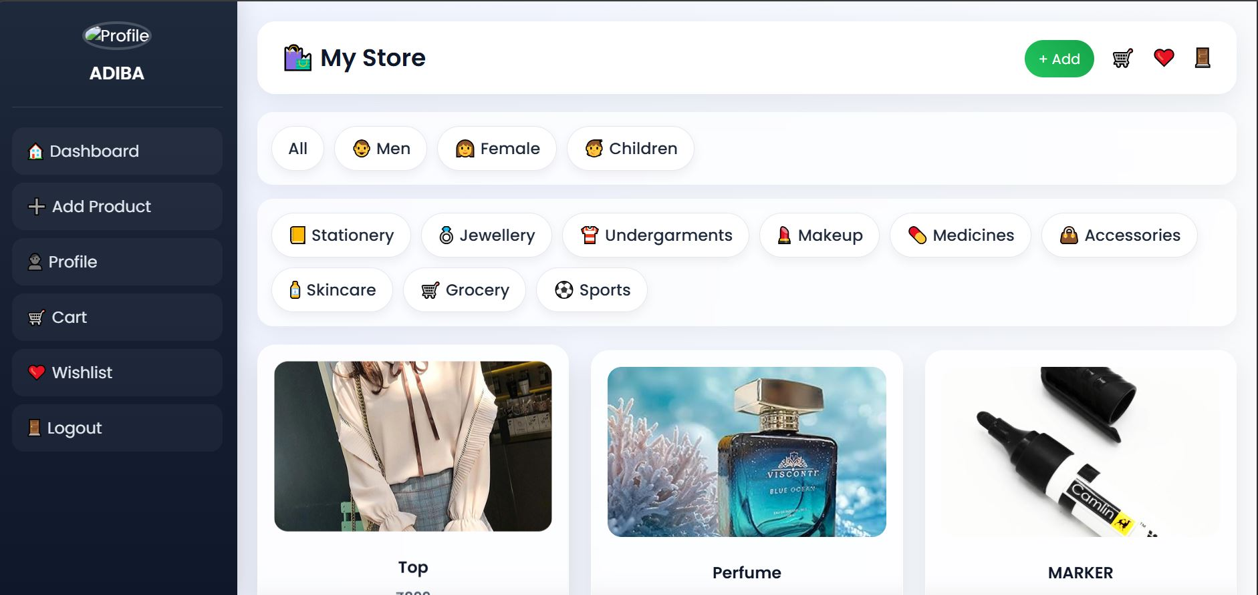

4.3.2 Functional Flow
- Page verifies $_SESSION['id'] — redirects to login.php if not set
- Reads filter parameters from GET: gender, category, search
- Builds dynamic SQL query with WHERE clauses based on active filters
- Executes query and fetches all matching products for this user
- Renders sidebar with navigation menu and user profile
- Renders top bar with store title, quick links, and Add button
- Renders two category bars (gender + category) with dynamic filter links
- Loops through result set to render product cards in CSS grid

4.3.3 Dynamic Query Builder

$query = "SELECT * FROM products WHERE user_id='$user_id'";
if ($search != "") { $query .= " AND name LIKE '%$search%'"; }
if ($gender != "") { $query .= " AND (gender='$gender' OR gender='all')"; }
if ($category != "") { $query .= " AND category='$category'"; }
$result = $conn->query($query);

4.3.4 buildLink() Helper Function
A custom buildLink() function constructs filter URLs while preserving existing filter state. For example, clicking a gender filter retains the current category and search term

function buildLink($g, $c, $s) {
$params = [];
if ($g) $params[] = "gender=$g";
if ($c) $params[] = "category=$c";
if ($s) $params[] = "search=$s";
return "dashboard.php?" . implode("&", $params);
}

4.3.5 Product Card Features

Element | Source Data | Notes
Product Image | images/{filename} | Falls back to images/default.png on error
Product Name | products.name | Displayed as card heading
Price | products.price | Formatted with ₹ symbol
Stock | products.quantity | Shows current quantity
Cart Button | Link to cart.php?add={id} | Emoji icon (🛒)
Wishlist Button | Link to wishlist.php?add={id} | Emoji icon (❤️)
Delete Button | Link to delete.php?id={id} | Emoji icon (❌)

4.4 Product Management Module (add.php & product.php)

4.4.1 Add Product (add.php) — Purpose
This module provides the form and handler for adding new products to the inventory. It handles both rendering the form (GET) and processing the submission (POST), including file upload for product images.

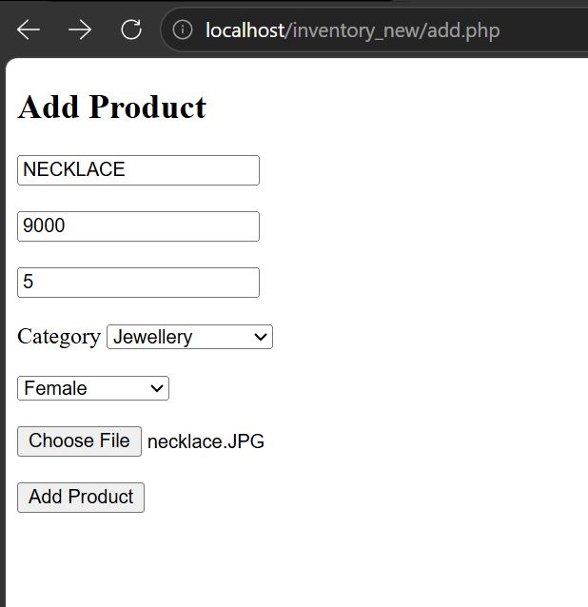

4.4.2 Add Product — Form Fields
Field | Input Type | Validation | Database Column
Product Name | text | required | products.name
Price | number | required | products.price
Quantity | number | required | products.quantity
Category | select | required, 9 options | products.category
Gender Section | select | required, 4 options | products.gender
Product Image | file | required | products.image (filename)

4.4.3 Image Upload Logic
$image = $_FILES['image']['name'];
move_uploaded_file($_FILES['image']['tmp_name'], 'images/' . $image);
// Image filename stored in DB; file saved to images/ directory

4.4.4 Product Detail View (product.php) — Purpose
This module displays a detailed view of a single product identified by its ID in the URL (?id=X). It shows the product image, price, stock count, category, and section, with buttons to add to cart or wishlist.

4.5 Cart Module (cart.php)

4.5.1 Purpose
The cart module manages the shopping cart for authenticated users. It handles adding items (via GET parameter ?add=), displaying current cart contents with product details, and removing items.

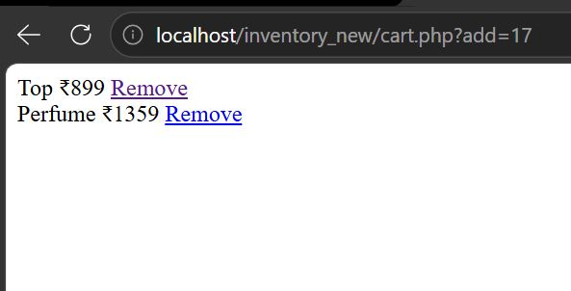

4.5.2 Estimated Functional Flow

- Check authentication — redirect if not logged in
- If ?add= parameter present: INSERT into cart table (user_id, product_id)
- SELECT all cart items joined with products table for this user
- Display cart items with name, image, price, and quantity
- Provide remove/delete functionality per item
- Cart total calculation (sum of price * quantity)

4.5.3 Cart Table Query Pattern

SELECT c.id, p.name, p.price, p.image, c.quantity
FROM cart c
JOIN products p ON c.product_id = p.id
WHERE c.user_id = '$user_id'

4.6 Wishlist Module (wishlist.php)

4.6.1 Purpose
The wishlist module allows users to save products for future reference without adding them to the cart. It mirrors the cart module's structure but without quantity management.

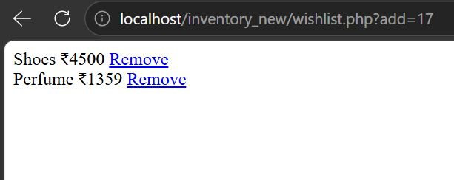

4.6.2 Key Differences from Cart

Aspect | Cart | Wishlist
Quantity tracking | Yes (per item quantity) | No (binary: saved or not)
Primary use | Items ready to purchase | Items of interest/saved for later
Table | cart | wishlist
Checkout action | Leads to payment flow | Convert to cart action

4.7 Update profile module (update_profile.php)

4.7.1 Purpose
The update profile module updates the user profile and redirects the changes in profile section of dashboard we can edit name , profile picture , edit gender , mobile number and email.

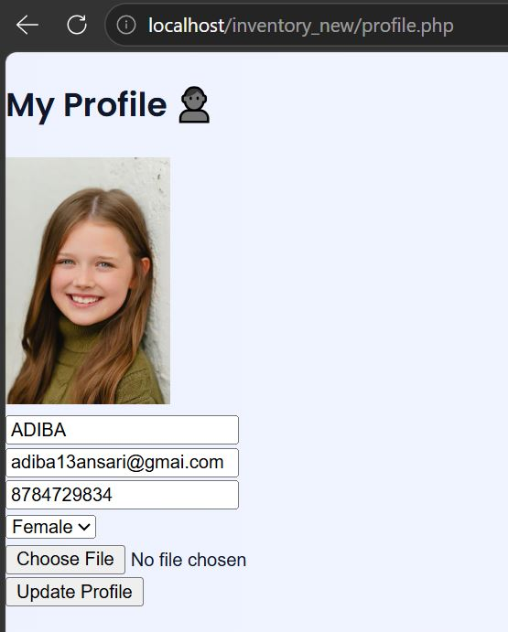

4.8 Logout Module (logout.php)

4.8.1 Purpose
The logout module destroys the current user session and redirects to the login page, effectively ending the authenticated session.

4.8.2 Implementation

<?php
session_start();
session_unset(); // Clear all session variables
session_destroy(); // Destroy the session
header("Location: login.php");
exit();
?>

The logout implementation is clean and straightforward. It correctly calls both session_unset() and session_destroy() to ensure complete session termination.

5. User Interface Design

5.1 Design Philosophy
The UI of this system follows a modern glassmorphism and gradient-forward design aesthetic. The interface combines translucent frosted glass panels, vibrant gradient backgrounds, smooth CSS animations, and card-based layouts to create a visually appealing and contemporary experience.

5.2 Color Palette
Color Name | Usage
Primary Blue | Buttons, active states, links
Dark Navy | Sidebar background, headings
Light Background | Page body background gradient
Success Green | Add button, price text, stock indicators
White (Glass) | Card backgrounds with backdrop-filter
Gradient Purple | Form submit button gradient end, login gradient

5.3 Layout System

5.3.1 Sidebar + Content Layout
The main application uses a fixed sidebar layout:
- Sidebar: 240px wide, fixed position, dark gradient, contains profile section and navigation menu
- Content area: margin-left: 240px, full viewport height, padded content
- On mobile (max-width: 768px): sidebar becomes relative, full width, stacks above content

5.3.2 Product Grid
Products are displayed using CSS Grid with auto-fill and a minimum column width of 230px. This creates a responsive grid that automatically adjusts the number of columns based on the available viewport width — from 4-5 columns on widescreen monitors down to 1-2 on mobile.

5.4 Animation Effects
Animation | Element | Effect | Duration
slideIn | Login container | Fade + translate + scale on page load | 0.8s
gradientShift | Login image panel | Background color cycling | 15s infinite
bounce | Shield icon | Vertical bounce loop | 2s infinite
float | Body background | Subtle radial gradient drift | 20s infinite
floatShape | Background shapes | Floating circles with rotation | 6s infinite
shake | Error message | Horizontal shake on credential error | 0.5s
gradientShift (form btn) | Submit buttons | Shimmer/shine sweep on hover | 0.5s

5.5 Responsive Design
The CSS includes a breakpoint at max-width: 768px. At this breakpoint:
- The sidebar loses its fixed position and becomes a top navigation strip
- The login container changes from row to column layout
- Top bar switches from flex-row to flex-column
- The product grid reduces minimum column width, fitting 1-2 cards per row

5.6 Accessibility Considerations
The current implementation has limited accessibility considerations. Identified gaps include:
- No ARIA labels on icon-only buttons (cart, wishlist, delete emoji icons)
- Color contrast of some gradient text over white backgrounds may be insufficient for WCAG AA
- No keyboard navigation support for the sidebar filter links
- Image alt attributes use raw filenames rather than descriptive text

6. Security Analysis

6.1 Security Overview
A thorough security audit of the codebase reveals several significant vulnerabilities that must be addressed before this application can be deployed in any production environment. This chapter categorizes each vulnerability by severity, explains its impact, and provides remediation guidance.

Vulnerability | Severity | Status
SQL Injection (dashboard, product, delete) | CRITICAL | Unmitigated
Plaintext Password Storage | CRITICAL | Unmitigated
Unrestricted File Upload | HIGH | Unmitigated
Missing Auth Check (product.php) | HIGH | Unmitigated
Cross-Site Scripting (XSS) — Output | HIGH | Partially mitigated
CSRF — No Token Protection | MEDIUM | Unmitigated
Session Fixation Risk | MEDIUM | Partially mitigated
Error Reporting in Production | LOW | Active (enabled in login.php)

6.2 SQL Injection
SQL injection is the most critical vulnerability in this system. It occurs when user-supplied input is directly concatenated into SQL query strings without parameterization.

6.2.1 Attack Scenario
An attacker could manipulate the search parameter on the dashboard with a payload like: ' OR '1'='1 — which would return ALL products in the database, bypassing the user_id filter. More destructive payloads could drop tables or exfiltrate user credentials.

6.3 Plaintext Password Storage
The login module directly compares user-submitted passwords against plaintext values stored in the database. This means that if the database is ever compromised, all user passwords are immediately exposed.

7. Testing & Quality Assurance

7.1 Testing Approach
Since this is an academic project without a formal test suite, this chapter outlines the recommended testing strategy and provides test case specifications that should be executed to validate system behavior. Testing is organized across four levels: Unit, Integration, System, and User Acceptance Testing (UAT).

7.2 Functional Test Cases — Authentication
Test Case | Input | Expected Result | Pass/Fail
Valid login | Correct email + password | Redirect to dashboard.php | pass
Invalid password | Correct email, wrong password | Show error: Invalid Email or Password | pass
Invalid email | Non-existent email | Show error message | pass
Empty fields | Blank email and password | HTML5 validation prevents submit | pass
SQL injection in login | ' OR '1'='1 as email | Should fail | pass
Registration with valid data | New unique email + password | Account created, redirect to login | pass
Registration — duplicate email | Existing email | Error or duplicate key exception | pass
Session persistence | Login, close tab, reopen | Session maintained (browser session) | pass
Logout | Click logout link | Session destroyed, redirect to login | pass
Direct URL access without login | Navigate to dashboard.php directly | Redirect to login.php | pass

7.3 Functional Test Cases — Product Management
Test Case | Input | Expected Result
Add product — all fields | Valid name, price, qty, category, image | Product appears in dashboard grid
Add product — missing field | Blank name | HTML5 required validation triggered
Add product — non-image file | Upload a .php or .txt file | Currently accepted (vulnerability)
Delete product | Click delete on own product | Product removed from database and grid
View product detail | Click on product card | Detail page shows correct product data
Filter by category | Click Jewellery filter | Only jewellery products shown
Filter by gender | Click Men filter | Men and All-gender products shown
Search by name | Type partial product name | Matching products shown in real time
Combined filter | Gender=Female + Category=Makeup | Only female/all makeup products shown
Image fallback | Product with missing/broken image | default.png shown via onerror handler

7.4 Functional Test Cases — Cart & Wishlist
Test Case | Expected Result
Add to cart | Product appears in cart with quantity
Add same product twice | Quantity increments (or duplicate entry created)
Remove from cart | Item removed from cart display
Add to wishlist | Product saved in wishlist
Remove from wishlist | Product removed from wishlist
View empty cart | Cart page shows empty state message

7.5 Browser Compatibility Testing
Browser | Result | Notes
Google Chrome | Expected: Pass | Primary development target
Mozilla Firefox | Expected: Pass | CSS animations may vary slightly
Microsoft Edge | Expected: Pass | Chromium-based, similar to Chrome
Safari (iOS) | Expected: Mostly Pass | backdrop-filter may need -webkit- prefix
Chrome (Android) | Expected: Pass | Responsive layout tested

7.6 Responsive Design Testing
Device / Viewport | Expected Behavior
Large Desktop | 5-column product grid, full sidebar
Desktop | 4-column grid, full sidebar
Laptop | 3-column grid, sidebar visible
Tablet (landscape) | 2-3 column grid, sidebar collapses
Tablet (portrait) | Breakpoint triggers, sidebar stacks
Mobile | 1-2 column grid, stacked layout

7.7 Input Validation Testing
Field | Test Input | Expected Behavior
Price | Negative value (-100) | No HTML5 prevention; server should validate
Quantity | Non-integer (10.5) | Browser rounds down; server accepts
Product Name | Very long string (500+ chars) | May truncate at DB VARCHAR limit
Search | Special characters (<, >, &) | Should be escaped before SQL and HTML output
Email | Invalid format | HTML5 type=email rejects at client side

8. Performance Evaluation

8.1 Performance Characteristics
This chapter evaluates the performance profile of the application — identifying bottlenecks, estimating load capacity, and providing optimization recommendations.

8.2 Database Query Analysis
The system's main performance concern is on the dashboard page, which executes a single SELECT query per page load. However, the query design has several performance implications as the product catalog grows.
Query | Performance Concern | Optimization
SELECT * FROM products WHERE user_id=? | SELECT * fetches all columns unnecessarily | Specify needed columns explicitly
AND name LIKE '%$search%' | Leading wildcard prevents index use | Consider full-text search index
No LIMIT clause | Returns all products at once | Add pagination with LIMIT/OFFSET
cart JOIN products | JOIN on large tables | Ensure foreign key indexes exist

8.3 Image Performance
Product images are stored as files in the images/ directory and served directly by the web server. Current performance considerations:
- No image compression or resizing on upload — large images slow page load
- No lazy loading attribute on product card images
- No CDN or caching headers configured
- Recommended: Add loading='lazy' to all product images
- Recommended: Compress images on upload using PHP's GD library or Imagick

8.4 Front-End Performance
The UI loads two external resources that may impact initial load time:
Resource | Provider | Size Impact | Optimization Option
Poppins font (login.php) | Google Fonts | Medium (~30-80KB) | Use font-display: swap
Font Awesome 6.4.0 CSS | cdnjs.cloudflare.com | Medium (~100KB) | Use subset or SVG sprites
Poppins font (style.css) | Google Fonts | Medium | Preload with <link rel=preload>

9. Uses and daily applications

9.1 Practical Uses of the System

Use Case | Description | Benefit
Product Management | Store owners can add, delete, and view product details | Keeps inventory organized and accessible
Inventory Tracking | Displays available items in the system | Helps monitor stock manually
User Authentication | Secure login system for users/admins | Prevents unauthorized access
Shopping Cart Feature | Users can add products to cart or wishlist | Improves user interaction and shopping experience
Database Storage | Stores product and user data in MySQL database | Ensures structured and reliable data storage
Category Filtering | Products can be grouped into categories | Makes searching and browsing easier

9.2 Daily Life Applications
• Retail Shops: Small shopkeepers can use this system to maintain digital records of their products instead of manual registers.
• Supermarkets: Helps in organizing items into categories and viewing available stock quickly.
• Online Stores (Basic Level): Can serve as a foundation for an e-commerce website with further improvements.
• Warehouses: Useful for keeping track of stored goods and checking availability.
• Educational Purpose: Helps students understand real-world implementation of web development and database concepts.
• Startups & Small Businesses: Provides a low-cost solution for managing inventory without expensive software.

10. Limitations & Known Issues

10.1 Functional Limitations
Limitation | Description | Impact
No product editing | Once added, products cannot be modified | Users must delete and re-add to update info
No pagination | All products load at once on dashboard | Slow with large inventories
No checkout/payment | Cart has no checkout functionality | System cannot complete a sale transaction
No stock management | Quantity doesn't auto-decrement on cart add | Inventory counts become inaccurate
No low-stock alerts | No notification when items run low | Manual monitoring required
No order history | No record of past transactions | Business intelligence is impossible
No product editing | No update form for existing products | Changes require delete + re-add workflow
Single image per product | Only one image supported | Cannot show multiple product angles

10.2 Security Limitations (Summary)
- SQL injection vulnerabilities in dashboard, product view, and delete modules
- Plaintext password storage — critical data breach risk
- No file type validation on image upload — RCE risk
- No CSRF protection on any form
- No rate limiting — susceptible to brute force attacks on login
- error_reporting(E_ALL) is active in login.php — exposes internal errors to users

10.3 Usability Limitations
- Delete action has no confirmation dialog — accidental deletions are permanent
- No feedback when adding to cart or wishlist (redirects silently)
- Search requires full page reload — no real-time AJAX search
- No sorting options (by price, name, or date added)
- No product count display per category
- Profile page (profile.php) details not visible in shared code — functionality unknown

11. Future Enhancements

11.1 Short-Term Improvements (1-3 Months)
These improvements are relatively straightforward to implement and address the most critical gaps in the current system:

Enhancement | Priority | Estimated Effort
Fix all SQL injection vulnerabilities (prepared statements) | CRITICAL | 2-3 days
Implement password hashing (password_hash/verify) | CRITICAL | 1 day
Add file upload validation (MIME type, size, rename) | HIGH | 1 day
Add product edit functionality | HIGH | 2 days
Add delete confirmation dialog (JavaScript confirm()) | HIGH | 2 hours
Implement pagination on dashboard | MEDIUM | 1 day
Add htmlspecialchars() to all output | HIGH | Half day
Remove error_reporting from production | LOW | 30 minutes

11.2 Long -Term Improvements (3-6 Months)
- Migrate to a PHP MVC framework (Laravel or CodeIgniter) for better structure
- Implement AJAX-based real-time search without page reload
- Add product sorting (by price, name, date, stock level)
- Implement stock decrement on cart addition with sold-out state
- Add checkout workflow with order summary and order history
- Implement email verification for new user registrations
- Add admin panel to oversee all users and their product listings
- Implement product image gallery (multiple images per product)
- Add inventory reports and basic analytics dashboard

12. Conclusion
The PHP Inventory Management System evaluated in this report stands as a well-structured and thoughtfully designed web application that effectively fulfills its intended purpose. Built using core web technologies such as PHP, HTML, CSS, and MySQL, the system provides essential functionalities required by small business owners, including product cataloging, inventory tracking, and a basic e-commerce interface with cart and wishlist features. These capabilities demonstrate a clear understanding of user needs and practical application development.
From a design and development perspective, the system reflects several strong technical decisions.
The implementation of prepared statements in the authentication module indicates awareness of secure database interaction practices, even though it is not consistently applied across all modules. The inclusion of a helper function like buildLink() for maintaining filter states shows attention to usability and clean URL management, which enhances user experience. Additionally, the CSS structure is notably well-organized, incorporating a consistent design system with meaningful variable naming conventions and responsive breakpoints. The adoption of a modern glassmorphism UI further elevates the application’s visual appeal, making it comparable to current industry design trends.

Despite these strengths, the security evaluation highlights significant vulnerabilities that must be addressed before the system can be considered for real-world deployment. The presence of SQL injection risks in multiple areas suggests inconsistent input handling and lack of comprehensive validation. Storing passwords in plaintext is a critical flaw, as it exposes user credentials to severe risk in the event of a data breach. Furthermore, the absence of restrictions on file uploads creates potential entry points for malicious files, posing a serious threat to the server and its data. These issues are not minor oversights but fundamental security concerns that require immediate attention and resolution.
Looking ahead, the system has strong potential for growth and improvement. By implementing the recommended security measures—such as consistent use of prepared statements, password hashing, and secure file handling—the application can establish a robust and secure foundation. Once these critical issues are resolved, further enhancements like product editing features, pagination for better data management, and performance optimizations can be introduced. Transitioning the application to a structured MVC (Model-View-Controller) framework would also improve scalability, maintainability, and code organization.

In conclusion, this project demonstrates a solid grasp of fundamental PHP and web development concepts, along with an appreciation for modern UI design and user experience. While it currently falls short in terms of security readiness, it provides an excellent learning platform and a promising base for building a more secure, scalable, and production-ready web application in the future.

References & Bibliography

1. PHP Official Documentation
Available at: https://www.php.net/
Used for understanding server-side scripting, session management, and backend development.

2. MySQL Reference Manual
Available at: https://dev.mysql.com/doc/
Used for database creation, queries, and inventory data management.

3. XAMPP Documentation
Available at: https://www.apachefriends.org/
Used to set up the local server environment for running PHP and MySQL.

4. W3Schools
Available at: https://www.w3schools.com/
Used for learning HTML, CSS, PHP, JavaScript, and SQL concepts.

5. GeeksforGeeks
Available at: https://www.geeksforgeeks.org/
Referred for understanding PHP authentication, prepared statements, and web development techniques.

6. Visual Studio Code Documentation
Available at: https://code.visualstudio.com/
Used as the primary code editor for writing and debugging the project.

7. Duckett, Jon
HTML and CSS: Design and Build Websites
Publisher: John Wiley & Sons, 2011
Used for designing the user interface.

8. Youtube & Artificial Intelligence
Youtube link : https://youtu.be/E9FfZ8goVTQ?si=g7ax4Any3uowP-Ox
Chatgpt : https://chatgpt.com/c
Claude Ai link : https://claude.ai/new
Perplexity Ai link : https://www.perplexity.ai/

