Supplementary Information

Inverse machine learning framework to optimize lightweight metamaterials

Adithya Challapalli, Dhrumil Patel, Dr. Gouqiang Li

**Figure S1. Several 3D printed optimal lattice unit cells.**

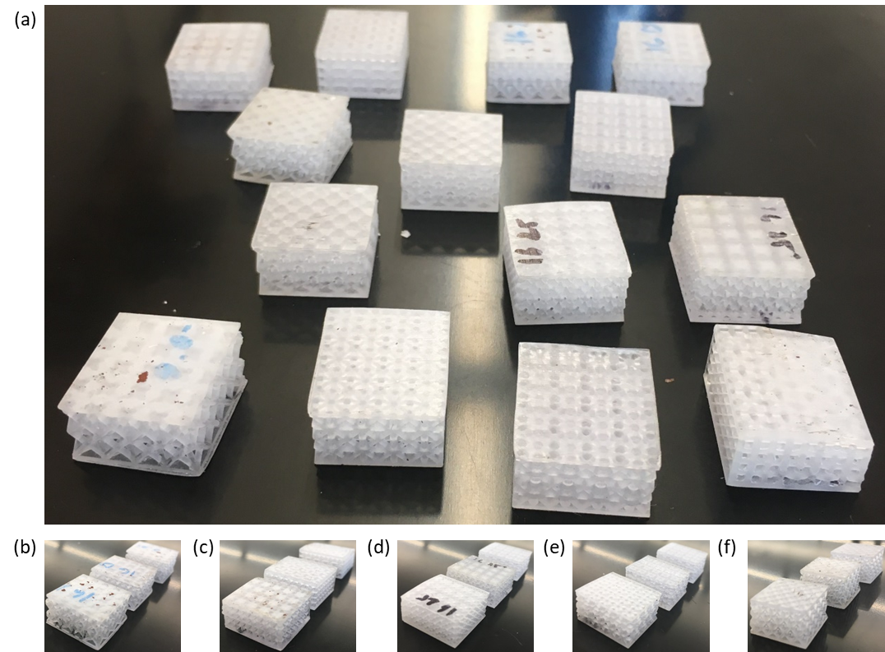

**Figure S2. (a) Several lattice core sandwich structures, (b) Lattice A, (c) Lattice B, (d) Lattice C, (e) Lattice D, (f) Octet sandwich structures.**

**Table S1. Comparisons for the performance of various lattice unit cells.**

|  |  |  |  |  |
| --- | --- | --- | --- | --- |
| SET 1 | Mass (Kg) | Change in mass (%) compared to Octet lattice cell | Compression Load (N) | Change in compression load (%) compared to Octet lattice cell |
| Lattice 1 | 0.00117 | -33.50196101 | 37.56716981 | -27.81 |
|  | 0.002632 | -33.49838319 | 84.95471698 | -0.29 |
|  | 0.00468 | -33.50053999 | 152.0150943 | -0.31 |
| Lattice 2 | 0.003534 | 100.8582959 | 100.5358491 | 93.20 |
|  | 0.007951 | 100.8589329 | 238.5433962 | 99.04 |
|  | 0.014135 | 100.861138 | 446 | 103.65 |
| Lattice 3 | 0.003343 | 90.01307338 | 101.9622642 | 95.94 |
|  | 0.007522 | 90.01364188 | 244.8075472 | 104.26 |
|  | 0.013372 | 90.01875746 | 461.6226415 | 110.78 |
| Lattice 4 | 0.002538 | 44.27897459 | 79.70943396 | 53.18 |
|  | 0.005711 | 44.27799111 | 181.0867925 | 51.10 |
|  | 0.010153 | 44.27613255 | 325.5811321 | 48.66 |
|  | Average | 32.18358101 | Average | 45.71 |
| SET 2 |  |  |  |  |
| Lattice 5 | 0.0012844 | -26.99369067 | 54.78113 | 5.27 |
|  | 0.00289 | -26.99070331 | 125.1245 | 4.40 |
|  | 0.0051378 | -26.99084863 | 226.3811 | 3.37 |
| Lattice 6 | 0.001399 | -20.47973626 | 60.1283 | 15.55 |
|  | 0.0031476 | -20.48302344 | 143.5019 | 19.74 |
|  | 0.0055958 | -20.4825783 | 268.5623 | 22.63 |
| Lattice 7 | 0.0015638 | -11.11237424 | 44.1434 | -15.17 |
|  | 0.0035186 | -11.11054972 | 109.4075 | -8.71 |
|  | 0.0062553 | -11.11095322 | 209.9396 | -4.14 |
| Lattice 8 | 0.0036154 | 105.5021884 | 128.3925 | 146.73 |
|  | 0.0081346 | 105.5022231 | 297.3547 | 148.11 |
|  | 0.014462 | 105.5078724 | 543.8113 | 148.31 |
|  | Average | 8.797364134 | Average | 30.38 |
| Set 3 |  |  |  |  |
| Lattice 9 | 0.001561 | -11.27721253 | 56.88301887 | 9.31 |
|  | 0.003512 | -11.27728375 | 128.9622642 | 7.60 |
|  | 0.006244 | -11.27721253 | 231.445283 | 5.68 |
| Lattice 10 | 0.001058 | -39.83970898 | 74.66037736 | 43.47 |
|  | 0.002381 | -39.8418553 | 171.1307953 | 42.79 |
|  | 0.004233 | -39.84255101 | 310.8 | 41.91 |
| Lattice 11 | 0.001311 | -25.47604161 | 65.60754717 | 26.08 |
|  | 0.00295 | -25.47746564 | 148.6603774 | 24.04 |
|  | 0.005244 | -25.47746263 | 266.6075472 | 21.73 |
| Lattice 12 | 0.001058 | -39.83970898 | 38.6 | -25.82 |
|  | 0.002381 | -39.8418553 | 87.88679245 | -26.67 |
|  | 0.004233 | -39.84255101 | 158.554717 | -27.60 |
|  | Average | -21.83193183 | Average | 8.91 |
| Set 4 |  |  |  |  |
| Lattice 13 | 0.0011462 | -34.84908771 | 52.50943 | 0.91 |
|  | 0.002579 | -34.8474131 | 119.5057 | -0.29 |
|  | 0.0045849 | -34.84766669 | 215.4566 | -1.62 |
| Lattice 14 | 0.0022451 | 27.61325527 | 127.3774 | 144.78 |
|  | 0.0050515 | 27.61469281 | 287.2302 | 139.66 |
|  | 0.0089804 | 27.61325527 | 512 | 133.78 |
| Lattice 15 | 0.001239 | -29.57426249 | 87.30189 | 67.77 |
|  | 0.0027879 | -29.57002829 | 197.4226 | 64.73 |
|  | 0.0049562 | -29.57142045 | 353.117 | 61.24 |
| Lattice 16 | 0.0028358 | 61.1891093 | 141.6755 | 172.26 |
|  | 0.0063806 | 61.19139046 | 327.3019 | 173.10 |
|  | 0.011343 | 61.18626727 | 595.3962 | 171.86 |
|  | Average | 4.571755729 | Average | 70.53 |

From the average values of change in mass and compression load percent’s in the table above, it can be observed that for each iteration of optimization, i.e. for each set, the mass or compression load or both gets better. The change in mass and compression load percent for each of lattice unit cells is obtained by subtracting those properties by octet unit cell properties. The negative sign indicates the decrease in the mass or compression load compared to the octet unit cell and positive sign indicates the increase in the properties. The decrease in mass is advantageous as controls the relative density and increase in impression load is advantageous as it directly related to the compression strength of the unit cells.