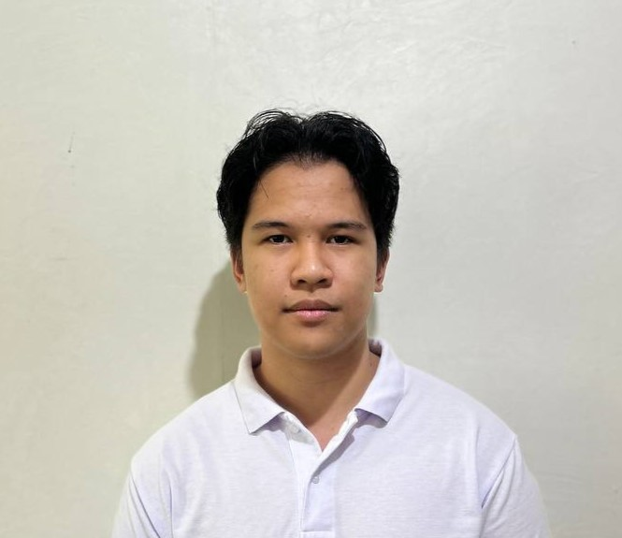**JOHN DAVE M. ROJO**

St. Francis st, Cagayan de Oro, 9000 Misamis Oriental

0991 895 5673

Johndave.rojo2004@gmail.com

|  |  |
| --- | --- |
| **OBJECTIVE:**  To be able to apply my acquired knowledge in Computer Programming into your reputable company and further enhance my skills through actual application.  **WORK EXPERIENCE:** Virtual Assistant – EXP Realty. April 2022 – March 2023 I worked as a virtual assistant for 11 months under Hera Boncaros from EXP Realty.   * I managed a list of over a thousand people who needed to be contact traced * Updates Facebook and Instagram page frequently for possible real estate sales * Assisted with the creation and editing of material on a website * Regularly communicating with various people on the Facebook Marketplace and checking on the posted houses * Assisted with multiple projects for the Real Estate Company | |
|  | |
| **EDUCATION:** | |
|  | |
| 2023 – Present  2021 – 2023 | **University of Science and Technology in Southern Philippines - CDO**  Taking the Degree of B.S Information Technology  **Valencia National High School** |
|  | Taking the Technical-Vocational Livelihood (TVL) pursing the strand of Information and Communication Technology (ICT)  *Specializations:* Computer Programming  Senior High School Completer  *Awards*: TVL Valedictorian |
| 2017 – 2021  2012 – 2017 | **Valencia National High School**  Special Science Program  Junior High School Completer  *Awards:* With High Honor  **Valencia City Central School**  Cream Class  Elementary School Completer  *Awards:* With Honor |

|  |
| --- |
|  |
| **SKILLS:**  Communication Skills   * I am able to express my thoughts effectively. For I have practiced conversing efficiently during my job as a virtual assistant. Talking with different people enhance my communication skills further.   I.T Skills   * In my job I have always used a laptop to encode, layout, and editing our outputs. * I also have undergone weeks of training on how to use Microsoft office, and different tools which honed my skills during my senior high years. This includes Microsoft word, Microsoft PowerPoint, Microsoft Excel and etc.   Interpersonal Skills   * Since I am involved in an organization and ministry, I have practiced to get acquainted with different kinds of people and personalities that has aided me to learn and adjust to these variances |
|  |
| **REFERENCE:**   |  |  | | --- | --- | | **0977 493 0470** | **HERA R. BONCAROS**  Marketing Associate – EXP Realty  [heraboncaros@gmail.com](mailto:heraboncaros@gmail.com) | |

I CERTIFY THAT THE CONTAINED DATA ARE TRUE AND CORRECT TO THE BEST OF MY KNOWLEDGE AND BELIEF.

JOHN DAVE M. ROJO

NAME AND SIGNATURE

