**Modifying Pixel Properties In Adaptive Steganography Using Substitute Method**

**Abstract:**

In steganography, the distortion purpose is used to explain the modification cost on cover elements ,which are definitely crucial to the security of current adaptive steganography.. In this project, we suggest a novel cost reassignment rule that's implemented to not one but a batch of present distortion functions. We notice that the costs assigned on a few pixels by several steganographic strategies may be very dissimilar even though those strategies exhibit close security levels. Such pixels are named as “controversial pixel”. Experimental results display that steganalysis features are unresponsive to those pixels, therefore these pixels are appropriate to hold extra payloads. We name this rule as the Controversial Pixels Prior (CPP) rule. steganalysis features and cover databases, we exhibit that the CPP rule can enhance the security of state-of-the-art steganographic algorithms for spatial snapshots.

**Keywords:**

Steganography, Distortion, Security, Cost reassignment, Controversial pixel, Payloads, Stego algorithms, Steganalysis, databases.

**Existing System**

* It defines distortion functions by investigating how to reasonably define the complex degrees of pixels in the sense of resisting detection.
* The core idea of *Complexity Prior*, several effective rules for ranking priority of pixels have been proposed by previous works
* Cost spreading rule: An element with high priority should spread its high rank to its neighbourhood and vice versa(low priority)
* This is also called as clustering rule
* SMD rule(synchronizing modification rule): The rule of synchronizing the modification direction ,which means the neighbouring pixels changedd in the same direction i.e; +1 or -1

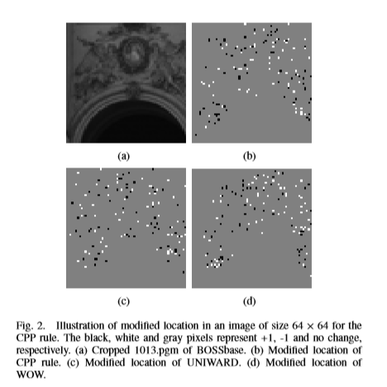

**Proposed System**

* The costs assigned on a few pixels by means of numerous steganographic strategies may be very distinct even though those strategies show off close security levels.
* Experimental effects display that stega analysis capabilities are not touchy to arguable pixels; therefore these pixels are appropriate to hold extra payloads. We name this rule the controversial Pixels earlier (CPP) rule.
* The CPP rule considers a combination of several existing methods instead of remaining fixed on a single method.
* An essential principle in selecting candidate algorithms for the CPP rule is that basic methods have comparable security performances.
* In addition, the CPP rule provides a novel tool for designing steganographic schemes.

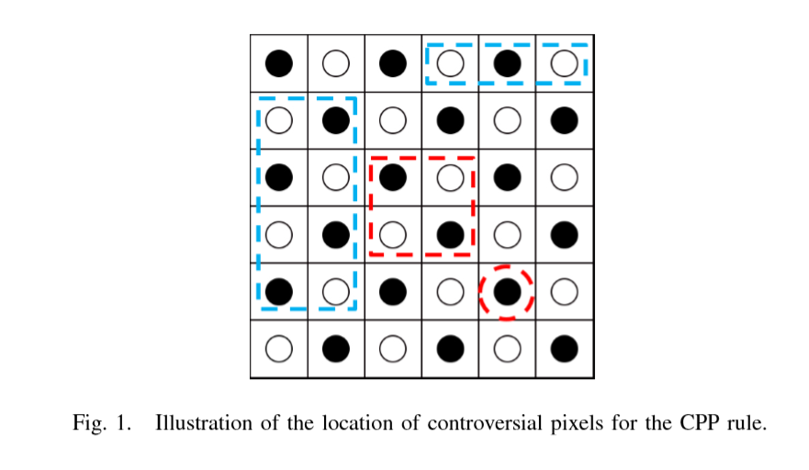

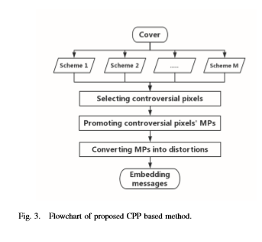

**Existing Vs Proposed**

|  |  |
| --- | --- |
| **Drawbacks** | **Advantages** |
| Moderate distortion | Noise reduction |
| Noise is high | Improved distortion |

**Future Enhancement**

* The proposed framework reduces the design of secure steganography in empirical covers to the problem
* By working out the proposed methodology in detail for a specific choice of the distortion function, we experimentally validate the approach and discuss various options available to the steganographer
* Current model-preserving (CMP) steganographic algorithm is used
* We make a connection between steganography design by minimizing embedding distortion and statistical physics
* We provide a complete theoretical framework and describe practical tools, such as the thermodynamic integration for computing the rate-distortion bound.

**Proposed vs Future**

|  |  |
| --- | --- |
| **ENRICHMENT** | **EXTRAVAGANCE** |
| Noise reduction | Thermodynamic integration. |
| Improved distortion rate | Rate-distortion bound. |

**SYSTEM REQUIREMENTS:**

**SOFTWARE REQUIREMENT**

* Operating system :- Windows7(with service pack1),8,8.1 and 10
* Front End :- Microsoft Visual Studio .Net 2013
* Coding Language :- C#
* Backend :- SQL Server 2012

**HARDWARE REQUIREMENT**

* Processor : Pentium Dual Core 2.00GHZ
* Hard disk : 120 GB
* Mouse : Logitech.
* RAM : 2GB(minimum)
* Keyboard : 110 keys enhanced