TASK: FE

**Name:** Atanas Ivanov

**Date Finished:**  23.04.2022

TABLE OF CONTENTS:

**Instructions** **2**

Estimations: 2

Results: 2

**Goals and Requirements** **2**

**Bonus points** **6**

**Results** **6**

Estimations: 6

Comments: 6

Demo: 7

**Contact Us** **7**

# Instructions

Please read the whole document before starting the task.

## Estimations:

* Please break the task down to smaller **subtasks** and give a rough estimation in the table under the Results section.
* It is completely normal if the estimations have a big difference than the time it took to finish the task.
* Estimations are important, please **log the hours** needed for research/implementation of each subtask in the Results -> Accomplished column.
* Also please **reply to our representative** with the initial estimations before starting, so we know roughly how much time you will need.

## Results:

* After finishing the task, please fill in your Name and Date of finish on top of this document.
* The results must go in the **Results -> Demo** table as well.

# Goals and Requirements

Utilizing Bootstrap 5, Next.js and React create a basic business website from the following mockup:

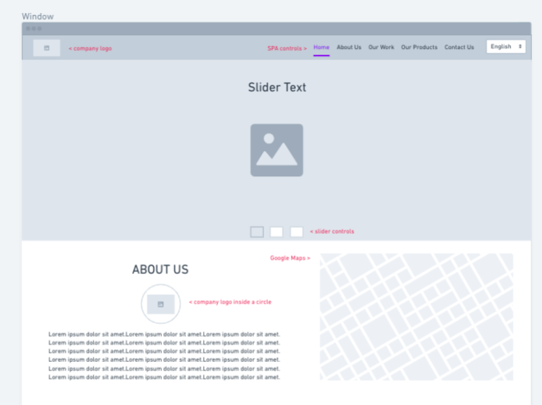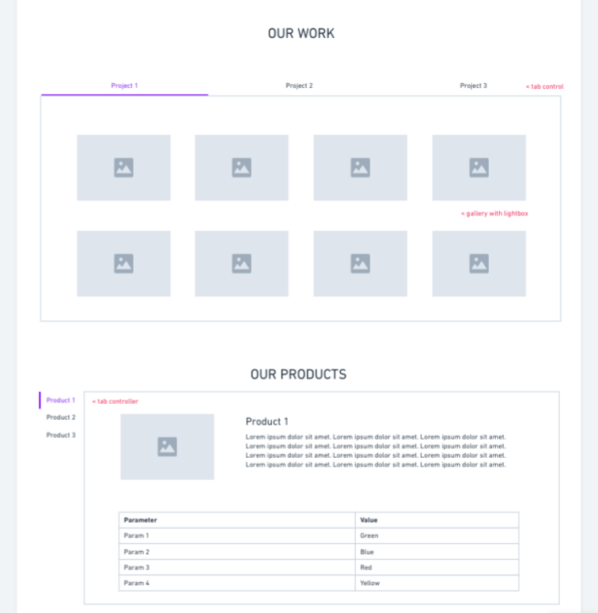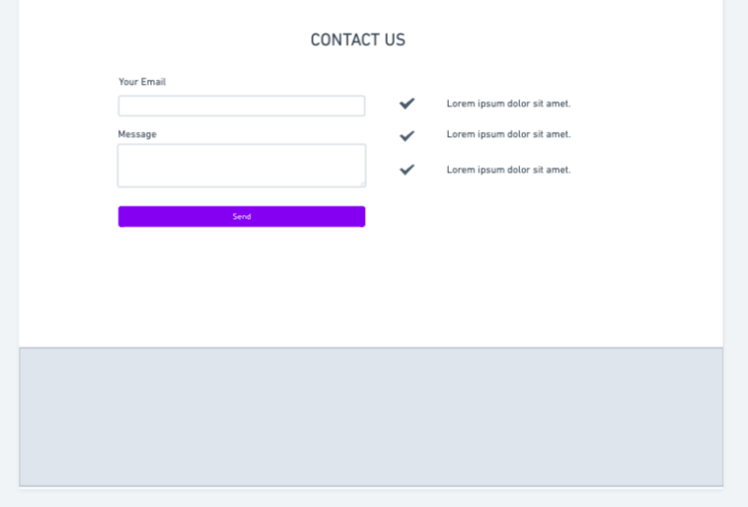

All images must be dynamically generated from: <https://picsum.photos/> and changed on every page load.

The site must support i18n with language files.

When the task is done, please upload all the files and export the database (if applicable) to a git repository (Github/GItlab/BItbucket etc.) and add it to the Results -> Demo table.

You have complete freedom regarding:

* Design of the website;
* Content (texts, graphics, media) of the website;
* Plugins/themes/libraries you use;

# Bonus points

For:

* Using Docker as dev environment;
* Using Docker-compose for the dev environment;
* Having a proper Markdown readme;
* Nice effects (ex. parallax);
* Following the appropriate coding standards and best practices;
* Using the SOLID/KISS/DRY principles;
* Having great responsive/adaptive design;
* Having proper comments;
* Implement any type of optimizations;
* Implement good security practices;
* Attention to detail;

# Results

## Estimations:

|  |  |  |
| --- | --- | --- |
| **Task Name** | **Estimated Time (h)** | **Accomplished for (h)** |
| Header navigation | 30min | 45min |
| Slider carousel | 60min | 80min |
| Section About | 30min | 30min |
| Section Our Work and  Section Our Products | 120min | Arround 100min |
| Section contact form | 40min | 45min |
| Footer section | 10min | 10min |

* *Please insert more rows if needed.*

## Comments:

|  |
| --- |
| If you have any comments or something that we need to note while checking your results, please enter them here: |
|  |

## Demo:

If the task requires a live demo and/or repository URL, please provide it here:

|  |  |
| --- | --- |
| **Description** | **URL** |
| Task | https://github.com/Adidesing/task/tree/main |
|  |  |

* *Please insert more rows if needed.*

# Contact Us

If you are stuck or have any assistance, please contact us at:  
[office@theorigamicorporation.com](mailto:office@theorigamicorporation.com)

Good luck!