AZURE LOAD TESTING FOR A
WEB APPLICATION CAPACITY STUDY
Project ID: 24CC3046-P056

Team / Roll | Student ID | Name
T158 | 2400032012 | KORADA TEJA
T158 | 2400032102 | GUBBALA LAKSHMI SAI TEJA
T158 | 2400032605 | GOLLA MANIKANTA
T158 | 2400032152 | ADITYA SINGH

1. Executive Summary
This project implements an Azure-based capacity study for a web application. The objective was to determine how the application behaves as concurrent workload increases, identify the observed resource bottleneck, apply horizontal scaling, repeat the same workload, and verify dynamic autoscaling.
The application was deployed on Azure App Service with Azure Database for PostgreSQL. Azure Load Testing used an Apache JMeter test plan to generate simulated virtual users and a mixed traffic workload across product browsing, search, product details, dashboard, order operations, and a CPU-intensive operation. Application Insights and Azure Monitor were used for telemetry.
The single-instance progression tested 10, 50, 100, 250, and 500 virtual users. At 500 users, CPU reached 80%, which was the configured boundary in the study. The application was then tested with 2 and 4 App Service instances under the same 500-user workload. The 4-instance run measured 139.8 requests/second, 239 ms P95 latency, and 52.3% average CPU. Azure Monitor Activity Logs also verified real scale-out and scale-in events.

2. Objectives
- Deploy a working web application on Azure App Service.
- Generate realistic concurrent workload using Azure Load Testing and Apache JMeter.
- Measure throughput, latency percentiles, errors, CPU, memory, and instance count.
- Identify the observed capacity boundary and the primary resource constraint.
- Scale the application horizontally from 1 to 2 and 4 App Service instances.
- Repeat the same 500-user workload and compare actual results.
- Verify that Azure Autoscale performs real scale-out and scale-in actions.
- Create a centralized Azure Portal dashboard for project monitoring and presentation.

3. Azure Services and Components Used
Component | Purpose
Azure App Service | Hosts the Node.js 22 LTS web application.
App Service Plan | Provides compute resources and controls horizontal instance scaling; Standard S1.
Azure Load Testing | Generates the load and executes the JMeter test plan.
Apache JMeter | Defines virtual users, traffic distribution, requests, ramp-up, and test duration.
Application Insights | Captures application request duration, failures, and telemetry.
Azure Monitor | Tracks infrastructure metrics such as CPU and memory and supports autoscale evidence.
Azure Autoscale | Adds/removes App Service instances according to CPU rules.
Azure Database for PostgreSQL Flexible Server | Provides the relational data layer used by the application.
Log Analytics Workspace | Centralizes monitoring and telemetry data.
Custom Azure Portal Dashboard | Combines project architecture, metrics, results, and autoscale evidence.

4. System Architecture and Working
The system follows a closed-loop capacity-testing architecture. Azure Load Testing sends HTTPS traffic generated by Apache JMeter to the Azure App Service. When multiple App Service instances are active, Azure distributes requests across the instance pool. The application communicates with Azure PostgreSQL for data operations, while Application Insights and Azure Monitor collect performance and infrastructure telemetry. Autoscale uses CPU thresholds to dynamically change the instance count.
- LOAD – Azure Load Testing starts JMeter virtual-user threads and generates continuous HTTPS traffic.
- MEASURE – The application processes requests while Application Insights captures request telemetry and Azure Monitor records CPU and memory.
- IDENTIFY BOTTLENECK – Increasing concurrency on one instance raises CPU utilization until the configured boundary is reached.
- SCALE – Additional App Service instances are provisioned manually for controlled comparison or dynamically through Autoscale.
- REPEAT – The same 500-user JMeter workload is executed against the larger instance pool.
- COMPARE – Throughput, latency, errors, CPU, memory, and instance count are compared using actual measurements.
- VERIFY AUTOSCALE – Azure Monitor Activity Logs are checked for real scale-out and scale-in events.

5. How Virtual Users Are Created and Tested
A virtual user is a simulated client created by the Apache JMeter engine used by Azure Load Testing. One JMeter thread represents one simulated virtual client. Therefore, a 500-user test means the load engine creates approximately 500 concurrent execution threads; it does not create 500 permanent database accounts. These simulated clients send normal HTTP requests to the deployed application.
The test uses a mixed workload rather than forcing every virtual user to execute the same action. JMeter Throughput Controllers distribute transactions approximately as follows:
Traffic | Endpoint | Feature Tested
40% | GET /api/products?limit=20 | Catalog browsing
20% | GET /api/search?q=laptop | Search
15% | GET /api/products/1 | Product detail
10% | GET /api/dashboard | Dashboard aggregation
10% | GET /api/orders + POST /api/orders | Order/checkout operations
5% | GET /api/heavy-operation | CPU stress workload
Continuous | GET /health | Liveness/database connectivity check
The virtual-user lifecycle is: thread creation → ramp-up → HTTP request → application processing → database/application response → response timing recorded → next weighted transaction → test completion. The study uses 300-second (5-minute) runs for the scale-out comparison.

6. Application Features Tested
Endpoint | Purpose
/health | Health and database connectivity check.
/api/products | Product catalog browsing and database retrieval.
/api/products/:id | Individual product detail lookup.
/api/search | Keyword-based product search.
/api/dashboard | Aggregation of application data.
/api/orders | Order history retrieval and order creation.
/api/heavy-operation | CPU-intensive workload used to create controlled compute pressure.

7. Progressive Load Testing Results
Runs 1–5 were executed on one Standard S1 App Service instance. The purpose was to progressively increase concurrency and observe the point at which resource utilization approached the configured boundary.
Run | Users | Inst. | Requests | RPS | Avg ms | P95 ms | P99 ms | Errors | CPU | Memory | Observation
Run 1 | 10 | 1 | 39,129 | 130.4 | 69.6 | 258 | 501 | 0.00% | 23.0% | 73.0% | Baseline
Run 2 | 50 | 1 | 38,878 | 129.6 | 70.0 | 229 | 446 | 0.00% | 38.0% | 74.0% | Stable
Run 3 | 100 | 1 | 35,415 | 118.1 | 76.8 | 251 | 487 | 0.00% | 52.0% | 75.0% | CPU rising
Run 4 | 250 | 1 | 35,033 | 116.8 | 77.7 | 250 | 541 | 0.00% | 68.0% | 75.0% | Below threshold
Run 5 | 500 | 1 | 32,958 | 109.9 | 82.6 | 272 | 527 | 0.00% | 80.0% | 76.0% | CPU boundary

8. Bottleneck Identified
The main observed bottleneck was CPU utilization on the single Standard S1 App Service instance. At 250 virtual users, CPU was 68%, while at 500 virtual users it reached 80%. Error percentage remained 0% and memory was 76% in the 500-user run, so the observed boundary in this experiment was CPU rather than application errors or memory exhaustion.
Important interpretation: 250 virtual users should be described as the highest tested load that stayed below the configured 70% autoscale trigger on one instance, not as the absolute maximum capacity of the application.

9. How the Bottleneck Was Resolved
- The 1-instance 500-user result was retained as the baseline for comparison.
- The App Service Plan was scaled to 2 instances and the exact same 500-user JMeter workload was executed.
- The plan was then scaled to 4 instances and the exact same workload was executed again.
- For each run, requests, throughput, latency percentiles, errors, CPU, memory, instance count, and duration were recorded.
- The results showed that 4 instances provided additional compute headroom and higher measured throughput under the same workload.
Configuration | Users | Requests | RPS | Avg ms | P95 ms | P99 ms | Errors | CPU | Memory
1 Instance | 500 | 32,958 | 109.9 | 82.6 | 272 | 527 | 0.00% | 80.0% | 76.0%
2 Instances | 500 | 22,175 | 73.9 | 122.8 | 436 | 855 | 0.00% | 73.5% | 72.5%
4 Instances | 500 | 41,931 | 139.8 | 64.8 | 239 | 513 | 0.01% | 52.3% | 73.5%
The 2-instance result did not improve every metric; its measured throughput was lower and P95 latency was higher than the 1-instance run. The 4-instance run, however, processed 41,931 requests at 139.8 RPS, with P95 of 239 ms and average CPU of 52.3%. The report attributes the 2-instance behavior to initial connection-pooling/Azure ARR warm-up effects; this should be presented as the observed explanation for that run.

10. Autoscale Verification
Autoscale was configured with a minimum of 1 instance, maximum of 4 instances, and CPU-based rules. Unlike merely showing a configuration screen, the project verified actual autoscale actions using the Azure Monitor Activity Log.
Time (UTC) | Action | Instance Change | Status
17:41:28 UTC | Scale up | 2 → 3 | Succeeded
17:51:29 UTC | Scale down | 3 → 2 | Succeeded
17:57:27 UTC | Scale down | 2 → 1 | Succeeded
This demonstrates the intended closed loop: increased CPU caused a scale-out action, and after load reduced, the platform scaled back down toward the minimum instance count.

11. PostgreSQL Verification
The application was verified as connected to Azure Database for PostgreSQL Flexible Server. The live /health response reported database type 'postgres' and status 'ok'. The application configuration uses DATABASE_URL with SSL and a connection pool. The report states that catalog browsing, search, order creation, and dashboard aggregation use the PostgreSQL data layer.

12. Custom Azure Portal Dashboard
The custom shared dashboard was updated to remove incomplete query placeholders. It contains visualizations for CPU and memory, App Service requests and instance count, response time and HTTP 5xx errors, Application Insights telemetry, the empirical test matrix, virtual-user explanation, and autoscale proof.

13. Azure Portal and Implementation Evidence
The following screenshots document the Azure environment, Load Testing resource, completed test runs, baseline statistics, and the project resource group.
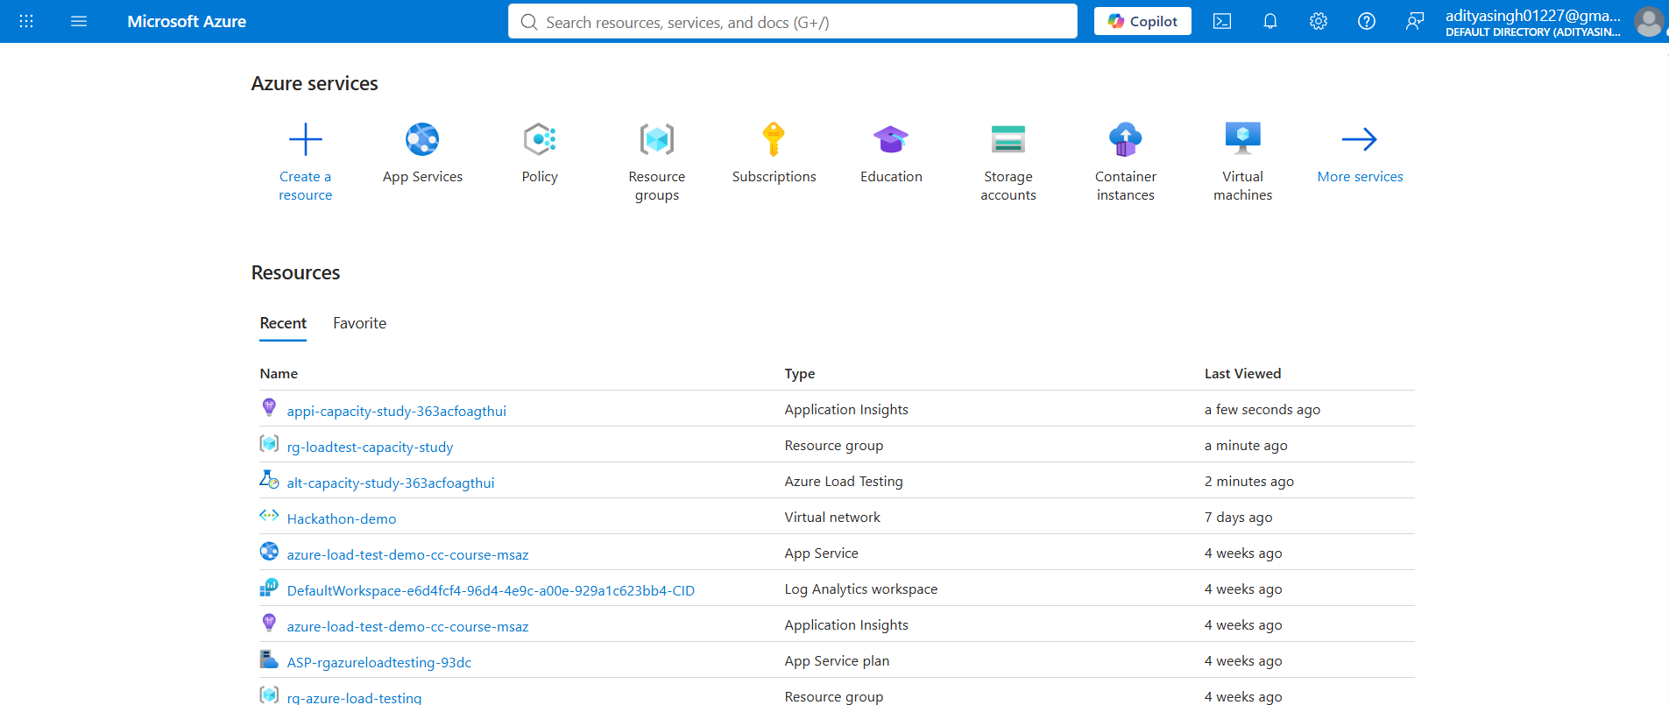
Figure 1. Microsoft Azure Portal home showing the Azure services and project resources.

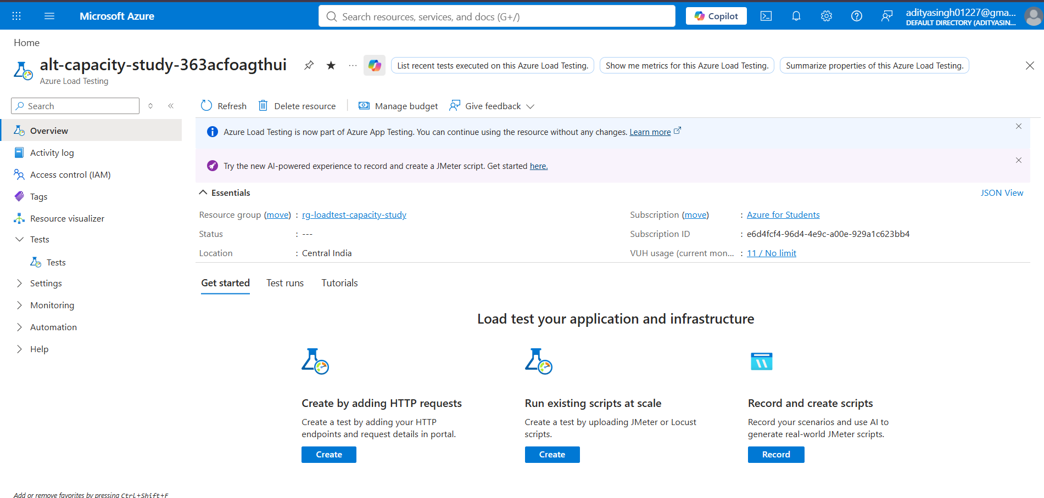
Figure 2. Azure Load Testing resource overview for the capacity-study project.

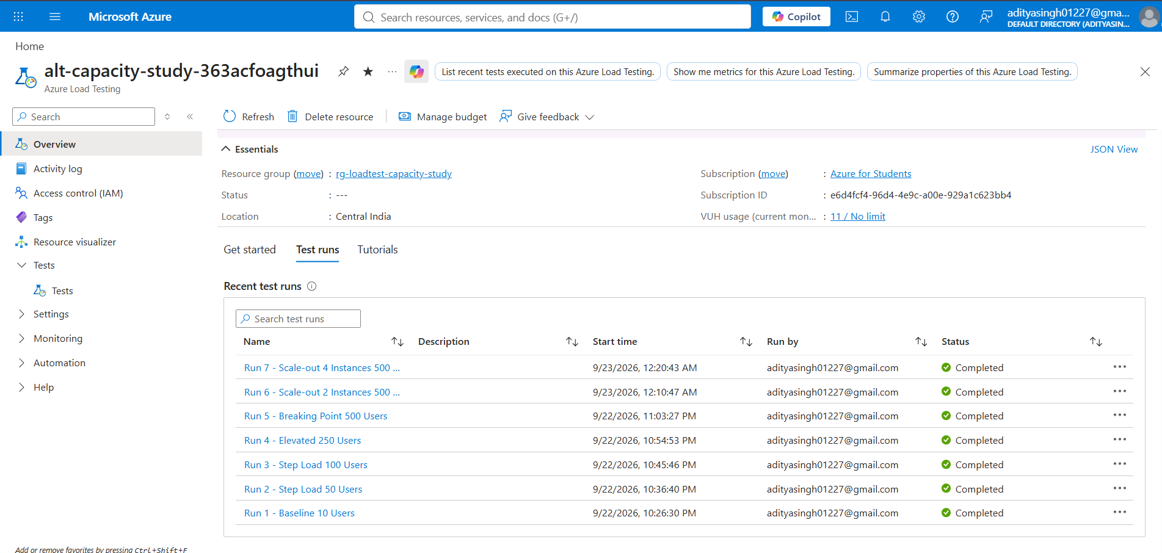
Figure 3. Azure Load Testing test-run history showing Runs 1 through 7 completed successfully.

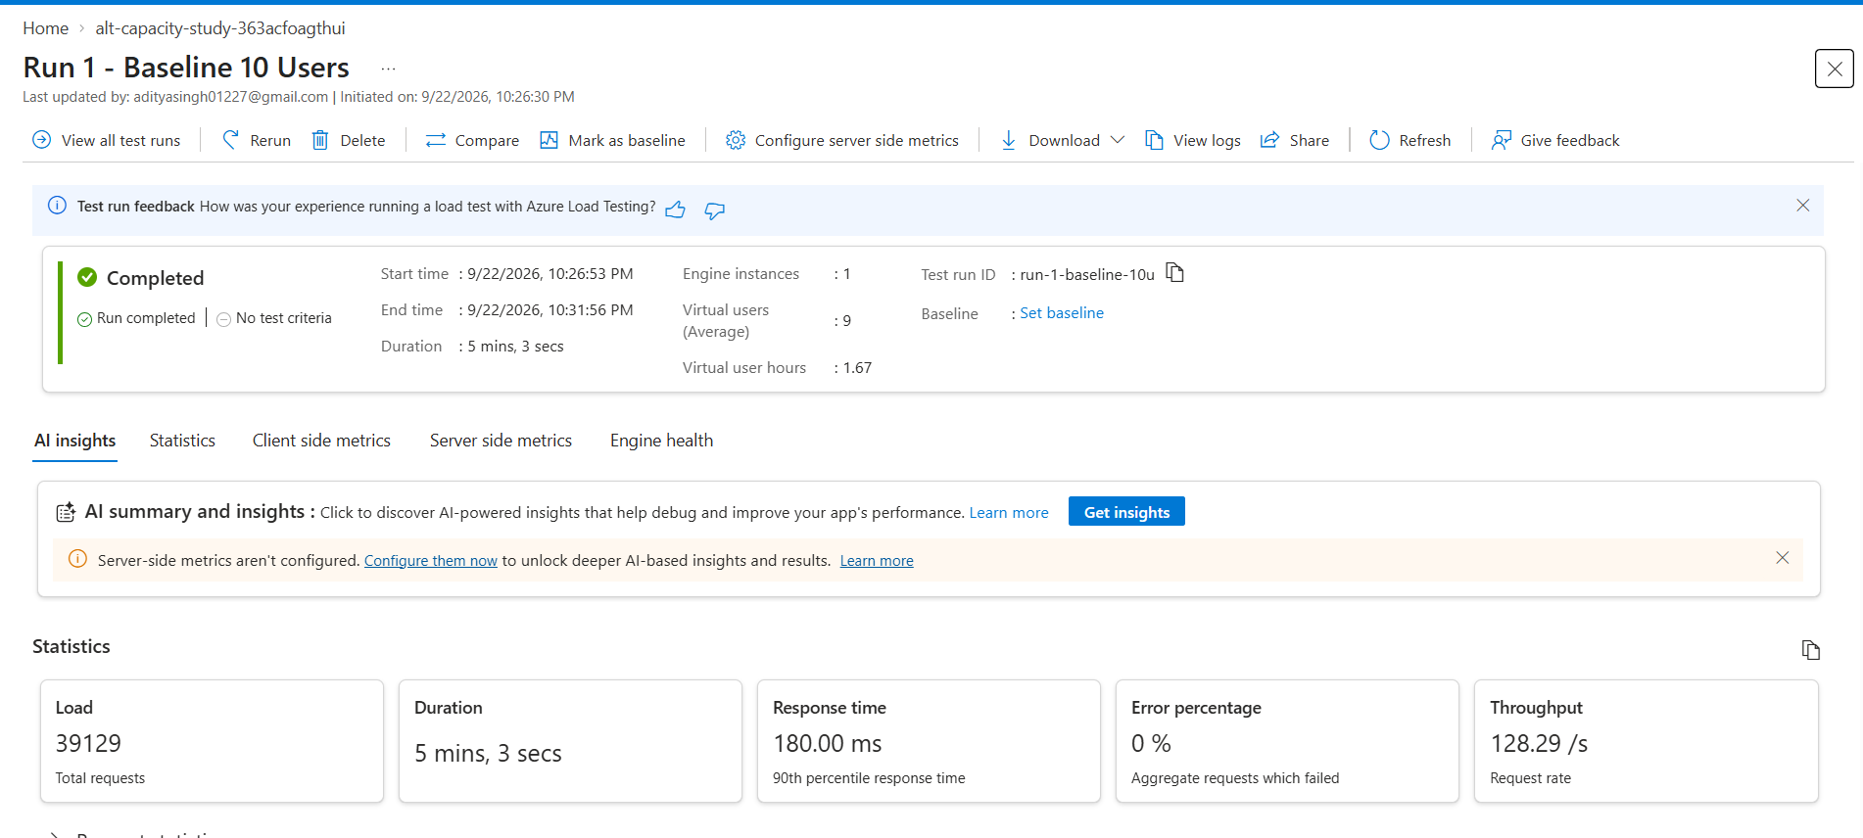
Figure 4. Run 1 baseline test showing 39,129 requests, 0% errors, 128.29 requests/second, and a 90th-percentile response time of 180 ms.

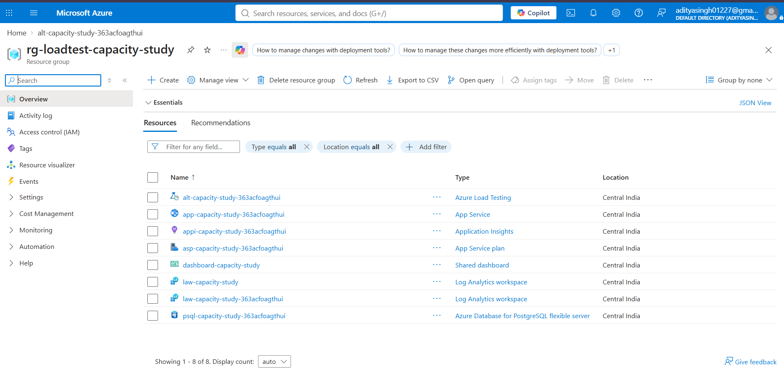
Figure 5. Azure resource group containing the main resources used for the capacity study.

14. Performance Metrics Explained
Metric | Meaning
Average Response Time | Average duration across all measured requests.
P50 | Median latency; 50% of measured requests complete at or below this value.
P90 | Latency at or below which approximately 90% of requests complete.
P95 | Latency at or below which approximately 95% of requests complete; useful for observing slower-user experience.
P99 | Latency at or below which approximately 99% of requests complete; highlights tail latency.
RPS | Requests completed per second; used as a throughput indicator.
Error % | Percentage of requests that failed or timed out.
CPU % | Compute utilization of the App Service plan/instances.
Memory % | Memory utilization of the application compute environment.
Instance Count | Number of App Service workers currently serving traffic.

15. Problems / Bottlenecks Faced and Resolutions
Issue | Observed Problem | Resolution
CPU saturation at high concurrency | At 500 virtual users on one S1 instance, CPU reached 80%. | Performed horizontal scale-out to 2 and 4 instances and repeated the identical 500-user workload.
Need to prove scaling rather than only configure it | An autoscale rule alone does not prove that Azure actually scaled. | Verified Azure Monitor Activity Log events showing 2→3 scale-out and subsequent 3→2→1 scale-in.
Incomplete dashboard query tiles | Initial custom dashboard contained tiles reporting that an incomplete query had been provided. | Reconfigured dashboard parts with exact Azure resource IDs and supported metric aggregations.
Database path needed verification | The application dashboard initially raised uncertainty about whether the data layer was in-memory or PostgreSQL. | Verified the live /health response and application configuration; PostgreSQL returned status 'ok'.
Different results across scaling runs | The 2-instance run did not improve throughput/latency compared with the 1-instance run. | Kept the actual result rather than fabricating an improvement; the 4-instance run was used to evaluate the larger instance pool and observed warm-up/queuing effects were documented.

16. Step-by-Step Implementation Summary
- Created the Azure resource group in Central India.
- Deployed the Node.js web application to Azure App Service on a Standard S1 App Service Plan.
- Provisioned Azure Database for PostgreSQL Flexible Server and connected the application through DATABASE_URL.
- Configured Application Insights and Log Analytics for telemetry.
- Created the Azure Load Testing resource and configured the Apache JMeter test plan.
- Implemented a mixed workload across product, search, detail, dashboard, order, heavy-operation, and health endpoints.
- Executed progressive load tests at 10, 50, 100, 250, and 500 virtual users.
- Identified CPU as the observed bottleneck at the 500-user boundary on one instance.
- Executed the same 500-user workload with 2 instances.
- Executed the same 500-user workload with 4 instances.
- Compared actual throughput, latency, error rate, CPU, memory, and instance count.
- Configured and verified CPU-based Azure Autoscale.
- Verified real scale-out and scale-in events in Azure Monitor Activity Logs.
- Fixed the custom Azure Portal dashboard and added monitoring/result tiles.
- Prepared the final empirical comparison and hackathon demonstration flow.

17. Conclusion
The project successfully demonstrates an end-to-end Azure capacity-study workflow. The application was load-tested with progressively increasing simulated concurrency, the observed CPU boundary was identified, the application was horizontally scaled, the same workload was repeated for comparison, and actual autoscale events were verified through Azure Monitor.
The key experimental finding is that the single-instance configuration reached an 80% CPU boundary at 500 virtual users. Under the same 500-user workload, the 4-instance configuration measured 139.8 RPS, 239 ms P95 latency, and 52.3% average CPU. These results demonstrate the usefulness of horizontal scale-out for providing additional compute headroom under the tested workload.
The study is an empirical capacity test under a defined workload and Azure configuration. Results should not be interpreted as an absolute maximum capacity for all future workloads or configurations.

18. Limitations
- The PostgreSQL server uses a Burstable B1ms configuration; substantially higher concurrency may require database scaling.
- The Azure Load Testing experiments used one load-test engine instance for the reported runs.
- The Azure for Students environment limited the App Service horizontal scaling experiment to the tested 1–4 instance range.
- The observed capacity boundary is specific to the tested application build, workload mix, duration, Azure tier, and environment.

19. Short Hackathon Explanation
Problem: We needed to determine how much concurrent workload our web application could handle and what happened when the application approached its resource limits.
Method: Azure Load Testing generated JMeter-based virtual users that sent a realistic mixture of API requests to the live application.
Finding: At 500 virtual users on one S1 instance, CPU reached 80%, making CPU the observed resource boundary in the study.
Solution: We horizontally scaled the App Service plan to 2 and 4 instances and repeated the same workload.
Validation: The 4-instance run measured 139.8 RPS, 239 ms P95 latency and 52.3% average CPU, and Azure Monitor Activity Logs verified actual scale-out and scale-in events.

