**CHAPTER 1: INTRODUCTION**

## Background of the Project

The tourism industry has witnessed unprecedented growth in recent years, fueled by factors such as globalization, technological advancements, and a growing appetite for travel among consumers. With millions of people embarking on journeys around the globe annually, the demand for efficient tour planning tools has never been higher.

Traditionally, travelers relied on guidebooks, travel agencies, and word-of-mouth recommendations to plan their trips. However, the digital revolution has transformed the landscape of travel planning, ushering in a new era of online platforms and mobile applications designed to simplify the process.

Recognizing the need for innovative solutions to enhance the travel experience, our project, the Tour Planner, emerged as a response to the challenges faced by modern travelers. Drawing inspiration from existing travel planning tools and leveraging advancements in technology, our team embarked on a mission to develop a comprehensive platform that seamlessly integrates accommodation and tourist attraction recommendations.

Through extensive research and analysis of user preferences and behaviors, we identified key pain points in the tour planning process, including the overwhelming amount of information available, the lack of personalized recommendations, and the cumbersome booking procedures. Armed with these insights, we set out to design a solution that addresses these challenges head- on.

The Tour Planner harnesses the power of data analytics, machine learning, and user-centric design principles to deliver a tailored experience for each user. By aggregating vast amounts of data from multiple sources, including hotel booking platforms, review websites, and tourist information databases, the system is able to generate intelligent recommendations that align with users' preferences and constraints.

Moreover, our project is underpinned by a commitment to accessibility and usability, ensuring that the platform caters to users of all demographics and technological proficiencies. Whether accessing the Tour Planner via a desktop computer or a smartphone, users can expect a seamless and intuitive experience that facilitates effortless trip planning.

## Scope of the Project

* + - Destination Selection: Users can input their desired destination(s) along with travel dates and any specific preferences or constraints they have, such as budget limitations or preferred types of accommodation.
    - Data Aggregation: The system collects and aggregates data from various sources including hotel booking platforms, tourism websites, review platforms, and geographic databases to gather information on available accommodations and tourist attractions at the specified destination.
    - Recommendation Engine: The Tour Planner analyzes the aggregated data to generate personalized recommendations for hotels and tourist attractions based on user preferences, ratings, reviews, proximity, and availability.
    - User Interface Design: The project includes the design and development of user-friendly interfaces accessible via web browsers and mobile applications. The interfaces allow users to interact with the system, input their preferences, view recommendations, and make bookings.
    - Accommodation Booking: Users can browse through recommended hotels, view detailed information including prices, amenities, and reviews, and proceed with booking directly through the platform. Integration with external booking APIs facilitates seamless transactions.
    - Attraction Exploration: The Tour Planner presents users with a curated list of tourist attractions and activities at the chosen destination, providing detailed descriptions, images, reviews, and relevant information to aid in decision-making.
    - Customization and Filtering: Users have the option to customize their preferences further and apply filters to refine their search results based on criteria such as price range, accommodation type, star ratings, popularity, and proximity to attractions.

The scope of the Tour Planner project encompasses the development of a comprehensive and user-centric platform for trip planning, accommodation booking, and tourist attraction exploration, leveraging technology to enhance the travel experience for users worldwide.

## Objectives of the Project

The objectives of the Tour Planner project are multifaceted, aiming to address key challenges faced by travelers while enhancing their overall trip planning and exploration experience. Firstly, the project seeks to streamline the tour planning process by providing users with a centralized platform where they can easily input their destination preferences, travel dates, and budget constraints

Secondly, the project aims to leverage advanced data aggregation and machine learning techniques to generate personalized recommendations for accommodations and tourist attractions tailored to each user's preferences and requirements

Thirdly, the project focuses on designing intuitive and user-friendly interfaces accessible via web browsers and mobile applications, ensuring seamless navigation and interaction for users of all demographics and technological proficiencies. Additionally, the project aims to facilitate seamless booking processes for accommodations and activities, integrating with external booking platforms to simplify transactions and enhance convenience.

Moreover, the project strives to empower users with comprehensive information and insights about their chosen destinations, enabling informed decision-making and exploration of diverse tourist attractions. Furthermore, the project emphasizes scalability and maintenance to accommodate a growing user base and evolving travel trends, ensuring the reliability, security, and performance of the platform over time. Ultimately, the overarching objective of the Tour Planner project is to revolutionize the way people plan and experience travel, empowering them to embark on memorable journeys with confidence, convenience, and personalized recommendations.

## Applicability

The Tour Planner project holds significant applicability across various sectors of the travel and tourism industry, catering to the needs of both individual travelers and businesses alike. Firstly, for individual travelers, the Tour Planner offers a comprehensive solution to streamline the trip planning process, providing personalized recommendations for accommodations and tourist attractions based on individual preferences, budget constraints, and travel dates.

By leveraging advanced data analytics and machine learning algorithms, the platform ensures that users receive tailored suggestions that align with their unique interests and requirements, enhancing their overall travel experience. Additionally, the user-friendly interfaces accessible via web browsers and mobile applications make the Tour Planner accessible to a wide range of users, from seasoned travelers to novices, facilitating seamless navigation and interaction. Moreover, the platform's integration with external booking services simplifies the booking process for accommodations and activities, saving users time and effort.

Furthermore, the Tour Planner project also holds applicability for businesses operating in the travel and tourism industry. Hotels, tour operators, and tourist attractions can leverage the platform to reach a broader audience of travelers, increasing their visibility and bookings. By integrating with external booking platforms, businesses can streamline their booking processes and maximize their revenue potential. Additionally, the platform's analytics tools provide valuable insights into user behavior, booking trends, and performance metrics, enabling businesses to make informed decisions and optimize their operations. Overall, the Tour Planner project offers a versatile and scalable solution with broad applicability across the travel and tourism ecosystem, benefiting both travelers and businesses alike

## CHAPTER 2: LITERATURE REVIEW

The concept of tourism, as we understand it today, has evolved over centuries, shaped by various historical events and individuals. While it is challenging to attribute the invention of tourism to a single individual or moment, its roots can be traced back to ancient civilizations where people traveled for religious pilgrimages, trade, and cultural exchanges. However, the modern tourism industry began to take shape in the 19th century with the rise of the Grand Tour, a traditional trip undertaken by young European aristocrats to explore cultural and historical sites in continental Europe.

One significant milestone in the history of tourism was the invention of the internet, which revolutionized the way people access information and plan their travels. The internet became widely accessible to the public in the 1990s, leading to the emergence of online travel agencies, booking platforms, and travel-related websites. Among the pioneers in this space was companies like Expedia, founded in 1996, which offered users a convenient platform to search for flights, hotels, and rental cars.

The availability of tourism-related information on the internet transformed the industry, making it easier for travelers to research destinations, compare prices, and make bookings from the comfort of their homes. Additionally, the internet enabled the democratization of travel information, allowing individuals to share their experiences, tips, and recommendations through blogs, forums, and social media platforms.

In recent years, advancements in technology, such as mobile applications and artificial intelligence, have further enhanced the accessibility and convenience of travel planning. Innovative projects like the Tour Planner aim to leverage these technologies to provide personalized recommendations, streamline booking processes, and enhance the overall travel experience for users.

While the invention of tourism cannot be attributed to a single individual, the modern tourism industry has been shaped by historical developments and advancements in technology.

With early forms of travel documented in ancient civilizations such as the Greeks and Romans who journeyed for leisure, trade, and cultural exchange. However, the modern tourism industry as we know it today began to take shape in the 19th century with the emergence of the Grand Tour, a traditional journey undertaken by European aristocrats to explore the cultural landmarks of continental Europe. This period also saw the development of infrastructure such as railways and steamships, which made travel more accessible to the masses.

Following Expedia's success, numerous other online travel companies emerged, including Booking.com, TripAdvisor, and Airbnb, each offering unique features and services to cater to the diverse needs of travelers worldwide. Booking.com, founded in 1996, focused primarily on hotel reservations, while TripAdvisor, established in 2000, provided user-generated reviews and recommendations for accommodations, restaurants, and attractions. Airbnb, founded in 2008, disrupted the hospitality industry by enabling individuals to rent out their homes or spare rooms to travelers, offering a more personalized and immersive travel experience.

These online platforms revolutionized the way people research, plan, and book their trips, offering convenience, choice, and transparency in a previously opaque and fragmented industry. Today, the internet plays a central role in every stage of the travel journey, from inspiration and planning to booking and sharing experiences. With the proliferation of smartphones and mobile apps, travelers have access to a wealth of information and services at their fingertips, empowering them to explore the world with ease and confidence.

In summary, while the concept of tourism has ancient roots, the modern tourism industry has been shaped by technological advancements such as the internet, which have democratized access to travel information and services. Pioneering companies like Expedia, Booking.com, TripAdvisor, and Airbnb have played a pivotal role in transforming the way people discover, plan, and experience travel, making it more accessible, affordable, and personalized for travelers worldwide.

## CHAPTER 3: REQUIREMENTS AND ANALYSIS

* 1. **Problem Definition**

The problem definition of the Tour Planner project revolves around the challenges faced by travelers in efficiently planning and organizing their trips, particularly in terms of finding suitable accommodations and identifying tourist attractions at their chosen destinations. Traditional methods of trip planning often involve tedious manual research, browsing multiple websites, and sifting through overwhelming amounts of information to make informed decisions. This process is time-consuming, prone to error, and lacks personalization, resulting in frustration and dissatisfaction among travelers.

## Requirements Specification

* + 1. **Functional Requirements**
       1. **User authentication:** It should be possible for users to register and safely log in.
       2. **Customization Tools:** Users should be able to Search for all the Tourist places by just adding City or Town (Eg:- Mumbai).
       3. **Itinary:** User will get the perfect information of all the tourist places in the Itinary.
       4. **Real-time location:** Users will be able to get real-time location of the tourist places.

## Non-Functional Requirements

* + - 1. **Performance:** Even at times of high traffic, the platform should load pages in two seconds or less.
      2. **Security:** Implement encryption protocols to **protect** user data and adhere to industry standards.
      3. **Usability:** Ensure an intuitive and user-friendly interface through user tests.
      4. **Scalability:** Design a system using a cloud-based infrastructure to handle increased user traffic and growing design repositories.
      5. **Data backup and recovery:** Regular automatic backup and recovery to minimize data loss.

## Software Requirements:

* + - 1. **Operating System (OS):** Windows OS (Windows 11)
      2. **Web Development Framework:** HTML, CSS, JavaScript for frontend development.

### Frontend Libraries and Frameworks:

* + - * + **Bootstrap:** For responsive and user-friendly UI components.

### Code Editor:

* + - * + **Visual Studio Code (VSCode):** A feature-rich and popular code editor that supports web development.

### Web Server and Database:

* + - * + **Node.js :** Node.js is an open-source, cross-platform JavaScript runtime environment facilitated by the Linux Foundation's Collaborative Projects program.
      1. **Browser Developer Tools:** Make use of browser developer tools (e.g., Chrome DevTools) for debugging and inspecting web pages.
      2. **Local Testing Browsers:** Ensure you have multiple web browsers (e.g., Chrome, Firefox, Edge) installed for testing cross-browser compatibility.

## Hardware Requirements:

* + - 1. **Processor (CPU):** Dual-core processor or higher.
      2. **RAM (Memory):** 4 GB of RAM or more.
      3. **Storage (Hard Drive):** 128 GB SSD or HDD with sufficient free space for project files and development tools.
      4. **Graphics Card (GPU):** Basic integrated graphics are sufficient for web development.
      5. **Display:** A monitor with a minimum resolution of 1366 x 768 pixels is recommended for comfortable coding and testing.
      6. **Input Devices:** Standard keyboard and mouse.

## Planning and Scheduling

* + 1. **Project Scope**

In this shortened timeline, the project scope will focus on the essential features necessary for a basic launch of the Tour Planner platform. The emphasis will be on rapid development and testing.

## Timeline and Milestones

**Month 1: Project Initiation and Development**

Week 1: Project kick-off.

Week 2: Detailed project plan and requirements documentation.

Week 3-4: Development of core interactive design tools and user registration features. **Month 2: Testing, Launch, and Post-launch**

Week 1: User acceptance testing and refinement.

Week 2: Integration of user collaboration features, communication channels, and final testing. Week 3: Platform launch.

Week 4: Post-launch monitoring and support initiation

|  |  |  |  |  |  |
| --- | --- | --- | --- | --- | --- |
| Planning Task | | | | | |
| **Task** | **Plan Start**  **Date** | **Plan End**  **Date** | **Actual**  **Start Date** | **Actual End**  **Date** | **%Completion** |
| Planning | 15-06-2023 | 14-07-2023 | 15-06-2023 | 06-07-2023 | 100% |
| Requirement | 14-07-2023 | 28-07-2023 | 06-07-2023 | 20-07-2023 | 100% |
| Designing | 28-07-2023 | 08-09-2023 | 20-07-2023 | 17-08-2023 | 100% |
| Implementation | 08-09-2023 | 29-12-2023 | 17-08-2023 | 21-12-2023 | 100% |
| Testing | 29-12-2023 | 19-01-2024 | 21-12-2023 | 04-01-2024 | 100% |
| Deployment | 19-01-2024 | 02-02-2024 | 04-01-2024 | 18-01-2024 | 100% |
| Maintenance | 02-02-2024 | 16-02-2024 | 18-01-2024 | 01-02-2024 | 100% |

Table 1: Planning Task

|  |  |  |  |
| --- | --- | --- | --- |
| **Data Preparation** | | | |
| **Task** | **Actual Start Date** | **No. of Days** | **No.of days Completed** |
| Planning | 15-06-2023 | 21 | 21 |
| Requirement | 06-07-2023 | 14 | 14 |
| Designing | 20-07-2023 | 28 | 28 |
| Implementation | 17-08-2023 | 126 | 126 |
| Testing | 21-12-2023 | 14 | 14 |
| Deployment | 04-01-2024 | 14 | 14 |
| Maintenance | 18-01-2024 | 14 | 14 |

Table 2: Data Preparation

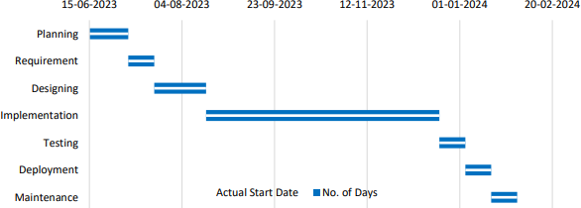

Figure 1: Tracking Project Progress

## CHAPTER 4: SYSTEM DESIGN

### Schema Design Admins Table:

|  |  |  |  |
| --- | --- | --- | --- |
| **Column Name** | **Data Type** | **Description** | **Constraint** |
| id | int | Primary key, unique admin identifier | Not null |
| username | varchar(50) | Admin's first name | Not null |
| password | varchar(255) | Admin's hashed password | Not null |

Table 3: Admin Table **Users**

### Table:

|  |  |  |  |
| --- | --- | --- | --- |
| **Column Name** | **Data Type** | **Description** | **Constraint** |
| id | int | Primary key, unique user identifier | Auto_Increment |
| name | varchar(255) | User's first name | Not null |
| email | varchar(255) | User's email address | Not null |
| password | varchar(10) | User's hashed password | Not null |

Table 4: User Table

ER DIAGRAM

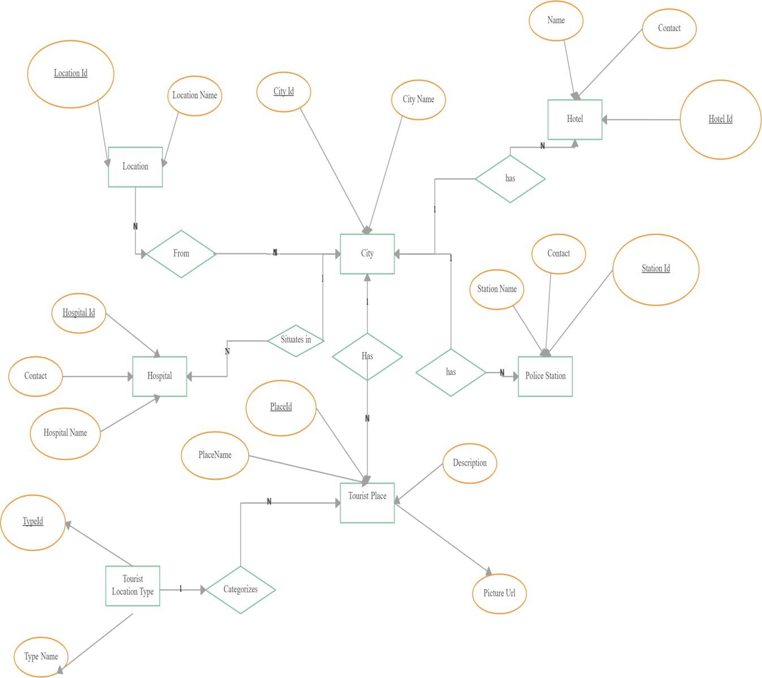

Figure 2: ER Diagram

## UML Diagrams / Block Diagram/ Circuit Diagram/ Algorithms Design

### USECASE DIAGRAM

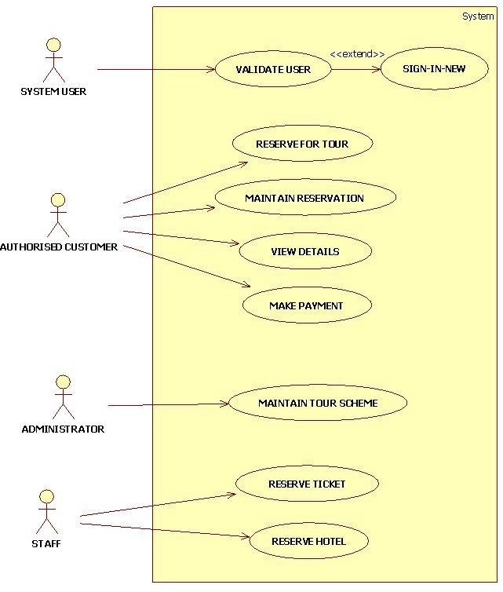

Figure 3: Usecase Diagram

### ACTIVITY DIAGRAM

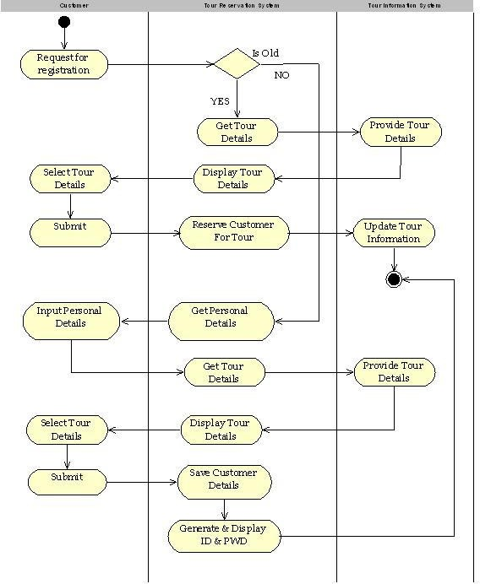

Figure 4: Activity Diagram

## State Diagram

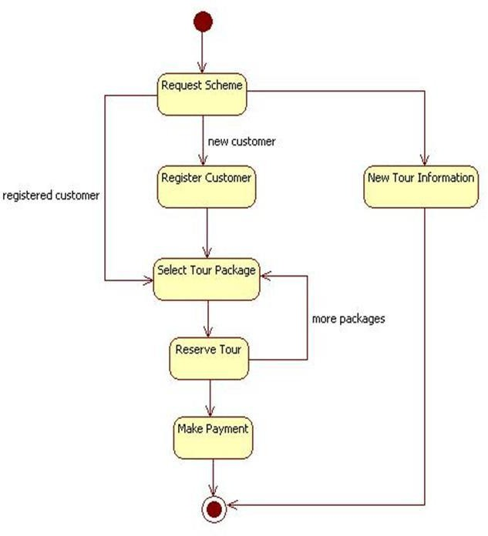

Figure 5: State Diagram

## 4.3 User interface design

1. **User Interface Page**

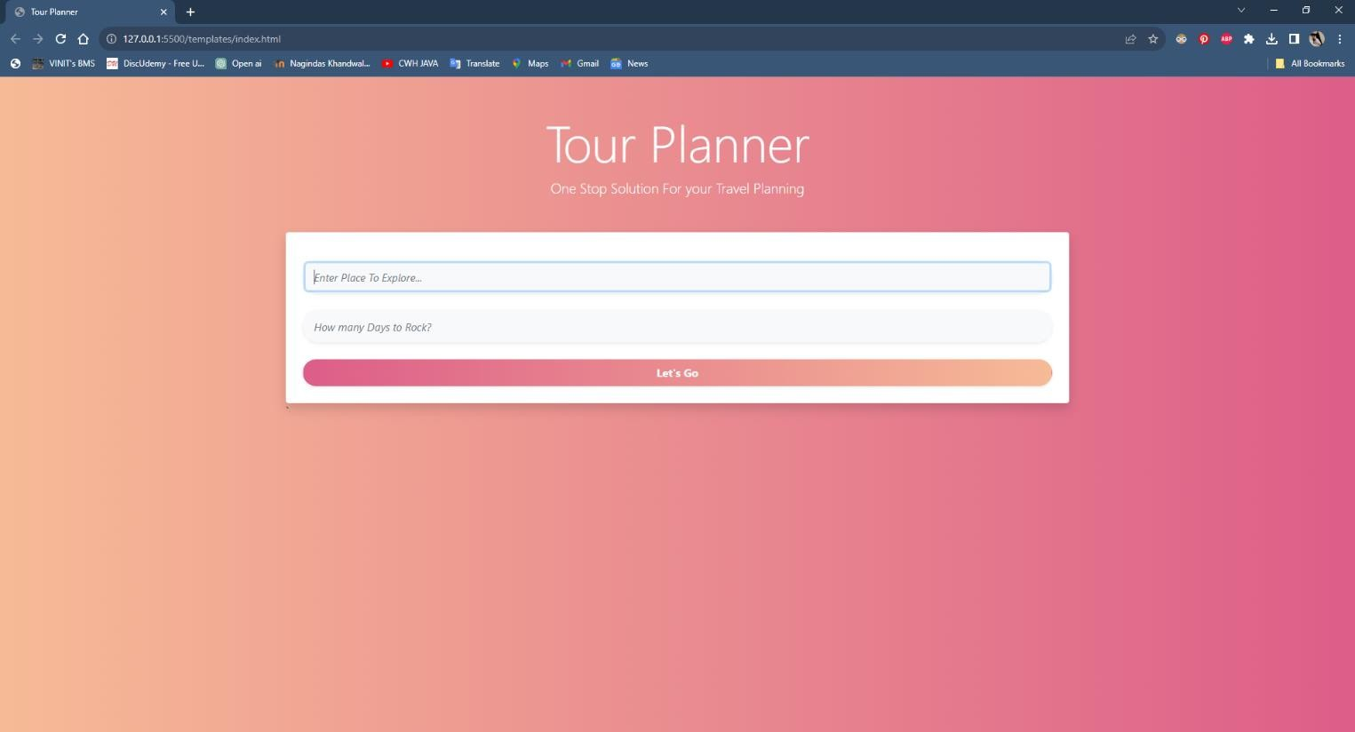

Figure 6: User Interface Page

## Location Search Page & Home Page



Figure7: Location Search Page & Home Page

## Map

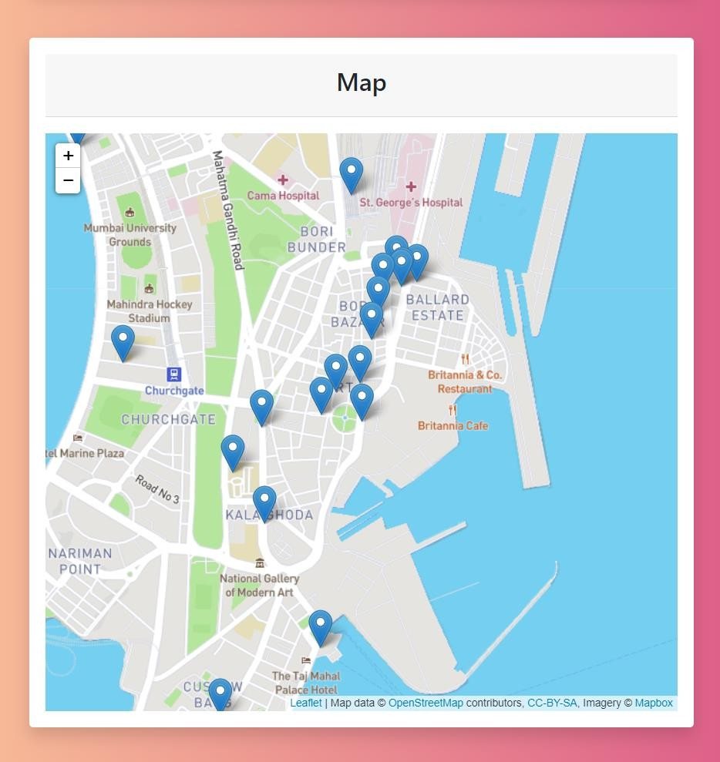

Figure 8: Map

## Itinerary

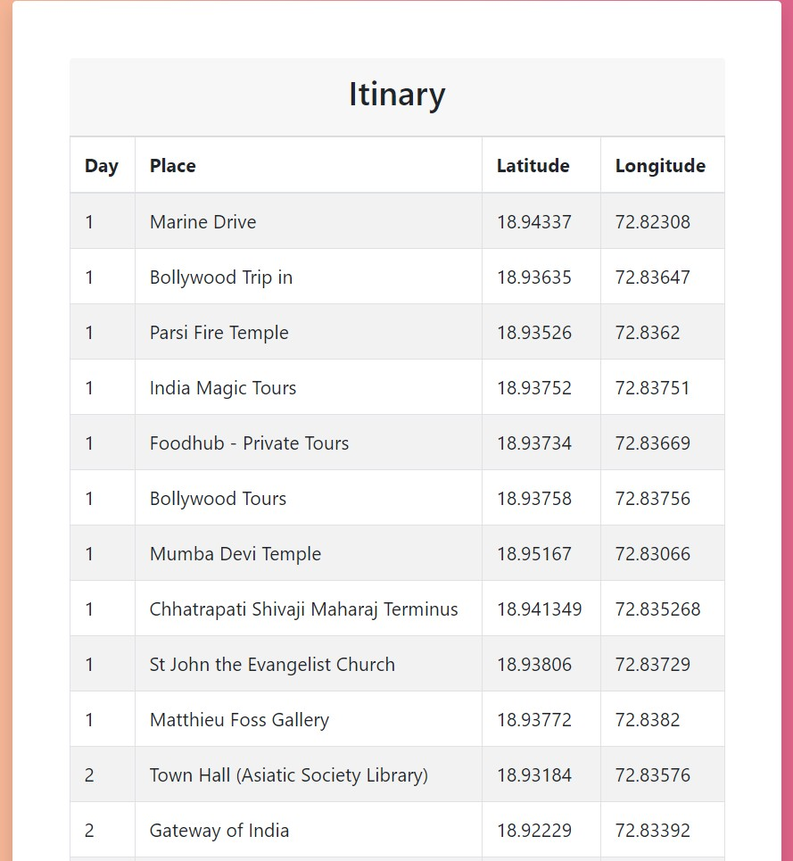

Figure 9: Itierary

## CHAPTER 5: IMPLEMENTATION AND TESTING

**5.1 Index**

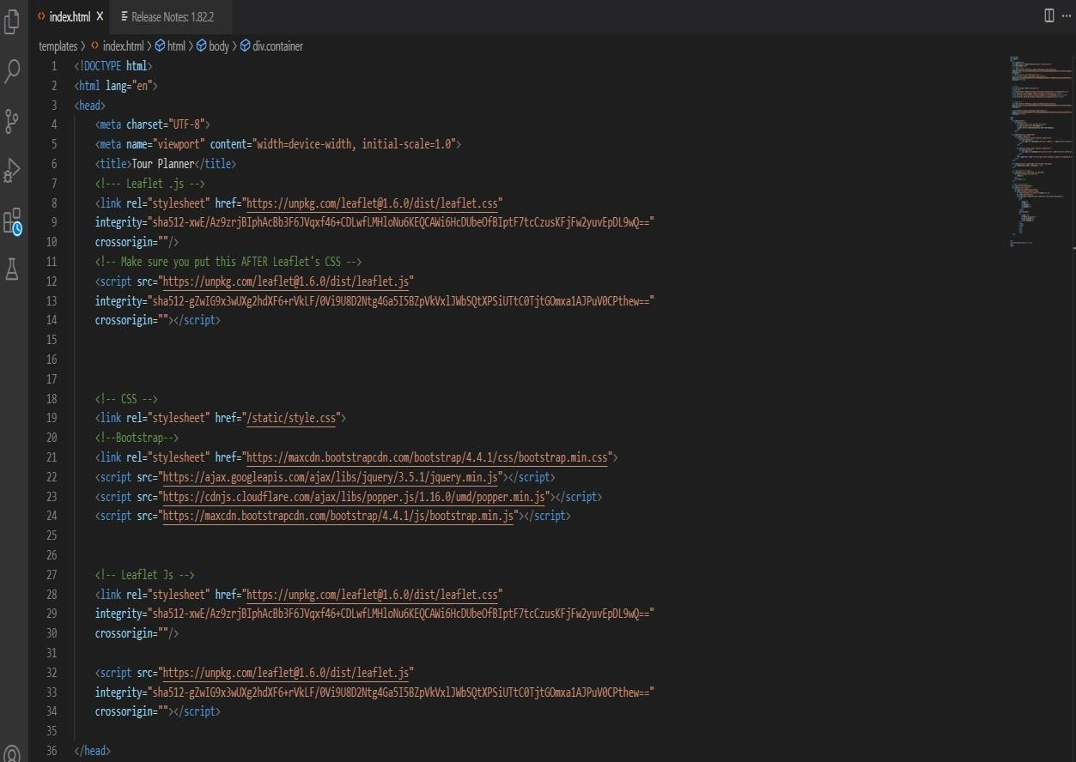

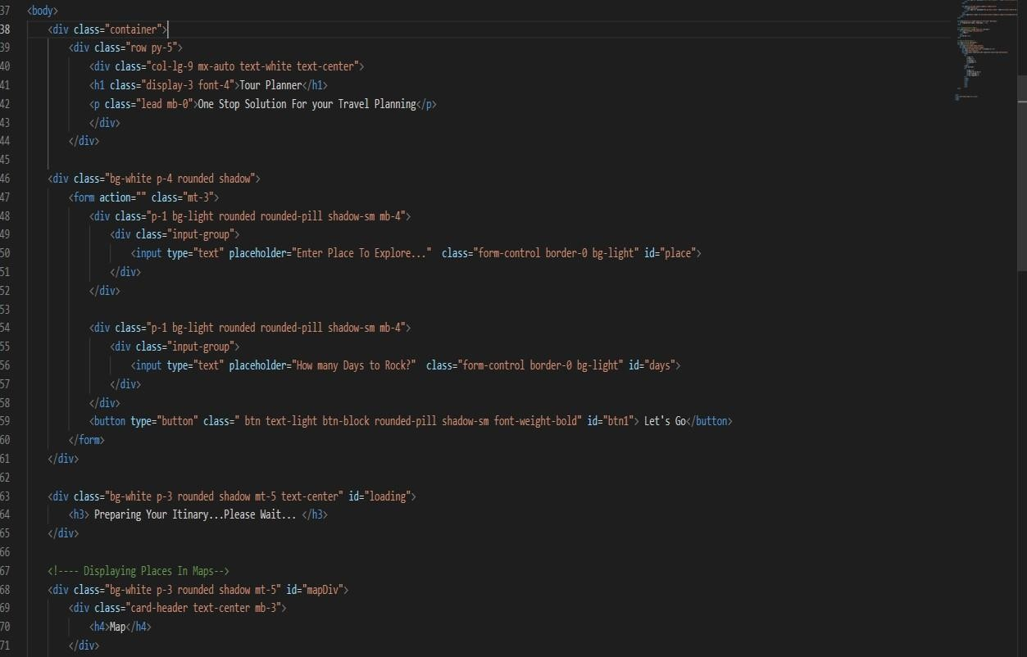

Figure 10: Index

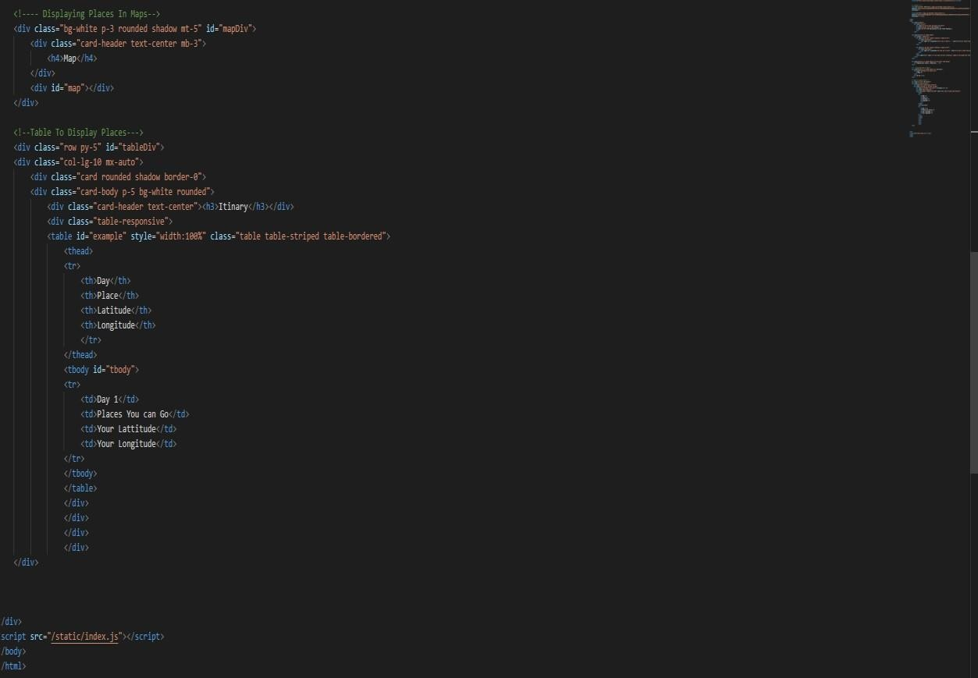

Figure 11: Index

## Index.js

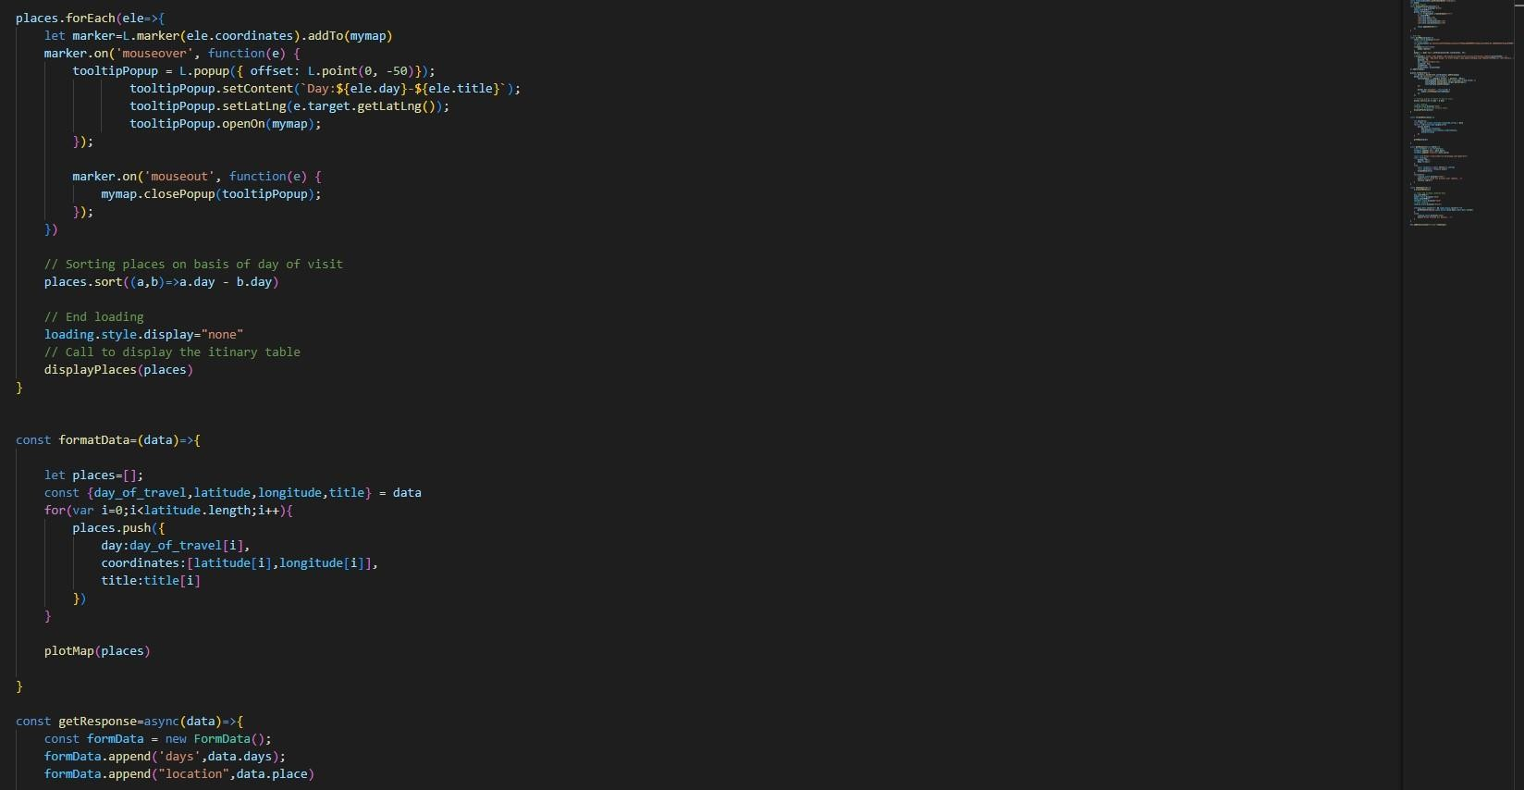

Figure 12: Index.js

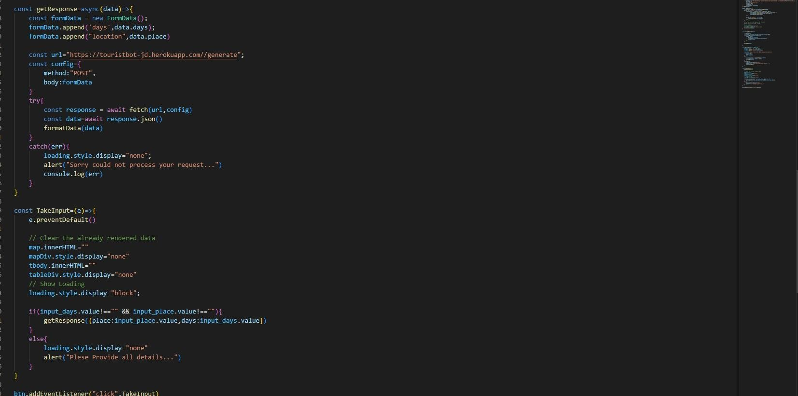

Figure 13: Index.js

## Testing Approach and Test Cases

**Login and Registration:**

|  |  |  |  |  |
| --- | --- | --- | --- | --- |
| Test Case ID | Description | Expected Results | Actual Result | Result (Pass/Fail) |
| 1. | Name: Rohit Email:  [rohit@gmail.com](mailto:rohit@gmail.com) Password: Hit@369 | User should be registered | User Registered | Pass |
| 2. | Name: Rohit Email:  [rohit@gmail.com](mailto:rohit@gmail.com) Password: Hit@369 | User Should not be registered successfully | User not registered successfully | Pass |
| 3. | Name: Rohit Email:  [rohit@gmail.c0m](mailto:rohit@gmail.c0m) Password: Hit369 | User Should not be registered again | User not Registered successfully | Pass |

Table5:- login & Registration

## CHAPTER 6: DISCUSSION AND CONCLUSION

1. **User Convenience and Accessibility**: The tour planner application offers users the convenience of easily searching for tourist places based on their current location. This feature enhances accessibility and simplifies the travel planning process, catering to the needs of modern travelers who value efficiency and convenience.
2. **Personalization and Customization:** By allowing users to input their location, the application can provide personalized recommendations tailored to their preferences and interests. This level of customization enhances user experience and increases the likelihood of user engagement and satisfaction.
3. **Integration of Location-Based Services:** Leveraging location-based services enriches the functionality of the tour planner application, enabling users to discover nearby attractions, restaurants, and accommodations. Integration with mapping services further enhances usability and provides users with comprehensive information to plan their trips effectively.
4. **Enhanced Decision-Making:** The ability to search for tourist places by adding location empowers users to make informed decisions when planning their itineraries. By providing detailed information about nearby attractions, including ratings, reviews, and opening hours, the application equips users with the knowledge they need to create memorable travel experiences.
5. **Potential for Expansion and Growth:** As the popularity of travel applications continues to grow, there is significant potential for the tour planner application to expand its user base and geographic coverage. Continuously updating and improving the application based on user feedback and emerging trends will be essential for sustaining growth and remaining competitive in the market.

## Conclusion:

In conclusion, the tour planner application represents a valuable tool for modern travelers seeking convenience, personalization, and accessibility in their trip planning process. By integrating location-based services and enabling users to search for tourist places by adding their location, the application facilitates informed decision-making and enhances the overall travel experience. Moving forward, ongoing development and refinement of the application, along with strategic marketing initiatives, will be key to capitalizing on opportunities for expansion and solidifying its position in the competitive landscape of travel technology.

In the fast-paced world of travel and tourism, the tour planner application emerges as a beacon of efficiency and convenience for modern travelers. By harnessing the power of location-based services, this application empowers users to explore the world around them with ease and confidence.

The ability to search for tourist places by adding location not only streamlines the trip planning process but also enhances the overall travel experience. Whether users are seeking hidden gems in their hometown or embarking on adventures in unfamiliar territories, this application serves as a trusted companion, providing invaluable insights and recommendations every step of the way.

In conclusion, the tour planner application represents more than just a tool—it's a gateway to new experiences, a catalyst for exploration, and a testament to the boundless spirit of adventure that lies within us all.

## CHAPTER 7: LIMITATIONS

1. **Reliance on Location Accuracy:** The effectiveness of the tour planner application relies heavily on the accuracy of location data. Inaccuracies or inconsistencies in GPS signals or mapping data could lead to incorrect recommendations or difficulty in finding desired tourist places.
2. **Limited Coverage:** The availability of comprehensive data on tourist places may vary depending on the geographic region. In areas with sparse coverage or limited tourist attractions, users may encounter challenges in finding relevant recommendations or information.
3. **Data Quality and Currency:** Ensuring the quality and currency of data within the application is crucial for providing accurate and reliable recommendations. Outdated information or inaccuracies could undermine user trust and satisfaction.
4. **User Privacy:** Collecting and storing user location data for personalized recommendations raises privacy concerns. Striking a balance between personalized user experiences and respecting user privacy preferences is essential to maintain user trust.
5. **Internet Connectivity Requirements:** The tour planner application may require a stable internet connection to access mapping services and retrieve up-to-date information on tourist places. Limited connectivity or reliance on mobile data could hinder user experience in remote or low-network areas.
6. **Device Compatibility:** Compatibility with various mobile devices and operating systems is essential to ensure broad accessibility for users. Incompatibility issues or performance disparities across different devices may limit the application's reach and usability.
7. **Dependency on User Input:** The effectiveness of the search functionality in the application relies on users providing accurate location information. In scenarios where users input incorrect or vague location details, the application may struggle to deliver relevant recommendations.
8. **Competitive Landscape:** The tour planner market is highly competitive, with numerous similar applications vying for user attention. Standing out among competitors and attracting and retaining users in a crowded marketplace poses a significant challenge.
9. **Legal and Regulatory Compliance:** Legal and regulatory requirements, such as data protection laws and licensing agreements for third-party data sources, is essential to mitigate legal risks and ensure compliance with industry standards.
10. **Scalability and Maintenance :** As the user base grows and the application expands to new regions, scalability and maintenance become critical considerations. Ensuring seamless performance, timely updates, and ongoing support for users requires robust infrastructure and dedicated resources.

## CHAPTER 8: FUTURE WORK

1. **Collaboration with Local Businesses:** Forge partnerships with local businesses, tour operators, and cultural institutions to offer exclusive deals, discounts, and curated experiences within the application, thus adding value to users and fostering community engagement.
2. **Sustainability:** Incorporate features promoting sustainable travel practices, such as highlighting eco-friendly accommodations, carbon footprint calculators, and responsible tourism guidelines, to encourage environmentally-conscious travel choices among users.
3. **Smart Recommendation Engines:** Develop advanced recommendation engines leveraging AI and data analytics to suggest personalized travel experiences based on factors such as user demographics, past travel history, and real-time context, thereby enhancing user engagement and satisfaction.
4. **Multilingual Support:** Expand language support within the application to cater to a diverse global audience, enabling users to access content and interact with the application in their preferred language, thus enhancing usability and accessibility.
5. **Integration with Transportation Services**: Partner with transportation services, such as ride-sharing platforms or public transit systems, to seamlessly integrate transportation options into travel itineraries, providing users with comprehensive end-to-end trip planning capabilities.
6. **Accessibility Features:** Improve accessibility features within the application to cater to users with disabilities, such as providing voice-guided navigation, text-to-speech functionality, and customizable user interfaces to ensure inclusivity for all travelers.
7. **Social Integration:** Enhance social integration by allowing users to share their travel experiences, recommendations, and photos directly within the application, fostering a sense of community and enabling peer-to-peer recommendations.
8. **Offline Functionality:** Develop offline functionality within the application to allow users to access essential features, such as saved itineraries and maps, without requiring a constant internet connection, thus catering to travelers in remote areas or with limited connectivity.
9. **Machine Learning for Personalization**: Implement machine learning algorithms to analyze user preferences, behavior patterns, and feedback data to offer more personalized recommendations and tailor-made travel itineraries.
10. **Augmented Reality Integration**: Explore incorporating AR features into the application to provide users with immersive experiences, such as virtual tours of tourist attractions or overlaying information about nearby points of interest in real-time through their smartphone cameras.

**REFERENCES**

* 1. Adler, J. (1989) Origins of sightseeing. Annals of Tourism Research, 16(1), 7-29. Andronicou, A. (1979) Tourism in Cyprus. In de Kadt, E. (ed.), Tourism: Passport to Development, New York, Oxford Univ. Press.
  2. Barry, I. (1991) Tourist Guiding Techniques, Suva, Tourism Council of the South Pacific. Brokensha, P., and Guldberg, H. (1992) Cultural Tourism in Australia. Canberra, Department of the Arts, Sport, the Environment and Territories.
  3. Cohen, E., (1985) The tourist guide. Annals of Tourism Research, 12(1), 5-29.
  4. Greenwood, D. (1977) Culture by the pound: an anthropological perspective on tourism as cultural commoditization. In Smith, V. (ed.) Hosts and Guests, (pp129-139), Philadelphia, University of Philadelphia Press.
  5. Gurung, G., Simmons, D. and Devlin, P. (1996) The evolving role of tourist guides: the Nepali experience.
  6. In Butler R., & Hinch, T. (eds.) Tourism and Indigenous People, London, International Thompson Business Press. Hughes, K. (1991) Tourist satisfaction: a guided
  7. Lopez, E., (1980) The effects of leadership style on satisfaction levels of tour quality. Journal of Travel Research, 18(4), 20-23.
  8. Mancini, M. (1990) Conducting Tours: A Practical Guide. Cincinnati, Southwestern Publishing. Moscardo, G. (1996)
  9. Nettekoven, L., (1979) Mechanisms of cultural interaction. In de Kadt, E., (ed.) Tourism: Passport to Development, New York, Oxford University Press.
  10. Pearce, P. (1984) Tourist-guide interaction. Annals of Tourism Research, 11(1), 129- 146.
  11. Pearce, P., Morrison, A. and Rutledge, J. (1998) Tourism: Bridges Across Continents. Sydney, McGraw Hill.
  12. Pond, K. (1993) The Professional Guide: Dynamics of Tour Guiding. New York, Van Nostrand Reinhold.
  13. Quiroga, I. (1990) Characteristics of package tours in Europe. Annals of Tourism Research, 17(1), 185-207.
  14. Reisinger, Y., and Waryszak, R. (1994) Japanese tourists' perceptions of their tour guide: Australian experience. Journal of Vacation Marketing, 1(1), 28-40.
  15. Ryan, C. (1995) Researching Tourist Satis-faction: Issues, Concepts, Problems, London, Routledge.
  16. Ryan, C. and Glendon, I. (1998) Appication of leisure motivation scales to tourism. Annals of Tourism Research, 25(1), 169-184
  17. Samovar, L. and Porter, R. (1995) Communication Between Cultures. Belmont: Wadsworth Publishing Company.
  18. Smith, V. (1961) Needed: geographically trained tourist guides. The Professional Geographer, 13(6), 28-30.
  19. Weiler, B. and Crabtree, A. (1998) Developing competent ecotour guides. Paper to the Heritage Interpretation Conference, September, Manly, New South Wales.
  20. Zellmont, L., (1979) Mechanisms of cultural interaction. In de Kadt, E., (ed.) Tourism: Passport to Development, New York, Oxford University Press.