Assignment 4. Experiment Execution, Results and Discussion
Students: Adil Ramazan, Yesbol Bagyt, Nurassyl Aitbay
Group: SE-2415
Repository: [GitHub link], release tag “assignment-4”

1. Final / Revised Research Title
Evaluating the Portability, Specificity, and Sequential Stability of Knowledge Updating Methods in Large Language Models: Evidence from 1,000 Sequential Edits on GPT2-XL and Llama-3.2-3B

2. Primary Research Question, Aim, Objectives, and Hypotheses
Research question. To what extent do existing knowledge-editing methods maintain portability, specificity, and long-term stability during sequential knowledge updates in Large Language Models?
Aim. To quantitatively evaluate the extent to which existing knowledge-editing methods maintain portability, specificity, and long-term stability when open-weight Large Language Models are subjected to multiple sequential knowledge updates.
Objectives. RO1 – evaluate portability on multi-hop and reverse-relation queries; RO2 – quantify unintended changes to unrelated facts (specificity); RO3 – track degradation over a high volume of successive edits (sequential stability); RO4 – compare editing techniques to identify which best preserves overall reliability.
Hypotheses. H1: editing methods update the direct fact but give significantly lower accuracy on logically dependent two-hop and inverse-relation queries. H2: as the number of sequential edits grows, specificity and stability fall, i.e., the share of untouched facts whose prediction changes rises. E1 (expected comparison for RO4, from Meng et al., 2023): MEMIT keeps a higher overall reliability than ROME and the fine-tuning baseline after the full edit stream, on both models.

3. Deviations from the Frozen Protocol
The protocol form (Appendix A) was completed after a five-edit pilot on the development split and already declares every change relative to Assignment 3: smaller models, RippleEdits as the only benchmark, two added baselines, covariance statistics from wikitext-103, non-parametric tests, and four decisions taken on the development split before any test run (ROME with its original covariance adjustment, FT-M instead of FT-L, token-level locality, Wilcoxon test for H2). Table 1 lists what changed after the protocol was frozen.
Table 1. Deviations after the protocol freeze.
# | Deviation | Reason | Effect on conclusions
1 | The GPT2-XL final runs were launched at about 21:30 on 28 October 2026; the form was uploaded to Moodle at [upload date and time]. | The team launched the runs before uploading the form. | No setting was changed after the pilot, and no test-set output was inspected before the upload.
2 | In H1, “portability” is operationalised as two-hop plus inverse-relation tests, the query types named in H1. The all-type score is reported as a sensitivity analysis. | The form did not specify which ripple tests enter H1. The clarification was made after the main table showed that 83% of all ripple tests are subject-alias paraphrases, which are not multi-hop. | None: both versions give the same verdict (gap ≥ 10 points in 5 of 6 conditions).
3 | Between Kaggle sessions, completed runs were removed from the job queue; interrupted runs resumed from their last checkpoint (saved every 50 edits). | Kaggle limits a session to 12 hours. | None: the same edit streams were used and the saved weights were reloaded.
4 | Error-analysis labels were drafted with AI assistance and then checked and accepted by all three authors. | Course rules allow AI assistance with verification. | None on the quantitative results.

4. Final Experimental Setup
Data. We used the counterfactual subsets (popular, random) of RippleEdits (Cohen et al., 2024). After removing non-Latin-script items, unparseable prompts and duplicate subject–relation pairs, 2,518 edits remained. They were split by subject into a test pool of 1,761 edits, a development pool of 126 edits used only for the pilot, and held-out subjects whose 2,530 true facts form the locality pool; the first 500 of these facts are the locality probes for both models. Each seed (0, 1, 2) draws one stream of 1,000 test edits, applied in the same order to every method. File hashes are given in Appendix A.
Measurements. After every edit we record efficacy (the edited fact is produced), the RippleEdits ripple tests (two-hop, inverse relation, other logical, subject alias) and relation specificity. As in RippleEdits, a ripple test is executed only if the unedited model passes its condition queries (3,843 of 7,895 tests for GPT2-XL, 4,062 for Llama). At N = 1, 10, 50, 100, 250, 500, 750 and 1,000 we measure edit retention (ER) over all edits so far, locality (LOC) on the 500 probes, and perplexity (PPL) on 100 wikitext-103 test paragraphs. Correctness is teacher-forced exact match on the gold answer or an alias; LOC is the share of answer tokens whose prediction is unchanged relative to the unedited model. The primary metric, the Editing Reliability Score (ERS), is the harmonic mean of ER and LOC at N = 1,000.
Conditions and fairness. The unedited model is the simple baseline; FT-M, fine-tuning of one MLP layer with a loss on every target token (Zhang et al., 2024), is the literature baseline; ROME and MEMIT are the methods under study. All use EasyEdit’s published hyper-parameters (Wang et al., 2024) without tuning, and share the streams, probes, scoring code and hardware. Each editor was also applied to 100 isolated edits (edit, evaluate, restore) to separate the effect of one edit from accumulation. Table 2 gives the implementation details.
Table 2. Final experimental setup.
Component | Setting
Models | GPT2-XL (1.5B parameters, fp32); Llama-3.2-3B (3.2B, fp16; ungated mirror of the Meta weights)
Edited layers | FT-M: GPT2-XL layer 0 (L∞ ≤ 5·10⁻⁴), Llama layer 21. ROME: layer 17 / layer 5, with covariance adjustment. MEMIT: layers 13–17 / 4–8, preservation weight λ = 20,000 / 15,000
Covariance statistics | 20,000 wikitext-103 training paragraphs (≤ 256 tokens), seed 2026
Edit streams | 3 seeds × 1,000 sequential edits; 100 isolated edits (seed 0)
Hardware | Kaggle notebooks, 2 × NVIDIA T4 16 GB; one run per GPU
Software | Python 3.13, PyTorch 2.11.0 (CUDA 12.8), transformers 5.5.4, datasets 4.8.5; EasyEdit commit 4c10987 (vendored)
Runs and compute | 30 runs (24 sequential, 6 isolated), 53.5 GPU-hours, no edit errors
Configuration files | configs/experiment.yaml; configs/hparams/<model>/<method>.yaml

5. Main Results
After 1,000 sequential edits no method kept both the new facts and the untouched knowledge. The best primary score was ERS = 33.5 ± 0.6% for FT-M on Llama-3.2-3B and 20.6 ± 1.4% for ROME on GPT2-XL; every other editing condition scored below 8% (Table 3).
Table 3. Main results at N = 1,000 (mean ± SD over three streams, %). ERS is the primary metric. Efficacy, multi-hop portability (two-hop and inverse relation) and relation specificity (Rel. spec.) are measured right after each edit; ER, LOC and perplexity (PPL) at the end of the stream.
Model | Method | ERS | Efficacy | Multi-hop port. | Rel. spec. | ER | LOC | PPL
GPT2-XL | No edit | 0.3 ± 0.3 | 0.1 ± 0.2 | 3.5 ± 0.6 | 100.0 ± 0.0 | 0.1 ± 0.2 | 100.0 ± 0.0 | 33.1
 | FT-M | 2.9 ± 0.3 | 94.8 ± 3.3 | 7.2 ± 1.7 | 4.4 ± 0.5 | 2.5 ± 0.4 | 3.9 ± 1.8 | 31,829 ± 19,734
 | ROME | 20.6 ± 1.4 | 99.4 ± 0.3 | 7.4 ± 0.7 | 17.1 ± 3.1 | 28.8 ± 5.6 | 16.3 ± 0.9 | 55.4 ± 14.8
 | MEMIT | 7.6 ± 0.9 | 75.5 ± 1.4 | 6.9 ± 1.0 | 22.7 ± 1.9 | 5.7 ± 1.3 | 11.9 ± 1.1 | 129.5 ± 22.1
Llama-3.2-3B | No edit | 0.1 ± 0.1 | 0.1 ± 0.1 | 2.0 ± 0.5 | 99.7 ± 0.0 | 0.1 ± 0.1 | 100.0 ± 0.0 | 15.2
 | FT-M | 33.5 ± 0.6 | 100.0 ± 0.0 | 9.3 ± 1.1 | 26.0 ± 1.5 | 81.3 ± 1.3 | 21.1 ± 0.6 | 42.5 ± 3.4
 | ROME | 1.4 ± 1.2 | 75.4 ± 2.6 | 6.3 ± 1.4 | 6.1 ± 0.6 | 8.3 ± 1.5 | 0.8 ± 0.8 | 24,329 ± 2,843
 | MEMIT | 0.0 ± 0.0 | 5.9 ± 0.8 | 1.3 ± 0.7 | 2.9 ± 1.9 | 0.0 ± 0.0 | 1.5 ± 2.0 | 9.0·10⁹ ± 1.6·10¹⁰
Efficacy was high for ROME on GPT2-XL (99.4%) and for FT-M (94.8% and 100%), lower for ROME on Llama and MEMIT on GPT2-XL (about 75%), and almost absent for MEMIT on Llama (5.9%). Multi-hop portability stayed between 1.3% and 9.3%, only a few points above the unedited models (3.5% and 2.0%), which answer some of these questions without any edit. No method passed a single inverse-relation test (0 of 319 for GPT2-XL and 0 of 334 for Llama per method, Figure 3).
Figure 1 shows how the stream unfolds. ROME and MEMIT keep LOC above 89% for the first 10 edits; LOC then halves between 50 and 250 edits and ends at 0.8–16.3%. FT-M changes untouched facts from the first edits (GPT2-XL: 64.6% after one edit), but on Llama it retains its own edits best (ER 81.3%). Perplexity (Figure 2) confirms the ordering: ROME on GPT2-XL rises moderately from 33.1 to 55.4, whereas FT-M on GPT2-XL and ROME and MEMIT on Llama reach 10⁴–10¹⁰, i.e., the language model collapses. Variability across streams is small (SD ≤ 5.6 points for ERS, ER and LOC), except for FT-M on GPT2-XL, whose LOC after the first edit ranged from 22% to 92% depending on the fact edited.
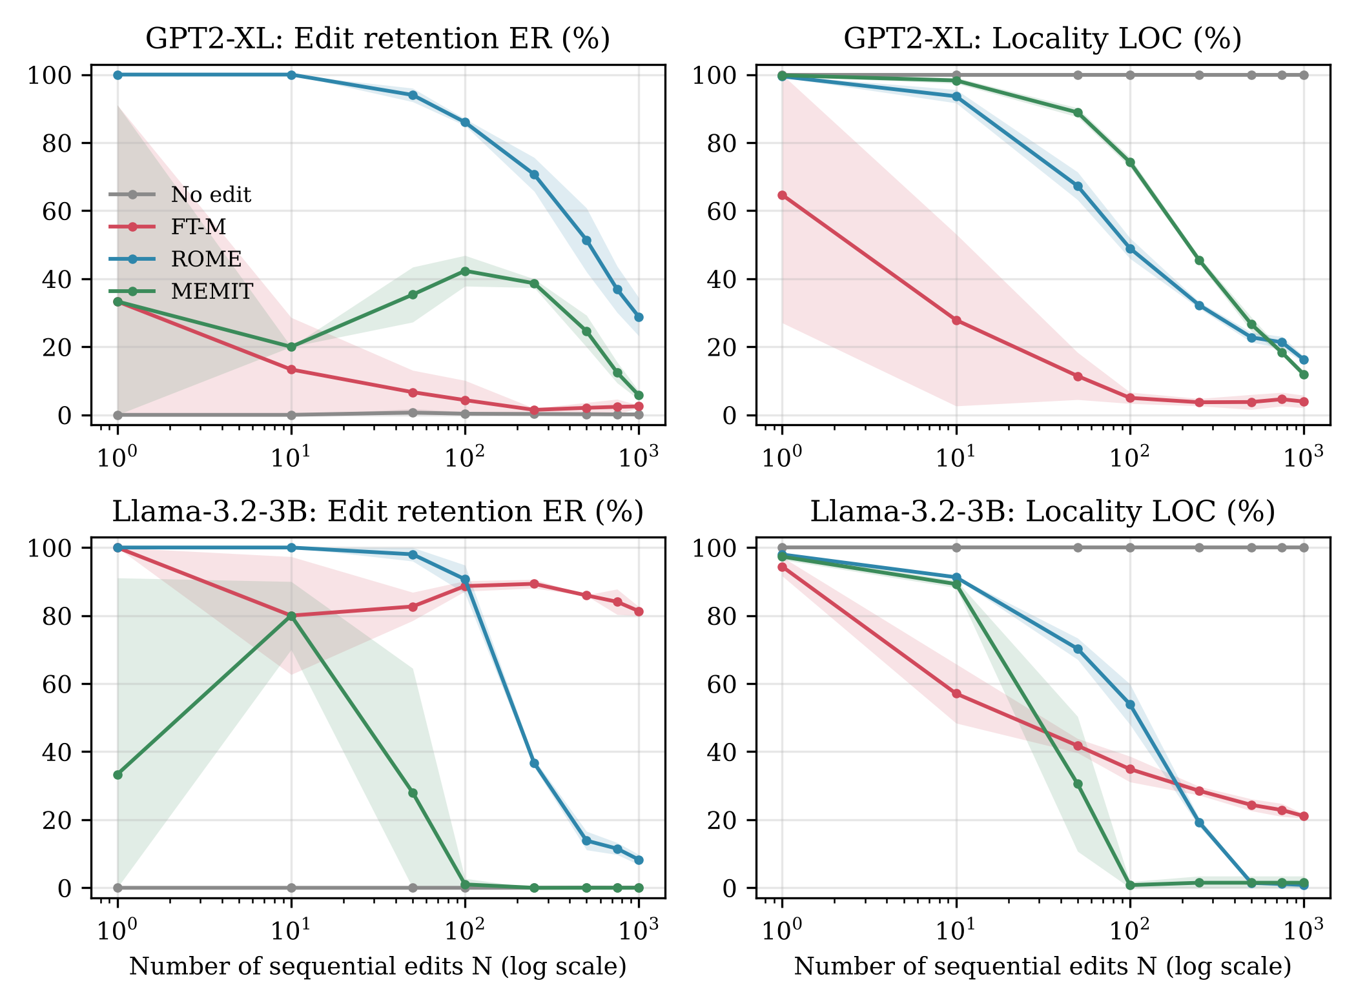
Figure 1. Edit retention (left) and locality (right) as a function of the number of sequential edits, mean ± SD over three streams. Source: results/analysis/curves.csv.
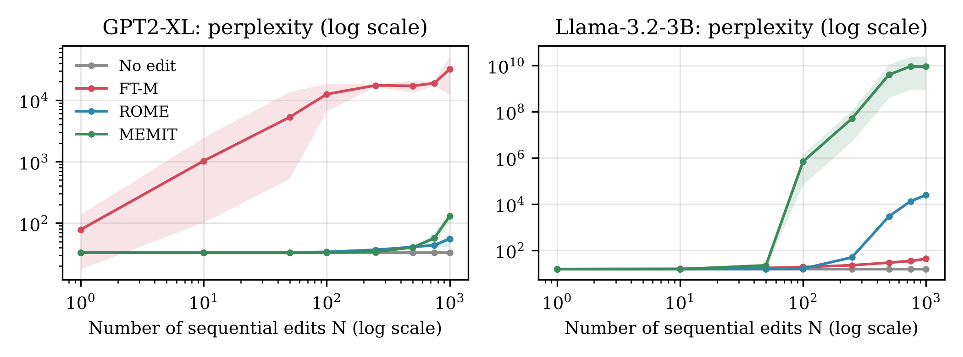
Figure 2. Perplexity on 100 wikitext-103 test paragraphs (log scale; mean ± SD over streams). Unedited values: 33.1 (GPT2-XL) and 15.2 (Llama).
Statistical tests. Table 4 reports the pre-registered tests. For H1, the paired per-edit difference between efficacy and multi-hop portability was 55.6–91.3 percentage points in five conditions (Wilcoxon signed-rank, Holm-adjusted p ≤ 1.6·10⁻⁸⁴, rank-biserial r ≥ 0.97) and 5.0 points for MEMIT on Llama, where efficacy itself had collapsed. For H2, LOC fell by 61–97 points from N = 1 to N = 1,000; the Wilcoxon test on the 500 probes was significant in every stream (largest Holm-adjusted p = 8.0·10⁻²⁷) and the LOC slope was negative in all 18 runs. For E1, the stratified paired bootstrap shows that MEMIT was better than the alternative in only one of four comparisons (Table 5). All differences are large in practical terms, tens of percentage points, far above the stream-to-stream variability.
Table 4. Tests of H1 (sequential streams, multi-hop portability, pooled edits) and H2 (500 locality probes, N = 1 vs N = 1,000).
Model | Method | H1: efficacy / portability (%) | H1: difference, pp [95% CI] | H1: p (Holm); r | H2: LOC N=1 → N=1,000 (%) | H2: p (Holm, max over streams) | H2: slope, pp per decade
GPT2-XL | FT-M | 92.5 / 7.1 | 85.4 [82.7, 87.8] | 1.9·10⁻¹³²; 1.00 | 64.6 → 3.9 | 8.0·10⁻²⁷ | −19.1 ± 10.9
 | ROME | 98.3 / 7.3 | 91.1 [89.0, 93.0] | 6.7·10⁻¹⁴¹; 1.00 | 99.5 → 16.3 | 1.4·10⁻⁸⁶ | −31.1 ± 0.3
 | MEMIT | 62.3 / 6.7 | 55.6 [51.9, 59.3] | 1.6·10⁻⁸⁴; 0.97 | 99.8 → 11.9 | 2.7·10⁻⁸⁸ | −32.2 ± 0.4
Llama-3.2-3B | FT-M | 100.0 / 8.8 | 91.3 [89.5, 92.9] | 1.2·10⁻¹⁵⁹; 1.00 | 94.4 → 21.1 | 5.1·10⁻⁷⁸ | −23.4 ± 0.6
 | ROME | 64.0 / 6.1 | 57.9 [54.5, 61.3] | 1.3·10⁻¹⁰¹; 0.99 | 97.9 → 0.8 | 1.1·10⁻¹⁰⁰ | −37.9 ± 0.2
 | MEMIT | 6.1 / 1.1 | 5.0 [3.5, 6.6] | 8.1·10⁻¹⁰; 0.94 | 97.3 → 1.5 | 2.4·10⁻⁹⁵ | −37.3 ± 0.3
Table 5. Pairwise ERS differences at N = 1,000 (stratified paired bootstrap, 10,000 resamples).
Model | Comparison | Difference, pp (mean ± SD) | 95% CI | Same sign in all streams | p (Holm)
GPT2-XL | MEMIT − ROME | −13.0 ± 1.1 | [−14.2, −11.8] | yes | 0.0006
 | MEMIT − FT-M | +4.7 ± 0.7 | [3.9, 5.5] | yes | 0.0006
 | ROME − FT-M | +17.7 ± 1.1 | [16.6, 18.9] | yes | 0.0006
Llama-3.2-3B | MEMIT − ROME | −1.4 ± 1.2 | [−1.8, −1.0] | yes | 0.0006
 | MEMIT − FT-M | −33.5 ± 0.6 | [−35.2, −31.7] | yes | 0.0006
 | ROME − FT-M | −32.1 ± 1.7 | [−33.8, −30.4] | yes | 0.0006
The p-value 0.0006 is the smallest attainable value (1/10,000 bootstrap resamples, Holm-adjusted for six comparisons).

6. Additional Analysis: Why Does It Work (or Not)?

6.1 Error analysis
We categorised a stratified sample of 84 failures (42 per model; per method, 6 portability, 4 retention and 4 locality failures) into seven types using the stored greedy generations and the unedited model’s output (Appendix B). Half of the failures (42) are degenerate outputs—repetition, gibberish or empty strings—mostly from ROME and MEMIT after collapse. Interference from other edits accounts for 18% (15 cases, 12 of them FT-M): asked an untouched question about Jeanie Buss’s gender, the edited GPT2-XL answers “bigender … female organism”, objects of other edits in the same stream. Portability fails in two ways: the edit does not reach the question at all (output identical to the unedited one, 8 cases, mainly ROME), or the model recalls the new object but does not apply the second relation (7 cases, e.g., “Egypt Eyalet” instead of its capital).

6.2 Sensitivity to edit volume
Isolated edits behave very differently from a stream (Table 6). Applied one at a time, ROME and MEMIT change almost no untouched predictions (LOC 97.4–99.8%), and ROME succeeds on 97–100% of edits. The collapse in a stream is abrupt: for MEMIT on Llama, the norm of the edited weight matrices grew from 88 to 190 within 100 edits and to 3,000–5,000 by edit 1,000, and from about edit 85 the internal optimisation could no longer make the new object probable; efficacy for edits 101–1,000 was ≤ 0.1%.
Table 6. Isolated single edits (seed 0, 100 edits) versus the end of the sequential streams (%).
Model | Method | Isolated: efficacy | Isolated: LOC | Sequential: efficacy | Sequential: LOC at N=1,000
GPT2-XL | FT-M | 65.0 | 82.3 | 94.8 | 3.9
 | ROME | 97.0 | 99.2 | 99.4 | 16.3
 | MEMIT | 24.0 | 99.8 | 75.5 | 11.9
Llama-3.2-3B | FT-M | 100.0 | 86.5 | 100.0 | 21.1
 | ROME | 100.0 | 97.8 | 75.4 | 0.8
 | MEMIT | 90.0 | 97.4 | 5.9 | 1.5

6.3 Subgroups and efficiency
Locality loss is concentrated on relations that were edited in the stream: at N = 1,000, probes whose relation also appeared among the edits kept fewer of their predictions than probes of other relations (FT-M on Llama 19.6% vs 38.4%; ROME on GPT2-XL 15.5% vs 25.0%). For MEMIT on GPT2-XL, efficacy rose with stream position (36.3% for edits 1–100, 86.1% after edit 500). Cost does not buy stability (Table 7): the cheapest method, FT-M, was the most stable on Llama.
Table 7. Efficiency per sequential run (1,000 edits, mean over streams).
Model | Method | Seconds per edit | GPU-hours per run | Peak GPU memory, GB
GPT2-XL | FT-M | 1.97 | 0.68 | 7.5
 | ROME | 15.18 | 4.35 | 12.3
 | MEMIT | 11.62 | 3.36 | 8.4
Llama-3.2-3B | FT-M | 0.24 | 0.14 | 8.1
 | ROME | 9.04 | 2.57 | 9.8
 | MEMIT | 14.90 | 4.20 | 9.0
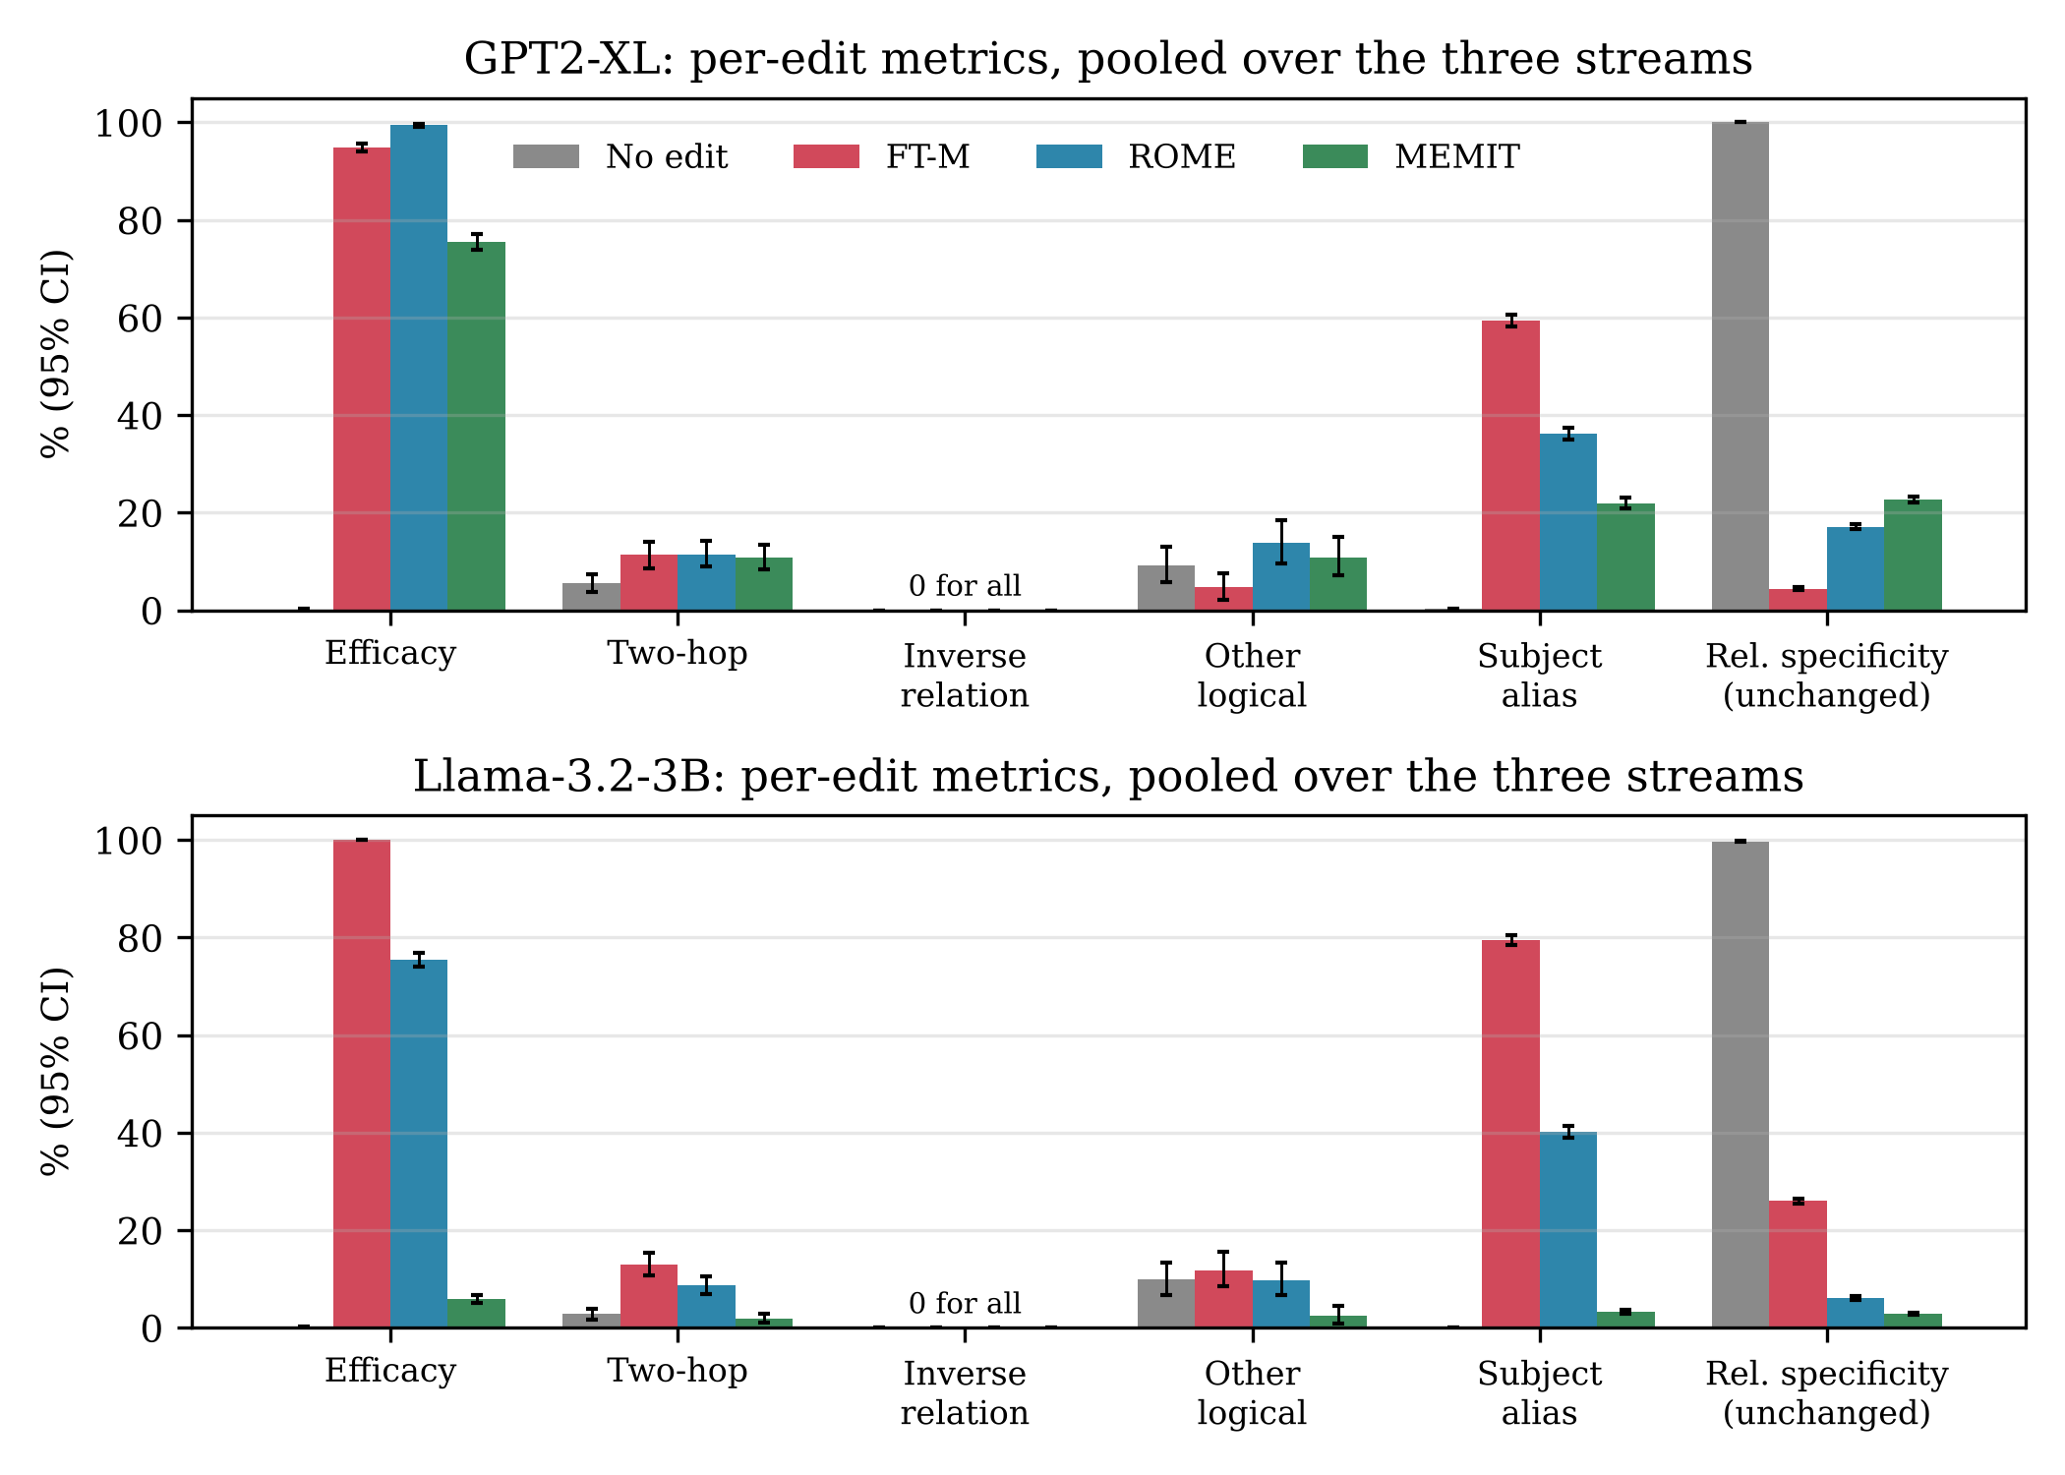
Figure 3. Per-edit efficacy, ripple tests by type and relation specificity, pooled over the three streams (95% bootstrap CI). No method passed any inverse-relation test.

7. Answering the Research Question and Hypotheses
Table 8. Evidence for each hypothesis and objective.
Hypothesis / Objective | Evidence | Result in numbers | Verdict
H1 / RO1: lower portability than efficacy | Table 4, Figure 3 | Gap 55.6–91.3 pp, p ≤ 1.6·10⁻⁸⁴ in 5 of 6 conditions; 5.0 pp for MEMIT on Llama (efficacy 6.1%); inverse relation 0% for every method | Partly supported (5 of 6)
H2 / RO2: specificity falls with edit volume | Tables 3–4, Figure 1 | LOC −61 to −97 pp from N = 1 to 1,000, p ≤ 8.0·10⁻²⁷ in every stream; relation specificity 2.9–26.0% | Supported
RO3: sequential stability | Figures 1–2, Table 6 | ER at N = 1,000: 0.0–81.3%; PPL rises to 10⁴–10¹⁰ in three of six conditions; isolated edits keep LOC ≥ 97.4% (ROME, MEMIT) | Degradation in all conditions
E1 / RO4: MEMIT most reliable | Table 5 | MEMIT better in 1 of 4 comparisons (+4.7 vs FT-M on GPT2-XL), worse in 3 (−1.4 to −33.5 pp); best method: ROME on GPT2-XL, FT-M on Llama | Not supported (contradicted in 3 of 4)
Answer to the research question. Only to a very limited extent. With default settings, FT-M, ROME and MEMIT can insert an individual counterfactual fact (efficacy up to 99–100%), but the new fact is rarely used in reasoning: multi-hop portability stayed at 1–9% and no inverse relation was ever inferred. Specificity and stability hold only for short horizons. ROME and MEMIT leave untouched predictions almost intact for an isolated edit and for the first ten sequential edits, yet after 1,000 edits 84–99% of the answer tokens on untouched facts had changed and only 0–29% of the edits were still retained. No method was reliable by our primary metric (best ERS 33.5%), and the best method depended on the model. These conclusions apply to the two tested models, one-at-a-time editing of RippleEdits counterfactuals and EasyEdit default hyper-parameters.

8. Discussion

8.1 Interpretation
The results reveal three distinct failure mechanisms rather than one forgetting curve. First, portability fails because locate-and-edit methods rewrite one subject→object association: the edited model either answers as before or repeats the new object without applying the next relation. The total absence of inverse inferences matches the reversal curse described for training (Berglund et al., 2024): a fact stored as “mother of X → Y” is not retrievable starting from Y. Second, ROME and MEMIT are local for one edit, but each update also moves the keys of other facts; these changes accumulate until, by N = 1,000, half of the failures are degenerate text. For MEMIT on Llama the accumulation is directly visible as a 30–50-fold growth of the edited weight norm, after which the method can no longer write new facts. Third, FT-M does not collapse on Llama but leaks its targets into other answers (12 of 15 interference cases), lowering locality while fluency is preserved (PPL 15.2 → 42.5).

8.2 Comparison with previous studies
Meng et al. (2022) reported that ROME edits are both effective and specific. Our isolated-edit runs reproduce this (efficacy 97–100%, LOC ≥ 97.8%), so the contrast with our sequential results is explained by the setting: they evaluate each edit on a fresh model. Meng et al. (2023) showed that MEMIT scales to thousands of edits, whereas we found it the least reliable method. The difference is again the protocol: MEMIT was designed to insert many edits together in one batch, while we inserted them one at a time, so each call solves for a single key under a strong preservation term (λ = 15,000–20,000). On GPT2-XL this term limits how much of the target is written per call (24% efficacy for isolated edits); on Llama the repeated updates inflate the weights. Cohen et al. (2024) found that editing methods change the direct fact but rarely its ripple effects; our two-hop accuracy of 2–13% and 0% for inverse relations agrees and extends this to sequential streams. Yao et al. (2023) identified portability and sequential editing as open problems; our data confirm both and locate the collapse between 50 and 250 edits. The two-phase pattern—gradual decline followed by abrupt collapse—is the one described by Gupta et al. (2024) for ROME and MEMIT at scale. Zhang et al. (2024) report FT-M as a strong baseline; we confirm this on Llama but not on GPT2-XL, where EasyEdit’s configuration updates layer 0 and therefore perturbs every token representation.

8.3 Unexpected results
Three results were not expected. MEMIT was the least reliable method although we predicted the opposite (E1); the explanation above suggests that this concerns one-edit-at-a-time use rather than MEMIT as a batch editor. MEMIT’s efficacy on GPT2-XL increased along the stream (36% → 86%); a plausible but untested explanation is that earlier updates enlarge the weights and thereby weaken the relative effect of the preservation term. Finally, the baseline FT-M was the most stable method on Llama and the least stable on GPT2-XL, so the ranking of methods depends on the architecture and configuration.

8.4 Practical implications
Engineers who maintain a deployed model should not apply ROME or MEMIT edit by edit to more than a few dozen facts without monitoring: retention and locality must be tracked continuously and a rollback checkpoint kept, because the collapse is abrupt. Edits should not be expected to update dependent facts or inverse relations; when facts are linked, retrieval-based updates or batch editing are safer. Researchers should evaluate editors on more than one architecture, because rankings changed between our two models.

8.5 Threats to validity
Internal validity. Llama was edited in fp16, which may accelerate weight growth; covariance statistics came from wikitext-103 rather than Wikipedia; all editors used untuned defaults. External validity. Results cover two models of at most 3.2B parameters, English counterfactual facts about mostly obscure entities (the models knew only 2.0% and 12.6% of the original facts) and one-at-a-time editing. Construct validity. Exact match under teacher forcing is strict, and LOC measures the stability of predictions mainly on facts the models did not know (11 and 72 of the 500 probes were known); accuracy on the known probes fell to 0–4% as well, which supports our interpretation. Statistical conclusion validity. There were only three streams, and they share edits, so pooled per-edit observations are not independent; we therefore also required consistency in every stream. The most serious threat is the untuned configuration: stronger regularisation or higher precision might delay the collapse.

8.6 Limitations and future work
Future work should (1) compare one-at-a-time with batched MEMIT updates of 10 and 100 edits on the same streams; (2) repeat the study on the originally planned 7–8B models in bf16 on 24 GB GPUs; (3) test editors designed for lifelong editing under the same protocol; (4) run a hyper-parameter sensitivity study (preservation weight, norm clamp) on the development split; and (5) add generation-based and CounterFact-style neighbourhood evaluations and more seeds.

9. Reproducibility Statement and Repository Link
All code, frozen data, configuration and raw logs are available at [GitHub link] (release “assignment-4”, MIT licence). The README lists the exact commands; requirements.txt fixes library versions; data/processed/SHA256SUMS fixes the dataset files. For every run, results/<model>/<mode>/<method>_seed<k>/ contains the per-edit log (edits.jsonl), the milestone log (milestones.jsonl), the configuration with library versions (run_config.json) and the editor output. The command python src/analyze.py regenerates every table and figure of this report from these logs on a CPU in under a minute; the analysis was executed on Kaggle and on a second machine and produced identical tables. Appendix C records the reproduction test. No personal data or credentials are included.

10. References
Berglund, L., Tong, M., Kaufmann, M., Balesni, M., Stickland, A. C., Korbak, T., & Evans, O. (2024). The reversal curse: LLMs trained on “A is B” fail to learn “B is A”. In The Twelfth International Conference on Learning Representations (pp. 18623–18642).
Cohen, R., Biran, E., Yoran, O., Globerson, A., & Geva, M. (2024). Evaluating the ripple effects of knowledge editing in language models. Transactions of the Association for Computational Linguistics, 12, 283–298. https://doi.org/10.1162/tacl_a_00642
Gupta, A., Rao, A., & Anumanchipalli, G. (2024). Model editing at scale leads to gradual and catastrophic forgetting. In Findings of the Association for Computational Linguistics: ACL 2024 (pp. 15202–15232). https://doi.org/10.18653/v1/2024.findings-acl.902
Meng, K., Bau, D., Andonian, A., & Belinkov, Y. (2022). Locating and editing factual associations in GPT. Advances in Neural Information Processing Systems, 35, 17359–17372.
Meng, K., Sharma, A. S., Andonian, A., Belinkov, Y., & Bau, D. (2023). Mass-editing memory in a transformer. In The Eleventh International Conference on Learning Representations. https://openreview.net/forum?id=MkbcAHIYgyS
Wang, P., Zhang, N., Tian, B., Xi, Z., Yao, Y., Xu, Z., Wang, M., Mao, S., Wang, X., Cheng, S., Liu, K., Ni, Y., Zheng, G., & Chen, H. (2024). EasyEdit: An easy-to-use knowledge editing framework for large language models. In Proceedings of the 62nd Annual Meeting of the Association for Computational Linguistics (Volume 3: System Demonstrations) (pp. 82–93). https://doi.org/10.18653/v1/2024.acl-demos.9
Yao, Y., Wang, P., Tian, B., Cheng, S., Li, Z., Deng, S., Chen, H., & Zhang, N. (2023). Editing large language models: Problems, methods, and opportunities. In Proceedings of the 2023 Conference on Empirical Methods in Natural Language Processing (pp. 10222–10240). https://aclanthology.org/2023.emnlp-main.632/
Zhang, N., Yao, Y., Tian, B., Wang, P., Deng, S., Wang, M., Xi, Z., Mao, S., Zhang, J., Ni, Y., Cheng, S., Xu, Z., Xu, X., Gu, J.-C., Jiang, Y., Xie, P., Huang, F., Liang, L., Zhang, Z., Zhu, X., Zhou, J., & Chen, H. (2024). A comprehensive study of knowledge editing for large language models (arXiv:2401.01286). arXiv. https://doi.org/10.48550/arXiv.2401.01286

Appendix A. Experiment Protocol Freeze Form
Uploaded to Moodle before the final runs. Date and time of upload: [date and time].
Item | Our decision
Primary research question | To what extent do existing knowledge-editing methods maintain portability, specificity, and long-term stability during sequential knowledge updates in Large Language Models? (unchanged from Assignments 2–3)
Hypotheses / expected comparisons | H1 (A2): editing methods update the direct fact but give significantly lower accuracy on logically dependent two-hop and inverse-relation queries (low portability). H2 (A2): as the number of sequential edits grows, locality and stability fall, i.e. the share of untouched, unrelated facts whose prediction changes rises. E1 (RO4, expected comparison from Meng et al., 2023): MEMIT keeps overall reliability (ERS) higher than ROME and FT-M after the full edit stream, on both models.
Primary outcome / metric and justification | Editing Reliability Score (ERS) at N = 1,000 edits = harmonic mean of Edit Retention (ER: share of all 1,000 edited facts still produced) and Locality (LOC: mean over 500 untouched held-out facts of the share of answer tokens whose prediction is unchanged vs. the unedited model, the EasyEdit locality definition; Yao et al., 2023). It follows the harmonic-mean “Score” of Meng et al. (2022). It cannot be gamed: not editing gives ER ≈ 0, while collapsing the model gives LOC ≈ 0. It summarises the core of the RQ (stability + specificity after sequential editing) in one number per run.
Secondary metrics | Immediate efficacy (edit correct right after it is applied); portability by type (two-hop, inverse relation, other logical, subject alias; RippleEdits tests); relation specificity (share of answer tokens unchanged on other facts of the edited subject); known-fact accuracy (LOC_known, specificity on facts the unedited model answered correctly); ER and LOC at milestones N = 1, 10, 50, 100, 250, 500, 750, 1,000; side-effect distortion rate = 1 − LOC; perplexity on 100 wikitext-103 test paragraphs; seconds per edit, peak GPU memory. Correctness = teacher-forced exact match on the gold answer or any alias.
Baseline 1 (simple) | Unedited model (no intervention), evaluated on exactly the same edit streams, probes and milestones.
Baseline 2 (strong / literature) | FT-M: fine-tuning of one MLP layer with the loss on every target token (Zhang et al., 2024), EasyEdit default hyper-parameters. Chosen over FT-L on the dev pilot: FT-L's last-position objective learned 0 of 5 multi-token edits.
Proposed method / condition | Existing editing methods under evaluation: ROME (Meng et al., 2022) and MEMIT (Meng et al., 2023), EasyEdit default hyper-parameters (commit 4c10987), no tuning for any method; ROME uses the covariance adjustment of the original paper (mom2_adjustment: true), which EasyEdit's default disables. Models: GPT2-XL (1.5B, fp32) and Llama-3.2-3B (fp16). Sequential setting: 1,000 edits applied one after another to the same model. Control: isolated single edits (edit → evaluate → restore), 100 edits, seed 0.
Final dataset version, size, and test-set identifier (count / hash) | RippleEdits (Cohen et al., 2024), GitHub commit 54f3b88, popular + random subsets; 2,518 edits after filtering, split by subject (seed 2026). Test pool: 1,761 edits, edits_test.jsonl, SHA-256 b9da85017da7109ddebce80b03b69ba5b640fc3e4a66425ad78a2bac7d116874 (3,727 two-hop, 263 inverse-relation, 698 other-logical, 3,207 alias, 5,836 relation-specificity tests). Locality pool: 2,530 held-out true facts, locality_pool.jsonl, SHA-256 519d0038f7d5ab21dfb39dee83e8c036c6fecda538eb4eb45faf9806d6127117 (the first 500 in the fixed file order are used for every model). Dev pool (pilot only): 126 edits, edits_dev.jsonl, SHA-256 e22037376848f4266e2c178d19dcdb5defabc78fdbf0505c10ce9abfbc13e96a.
Number of runs, seeds, folds, trials, or participants | 3 seeds (0, 1, 2); each seed draws one fixed stream of 1,000 edits from the test pool, identical for all methods. 2 models × (FT-L, ROME, MEMIT) × 3 seeds = 18 sequential runs, + 6 unedited-baseline runs, + 6 isolated single-edit runs (100 edits each). Hardware: Kaggle NVIDIA T4 16 GB for all conditions. Dev-split pilot with the final configuration, GPT2-XL (5 edits): FT-M 2.6 s, MEMIT 13.8 s, ROME 21.0 s per edit; projected ≈ 42 GPU-hours, so GPT2-XL uses n = 1,000. Pre-specified rule for Llama-3.2-3B, decided from its dev-split timing only and before any test run: n = 1,000 if its pilot projects ≤ 60 GPU-hours for all its runs, otherwise n = 500 (milestones above 500 dropped). Llama-3.2-3B dev pilot (5 edits): FT-M 0.4 s, ROME 6.2 s, MEMIT 14.1 s per edit; projected ≈ 26 GPU-hours ≤ 60, so Llama-3.2-3B also uses n = 1,000.
Statistical test(s) and multiple-comparison correction | H1: Wilcoxon signed-rank test on per-edit paired differences (efficacy − portability), effect size = rank-biserial r and the difference in percentage points with 95% bootstrap CI. H2: Wilcoxon signed-rank test on the 500 per-probe locality scores, N = 1 vs N = 1,000, in each seed, effect size = rank-biserial r (intersection–union: significant only if significant in every seed); slope of LOC on log10(N) per seed. E1: stratified paired bootstrap (10,000 resamples) of the ERS difference across the 3 seeds. Holm correction across the 6 model × method tests of each hypothesis; α = 0.05. Variability: mean ± SD over seeds and 95% bootstrap CIs.
Result that would SUPPORT each hypothesis | H1: efficacy − portability ≥ 10 percentage points and Holm-adjusted p < 0.05 in all 6 model × method conditions. H2: LOC(1,000) is lower than LOC(1) by ≥ 5 points, Holm-adjusted Wilcoxon p < 0.05, and the LOC slope is negative in all 3 seeds, in all 6 conditions. E1: ERS(MEMIT) − ERS(other) > 0 with a 95% CI excluding 0 after Holm and the same sign in all seeds, for both comparisons on both models.
Result that would NOT support each hypothesis | H1: the gap is < 10 points or not significant in every condition (if it holds in only some: “partly supported”). H2: no condition shows a significant decline of ≥ 5 points (some but not all: “partly supported”). E1: MEMIT is not significantly better in any of the 4 comparisons (some: “partly supported”; MEMIT significantly worse: contradicted).
Planned additional analyses (error analysis + ...) | (1) Error analysis: ≥ 30 failed cases per model categorised manually (portability, retention and locality failures with free-text generations; automatic categories as a starting point, manual labels decide). (2) Sensitivity analysis: all metrics vs. edit volume N, and isolated single edits vs. sequential editing. (3) Subgroup analysis: portability by test type, entity popularity (popular vs. random subset), whether the model knew the original fact, and locality by whether the probe's relation was edited in the stream. (4) Efficiency: seconds per edit, GPU-hours per run, peak GPU memory.

Appendix B. Error Analysis Table
Stratified sample of 84 failed cases (42 per model; per method: 6 portability, 4 retention and 4 locality failures; random seed 2026). Labels were drafted with AI assistance from the stored generations and the unedited model’s output and verified by the three authors; entities attributed to other edits were checked against each run’s edit list. Full list: results/error_analysis/labelled_failures.csv.
Error type | Definition | Count | % of errors | Example (case id, model, method) | Possible cause
Degenerate output | Repetition, gibberish or empty output | 42 | 50.0 | E55, Llama, MEMIT: “The occupation of Anthony Morgan is” → “is is is is …” | Collapse after accumulated updates (weight-norm growth); layer-0 perturbation for FT-M on GPT2-XL
Interference from other edits | Output contains objects of other edits in the same stream | 15 | 17.9 | E31, GPT2-XL, FT-M: untouched “The gender of Jeanie Buss is” → “bigender-gender female organism …” | Updates shift relation-level directions shared by many facts; fine-tuning pulls the relation template toward recent targets
Unedited behaviour | Same (or nearly the same) answer as the unedited model | 8 | 9.5 | E15, GPT2-XL, MEMIT: “Pascal is followed by” → “the C++ language …” (identical before the edit) | Edit stored as a subject-specific association; query starts from another entity or an alias
No second hop | Repeats the new object instead of applying the second relation | 7 | 8.3 | E46, Llama, FT-M: “capital city of the country Kwanzaa is associated with” → “Bogd Khanate of Mongolia …” | New object retrieved but not composed with the next relation
Wrong entity | Fluent, specific wrong answer unrelated to the edits | 5 | 6.0 | E08, GPT2-XL, ROME: “The place of birth of Barend Kalraat is” → “Hanoi, Vietnam” | Weak prior knowledge; alias not linked to the edited subject
Partial target | First token(s) of the correct target, then drift | 5 | 6.0 | E61, Llama, FT-M: gold “Ambazonia” → “Ambazononsky Kingdom of the Philippines …” | Later edits disturb the continuation of multi-token objects
Partial propagation | Answer related to the new fact but wrong | 2 | 2.4 | E13, GPT2-XL, MEMIT: capital of the new country (Philippines) → “Cebu City” | Second hop retrieved only approximately
Table B2. Error types by model and method (counts).
Error type | GPT2-XL | Llama-3.2-3B | FT-M | ROME | MEMIT
Degenerate output | 18 | 24 | 7 | 16 | 19
Interference from other edits | 8 | 7 | 12 | 1 | 2
Unedited behaviour | 6 | 2 | 0 | 6 | 2
No second hop | 1 | 6 | 5 | 1 | 1
Wrong entity | 5 | 0 | 0 | 3 | 2
Partial target | 2 | 3 | 3 | 1 | 1
Partial propagation | 2 | 0 | 1 | 0 | 1
Total | 42 | 42 | 28 | 28 | 28
The automatic heuristic used to pre-sort cases misclassified one example (E43: “Pirkkala, Finland” was counted as containing the gold language because the alias “fi” occurs inside “Finland”); the manual labels are therefore used throughout.

Appendix C. Reproduction Test Record
Item | Record
Person who reproduced the results | [name of the team member]
Date, machine, operating system | [date; machine; OS]
Commit / release tag used | assignment-4 ([commit hash])
Commands executed | git clone <repository>; pip install -r requirements.txt; python src/analyze.py (regenerates all tables and figures from the committed logs). Full re-run of the experiment: notebooks/kaggle_runner.ipynb, as described in the README.
Did the main results table reproduce? (Yes / Partly / No) | [Yes / Partly / No]
Differences observed and explanation | [describe or “none”]
Problems in the README fixed after the test | [describe or “none”]

