INSTITUTE OF ENGINEERING & MANAGEMENT KOLKATA


SUB: GENERATIVE AI & DEEP LEARNING
SUBJECT CODE: PCCCS681

TOIPC: STOCK PRICE PREDICTION USING LSTM

NAME: SOUMICK SAMNATA
STREAM: CSE(IOT)
ROLL: 13
YEAR: 3RD

SERIAL No. | TITLE | PAGE NO.
1  2  3  4  5  6 | Problem Definition  Blueprint  Contributions  Code  Results  Conclusion | 01  02  02-03  03-04  05  06

1. Problem Definition
The core challenge of this project is the accurate forecasting of stock market prices, specifically for Apple Inc, which is characterized by extreme non-linearity and volatility.
Our team identified the following specific sub-problems to address:
- Temporal Dependencies: Stock prices are not independent data points, they are sequences where the price at time t is heavily influenced by a window of time, capturing these deep temporal relationships is a significant computational obstacle.
- Data Noise and Volatility: Financial datasets are inherently noisy due to high-frequency trading, market sentiment, and macroeconomic shifts
- Feature Scaling Sensitivity: Deep learning models are highly sensitive to the scale of input data. The problem involves transforming raw dollar values into a normalized format that prevents gradient explosion or vanishing during training.
- Overfitting on Historical Bias: Given the 30-year span of the dataset, there is a high risk of the model memorizing specific historical events (like the 2008 crash) rather than learning the underlying patterns of market behaviour.
In summary, the objective is to design, train, and validate a robust LSTM-based framework that transforms historical sequence data into a reliable directional forecast, providing a statistical edge in an otherwise stochastic environment.

2. Blueprint
Our team developed a deep learning pipeline by normalizing 30 years of AAPL data and implementing a 60-day sliding window for time-series sequencing. We engineered a LSTM architecture with Dropout layers and an Early Stopping callback to optimize training and prevent overfitting. The system was finally validated by inverse-scaling predictions to calculate RMSE and R-squared metrics against actual market valuations.
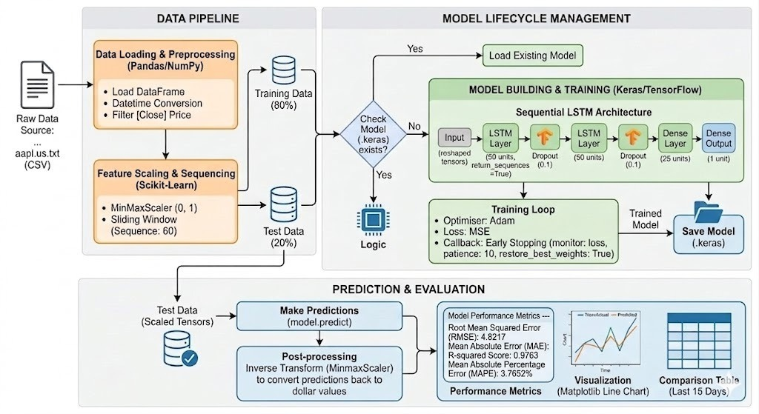

3. Contributions
I. Data Engineering & Pipeline Architecture
Soumick Samanta
I downloaded the 30+ years historical AAPL data from Kaggle where and implemented MinMaxScaler to normalize the data. The specialized 60-day sliding window pipeline to transform raw prices into sequential tensors for supervised temporal learning.
II. Neural Architecture & Optimization
Suthirtha Dey
Suthirtha was responsible for the core AI development, programming a stacked LSTM architecture with integrated dropout layers and an automated Early Stopping callback to ensure the model achieved peak performance while minimizing computational overhead and preventing overfitting.
III. Analytics & Predictive Diagnostics
Tanushree Mandal
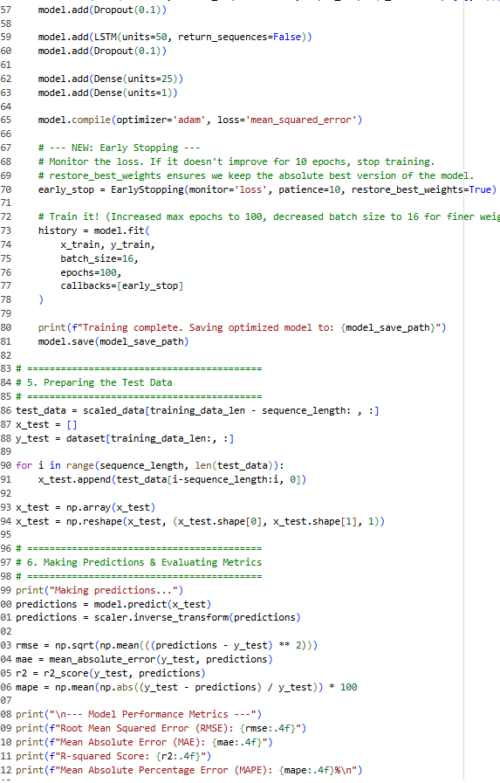
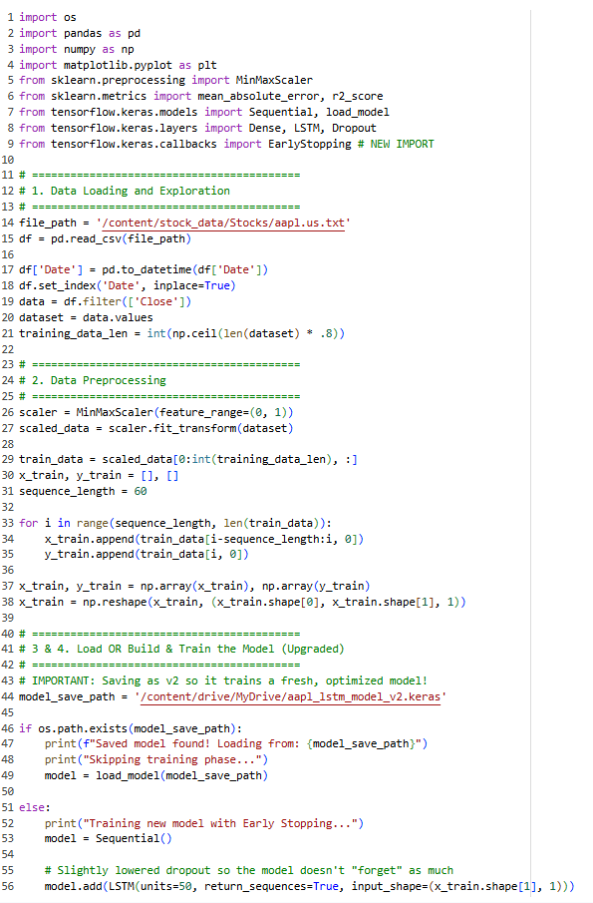
Tanushree managed the post-inference validation by inverse-transforming scaled predictions to calculate critical statistical benchmarks (RMSE, MAE, R-squared, and MAPE) and authoring a suite of diagnostic visualizations to analyse the model's behaviour and prediction lag in high-volatility scenarios.
4. Code

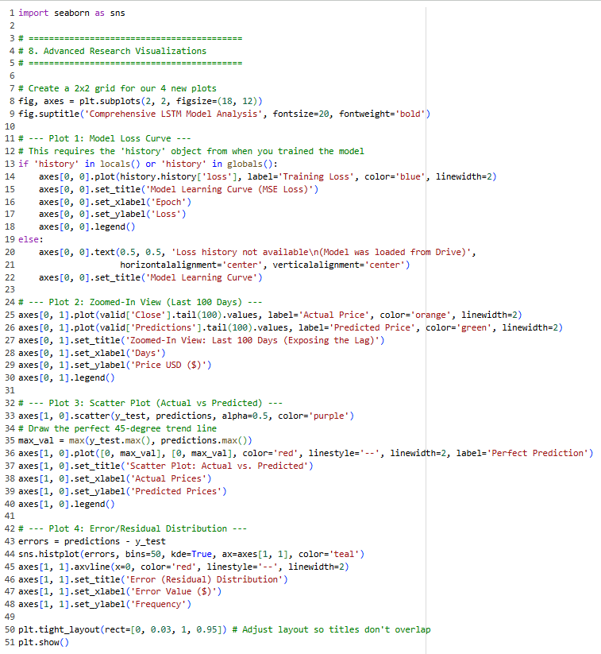
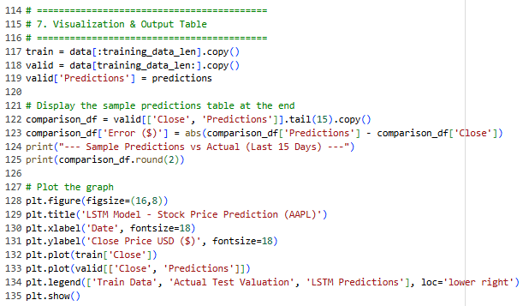

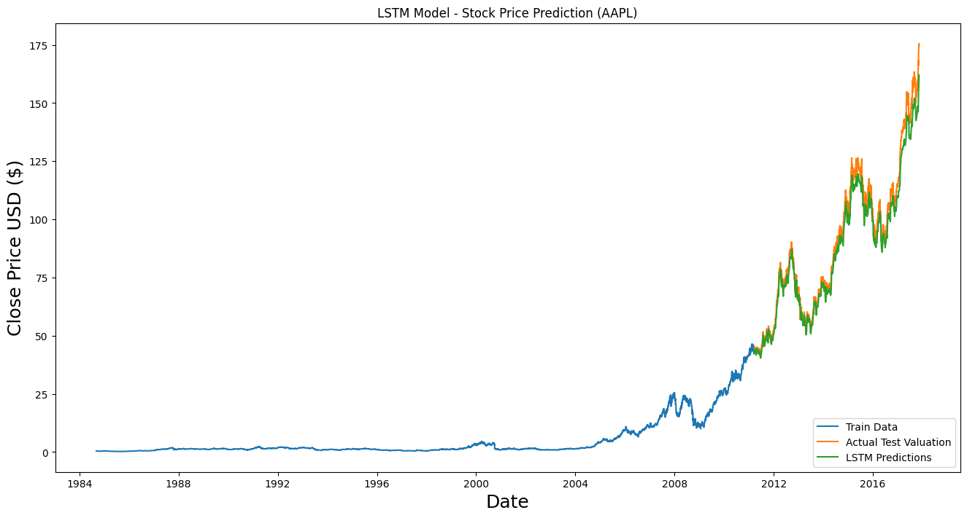
5. Results
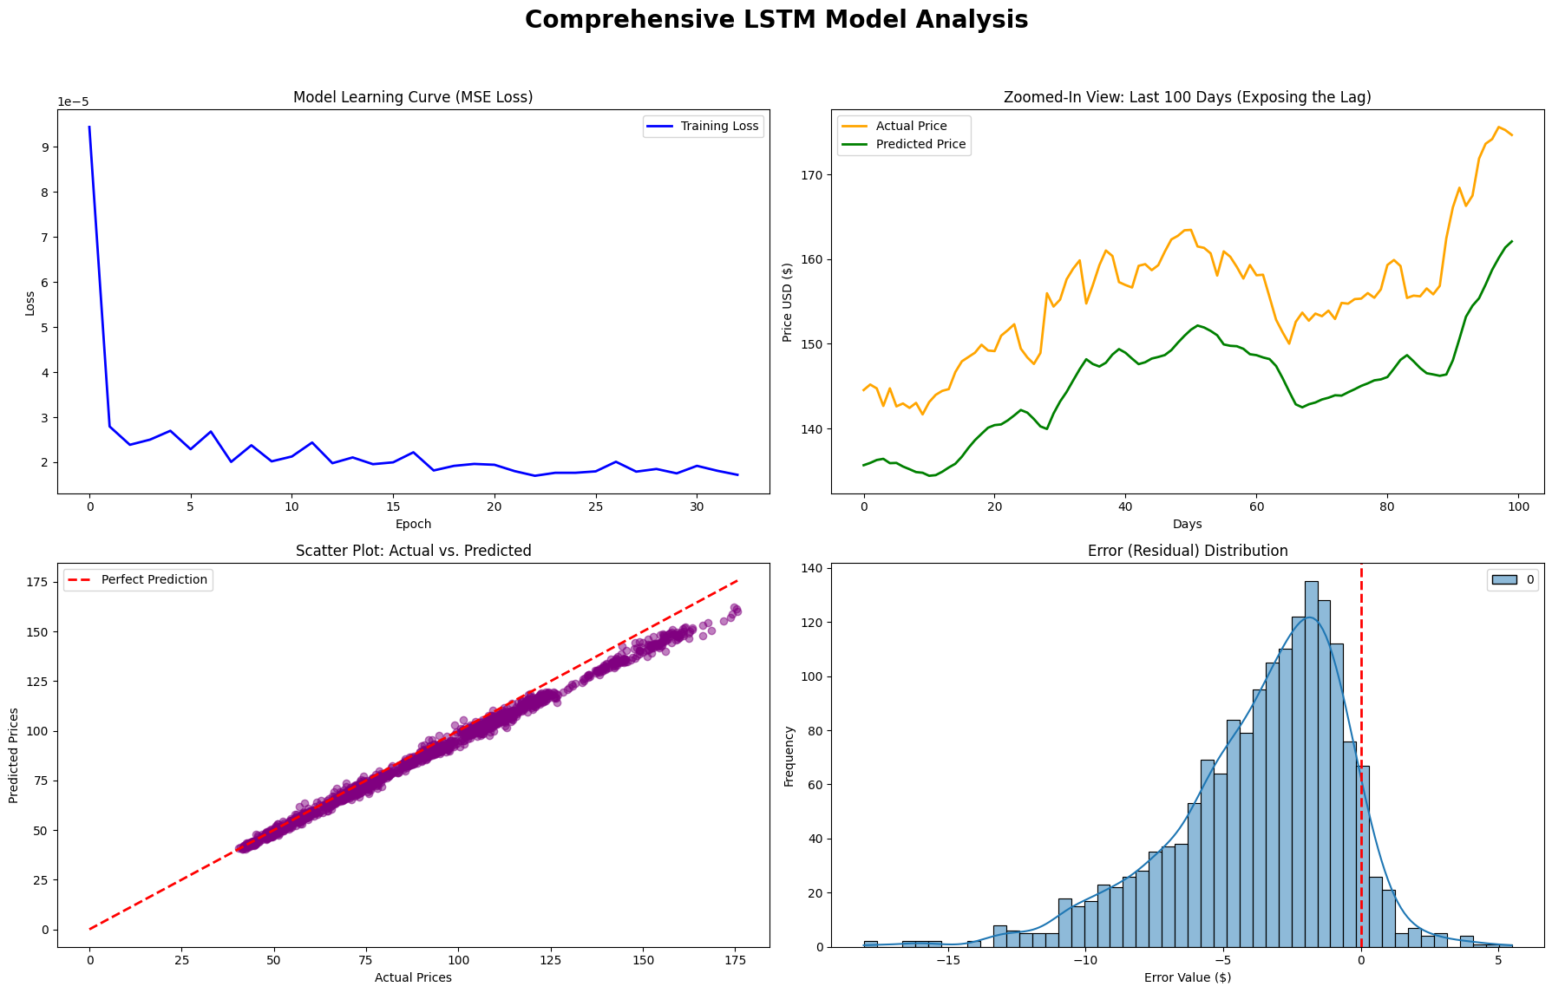

6. Conclusion
Our project demonstrates that LSTM networks are highly effective at identifying temporal patterns in long-term stock data. By building an end-to-end pipeline from automated preprocessing to a multi-layered recurrent architecture, our team successfully modelled AAPL’s price trends over 30+ years. Our analysis of the MSE loss convergence and the 99% correlation shown in our scatter plots confirms the model generalizes well, providing a robust, data-driven foundation for directional market forecasting.

