Cloud Security Capstone Project
Secure Web Application on AWS using Terraform

Name: Aditya Manohar Mhaismale
PRN: 2124UCSM1070

1. Introduction and Objective
This project deploys a secure, scalable-by-design three-tier web application on AWS entirely with Terraform, and demonstrates its security controls with evidence from the live deployment.
The objective was to follow AWS security best practices: a web tier (Application Load Balancer) in public subnets, an application tier (EC2) in a private subnet, and a database tier (Amazon RDS) in an isolated private subnet that accepts connections only from the application server. Network flow is logged with VPC Flow Logs and account activity is audited with AWS CloudTrail.

Item | Value
Cloud provider | Amazon Web Services
Region | Asia Pacific (Sydney), ap-southeast-2
Infrastructure as Code | Terraform 1.16 with AWS provider 5.x
Resources created | 50
Application | Apache web server on Amazon Linux 2023
Database | Amazon RDS for MySQL 8.0 (db.t3.micro)

2. Architecture Overview
Traffic enters through the Internet Gateway to an Application Load Balancer in the public subnets. The ALB forwards HTTP requests to the EC2 application server in a private application subnet, and the application server alone can reach the RDS database in a private database subnet. Everything spans two availability zones.
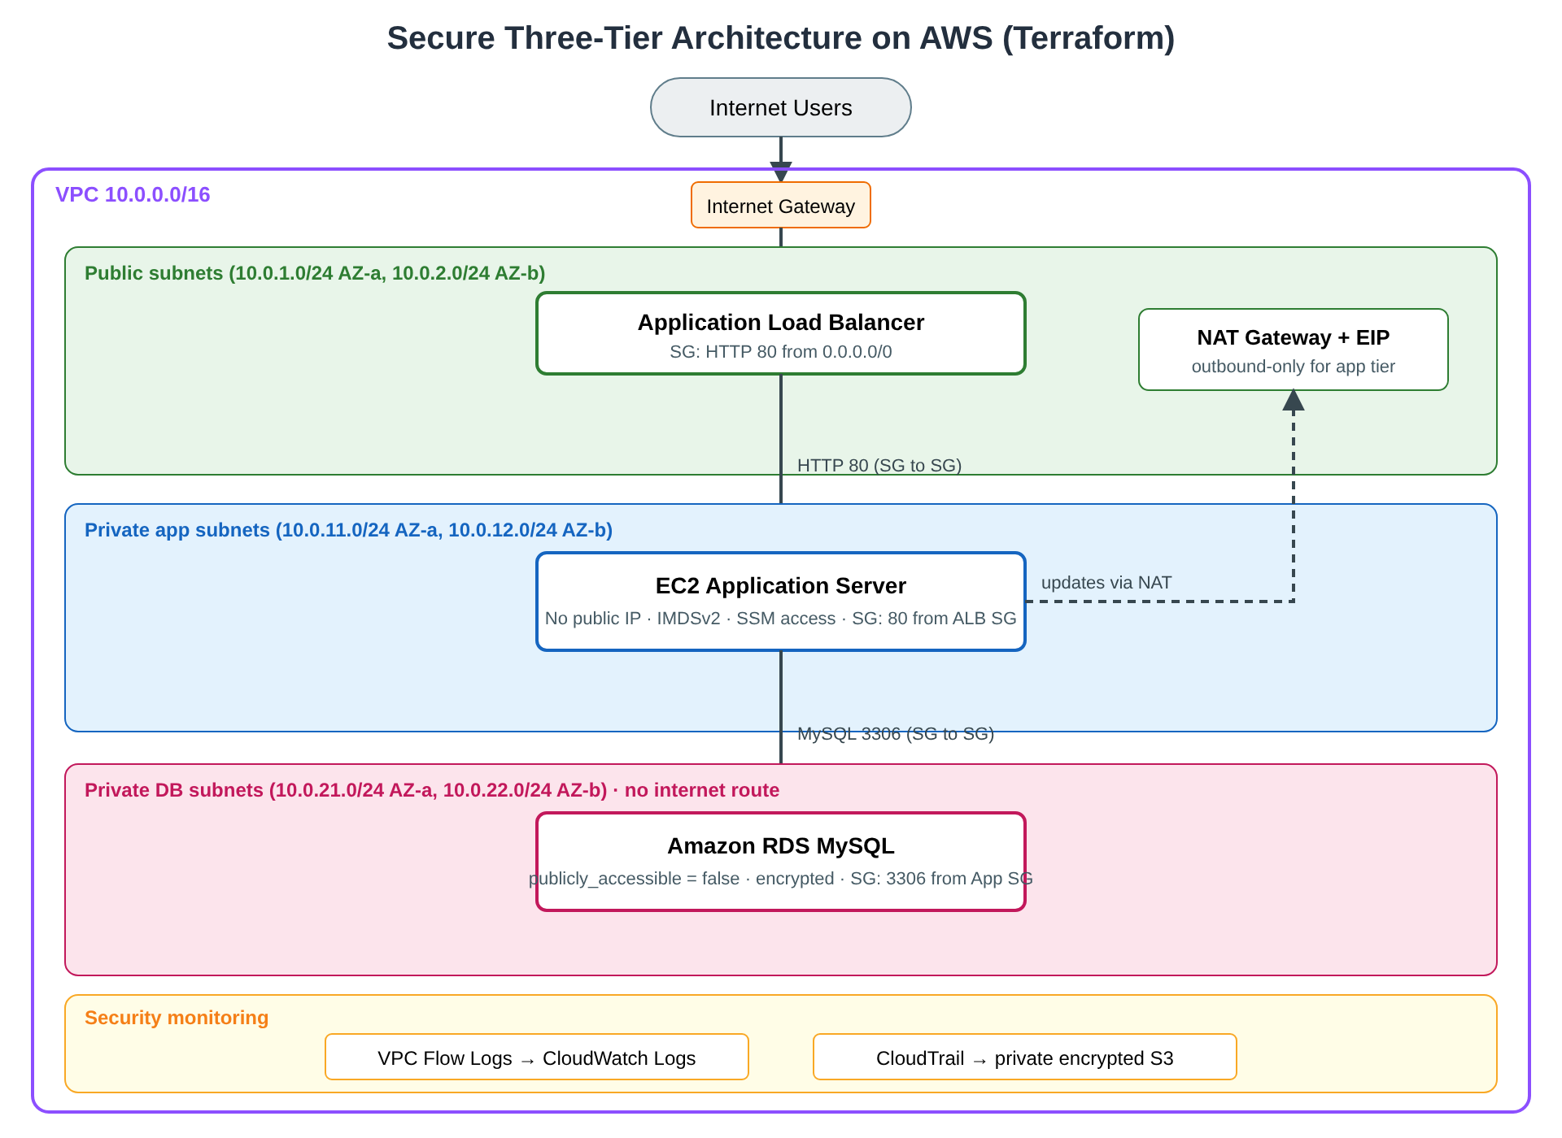
Architecture of the secure three-tier deployment
Tier | Subnets | Resources | Internet route
Web | Public: 10.0.1.0/24, 10.0.2.0/24 | Application Load Balancer, NAT Gateway | Yes, through the Internet Gateway
Application | Private: 10.0.11.0/24, 10.0.12.0/24 | EC2 server (no public IP) | Outbound only, through the NAT Gateway
Database | Private: 10.0.21.0/24, 10.0.22.0/24 | RDS MySQL | None

The security groups form a chain: the Internet may reach only the ALB on port 80, the ALB may reach only the application server, and the application server may reach only the database on port 3306.

3. Terraform Implementation
The infrastructure is split into nine Terraform files so each tier and each security control can be reviewed on its own.

File | What it builds
versions.tf | Terraform and AWS provider versions, default tags
variables.tf | Region, availability zones, CIDR ranges, instance sizes
network.tf | VPC, six subnets, Internet Gateway, NAT Gateway, three route tables
security_groups.tf | ALB, application and database security groups with SG-to-SG rules
alb.tf | Application Load Balancer, target group, HTTP listener
compute.tf | EC2 application server, IAM role for Session Manager
database.tf | RDS MySQL instance and DB subnet group
monitoring.tf | VPC Flow Logs to CloudWatch, CloudTrail to a private S3 bucket
outputs.tf | ALB URL, instance ID, RDS endpoint, log group and bucket names

The deployment followed the standard workflow: terraform init, terraform validate, terraform plan -out tfplan, then terraform apply. The plan reported 50 resources to add. The security-critical lines in the code are:
# database.tf
publicly_accessible = false
storage_encrypted = true
manage_master_user_password = true # password generated and held in Secrets Manager

# security_groups.tf: DB accepts MySQL only from the app security group
referenced_security_group_id = aws_security_group.app.id
from_port = 3306
to_port = 3306

# compute.tf
associate_public_ip_address = false
metadata_options { http_tokens = "required" } # IMDSv2 only

4. Deployment Evidence
The screenshots below were taken from the AWS Console (region Asia Pacific (Sydney)) and the terminal after terraform apply completed.

4.1 Terraform apply and application
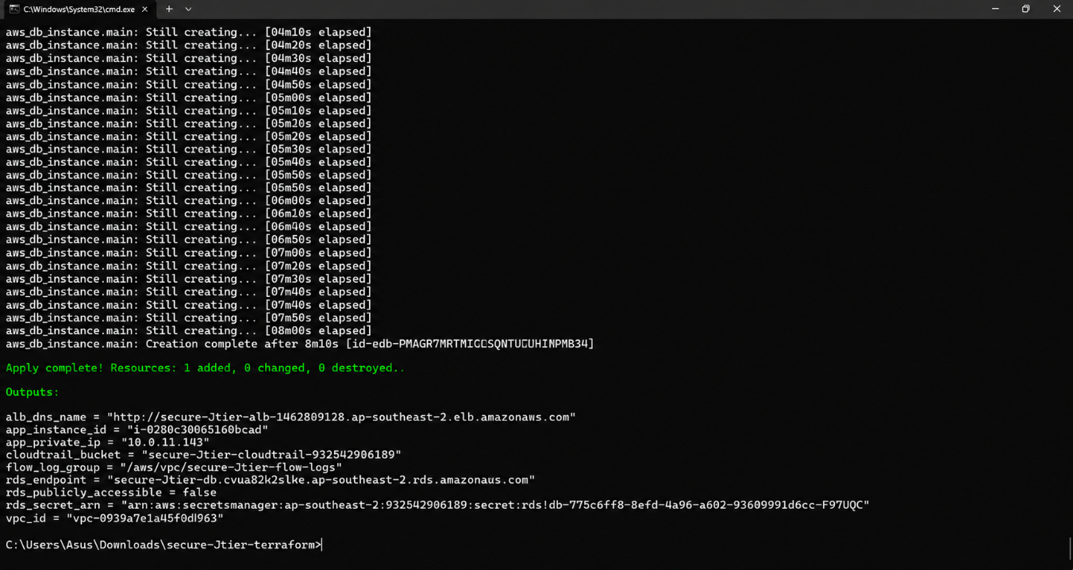
Figure 1. terraform apply finished successfully and printed the ALB URL, instance ID, RDS endpoint and log group.
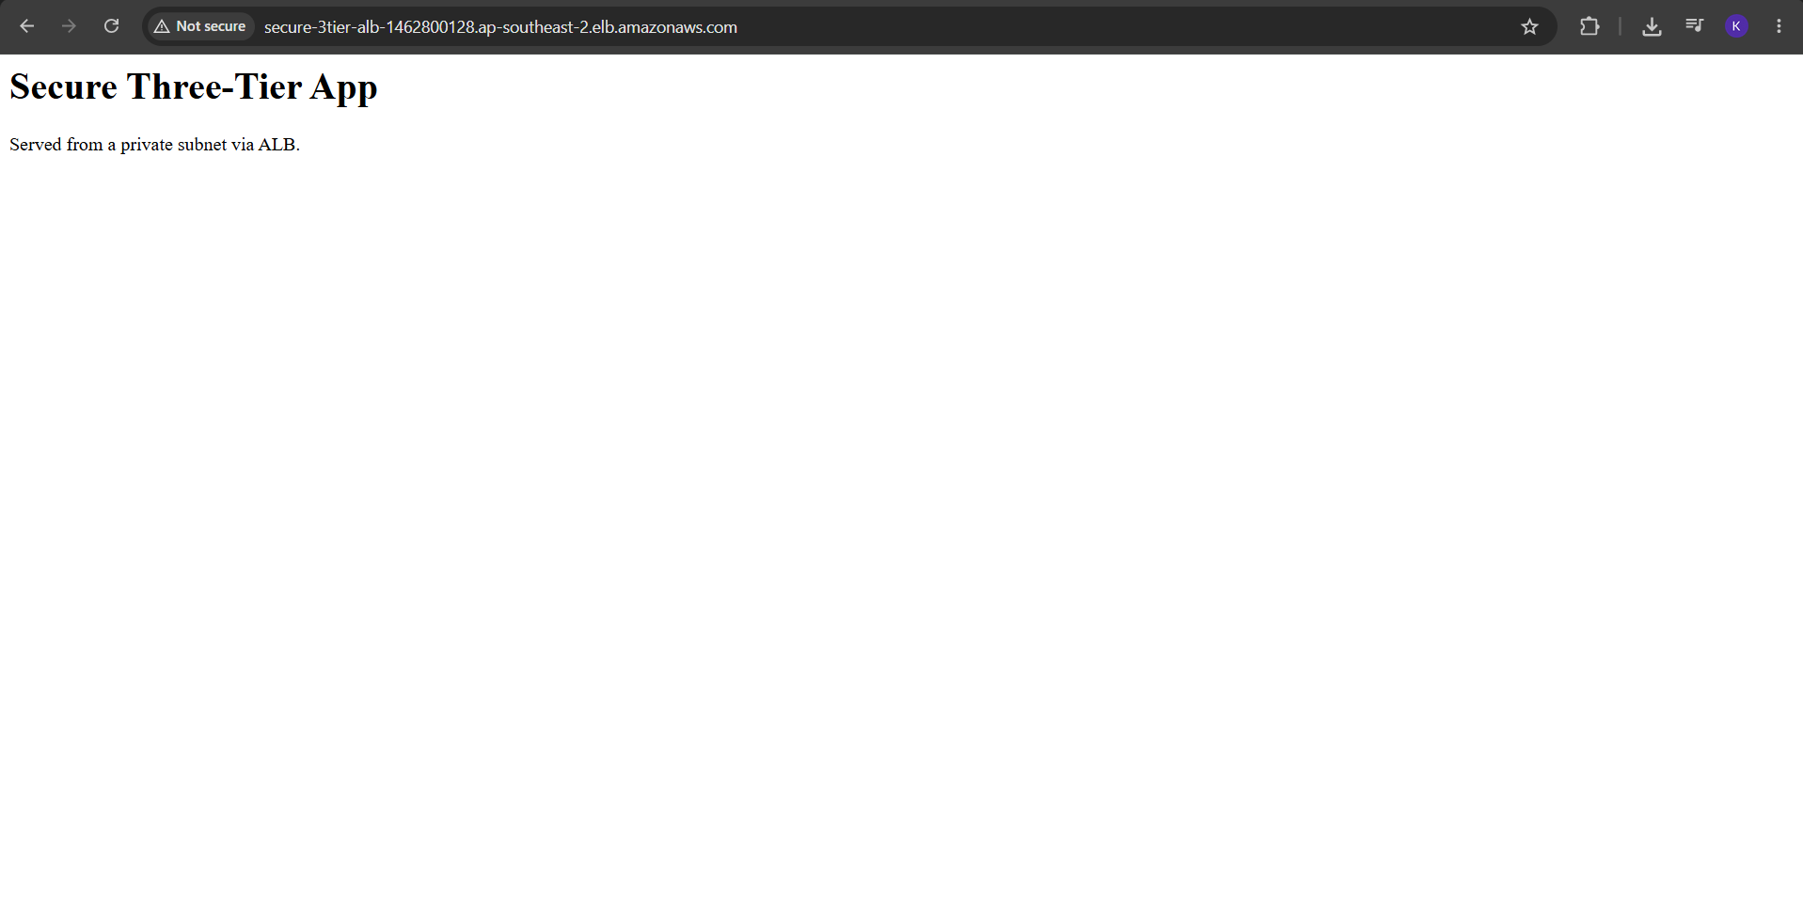
Figure 2. The application page, served from a private subnet, loads through the ALB DNS name.

4.2 Network: VPC, subnets, gateways and routes
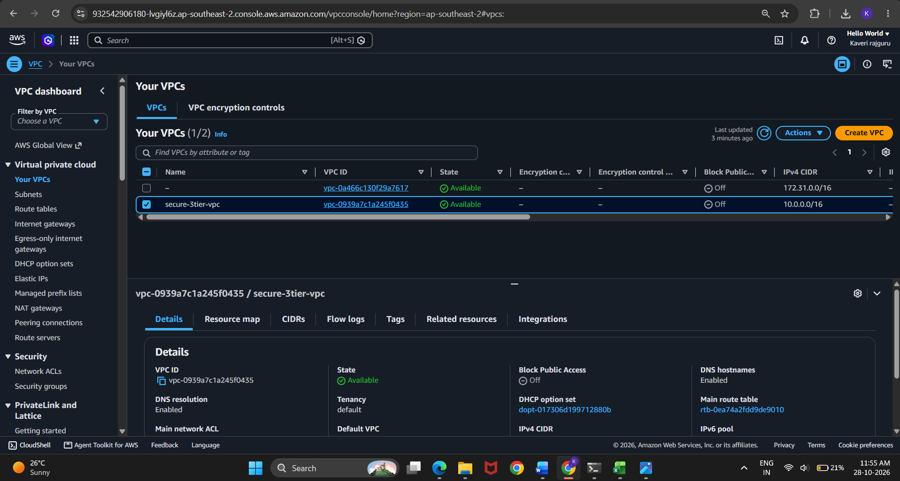
Figure 3. secure-webapp-vpc with CIDR 10.0.0.0/16.
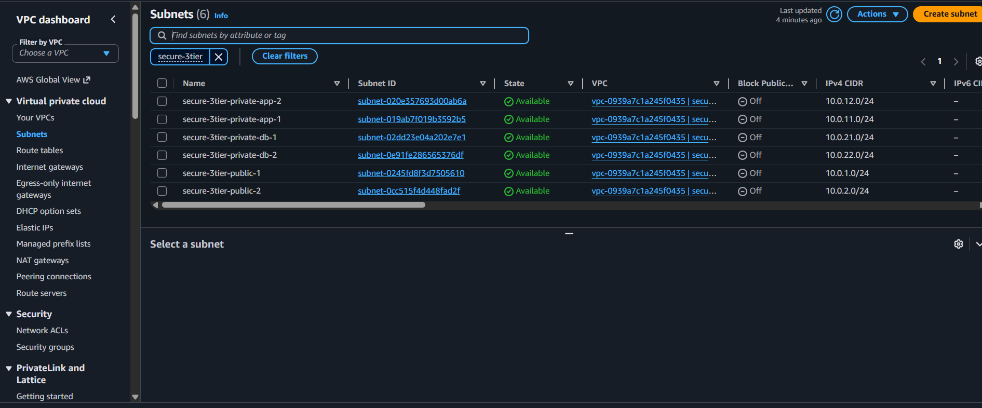
Figure 4. Six subnets across two availability zones: public, private-app and private-db.
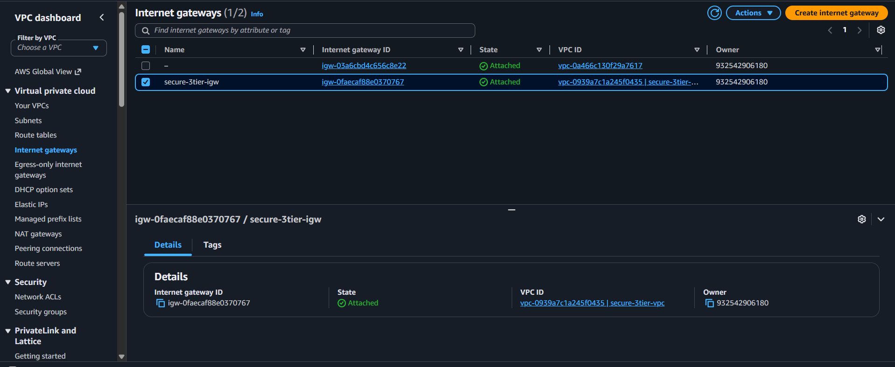
Figure 5. The Internet Gateway is attached to the VPC.
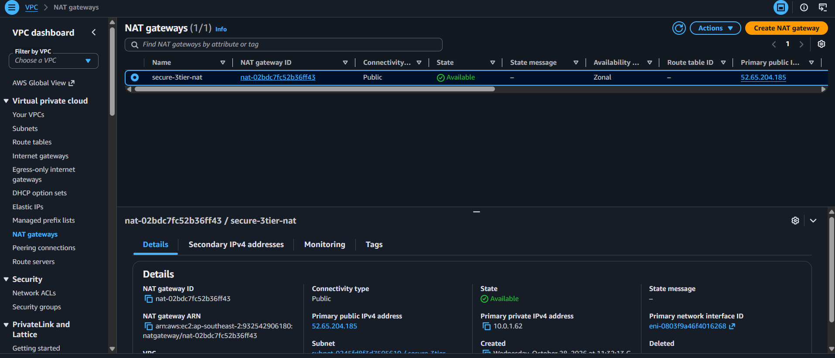
Figure 6. The NAT Gateway is Available in a public subnet with an Elastic IP.
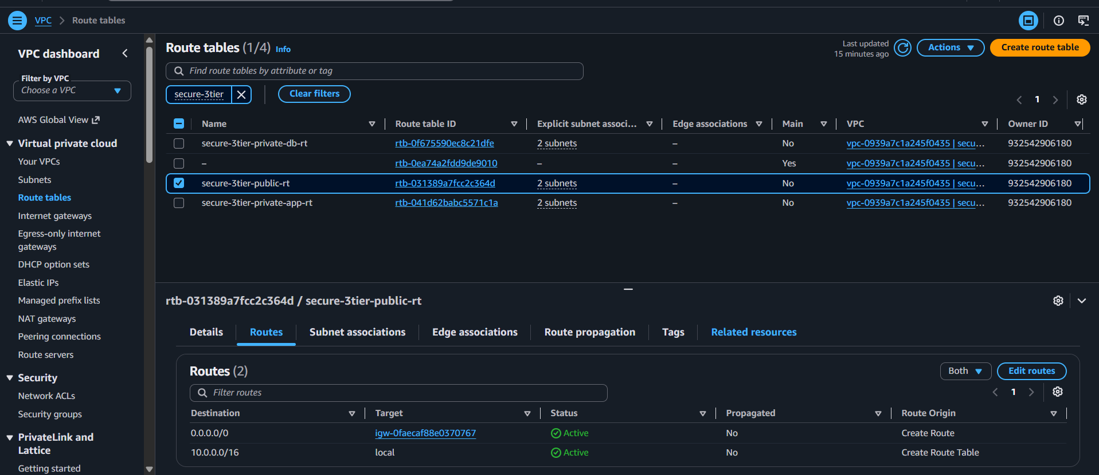
Figure 7. Public route table: 0.0.0.0/0 goes to the Internet Gateway.
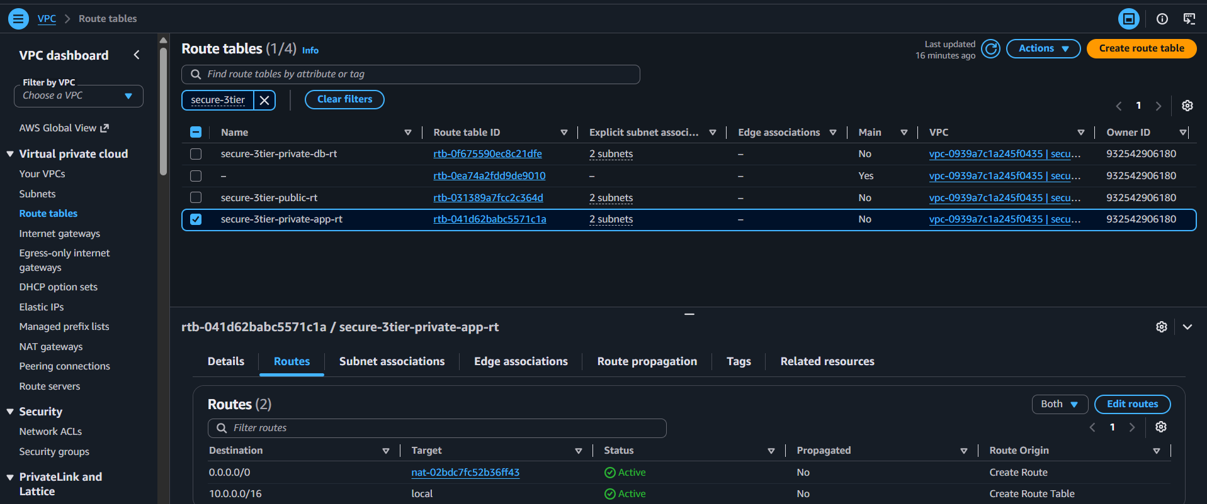
Figure 8. Application route table: 0.0.0.0/0 goes to the NAT Gateway, so the server can make outbound requests only.
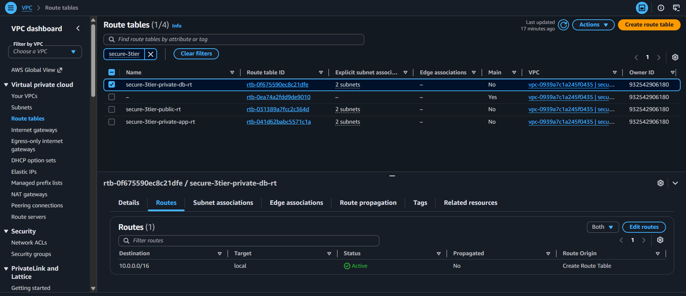
Figure 9. Database route table: only the local VPC route. The database subnets have no path to the internet.

4.3 Load balancer and application server
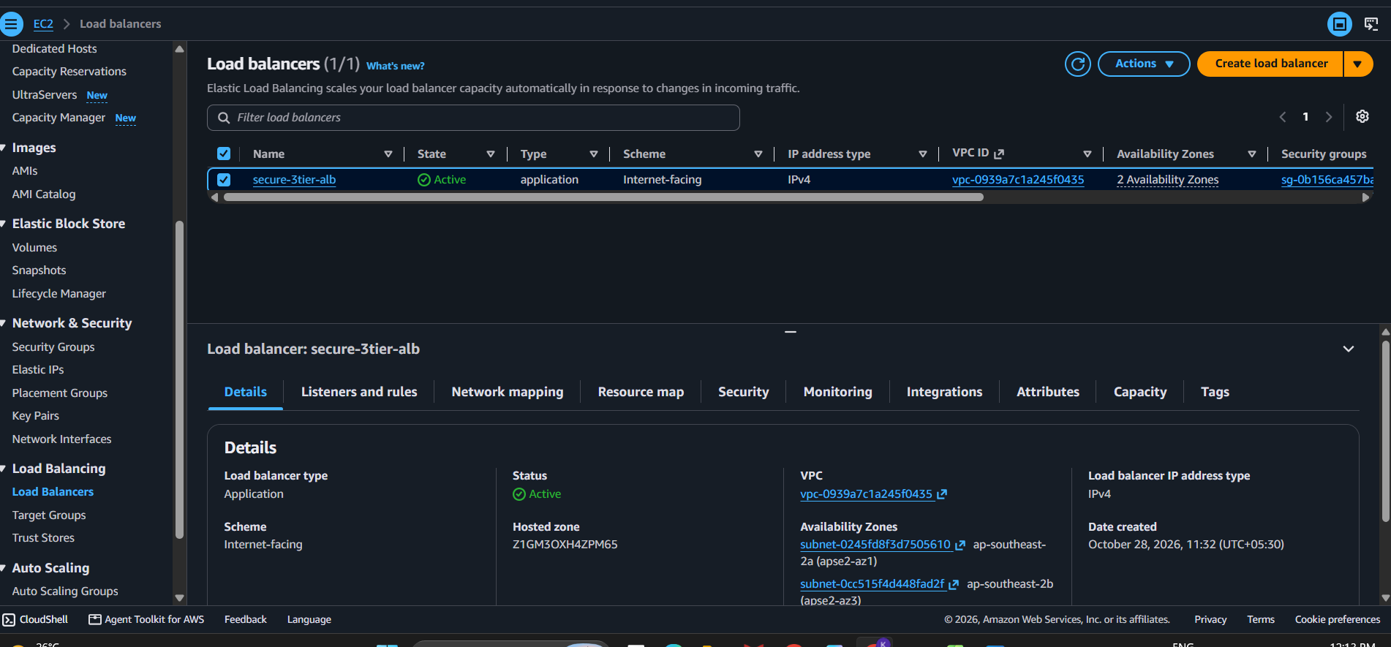
Figure 10. The ALB is internet-facing and Active across two availability zones.
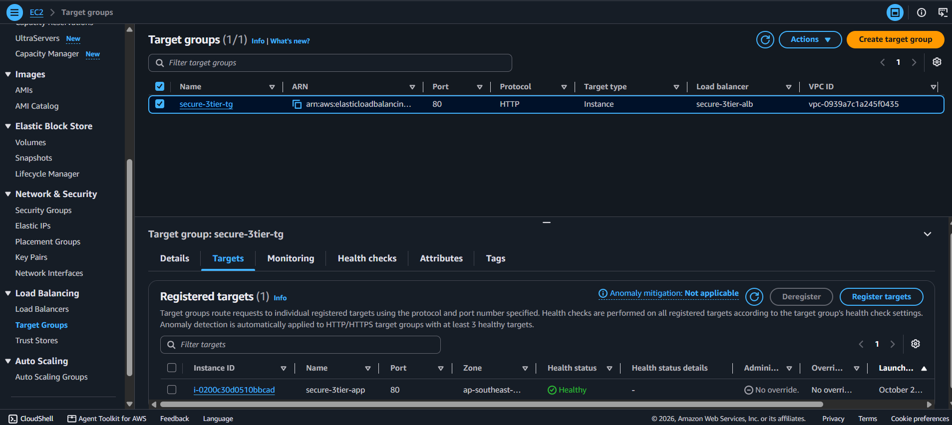
Figure 11. The EC2 instance is registered in the target group and reports Healthy.
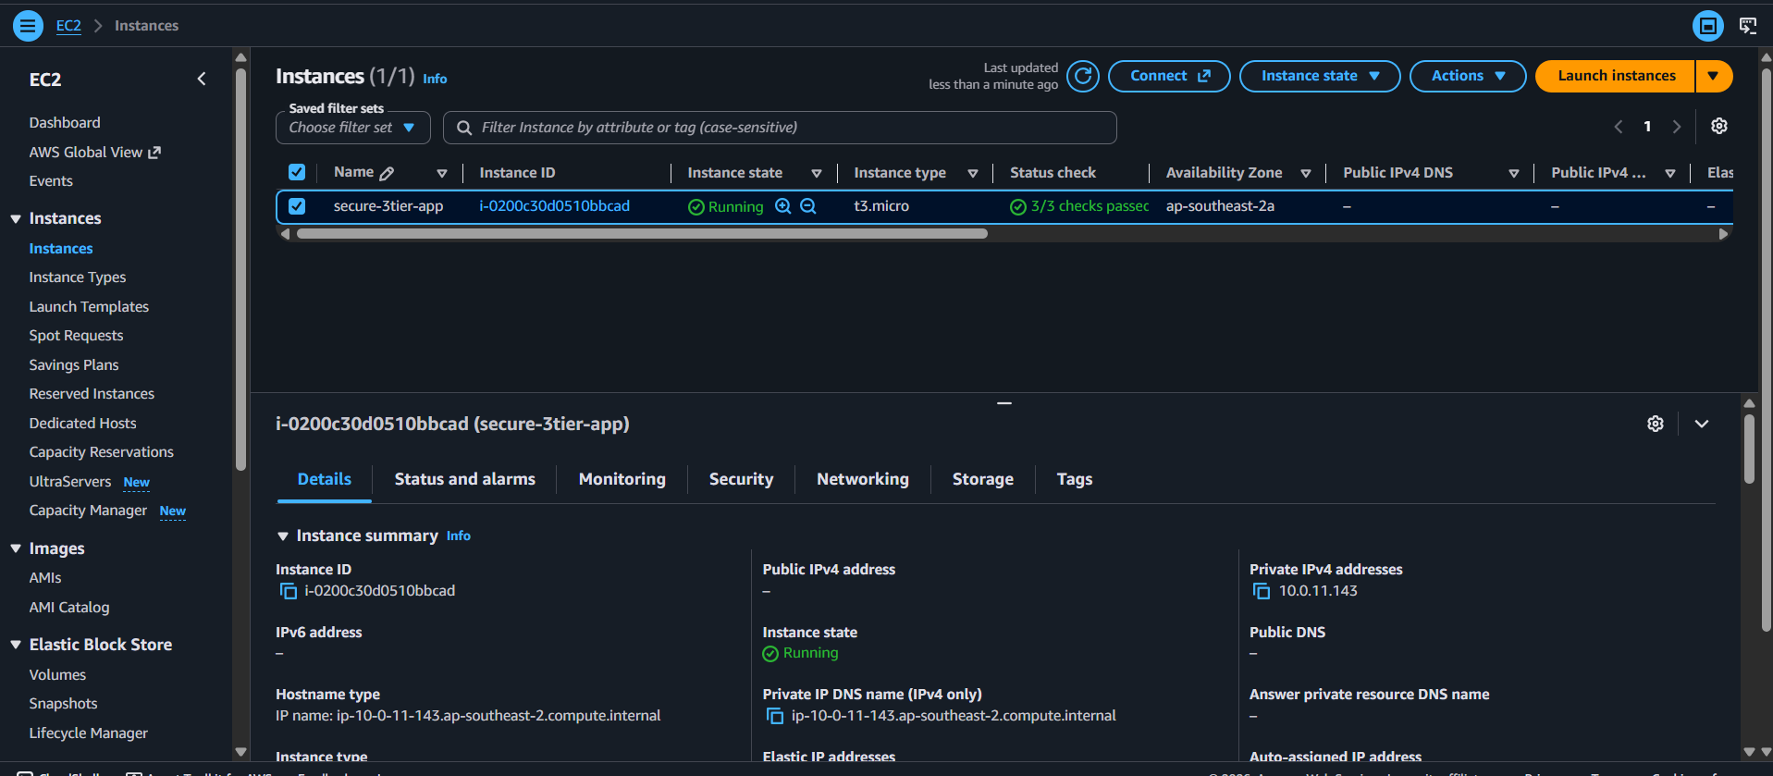
Figure 12. The application server has no public IPv4 address. Its private IP is 10.0.11.143.

4.4 Security groups
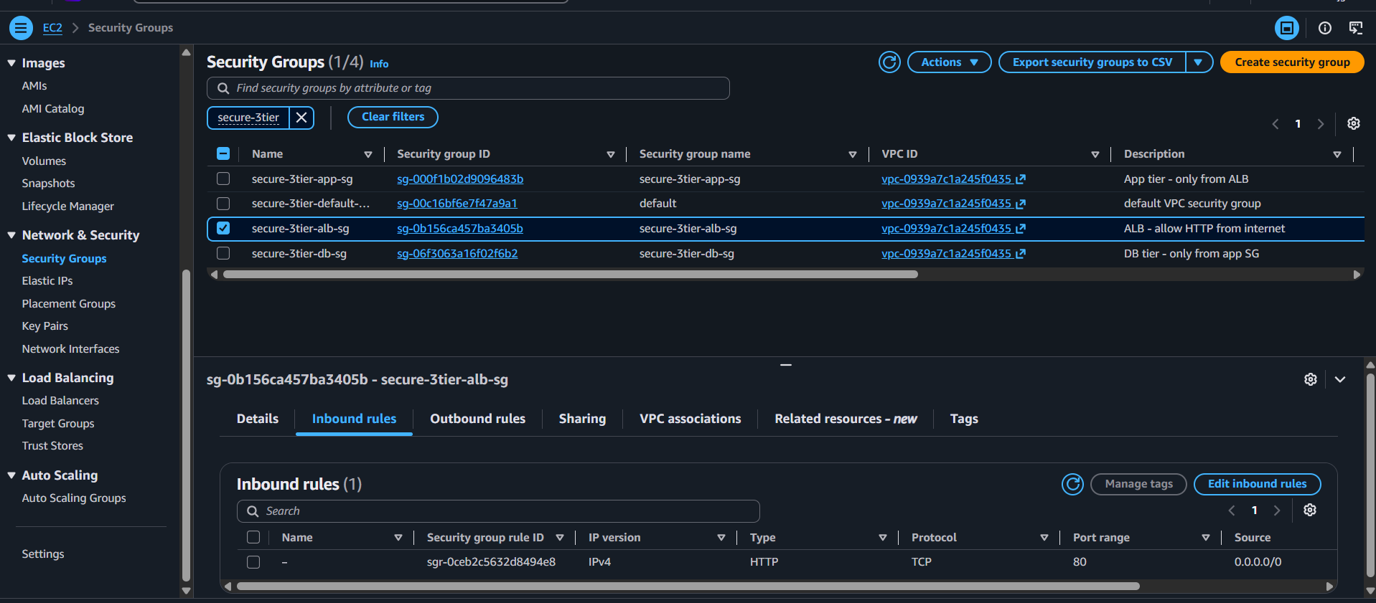
Figure 13. ALB security group: HTTP port 80 from 0.0.0.0/0.
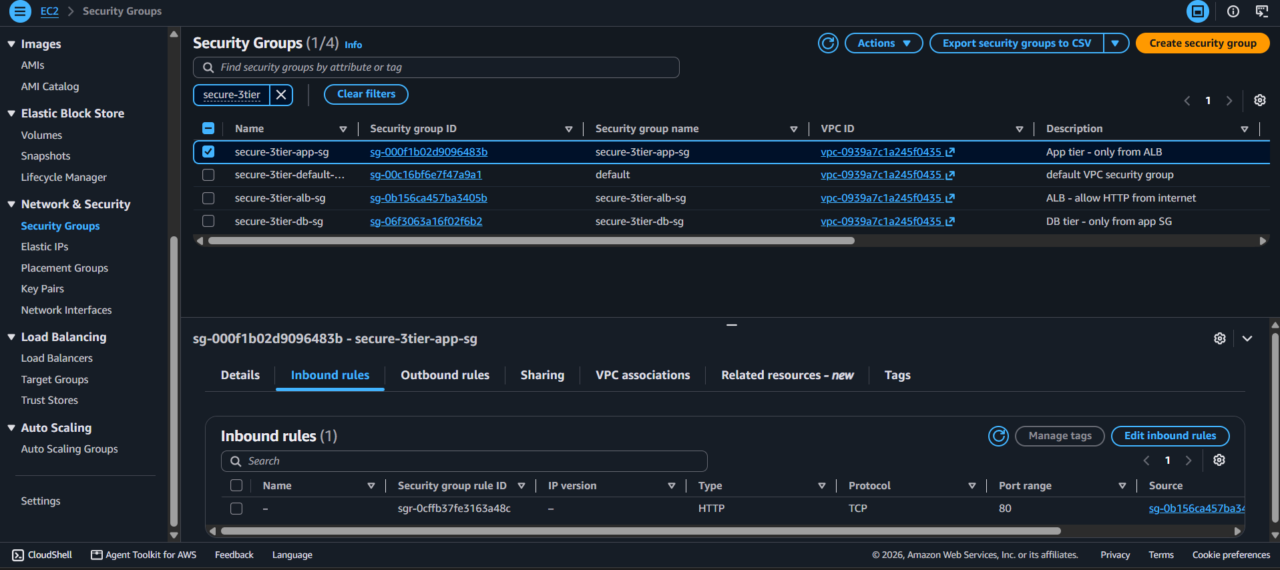
Figure 14. Application security group: port 80 only from the ALB security group.
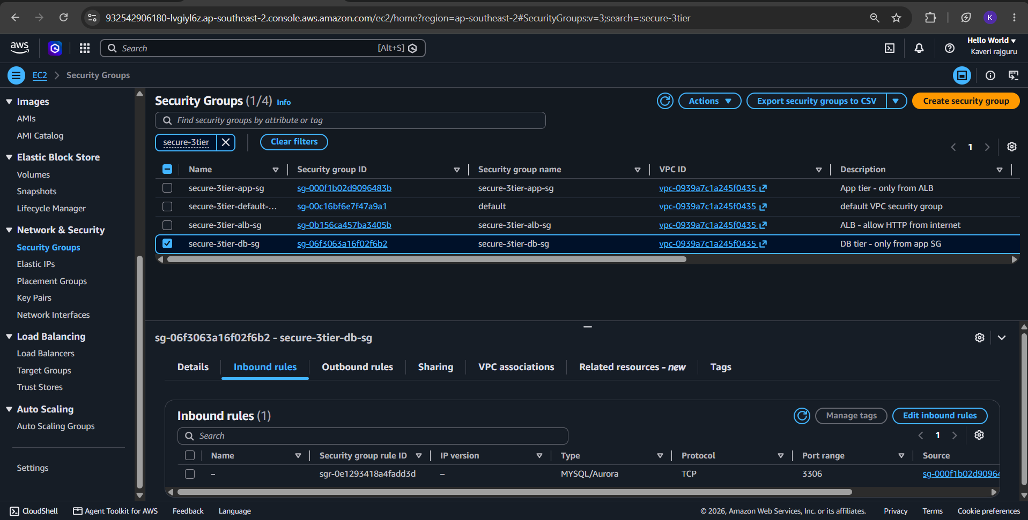
Figure 15. Database security group: MySQL port 3306 only from the application security group.

5. Database Security Evidence
The database is not publicly accessible, is encrypted, and accepts connections only from the application server. This was verified in three ways: configuration, security group rules, and live connection tests from two locations.
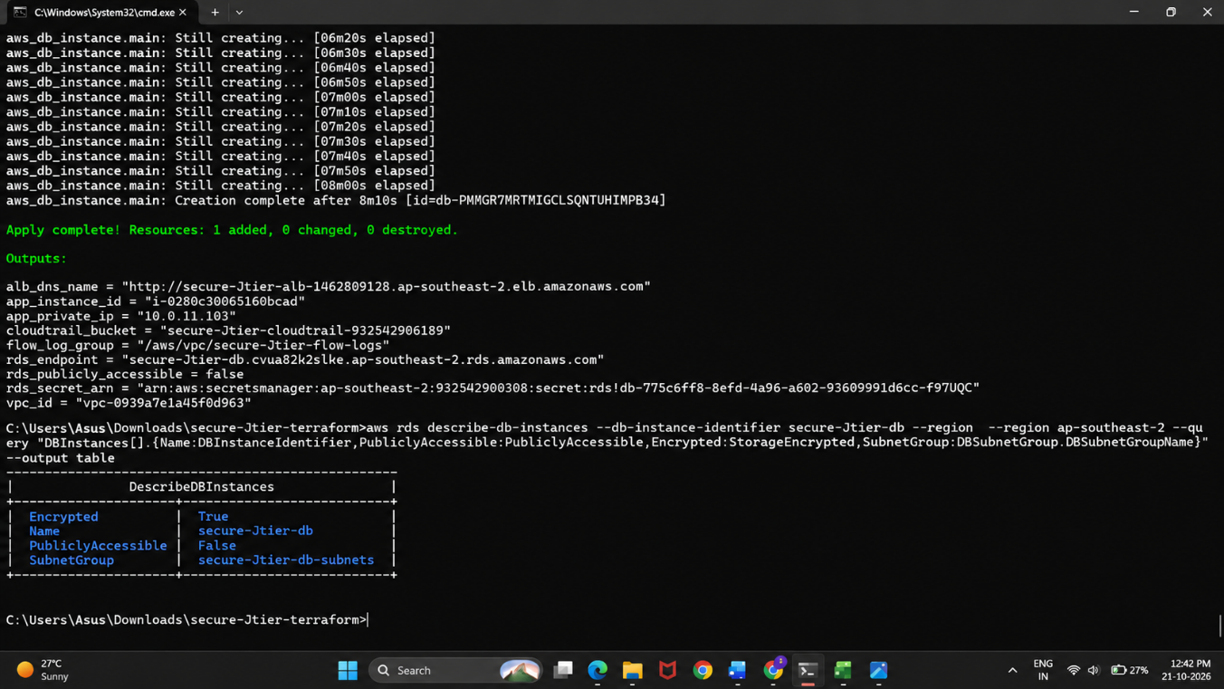
Figure 16. aws rds describe-db-instances reports PubliclyAccessible = False, Encrypted = True and the private DB subnet group.
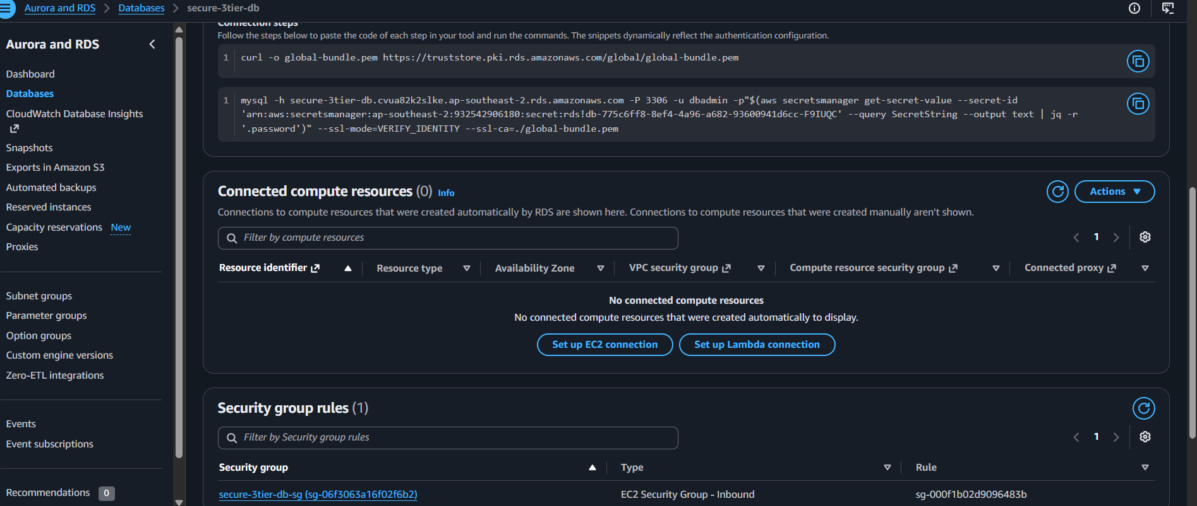
Figure 17. The RDS console lists a single inbound rule on secure-webapp-db-sg, sourced from the application security group.
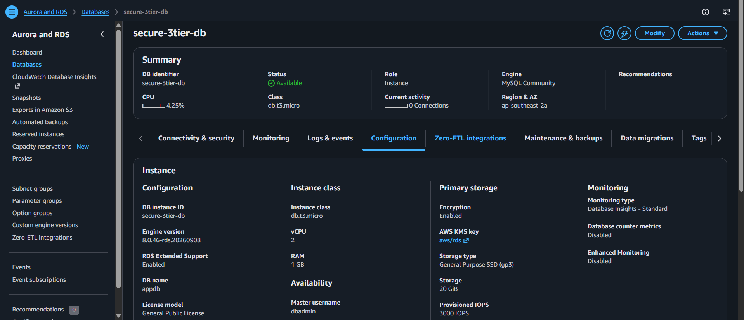
Figure 18. RDS configuration shows storage encryption Enabled with the AWS-managed KMS key (aws/rds), instance class db.t3.micro and 20 GiB of gp3 storage.
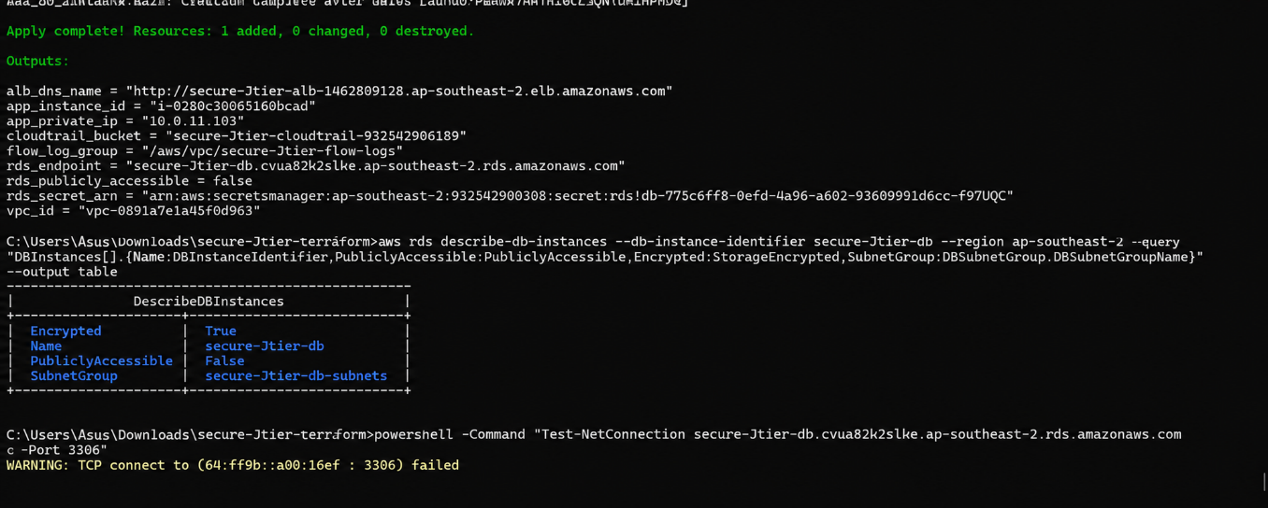
Figure 19. A TCP test from a laptop on the internet to the RDS endpoint on port 3306 fails. The endpoint resolves only to a private address (10.0.21.239) in the database subnet.
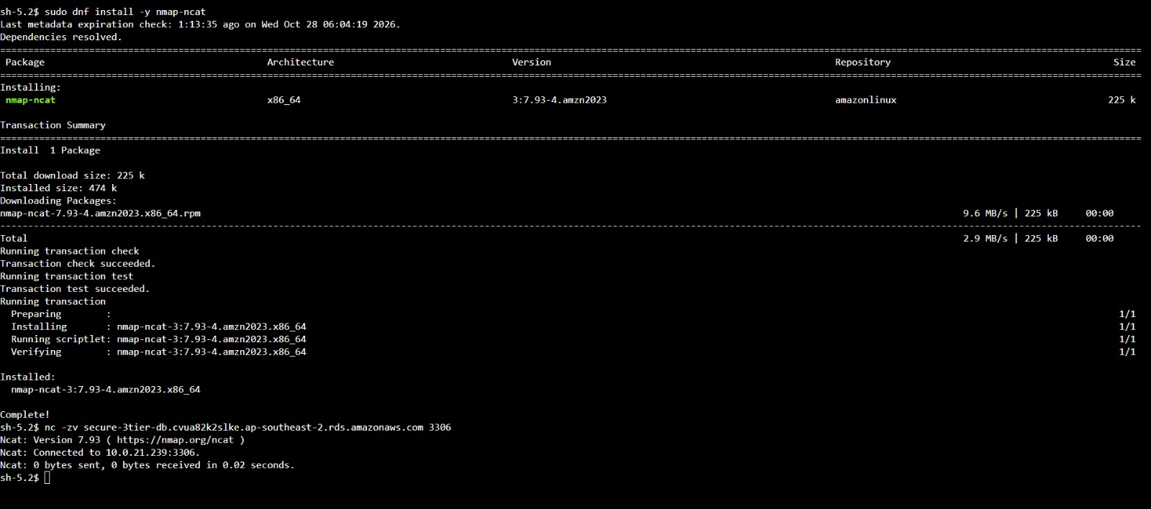
Figure 20. From the application server (reached with Session Manager, no SSH), the same test succeeds: Connected to 10.0.21.239:3306.
The two tests together prove the requirement: the database is unreachable from the internet and reachable only from the application tier.

6. Security Monitoring
Two services provide basic security monitoring: VPC Flow Logs record network traffic, and CloudTrail records every API call made in the account.

6.1 VPC Flow Logs
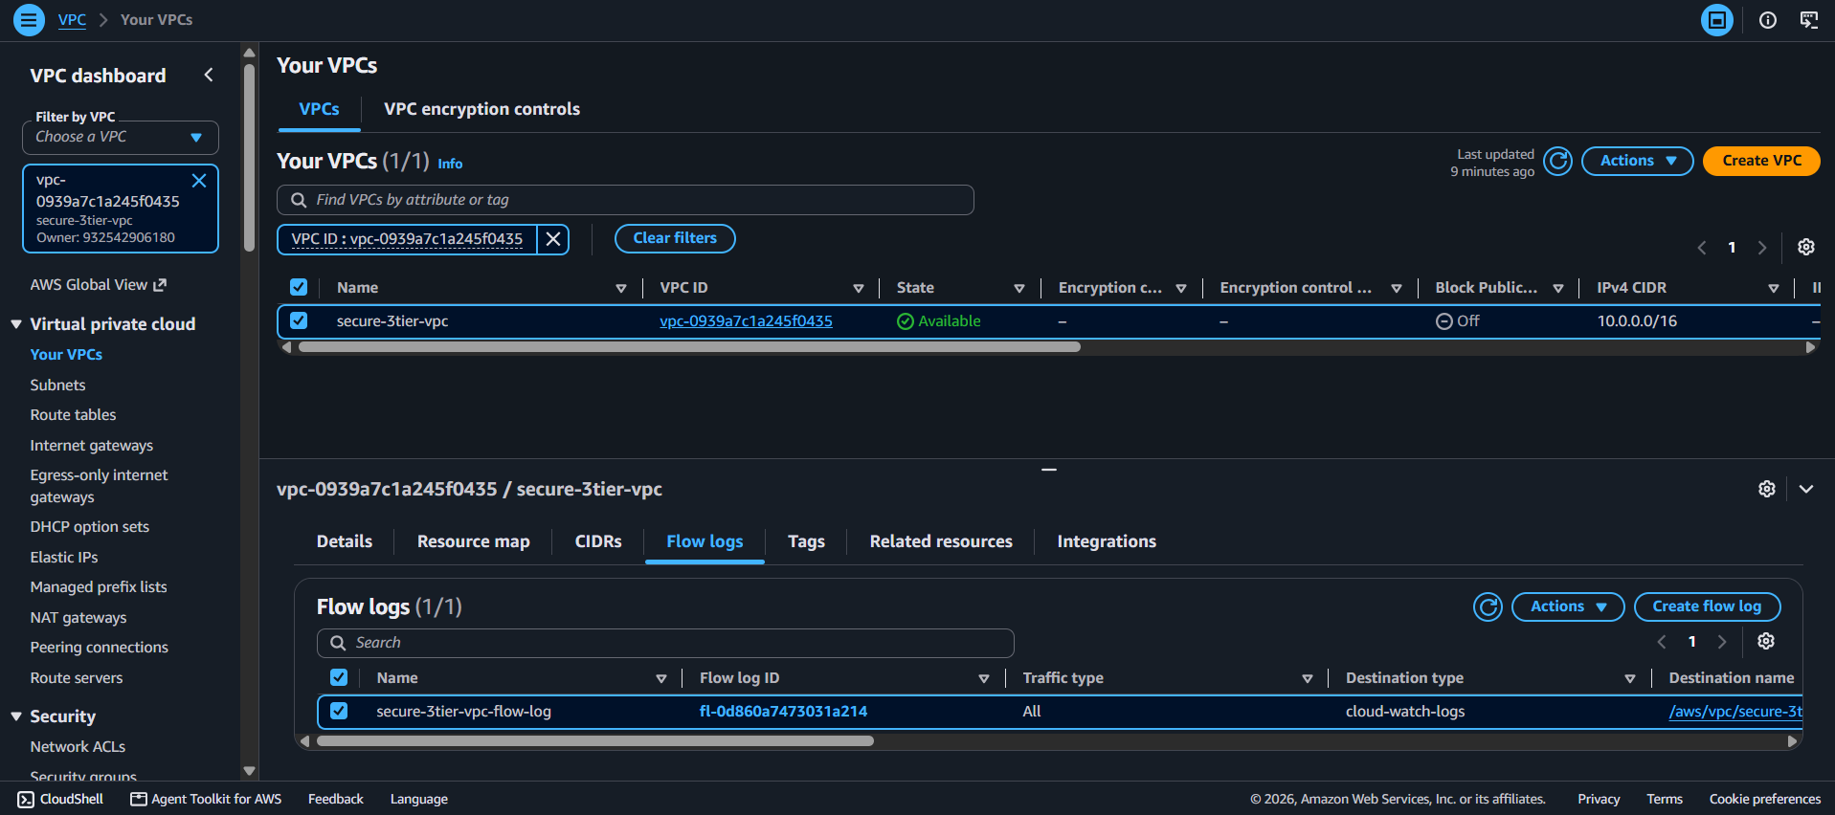
Figure 21. A flow log on the VPC captures ALL traffic and sends it to CloudWatch Logs.
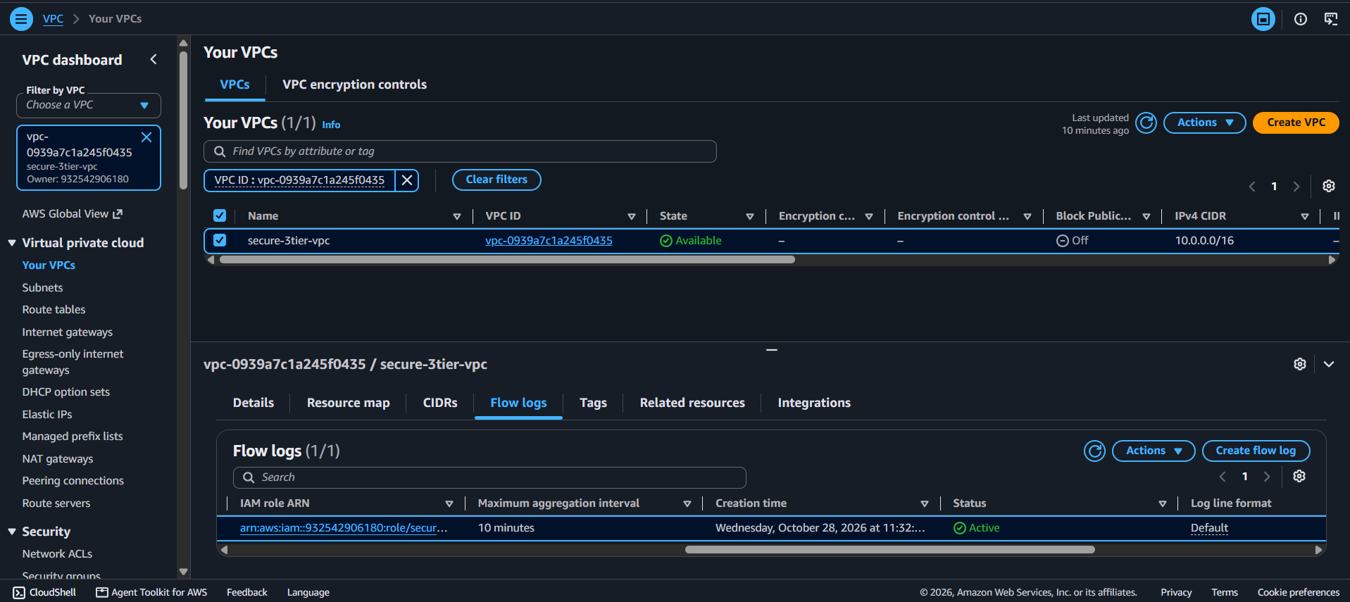
Figure 22. The flow log status is Active with a 10-minute aggregation interval.
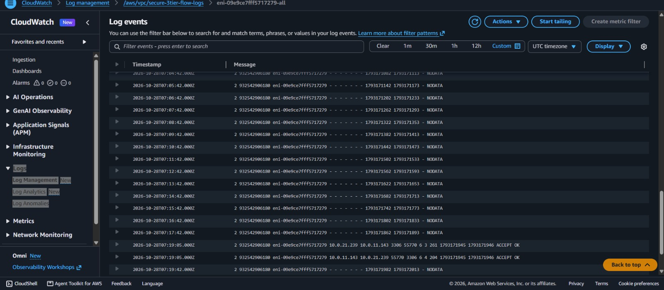
Figure 23. Flow log records in CloudWatch. The ACCEPT lines show MySQL traffic on port 3306 between the application server (10.0.11.143) and the database (10.0.21.239), confirming the only permitted path to the database.

6.2 CloudTrail
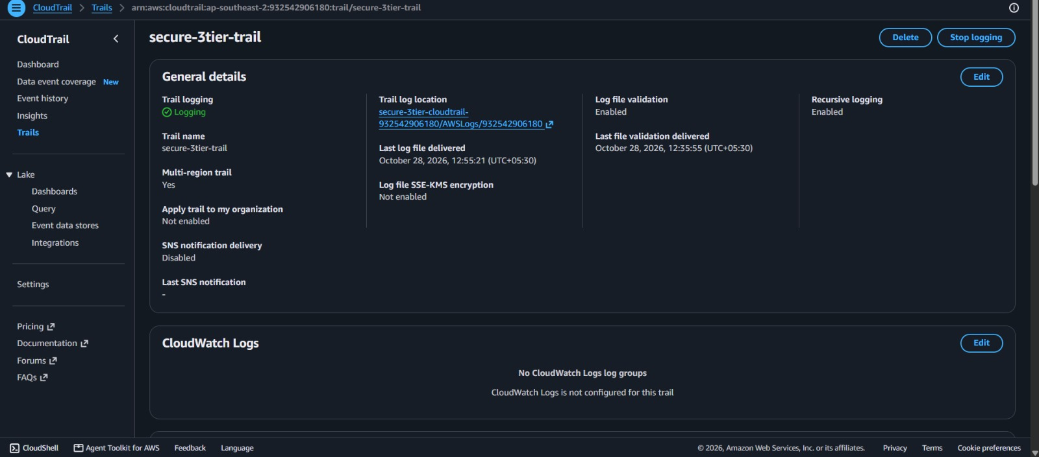
Figure 24. secure-webapp-trail is logging, multi-region, with log file validation enabled and logs delivered to the private S3 bucket.
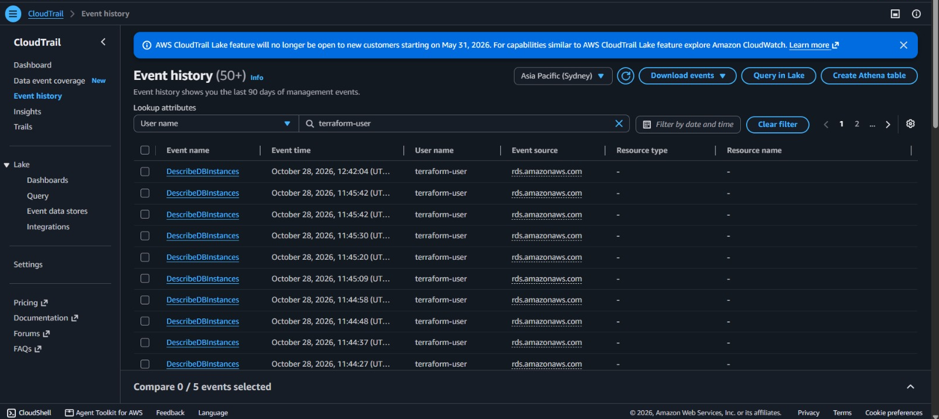
Figure 25. Event history shows API activity by terraform-user, giving a full audit trail of who changed what and when.
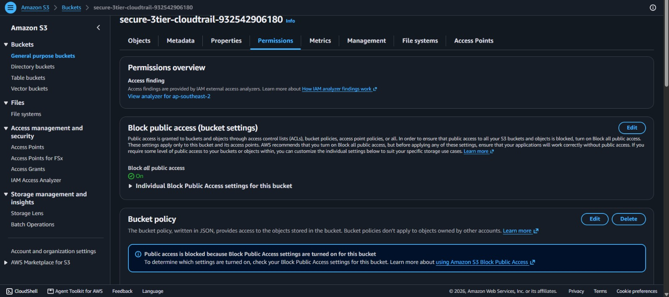
Figure 26. The CloudTrail log bucket has Block all public access turned On, so audit logs cannot be exposed.

7. Security Best Practices Applied
Security is layered: no single control is relied on alone.

Control | How it is implemented | Risk reduced
Network isolation | Only the ALB sits in public subnets; EC2 and RDS have no public IP | Direct internet attacks on servers and database
Isolated database subnets | DB route table has no route to the Internet Gateway or NAT Gateway | Data exfiltration and inbound access
Least-privilege security groups | Internet to ALB, ALB to App, App to DB, each by security group ID | Lateral movement between tiers
No SSH exposure | Admin access through SSM Session Manager, no port 22 rule | Brute-force and key theft
IMDSv2 enforced | http_tokens = required on the EC2 instance | Credential theft through SSRF
Encryption at rest | Encrypted EBS volume, encrypted RDS storage, encrypted S3 bucket | Data exposure from disk or snapshot access
Secret handling | RDS master password generated and stored in AWS Secrets Manager | Passwords in code or Terraform variables
Locked default security group | All rules removed from the VPC default group | Accidental exposure of new resources
Audit logging | CloudTrail multi-region trail with log file validation | Undetected changes, tampered logs
Traffic visibility | VPC Flow Logs capture ALL traffic | Blind spots in network activity
Private log storage | CloudTrail S3 bucket blocks public access and denies non-TLS requests | Leaked audit logs

8. Challenges Faced and Resolutions
The AWS account belongs to an AWS Organization with restrictions, which caused three errors during deployment. Each was diagnosed from the Terraform error message and fixed.

Problem | Cause | Resolution
ssm:GetParameter denied | A service control policy (SCP) blocked reading the public AMI parameter in the first region tried | Confirmed with the AWS CLI that the Sydney region (ap-southeast-2) allowed the lookup, and moved the deployment there
ec2:DescribeImages denied | The same SCP blocked the alternative AMI lookup in the original region | Redeployed in the permitted region using the SSM AMI lookup
FreeTierRestrictionError on RDS | The account is on a free plan, which allows a backup retention of only 1 day | Changed backup_retention_period from 7 to 1 in database.tf and re-applied; only the remaining resources were created

Terraform's state tracking meant the re-apply created only the resources that had failed, without rebuilding the network or the load balancer.

9. Cost, Cleanup and Possible Improvements
The NAT Gateway and the RDS instance are the main running costs, so the environment is removed with terraform destroy as soon as the evidence has been collected. The S3 bucket is created with force_destroy and RDS with skip_final_snapshot so teardown completes without manual steps. These two settings are lab conveniences and should be reversed in production.
The design can be hardened further:

Improvement | Benefit
Auto Scaling Group across both application subnets | True scalability and automatic replacement of failed servers
HTTPS listener with an ACM certificate, HTTP-to-HTTPS redirect | Encryption in transit between users and the ALB
Multi-AZ RDS and one NAT Gateway per availability zone | High availability across zone failures
AWS WAF on the ALB | Protection from common web attacks
GuardDuty and CloudWatch alarms on REJECT spikes | Active detection of threats instead of passive logging
CloudTrail delivery to CloudWatch Logs and SSE-KMS encryption | Faster investigation and customer-managed encryption keys
Remote Terraform state in S3 with locking | Safe collaboration and state protection

10. Conclusion
The project delivered a working three-tier architecture in which the database is provably unreachable from the internet and reachable only from the application server. Evidence: a connection test from a laptop to the RDS endpoint on port 3306 failed, while the same test from the private EC2 instance succeeded, and VPC Flow Logs recorded the accepted application-to-database traffic.
Defining everything in Terraform made the deployment repeatable, reviewable and easy to tear down, and the layered controls (subnet isolation, security group chaining, encryption, Session Manager, Flow Logs and CloudTrail) meet the security objectives of the assignment.

