ECON 206 Final Project: Japan
Adam

Question 1
The country of choice is Japan. The first year in the sampled period is 1976, the last year is 2023, and the dataset contains 48 yearly observations. Following the assignment, I treat 1976 as period t = 0.

Question 2
The production function in the prompt is
$$Y_{t}=A_{t}K_{t}^{α}L_{t}^{1−α}.$$
Dividing both sides by population or labor, $L_{t}$, gives per-capita output:
$$\frac{Y_{t}}{L_{t}}=A_{t}\frac{K_{t}^{α}L_{t}^{1−α}}{L_{t}}=A_{t}K_{t}^{α}L_{t}^{−α}.$$
Since per-capita capital is
$$k_{t}=\frac{K_{t}}{L_{t}},$$
the per-capita production function is
$$y_{t}=f(k_{t})=A_{t}k_{t}^{α}.$$
This is the Solow-model relationship I use in the rest of the project.

Question 3
Using Japan’s data from 1976 to 2023, the sample averages are:
Parameter | Value
Population growth, n | 0.001766
Depreciation, delta | 0.037779
Saving rate, sigma | 0.297699
Labor share, 1 - alpha | 0.577921
Capital share, alpha | 0.422079
So the key calibrated values are
$$n=0.001766, δ=0.037779, σ=0.297699, 1−α=0.577921.$$
Equivalently,
$$α=0.422079.$$
Economically, these numbers describe Japan as a mature economy with very low population growth, moderate depreciation, and a relatively high average saving rate.

Question 4
Per-capita capital is constructed as
$$k_{t}^{Data}=\frac{K_{t}}{L_{t}}=\frac{{\text{rnna}}_{t}}{{\text{pop}}_{t}}.$$
In the data, Japan’s capital stock per capita rises from 75,848 in 1976 to 241,205 in 2023.
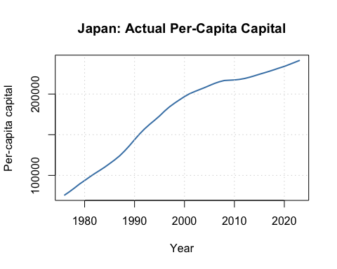
The upward trend suggests substantial long-run capital deepening.

Question 5
The initial capital stock in the data is
$$k_{0}^{Data}=75,847.6944.$$
With $A_{0}=1$, the model-predicted period-0 values are
$$y_{0}^{Model}=A_{0}(k_{0}^{Data})^{α}=114.7415,$$
$$s_{0}^{Model}=σy_{0}^{Model}=34.1584,$$
$$c_{0}^{Model}=(1−σ)y_{0}^{Model}=80.5830,$$
and
$$Δk_{0}^{Model}=σy_{0}^{Model}−(δ+n)k_{0}^{Data}=−2,965.2465.$$
Since $Δk_{0}^{Model}<0$, capital accumulation is negative under the normalization $A_{0}=1$. To ensure positive capital accumulation, we need
$$A_{0}>\frac{(δ+n)k_{0}^{Data}}{σ(k_{0}^{Data})^{α}}=87.8086.$$
Therefore, the minimum integer that makes $Δk_{0}^{Model}>0$ is
$$A_{0}=88.$$
Using this adjusted value, the revised period-0 model predictions are
$$y_{0}^{Model}=10,097.2504, s_{0}^{Model}=3,005.9433, c_{0}^{Model}=7,091.3071, Δk_{0}^{Model}=6.5383.$$
I use this minimum integer, $A_0 = 88, for the recursive model calculations below.

Question 6
The steady-state condition is
$$σf(k^{*})=(n+δ)k^{*}.$$
Using the per-capita production function from Question 2, $f(k)=Ak^{α}$, we get
$$σA(k^{*})^{α}=(n+δ)k^{*}.$$
Solving for $k^{*}$:
$$k^{*}={\left(\frac{σA}{n+δ}\right)}^{\frac{1}{1−α}}.$$
Using the adjusted technology level from Question 5, $A = 88, the theoretical steady-state capital stock per capita is
$$k^{*}={\left(\frac{0.297699×88}{0.039545}\right)}^{\frac{1}{1−0.422079}}≈76,134.0139.$$
For reference, if one keeps the pure normalization $A=1$, then
$$k^{*}≈32.8824.$$

Question 7
The Golden Rule capital stock satisfies
$$f^{′}(k_{GR})=n+δ.$$
Since
$$f(k)=Ak^{α},$$
we have
$$f^{′}(k)=αAk^{α−1}.$$
Therefore,
$$αAk_{GR}^{α−1}=n+δ ⇒ k_{GR}={\left(\frac{αA}{n+δ}\right)}^{\frac{1}{1−α}}.$$
Using $A = 88,
$$k_{GR}≈139,291.8828.$$
Because
$$k^{*}≈76,134.0139<k_{GR}≈139,291.8828.$$
Japan is below the Golden Rule in this calibration. Economically, that means the model-implied steady state has less capital than the level that would maximize steady-state consumption per capita.

Question 8
Starting from $k_{0}^{Data}$ and using $Δk_{0}^{Model}$ from Question 5, the recursive law of motion is
$$k_{t+1}^{Model}=k_{t}^{Model}+Δk_{t}^{Model},$$
where
$$Δk_{t}^{Model}=σA_{0}(k_{t}^{Model})^{α}−(δ+n)k_{t}^{Model}.$$
For each year, I then compute
$$y_{t}^{Model}=A_{0}(k_{t}^{Model})^{α}, s_{t}^{Model}=σy_{t}^{Model}, c_{t}^{Model}=(1−σ)y_{t}^{Model}.$$
Using $A_0 = 88, the first few and last few predicted observations are:
 | Year | k_model | y_model | s_model | c_model | delta_k_model
1 | 1976 | 75847.69 | 10097.25 | 3005.94 | 7091.31 | 6.54
2 | 1977 | 75854.23 | 10097.62 | 3006.05 | 7091.57 | 6.39
3 | 1978 | 75860.62 | 10097.98 | 3006.16 | 7091.82 | 6.24
46 | 2021 | 76032.80 | 10107.64 | 3009.04 | 7098.61 | 2.31
47 | 2022 | 76035.11 | 10107.77 | 3009.08 | 7098.70 | 2.26
48 | 2023 | 76037.37 | 10107.90 | 3009.11 | 7098.79 | 2.21
Under constant technology, the model predicts only a very small increase in capital per capita, from 75,848 to 76,037.

Question 9
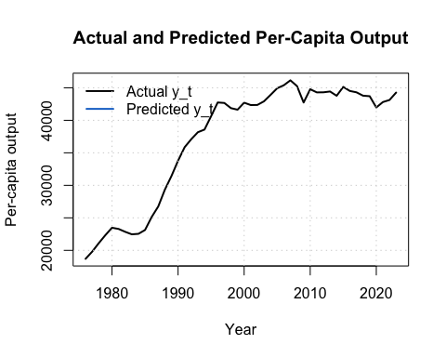
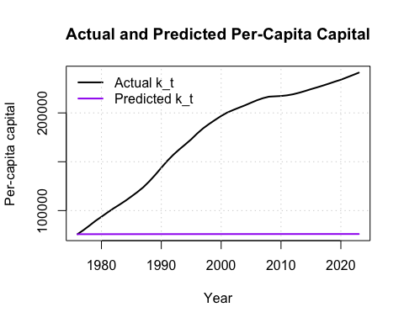
The constant-technology Solow model does not explain Japan’s growth path very well. The model produces only a slight increase in both output per capita and capital per capita, while the actual data show a much stronger upward trend. Quantitatively, the root mean squared error is 28,444 for output and 112,383 for capital.
A likely reason is that Japan’s growth over this period cannot be captured by capital accumulation alone. Postwar catch-up, technological upgrading, industrial restructuring, and improvements in efficiency all mattered. A Solow model with constant technology leaves those forces out, so it underpredicts the rise in living standards.

Question 10
The prompt now allows technology to grow at 2% per year. Because “2% per year” implies a constant gross growth factor of $1.02$, I use
$$A_{t}=A_{0}(1.02)^{t},$$
which is equivalent to
$$A_{t+1}=1.02A_{t}.$$
Using $A_0 = 88, the technology path starts at 88.00 in 1976 and reaches 223.20 in 2023.
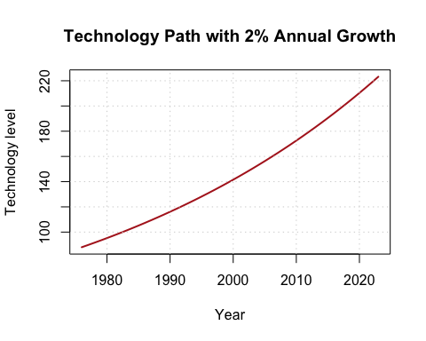

Question 11
With technological progress, the law of motion becomes
$$Δk_{t}^{Model}=σA_{t}(k_{t}^{Model})^{α}−(δ+n)k_{t}^{Model},$$
$$k_{t+1}^{Model}=k_{t}^{Model}+Δk_{t}^{Model}.$$
The first few and last few observations from the technology-augmented simulation are:
 | Year | A_t | k_model | y_model | s_model | c_model | delta_k_model
1 | 1976 | 88.00 | 75847.69 | 10097.25 | 3005.94 | 7091.31 | 6.54
2 | 1977 | 89.76 | 75854.23 | 10299.57 | 3066.17 | 7233.40 | 66.51
3 | 1978 | 91.56 | 75920.74 | 10509.45 | 3128.65 | 7380.79 | 126.36
46 | 2021 | 214.53 | 147017.67 | 32548.26 | 9689.59 | 22858.67 | 3875.76
47 | 2022 | 218.82 | 150893.43 | 33565.86 | 9992.53 | 23573.33 | 4025.43
48 | 2023 | 223.20 | 154918.86 | 34619.75 | 10306.27 | 24313.48 | 4179.99
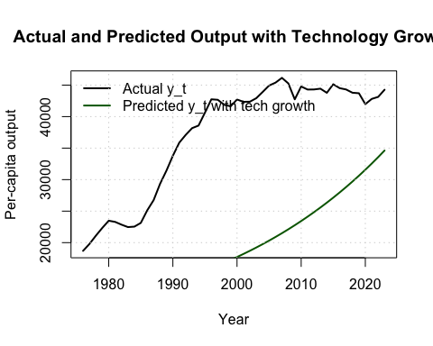
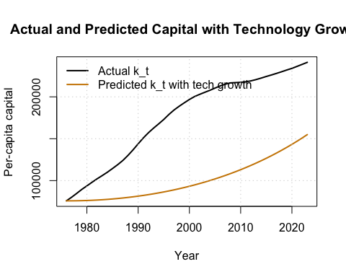
Technological progress improves the fit of the Solow model. The RMSE for output falls from 28,444 to 18,849, and the RMSE for capital falls from 112,383 to 82,749. The model still does not match Japan perfectly, but it performs better once productivity growth is allowed.
This is economically sensible. In a mature economy like Japan, higher productivity can come from innovation, organizational efficiency, digitalization, and better use of human and physical capital. Those channels raise output per capita beyond what pure capital accumulation can generate.

Question 12
The policy lesson from the full exercise is that long-run growth in Japan depends on both capital accumulation and productivity growth, but the latter appears especially important.
First, because the economy is below the Golden Rule in this calibration, policies that raise productive investment can improve long-run outcomes. This could include public infrastructure with high social returns, incentives for private capital formation, and measures that improve the allocation of capital across firms.
Second, the technology-augmented Solow model fits the data better than the constant-technology model. That strongly suggests that productivity policy matters. Japan should continue to support research and development, advanced manufacturing, AI and robotics adoption, university-industry collaboration, and diffusion of new technology to smaller firms.
Third, Japan’s low population growth means labor constraints are a central issue. Policies that raise labor-force participation, improve worker training, encourage lifelong skill formation, and make better use of an aging population would help sustain per-capita GDP growth.
Finally, macroeconomic stability and strong institutions remain important because they support saving, investment, innovation, and confidence. A growth strategy centered only on higher saving would be incomplete; the stronger recommendation is to combine investment with sustained productivity improvement.

