AI RECONSTRUCTION REPORT

1. Executive Technical Summary
Core Scientific Contribution: Not Specified
Technical Dimension | Extracted Detail
Architecture | Not Specified
Datasets | Math-500, AIME24, AMC23, HumanEval, HellaSwag, WinoGrande, MMLU, ARC, GSM8K
Key Metrics | Accuracy: Not Specified

2. Reconstructed Abstract
**Combined Executive Abstract**
This comprehensive analysis encompasses a multifaceted examination of large language models (LLMs), delving into their robustness, style, and adaptability across various domains and tasks. The investigation commences with an assessment of the stylistic capabilities of several LLMs, including OLMo-1B, LLaMA1-7B, Amber-13B, StarCoder-15.5B, and LLaMA1-65B, evaluating their performance in instructional, expository, conversational, coding, and mathematical contexts. The results indicate a wide range of proficiency levels among these models, with certain models excelling in specific areas, such as LLaMA1-65B demonstrating high scores in instructional and expository tasks.
Furthermore, the analysis explores the concept of "Data Mixture Surgery," which involves estimating the latent effective prior of a trained LLM's domain mixture. This is crucial for understanding how the model's internal usage of domains may diverge from the training proportions. The study formulates this problem mathematically, defining the conditional distribution of text within specific domains and the mixture distribution of the training corpus. The objective is to estimate the vector π, representing the model's actual domain mixture, given a set of generated samples.
In addition, the research investigates the effectiveness of various fine-tuning strategies, including full fine-tuning, online fine-tuning (OFT), and LoRA (Low-Rank Adaptation) fine-tuning, in adapting LLMs to specific tasks and domains. The results of these experiments are presented in a case study, which demonstrates the potential of layer-wise generator scaling to recover general ability while preserving target-specific gains.
The findings of this comprehensive analysis have significant implications for the development and deployment of LLMs in real-world applications. By understanding the strengths and limitations of these models, as well as the factors that influence their performance, researchers and practitioners can design more effective training and fine-tuning strategies, ultimately leading to improved language understanding and generation capabilities.

3. Core Mathematical Calculations
- dproc = minR⊤R=I ∥X1R − X0∥F
- CKA(X0, X1) = ∥X⊤0 X1∥2F / (∥X⊤0 X0∥F ∥X⊤1 X1∥F + ϵ)
- dgram = ∥Z1Z⊤1 − Z0Z⊤0 ∥F

4. Extracted Graphs & Visuals

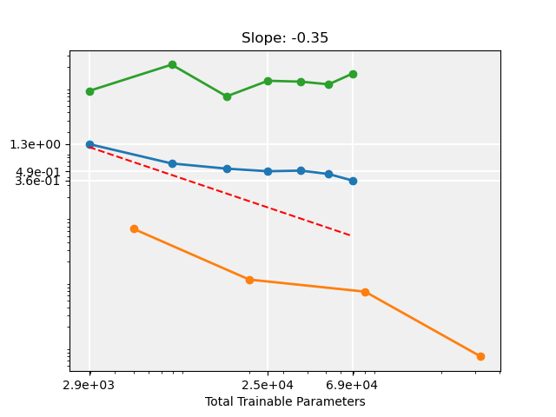
Source file: graph_page8_3.png

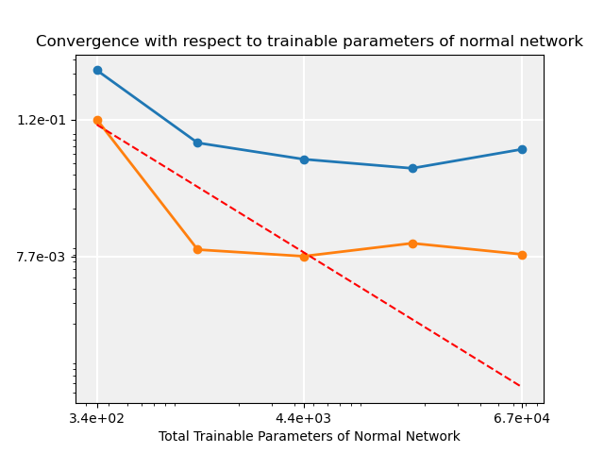
Source file: graph_page16_2.png

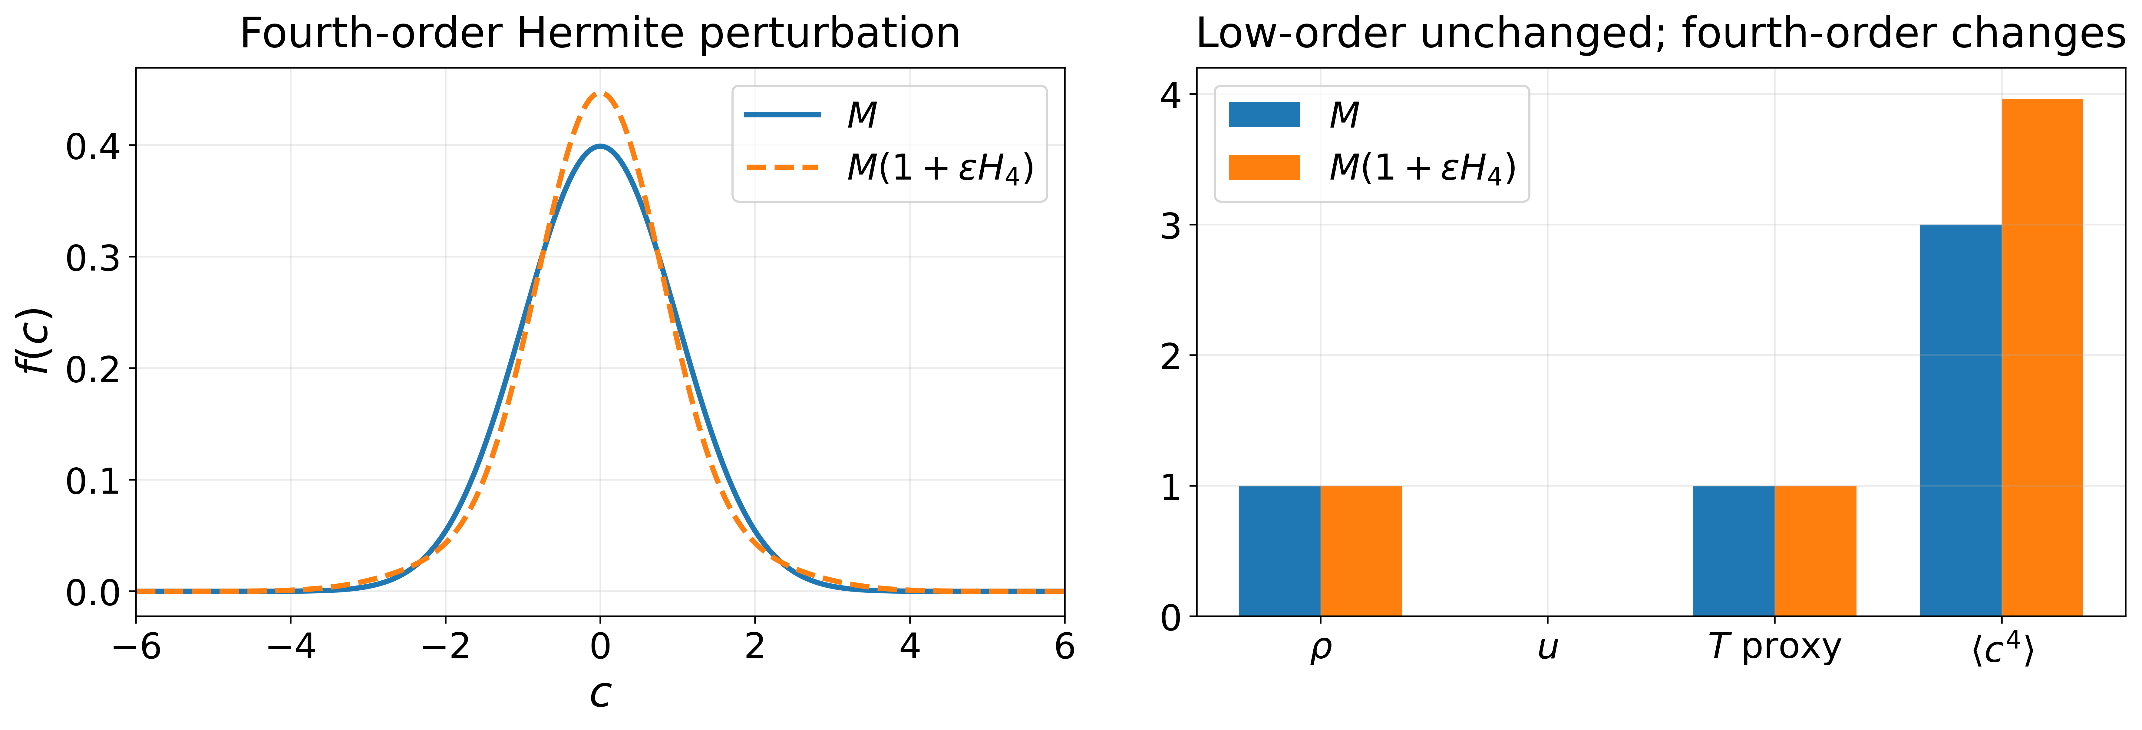
Source file: graph_page9_0.png

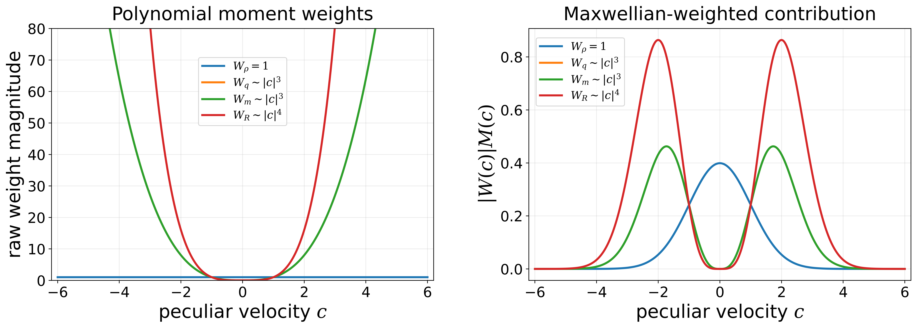
Source file: graph_page10_0.png

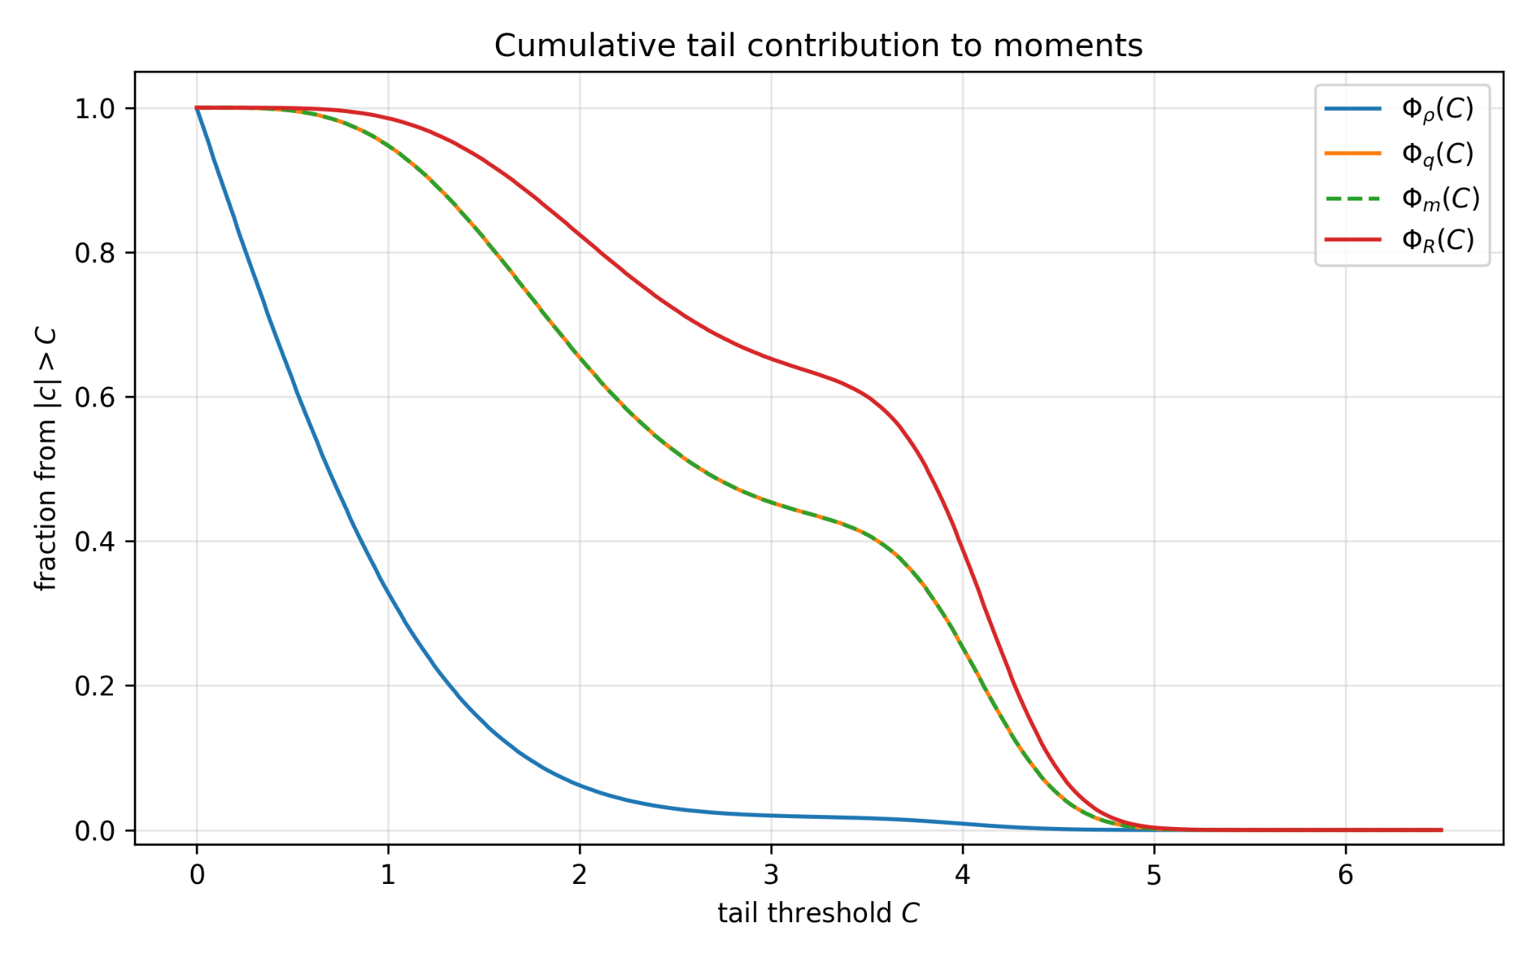
Source file: graph_page11_0.png

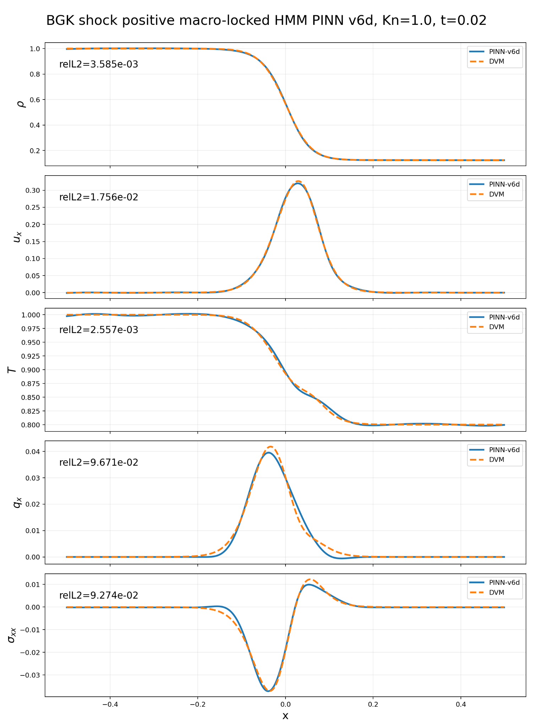
Source file: graph_page13_0.png

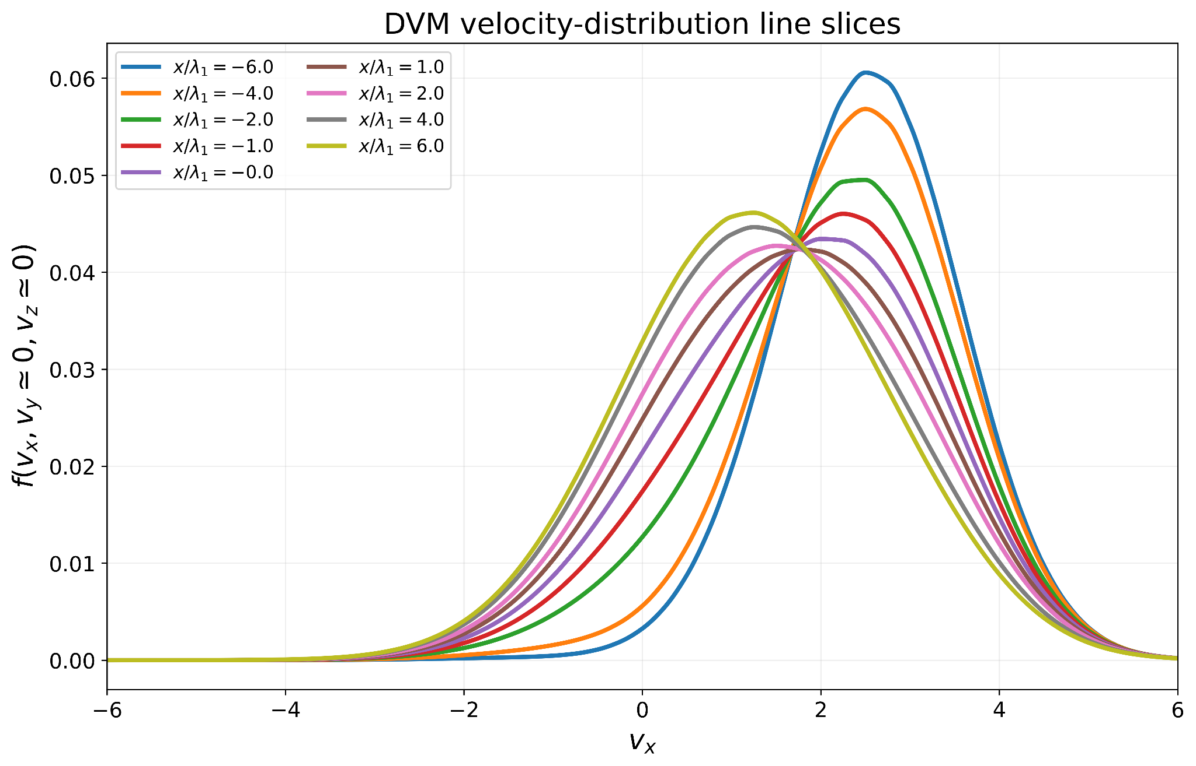
Source file: graph_page16_0.png

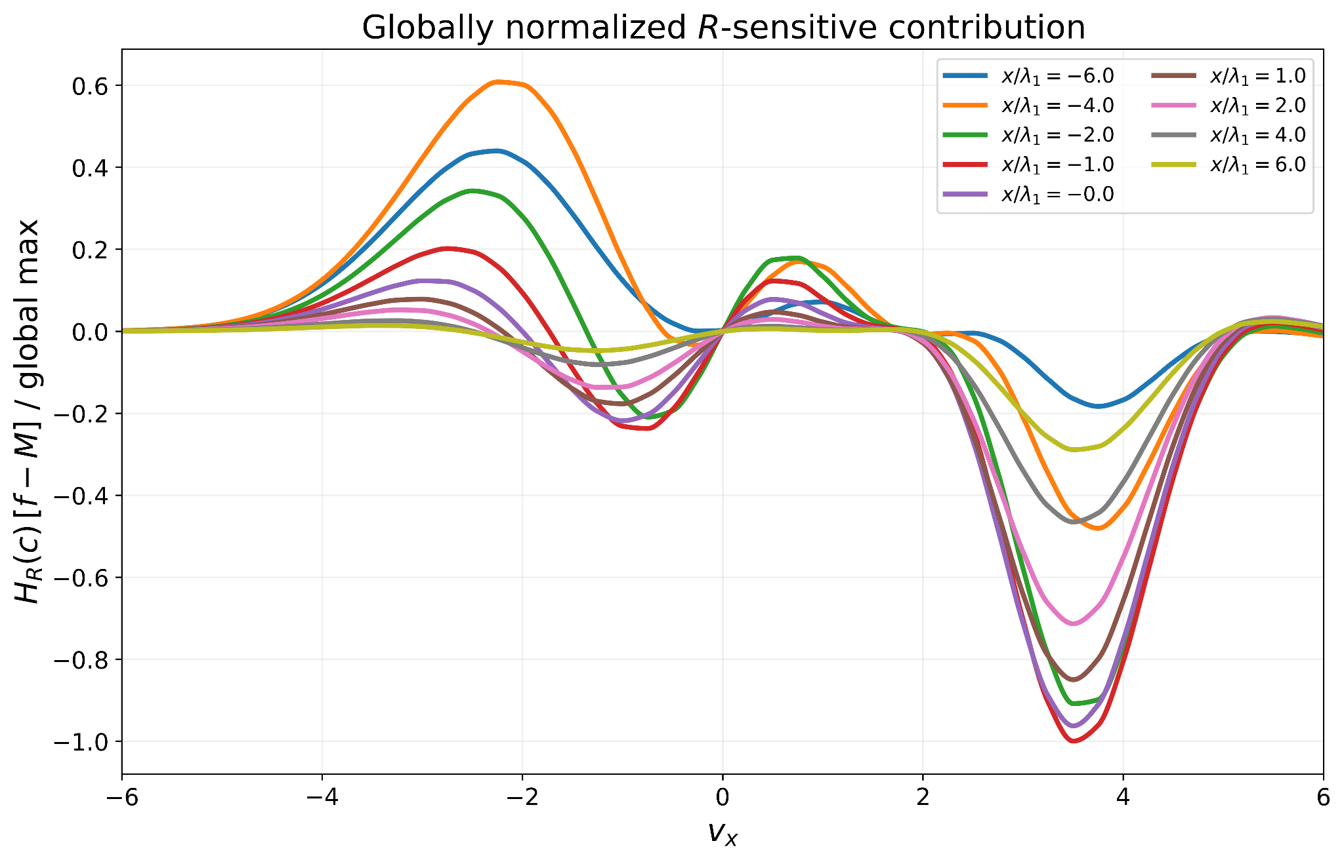
Source file: graph_page16_1.png

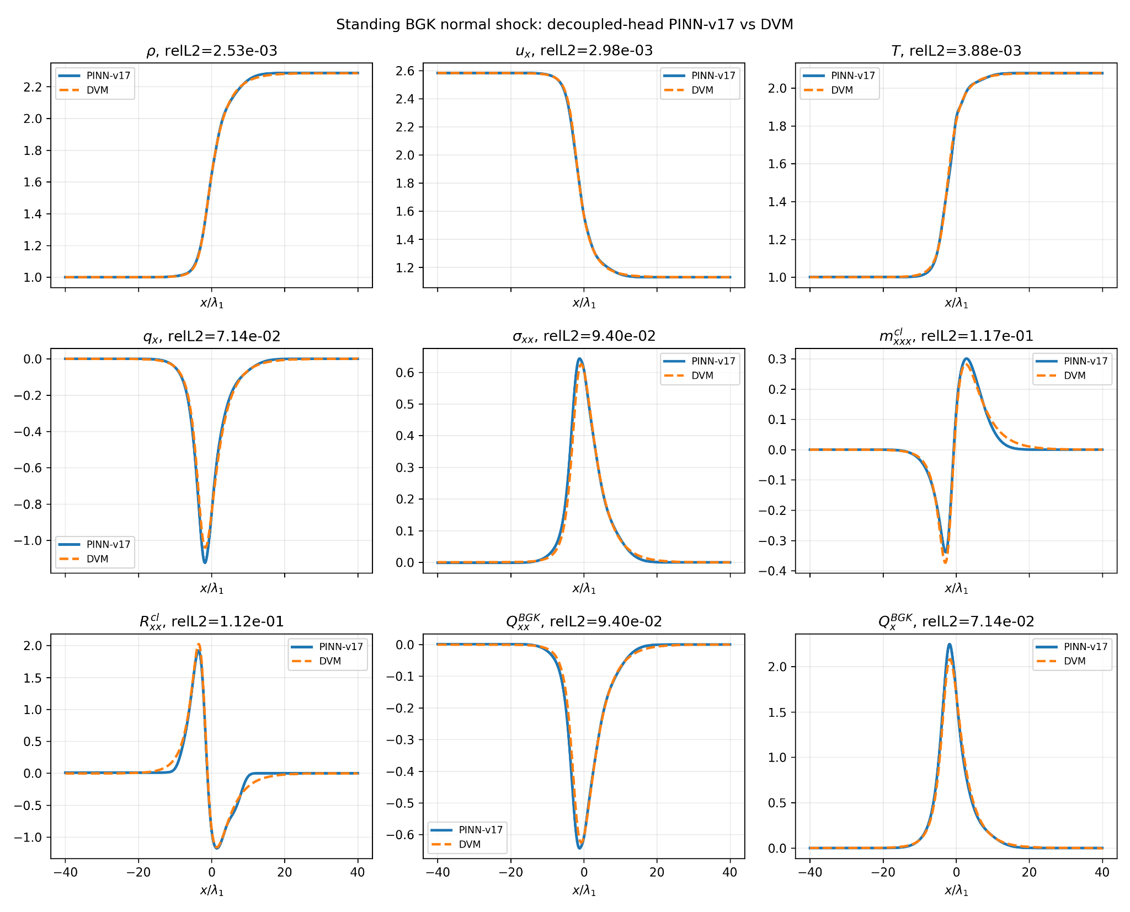
Source file: graph_page17_0.png

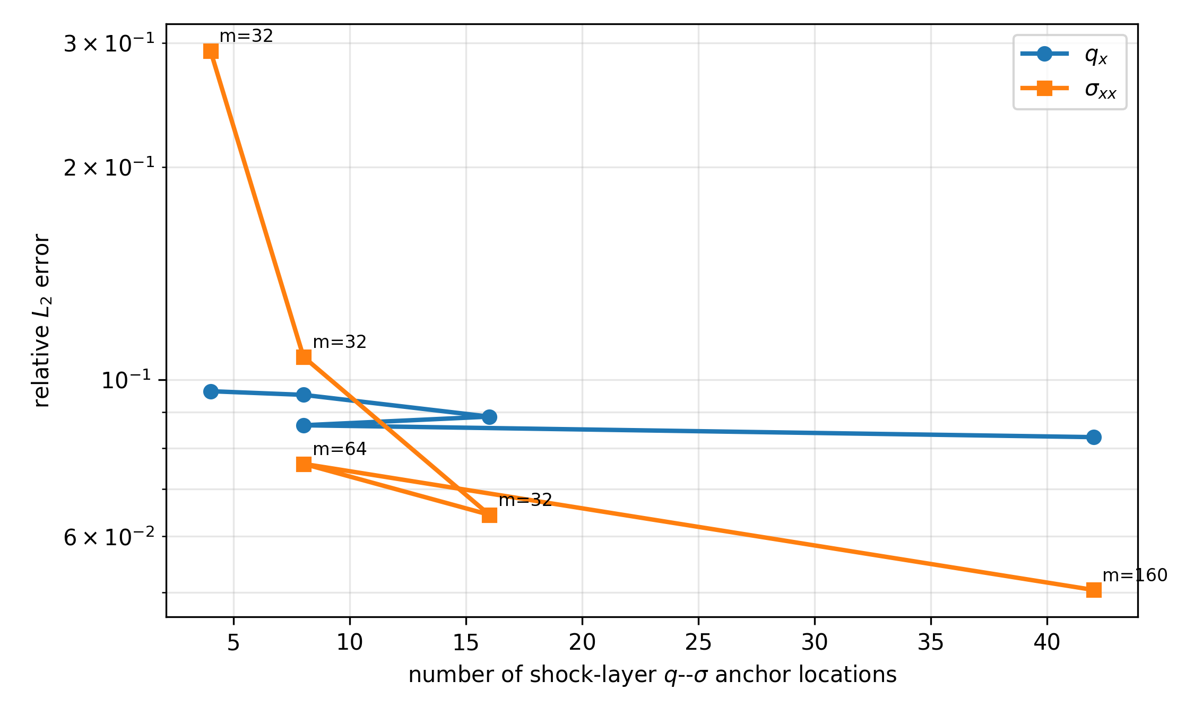
Source file: graph_page21_0.png

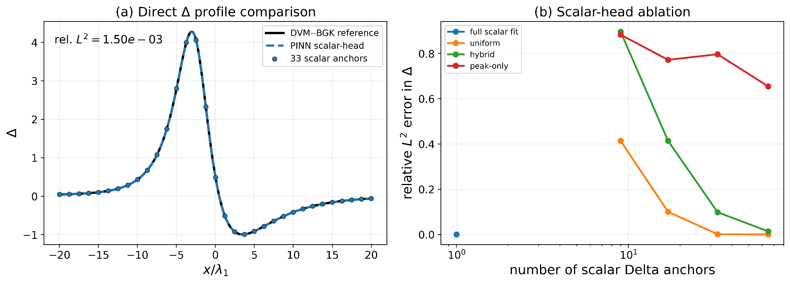
Source file: graph_page28_0.png

5. Final Holistic Summary
The paper presents a comprehensive evaluation of various PEFT methods, including LoRA, OFT, MiLoRA, and PiSSA, on a range of tasks and datasets. The results show that OFT outperforms other methods in terms of general-capability retention and activation-geometry preservation. The paper also provides insights into the weight-space and activation-space geometry of the models, highlighting the importance of these internal perspectives in understanding the retention behavior of PEFT methods.

