AI RECONSTRUCTION REPORT

1. Executive Technical Summary
Core Scientific Contribution: Not Specified
Technical Dimension | Extracted Detail
Architecture | Not Specified
Datasets | HumanEval, HellaSwag, WinoGrande, MMLU, ARC, GSM8K, Math-500, AIME24, AMC23, IFEval, NQ, BBH
Key Metrics | Forgetting: 17.31  Proc. / Gram / CKA: Not Specified

2. Reconstructed Abstract
**Abstract**
This paper presents a comparative study of parameter-efficient fine-tuning (PEFT) methods for large language models, with a focus on their ability to retain general capabilities while adapting to specific tasks. We investigate the performance of various PEFT methods, including Full Fine-Tuning (Full FT), Online Fine-Tuning (OFT), LoRA, and PiSSA, on math and medical tasks. Our results show that OFT exhibits a unique advantage in preserving general capabilities, while also achieving competitive performance on target tasks. We provide insights into the underlying mechanisms of PEFT methods through weight-space and activation-space analyses, revealing that OFT's advantage is reflected in its ability to maintain the geometric stability of representations. Our findings have implications for the development of efficient and effective fine-tuning methods for large language models, and highlight the importance of considering both target-task performance and general-capability retention in PEFT evaluation.

3. Core Mathematical Calculations
- CSDrel(D) = Eh∼D ‖∆Wh‖2 2 ‖W0h‖2 2 + ϵ
- CKA(X0, X1) = ‖X⊤ 0 X1‖2 F ‖X⊤ 0 X0‖F ‖X⊤ 1 X1‖F + ϵ
- dproc = minR⊤R=I ‖X1R − X0‖F

4. Extracted Graphs & Visuals
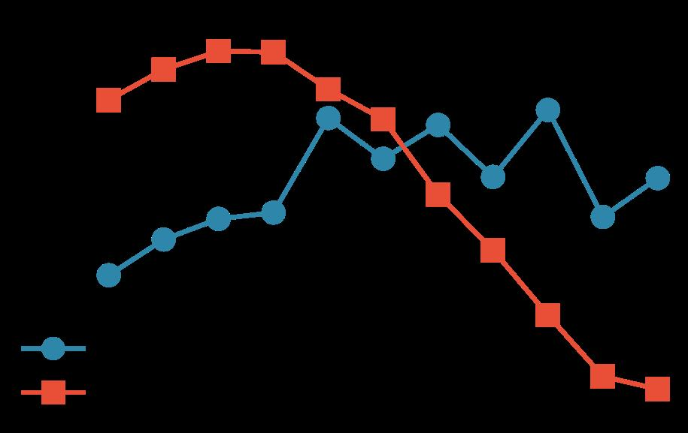
Source file: graph_page2_0.jpeg

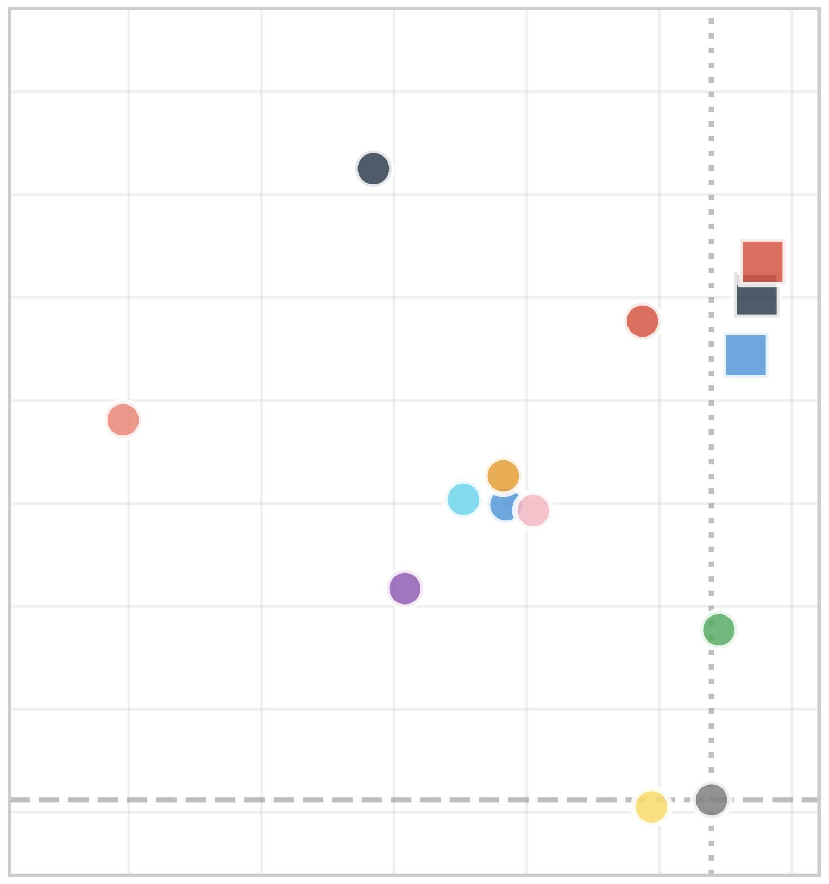
Source file: graph_page2_1.jpeg

5. Final Holistic Summary
The paper presents the results of various experiments on different benchmarks, including HumanEval, HellaSwag, WinoGrande, MMLU, ARC, and GSM8K. The authors also provide detailed information about the evaluation protocol, including the metrics used and the experimental setup. The results show that the models perform well on the benchmarks, with some methods outperforming others. The paper also discusses the importance of preserving activation geometry and provides metrics for measuring this. Overall, the paper provides a comprehensive analysis of the performance of different models on various benchmarks and highlights the importance of considering activation geometry in the evaluation of model performance.

