AI RECONSTRUCTION REPORT

1. Executive Technical Summary
Core Scientific Contribution: Not Specified
Technical Dimension | Extracted Detail
Architecture | Not Specified
Datasets | Pile dataset, HumanEval, HellaSwag, WinoGrande, MMLU, ARC, GSM8K
Key Metrics | Accuracy: Not Specified

2. Reconstructed Abstract
Abstract:
This paper presents a comprehensive analysis of the robustness of large language models (LLMs) in generating text across various domains and styles. Our experiments evaluate the performance of several state-of-the-art LLMs, including OLMo-1B, LLaMA1-7B, Amber-13B, StarCoder-15.5B, and LLaMA1-65B, on a range of tasks, such as instructional, expository, conversational, coding, and math text generation. We also investigate the importance of inverse correction and dataset category merging on the models' performance. Furthermore, we introduce the concept of Data Mixture Surgery, which aims to estimate the latent effective prior of domain mixture encoded by a model's behavior. Our results provide insights into the strengths and weaknesses of current LLMs and highlight the need for further research in improving their robustness and adaptability across different domains and tasks.

3. Core Mathematical Calculations
- CSDrel(D) = Eh∼D ‖∆Wh‖2 2 ‖W0h‖2 2 + ϵ
- CSDun(D) = Eh∼D ‖∆Wh‖2 2 ‖W0h‖2 2 + ϵ

4. Extracted Graphs & Visuals

Source file: graph_page1_0.png

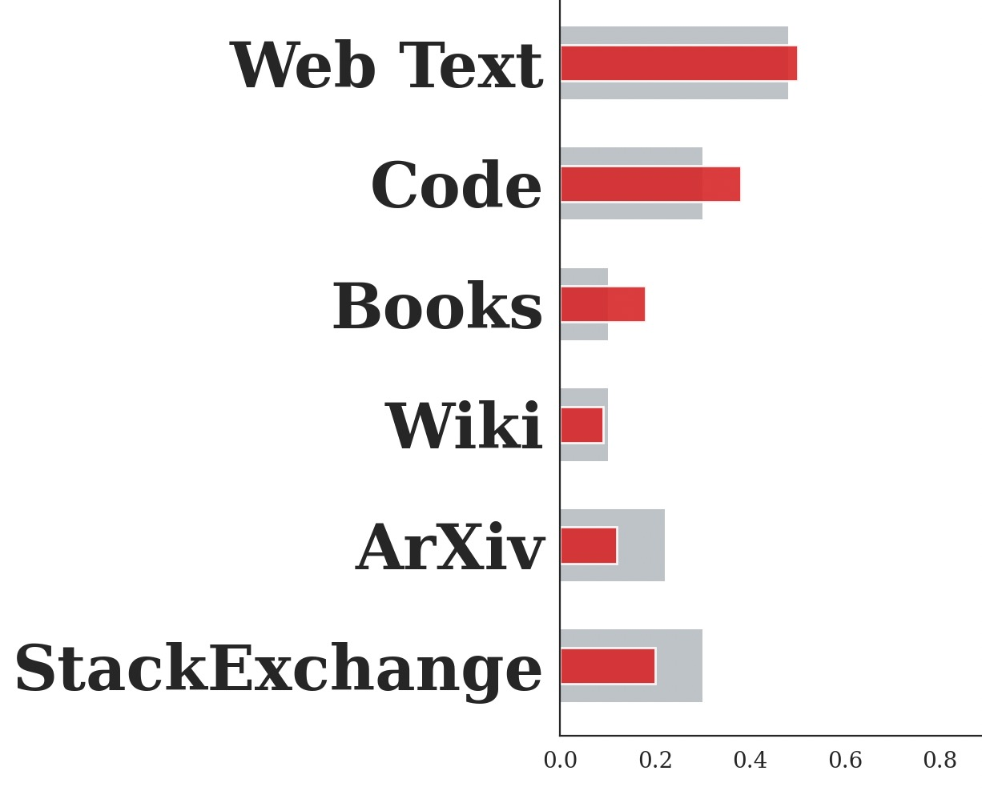
Source file: graph_page1_3.jpeg


Source file: graph_page1_4.png

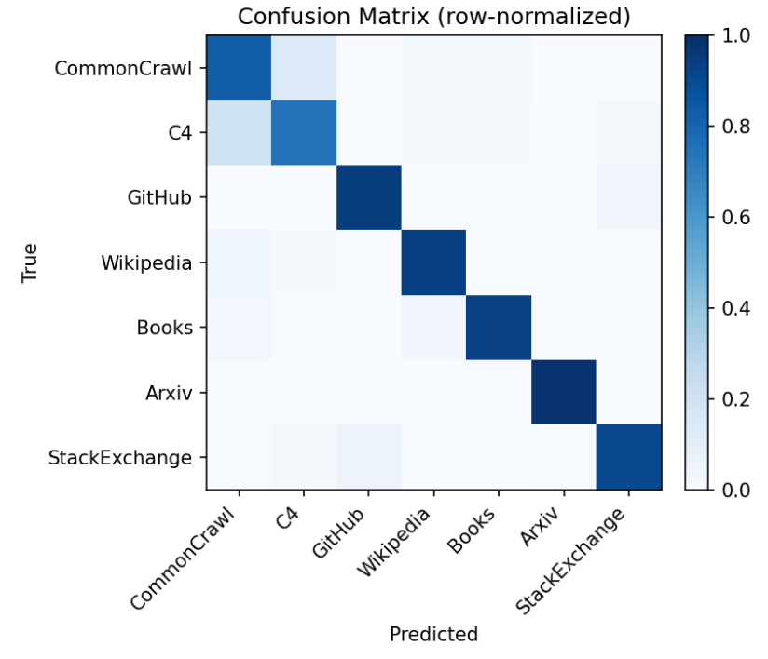
Source file: graph_page2_22.png

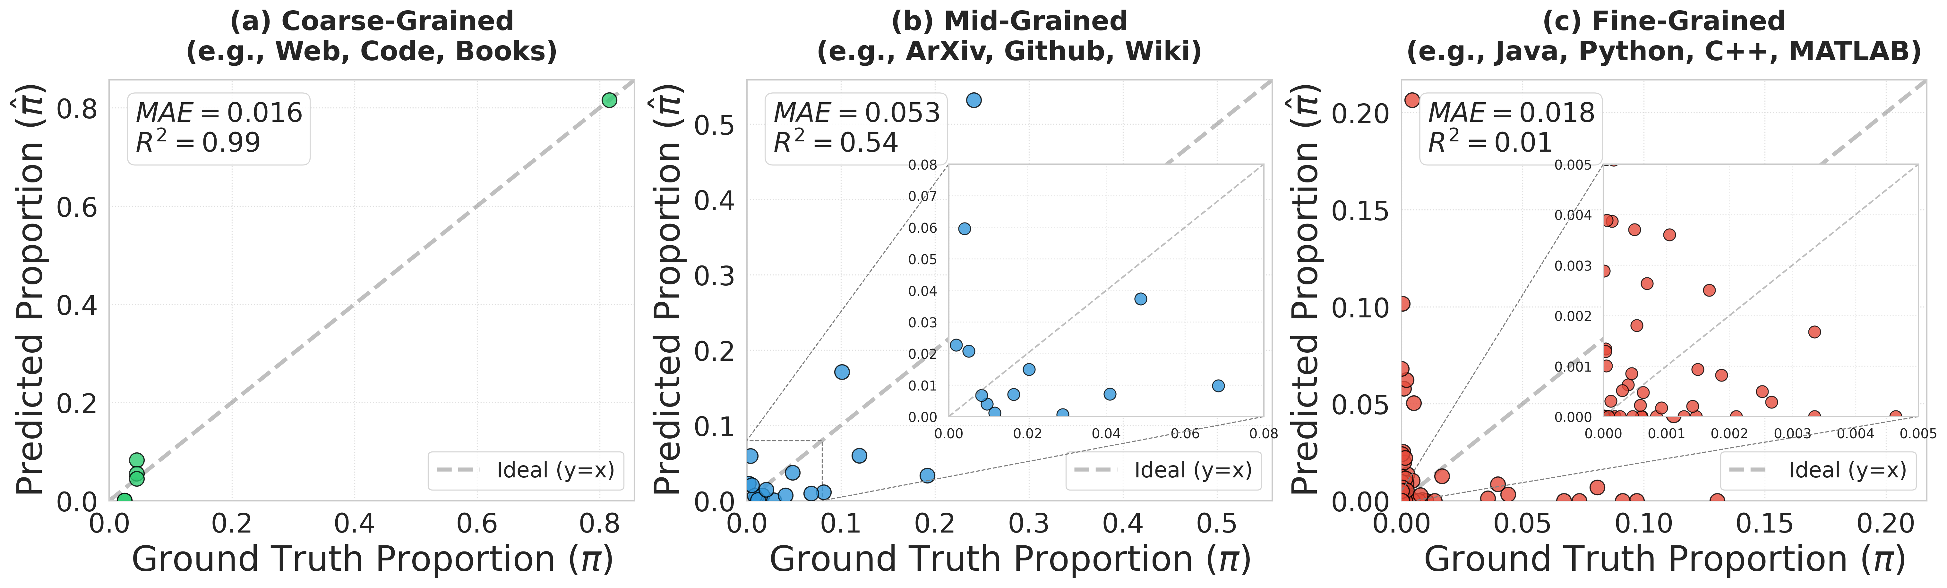
Source file: graph_page7_0.png

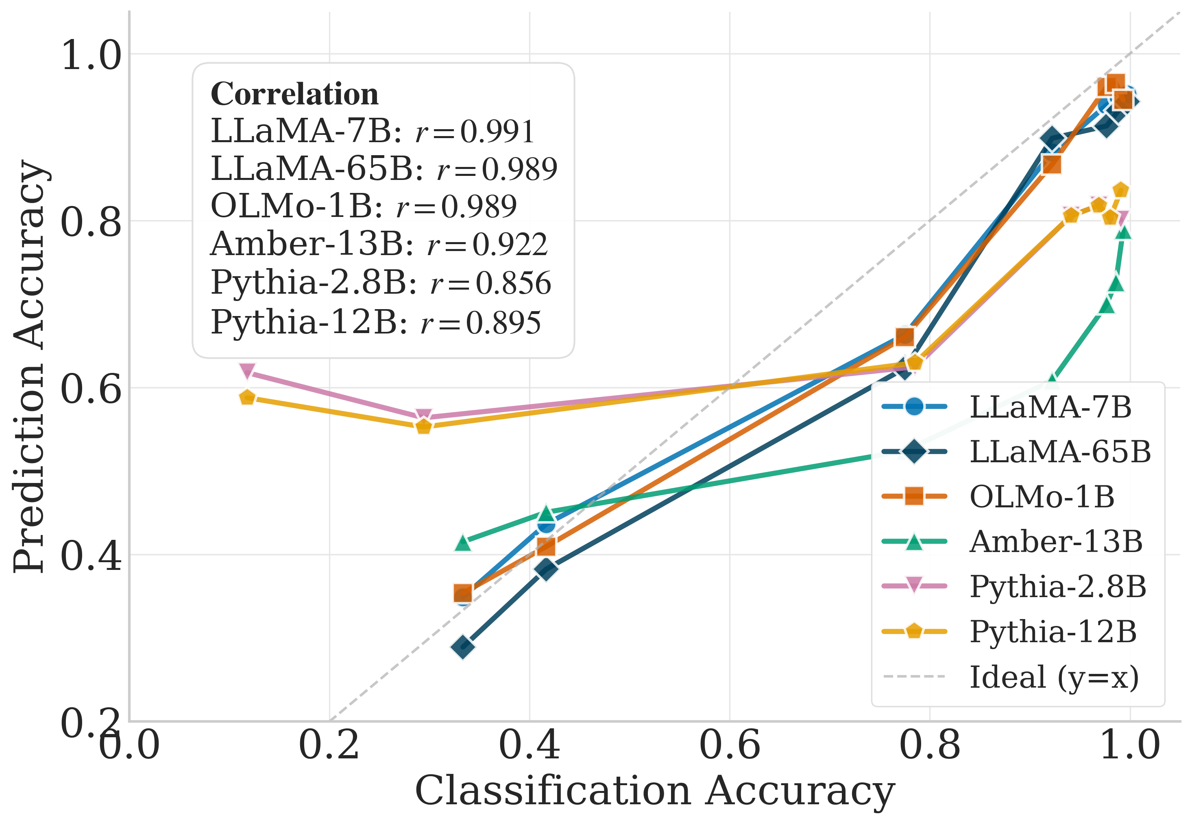
Source file: graph_page8_0.png

5. Final Holistic Summary
The paper presents a comprehensive analysis of detection errors across various data source categories, including coarse-grained, mid-grained, and fine-grained evaluations. The results indicate larger detection errors for certain broad data sources, such as Common Crawl, while smaller errors are observed for categories such as HackerNews. The paper also evaluates the performance of various models on expanded general-capability benchmarks, including HumanEval, HellaSwag, WinoGrande, MMLU, ARC, and GSM8K. The findings provide insights into the detection behavior of the models across different data sources and categories.

