# AWS TUTORIAL

1. AWS Certified Cloud Practitioner is the entry level AWS Certification Teaching
2. AWS Certification is valid for 3 years.
3. Exam is to check if you understand the Cloud.
4. 50 scored and 15 unscored--Meaning?
5. From 15 to 30 talks about the exam stuff to expect.

**NOTES**

1. Validators check if the resources are deployed right in the AWS Cloud.
2. Cloud computing is the use of a network of remote servers hosted on the internet to store,manage and process data rather than using a local server or a PC.
3. On-Premise provides own the server whereas Cloud Providers own the cloud.
4. Before,you need a dedicated machine to host a server or a business.Later came,shared hosting which involved one physical machine shared by 100s of businesses.
5. Cloud Hosting later came,hence distributed computing where there’s multiple physical machines that act on one system call the cloud service.Hence virtual machines came about.
6. Amazon was fiunded in 1994 by Jeff Bezos.Amazon’s cloud service provider (CSP) is therefore Amazon Web Services.
7. AWS was launched in 2006 and is the leading cloud service provider in the world.
8. AWS is made up of Simple Queue Service,Simple Storage Service(s3) and Elastic Compute Cloud(EC2).
9. CSP is a company that provides multiple cloud services.CSP have InfrastructureAs A Service(IaaS) offerings.
10. Note that Twilo,Databricks and HashiCorp are cloud platforms and not cloud service providers.

11.

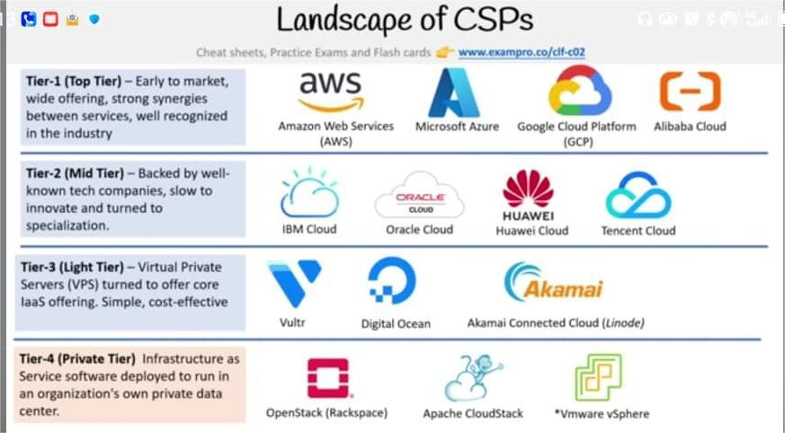

1. Most Common Type of Cloud Services are:

-Compute(having a virtual computer that can run an application,programs and code).Eg is EC2 Virtual Machines

-Storage(a virtual hard drive that can store files).Eg is EBS Virtual Hard Drives

-Networking(a virtual network that defines internet connections) .Eg is VPC which is Private Cloud Network

-Databases(a virtual database for storing all report-related data).Eg is RDS that is SQL Databases.

1. Virtual machine is a machine on top of a machine.The hypervisor is the software later that allows to run the virtual machine.These are easy to scale.
2. Deployment Models include Cloud usually for startups,Hybrid usually for banks and FinTech and On-Premise usually Public Sector like Government and Hospitals and Insurance Companies.
3. IAM is Identity Access Management and it uses an Account ID to log in.
4. Cloud is the latest innovation wave and it is a burning platform in that there is an abandonment of an old technology for a new technology with no hope of success though.
5. Computing Power dealts with throughput for a compuational task.
6. GPU is 50 times faster than traditional CPUs.Latest is the Qunatum Computing which is still being explored.QPU that is Quantum Processing Units
7. Amazon Bracket allows to perform quantum computing tasks on AWS.
8. Advantages of Cloud

- Pay Only What You Consume

- Scalability to meet need

- Going Global In Minutes

- Secure By Default

- Reliable

1. AWS Global Infrastructure is a globally distributed hardware and datacenters that are physically networked together to act as one large resource for end customers.
2. Regions are the distinct locations that have the availabilty zones for the AWS Cloud Infrastructure.Cost of AWS services vary per region.The selected region is in the AWS Management Console.
3. Global Services Include Amazon S3,CloudFront,RouteS3 and IAM.
4. Availability Zones are physical locations that are made up of multiple data centers.

- A datacenter is a secured building that contains thousands of computers.

1. Generally,most regions have 3 availability zones.
2. Availability Zones are denoted by a Region Code followed by a letter identifier.Eg us-east-1a.You chose a subnet when choosing an availaibity zone.

Eg Say in Canada Central,the AZ’s may be ca-central-1a,ca-central-1b and ca-central-1d.These are interconnected.There are 100km away from each other.All traffic between AZs is encrypted.

1. For Global Sevices,availability zones are not selected.
2. Fault Domain is a section of a network that is vulnerable to damage if a critical device or system fails.Purpose of this is to ensure that damages are limited to one domain instead of an entire system.Fault Level is a collection of fault domains.Eg is an entire room in a datacenter.CSP defines the fault domains.
3. AWS Global network is the interconnection between AWS Global Infrastruture.
4. Point Of Presence(PoP) is an intermediate location betweeen an AWS region and an end-user which could be a data center or a collection of hardware.PoP resources include edge locations and regional edge caches.
5. Edge Locations are datacenters that hold cached data of the most popular files say images and videos so that delivery to an end user is reduced.
6. Regional Edge Locations are data centers that hold much more cached data thus reducing the full round trip to reduce the transfer fees.
7. Amazon CloudFront is a Content Delivery Network(CDN) that routes requests to the nearest edge location caches.
8. AWS Direct Connect is a dedicated or private connection between your data center ,office,co-location and AWS.
9. Co-location/Carrier-Hotel is a data center where equipemt,space,bandwidth are all available for rental to retail customers.
10. Direct Connection Location is a trusted datacenter that you can establis a dedicated high speed and low-latency connection from your on-premise to AWS.
11. Local Zones are data centers that are close to densely populated areas that provide single-digit millisecond of low latency performance for that area.These were setup for higky demanding applications sensitive to latencies such as media and entertainment and Electronic Design Automation(EDA) as well as Machine Learning.
12. AWS Wavelength Zones allow for edge-computig on a 5G network.
13. AWS Ground Station is a fully managed service that allows one control satellite communication,process data and scale operations without worrying about building one’s won ground station infrastruture.

Ground Stations are used for weather forecasting,video broadcasts and communications.Eg is that a company reaches a satellite imagery provider to take satellite photos of a specific region.AWS Ground Station can be used to **communicate with the company’s satellite** and download the s3 image data.

1. A rack is a frame designed to hold and organzie IT equipment.AWS Outposts is a rack of these servers that run the AWS infrastructure on a physical location.
2. High availability is achieved by ensuring workloads are distributed acroos multiple availability zones.This is achieved by an elastic load balancer that allows to distribute traffic to multiple servers.
3. Scalabilty refers to the ability to increase capacity based on the demand of traffic,memory and computing power.

- Vertical Scaling is upgrading to a bigger server and Horizontal Scaling is adding more servers of the same size.

1. Elasticity deals with automatic scalability.In AWS,this is achieved by Auto Scaling Groups.
2. High Fault Tolerance is preventing the chances of failure in that there is fail-overs as in a plan to shift traffic to a redundant system in event the primary system fails.RDS Multi-AZ is a classic example in AWS that runs a duplicate standby database in another availabilty zone in event that the primary fails.
3. High durability is the recovery from a disaster that is dealing with the availabilty of a backup.In AWS,this is achieved by CloudEndure Disaster Recovery where AWS replicates a machine into a low cost staging area in your AWS account for recovery purposeds in event of a datacenter failure.
4. Recovery Time Objective is the maximum acceptable delay between an interruption of service and a restoration of service.
5. Recovery Point Objective is the maximum amount of time since that last data recovery.
6. ALB - Application Load Balancer and note that S3 is a storage bucket.
7. AWS has APIs that can be run in postman to test it out.
8. AWS Account ID is 12 digits.
9. PowerShell can be used to create S3 buckets and push those buckets to the AWS Console.
10. Amazon Resource Name(ARN) are unique identifiers for all AWS resources.

Eg arn:aws:::my-bucket.A use case is getting a colleague to look at that specific resource using an ARN.

1. Note that ec2,s3 and iam are all separate services.
2. Shell,Terminal,Console are all the same thing and egs are bash,Powershell and Zsh.
3. Software Development Kit is a collection of software tools in one package.
4. AWS SDK is available in a lot of languages and is most used to create,delete and interact with AWS resources.

GitPod is a **cloud-based development environment** that lets you write, run, and debug code directly from your browser — without installing anything on your computer.

Think of it like **VS Code or JetBrains running in the cloud**, connected to a full Linux workspace, where you can code from any device and start working instantly.

1. AWS CloudShell is a browser-based shell built into the AWS Management Console.
2. IaC is Infrastructure as Code which is a blueprint that allows to share,version or inventory a cloud infrastrure.Eg is AWS Cloud Formation that allows to wtite IaC as code which is either JSON or YAML files.
3. Access Key is a secret and key required to have access to AWS resources when interacting with the AWS API Outside the AWS Management Console.Typically,it is the AWS Credentials.Do’t commit these to an online platform.These are stored in the ~/.aws/credentials files
4. AWS Shared Responsibility Model is a cloud security framework that defines security obligations of the customer and that of the Cloud Service Provider.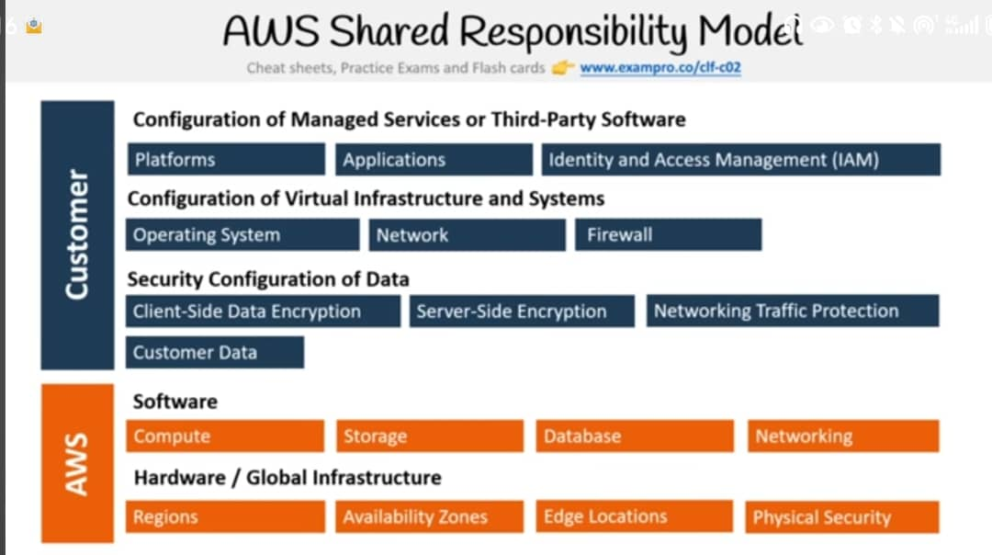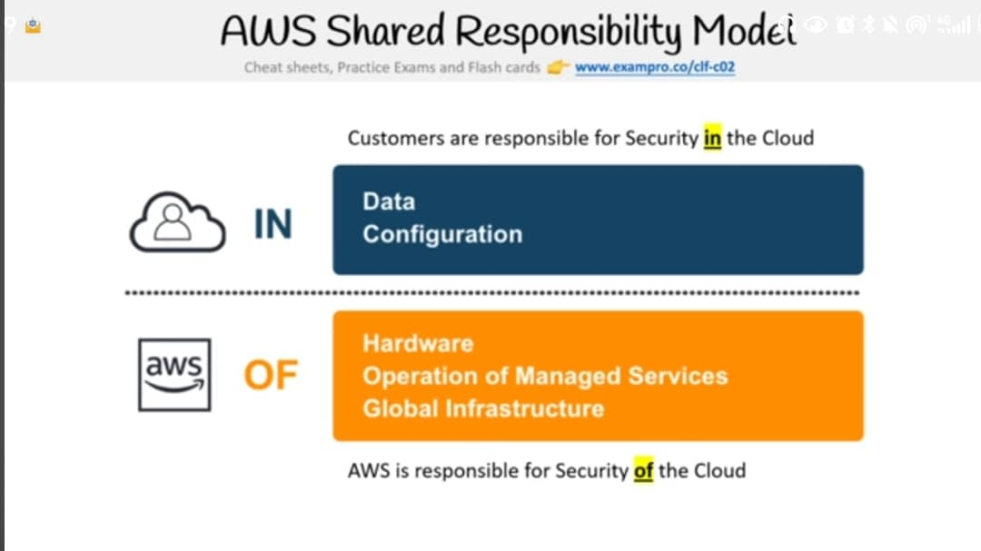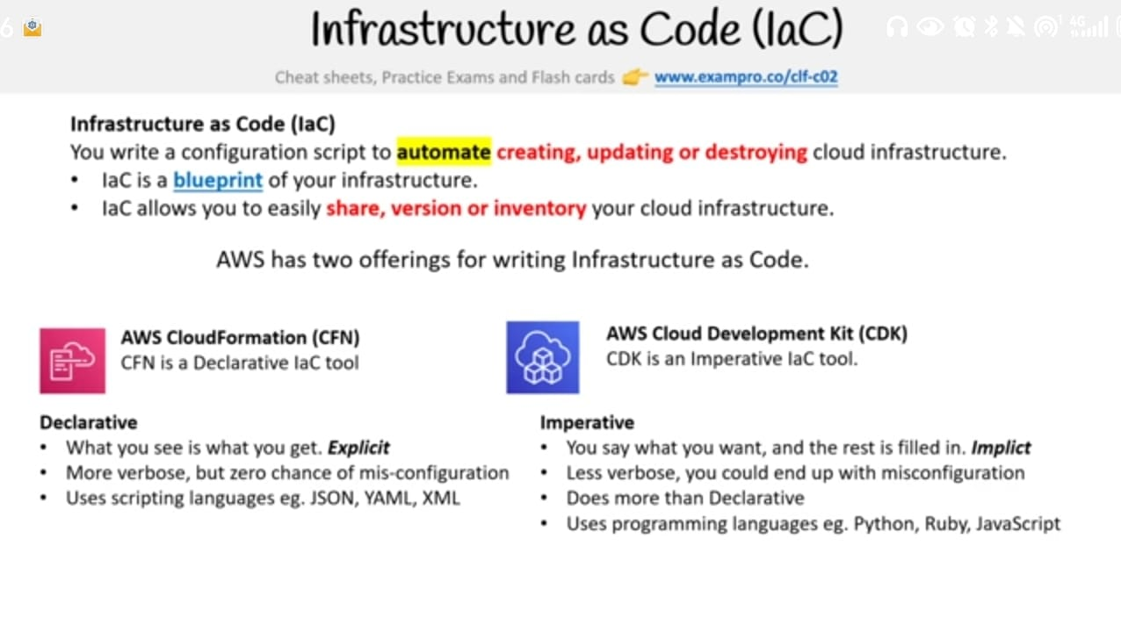

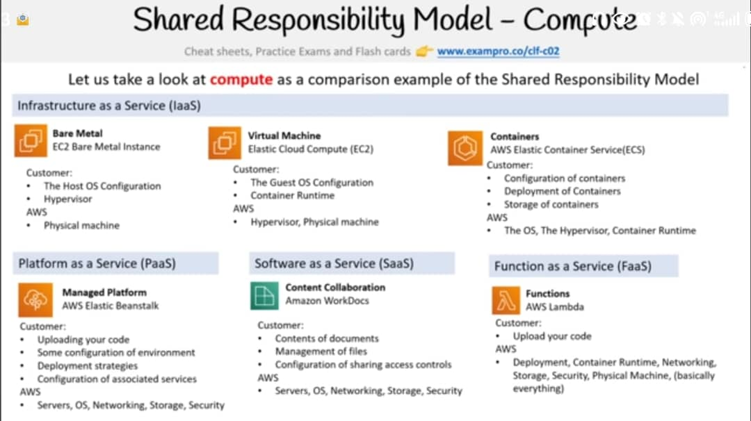

1. The In and Of Video Is Usually Asked In The Exam.Where In the cloud is the responsibility of the customer and Of the Cloud is the responsibility of the CSP.
2. Ms Word is SaaS.
3. Customer is responsible for data and configuration of access controls that resides in AWS.
4. Computing Services

- Elastic Compute Cloud(EC2) allows one to launch Virtual Machines.A virtual machine is an emultion of a physical computer using software.

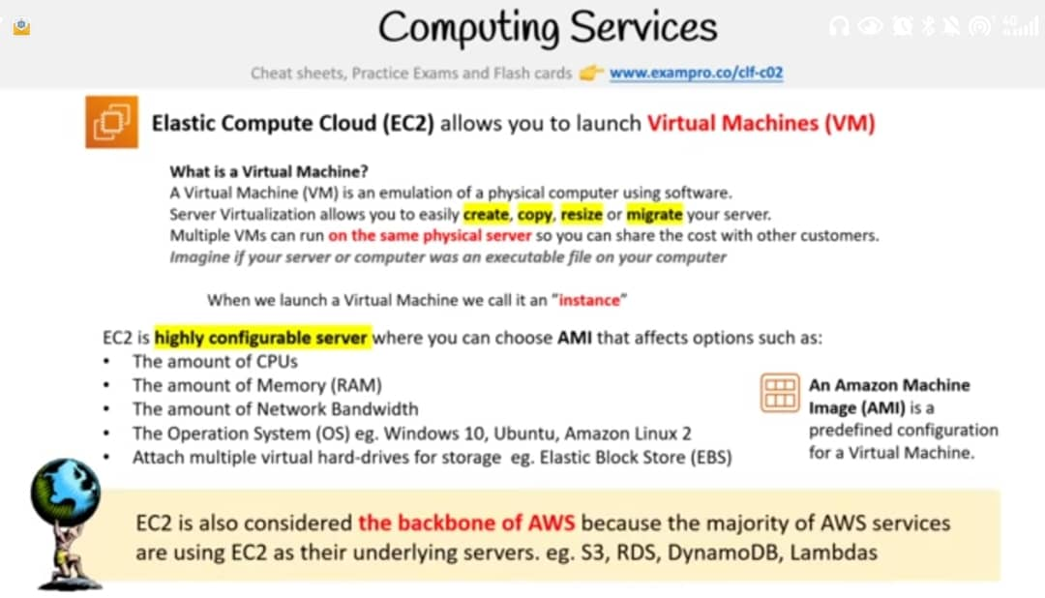

- High Performance Computing is the use of thousands of servers with fast connections between each of them with the purpose of boosting computing capacity.AWS does this using the AWS Parallel Cluster.

- Edge computing is computing on phones,IoT Devices or external servers and not within the cloud.

- Hybrid Computing is the ability to run workloads on on-premise data centers and the AWS Virtual Private Cloud(VPC).

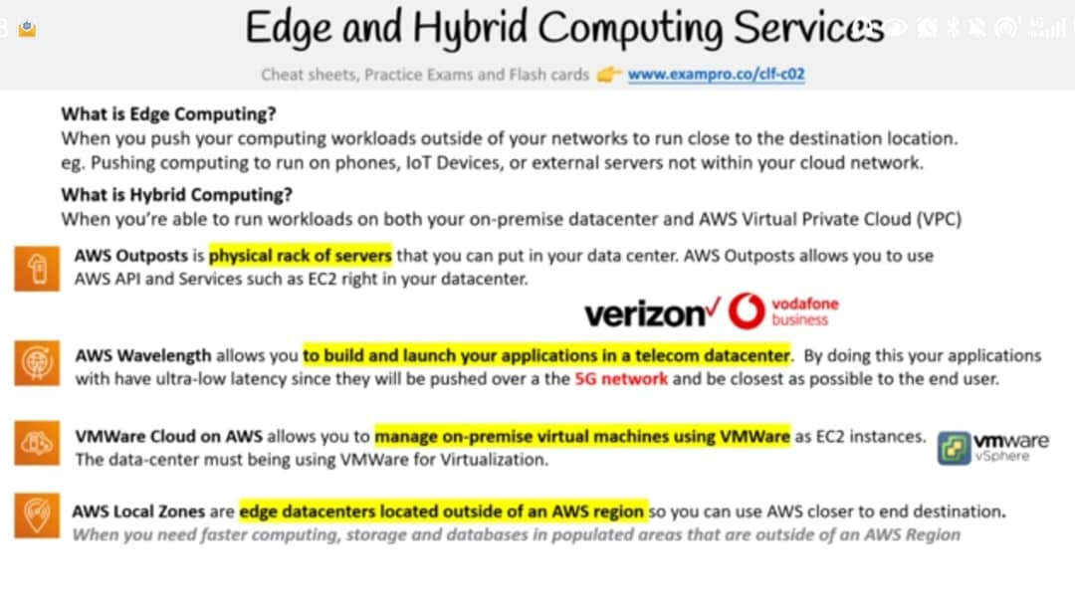

1. AWS Snow Family is a storage and a compute device that is physically used to move data in or out of the cloud when moving data over the internet or a connection is either too slow or too costly.This processes data at the edge and migrates it into the cloud and out of AWS.
2. You can make an S3 bucket public or private.This allows to upload large image files or any files not necessarily images.
3. Elastic Block Store are virtual harddrives for EC2.
4. Elastic File System are for saving a system of files.Even RSA and AES are used here!
5. Database is a data store for semi-strutured and structured data.The types include:

- Relational Database : Structured data denoted as tabular data in the form of tables that is rows and columns.Hence,these are row-oriented or columnar-oriented.

- Non-relational Databases: Semi-structured that may or may not represent tabular

A **relational database** stores data in tables made up of rows and columns, with each table having a defined structure known as a schema. The data in different tables can be linked using relationships such as foreign keys, and queries are written in SQL (Structured Query Language). These databases are well-suited for applications that require strong consistency, complex queries, and clearly defined relationships between data. Examples of relational databases include **MySQL managed by Oracle**, **PostgreSQL also called PSQL**, **Aurora**,**MariaDB,Oracle which is Oracle’s Proprietatry SQL Database**, and **SQL Server**. They are commonly used in banking systems, inventory management, and enterprise applications where ACID transactions are important.

A **non-relational database** (often referred to as NoSQL) stores data in flexible formats such as **key-value pairs, documents, graphs, or wide-column stores**. It does not **require a fixed schema**, meaning records can have different structures, and new fields can be added without affecting existing data. Relationships are often stored within the data itself, and the focus is on scalability and speed rather than complex joins. Non-relational databases are well-suited for handling large volumes of unstructured or semi-structured data, and they scale easily across multiple servers. Examples include **MongoDB** (document store), **Redis** (key-value store), **Cassandra** (wide-column store), **DynamoDB,**and **Neo4j** (graph database). These are often used in real-time analytics, IoT applications, social networks, and content management systems.

In short, relational databases are like a neatly organized filing cabinet with fixed folders, while non-relational databases are like flexible storage boxes that can hold items of any shape, making them more adaptable to rapidly changing or varied data.

1. Data Warehouse is a relational datastore designed for analytical workloads which is generally a column-oriented data store.These are usually for aggregation that is the grouping of data to find a total or an average.These are infrequently accessed in that they are not intended for real-time reporting.Eg is RedShift

Data Warehouse consumes data from a relational database on a regular basis.

1. **Key-Value Store** is a type of a type of non-relational database that uses a simple key-value method to store the data.They lack features of relationships,indexes and aggregation.
2. Document Store is a NoSQL database that stores documents primarily as it’s data structure that is the Xml or JSON format.
3. DynamoDB is AWS noSQL Database.
4. DocumentDB is a NoSQL document database that is MongoDB compatible.
5. ElasticCache is a managed Database of the in-memory and caching technologies of Redis or Memcached.
6. Neptune is a managed graph database where data is represented in the form of interconnected nodes.Thus,this deals with mappings and relationships.
7. Amazon TimeStreams is a time series Database.This helps when dealing with IoT devices and allows to send lots of data that are time-sensitve that how a particular variable changes over time.
8. Amazon Quantum Ledger Database is used to keep record of financial activities that can be trusted.
9. Database Migration Service helps to migrate an on-premise database to AWS and also from a SQL to a NoSQL Database.
10. Cloud Native Networking Services …………….VPC isa logistically isolated section of AWS Cloud where one can launch AWS resources.
11. AWS VPN is a secured connection between on-premise,remote offices and mobile employees.Private Links keep the traffic within the AWS network and not traverse the internet to keep traffic secure.

Subnet is a logical partition of an IP network into multiple smaller network segments.This in essence involves breaking an IP range for a VPC into smaller networks.Public subnet is one that can reach the internet whereas a private subnet is one that cannot reach the internet.

1. Network Access Control Lists(NACL) acts as a virtual firewall at the subnet level that allows or denies rules.This is used to block a specific IP address known for an abuse.
2. Security Groups are a virtual firewall at the instance level.This implicitly denies all traffic by creating only some specific allow rules.You can’t block a specific IP address unlike the NACL.
3. Recall that cloudFront is a Content Delivery Network and stores cached data.
4. Elastic Compute Cloud(EC2) is a highly configurabel virtual server or virtual machine.This is thought to be the backbone of AWS because everywhihing on the AWS is somewhat under the hood uses EC2.
5. Instance Families are different combinations of CPU,Memory,Storage and networking capacity.These allow to select the appropriate combination of capacity eed to meet an application’s unique requirements.
6. Instance Type is a particular instance size and instance family.Patterns of instance sizes include: nano,micro,small,large.xlarge……
7. AMI refers to Amazon Machine Image
8. EC2 Health Check is just to check if the server is up and running.
9. ALB stands for Automatic Load Balancer allows to scale whenever the need arrives.
10. On-Demand is a Pay As You Go Model(PAYG) where you consume compute and then you pay per consumption.
11. Reserved Instances(RI) is designed for applications that have a steady-state,predictable usage and a reserved capacity.These are usaully related to pricing models.

RI Limits refer to the number of reserved instances that one can purchase per month.

1. Capacity Reservation is a service of EC2 that allows to request a reserve of an EC2 instance type for a specific region and availability zone.
2. Standard RIs can be:

- Modified but Convertible RIs they cannot

- Can’t be excanged but Convertible RIs can be exchanged.

1. EC2 Reserved MarketPlace allows to sell unused standard RI to recoup your RI spend for RI that you don’t intend to use or can’t use.
2. Single-Sign On(SSO) is an authentication scheme that allows a user log in using a single ID and password to different systems and software.

- SSO allows IT departments to administor a single identity that can access multiple machines and many cloud services.

1. Light Weight Directory Access Protocol provides a single central place to store usernames and passwords.This allosw for Same Sign On.This LDAP came in because some browsers don’t allow for SSO hence LDAP was invented.
2. MFA is to protect against people who have stolen your password.
3. Security Key is an authentication process that’s a second layer before getting access to an application,device or workstation.

YubiKey us such that when you press a button,the device generates and fils a token into the system.

1. AWS IAM (Identity and Access Managent)
2. IAM Policies are written in JSON and these contain permissions that determine which API actions are allowed or denied.
3. Messaging System is to provide an asynchronous communication and decouple processes via messages or events from a sender to a receiver.
4. Queueing System is a messaging system that generally deletes messages once they are consumed.Hence,a simple communication which is not real-time.In aws,there’s Simple Queueing Service(SQS) that’s a queuing service that enables to decouple and scale microservices ,distributed systems and serverless applications.
5. Streaming is a messaging system where multiple consumers can react to events called messages.This is in real time unlike for queuing systems.Typical example is Kafka but for Kinesis that’s is for AWS ,it is used for collecting,processing and analyzing stream data in the cloud.These also deal with producer and consumers.

Typical example is that an EC2 instance produces data and it is published then a NoSQL database can consume the messages in real-time to be logged.

1. Pub/Sub is also a messaging system that is usually called Publish-Subscribe.
2. API Gateway is a program that sits between a single-entry point and multiple backends.

Amazon API Gateway is for creating secure APIs in your cloud environment.

106.

An **API Gateway** and a **middleware layer** are not the same, even though both can sit between a client and backend services.

An **API Gateway** is a single entry point for client requests that need to reach multiple backend services. It operates at the edge of the system, handling requests before they enter the internal network. Its primary role is to manage and route external traffic to the correct service, while also enforcing system-wide rules. Common functions of an API Gateway include request routing, authentication and authorization, rate limiting, load balancing, request/response transformation, and monitoring. For example, **AWS API Gateway**, **Kong**, **Azure API Management**, and **Nginx (as an API Gateway)** can direct incoming API calls to the correct microservice, apply security checks, limit how many requests a user can make per second, and transform JSON payloads before sending them to a backend.

A **middleware layer** is code that runs within an application’s request-processing pipeline, after the request has reached the application or service. It’s used to perform reusable logic on incoming requests or outgoing responses without duplicating code in each route or controller. Common middleware functions include logging requests, validating input, parsing request bodies (e.g., JSON parsing), handling authentication at the service level, managing sessions, and catching errors. For example, in **Express.js**, middleware might log every request, check if the user is authenticated, and then pass the request to the correct route handler. In **ASP.NET**, middleware components handle cross-cutting concerns such as exception handling or adding security headers.

In short, an **API Gateway** is like the receptionist at the front desk of a building who directs visitors to the right department while checking IDs and enforcing visitor rules, whereas **middleware** is like the internal checkpoints inside the building that process and filter requests before they reach their specific office or department.

1. Virtual Machines have some wasted space however when a Container like Docker is used,there’s no wasted space.
2. Monolithic Architecture is where one app is responsible for everything hence tight coupling whereas Microservice architecture is multiple apps being repsonsible for one thing hence the subdivision.This is stateless and the functionalities are isolated.
3. Kubernetes is an open-source container orchestration system for automating deployment,scaling and management of containers.Commonly called K8.

**Image Description**

1. Docker is a Platform as a Service product that uses OS-level virtualization to deliver software in packages called containers.

**Image Description**

1. Podman is a container engine that’s an alternative to Docker.
2. Container Services on AWS include:Elastic Container Service,AWS Fargate,Elastic Kubernetes Services,AWS Lambda.To deploy the containers,

Elastic BeanStalk,App Runner,AWS Copilot CLI.

1. AWS Control Tower allows entities to setup AWS multi-accounts.
2. AWS Quick Starts are prebuilt templates by AWS and AWS parteners that help to deploy a wide range of stacks.
3. Tag is a key value pair that you can assign to an AWS resource.
4. Resource Groups are a collection of resources that share one or more tags.
5. Business Centric Services

**Image Description**

1. Provisioning Services has to do with the allocation and creation of resources and services to a customer.Hence,an AWS provision service is responsible for setting up and managing these AWS services.

**Image Description**

1. AWS Elastic Beanstack is a PaaS that allows to deploy a web-app with little-to-no knowledge of the underlying infrastrure so one focuses on the writing of the application code instead of setting up an automated deployment pipeline and DevOps tasks.
2. ASG is autoscaling groups

**Image Description**

Looking at it’s functionality,elastic beanstalk is not recommended for production applications.

1. Serverless Service is where a CSP handles all the underlying servers,infrastructure and operating system that an entity needs.These are usually for a pay for what you use.Eg DynanomoDB for database,Simple Storage Service(s3) for storage purposes,ECS Fargate for container services,AWS Lambda which is a serverless function service.

**Image Description**

1. Serverless Architecture deals with fully managed cloud services.

LOGGING SERVICES

1. CloudTrail logs all API calls between AWS Services.
2. CloudWatch Log Insights enables to search and analyze cloudwatch log data.

This helps to filter the logs and draw dedcutions from them.

**INTRODUCTION TO ML AND AI IN AWS SERVICES**

1. AI is machines performing jobs that mimic human behaviour whereas ML is machine getting better at tasks without explicit programming.
2. Deep Learning is artificial neural network inspired by the human brain to solve complex problems.

**IMAGE DESCRIPTION**

1. Big Data refers to massive volumes of structured and unstructured data that is so large that it is difficult to move and process using traditional database and software techniques.
2. Generative AI is a type of AI capable of generating content in the form of images,text or videos.Eg is MidJourney which can generate an image from a prompt.
3. Apache MXNet is a deep learning framwork that supports multiple programming languages.
4. GPU are mainly for high resolution images and videos.They can also be used for ML and scientific computation.
5. CPUs can have 4 to 16 processor cores whilest a GPU can have thousands of the processor cores.4 to 8 GPU is equivalent to 40,000 cores.
6. Total Cost of Ownership is a financial estimate intended to help buyers and owners determine the direct and indirect cost of a service or a product.
7. Capital Expenditure(Capex) is money spent on physical infrastruture whereas Operational Expenditure deals with non-physical costs such as training employees in cloud services.
8. AWS Pricing Calculator is an estimate tool that can be used in a web browser without need of an AWS account to estimate the cost of AWS services.
9. AWS Migration Evaluator is an estimate tool that helps to determine an entities on-premise cost so it compares against it’s AWS cost for a planned cloud migration.It uses Agentless Collector for this.
10. AWS Database Migration Service allows to quickly and securely migrate from one database to another say an on-premise database to AWS.
11. AWS has some free services.