# AWS TUTORIAL

1. AWS Certified Cloud Practitioner is the entry level AWS Certification Teaching
2. AWS Certification is valid for 3 years.
3. Exam is to check if you understand the Cloud.
4. 50 scored and 15 unscored--Meaning?
5. From 15 to 30 talks about the exam stuff to expect.

**NOTES**

1. Validators check if the resources are deployed right in the AWS Cloud.
2. Cloud computing is the use of a network of remote servers hosted on the internet to store,manage and process data rather than using a local server or a PC.
3. On-Premise provides own the server whereas Cloud Providers own the cloud.
4. Before,you need a dedicated machine to host a server or a business.Later came,shared hosting which involved one physical machine shared by 100s of businesses.
5. Cloud Hosting later came,hence distributed computing where there’s multiple physical machines that act on one system call the cloud service.Hence virtual machines came about.
6. Amazon was fiunded in 1994 by Jeff Bezos.Amazon’s cloud service provider (CSP) is therefore Amazon Web Services.
7. AWS was launched in 2006 and is the leading cloud service provider in the world.
8. AWS is made up of Simple Queue Service,Simple Storage Service(s3) and Elastic Compute Cloud(EC2).
9. CSP is a company that provides multiple cloud services.CSP have InfrastructureAs A Service(IaaS) offerings.
10. Note that Twilo,Databricks and HashiCorp are cloud platforms and not cloud service providers.

11.

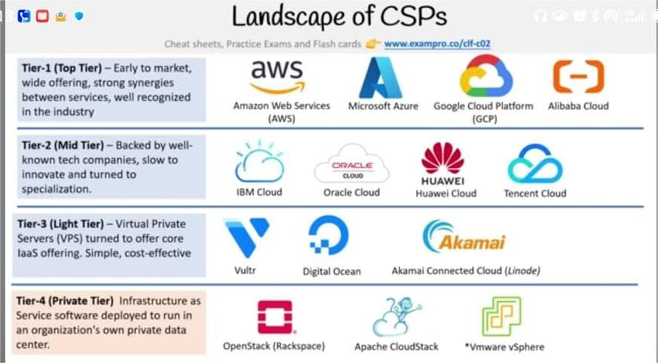

1. Most Common Type of Cloud Services are:

-Compute(having a virtual computer that can run an application,programs and code).Eg is EC2 Virtual Machines

-Storage(a virtual hard drive that can store files).Eg is EBS Virtual Hard Drives

-Networking(a virtual network that defines internet connections) .Eg is VPC which is Private Cloud Network

-Databases(a virtual database for storing all report-related data).Eg is RDS that is SQL Databases.

1. Virtual machine is a machine on top of a machine.The hypervisor is the software later that allows to run the virtual machine.These are easy to scale.
2. Deployment Models include Cloud usually for startups,Hybrid usually for banks and FinTech and On-Premise usually Public Sector like Government and Hospitals and Insurance Companies.
3. IAM is Identity Access Management and it uses an Account ID to log in.
4. Cloud is the latest innovation wave and it is a burning platform in that there is an abandonment of an old technology for a new technology with no hope of success though.
5. Computing Power dealts with throughput for a compuational task.
6. GPU is 50 times faster than traditional CPUs.Latest is the Qunatum Computing which is still being explored.QPU that is Quantum Processing Units
7. Amazon Bracket allows to perform quantum computing tasks on AWS.
8. Advantages of Cloud

- Pay Only What You Consume

- Scalability to meet need

- Going Global In Minutes

- Secure By Default

- Reliable

1. AWS Global Infrastructure is a globally distributed hardware and datacenters that are physically networked together to act as one large resource for end customers.
2. Regions are the distinct locations that have the availabilty zones for the AWS Cloud Infrastructure.Cost of AWS services vary per region.The selected region is in the AWS Management Console.
3. Global Services Include Amazon S3,CloudFront,RouteS3 and IAM.
4. Availability Zones are physical locations that are made up of multiple data centers.

- A datacenter is a secured building that contains thousands of computers.

1. Generally,most regions have 3 availability zones.
2. Availability Zones are denoted by a Region Code followed by a letter identifier.Eg us-east-1a.You chose a subnet when choosing an availaibity zone.

Eg Say in Canada Central,the AZ’s may be ca-central-1a,ca-central-1b and ca-central-1d.These are interconnected.There are 100km away from each other.All traffic between AZs is encrypted.

1. For Global Sevices,availability zones are not selected.
2. Fault Domain is a section of a network that is vulnerable to damage if a critical device or system fails.Purpose of this is to ensure that damages are limited to one domain instead of an entire system.Fault Level is a collection of fault domains.Eg is an entire room in a datacenter.CSP defines the fault domains.
3. AWS Global network is the interconnection between AWS Global Infrastruture.
4. Point Of Presence(PoP) is an intermediate location betweeen an AWS region and an end-user which could be a data center or a collection of hardware.PoP resources include edge locations and regional edge caches.
5. Edge Locations are datacenters that hold cached data of the most popular files say images and videos so that delivery to an end user is reduced.
6. Regional Edge Locations are data centers that hold much more cached data thus reducing the full round trip to reduce the transfer fees.
7. Amazon CloudFront is a Content Delivery Network(CDN) that routes requests to the nearest edge location caches.
8. AWS Direct Connect is a dedicated connection between your data center ,office,co-location and AWS.