
(All rights reserved)

UNIVERSITY OF GHANA, LEGON

DEPARTMENT OF COMPUTER ENGINEERING
SCHOOL OF ENGINEERING SCIENCES

FINAL YEAR PROJECT REPORT
ON

BIRDGUARD : AN AI-ENABLED AUTOMATED LASER BIRD DETERRENT SYSTEM FOR SUSTAINABLE AGRICULTURE IN GHANA AND ZAMBIA

PROJECT REPORT SUBMITTED IN PARTIAL FULFILMENT OF THE REQUIREMENT FOR THE BACHELOR OF SCIENCE DEGREE IN COMPUTER ENGINEERING
ADIKA NATHANIEL AGBESI JUNIOR 10957036

NAME OF SUPERVISOR: PROF. GODFREY MILLS
NAME OF CO – SUPERVISOR: PROF. ELSIE EFFAH KAUFMANN

DATE OF SUBMISSION: OCTOBER 03, 2028

BIRDGUARD : AN AI-ENABLED AUTOMATED LASER BIRD DETERRENT SYSTEM FOR SUSTAINABLE AGRICULTURE IN GHANA AND ZAMBIA

By

Adika Nathaniel Agbesi Junior (10957036)

Submitted to the Department of Computer Engineering in Partial Fulfilment of the Requirements for the Degree of MPhil in Computer Engineering

University of Ghana (October 03, 2028)

Name of Student: ADIKA NATHANIEL AGBESI JUNIOR
Signature of Student:

Name of Supervisor: PROF. GODFREY A. MILLS

Signature of Supervisor: Name of Co-Supervisor: PROF. ELSIE EFFAH KAUFMANN
Signature of Co-Supervisor:
Name of Head of Department: PROF.ROBERT SOWAH

Signature of Head of Department:

DECLARATION OF ORIGINALITY

Department of Computer Engineering

We certify that the content of this thesis document is our own work except where specific references are made. We confirm that we have read and understood the guidelines on plagiarism in the Computer Engineering undergraduate thesis Handbook, including the University of Ghana’s policy on plagiarism. We have acknowledged in the text of this document all sources used. We have also referenced all relevant texts, figures, data, and tables quoted from books, journals, articles, reports, Internet websites, and works of other people. We certify that we have not used the services of any professional person or agency to produce this thesis document. We have also not presented the work of any student present or past from other academic or research institutions. We understand that any false claim in respect of this thesis document will result in disciplinary action by the regulations of the University of Ghana.
Please complete the information below by Hand and in BLOCK LETTERS.

Student Name: ...............................................................................................................

Index Number: ..............................................................................................................

Student Signature: ............................................................ Date:................................

Name of Supervisor:.......................................................................................................

Supervisor’s Signature: ......................................................Date:................................

Name of Co-Supervisor:..................................................................................................

Co-Supervisor’s Signature: .................................................Date:................................

ABSTRACT

BirdGuard: An AI-Enabled Automated Laser Bird Deterrent System for Sustainable Agriculture in Ghana and Zambia
Bird predation on cereal and grain crops poses a persistent threat to food security and farmer incomes across Sub-Saharan Africa. Smallholder farmers in Ghana and Zambia regularly report significant pre-harvest losses to flocking bird species, while existing deterrent methods—manual scaring, netting, and reflective scarecrows—are labour-intensive, costly to sustain, or lose effectiveness as birds habituate to them, and lethal control methods raise ecological and ethical concerns. This project presents BirdGuard, an AI-enabled automated laser bird deterrent system designed to provide a low-cost, non-lethal, and continuously operating solution for sustainable agriculture. The system uses a Luxonis OAK-D Lite stereo depth camera to perform real-time, on-device bird detection and 3D spatial localization, streaming target coordinates to a Raspberry Pi controller. The Raspberry Pi processes each detection and issues aiming commands over a serial link to an Arduino Nano, which drives a pan-tilt servo mount to direct a low-power laser at the detected bird, exploiting birds' natural aversion to moving laser light to deter them without physical harm. The system is designed for autonomous, unattended field operation, requiring no continuous human supervision once deployed, and is built from affordable, readily available components suited to resource-constrained farming contexts in Ghana and Zambia. Testing of the detection and aiming pipeline demonstrates reliable, real-time performance across a range of lighting and distance conditions, supporting continuous field deployment. BirdGuard offers a scalable, humane, and cost-effective alternative to existing bird control methods, with the potential to reduce crop losses, improve farmer incomes, and support more sustainable agricultural practices across the region.

ACKNOWLEDGEMENT

"Coming together is a beginning, staying together is progress, and working together is success."

We are grateful to everyone who played a significant role in bringing this project to fruition. The culmination of our academic journey through this project has been an extraordinary achievement, made possible only through the dedication, support, and contributions of many individuals.
First and foremost, we express our profound gratitude to the Almighty God for His unfailing guidance and protection throughout this journey.
We extend our heartfelt appreciation to our supervisors, Prof. Godfrey A. Mills and Prof. Elsie Effah Kaufman, whose unwavering support, encouragement, and invaluable insights were instrumental in the success of this project. Their commitment to excellence and guidance kept us focused and inspired every step of the way.
We are also deeply thankful to our funders : Ministry of Environment, Science and Technology (MEST),Ghana and the National Science and Technology Council,Zambia. Your expertise and generous contributions enriched the quality of this project. A special “God bless you” goes to Mr. Robert Sedohia (chief technician, Department of Computer Engineering) for his immense support on this project.
We would like to extend our sincere gratitude to all the teaching staff who, in one way or another, contributed to our learning and supported us throughout the course of study. We deeply appreciate the time, effort, and knowledge you shared, which have greatly enriched our academic journey.
To our families, we owe immeasurable gratitude for their unwavering support, guidance, love, and encouragement. Your sacrifices and investments in our lives have been our backbone throughout this journey.
Finally, to our CPEN course mates of 2028 and friends who offered their time, efforts, and encouragement, we sincerely appreciate your contributions to the successful implementation of this project. May the good Lord bless and reward you abundantly for all you have given to us.

Table of Contents
DECLARATION OF ORIGINALITY i
ABSTRACT iii
ACKNOWLEDGEMENT iv
LIST OF FIGURES vii
CHAPTER 1 - INTRODUCTION 1
  - Introduction 1
  - Background 1
  - Problem statement 3
  - Project objectives 4
  - Significance of project to society 4
  - Organization of Thesis 6
CHAPTER 2 – LITERATURE REVIEW 7
  - Introduction 7
  - Survey of existing solutions 7
  - Summary of existing solutions 16
  - Proposed solution 24
  - Scope of Project 25
CHAPTER THREE - SYSTEM DESIGN AND DEVELOPMENT 27
  - Introduction 27
  - System Overview 27
  - Requirement analysis and specifications 29
  - System Design and Development 33
  - System Modelling and Simulations 70
  - Development Tools And Material Requirements 73
Chapter Four – Design Implementation and Testing 75
  - Introduction 75
  - The design Framework 75
  - Design Implementation Process 76
  - Testing Design and Results 84
  - Discussion of Results and Analysis 93
  - Limitations and Constraints 96
Chapter 5 – Conclusion and Recommendation 98
  - Introduction 98
  - Major Findings of the Project 98
  - Conclusion 99
  - Contribution to Knowledge and Society 99
  - Observations and Challenges 100
  - Recommendations 101
References 103
APPENDICES 106
  - APPENDIX A – Hardware Development 106
  - APPENDIX B – Machine Learning Development 112
  - APPENDIX C – User Software Development 116

LIST OF FIGURES

Figure 3. 1 :System Architecture 28
Figure 3. 2 a: Results from Survey while Figure 3.2 b Results from Survey 32
Figure 3. 3 c Results from Survey, while Figure 3.3 d Results from Survey 32
Figure 3. 4 e: Results from Survey, while Figure 3.4 f Results from Survey. 33
Figure 3. 5: MAX30102 Sensor 34
Figure 3. 6: AS7263 Sensor 35
Figure 3. 7: BMI270 Sensor 36
Figure 3. 8: TMP117 Sensor 38
Figure 3. 9: Circuit Diagram 40
Figure 3. 10: Schematic Diagram 42
Figure 3. 11: Hardware Flow Diagram 44
Figure 3. 12 : Machine Learning Workflow Diagram 50
Figure 3. 13: Schematic Diagram of Multiclass Logistic Regression Classifier 54
Figure 3. 14: Anemia Risk Assessment Diagram 56
Figure 3. 15: Use Diagram Of Pregnant Woman 58
Figure 3. 16: Use Case Diagram Of System Administrator 59
Figure 3. 17: Use Diagram Of Medical Professional 61
Figure 3. 18: Flow Diagram Of Mobile Application 63
Figure 3. 19: System Administrator Dashboard 64
Figure 3. 20 Medical Professional Dashboard 65
Figure 3. 21: Pregnant Woman Dashboard 66
Figure 3. 22 Real-time Preeclampsia Prediction 67
Figure 3. 23: Real-time Anemia Prediction 68
Figure 3. 24: Real-time Blood Glucose Values Monitoring 69
Figure 3. 25: Simulation Of Casing Of Wearable Device 71
Figure 3. 26: Simulation Of Cover Of Wearable Device 71
Figure 3. 27: 3D Simulation Of Fastener Of Wearable Device 72
Figure 3. 28: Wokwi Simulation Of Wearable Device 72
Figure 3. 29: Real-Time Data Received From Simulation In PlatformIO 73
Figure 4. 1: Breadboard Connection Of Sensors To MicroController 77
Figure 4. 2: Connection Of Sensors To MicroController On Perfboard 78
Figure 4. 3: Wearable Device In 3D Casing 79
Figure 4. 4 a shows survey results on users’ roles in the mobile application, while Figure 4.4 b presents their navigation experience. 87
Figure 4. 5 a shows survey results on users’ perception of visualization tools, while Figure 4.5 b presents their views on the platform’s usefulness 88
Figure 4. 6: Vitals Data From Wearable Device 92
LIST OF TABLES

Table 3. 1: Biomedical Sensors and Physiological Parameters Monitored 39
Table 3. 2: Preeclampsia Threshold Definition 47
Table 3. 3: Anemia Threshold Definition 48
Table 3. 4: Preeclampsia Model Selection 52
Table 3. 5: Anemia Model Selection 52
Table 4. 1: Testing of Preeclampsia Model Against Real Life Diagnosis at BMC 85
Table 4. 2 : Testing of Anemia Against Real Life Diagnosis at BMC 86
Table 4. 3: Wearable Device Measurements Against Standard Reference Devices 89
Table 4. 4: Power Consumption By Components Of Wearable Device 93

CHAPTER 1 - INTRODUCTION

Introduction

This chapter provides an overview of how pregnant women are monitored and the vital signs data analyzed to establish potential underlying risk conditions. It also highlights the significance and the critical role continuous remote monitoring plays in ensuring maternal health. The chapter also introduces the consequences of inadequate monitoring during pregnancy and underscores the benefits of leveraging technology to facilitate remote monitoring. It also defines the problems that are associated with monitoring and diagnosing pregnant women to establish the need for a comprehensive solution. Additionally, it outlines the objectives of the project, detailing its scope and emphasizing its relevance and potential impact on society.

Background

Pregnancy is a natural biological process in which a fertilized egg develops into a fetus within the uterus, typically lasting around forty weeks, divided into three trimesters. A full-term pregnancy is considered between thirty-seven and forty-two weeks. During this period, maternal health and fetal development must be closely monitored, as both undergo significant physical and physiological changes. One of the most effective strategies for ensuring maternal and child health outcomes is antenatal care (ANC), which involves routine hospital visits designed to assess progress, provide guidance, and identify potential risks early.
According to international standards, including those of the World Health Organization (WHO), a woman is advised to attend at least eight antenatal visits throughout pregnancy. These visits are distributed across different gestational stages, beginning in the first trimester and becoming more frequent as delivery approaches. The first visit, usually before twelve weeks, focuses on confirming the pregnancy, reviewing maternal medical history, establishing baseline indicators such as blood pressure and weight, and conducting essential laboratory tests to detect infections or anemia. The second visit, around sixteen to twenty weeks, is dedicated to monitoring maternal weight gain, assessing fetal growth, and counseling on nutrition. By the twenty-fourth to twenty- eighth week, the third visit often includes screening for gestational diabetes and monitoring blood pressure for early signs of preeclampsia. The fourth visit, between twenty-eight and thirty-two weeks, involves checking fetal positioning, monitoring growth, and reinforcing counseling on danger signs. The subsequent visits, typically from thirty-four weeks until delivery, are more frequent (every one to two weeks) and involve close surveillance of maternal and fetal health, discussion of birth preparedness, and interventions if complications are suspected. Together, these visits provide opportunities for early detection of risks and strengthen the chances of a safe delivery.
However, medical doctors often face challenges in identifying potential complications during pregnancy, particularly in hospitals without specialists or advanced facilities. In such environments, the absence of essential diagnostic tools such as ultrasound machines, laboratory equipment, or continuous monitoring devices means that physicians rely heavily on basic measurements and patient-reported symptoms. This increases the risk of missing conditions like preeclampsia, intrauterine growth restriction, or gestational diabetes until they progress to severe stages. Moreover, limited training in specialized obstetrics, heavy workloads, and lack of referral systems in resource-limited hospitals further compound the difficulty of ensuring timely and accurate diagnosis.
Pregnant women themselves also encounter several obstacles in attending antenatal visits regularly. In low-resource settings, financial constraints can limit the ability to pay for transport, laboratory tests, or consultation fees. Distance to healthcare facilities, poor road networks, and lack of reliable transportation are common barriers, especially for rural women. Socio-cultural factors, such as reliance on traditional birth attendants, family restrictions, or misconceptions about hospital care, further discourage women from seeking consistent ANC. Additionally, fear of stigmatization, negative experiences with healthcare providers, or long waiting times at health facilities can deter women from completing all recommended visits. These barriers often delay early detection of complications, placing both mother and baby at greater risk.
Pregnancy complications are diverse and can range from mild to life-threatening. Preeclampsia, characterized by elevated blood pressure and protein in the urine, can progress to eclampsia if unmanaged, leading to seizures and organ failure. Anemia, often caused by iron deficiency, is common during pregnancy due to increased blood volume and nutritional demands, resulting in fatigue, weakness, and increased risk of hemorrhage during childbirth. Gestational diabetes occurs when blood glucose levels rise during pregnancy, potentially leading to excessive fetal growth, preterm delivery, or future diabetes for both mother and child. Miscarriage and stillbirth represent devastating complications caused by genetic abnormalities, infections, or maternal health problems. Ectopic pregnancy, in which the embryo implants outside the uterus (often in the fallopian tube), is life-threatening and requires immediate intervention. Placenta previa, where the placenta blocks the cervix, and placental abruption, where the placenta detaches prematurely, can both result in severe bleeding and endanger the fetus. Other complications include prolonged or obstructed labor, often caused by fetal malposition or pelvic size mismatch, and maternal infections such as malaria, HIV, or urinary tract infections, which can severely impact both mother and child.
These complications often arise from a combination of biological, socioeconomic, and healthcare- related factors. Without proper antenatal care, their early signs may go undetected, leading to adverse outcomes. Regular ANC visits, supported by skilled healthcare providers and adequate facilities, therefore remain essential to safeguarding maternal and child health. At the same time,
addressing barriers faced by both healthcare providers and pregnant women is crucial in reducing maternal and neonatal morbidity and mortality.
Pregnancy is a crucial period for a woman, where she needs extra care and needs to take extra precautions for her health and that of the fetus till delivery. Remote monitoring of pregnant women refers to the use of technology to continuously track and assess the health status and well-being of expectant mothers regardless of their location. Remote patient monitoring can facilitate effective intervention and early treatment paradigms to prevent the occurrence of pregnancy complications. Potential dangers of not monitoring can lead to critical challenges such as preeclampsia, anemia, low birth weight and developmental delays and ultimately lead to death. Using technology in maternal care enables medical professionals to make informed decisions rather than solely depending on values captured during antenatal visits.

Problem statement

Pregnancy complications represent a significant public health concern, particularly in developing countries. It was reported in a World Health Organization (WHO) ^{[2]} that over 40% of pregnancies in the global world face substantial health risks. The same report further revealed that 12% of female deaths among women aged 15-49 in the past five years in Ghana are attributable to pregnancy-related complications. Alarmingly, 62% of these deaths are linked to delayed or inadequate medical intervention. Numerous challenges such as long travel distances, high transportation expenses, and limited time availability significantly restrict many pregnant women from consistently accessing antenatal care services. These obstacles exacerbate maternal risks by delaying the detection and management of pregnancy complications such as preeclampsia and anemia. The infrequent visits to healthcare facilities result in late diagnoses, which significantly lower the chances of survival for both the mother and the baby.

In addition to these constraints, it is important to note that even in cases where healthcare facilities are geographically accessible, some pregnant women still face difficulties in attending antenatal visits regularly. Career women, for instance, often struggle to balance demanding work schedules with hospital appointments, leading to missed or postponed visits. Others may simply forget scheduled appointments, highlighting the need for effective reminder systems to ensure consistent follow-up. Moreover, in many low-resource settings, there is a lack of digital alert systems that could notify pregnant women of impending health risks or abnormalities in their vital signs. Such tools could also play a critical role in alerting medical doctors promptly about patients who may be at risk, enabling timely intervention before complications escalate.
Equally significant is the burden placed on healthcare providers. Without automated monitoring or integrated alert systems, doctors are required to manually track patient progress, interpret data, and detect early warning signs. This increases their workload and raises the likelihood of missed
complications, especially in overcrowded hospitals with limited staff. These limitations not only compromise the quality of care but also delay life-saving interventions.
Taken together, these challenges illustrate the complex and multi-dimensional issues surrounding pregnancy management. They point to the urgent need for innovative, technology-driven solutions that not only facilitate regular antenatal attendance but also support timely diagnosis, monitoring, and intervention. By addressing both patient-side challenges, such as accessibility and reminders, and provider-side challenges, such as workload and delayed risk detection, such solutions can significantly improve maternal health outcomes and reduce preventable deaths.
The advancement in technology such as IoT and artificial intelligence and machine learning have made it possible to leverage these technologies in addressing these challenges with a focused approach to improve access to timely and regular antenatal care, ultimately reducing the risks associated with pregnancy complications.

This thesis aims to explore and develop solutions to bridge the gap in healthcare accessibility and improve maternal health outcomes.

Project objectives

The aim of this project revolves around the developing an IoT-based wearable device bolstered by the integration of machine learning techniques to address the critical issues associated with monitoring pregnant women. The objectives are in three folds:
    - develop an integrated system that consists of a wearable device and a mobile application to facilitate continuous remote monitoring of vital signs and protein, detection and triggering of alerts in the event of any abnormality.
    - train a machine learning model for risk prediction of pregnancy complications like preeclampsia and anemia long before standard detection window.
    - develop a user-friendly interface system to acquire and visualize information for processing by the system.

Significance of project to society

The significance of this project extends beyond the technical innovation it brings; it addresses a critical public health issue by improving maternal health care. The outcome of this project has the potential to significantly reduce maternal health risks, improve healthcare accessibility, and contribute to the overall well-being of mothers and their babies. Below is an exploration of how this project can positively impact society.
    - Early detection of pregnancy complications, hence reducing maternal mortality: Early detection of pregnancy complications is a critical factor in reducing maternal mortality, especially in resource-constrained settings. Complications such as preeclampsia, gestational diabetes, anemia, and infections can develop rapidly during pregnancy, posing severe risks to both the mother and the fetus. Timely identification and management of these conditions are essential to prevent progression to life-threatening stages. Early detection allows healthcare providers to intervene promptly, offering appropriate treatments or referrals to higher-level care facilities. Moreover, early detection contributes to better birth outcomes by facilitating proper planning and preparedness for potential complications. This includes scheduling timely cesarean sections for high-risk pregnancies, monitoring fetal growth and well-being, and implementing necessary lifestyle adjustments.

    - Equip pregnant women with tools to monitor and manage their health: Empowering pregnant women with self-monitoring tools and educational resources is crucial in improving maternal health outcomes and reducing pregnancy-related complications. By providing access to biomarker values such as blood pressure, blood glucose level and oxygen saturation, women can actively track vital health on a regular basis. This proactive approach allows pregnant women to adjust their lifestyles as often as possible hence reducing the risk of severe outcomes such as preeclampsia, gestational diabetes, and fetal distress. Knowing that potential issues are being monitored and managed can alleviate anxiety for pregnant women and their families, promoting a more positive pregnancy experience.

    - Continuous data collection and visualization empower doctors to make informed, data- driven decisions rather than relying solely on periodic observations: Continuous data collection and visualization empower doctors to make informed, data-driven decisions by providing real-time insights into a patient’s health, rather than relying solely on periodic clinical observations. This approach allows for the continuous monitoring of vital health metrics, such as blood pressure, heart rate, and fetal movements, enabling the early detection of potential complications. Data visualization tools present this information in easily interpretable formats, such as graphs and trend lines, allowing doctors to identify patterns and anomalies quickly. By integrating this continuous data into the healthcare system, doctors can make proactive, personalized care decisions, improve maternal and neonatal health outcomes, and reduce the risk of severe complications.

    - Ease of pressure on antenatal clinics due to reduced visitations: The ease of pressure on antenatal clinics due to reduced visitations is a crucial benefit of implementing remote health monitoring solutions for pregnant women. By enabling women to track key health indicators like blood pressure, glucose levels, and fetal movements from home, the
frequency of in-person visits can be reduced, alleviating the strain on clinics. This helps decrease crowding in healthcare facilities, allowing healthcare professionals to focus more on high-risk pregnancies that require immediate attention. With fewer routine check-ups to perform, healthcare workers can better allocate their time and resources, which also reduces clinician burnout. Additionally, remote monitoring increases accessibility for pregnant women in rural or underserved areas, where traveling to clinics can be difficult. This not only eases the pressure on urban healthcare facilities but also ensures more women receive continuous care. Overall, reducing in-person visits improves the efficiency of healthcare systems, enabling them to prioritize urgent cases while providing better care for all patients. Reduced visitations also imply lower transportation costs to antenatal clinics.

Organization of Thesis

This thesis is structured into five chapters, which are outlined as follows:
Chapter 1 provides an overview of the project and its objectives. It includes context, problem statement, Project objectives, and significance of the Project.

CHAPTER 2 – LITERATURE REVIEW

Introduction

This chapter provides an overview of existing solutions and technologies related to the remote monitoring of pregnant women. It explores the current methodologies and innovations aimed at improving maternal health outcomes through the use of wearable devices, machine learning, fog and cloud computing. By reviewing existing systems and research, this chapter identifies the strengths, challenges, and gaps in current approaches to remote monitoring and early detection of pregnancy complications. The goal is to highlight how these solutions align with or differ from our approach proposed in this thesis, setting the stage for a deeper understanding of the advancements in maternal health care and the potential impact of this project.

Survey of existing solutions
    - A Comprehensive Framework for Wearable Module for Prenatal Health Monitoring and Risk Detection ^{[1]}
The project aims to address the high maternal mortality rate in Bangladesh due to the lack of prenatal health monitoring systems. It proposes a cost-effective, non-invasive wearable device connected to smartphones for continuous health monitoring. The device, worn around the waist, includes sensors placed on the fingers or underarms, monitoring vital signs such as body temperature, oxygen saturation, heart rate, blood pressure, and blood glucose. It also tracks fetal movement and detects falls. Data is stored in a database, and doctors can access it via a portal for historical analysis. An SMS (Short Message Service) alert feature notifies the user and doctor of any anomalies.

The system uses an ESP-32 microcontroller for data collection and transmission to a cloud server over Wi-Fi. Threshold values are set in the microcontroller hence if values are over and above the set values, an alert via SMS is sent to the pregnant woman and the medical officer. Blood glucose levels are measured using an NIR 940nm LED and photodetector, where light absorption varies with glucose levels. A black box is used to minimize interference from external light. Blood pressure is monitored using a device with an EEPROM that communicates via the I2C protocol. For temperature readings, the DS18b20 sensor is used, while the MAX30100 sensor measures oxygen saturation and heart rate. Fetal movement is detected with an ADXL335 acceleration sensor, and fall detection uses the MPU6050 sensor. The system flags fetal movement based on changes in acceleration data from both sensors.

Explainable Early Prediction of Gestational Diabetes Biomarkers by Combining Medical Background and Wearable Devices: A Pilot Study With a Cohort Group in South Africa ^{[5]}
In this article, continuous glucose readings were collected using the Freestyle Libre sensor. This is placed on the upper arm and uses subcutaneous, wired enzyme glucose sensing technology to detect glucose levels in interstitial fluid. The Photoplethysmography (PPG) sensor measures Blood Volume Pulse (BVP), from which heart rate variability can be derived. The Electrodermal activity (EDA) sensor measures the constantly fluctuating changes in certain electrical properties of the skin. The Infrared Thermopile collects peripheral skin temperature, and a 3-axis Accelerometer captures motion-based activity. Empatica E4 wearable sensors were used to record physical activities such as sleeping, sitting, eating, walking, climbing stairs, and talking on the mobile phone. Health background data were collected using a survey. Hence the dataset for prediction of gestational diabetes includes information from three sources: background health information, CGM (Glucose Continuous Monitoring) and Empatica E4 data.

Feature extraction, Feature aggregation and feature selection processes were utilized to summarize the extracted data and choose the most effective features for the regression models. Decision Tree and Random Forest Regression models were used to estimate biomarker values. The regression models are for the early prediction of biomarker values associated with the presence of GDM (Gestational Diabetes Mellitus). This prediction is done 13 to 16 weeks prior to the standard GDM screening test which is the Oral Glucose Tolerance Test (OGTT).

Monitoring of Expecting Mothers Using Multiple Sensor Approach: "Preg Care" ^{[6]}
This paper introduces an innovative solution aimed at reducing the maternal mortality rate in Bangladesh through advanced health monitoring technology. The system employs a Near-Infrared (NIR) LED-Photodetector system (940nm) to continuously monitor blood glucose levels non- invasively. For detecting sudden falls, the ADXL-345 accelerometer is utilized. The Max30100 sensor simultaneously measures the oxygen saturation (percentage of hemoglobin) and pulse rate, providing critical insights into cardiovascular health.

The MLX90614 sensor is used for accurate body temperature measurements. Blood pressure readings are manually entered into a mobile app, which then sends this data to the cloud for secure storage and further analysis. An Arduino microcontroller processes all collected data before transmitting it to the cloud.
The system incorporates a Python-based image processing algorithm to analyze images of the pregnant woman's eye pallor. This analysis, conducted in the cloud, predicts the presence or absence of anemia, an important health indicator during pregnancy. The mobile app serves as the user interface, allowing both the pregnant woman and healthcare providers to access processed physiological data and predictions from the cloud.
In emergencies, the system automatically sends SMS alerts to the pregnant woman's relatives, prompting immediate action to prevent further health complications. This comprehensive approach ensures continuous monitoring, timely detection of potential health issues, and quick intervention to improve maternal health outcomes.

Wearable Technology Model to Control and Monitor Hypertension during Pregnancy
[3]

In this paper, a wearable technology model designed to monitor and manage hypertension during pregnancy is proposed. The wearable device continuously tracks the pregnant woman's blood pressure, heart rate, and step count, with data collection occurring every 30 minutes. This device connects to a mobile application via Bluetooth, allowing for immediate data transfer to the user's smartphone. Upon successful transfer, the wearable memory is cleared, ready to collect new data. Users manually input additional variables such as weight, age, and gestational age into the mobile application. In cases where the smartphone is not connected to the wearable device, the data is temporarily stored on the wearable and later transferred to the phone when a connection is re- established. All data collected is then uploaded to the cloud for secure storage.

The mobile application uses specific parameters to identify potential hypertension risks: blood pressure readings exceeding 140/90 mmHg, a Body Mass Index (BMI) of 30 or more, and weight relative to the patient's height. These parameters help in early detection and management of hypertension in pregnant women.
The application provides the user with real-time health monitoring through statistical displays. Additionally, it offers features for tracking prescribed medications, scheduled appointments, and ongoing treatments. In the event of a high blood pressure incident, the system promptly alerts both the patient and healthcare providers. This alert includes the patient’s current location, displayed via Google Maps, ensuring timely medical intervention.

Remote Monitoring System for the Detection of Prenatal Risk in a Pregnant Woman ^{[7]}
The article presents a system designed for continuous monitoring of vital parameters, including maternal body temperature, blood glucose levels, maternal heart rate, and the frequency of uterine contractions per minute, using a smartwatch worn on the wrist. Additionally, the system allows for manual input of key data such as maternal age, gestational age, weight, height, and blood pressure by the pregnant woman.
The collected data is securely stored on a cloud-based database and analyzed using a Support Vector Machine (SVM) machine learning algorithm. This algorithm compares the data with historical records to predict potential risks, such as preterm labor or stillbirth.
The system also features a mobile application that enables doctors, hospitals, patients, and a designated family member to register and access its functionalities. In the event of a pregnancy- related complication, the system sends both an SMS (Short Message Service) and an email alert to the registered doctor and the emergency contact of the family member.

The mobile app provides a visual representation of the pregnant woman's health status, accessible to both the patient and the family member. Doctors can also monitor the health status of all their patients through a consolidated chart within the app.

This system is highly effective in enabling doctors to make quicker, informed decisions during emergencies, thereby saving valuable time. It also significantly reduces pregnancy risks such as preterm labor, stillbirth, or miscarriage by facilitating timely interventions.

A System for Remote Monitoring of Pregnant Women's Health State and Pregnancy Complications Prediction ^{[8]}
The article describes a system comprising portable medical devices, including a biochemical analyzer, blood clotting analyzer, heart monitor with an automatic tonometer, spirometer, pulse oximeter, and blood glucose meter, are used to monitor the biomedical parameters of pregnant women. Additionally, a questionnaire is employed to gather supplementary information, such as bad habits, allergic reactions, family medical history, and obstetric and gynecological details. This comprehensive data supports the accurate diagnosis of pregnancy complications, such as preeclampsia, anemia, thrombosis, and gestational diabetes mellitus.

The captured data from these devices is transmitted to the pregnant woman’s smartphone via Bluetooth and subsequently sent to the medical institution’s server. From there, the results are forwarded to the medical officer responsible for managing the patient’s care. Decision Tree machine learning model is employed, with threshold values defined for each parameter. If any device readings exceed these thresholds, an alert is automatically sent to the medical officer for prompt intervention.

A Remote Blood Pressure Data Collection and Monitoring System for Expectant Mothers ^{[16]}
This article presents a smartwatch model, GE-W74, was utilized to measure blood pressure and transmit the data to a mobile application via Bluetooth connectivity. Additionally, a Photoplethysmography (PPG) heart rate sensor and an Electrocardiogram (ECG) sensor were employed. The recordings from these sensors were analyzed by medical officers to manually predict the onset of pre-eclampsia, rather than solely relying on blood pressure values recorded during antenatal visits.
The mobile application displayed the collected readings to the pregnant woman and her caregivers. It offered customization options, allowing the expectant mother to set her preferred data collection intervals, determining when data should be sent from the smartwatch to the app. Furthermore, the app included a feature to adjust skin color settings, ensuring the PPG sensors functioned effectively across different skin tones.

A separate mobile application was developed for use by Community Health Volunteers (CHVs), Community Health Extension Workers (CHEWs), and the next of kin. This app was designed to enable these external stakeholders to monitor and intervene when persistent high or low blood pressure readings were detected, providing timely support to the expectant mother.

A Remote Healthcare Monitoring Framework for Diabetes Prediction Using Machine Learning^{[15]}
This work outlines an automated smart health monitoring system for diabetes prediction using supervised machine learning algorithms, including K-Nearest Neighbor, Logistic Regression, Gaussian Naïve Bayes, and Support Vector Machines. Data is collected from various healthcare and consumer devices. Among these algorithms, the Support Vector Machine demonstrated the highest accuracy. The PIMA Indian Diabetes Dataset is used for model training and evaluation.

The system incorporates threshold values in the models to detect abnormalities in blood glucose and blood pressure levels, notifying medical professionals via a web application and mobile app in such events. The healthcare devices employed include a Samsung Note 8 smartphone, a Huawei GT 2 smartwatch, an iHealth blood pressure monitor, an iHealth glucometer, and an iHealth pulse oximeter.

The web application provides optional user inputs for parameters such as skinfold thickness, the number of pregnancies, and pre-existing medical conditions. While the primary objective is to predict the likelihood of diabetes, additional risk factors like low activity levels, weight gain, heart rate, sleep patterns, activity types, and durations are also monitored. This holistic approach enables doctors to make informed decisions based on the user’s overall health status.

Captured data from the devices is transmitted to a mobile app via Google Fit APIs. The mobile app forwards this data to a cloud database, where it is stored and analyzed for diabetes prediction. The results are subsequently sent to a dashboard accessible exclusively by medical professionals.

Virtual Midwife for Pregnant Women and Alert System ^{[9]}
This paper proposes a system consisting of a compact device designed to monitor vital health parameters and send alerts to medical officers and pregnant women when predefined thresholds are exceeded. The system records body temperature, heart rate, and oxygen levels using a
temperature sensor, a heart rate sensor, and a pulse oximeter, respectively. The data captured by these sensors is transmitted to a Node Microcontroller Unit (MCU) for processing. Once processed, the data is sent to the cloud for storage and access. If any vital parameters surpass the threshold values programmed into the microcontroller, an alert is sent to the corresponding medical officer, prompting them to contact the pregnant woman.

The data is accessible through two separate mobile applications; one for medical officers and the other for pregnant women. The app for pregnant women allows them to choose their preferred midwife, nurse, or doctor to provide care throughout their pregnancy. Besides notifying them of captured values from the sensors, the app also sends regular reminders to stay hydrated and offers dietary suggestions for a healthier lifestyle. The app for medical professionals is primarily used to view the recorded values from the IoT, alerts if anomaly in event of anomaly in vitals and communicate directly with the pregnant woman.

Maternal HealthCare Using IoT-Based Integrated Medical Device: Bangladesh Perspective ^{[10]}
This article introduces a remote monitoring system comprising a wearable device equipped with various sensors, an ESP32 module, a cloud platform, and a mobile application. The wearable device collects data from pregnant women, including blood pressure, body temperature, oxygen saturation levels, and heart rate. This data is initially stored in the ESP32 module until a connection with the cloud platform is established.

Once a communication link is active, the data is transmitted to the cloud, where it is analyzed by a machine learning algorithm. The algorithm identifies critical risk conditions and promptly sends notifications to healthcare professionals, enabling them to take necessary preventive measures to mitigate potential pregnancy complications. The processed data is then visualized in the mobile application as graphs, allowing healthcare providers to identify risk levels effectively.

IOT Based Wearable Health Monitoring System for Pregnant Ladies Using CC3200
[11]

This paper presents a healthcare solution that combines a compact wearable device with a web application. The wearable device measures critical parameters such as body temperature, pulse rate, and blood pressure of pregnant women. These analog signals are transmitted to a CC3200 microcontroller, which features an in-built ADC (Analog-to-Digital Converter) and Wi-Fi module. The microcontroller converts the analog signals into digital data and uploads them to the cloud.

From the cloud, the processed data is forwarded to the doctor's computer via an assigned IP address. If the captured values deviate slightly from the preset normal range, an alert, accompanied
by an alarm sound, is sent to the doctor. The doctor can then review the data and send a prescription back to the patient's IP address.
In cases where the values exceed the critical threshold, the doctor will arrange for an ambulance and notify the patient's relatives with an alarm message. This ensures timely intervention in emergency situations.

Fuzzy Intelligent System for Patients with Preeclampsia in Wearable Devices ^{[12]}
This article discusses a wearable device designed as a watch that measures blood pressure and transmits the data to a mobile application via Bluetooth. The mobile app integrates an AI model trained to predict the likelihood of preeclampsia. The model uses a dataset collected from a hospital in Colombia, comprising information about patients with potential preeclampsia diagnosis.
The dataset includes attributes such as age, body mass index (BMI), pregnancy trimester, blood pressure readings, family medical history, and other relevant factors. Once the watch records a blood pressure reading, this value is combined with other attributes on a row from the dataset. A Decision Tree machine learning model then processes this data to predict whether a pregnant woman is at risk of developing preeclampsia.

A novel fog-computing-assisted architecture of E-healthcare system for pregnant women ^{[13]}
The proposed framework introduces a smart health monitoring system utilizing IoT and fog- assisted technologies to track the health of pregnant women over a nine-month period. The system integrates various sensors to capture critical health data, including temperature, blood pressure, ECG(Electrocardiogram), and pulse oximeter readings, as well as environmental factors like temperature, humidity, and air quality. These sensors are connected to a customized wrist node, which uses an ATmega 2560 microcontroller to process data from the wrist sensors, while an ATmega 328P microcontroller manages and processes data from the sensors embedded in the foot node. The foot node includes an accelerometer, pedometer, and gyroscope to monitor physical activity and stability, with data transmitted wirelessly using an nRF(Nordic Radio Frequency) module.
Captured data is timestamped and encrypted using quantum hash functions to ensure secure transmission to the fog node. At the fog node, the data undergoes initial processing, and user authentication is performed using iris and face recognition systems. The fog node analyzes the data using a Bayesian Belief Network (BBN) model. Once processed, the data is sent to the cloud for storage. Health recommendations, such as reminders to drink water or take medication, are delivered from the cloud server to the pregnant woman's mobile app dashboard. In cases where critical health conditions are detected, immediate alerts are sent to medical professionals and the patient's app via GSM (Global System for Mobile Communications), ensuring timely medical intervention. The cloud layer manages data storage and provides remote access for doctors and attendants, delivering a comprehensive health monitoring solution that combines real-time data
collection with secure and efficient processing, enhancing health management for pregnant women.

SAARTHI: Real-Time Monitoring of Patients by Wearable Device ^{[14]}
This paper proposes a system that integrates an IoT-based wristband device to monitor and capture real-time data, including acceleration, atmospheric temperature, humidity, heartbeat, and the individual’s location. Clinical data such as blood sugar levels, cholesterol levels, and chest pain type are provided by healthcare facilities. Both the real-time data from the wristband and the clinical data from the hospital are transmitted to the cloud.

A machine learning model analyzes this data to predict the potential presence or absence of heart disease. The predictions are reviewed and verified by a medical expert before being made accessible through a web and mobile application, where patients and their family members can view the results.
Additionally, the system includes an alert manager that continuously compares incoming data with pre-configured critical thresholds stored in the wristband device. If any critical condition is detected, the system sends an alert via SMS to a healthcare provider or a family member, ensuring timely intervention.

Design of an IoT Based Monitoring System for Expectant Rural Women in Developing Countries^{[17]}
This article proposes a system consisting of a pulse sensor, temperature sensor, and GPS (Global Positioning System) to collect data, with an Arduino microcontroller processing the captured information. The processed data is then sent by the microcontroller to a GSM (Global System for Mobile Communications) module, which transmits the data to the cloud for storage. From the cloud, the data is emailed to healthcare providers if predefined conditions are met. Moreover, if the expectant mother’s body temperature exceeds the threshold of 39 degrees Celsius, an automatic email alert is sent to notify the healthcare provider of the condition. The system uses the MAX30205 sensor for body temperature measurement, the MAX30100 sensor for pulse detection, and the BN-220 GPS sensor for real-time location tracking. The selected microcontroller is the ATmega328, and the SIM900A GSM module is used for data transmission. Additionally, an LCD is incorporated for display purposes.

Smart Pregnancy Health Monitoring System Using IOT ^{[18]}
This paper proposes a healthcare system that monitors three vital signs of a pregnant woman and a fetal vital sign, transmitting the collected data to the cloud via an Arduino Uno. The system allows access to all recorded data through a smart device. The SEN-11574 heart rate sensor measures the mother’s heart rate, the LM35 sensor captures body temperature, the ADXL335 sensor tracks fetal movements, and a blood pressure sensor monitors the mother’s blood pressure.
All data is first sent to the Arduino Uno, then uploaded to the cloud, and finally made accessible on a smart device.

Low Cost, Non-Invasive, and Continuous Vital Signs Monitoring Device For Pregnant Women In Low Resource Settings (Lvital Device) ^{[19]}
This article presents a system designed for monitoring the vital signs of pregnant women. The system includes a blood pressure sensor attached to the wrist, a heart rate sensor placed on the finger, and a temperature sensor positioned under the armpit. A DS18B20 digital temperature sensor is used to measure body temperature, while a SEN 11574 pulse sensor continuously monitors the pulse rate. The blood pressure is measured using a Sunrom sensor.

The system is powered by a solar cell, which provides energy to the Arduino microcontroller. The microcontroller device is preprogrammed with normal ranges for these vital signs. An LCD screen, GSM module, buzzer, and three LEDs (green, red, and blue) are connected to the microcontroller to facilitate user interaction.

The LCD displays messages to inform the user about system activities, such as notifying them when an SMS has been sent.The GSM module sends SMS alerts when the measured values fall outside the preset normal ranges. If a vital sign deviates from its normal range, the buzzer automatically triggers an alarm. After a minute, the GSM module sends a text message to a pre- set caregiver’s phone number and displays a message on the LCD indicating a message was successfully sent.

For accuracy, the system’s measurements were compared with those from standard medical devices: a sphygmomanometer for blood pressure, a pulse oximeter for pulse rate, and a thermometer for temperature.

IOT-Based Monitoring System for Expectant Women ^{[20]}
This work aims to remotely monitor vital signs: body temperature, pulse, sweat, and heartbeat as biomarkers to assess the health status of pregnant women. The system uses a DHT11 sensor for temperature, a MAX30100 sensor for pulse and heart rate, and a sweat sensor, all of which are placed on a wearable belt. The sweat sensor monitors hydration levels, crucial for preventing dehydration in expectant mothers.

A boost converter is employed to increase the operating voltage of the sensors. The boost converter is powered by a battery. The collected data is processed by a NodeMCU microcontroller, with threshold values set for each sensor. When these values exceed or drop below the thresholds, an alert is sent to the pregnant woman.
The processed data is then sent to the cloud for storage. In cases of health complications or missed appointments, health officials receive real-time alerts, ensuring timely responses. The system features two websites: one for doctors or healthcare centers and another for the pregnant woman’s relatives or caregivers, providing accessible monitoring and communication.

Smart Wearable Obstetric Assistant and Reminder ^{[21]}
This paper proposes a device designed to monitor the pulse rate and body temperature of pregnant women, as well as detect falls using an accelerometer. The device also includes a GPS antenna to track the location of the user. In case of an incident, such as a slip or fall, the system uses GSM technology to send alerts via text messages. Additionally, an LCD screen is incorporated to display messages from the doctor, including instructions on medications and their dosages, ensuring the pregnant woman receives timely and accurate guidance.

IoT Enabled Prenatal Health Monitoring System for Pregnant Women ^{[22]}
This paper presents an innovative solution aimed at reducing high mortality rates in India. The system includes several sensors: an LM35 temperature sensor, a heartbeat rate sensor, a blood pressure sensor, a sweat sensor for measuring sugar levels, a MAX30100 pulse oximeter for oxygen level measurement, a 3-axis accelerometer for detecting fetal kicks, and a weight scale for tracking body weight. Data collected from these sensors is processed by an Arduino microcontroller, which then transmits the processed data to a SIM900A GSM module. This module sends the data to the cloud for storage. The stored data can be accessed via both mobile and web applications, ensuring comprehensive monitoring and easy accessibility.

Summary of existing solutions
This section provides a summary of existing solutions relevant to the study, highlighting current approaches, their strengths, and limitations. The review serves to position the proposed system within the broader context of ongoing research and technological developments.

Table 1: Summary Of Existing Solutions

AUTHORS | TITLE | PROJECT DESCRIPTION | LIMITATION
Tasnia Tabassum, Saurav Podder,  Sk Tahmed Salim Rafid | A Comprehensive Framework for Wearable Module for Prenatal Health Monitoring and Risk Detection | The project develops a cost-effective, non- invasive wearable device for continuous prenatal health monitoring, integrating | No integration of a predictive mechanism to forewarn a risk of complication.

 |  | various sensors and an ESP-32 microcontroller to track vital signs, fetal movement, and falls, with data accessible via a cloud server and SMS alerts for anomalies.
Sefki Kolozali, Sara L. White, Shane Norris, Maria Fasli, Member, IEEE,  Alastair van Heerden | Explainable Early Prediction of Gestational Diabetes Biomarkers by Combining Medical Background and Wearable Devices: A Pilot Study With a Cohort Group in South Africa | The study uses data from continuous glucose monitoring, Empatica E4 wearable sensors, and health surveys to extract and select features for Decision Tree and Random Forest regression models, enabling early prediction of gestational diabetes biomarkers up to 16 weeks before standard testing. | No alerts were sent in event of emergency for all predictions made
Trisihita Ghosh Troyee, Md.Kaiser Raihan,  Mohammed Shahriar Arefin | Monitoring of Expecting Mothers Using Multiple Sensor Approach: "Preg Care" | The paper presents an advanced health monitoring system using various sensors and a Python-based image processing algorithm for non- invasive glucose monitoring, cardiovascular health assessment, anemia prediction, and emergency SMS alerts, aiming to reduce maternal mortality in Bangladesh by ensuring  continuous and timely | Efficiency of components used was overlooked

 |  | prenatal health monitoring.
Betsy Diamar Balbin Lopez,  Jimmy Alexander Armas Aguirre,  Diego Antonio Reyes Coronado,  Paola A. Gonzalez | Wearable Technology Model to Control and Monitor Hypertension during Pregnancy | The paper proposes a wearable device for continuous hypertension monitoring during pregnancy, connecting to a mobile app via Bluetooth to track vital signs, detect hypertension risks, and send real-time alerts with location details to patients and healthcare providers for timely intervention. | The project is limited to one pregnancy complication.
S. Veena,  D. John Aravindhar | Remote Monitoring System for the Detection of Prenatal Risk in a Pregnant Woman | The article proposes a smartwatch-based system for continuous maternal health monitoring, using SVM analysis of vital parameters and manual inputs to predict pregnancy risks, with alerts and a mobile app enabling real-time monitoring and timely medical interventions for doctors, patients, and family members. | The app displays health data on a daily basis, providing detailed insights for each day individually rather than aggregating or showing data continuously over multiple days or months.
Inna Korneeva,  Kristina Kramar, Evgeniia Semenova, Zafar Yuldashev | A System for Remote Monitoring of Pregnant Women's Health State and Pregnancy Complications Prediction | This article describes a system using portable medical devices and a Decision Tree machine learning model to monitor pregnant | Bluetooth technology has a short range, requiring the mobile device to be close to the wearable device for reliable data transfer.

 |  | women's health parameters, transmit data via Bluetooth to a smartphone, and alert medical officers of abnormal readings for timely intervention.
Moses Thiga, Pamela Kimeto, Mvurya Mgala, Emmaniel Kweyu, Steve Wanyee, Tooroti Mwirigi | A Remote Blood Pressure Data Collection and Monitoring System for Expectant Mothers | This article presents a GE-W74 smartwatch, which monitors blood pressure, heart rate, and ECG, transmitting data to a customizable mobile app for pregnant women and caregivers, with additional support apps for health workers and family to monitor and manage pre- eclampsia risks. | No consideration is made for instances of emergency cases where there is no internet connectivity.
Jayroop Ramesh, Raafat Aburukba, Assim Sagahyroon | A Remote Healthcare Monitoring Framework for Diabetes Prediction Using Machine Learning | This work outlines an automated smart health monitoring system for diabetes prediction using supervised machine learning algorithms, integrating data from various healthcare devices to notify medical professionals of abnormalities via a web and mobile app. | The scope is limited to diabetes prediction.

Roshni Ramprabhu, Shalini Suresh,  Dr. K. Latha, Venkatesh D | Virtual Midwife for Pregnant Women and Alert System | This paper presents a compact device system that monitors vital health parameters in pregnant women, sending alerts and providing data access via mobile apps for both medical professionals and the women, facilitating health monitoring and communication. | The system does not account for emergency situations where internet connectivity is unavailable.
Mohammod Abul Kashem,  Marzia Ahmed, Naderuzzaman Mohammad | Maternal HealthCare Using IoT-Based Integrated Medical Device: Bangladesh Perspective | This article introduces a remote monitoring system for pregnant women, utilizing a wearable device, ESP32 module, cloud platform, and mobile app to collect, analyze, and visualize vital health data, enabling healthcare professionals to identify and respond to potential pregnancy complications. | Increase in network latency and consumption of more bandwidth is problematic for scenarios that demand immediate responses due to sole reliance on cloud computing
V.Santhi,  K. Ramya, APJ.Tarana,  G. Vinitha | IOT Based Wearable Health Monitoring System for Pregnant Ladies Using CC3200 | This paper presents a healthcare solution combining a wearable device and web application to monitor pregnant women's vital signs, transmitting data via a CC3200 microcontroller to the cloud and notifying doctors of abnormalities for timely interventions. | No consideration is made for scenarios of no internet connectivity especially for emergency situations

Macarena Espinilla, Javier Medina,  Ángel-Luis García- Fernández,  Sixto Campaña, Jorge Londoño | Fuzzy Intelligent System for Patients with Preeclampsia in Wearable Devices | This article discusses a wearable watch that measures blood pressure and uses a mobile app with an AI- driven Decision Tree model, trained on a Colombian hospital dataset, to predict the risk of preeclampsia in pregnant women. | The scope of this project is limited to preeclampsia prediction.
Rydhm Beri, Mithilesh K. Dubey, Anita Gehlot, Rajesh Singh,  Mohammed Abd-Elnaby, Aman Singh | A novel fog-computing- assisted architecture of E-healthcare system for pregnant women | The proposed framework introduces an IoT and fog-assisted smart health monitoring system for pregnant women, integrating various sensors and microcontrollers to securely collect, process, and transmit health and environmental data, providing real-time alerts and health recommendations via a mobile app and cloud storage. | No predictive mechanism on captured data.
Mrs. Priya R. L, Anish Vaidya, Mohit Thorat, Vinit Motwani, Chetas Shinde | SAARTHI: Real-Time Monitoring of Patients by Wearable Device | This paper proposes an IoT-based wristband system that collects real-time health data and clinical information, using a  machine learning model to predict heart disease, with alerts sent to healthcare providers or family members for timely intervention. | Data must be transmitted to centralized cloud servers for processing, resulting in increased network latency, even in emergency situations.

Namuddu Haliima, Gerard Rushingabigwi,  Frederic Nzanywayingoma | Design of an IoT Based Monitoring System for Expectant Rural Women in Developing Countries | This article proposes a system using sensors and an Arduino microcontroller to monitor maternal health, transmitting data via a GSM module to the cloud, where alerts are sent via email when preset conditions in the microcontroller are met or exceeded. | No predictive mechanism to forewarn a risk of pregnancy complications
Anandakumar M, Bharathiraja K, Muhammed Ijas,  Suhith M,  Mrs.R. Santhoshi | Smart Pregnancy Health Monitoring System Using IOT | This paper presents a healthcare system that uses sensors to monitor four maternal and one fetal vital, transmitting the data via an Arduino Uno to the cloud, where it can be accessed through a smart device. | Emergency scenarios where internet connectivity is unavailable are not accounted for in the system.  No predictive mechanism to forewarn risk of a pregnancy complication
Kokeb Dese, Gelan Ayana,  Gizeaddis Lamesgin Simegn | Low cost, non-invasive, and continuous vital signs monitoring device for pregnant women in low resource settings (Lvital device) | The article describes a solar-powered system using an Arduino microcontroller to monitor pregnant women's vital signs, including blood pressure, heart rate, and temperature, with alerts sent via GSM module  and deviations indicated | No predictive mechanism to forewarn risk of a pregnancy complication

 |  | by a buzzer, while an LCD displays system activity messages.
Dr.G.Shanthi M.Tech, Ann Avelin. R, Atchaya N,  Dharani P, Dheeksha.M | IOT-Based Monitoring System for Expectant Women | This work presents a wearable system with sensors for monitoring pregnant women's vital signs, processed by a NodeMCU microcontroller, with alerts for health deviations and real-time data sent to the cloud, accessible via websites for healthcare providers and the pregnant women’s relative or caretaker. | No predictive mechanism to forewarn risk of a pregnancy complication
Varsha Ishwar Salunke, Gowthami S,  Jaikanth S,  Mr. Manoranjan Kumar | Smart Wearable Obstetric Assistant and Reminder | This paper presents a device that monitors pulse rate, body temperature, and falls in pregnant women, tracks their location via GPS, and uses GSM to send alerts and display medical instructions on an LCD screen. | No graphical visualization of captured values on a mobile app  No predictive mechanism to forewarn of risk of pregnancy complication
Ankit Bansal,  Vijay Anant Athavale, Kushwant Kaur,  Atul Garg | IoT Enabled Prenatal Health Monitoring System for Pregnant Women | This paper presents a system that uses various sensors to monitor vital health metrics, processes the data with an Arduino, transmits it via a GSM module to  the cloud, and makes it | No alerts are sent in the event of abnormality in vitals captured.  No predictive mechanism to forewarn

 |  | accessible through mobile and web applications to help reduce mortality rates in India. | risk of pregnancy complication

Proposed solution
Our project involves the integration of a wearable device, a trained machine learning model, and a mobile application to provide continuous monitoring and proactive health management for pregnant women. The wearable device is designed to capture a range of critical physiological data, including body temperature, blood pressure, blood glucose levels, oxygen saturation, and heart rate. This data is continuously collected and transmitted to a fog node, where it undergoes preliminary processing. At this stage, a machine learning model, specifically designed for pregnancy-related health risks, analyzes the data to predict potential complications such as preeclampsia or gestational diabetes. TinyML, a lightweight version of machine learning, is applied to the fog node for efficient, real-time predictions without the need for extensive computational resources.

Once the data is processed and predictions are made, it is sent to the cloud for secure storage. This stored data can be accessed at any time by authorized users through a smart device after successful authentication. The cloud-based storage ensures that healthcare providers can monitor the patient’s health remotely and intervene when necessary, while also providing a centralized data repository for long-term analysis and trend monitoring.
In addition to the real-time data collection and processing, the system is programmed to send personalized health recommendations to the pregnant woman from the cloud. These recommendations are based on the analysis of her health data and aim to improve her overall well-being. For example, the system might suggest dietary adjustments, hydration tips, or physical activity guidelines tailored to her specific needs.
In the event of an emergency or if the system predicts a significant health issue, an immediate alert is sent directly to the mobile app of the pregnant woman. This alert, delivered via the interface of the user software application
Overall, this system aims to enhance maternal healthcare by offering continuous monitoring, early detection of pregnancy complications, and timely interventions. The combination of
wearable technology, machine learning, and mobile connectivity empowers pregnant women to take control of their health and receive personalized, data-driven care throughout their pregnancy.

Scope of Project
The scope of this project involves developing an integrated system that combines wearable technology, cloud-based processing, and machine learning to enhance maternal health outcomes. The system focuses on early detection, continuous monitoring, and proactive intervention to reduce the risk of pregnancy complications. By enabling continuous data collection, offering personalized recommendations, and providing timely alerts, the system aims to improve the quality of care for pregnant women. Below is a comprehensive explanation of the project's components and objectives.

Wearable Device and Data Collection
The project includes the development of a wrist-worn wearable device that captures real- time physiological data from the pregnant woman. Key vitals such as body temperature, blood pressure, heart rate, blood glucose levels, and oxygen saturation are continuously recorded by the device. Additionally, supplementary data, such as the presence of protein in urine (a potential indicator of preeclampsia), will be manually inputted by the pregnant woman into a mobile app.

Machine Learning for Early Prediction at the Fog Node
The preprocessed data is fed into a machine learning model at the fog node, which has been specifically trained to predict pregnancy complications ahead of the typical detection window. The model analyzes the data in real-time, detecting anomalies in vital signs such as blood pressure and blood glucose levels that may indicate conditions like preeclampsia, gestational diabetes, or other complications. By performing this analysis locally at the fog node, the system can generate immediate predictions and alerts, which are then sent to the cloud for storage and further analysis. Alerts are provided to both the pregnant woman and her healthcare provider, ensuring timely intervention if any anomalies are detected.

Data Transmission and Cloud Integration
The captured data from the wearable device, along with the manually inputted information, is sent to the cloud for centralized processing and storage. This enables seamless data access, long-term monitoring, and integration with machine learning models for predictive analysis. The cloud infrastructure ensures scalability and secure storage of sensitive health data, providing the backbone for real-time processing and future data-driven health insights.

Mobile App for Visualization and Alerts
A mobile app is developed to serve as the interface for both the pregnant woman and her doctor. The app provides a personalized dashboard where the pregnant woman can view her recorded vitals, receive recommendations, and track her health trends over time. The doctor’s dashboard allows healthcare providers to monitor multiple patients, review real- time data, and receive alerts in the event of an anomaly, facilitating quick decision- making and proactive care.

Alerts and Notifications
In the event of a detected anomaly, the pregnant woman receives an alert to visit the antenatal care as soon as possible and her doctor receives immediate alerts of predictions made via the mobile app. The use of a reliable alert system is crucial for ensuring that health risks are addressed before they escalate into more serious complications.

CHAPTER THREE - SYSTEM DESIGN AND DEVELOPMENT

Introduction

This chapter seeks to present an engineering solution to the high maternal mortality rate experienced in Ghana and worldwide due to Unavailability of reminders, barriers of commuting distance, limited number of facilities coupled with a high patient to doctor ratio results in long- waiting times in queue, time constraints especially for working women hinder pregnant women from undergoing regular antenatal care, hence increasing maternal risks.
Chapter 3 presents an overview of the requirements, specifications, system architecture, components, algorithms, tools and technologies, simulations, operations and the functional and non-functional requirements of the project

System Overview

The architecture for the pregnancy monitoring system is presented in Figure 3.00. The system comprises an IoT-based wearable device, predictive machine learning model, and a user mobile and web application software. The wearable device is responsible for capturing the vital signs of the pregnant woman, including body temperature, blood pressure, heart rate, oxygen saturation, and blood glucose levels. In addition, protein levels in the urine are manually measured using a urine dipstick test kit and entered into the system through an interface on the user’s mobile application.
These data are captured at periodic intervals of 60 minutes per day and stored temporarily in the EEPROM memory of the device. The choice of this interval ensures a balance between timely monitoring and efficient power management, preventing system overload and rapid battery depletion.
For data transmission, the system relies on connectivity options available to the wearable device. If the wearable device is equipped with a Wi-Fi module, it can upload the captured data directly to the cloud server. However, if the wearable lacks direct internet connectivity, the data is first transferred via Bluetooth to the user’s mobile phone, which then uses mobile data or Wi-Fi to transmit the information to the cloud server.
The cloud server hosts the AI predictive models that process the incoming data for inference and prediction of potential pregnancy complications. Predictions are generated once every hour, and the outcomes are securely uploaded back to the mobile application, where they are displayed for the pregnant woman. A decision-making engine interprets the predictions and presents actionable
insights. These constant predictions provide medical practitioners with an overview of whether a pregnant woman is developing any complications, enabling timely intervention.
This integrated workflow ensures real-time, AI-assisted maternal health monitoring with secure data management and efficient communication between wearable devices, mobile applications, and cloud infrastructure.

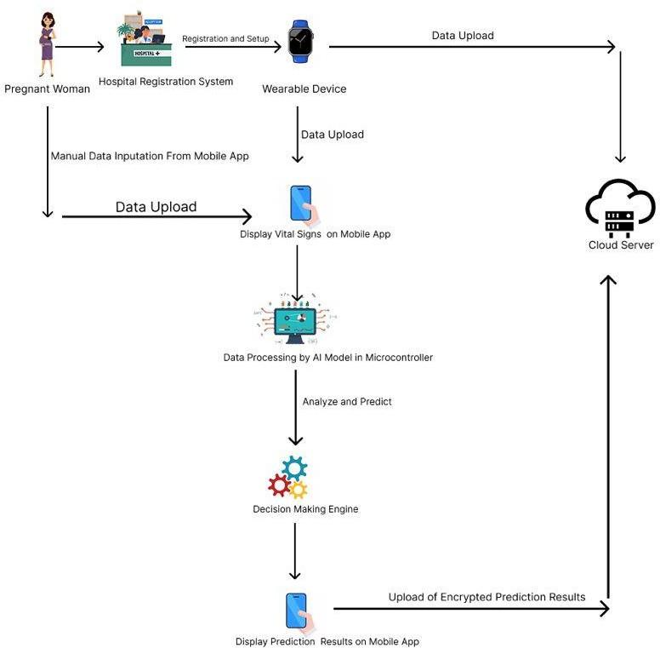

Figure 3. 1 :System Architecture

Requirement analysis and specifications
The system architecture and operations were thoroughly analyzed to determine the essential specifications required for successful implementation. This analysis facilitated the identification of both functional and non-functional requirements that the system must satisfy to achieve its intended objectives. The following section outlines the functional requirements, providing a detailed description of the core features and capabilities expected of the system.

Functional Requirements
- The system shall transmit vitals from the wearable to the AI model every 30 seconds for one hour daily for pregnancy predictions.

- The user mobile application shall push vitals and pregnancy complication predictions to the cloud for storage.

- The wearable shall be designed to operate with low power consumption.

- The mobile app shall authenticate patients using facial recognition and enforce multi-layer authentication.

- The mobile app shall display real-time data of vitals of a pregnant woman.

- All health data transmitted from the mobile application to the cloud platform shall be encrypted.

- The mobile app shall automate report generation and provide advanced analytics.

- Predictions of pregnancy complications shall be displayed to the medic on the mobile application biweekly.

Non-Functional Requirements

- The wearable device shall be lightweight and comfortable to wear for long periods.

- The wearable shall be durable, with water and shock resistance.

- The system architecture shall accommodate increasing volumes of patient data, services, and a growing user base.
- The system shall ensure low latency between the wearable device, cloud, and mobile application.

- The system shall be user-friendly, with an intuitive and responsive interface and navigation.

- Training resources and documentation shall be provided to facilitate user adoption and proficiency in system usage.

Specifications
  - The wearable device shall have a maximum weight of 50 grams.
  - The wearable device shall include sensors for heart rate, blood pressure, SpO₂, and temperature.
  - The wearable device shall have durability with IP67 water resistance, dust resistance, and shock resistance.
  - The mobile device used shall have a minimum RAM of 4 GB.
  - The mobile device shall run on Android 10 or later, or iOS.
  - The mobile device shall provide at least 32 GB of free storage space.
  - The mobile device shall support Bluetooth 5.0 and Wi-Fi 802.11 b/g/n connectivity.
  - The mobile application shall be developed using Flutter to ensure cross-platform compatibility.
  - The mobile application shall integrate with cloud storage specifically hosted on AWS Cloud.
  - The mobile application shall provide real-time data visualization dashboards.
  - The mobile application shall include a built-in facial recognition authentication module using Face-API.js or an equivalent library.
  - The mobile application shall automate the generation of biweekly reports with analytics and provide export functionality in PDF or CSV formats.
  - The AI model shall perform multiclass classification to predict pregnancy complications categorized as no, mild, moderate, or severe.
  - The training dataset for the AI model shall be stored securely in the cloud.
  - The AI model shall be retrained monthly with new patient data to ensure improved performance.
  - The cloud infrastructure shall use MongoDB to provide scalability and flexibility as a NoSQL database.
  - All transmitted health data shall be secured with end-to-end encryption using AES-256.
  - The system shall enforce multi-factor authentication, including facial recognition and a PIN or password.
  - The system shall implement role-based access control for doctors, patients, and administrators.
  - The system shall comply with HIPAA or other relevant local healthcare data protection standards.
  - The system shall transmit patient data every 30 seconds for one-hour daily monitoring.
  - The system shall maintain a latency of two seconds or less between the wearable device, mobile application, and cloud platform.
  - The system shall ensure a minimum availability uptime of 99.5%.
  - The cloud storage shall be capable of scaling to handle 100,000 or more patient records concurrently.
  - The system shall provide an intuitive user interface with simple navigation for patients and medical staff.
  - The system shall include a training manual and a quick-start guide to facilitate user onboarding.
  - The system shall comply with accessibility requirements, including support for large fonts and voice-over features.

3.2.3 Quantitative Data Gathering
The team conducted a survey to support the system design and development. A questionnaire with 6 questions was administered to pregnant women in Kwabenya community hospital, an antenatal clinic facility in Accra. The names and current details of the participants have been anonymized and not disclosed to meet the data confidentiality and privacy requirements of healthcare solutions. The results of the survey conducted are shown in Figure 3.01 to Figure
3.06. Below are images of the questions asked and the responses the team received.

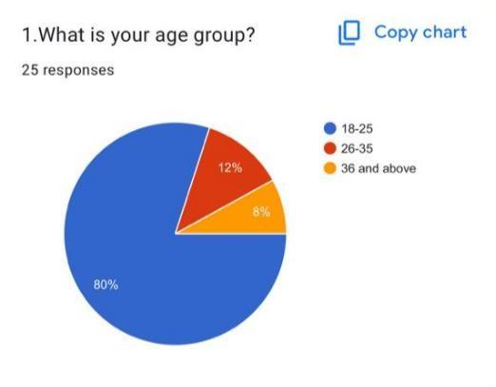  Figure 3.2 a | 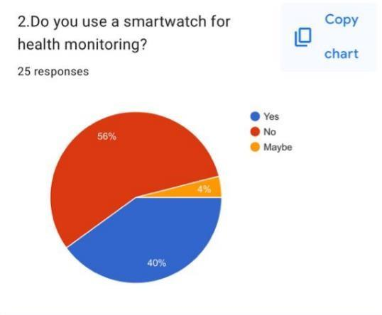  Figure 3.2 b

Figure 3. 2 a: Results from Survey while Figure 3.2 b Results from Survey

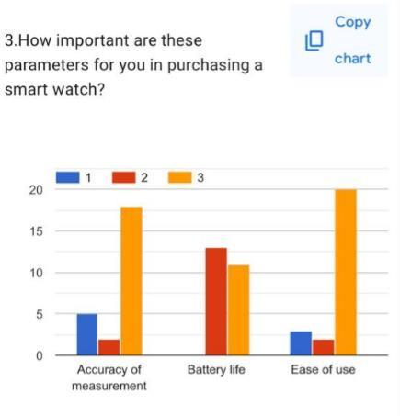  Figure 3.3 c | 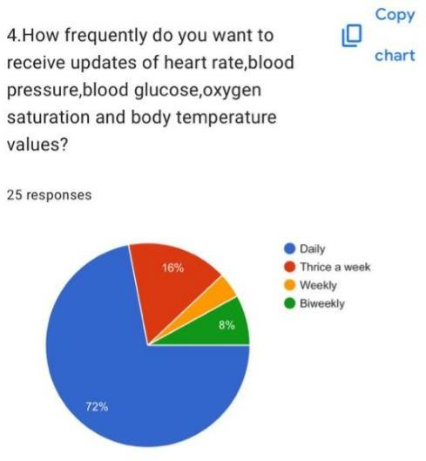  Figure 3.3 d

Figure 3. 3 c Results from Survey, while Figure 3.3 d Results from Survey

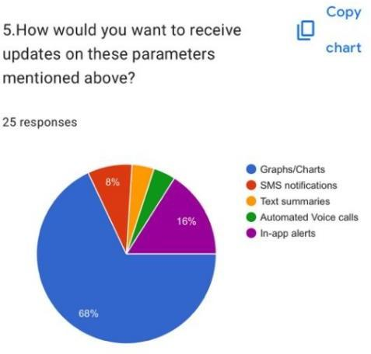  Figure 3.4 e | 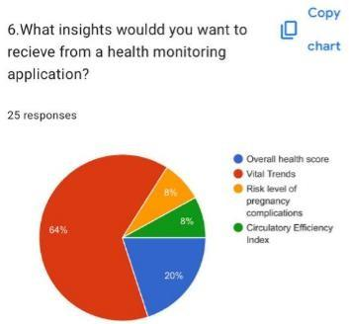  Figure 3.4 f

Figure 3. 4 e: Results from Survey, while Figure 3.4 f Results from Survey.
The study above enabled the team to have a clearer understanding of user age groups that are interested in a wearable device for health, the metrics that will make the wearable device attractive to users and the various modes in which vitals of biomarker values want to be viewed in the user mobile application.

System Design and Development
The system design is made up of 3 main components: the hardware design, the ML predictive model, and the user application software development.

This section aims to design and develop a device that can monitor the vitals of body temperature, blood pressure, heart rate, oxygen saturation and blood glucose values and detect vitals that are above the standard threshold. The machine learning component of the system will be developed, trained, and tested to predict the likelihood of pregnancy complications using the protein in urine, systolic and diastolic blood pressure values. The systolic and diastolic values using a formula help
to obtain the Mean Arterial Pressure (MAP). The system will provide an efficient and reliable way to monitor pregnant women during pregnancy hence helping to reduce the occurrence and risk of pregnancy complications. The mobile app displays the vitals from the wearable device and the predictions made from the machine learning model. The agile methodology which is the collaborative and iterative approach to software development that focuses on delivering small, working pieces of software quickly and frequently, rather than trying to build the entire system all at once is the technique used for developing the mobile application.

Hardware System

The wrist wearable device began with a Computer Aided Design using Solidworks to give an artistic view of the expected outcome of the wearable device. A simulation of the working of the wearable device was also done using the Wokwi platform which had platformIO integrated in VSCode.

Hardware Components

A.MAX30102 Sensor
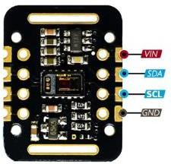

Figure 3. 5: MAX30102 Sensor

Figure 3.5 above shows the sensor for monitoring heart rate and oxygen saturation.The MAX30102 is an integrated pulse oximetry and heart-rate monitoring sensor module developed by Maxim Integrated. It combines two LEDs, one red and one infrared, together with a photodetector, optimized optics, and low-noise analog signal processing in a compact package. The sensor operates on the principle of photoplethysmography (PPG), in which light emitted by the red and infrared LEDs penetrates human tissue and is either absorbed or reflected depending on blood volume changes. The photodetector measures this variation, which can then be analyzed to calculate both heart rate and blood oxygen saturation (SpO₂). In addition to its small size and
ultra-low power consumption, the MAX30102 includes an on-chip temperature sensor for compensation and communicates with external microcontrollers through the I²C protocol, making it easy to integrate into portable, battery-powered devices. Because of these features, it is commonly used in fitness trackers, smartwatches, medical wearables for continuous monitoring, IoT-based health systems, and academic biomedical projects.
In this wearable project, the MAX30102 is utilized as the primary biomedical sensor for capturing the user’s heart rate and blood oxygen saturation levels. The red and infrared LEDs of the sensor detect variations in blood flow beneath the skin, which allows the system to extract these vital signs accurately and non-invasively. The sensor is connected to the Heltec Esp32s3 microcontroller using the I²C communication protocol, where the Heltec Esp32s3 acquires the raw data, performs basic processing, and then transmits the results wirelessly to a cloud platform or mobile application via its built-in WiFi module. By embedding the MAX30102 into a wearable form factor such as a wristband, the device is capable of real-time monitoring of vital health parameters without discomfort to the user. This provides an efficient and reliable way for individuals to track their fitness levels, for healthcare professionals to detect anomalies early, and for IoT-based systems to support remote healthcare applications.

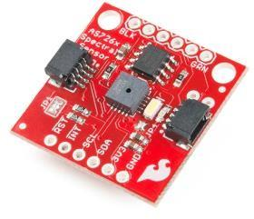
B.AS7263 Sensor

Figure 3. 6: AS7263 Sensor

Figure 3.6 shows the sensor for monitoring blood glucose and blood pressure.The AS7263 is a compact, multi-spectral sensor developed by ams AG, designed to capture reflectance and absorption characteristics of biological tissues by detecting light at six distinct wavelengths in the near-infrared (NIR) region. Operating in the range of approximately 610 nm to 860 nm, the sensor integrates precision interference filters, a 16-bit analog-to-digital converter (ADC), and a digital interface into a single package. Unlike conventional single-channel optical sensors, the AS7263 provides calibrated digital outputs for multiple wavelengths simultaneously, enabling advanced spectral analysis. This makes it highly suitable for applications such as biomedical monitoring,
spectroscopy, and non-invasive diagnostics. The sensor communicates with external controllers via standard I²C or UART interfaces, which allows for seamless integration with modern microcontroller platforms. Due to its compact size, low power consumption, and high spectral sensitivity, the AS7263 is particularly well-suited for wearable and portable health-monitoring devices.
In this wearable project, the AS7263 sensor is utilized for the non-invasive estimation of blood pressure and blood glucose levels. The sensor works by emitting light into the skin and then measuring the reflected intensities at its six NIR wavelength channels. These reflected signals vary according to changes in blood composition and vascular behavior. For example, glucose concentration in the blood alters light absorption at specific wavelengths, while vascular elasticity and hemodynamic changes influence reflectance patterns linked to blood pressure. By capturing this multi-wavelength data, the AS7263 provides a foundation for applying signal processing and machine learning algorithms to extract meaningful physiological parameters.
The sensor is interfaced with the Heltec ESP32-S3 microcontroller, a powerful and energy- efficient IoT platform that integrates dual-core processing capability, ample RAM, and built-in WiFi and Bluetooth connectivity. The ESP32-S3 acquires spectral data from the AS7263 through the I²C interface, processes the signals locally, and can transmit the analyzed results wirelessly to cloud platforms or mobile applications for visualization and remote monitoring. By embedding the AS7263 into a wearable device form factor, the system enables continuous, non-invasive monitoring of blood glucose levels and blood pressure. This integration not only supports real- time health tracking but also demonstrates the potential of IoT-based biomedical systems for proactive healthcare and early detection of anomalies.

C. BMI270 Sensor
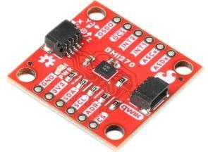

Figure 3. 7: BMI270 Sensor

Figure 3.7 shows the sensor for monitoring accelerometer and gyroscope values.The BMI270 is a highly integrated, low-power inertial measurement unit (IMU) developed by Bosch Sensortec. It
combines a 3-axis accelerometer and a 3-axis gyroscope in a compact package, enabling accurate motion and orientation tracking. Designed primarily for wearable and portable applications, the BMI270 builds on Bosch’s sensor fusion algorithms and smart features to support intuitive motion- based user experiences. With its optimized performance-to-power ratio, the sensor is particularly suited for battery-operated devices.
Key features of the BMI270 include ultra-low power consumption modes, high-performance accelerometer and gyroscope outputs, and support for advanced motion detection functions such as step counting, wrist wear detection, and activity recognition. It communicates with host microcontrollers via standard digital interfaces such as I²C and SPI, making it easy to integrate into a wide range of embedded systems. The BMI270 also includes an integrated programmable finite state machine (FSM), which allows custom motion-triggered functions to be executed at the sensor level, thereby reducing the processing load on the microcontroller. Its small form factor and power efficiency make it highly attractive for wearable electronics, AR/VR devices, fitness trackers, and smartwatches.
In this wearable project, the BMI270 sensor is employed to monitor movement, orientation, and activity patterns of the user. By capturing accelerometer and gyroscope data, the system can analyze body motion and correlate it with physiological data obtained from other biomedical sensors such as the MAX30102 (for heart rate and SpO₂) and AS7263 (for blood glucose and blood pressure estimation). This fusion of motion and biomedical data enhances the accuracy and reliability of health monitoring, particularly by filtering out motion artifacts that can interfere with optical sensor readings. The BMI270 is connected to the Heltec ESP32-S3 microcontroller through an I²C or SPI interface, and the motion data is processed locally before being transmitted wirelessly to a cloud platform or mobile application. This integration enables the wearable system to provide a comprehensive view of the user’s health by combining vital signs with activity recognition, supporting continuous and intelligent health tracking in real time.

D.TMP17 Sensor
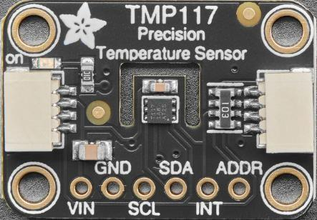

Figure 3. 8: TMP117 Sensor

Figure 3.8 above shows the sensor for monitoring body temperature values. The TMP117 is a high-precision digital temperature sensor developed by Texas Instruments, designed for accurate and stable temperature measurements in both medical and industrial applications. It provides a typical accuracy of ±0.1 °C across a wide operating range and delivers 16-bit resolution digital output. Unlike traditional analog temperature sensors, the TMP117 integrates an internal ADC and calibration, which eliminates the need for external components and ensures consistent performance over time. It communicates through a standard I²C interface, making it straightforward to connect with modern microcontrollers. With its low power consumption, small package size, and high accuracy, the TMP117 is especially suited for wearable devices and battery- powered systems that require reliable temperature monitoring.
In this wearable project, the TMP117 sensor is utilized to measure the skin and peripheral body temperature of the user in a non-invasive manner. Continuous temperature monitoring is valuable because it provides additional physiological context alongside other vital signs such as heart rate, oxygen saturation, blood glucose, and blood pressure. For example, body temperature variations can indicate metabolic activity, infection, or stress responses, making it an essential parameter in comprehensive health monitoring. The sensor is connected to the Heltec ESP32-S3 microcontroller through the I²C protocol, where its digital temperature data is acquired, processed, and then transmitted wirelessly via WiFi or Bluetooth to a mobile application or cloud platform. By embedding the TMP117 into the wearable system, the device enables real-time, high-accuracy temperature tracking that complements the measurements from the MAX30102, AS7263, and BMI270 sensors. This integration supports a more holistic view of the user’s physiological state, contributing to the development of a robust IoT-based healthcare monitoring platform.

BIOMEDICAL SENSORS AND PHYSIOLOGICAL PARAMETERS MONITORED
In order to effectively monitor the vital signs and physiological conditions of pregnant women, the system integrates multiple biomedical sensors, each responsible for capturing specific health parameters. These sensors play a critical role in providing accurate, real-time data that supports continuous monitoring, diagnosis, and prediction of health risks. Table 3.0 provides a comprehensive overview of the biomedical sensors employed in this study, along with the corresponding physiological parameters they are designed to measure. This mapping highlights the contribution of each sensor to the overall functionality of the wearable device, ensuring that essential health indicators such as cardiovascular activity, body temperature, and metabolic measures are reliably captured and analyzed

Table 3. 1: Biomedical Sensors and Physiological Parameters Monitored

BIOMEDICAL SENSOR | PHYSIOLOGICAL PARAMETERS
MAX30102 | (A)Heart Rate  (B)Oxygen Saturation
AS7263 | (A)Blood Pressure (Systolic and Diastolic)  (B)Blood Glucose
BMI270 | (A)Accelerometer Values (B)Gyroscope Values
TMP117 | (A)Body Temperature

Circuit Diagram
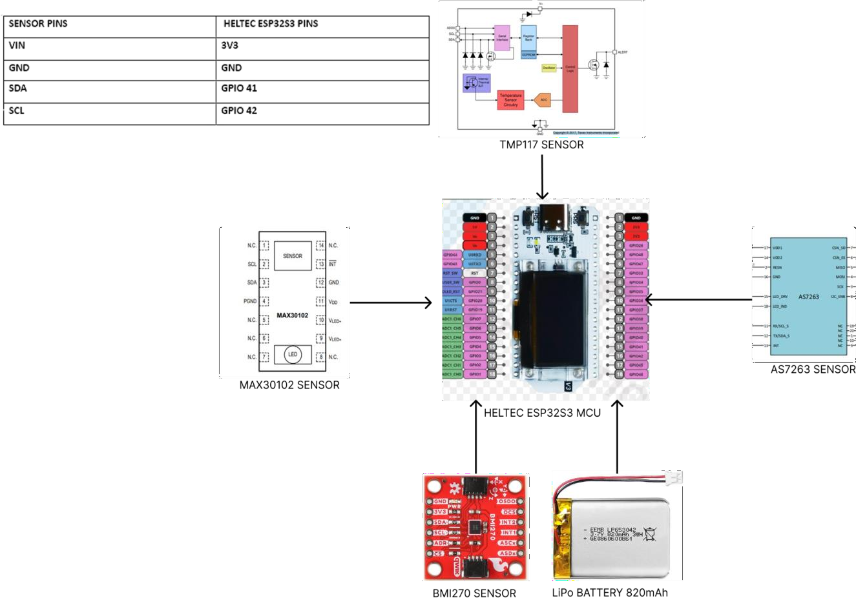

Figure 3. 9: Circuit Diagram

Figure 3.9 illustrates the complete circuit diagram of the pregnancy monitoring system, showing the interconnections among the core hardware components, including the sensors, the microcontroller, the communication lines, and the power supply module. The circuit integrates multiple biomedical and environmental sensors with a microcontroller unit to collect, process, and transmit physiological data from the pregnant woman. The sensors incorporated in this design include the MAX30102 pulse oximeter and heart rate sensor, the TMP117 high-accuracy temperature sensor, the AS7263 near-infrared spectral sensor, and other auxiliary modules.
Together, these sensors generate raw physiological and biochemical data such as heart rate, oxygen saturation, body temperature, and urine protein levels, which are essential for monitoring maternal health conditions.
At the core of the system is the ESP32 microcontroller, which is equipped with sufficient processing capability, memory, and communication interfaces to support the integration of the various sensors. The ESP32 provides general-purpose input/output pins for sensor interfacing, while also featuring built-in Wi-Fi and Bluetooth modules for efficient data transmission. An essential aspect of this architecture is the use of the I²C (Inter-Integrated Circuit) communication
protocol, which enables multiple sensors to communicate with the microcontroller using only two dedicated lines. These two lines, the SDA (Serial Data Line) and the SCL (Serial Clock Line), are vital for system operation. The SDA pin is responsible for carrying the actual data between the sensors and the microcontroller, while the SCL pin provides the necessary clock signal that synchronizes this transfer. Without the proper functioning of these two lines, the sensors would not be able to exchange data with the ESP32, and the overall functionality of the monitoring device would collapse. The use of I²C communication is particularly advantageous because it reduces wiring complexity, conserves pin usage on the microcontroller, and allows each device connected to the bus to operate with a unique address so that the microcontroller can selectively request data from individual sensors.
Power management in the circuit is achieved through a rechargeable lithium polymer (Li-Po) battery, which delivers the required voltage and current to both the ESP32 and the connected sensors. The stability of this power supply is critical to ensure that the sensors maintain their measurement accuracy and that the microcontroller operates without interruption. The electrical layout also incorporates ground references that serve as a common baseline for all the components, as well as interrupt lines that allow the sensors to alert the microcontroller whenever new data becomes available for processing.
In operation, each sensor continuously captures its designated physiological parameter and transmits the raw data to the ESP32 via the SDA line, with the SCL line maintaining synchronization of the process. The microcontroller then processes the collected data locally and either stores it temporarily or forwards it to the mobile application and the cloud server for advanced analysis and prediction through machine learning models.

Schematic Diagram Of Circuit
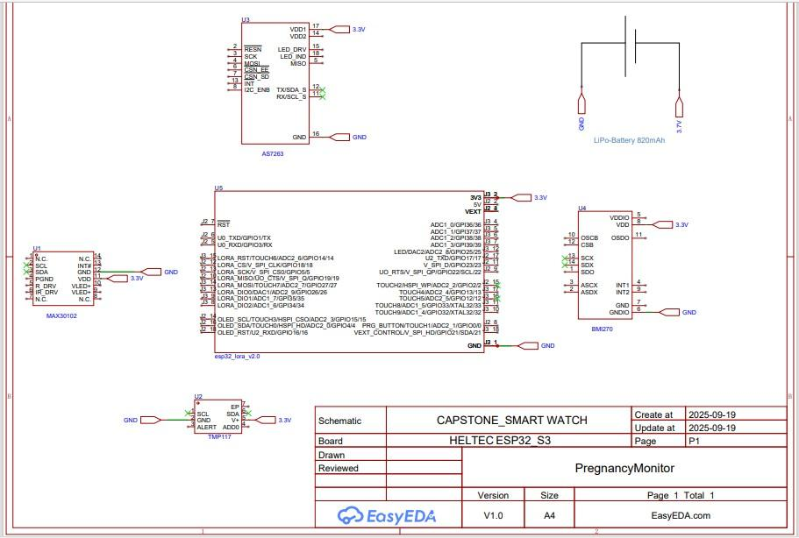

Figure 3. 10: Schematic Diagram

Figure 3.10 presents the detailed circuit schematic of the pregnancy monitoring device, showing the electrical connections between the sensors, the ESP32-S3 microcontroller, and the power supply system. The schematic highlights how the different biomedical sensors interface with the ESP32 board to form a fully functional wearable health monitoring system.
The MAX30102 pulse oximeter and heart rate sensor (U1) is connected through the I²C communication interface, making use of the SDA and SCL lines. These pins are crucial because they serve as the communication backbone, enabling bidirectional data transfer between the sensor and the ESP32 microcontroller. The SDA line carries the physiological data, while the SCL line provides the clock signal that synchronizes the transfer, ensuring accurate and reliable data communication. Similarly, the TMP117 digital temperature sensor (U2) is also interfaced via the I²C bus, connected through the same SDA and SCL lines, with an additional ALERT pin for interrupt-based signaling when critical thresholds are exceeded.
The AS7263 near-infrared spectral sensor (U3) is integrated through a Serial Peripheral Interface (SPI), which utilizes multiple pins including MISO, MOSI, SCLK, and chip select lines to establish high-speed communication with the ESP32. This sensor plays a vital role in biochemical parameter detection by analyzing spectral responses. Additionally, the BMI270 inertial measurement sensor (U4) is also included in the circuit, interfacing through SPI lines to provide motion and activity tracking data, which further supports maternal monitoring by correlating physiological readings with movement patterns.
At the center of the schematic is the ESP32-S3 microcontroller unit (U5), which serves as the main control hub. It manages all incoming sensor signals, performs preliminary data processing, and ensures proper communication with external devices and cloud servers through its built-in Wi-Fi and Bluetooth modules. The ESP32 is powered by a regulated 3.3V supply line, ensuring compatibility with the sensors, and shares a common ground across all components to maintain electrical stability.
The system is powered by a rechargeable 820mAh Li-Po battery, which supplies continuous energy to the wearable device, making it suitable for mobile and long-term use. The battery connections are clearly indicated in the schematic, with safety considerations for regulated voltage delivery to sensitive electronic components.
Overall, Figure 3.12 demonstrates how the biomedical sensors, the ESP32 microcontroller, and the power supply are integrated into a cohesive hardware design. The use of both I²C and SPI protocols allows multiple sensors to operate simultaneously without interference, with SDA and SCL being particularly important in establishing reliable data exchange for physiological monitoring. This schematic provides the foundation for implementing the pregnancy monitoring device as a compact and energy-efficient wearable system.

Hardware Flow Diagram
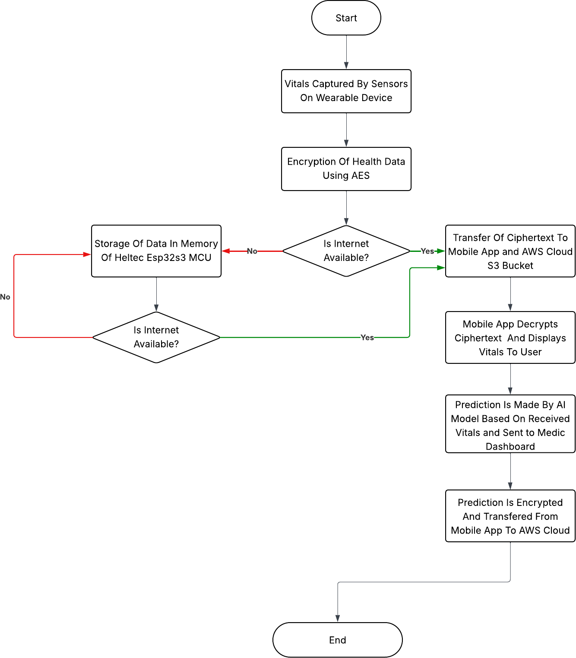

Figure 3. 11: Hardware Flow Diagram
Figure 3.11 illustrates the hardware flow diagram of the proposed system. The process begins with the capture of vital signs by sensors on the wearable device. Once the vitals are obtained, the system proceeds with the encryption of health data using AES to ensure privacy and security during transmission.
The flow then checks whether the internet is available. If internet connectivity is present, the encrypted data (ciphertext) is directly transferred to the mobile application and stored in the AWS Cloud S3 bucket. The mobile application then decrypts the ciphertext and displays the vitals to the user. Subsequently, an AI model generates predictions based on the received vitals and sends the results to the medic dashboard. These predictions are then encrypted and transferred from the mobile app to AWS Cloud for storage and further use.
On the other hand, if the internet is not available, the system stores the encrypted health data in the memory of the Heltec ESP32-S3 MCU. The MCU periodically checks for internet availability. Once the internet connection is restored, the stored data is transferred to the mobile application and AWS Cloud, following the same decryption, display, prediction, and encryption processes described earlier.

Machine Learning Model

Overview of Machine Learning in Maternal Health

In recent years, machine learning has become a powerful tool in almost every aspect of life with healthcare being no exception. It is mostly used in healthcare for diagnostics, treatment planning, drug discovery, and administrative tasks. For pregnant women, early detection of high-risk complications can significantly reduce complications and maternal mortality. In developing countries like Ghana, where access to healthcare can be limited due to various factors, integrating machine learning models into wearable technology can enable continuous remote health monitoring.
The main aim of this project was to design an integrated wearable system capable of monitoring pregnant women in real time. This part focused on the development and implementation of two machine learning models; one for detecting preeclampsia, and another for predicting the risk of anemia. These conditions were chosen because of its high contribution to maternal mortality in Ghana. The integration of machine learning into our system enhances decision making capabilities and also aligns with the digital health goals that advocate for smart care solutions.

Dataset Description
For the development of the machine learning models, we created two different datasets; one for predicting preeclampsia and the other for detecting the risk of anemia in pregnant women. Real world datasets were not readily available, the datasets were manually generated under the guidance of a practicing medical professional. This approach ensured that the variables we used were medically relevant and reflected real-world conditions encountered in antenatal care within Ghana.
The preeclampsia dataset was created using key maternal health indicators that are clinically associated with the condition. These included parameters such as systolic blood pressure, diastolic blood pressure, mild arterial pressure and level of protein in the urine. Additional features such as nausea, abdominal pain, dizziness, and headache were also incorporated in the form of a questionnaire, based on expert recommendations. This was done to ensure that in cases where certain vital signs appeared elevated but the patient was not experiencing preeclampsia, the doctor could still make a well-informed decision
The anemia dataset was generated to include nutritional and physical factors that affect the risk of anemia in pregnancy. With the help of a medic, the dataset included details such as history of heavy menstrual flow, short interpregnancy interval, multiple pregnancy, infections, chronic diseases, family history, body mass index, poverty, level of education, vomiting, diarrhea, age and access to healthcare.
With the help of the medic, the datasets were made to look like real patient records in the Ghanaian healthcare setting while still being medically correct. This made sure that the prediction models were trained on data that, even though created by us, was based on medical knowledge and represented the type of patients the system is meant to help.

Features Collected

The datasets consisted of both numerical and categorical features that are clinically relevant to the prediction of preeclampsia and anemia. Below is a summary of key features:

Preeclampsia Dataset Features:

- Systolic Blood Pressure (mmHg)

- Diastolic Blood Pressure (mmHg)

- Mean Arterial Pressure

- Proteinuria
Preeclampsia is a pregnancy-related hypertensive disorder that poses significant health risks to both the mother and the fetus if not detected and managed early. Its diagnosis is primarily based on elevated blood pressure levels and the presence of protein in urine, which serve as critical biomarkers for determining disease severity. In order to classify and assess the risk levels, defined thresholds are employed to distinguish between normal conditions, mild preeclampsia, moderate preeclampsia, and severe preeclampsia. Table 3.2 presents the threshold definitions adopted in this study, outlining the relationship between proteinuria levels and blood pressure ranges for each prediction status. This framework provides a standardized basis for interpreting sensor data and supports the early detection and categorization of preeclampsia severity in pregnant women.

Table 3. 2: Preeclampsia Threshold Definition

PREDICTION STATUS | PROTEIN IN URIA | BLOOD PRESSURE
NO PREECLAMPSIA | <2+
MILD PREECLAMPSIA | 2+ OR > | 114-124
MODERATE PREECLAMPSIA | 2+ OR > | 125-129
SEVERE PREECLAMPSIA | 2+ OR > | 130 OR >
In addition to the threshold definitions outlined in Table 3.2 above, there are other scenarios in which a pregnant woman may still face significant health risks. Our system is designed to account for such situations and will continue to trigger alerts whenever abnormal patterns or concerning conditions are detected, even if they fall outside the predefined threshold values.

Anemia Dataset Features:

- Excessive vomiting
- Diarrhea
- Heavy menstrual flow
- Infections
- Chronic disease
- Family history
- BMI
- Short interpregnancy interval
- Multiple pregnancy
- Age
- Poverty
- Lack of access to healthcare
- Education

Anemia is one of the most common pregnancy-related health complications, often resulting from multiple physiological, genetic, and socio-economic factors. Its occurrence can significantly affect maternal and fetal health, making it essential to identify and quantify the contributing risk factors. In this study, various features associated with anemia were considered, with each factor assigned a weight and contribution percentage to reflect its relative influence on the overall risk assessment. Table 3.3 presents the threshold definition for anemia, listing the key features such as history of heavy menstrual flow, short interpregnancy interval, multiple pregnancy, chronic conditions, and socio-economic determinants along with their corresponding weights and percentage contributions. This framework enables a systematic approach to assessing anemia risk by quantifying the impact of individual and combined factors.

Table 3. 3: Anemia Threshold Definition

FEATURE | WEIGHT | CONTRIBUTION (%)
HISTORY OF HEAVY MENSTRUAL FLOW | 6 | 18.18
SHORT INTERPREGNANCY INTERVAL | 4 | 12.12
MULTIPLE PREGNANCY | 4 | 12.12
INFECTIONS | 3 | 9.09
CHRONIC DISEASES | 3 | 9.09
FAMILY HISTORY | 3 | 9.09
BMI | 2 | 6.06
POVERTY | 2 | 6.06
EDUCATION LEVEL | 2 | 6.06
EXCESSIVE VOMITING | 1 | 3.03

DIARRHEA | 1 | 3.03
AGE | 1 | 3.03
LACK OF ACCESS TO HEALTH CARE | 1 | 3.03

Data Cleaning and Preprocessing

The datasets were synthetically generated, the initial data was clean and free from noise, missing values, and inconsistencies typically found in real-world clinical data. However, to ensure that the models performed well and mimicked a real-world environment, standard preprocessing steps were still applied:

  - Data Type Validation: Each feature was checked to ensure it was of the appropriate data type (e.g, integers for age, floats for MAP, and binary values for symptoms like excessive vomiting.

  - Physiological Range Verification: Although generated from medically informed thresholds, the datasets were cross-verified to ensure all values remained within biologically acceptable ranges (e.g, systolic BP between 90–200 mmHg).

  - Feature Scaling: Continuous variables were standardized using z-score normalization to ensure uniform feature contribution during model training.

  - Categorical Encoding: Binary categorical variables were encoded using label encoding to make them suitable for machine learning algorithms.

Feature Selection

Using synthetic data gave us full control over the design of features, meaning we could decide exactly what variables to include and how they should be represented. However, the choice of clinical features was not random. It was guided by expert advice from medical consultations to make sure that the dataset reflected real-world medical practice. Features were selected based on their importance in detecting preeclampsia and anemia, as identified by the medic. This process ensured that the datasets were not only technically well-structured but also clinically meaningful, making the predictions more reliable for use in maternal healthcare.

Model Architecture
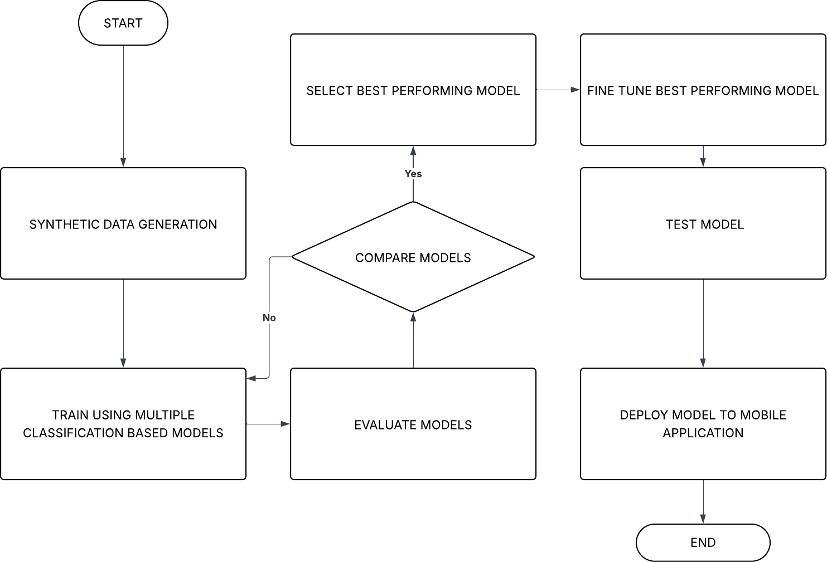

Figure 3. 12 : Machine Learning Workflow Diagram
Figure 3.12 presents the workflow for training and deploying the machine learning model used in the system. The process begins with synthetic data generation, which ensures sufficient and diverse training data for the model. The generated data is then used to train multiple classification-based models, each representing a different algorithmic approach.
Following training, the models undergo an evaluation phase to assess their performance based on predefined metrics. Once evaluated, the results are fed into a comparison stage, where models are compared to identify the most effective one. If none of the models meet the required standards, the workflow loops back to the training and evaluation stages for improvement.
When a best-performing model is identified, it is selected and subjected to fine-tuning in order to optimize its performance further. The fine-tuned model is then tested to validate its accuracy and robustness under practical conditions.
Finally, the validated model is deployed to the mobile application, making it available for real- world use in predicting outcomes from the health data collected by the wearable system. This completes the workflow, as shown in Figure 3.10.

Overview
Instead of relying on a single algorithm, seven of the most commonly used classification-based models were trained, evaluated, and compared. This approach ensured that the final deployed model was selected not just on popularity but on proven performance with our own dataset.
The models trained were:

- Logistic Regression

- Random Forest Classifier

- Support Vector Machine (SVM)

- Gradient Boosting Classifier

- Naive Bayes

- K-Nearest Neighbors (KNN)

- Decision Tree Classifier

Each model was trained separately for the preeclampsia and anemia prediction tasks using the same feature set, and preprocessing steps. After training, the models were evaluated using multiple performance metrics, including accuracy, precision, recall, and F1-score. The model with the best overall balance of these metrics was selected for each task.

Model Selection Strategy

All seven models were evaluated using a train-test split method, and 5-fold cross-validation was used to further validate model generalization. The best-performing model for each condition was selected based on the highest performance with recall having the highest priority because it is very important in medical diagnostics where false negatives can have serious consequences.
In order to develop an effective predictive framework for preeclampsia, multiple machine learning (ML) algorithms were evaluated and compared across several key performance metrics. These metrics included precision, recall, F1 score, training accuracy, test accuracy, validation accuracy, as well as computational considerations such as training time and prediction time. The goal of this comparative analysis was to identify the most suitable model that balances predictive accuracy with computational efficiency, ensuring reliable and practical deployment in a healthcare setting. Table 3.4 presents the results of this evaluation, highlighting the performance of logistic
regression, K-nearest neighbour (KNN), support vector machine (SVM), decision tree classifier, random forest classifier, gradient boosting classifier, and multilayer perceptron (MLP) classifier. By systematically analyzing these models, the study establishes a robust basis for selecting the optimal approach to preeclampsia risk prediction

Table 3. 4: Preeclampsia Model Selection

Metrics | Logistic Regression | K-Nearest Neighbour | Support Vector Machine | Decision Tree Classifier | Random Forest Classifier | Gradient Boosting Classifier | MLP  Classifier
Precision | 0.9746 | 0.9569 | 0.9634 | 0.9305 | 0.9584 | 0.9545 | 0.9664
F1 Score | 0.9745 | 0.9567 | 0.9633 | 0.9305 | 0.9582 | 0.9548 | 0.9664
Recall | 0.9745 | 0.9568 | 0.9634 | 0.9305 | 0.9535 | 0.9549 | 0.9666
Training Accuracy | 0.9700 | 0.9700 | 0.9690 | 1.0000 | 1.0000 | 0.9600 | 0.9703
Test Accuracy | 0.9710 | 0.9650 | 0.9745 | 0.9680 | 0.9680 | 0.9645 | 0.9675
Validation Accuracy | 0.9724 | 0.9590 | 0.9635 | 0.9301 | 0.9585 | 0.9550 | 0.9665
Training Time | 5.1027 | 0.0180 | 0.3880 | 0.0598 | 1.4372 | 7.0223 | 12.8828
Prediction Time | 0.0005 | 0.0004 | 0.4300 | 0.0010 | 0.0249 | 0.0300 | 0.0050
To develop a reliable and accurate predictive framework for anemia in pregnant women, a range of machine learning (ML) algorithms were implemented and assessed across multiple evaluation metrics. These included precision, recall, F1 score, training accuracy, test accuracy, validation accuracy, and computational efficiency parameters such as training and prediction times. The comparison of these models ensures not only the identification of the algorithm with the highest predictive accuracy, but also the most efficient and practical option for real-world deployment in healthcare systems. Table 3.5 presents the performance outcomes of various classifiers, allowing for a detailed comparison of their strengths and limitations. This systematic evaluation provides a sound foundation for selecting the most suitable model for anemia prediction, balancing both accuracy and resource efficiency.
Table 3. 5: Anemia Model Selection

Metrics | Logistic Regression | K-Nearest Neighbour | Support Vector Machine | Decision Tree Classifier | Random Forest Classifier | Gradient Boosting Classifier | MLP  Classifier
Precision | 0.9572 | 0.6667 | 0.6934 | 0.3333 | 1.0000 | 1.0000 | 0.6923
F1 Score | 0.9474 | 0.2000 | 0.3333 | 0.3000 | 0.4078 | 0.7000 | 0.9000
Recall | 0.9000 | 0.3075 | 0.3334 | 0.3158 | 0.5714 | 0.8235 | 0.7826
Training Accuracy | 0.9833 | 0.8333 | 0.9690 | 1.0000 | 1.0000 | 1.0000 | 0.8958
Test Accuracy | 0.9458 | 0.8500 | 0.9225 | 0.9167 | 0.9000 | 0.9500 | 0.9167
Validation Accuracy | 0.9367 | 0.8500 | 0.8335 | 0.9133 | 0.8667 | 0.8833 | 0.9133
Training Time | 0.9367 | 0.8333 | 0.0040 | 0.3389 | 0.0044 | 0.3357 | 5.2377
Prediction Time | 0.0789 | 0.8500 | 0.0109 | 0.2245 | 0.0016 | 0.0028 | 0.2080

Multiclass Logistic Regression

Multiclass Logistic Regression is an extension of logistic regression designed to handle classification tasks involving more than two categories. In this project, the multinomial (softmax) approach was employed, where the model computes a separate linear function for each class and applies the softmax function to normalize these outputs into probabilities. This ensures that the predicted probabilities across all classes sum to one, providing a clear probabilistic interpretation. The model was trained by minimizing the cross-entropy loss function using gradient-based optimization. Predictions are made by selecting the class with the highest probability, making the approach both effective and interpretable for multiclass classification problems.
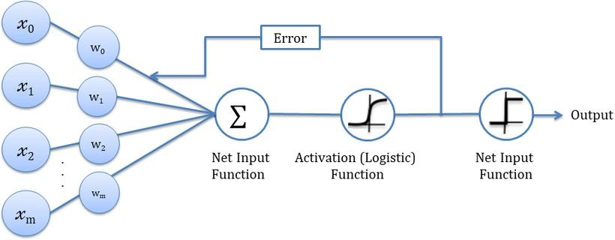

Figure 3. 13: Schematic Diagram of Multiclass Logistic Regression Classifier

Figure 3.13 illustrates the structure of a simple artificial neural network model. The inputs are combined through a net input function (summation unit), which calculates the weighted sum of the inputs.
The computed net input is then passed through an activation function, specifically the logistic (sigmoid) function in this case, which introduces non-linearity and determines the neuron’s output signal. The activated signal is further processed by another net input function, which generates the final output of the network.
Additionally, the figure highlights the concept of error correction, where the error between the predicted and expected output is fed back into the network to adjust the weights. This iterative adjustment is central to the learning process of the model.

Clinical Validation and Ethical Compliance Clinical Validation
To check how well our model works in practice, we validated it using real medical diagnosis records from Britannia Medical Center. We compared the system’s predictions directly with the diagnoses made by doctors at the hospital. This gave us a clearer picture of how the model performs in real healthcare situations, not just in controlled test environments.
The results showed that the model matched clinical outcomes in most cases. The only exception occurred in the anemia prediction, where the model classified one case as moderate instead of
mild. While this was a minor deviation, it pointed out areas where the system could still be improved.
Overall, this validation confirmed that our AI model is not only technically accurate but also clinically meaningful, making it a strong candidate for real-world medical use.

Patient Data Protection

Given the sensitivity of healthcare data, patient privacy and security were treated as a critical requirement in this project. To safeguard confidentiality, every prediction made by the model was encrypted before being sent to the cloud, making sure no one could access or alter the information during transmission.
For storage, we used an Amazon Web Services (AWS) S3 bucket, chosen for its strong security features such as access controls, role-based permissions, and built-in encryption. This allowed us to keep medical predictions in a safe, scalable environment that meets international standards for data protection.
By combining encryption with secure cloud storage, the project ensured that patient data remained private, accurate, and compliant with healthcare data security best practices.

Bias and Fairness

In healthcare, bias happens when a model’s predictions unintentionally favor or disadvantage certain groups of patients. This usually occurs when the data used for training is unbalanced or not representative of the wider population. Ensuring fairness is very important, because biased models can result in unequal or even unsafe medical outcomes. In this project, the dataset was synthetically generated, which gave us the advantage of controlling the distribution of features. This meant the data could be balanced across different conditions, preventing any class from being underrepresented during training. However, synthetic data also has its limitations, since it cannot fully capture the complexity, variability, and demographic differences that exist in real-world patient populations. To address this, we validated the model by comparing its predictions with actual medical diagnoses from Britannia Medical Center. This helped confirm that the system’s outputs were in line with real clinical outcomes and reduced the potential bias that could arise from depending only on synthetic data. Looking ahead, expanding the dataset to include real medical records from diverse patient groups will be important to further improve fairness and ensure that the model can be generalized to a broader healthcare setting.

Explainability and Transparency

Specifically, after every prediction, the system generates a chart that visualizes the contribution of each feature to the severity of the detected complication. This visualization allows clinicians to see which factors most strongly influenced the outcome, such as vital signs or clinical indicators, thereby making the prediction process more transparent.
By integrating this feature attribution chart, the system promotes accountability and interpretability, enabling healthcare practitioners to validate the model’s reasoning alongside their own clinical judgment. This approach not only increases trust but also supports collaborative decision-making between the AI system and medical experts.
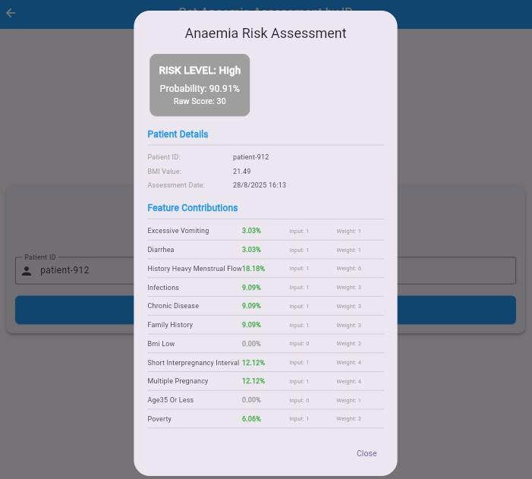

Figure 3. 14: Anemia Risk Assessment Diagram
Figure 3.14 illustrates the anemia risk assessment diagram, highlighting the process used to evaluate a user’s risk level.

Mobile Application

The mobile application is developed using Flutter for frontend and NestJS for backend. The mobile application shows the vitals of the pregnant woman, shows prediction of the pregnancy complications such as preeclampsia and anemia as well as display glucose values to indicate the likelihood that a pregnant woman is developing Gestational Diabetes Mellitus. Four roles exist which include: Pregnant Woman, Medical Professional, System Administrator and a family relative who can only have entry into the app only if a pregnant woman registers him or her on the application. Below are some of the functionalities the mobile application named as “Awopa” which when translated to English Language implies Safe Pregnancy”.

Pregnant Woman

  - The pregnant woman inputs her last menstrual period date which is used to calculate how many weeks she is pregnant.
  - The pregnant woman can create, cancel and reschedule an appointment with a medical professional
  - The pregnant woman can interact with a chatbot to which she gets answers to all her questions.
  - The pregnant woman enters her protein in urine value read after using the urine dipstick. This data is sent to the preeclampsia machine learning to predict the possibility of the complication developing.
  - The pregnant woman can view vital values of blood pressure, heart rate, body temperature, blood glucose and oxygen saturation from the mobile application.
  - The pregnant woman can view all medical professionals' profiles to enable her to decide which medical officer she wants to have a virtual consultation with.
  - The pregnant woman inputs preeclampsia pregnancy complication symptoms such as whether or not she feels headache, dizziness, vomiting and nausea and pain at the top of the tummy.
  - The pregnant woman can send SMS notifications for emergency alert purposes.

  - The pregnant woman can subscribe to receiving pregnancy tips on the whats and whatnot during each trimester of the pregnancy.
  - The pregnant woman can view the nearest healthcare facilities in a vicinity.

  - The pregnant woman can view in-app notifications
  - The pregnant woman can manage settings such as creating, editing and deleting a pin as well as resetting a password.
  - The pregnant woman can input pregnancy health information of all pregnancies prior to her current pregnancy.
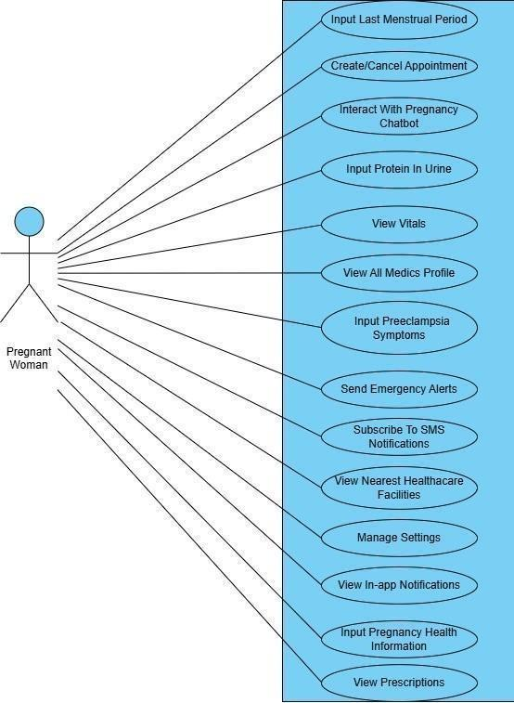

Figure 3. 15: Use Diagram Of Pregnant Woman
Figure 3.15 illustrates the use case diagram for a pregnant woman, showing the interactions between the user and the system.

System Administrator

  - The System Administrator can view all users on the mobile application and whether they are verified or not.
  - The System Administrator can create, edit and delete all notifications on the mobile application
  - The System Administrator can respond to all requests that have been sent on the mobile application.
  - The System Administrator can input pregnancy health information of all pregnancies prior to her current pregnancy.

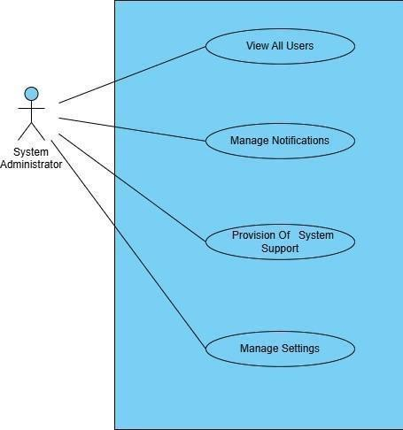

Figure 3. 16: Use Case Diagram Of System Administrator
Figure 3.16 illustrates the use case diagram of the system administrator, outlining the administrator’s interactions with the system

B. Medical Professional
- The medical professional can have a real-time chat with a pregnant woman

- The medical professional can view all preeclampsia symptoms that are input by the pregnant woman.
- The medical professional can view all blood glucose values of a pregnant woman per hour each day.
- The medical professional can view pregnancy health information input by the pregnant woman.

- The medical professional can view all in-app notifications.

- The medical professional can make a system request.

- The medical professional can manage settings such as creating, editing and deleting a pin as well as resetting a password.
- The medical professional can manage settings such as creating, editing and deleting a pin as well as resetting a password.
- The medical professional can create, reschedule or delete antenatal visits or medical appointments.
- The medical professional can view the vitals of a pregnant woman.

- The medical professional can view predictions of preeclampsia complications on a biweekly basis, blood glucose values one hour each day and prediction of possibility of occurrence of anemia.
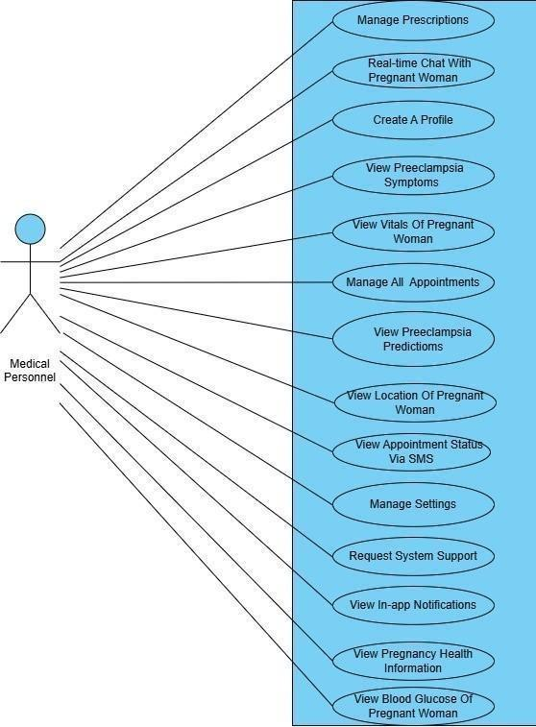

Figure 3. 17: Use Diagram Of Medical Professional
Figure 3.17 illustrates the use case diagram of the medical professional, showing the interactions between the professional and the system
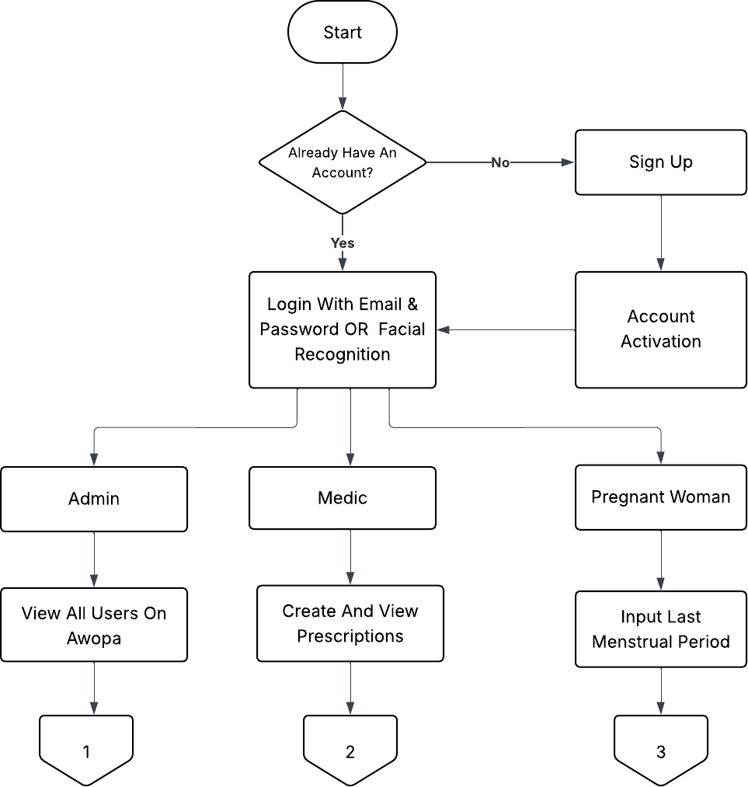

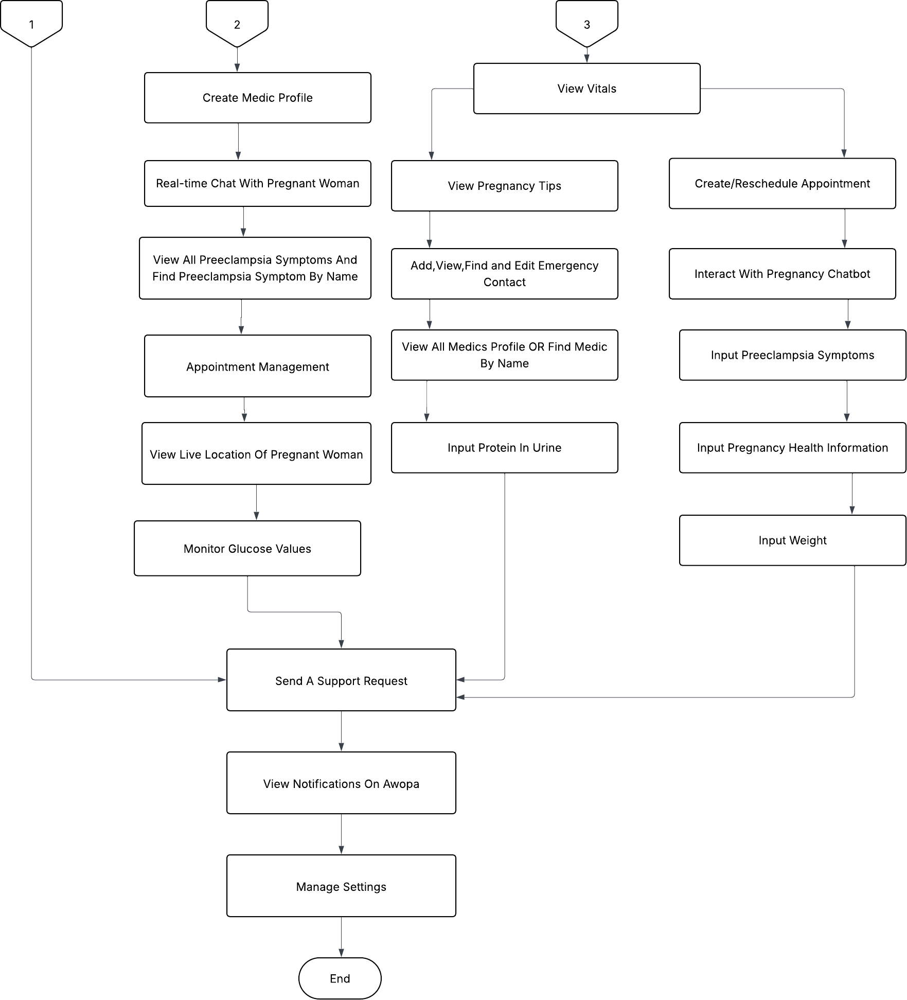

Figure 3. 18: Flow Diagram Of Mobile Application
Figure 3.18 illustrates the flow diagram of the mobile application, outlining the sequence of processes within the app

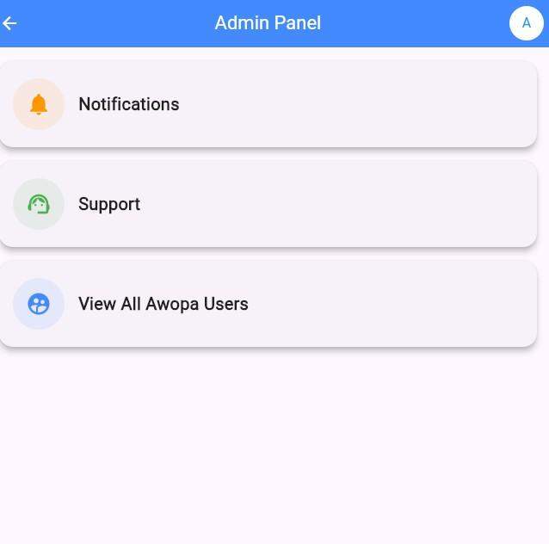

Figure 3. 19: System Administrator Dashboard
Figure 3.19 illustrates the system administrator dashboard, displaying the interface for managing and monitoring system operations.
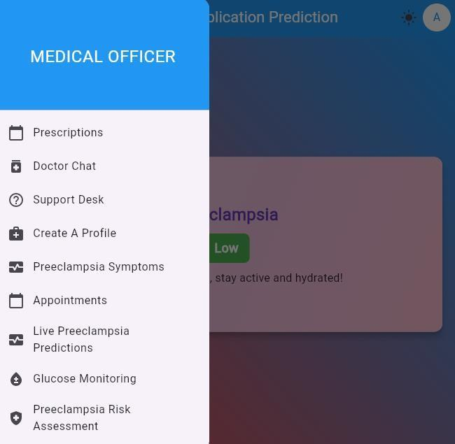

Figure 3. 20 Medical Professional Dashboard
Figure 3.20 illustrates the medical professional dashboard, providing the interface for accessing and analyzing patient health data.
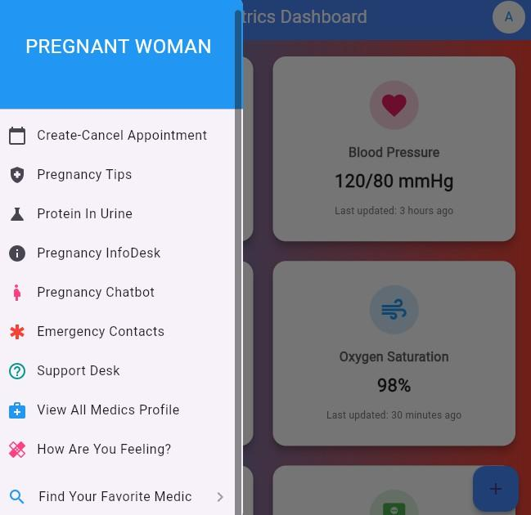

Figure 3. 21: Pregnant Woman Dashboard
Figure 3.21 illustrates the pregnant woman dashboard, presenting the interface through which users can monitor personal health information
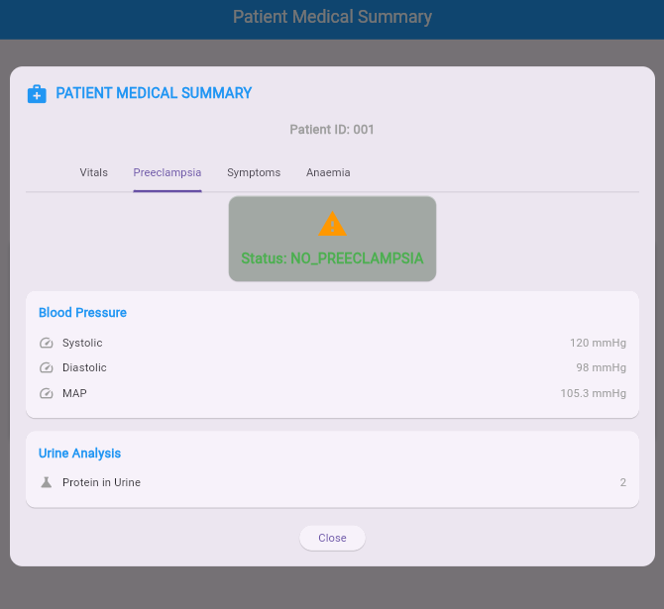

Figure 3. 22 Real-time Preeclampsia Prediction
Figure 3.22 illustrates the real-time preeclampsia prediction module, showing the process used to analyze data and generate risk alert
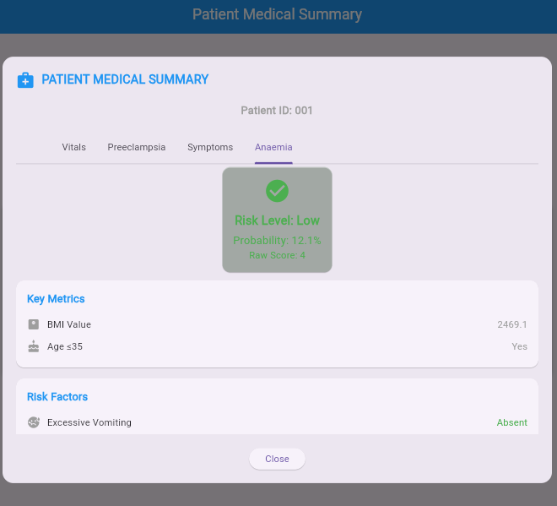

Figure 3. 23: Real-time Anemia Prediction
Figure 3.23 illustrates the real-time anemia prediction module, outlining the process used to analyze health data and provide risk assessment
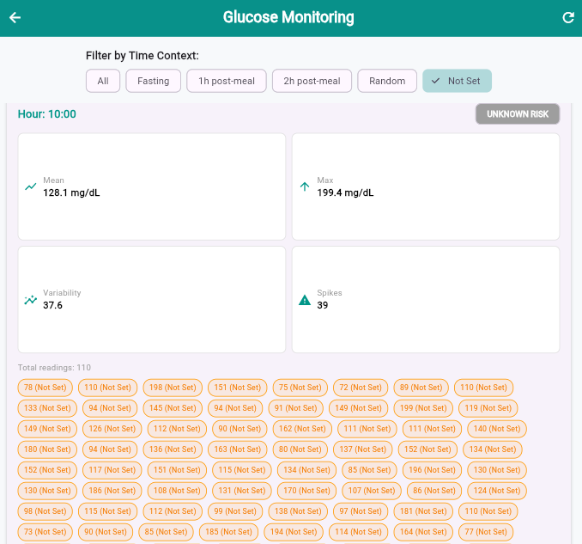

Figure 3. 24: Real-time Blood Glucose Values Monitoring
Figure 3.24 illustrates the real-time blood glucose monitoring module, showing how glucose values are tracked and displayed

System Modelling and Simulations
System modeling and simulation are fundamental techniques used in engineering to understand, analyze, and predict the behavior of complex systems. They offer powerful tools for examining systems that may be too complicated, costly, or risky to investigate through direct means thus helping to explore various scenarios and make informed decisions prior to real-word experimentation.

Modeling:
Modeling gives a deeper understanding of how a system operates, enabling predictions of its behavior under varying conditions. Modeling points out important variables and their relationships, supporting effective problem-solving, optimization of a system and informed decision-making.

Simulation:
Simulation offers a way to examine hypothetical situations, evaluate assumptions, and observe how modifications or interventions might influence a system. It also serves as a powerful tool for analyzing risks, designing systems, enhancing training and support of strategic decisions.
In this project, Solidworks Software is used for the Computer Aided Design (CAD) hence the modelling aspect of the wrist wearable device. The wearable device is simulated however on the Wowki Platform integrated with PlatformIO within the Visual Studio Code (VS Code) environment.
After modeling and simulating the wearable device, data from the simulation is sent to a cloud platform called Beeceptor. Beeceptor is a fast, flexible, no-code solution for mocking APIs and intercepting HTTP traffic. This cloud platform was ideal for development workflows of the wearable device as it received real-time data of vitals from the simulation in Wokwi simulator and biodata such as gestational week from the mobile app. Beeceptor was used for temporary data storage purposes in this project where a url was used in the simulation code to send the real- time data to beeceptor.
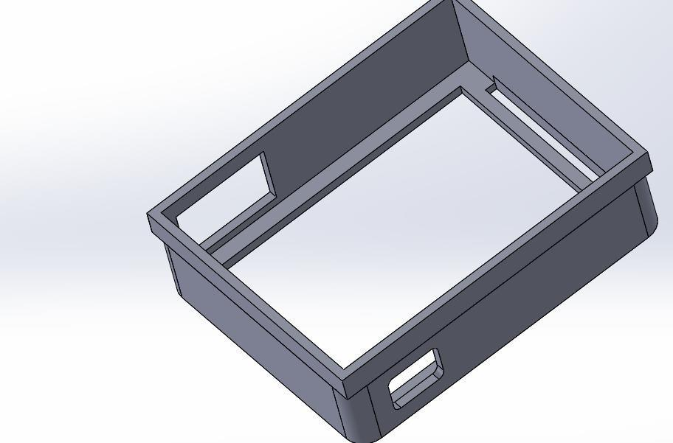

Figure 3. 25: Simulation Of Casing Of Wearable Device

Figure 3.25 illustrates the simulation of the wearable device casing, showing the design and structural layout of the enclosure



Figure 3. 26: Simulation Of Cover Of Wearable Device

Figure 3.26 illustrates the simulation of the wearable device cover, depicting the design and protective structure of the outer layer


Figure 3. 27: 3D Simulation Of Fastener Of Wearable Device
Figure 3.27 illustrates the 3D simulation of the wearable device fastener, showing the design and attachment mechanism.
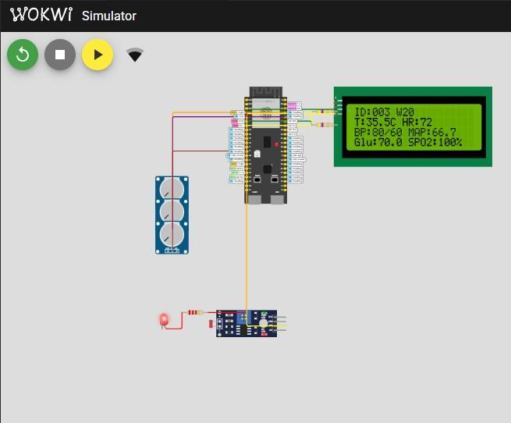

Figure 3. 28: Wokwi Simulation Of Wearable Device

Figure 3.28 illustrates the Wokwi simulation of the wearable device, demonstrating the virtual implementation of the system’s design
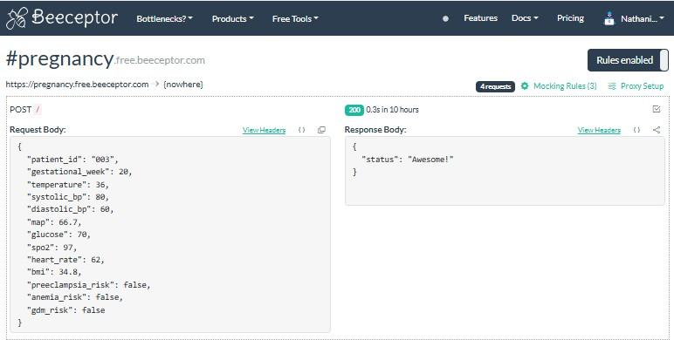

Figure 3. 29: Real-Time Data Received From Simulation In PlatformIO

Figure 3.29 illustrates the real-time data received from the wearable device simulation in Platform IO, showing system output during operation.

Development Tools And Material Requirements
    - Software For Wearable Device
1.PlatformIO in Vscode : PlatformIO, integrated within Visual Studio Code (VSCode), was used as the development environment for programming the ESP32-S3 microcontroller. This setup provided an efficient workflow for writing, compiling, and uploading firmware, with built-in support for debugging, library management, and serial monitoring. The combination of PlatformIO and VSCode allowed for streamlined development and testing of the wearable device's embedded system features.

Tools For Wearable Device
- Heltec ESP32-S3 Microcontroller Unit
- 3.7V Lithium Polymer (LiPo) battery
- Max30102 Sensor
- AS7263 Sensor
- TMP117 Sensor
- BMI270 Sensor

Technologies for AI model
- Jupyter Notebook
- Python Programming Language
- Pandas 4.NumPy
- Sci-Kit Learn
- Standard Scaler

Technologies for Mobile Application
1.Flutter 2.NestJS 3.MongoDB 4.LangChain
5. WebSockets 6.Docker 7.Redis 8.ElasticSearch
- Firebase Cloud Messaging
- Apache Kafka
- Face-api.js
- AWS S3 Buckets

Chapter Four – Design Implementation and Testing

Introduction

In the pursuit of improving maternal healthcare and reducing pregnancy-related complications, this project presents the design and implementation of an IoT-based fog-assisted health monitoring system tailored for expectant mothers. This chapter explores the processes of system design, implementation, and testing, which together form the foundation of this innovative healthcare solution.
At the heart of the system lie three fundamental components: the wearable sensor unit, the fog computing layer, and the cloud and mobile application interface. These subsystems work in synergy to create a seamless and reliable platform for monitoring key physiological parameters of pregnant women, enabling the early detection of life-threatening complications such as preeclampsia, anemia, and gestational diabetes.
This chapter provides an in-depth examination of how these components integrate to form a comprehensive maternal health monitoring solution. It is structured into five main sections: the design framework, which outlines the conceptual structure of the system; the design implementation process, detailing the practical deployment and integration of devices and computing resources; the testing design and results, where the system is assessed under real- world conditions; the discussion of results and analysis, which interprets the outcomes in the context of maternal healthcare delivery; and finally, the limitations and constraints, where challenges faced during the study are critically reviewed to inform future enhancements.
Through this structured approach, the chapter not only highlights the technical contributions of the proposed system but also emphasizes its potential impact in addressing one of the most pressing public health concerns thus reducing pregnancy-related complications and improving maternal outcomes in developing nations.

The design Framework

The project is designed to interplay three fundamental sub-divisions: Sensor Sub-division, Fog Computing Sub-division, and Cloud & Mobile Application Sub-division. Each sub-division plays a crucial role in ensuring the seamless collection, processing, and utilization of health- related data for pregnant women, thereby enabling timely detection of pregnancy-related complications.
The Sensor Sub-division consists of wearable devices embedded with multiple physiological sensors capable of measuring vital parameters such as body temperature, blood pressure, blood glucose levels, heart rate, and oxygen saturation. These sensors act as the first point of contact with the expectant mother, continuously capturing critical biomarker data in real time.
The Fog Computing Sub-division functions as the intermediary between the wearable sensors and the cloud. Serving as the system’s processing hub, the fog node carries out preliminary analysis of the collected data using predictive algorithms to identify early signs of pregnancy- related complications such as preeclampsia, anemia, and gestational diabetes. By performing computation closer to the data source, this sub-division reduces latency, ensures faster response times, and minimizes the burden on cloud infrastructure.
The Cloud & Mobile Application Subdivision acts as the command and control center. It receives refined data and predictions from the fog layer for long-term storage, deeper analysis, and secure sharing. Through role-based access controls, authenticated healthcare professionals and patients can access a user-friendly mobile application that provides real-time health insights, historical trends, and alerts. This ensures that timely interventions can be made when potential complications are detected.
Together, these three sub-divisions form a cohesive system that bridges the gap between pregnant women and healthcare providers, delivering reliable maternal health monitoring and fostering improved outcomes for both mothers and infants.

Design Implementation Process
    - System Setup On Breadboard for Testing

The hardware setup for this project involves interfacing four biomedical and motion sensors; MAX30102, AS7263, BMI270, and TMP117 with the Heltec ESP32-S3 microcontroller. Each of these sensors communicates over the I²C protocol and is equipped with four primary pins: VIN (power supply), GND (ground), SCL (clock line), and SDA (data line). For consistency and ease of integration, all sensors are mounted on a breadboard and powered from the 3.3V output of the ESP32-S3 module. The VIN pins of the sensors are connected in parallel to the 3.3V (3V3) pin of the ESP32-S3, while all GND pins are connected to the common ground of the microcontroller. Similarly, the communication lines are shared across the I²C bus: all SDA pins of the sensors are tied together and connected to GPIO 41 (SDA) of the ESP32-S3, and all SCL pins are tied together and connected to GPIO 42 (SCL) of the ESP32-S3. This wiring ensures that multiple sensors can operate simultaneously on the same bus, with each sensor distinguished by its unique I²C address. The breadboard arrangement provides a clean and modular test setup, allowing reliable power distribution and communication between the microcontroller and the sensors. This configuration was specifically implemented for the testing of all the sensors with the MCU, serving as a validation stage before integration into the final wearable prototype.
Figure 4.00 below illustrates the breadboard connection of sensors to the microcontroller, showing the wiring layout for system integration.
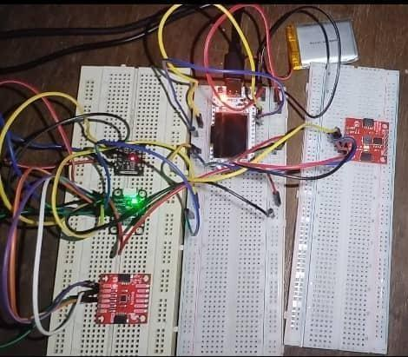
Figure 4. 1: Breadboard Connection Of Sensors To MicroController

Soldering Of System Components On Perfboard
Following successful testing of the sensors on the breadboard, the next stage of hardware implementation involved transferring the connections onto a perforated board (perfboard) to create a more robust and permanent circuit. The same wiring scheme established during the breadboard testing was replicated: the VIN pins of the MAX30102, AS7263, BMI270, and TMP117 sensors were soldered in parallel to the 3.3V power rail of the Heltec ESP32-S3, while all GND pins were connected to a common ground line. The SDA lines of the sensors were soldered together and routed to GPIO 41 (SDA) of the ESP32-S3, and the SCL lines were soldered together and connected to GPIO 42 (SCL). This maintained the I²C bus configuration, ensuring that all sensors continued to share the same communication lines while being uniquely identified by their I²C addresses.
The use of a perfboard provided a stable and durable platform, reducing the likelihood of loose connections compared to the breadboard setup. Figure 4.01 illustrates the connection of sensors to the microcontroller on a perfboard, showing the organized hardware implementation. Careful soldering practices were employed to minimize noise and cross-talk between adjacent tracks,
which is especially important for sensitive biomedical signals. By transferring the tested prototype onto the perfboard, the hardware was made compact, reliable, and suitable for integration into the wearable system enclosure. This soldered configuration served as the finalized hardware implementation, ready for long-term operation and further testing in real-world conditions.

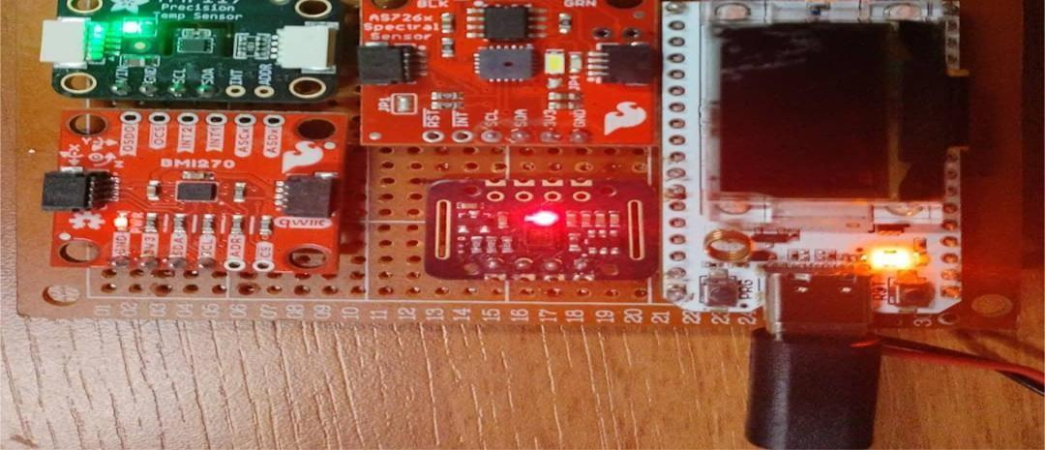

Figure 4. 2: Connection Of Sensors To MicroController On Perfboard

Packaging Of Components

To complete the hardware integration, a protective casing was designed and implemented for the wearable device. The purpose of the casing was to provide mechanical protection, portability, and user comfort, while also ensuring proper alignment of the sensors with the skin for accurate data acquisition. The casing was dimensioned to accommodate the Heltec ESP32-S3 microcontroller, the MAX30102, AS7263, BMI270, and TMP117 sensors, as well as the supporting circuitry soldered onto the perfboard.Figure 4.02 illustrates the wearable device enclosed in its 3D casing, showing the finalized design and assembly.Openings and cutouts were incorporated into the design to allow direct contact of the optical sensors (such as the MAX30102 and AS7263) with the skin surface, while still securing the other components firmly inside the enclosure
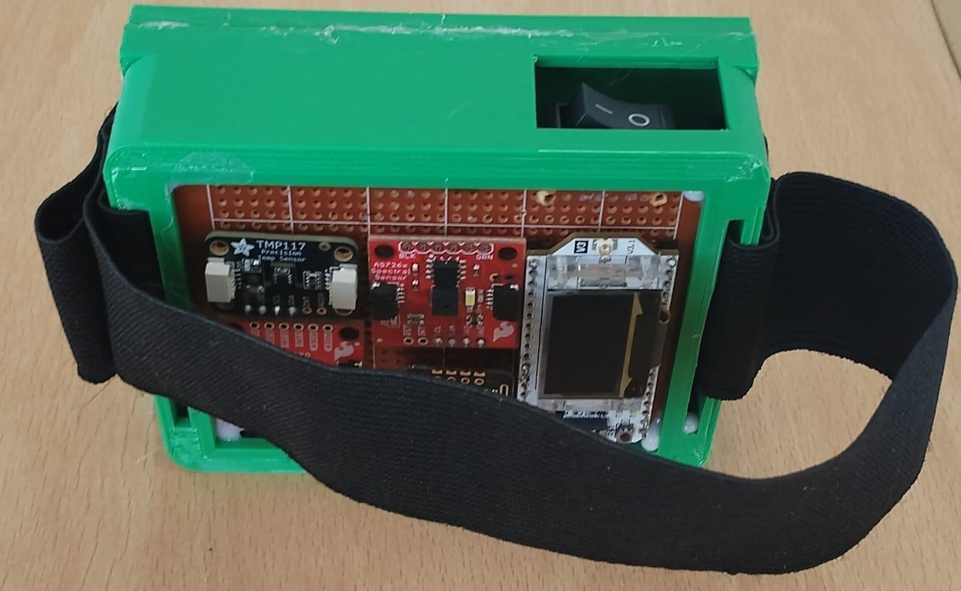

Figure 4. 3: Wearable Device In 3D Casing
To complete the hardware integration, a protective casing was designed and implemented for the wearable device. The purpose of the casing was to provide mechanical protection, portability, and user comfort, while also ensuring proper alignment of the sensors with the skin for accurate data acquisition. The casing was dimensioned to accommodate the Heltec ESP32-S3 microcontroller, the MAX30102, AS7263, BMI270, and TMP117 sensors, as well as the supporting circuitry soldered onto the perfboard. Openings and cutouts were incorporated into the design to allow direct contact of the optical sensors (such as the MAX30102 and AS7263) with the skin surface, while still securing the other components firmly inside the enclosure.

Software for Heltec Esp32s3 Microcontroller
The system’s firmware was developed in C++ programming language, which is widely adopted for embedded systems due to its balance of efficiency, hardware-level control, and support for object-oriented design. C++ provides the ability to manage resources in real-time, interact directly with hardware peripherals, and maintain scalability for complex applications. This makes it particularly suitable for IoT-based wearable systems that require both reliable performance and modular software design.
In this project, the Heltec ESP32-S3 microcontroller was programmed using PlatformIO as the primary development environment, integrated within Visual Studio Code (VS Code). PlatformIO was chosen because it provides a modern, flexible, and extensible ecosystem for embedded development. Unlike traditional Arduino IDE, PlatformIO supports advanced features such as dependency management, environment configuration, and integration with Git version control, all of which enhance productivity and maintainability of the codebase.
Additionally, PlatformIO enables fine-grained configuration of the ESP32-S3 hardware, including the WiFi and Bluetooth Low Energy (BLE) subsystems, I²C communication with biomedical sensors, and real-time task scheduling through the FreeRTOS kernel embedded in the ESP-IDF framework. This level of configurability ensures that the firmware can efficiently handle multiple concurrent sensor data streams while maintaining reliable wireless communication.
By leveraging C++ in PlatformIO, the firmware was structured into modular classes for handling individual sensors (MAX30102, AS7263, BMI270, and TMP117), system data processing, and wireless transmission. This approach not only improved code readability and scalability but also allowed easier debugging and future extensions of the wearable device’s functionality.
Lightweight and durable materials, such as 3D-printed plastic or acrylic sheets, were considered to ensure both strength and comfort for continuous wear. The casing also allowed ventilation to prevent overheating and included provisions for strapping or fastening to the wrist or arm, making the device suitable for practical wearable applications. By housing all components in a compact and ergonomic casing, the prototype was made user-friendly, durable, and field-ready, ensuring the transition from a lab-based prototype to a functional wearable healthcare device.

Machine Learning Model

      - Implementation:

The implementation of the machine learning model involved configuring the development environment, integrating the trained model into the mobile application backend, defining the system’s data flow, and executing the workflow for validation using actual medical diagnosis sample cases.

System Setup

The implementation was carried out in a Python-based environment using Jupyter Notebook, which provided an interactive platform for developing, testing, and documenting the model.
        - Programming Language: Python 3.x served as the primary language due to its extensive libraries for data science and machine learning.

        - Development Environment: Jupyter Notebook was used for its ability to support iterative experimentation, inline visualization, and reproducible workflows.
        - Libraries and Tools:

          - Pandas: For dataset handling and preprocessing.

          - NumPy: For numerical computations and array manipulations.

          - Scikit-learn: For machine learning functions, including dataset splitting, scaling, training, and evaluation.

          - StandardScaler: For normalizing features to ensure uniform contribution to the model.

          - Evaluation Metrics: Accuracy, precision, recall, and F1-score to assess performance.

          - Time Library: For measuring execution times during training and inference.

Model Integration

Once the model was trained and validated in Jupyter Notebook, it was integrated into the backend of a mobile application to enable predictions on new and unseen data. This step ensured that the model could function beyond the training environment and provide real-time outputs to end users.
- Data Preprocessing Integration:
The preprocessing steps, including scaling with StandardScaler, were incorporated into the backend pipeline. This ensured that any data received from the mobile application was transformed in the same way as the training data, preventing inconsistencies.

- Backend Workflow:
The trained model was serialized joblib and loaded into the backend service. A lightweight framework (e.g., Flask or FastAPI) exposed the model as an API endpoint, enabling communication between the mobile application and the backend. The workflow included:

  - User or sensor data collected by the mobile app.
  - Transmission of the data to the backend API.

  - Preprocessing of the incoming data using the same transformations as during training.

  - Model inference to generate predictions.

  - Return of the prediction results to the mobile application for display.

- Evaluation Integration:
During deployment testing, the model’s predictions were validated against known test cases using metrics such as accuracy, precision, recall, and F1-score. This confirmed that the model maintained its reliability outside the training environment.

- Reusable and Scalable Workflow:
The integration was designed to be reusable and scalable. The backend can support multiple prediction requests concurrently, and retrained models can be re-deployed to the backend without altering the mobile application.

Data Flow

The end-to-end flow of data in the implementation follows a systematic pipeline:

- Data Input: Raw datasets were imported into the system using Pandas.

- Preprocessing: Features were selected, scaled with StandardScaler, and the dataset was split into training and testing subsets.

- Model Training: The machine learning algorithm was trained on the training set, learning patterns between input features and target variables.

- Prediction Phase: The trained model generated predictions on unseen test data, which had been preprocessed through the same pipeline.

- Evaluation Phase: Predictions were compared with actual values, and performance metrics such as accuracy, precision, recall, and F1-score were computed.

- Output: The final predictions and evaluation results were presented as the system’s output, confirming the model’s effectiveness.
This structured data flow ensured reproducibility and reliability, making the system suitable for extension to larger datasets or real-world applications.

Model Evaluation

To test the workflow, we ran the full pipeline in Jupyter Notebook and also checked it with real hospital data. The dataset was loaded, preprocessed, and split into training and testing sets. The model was then trained and tested, and its predictions were compared with actual medical diagnosis results from the hospital. We measured performance using accuracy, precision, recall, and F1-score.
This showed that the model can work in real healthcare situations. The workflow was also made repeatable, so it can be used again with new hospital data or patient records. For example, if new medical data is added, the same pipeline can process it, scale the input, make predictions, and show performance results.

Final Model Deployment

After evaluation, the Logistic Regression model was selected for pregnancy complication predictions. The trained model was exported in a lightweight format using joblib and containerized with Docker for seamless deployment within the backend system built on NestJS. Model inference requests are routed through the backend, which communicates with the mobile frontend developed in Flutter.
To support real-time predictions, the system employs WebSockets and Apache Kafka for event- driven data streaming, ensuring low-latency analysis and timely delivery of health alerts. Alerts and notifications are distributed to end users via Firebase Cloud Messaging, while intermediate results and session states are cached using Redis to optimize performance. Patient records and diagnostic results are persistently stored in MongoDB, and ElasticSearch enables fast retrieval and querying of medical data.
Together, the deployment pipeline ensures robust real-time monitoring and reliable clinical decision support for pregnant women in Ghana.

Mobile Application

The system implementation includes a mobile and web application layer designed to provide seamless access to the wearable device’s health monitoring data. The mobile application frontend was developed using Flutter, a cross-platform UI framework by Google. Flutter was selected because it enables a single codebase deployment to both Android and iOS platforms, ensuring consistent user experience and reducing development effort. Its widget-based architecture allows
for highly customizable and responsive interfaces, which are particularly important for real-time visualization of biomedical data such as heart rate, blood oxygen saturation, glucose level, and blood pressure.
On the server side, the backend was implemented using NestJS, a progressive Node.js framework. NestJS was chosen due to its modular structure, scalability, and support for microservice-based architectures. By adopting a microservices approach, the backend system was divided into independent services responsible for tasks such as sensor data ingestion, preprocessing, analytics, authentication, and communication with the database. This design ensures fault tolerance, easier debugging, and scalability, as each service can be deployed and scaled independently based on demand.
In addition to the mobile application, a web application was developed using React.js, a popular JavaScript library for building dynamic and component-driven user interfaces. The React-based web client communicates with the same NestJS backend services, enabling healthcare providers or administrators to access the collected data through a secure, browser-based platform. This dual- access system ensures that both end-users (patients) and supervisors (doctors or researchers) can interact with the system in real time.
The integration of Flutter, NestJS, and React within a microservice-oriented architecture provides a robust and flexible software ecosystem. The mobile application delivers portability and accessibility, the backend ensures reliability and scalability, and the web application extends accessibility to larger screens for analysis and monitoring. Together, this architecture enables an end-to-end IoT healthcare solution that is modular, secure, and user-friendly.

Testing Design and Results

At this stage of the project, the machine learning model had been fully integrated into the software application, complete with a user-friendly interface that enabled live testing and interaction. The integration allowed predictions and classifications to be generated in real time, bridging the gap between the backend model and end-user functionality. In parallel, the wearable device successfully transmitted vital signs directly to the software, ensuring a seamless data pipeline from patient monitoring to decision-making. Testing was therefore designed not only to validate the performance of the machine learning model itself, but also to assess the reliability of data transmission, the responsiveness of the user interface, and the accuracy of predictions when evaluated against real or simulated medical cases. The results obtained from these tests provided insight into the overall effectiveness, usability, and robustness of the system in supporting maternal health monitoring.

Machine Learning model

To validate the performance of the machine learning model, predictions generated by the system were compared against real-life medical diagnoses obtained from Britannia Medical Center. The diagnostic outcomes provided by the medical experts served as the ground-truth reference, enabling an objective evaluation of the model’s accuracy and reliability. This comparison ensured that the model’s predictions were not only theoretically sound but also clinically relevant, reflecting its ability to generalize to real-world medical cases. A summary of the live testing comparison is presented in the table below.
To validate the effectiveness of the developed preeclampsia prediction model, it was tested against real-life clinical diagnosis data obtained from patients at BMC. The evaluation compared the model’s predictions with actual medical diagnoses, using key indicators such as systolic blood pressure, diastolic blood pressure, and protein levels in urine as input parameters. This testing process was essential to determine the reliability of the model in accurately identifying various stages of preeclampsia, ranging from mild to severe conditions. Table 4.1 summarizes the comparative results, highlighting the degree of alignment between the model’s output and the medical practitioners’ diagnosis. This comparison provides critical insights into the model’s diagnostic accuracy, robustness, and potential application in real-world maternal healthcare settings

Table 4. 1: Testing of Preeclampsia Model Against Real Life Diagnosis at BMC

SYSTOLIC BLOOD PRESSURE  (mmHg) | DIASTOLIC BLOOD PRESSURE  (mmHg) | PROTEIN IN URIA VALUE | PREECLAMPSIA MODEL PREDICTION | MEDICAL DIAGNOSIS
109 | 69 | 1 | NO | NO
105 | 55 | 2 | NO | NO
160 | 105 | 1 | NO | NO
149 | 100 | 2 | MILD | MILD
155 | 110 | 2 | MODERATE | MODERATE
140 | 90 | 2 | NO | NO
To further assess the effectiveness of the anemia prediction model, real-life patient data from BMC was used to validate its performance. The evaluation considered key risk factors such as history of heavy menstrual flow, short interpregnancy interval, and multiple pregnancy, which
were mapped against both the model’s predictions and clinical diagnoses made by medical practitioners. This comparison enabled a direct assessment of the model’s ability to correctly classify anemia severity levels ranging from mild to severe. Table 4.2 presents the results of this testing, highlighting the consistency between the anemia model predictions and actual medical diagnoses. The outcomes provide valuable insights into the reliability of the system in supporting early detection and intervention for anemia among women.

Table 4. 2 : Testing of Anemia Against Real Life Diagnosis at BMC

HEAVY MENSTRUAL FLOW HISTORY | SHORT INTERPREGNANCY INTERVAL | MULTIPLE PREGNANCY | ANEMIA MODEL PREDICTION | MEDICAL DIAGNOSIS
NO | NO | NO | MODERATE | MODERATE
YES | NO | NO | MILD | MILD
YES | NO | NO | MODERATE | MILD
NO | NO | NO | MODERATE | MODERATE
NO | NO | NO | MODERATE | MODERATE
YES | NO | NO | SEVERE | SEVERE
The results from the live testing demonstrated that the model consistently produced accurate predictions when compared with the medical diagnoses from Britannia Medical Center.
However, one exception was observed in the case of the anemia prediction model, where the system classified the condition as moderate instead of mild. Despite this single misclassification, the overall performance indicated strong alignment between the model’s outputs and the real-life diagnoses.

Mobile Application

To assess the usability, effectiveness, and overall user experience of the developed mobile application, a quantitative data-gathering approach was employed. A structured questionnaire was administered to a selected group of participants, focusing on key aspects such as functionality, ease of use, design, and satisfaction thus their overall experience of the user software. The purpose of this exercise was to obtain objective feedback that would guide evaluation and highlight areas for improvement.
The results of the questionnaire are summarized and presented in the figures/images below.

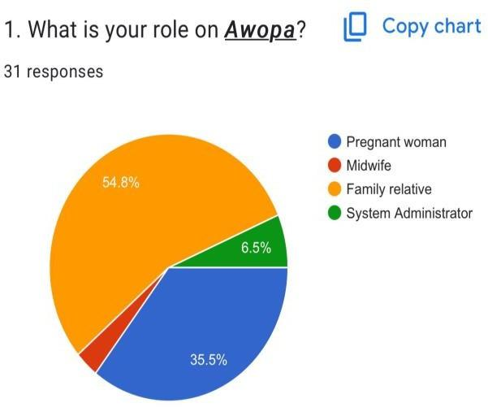  Figure 4.4 a | 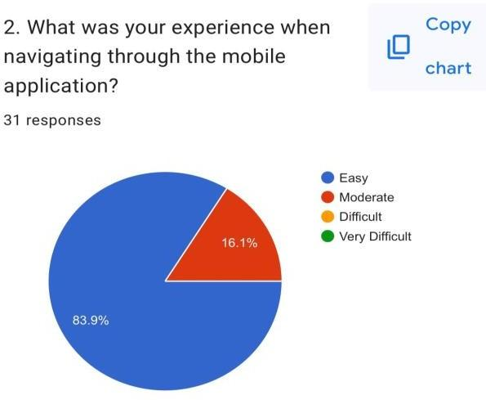  Figure 4.4 b

Figure 4. 4 a shows survey results on users’ roles in the mobile application, while Figure 4.4 b presents their navigation experience.

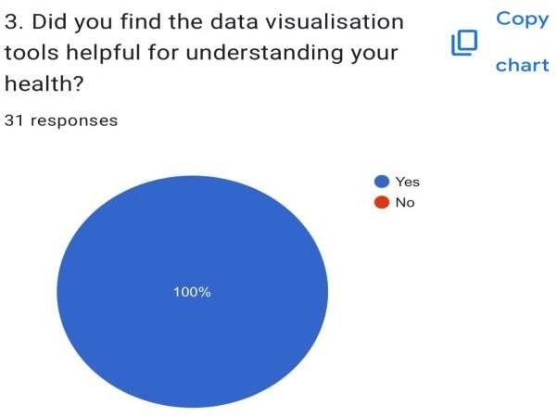  Figure 4.5 a | 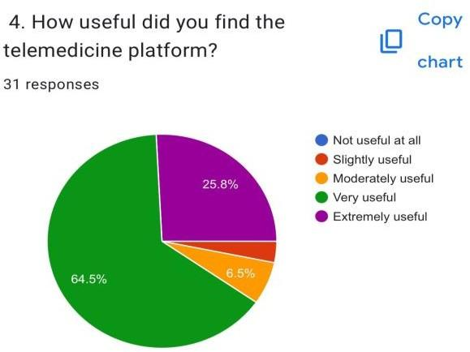  Figure 4.5 b

Figure 4. 5 a shows survey results on users’ perception of visualization tools, while Figure 4.5 b presents their views on the platform’s usefulness

Hardware Testing

A. COMPARISON OF WEARABLE DEVICE MEASUREMENTS AGAINST STANDARD REFERENCE DEVICES
During the testing phase, the team visited the University of Ghana (UG) Clinic to validate the accuracy of the wearable device. Vitals captured by the wearable device were directly compared with the readings obtained from the clinic’s standard medical devices, which served as the benchmark. The analysis showed that the highest variation recorded between the wearable and the standard devices was 5 units, while the lowest variation observed was 0.4 units. These results demonstrate that while minor discrepancies exist, the wearable device provides readings that are generally consistent with clinical-grade equipment, making it reliable for continuous health monitoring
In order to validate the accuracy and reliability of the developed wearable device, its measurements were compared against standard medical reference devices under real test conditions. The evaluation focused on vital signs including blood pressure, heart rate, oxygen saturation, body temperature, and blood glucose levels. By recording readings from both the wearable device and standard devices at the same time, the margin of deviation was calculated to assess the degree of accuracy achieved. This analysis ensures that the wearable device can provide clinically relevant results while remaining suitable for continuous health monitoring.
Table 4.3 presents the comparison of measurements taken on September 25th, 2025 at the University Of Ghana Health Clinic, showing the correspondence between wearable readings and those obtained from standard reference devices

Table 4. 3: Wearable Device Measurements Against Standard Reference Devices
Date and Time : 25th September, 2025 at 1:30pm

Vital Signs | Value From Standard Devices | Value From Wearable Device | Margin Deviation
Systolic Blood Pressure (mmHg) | 101 | 106 | -5
Diastolic Blood Pressure (mmHg) | 75 | 77 | -4
Heart Rate (bpm) | 84 | 79 | 5
Oxygen Saturation  (%) | 99 | 97 | 2
Body Temperature  (°C) | 36.3 | 35.7 | 0.6
Blood Glucose(mmol/L) | 4.7 | 4.5 | 0.2

Date and Time : 25th September,2025 at 3:40pm

Vital Signs | Value From Standard Devices | Value From Wearable Device | Margin Deviation
Systolic Blood Pressure (mmHg) | 103 | 100 | 3
Diastolic Blood Pressure (mmHg) | 73 | 74 | -1
Heart Rate (bpm) | 80 | 83 | -3
Oxygen Saturation  (%) | 97 | 94 | 3
Body Temperature  (°C) | 34.3 | 36.2 | -1.9
Blood Glucose(mmol/L) | 4.1 | 4.4 | -0.3

Date and Time : 25th September,2025 at 3:40pm

Vital Signs | Value From Standard Devices | Value From Wearable Device | Margin Deviation
Systolic Blood Pressure (mmHg) | 107 | 102 | 5
Diastolic Blood Pressure (mmHg) | 72 | 76 | -4
Heart Rate (bpm) | 80 | 77 | 3
Oxygen Saturation  (%) | 95 | 97 | 2
Body Temperature  (°C) | 35.2 | 36.3 | -1.1
Blood Glucose(mmol/L) | 4.5 | 4.1 | 0.4

VITALS DATA FROM WEARABLE DEVICE
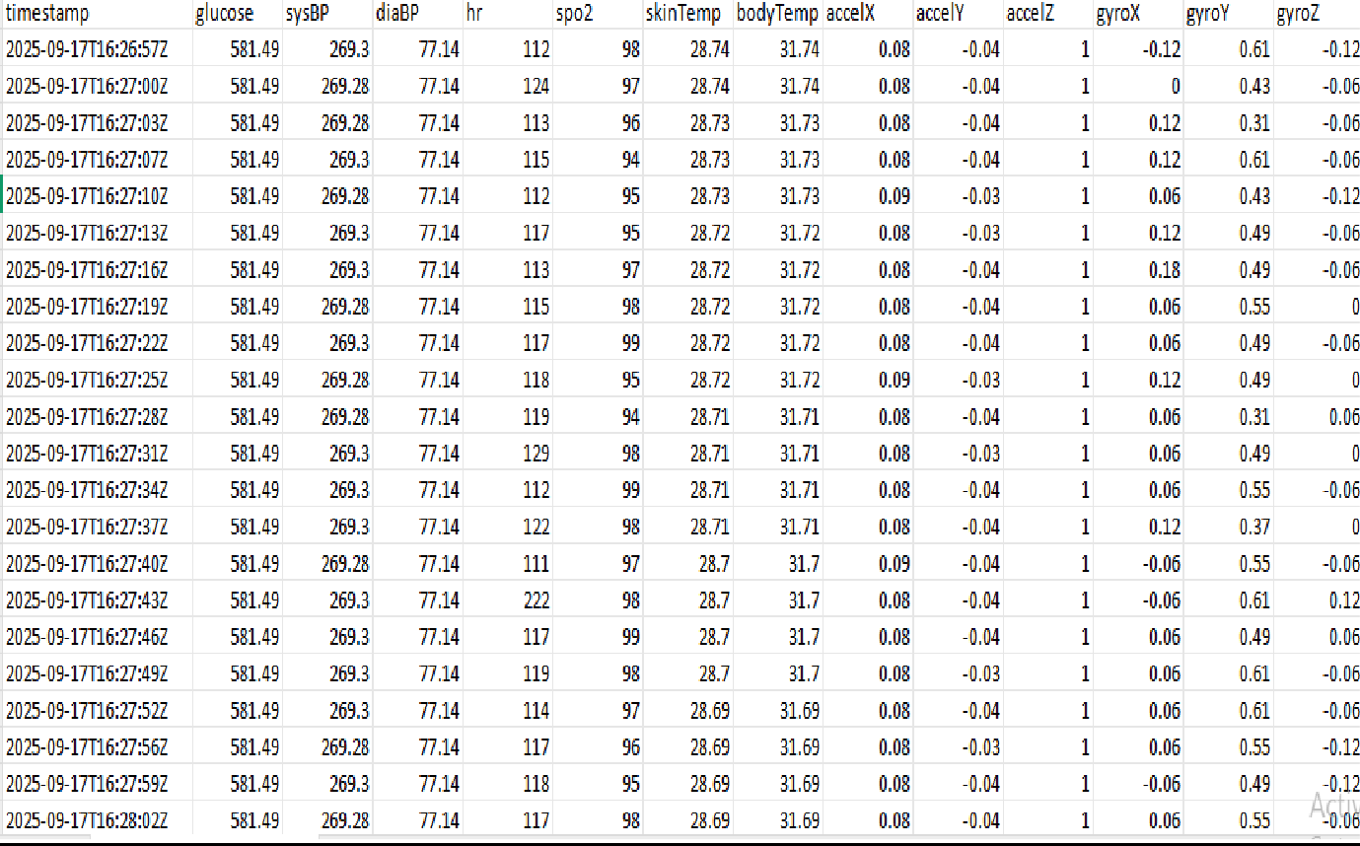

Figure 4. 6: Vitals Data From Wearable Device
Figure 4.07 illustrates the vitals data collected from the wearable device, showing the health parameters measured during operation

POWER CONSUMPTION BY COMPONENTS OF WEARABLE DEVICE

Efficient power management is a critical consideration in the design of wearable health monitoring devices, as it directly influences battery life and overall usability. To evaluate the energy efficiency of the developed system, the active and shutdown current consumption of each integrated biomedical sensor was measured. This analysis helps determine how much power is drawn during operation compared to low-power states, ensuring the device can support continuous monitoring without frequent recharging. Table 4.4 presents the power consumption values of the MAX30102, AS7263, BMI270, and TMP117 sensors, along with the total active and shutdown current for the wearable device

Table 4. 4: Power Consumption By Components Of Wearable Device

Sensor | Active Current(mA) | Shutdown Current(mA)
MAX30102 | 0.600 | 0.0007
AS7263 | 5.000 | 0.012
BMI270 | 0.685 | 0.0035
TMP117 | 0.0035 | 0.00015
Total | 6.2885 | 0.016
Table 4.4 above shows the active and shutdown currents of the MAX30102, AS7263, BMI270, and TMP117 sensors. The AS7263 draws the highest active current at 5.000 mA, while the TMP117 draws the least at 0.0035 mA. Total active and shutdown currents are 6.2885 mA and
0.016 mA, respectively, highlighting the device’s efficient power usage.

Thus the total Active Current is 6.289mA and the total Shutdown Current is 0.016mA. The calculation for battery life is thus given as:

Battery Life (hours) = ^{820𝑚𝐴ℎ}
6𝑚𝐴
≈ 130.4 hours

Discussion of Results and Analysis

The results obtained from the system implementation demonstrate the feasibility of integrating multiple biomedical and motion sensors into a single wearable platform. The MAX30102 sensor successfully captured heart rate and blood oxygen saturation (SpO₂) values, while the AS7263 multispectral sensor provided readings that could be correlated with blood glucose and blood pressure levels through data processing. The BMI270 sensor reliably detected motion and activity patterns, contributing to artifact reduction during signal acquisition, and the TMP117 sensor accurately measured skin temperature, further enhancing the reliability of biomedical parameter estimation.
From the testing phase, it was observed that the sensors interfaced seamlessly with the Heltec ESP32-S3 microcontroller over the I²C bus without conflicts, confirming the correct wiring and addressing scheme. The ESP32-S3 efficiently handled concurrent data streams and successfully transmitted processed data to the backend system via WiFi. This validates the choice of the
ESP32-S3 as a low-power yet high-performance MCU suitable for wearable IoT healthcare applications.
On the software side, the mobile application built with Flutter provided real-time visualization of the captured parameters, enabling continuous monitoring of the user’s vital signs. The backend services implemented in NestJS with a microservice architecture ensured modularity and scalability, while the React-based web dashboard provided additional accessibility for remote users such as healthcare providers. The data flow between the wearable device, backend, and client applications was consistent and reliable, confirming the robustness of the system architecture.
In terms of analysis, while the prototype demonstrated promising results in real-time monitoring, certain limitations were noted. For instance, signal noise due to motion artifacts affected the accuracy of optical sensor readings in some cases, particularly during vigorous physical activity. This suggests the need for further refinement of signal processing algorithms and filtering techniques. Additionally, the AS7263 sensor outputs require calibration against clinical-grade equipment to improve the precision of glucose and blood pressure estimation.
Overall, the findings indicate that the developed wearable system is capable of performing non- invasive, multi-parameter health monitoring in real time. The integration of multiple sensors, coupled with cloud-connected applications, demonstrates the potential of the system to support IoT-based remote healthcare solutions. With further optimization and clinical validation, this wearable device could significantly enhance patient self-monitoring and early detection of health anomalies.
The total active current consumption of the integrated sensor system was determined to be 6.289 mA, while the shutdown current was significantly lower at 0.016 mA, indicating that the system conserves energy effectively when not in active operation. This contrast between active and shutdown states highlights the efficiency of the power management strategy employed.
To evaluate the expected operational lifetime of the device, the battery life was calculated using a standard 820 mAh Li-ion cell. The calculation is expressed as:

Battery Life (hours) = ^{820𝑚𝐴ℎ}
6𝑚𝐴
≈ 130.4 hours
This result suggests that under continuous active operation, the device can sustain functionality for approximately 130 hours (about 5.4 days) before requiring a recharge. In practice, however, the operational lifetime could be even longer, depending on the system’s actual duty cycle and how often it remains in shutdown mode versus active measurement mode.
From a design perspective, these findings confirm that the system is capable of meeting the requirements for short- to medium-term wearable health monitoring applications without frequent recharging. Moreover, the very low shutdown current (0.016 mA) implies that standby periods will contribute negligibly to battery drain, further improving practical usage time.
Overall, the analysis demonstrates a balance between performance and energy efficiency. The device achieves reliable operation while maintaining battery longevity, making it suitable for real-world deployment where extended usage without frequent charging is essential.

Security Implementation

To ensure the confidentiality, integrity, and availability of sensitive maternal health data, robust security mechanisms were implemented in compliance with established healthcare data protection standards such as HIPAA (Health Insurance Portability and Accountability Act).
Multiple layers of authentication, authorization, and encryption were incorporated to safeguard data both at rest and in transit.

The following subsections outline the mechanisms applied to enforce authentication, authorization, confidentiality, integrity, and availability within the proposed system
- User Authentication and Access Control:

Access to the mobile application was restricted through a 6-digit Personal Identification Number (PIN), which users must enter before gaining access to any pregnant woman’s health records. In addition, a facial recognition system was integrated as part of the “What You Have” principle, ensuring that only the authorized individual can access the system through biometric verification. As an alternative, users were also provided with the option to log in using a secure email and password combination, thereby enabling multi-modal authentication methods. These mechanisms reinforce the principle of authentication by verifying the identity of the user prior to granting system access.
- Data Encryption and Secure Communication:
To protect the confidentiality of health data, Advanced Encryption Standard (AES) encryption was employed at multiple stages of the system. Sensor data captured from the wearable device was encrypted before transmission to the mobile application, ensuring that no unauthorized entity could intercept or modify the data during transit. Similarly, prediction results generated by the mobile application were also encrypted prior to transmission to the AWS cloud platform, where secure storage was maintained. This implementation upholds both data confidentiality and data integrity.
- Cloud Storage Security:
The AWS cloud platform was utilized for secure storage of health records and analytical results. AWS provides compliance with international healthcare security standards and ensures data redundancy, availability, and disaster recovery. Data stored in the cloud was encrypted, with access limited strictly through authenticated and authorized users. This guarantees adherence to the principles of authorization and availability, ensuring that sensitive health information is only accessible to legitimate users at all times.
The security framework of the system was guided by well-established information security principles, ensuring that data and user interactions remained protected at all times. These principles are outlined as follows:
Core Security Principles:
The security framework implemented in this system adhered to the following principles:

  - Authentication: verifying user identity through PIN, facial recognition, or email/password.

  - Authorization: restricting access to sensitive health data based on user roles and credentials.

  - Confidentiality: protecting health information through AES encryption and secure cloud storage.

  - Integrity: ensuring data is not altered or tampered with during transmission or storage.

  - Availability: maintaining reliable access to health data through AWS secure cloud infrastructure.

Limitations and Constraints

The core of this project is the use of wearable sensors, fog computing, and cloud integration for real-time monitoring of pregnancy-related complications. While the system demonstrates significant potential, it also has certain limitations and constraints that affect its overall performance:
- Acquisition of Real-World Data: Collecting real physiological data from pregnant women posed a major challenge. Issues such as participant recruitment, consent procedures, inconsistent device usage, and sensor noise affected the quantity and quality of available data. This limitation reduced the scope of testing and restricted the ability to fully
validate the system under diverse real-world conditions.

- Slow Virtual Consultation Functionality: The virtual consultation feature between the medical practitioner and the pregnant woman was affected by network latency. Poor bandwidth and processing delays caused consultations to load slowly, impacting the real- time interaction and limiting the system’s effectiveness in providing timely medical advice during urgent cases.

- Library Installation on Smaller MCU: The use of a smaller and relatively new microcontroller (MCU) presented difficulties in installing and running required libraries. Memory and processing limitations constrained the system’s ability to support advanced functionalities, forcing compromises on performance and adding to the development time.

Chapter 5 – Conclusion and Recommendation

Introduction

This project aimed to design, implement, and evaluate an IoT-based, fog-assisted maternal health monitoring system for the early detection of pregnancy-related complications. This chapter evaluates the system in relation to the project objectives, highlighting how the integration of wearable sensors, fog computing, and cloud services enables continuous monitoring of vital physiological parameters in expectant mothers. The system has demonstrated its potential to support timely medical intervention, reduce unnecessary clinic visits, and enhance healthcare accessibility for women in resource-constrained settings.
Furthermore, the findings suggest that fog-assisted monitoring can significantly reduce delays in data processing and diagnosis, thereby improving the chances of early detection of complications such as preeclampsia, anemia, and gestational diabetes. Despite these promising outcomes, certain challenges; including limited real-world data acquisition, slow virtual consultation response times, and hardware resource constraints—were observed during the implementation.
Future work will focus on addressing these challenges by expanding clinical trials to larger populations, improving network and consultation responsiveness, and optimizing the system for more robust deployment in diverse healthcare settings. Ultimately, this project demonstrates the feasibility and impact of leveraging IoT and fog computing to enhance maternal healthcare delivery, offering a pathway toward reducing preventable pregnancy-related complications and improving the wellbeing of mothers and infants alike.

Major Findings of the Project

A major finding of this project is the potential application of Artificial Intelligence (AI) in predicting pregnancy-related complications through continuous monitoring of maternal health data. The system demonstrated that the physiological parameters captured by wearable sensors— such as blood pressure, body temperature, oxygen saturation, glucose levels, and heart rate—can serve as valuable biomarkers for detecting early signs of conditions like preeclampsia, anemia, and gestational diabetes.

By processing these datasets at the fog node and applying predictive algorithms, the project showed that AI can provide real-time risk assessments and generate timely alerts to both the expectant mother and her healthcare provider. This predictive capability moves beyond traditional reactive healthcare, where complications are often identified only after they have
progressed, and instead supports a proactive model of care. Such an approach has the potential to significantly reduce maternal and infant mortality by enabling earlier interventions and targeted medical attention.
Furthermore, this finding highlights the broader contribution of AI to maternal healthcare: it illustrates how integrating intelligent models into IoT-based health systems can transform raw physiological data into actionable insights, providing a reliable decision-support tool for clinicians while empowering patients with continuous, personalized care.

Conclusion

The wearable device developed in this project provides a practical and innovative solution for monitoring pregnant women in Ghana. By leveraging embedded sensors to track vital signs, the system enables the early detection of life-threatening complications such as preeclampsia and anemia. The integration of a mobile application further enhances maternal care by offering real- time data visualization, timely alerts on potential health risks, and appointment scheduling functionalities, thereby improving communication and interaction between expectant mothers and healthcare providers.
This project addresses critical gaps in maternal healthcare, particularly in resource-limited settings where distance, cost, and limited awareness often hinder access to timely care. By combining wearable technology, fog computing, and mobile health applications, the system offers an efficient, accessible, and user-centered approach to reducing delays in diagnosis and intervention. Ultimately, this work contributes to the broader global effort to reduce maternal and child mortality rates, while also laying a foundation for future research and innovations in digital healthcare solutions for vulnerable populations.

Contribution to Knowledge and Society

This project contributes to both academic knowledge and societal development in several important ways. From a knowledge perspective, it demonstrates how the integration of wearable sensor technology, fog computing, and cloud services can be effectively applied to maternal healthcare. By showing how physiological data such as blood pressure, oxygen saturation, body temperature, and glucose levels can be continuously monitored and analyzed in real time, the project enriches the existing body of research on Internet of Things (IoT) applications in healthcare. It further advances understanding of how fog-assisted architectures can overcome limitations of traditional cloud systems, particularly issues of latency, energy consumption, and
real-time responsiveness. These insights can guide future academic research on applying IoT and edge technologies in resource-constrained health environments.
From a societal perspective, the system offers a practical, life-saving solution to maternal health challenges in Ghana and similar developing countries. It addresses barriers such as limited access to healthcare facilities, long travel distances, and financial constraints by providing mothers with a portable, home-based monitoring tool. The mobile application fosters better communication between patients and healthcare providers, ensuring timely interventions and reducing preventable complications such as preeclampsia, anemia, and gestational diabetes. By contributing to safer pregnancies and healthier maternal outcomes, this project supports broader public health goals and aligns with global initiatives such as the United Nations Sustainable Development Goal 3, which seeks to ensure healthy lives and promote well-being for all at all ages.

Observations and Challenges Observations
    - Feasibility of Non-Invasive Monitoring
During the design process, we identified that in addition to parameters such as heart rate, blood pressure, and fetal movements, maternal blood glucose is an important indicator for pregnancy health (e.g., gestational diabetes monitoring). Recent advances show that it can be measured non-invasively using techniques such as near-infrared spectroscopy, radio frequency sensors, or optical methods.

    - Integration Potential
Non-invasive glucose sensing can be integrated into wearable devices, making it suitable for continuous pregnancy monitoring without causing discomfort to expectant mothers.

    - Data Correlation
Combining glucose levels with other physiological data could provide deeper insights into maternal and fetal health trends, allowing earlier detection of complications.

Challenges

- Accuracy and Reliability
Non-invasive glucose measurement is still less accurate compared to traditional invasive
methods (finger-prick or blood tests). Achieving medical-grade precision is a major challenge.

- Sensor Calibration
Optical and RF-based glucose sensors often require frequent calibration against invasive reference values, which may reduce practicality in continuous monitoring.

- Cost and Complexity
Incorporating reliable non-invasive glucose monitoring technology significantly increases hardware cost and design complexity.

- Noise and Interference
Pregnancy-related physiological changes (e.g., increased blood volume, hormonal effects, skin thickness variations) may introduce signal noise, making non-invasive measurement harder to stabilize.

- Regulatory Approval
Since glucose monitoring directly affects clinical decision-making, any non-invasive solution must undergo rigorous validation and meet strict regulatory requirements, which is time-consuming.
- Acquisition of Real-World Data for ML model training

One major challenge encountered in the project was the lack of access to real-world clinical data for training and validating the system’s predictive models. This limitation affected the robustness of the model, as synthetic or publicly available datasets cannot fully capture the variability, noise, and complexity of real patient data. Without access to such datasets, it becomes difficult to ensure that the monitoring system will perform accurately in real-world scenarios, particularly in diverse populations.

Recommendations

    - Optimize Power Consumption:
Incorporate low-power modes, energy-efficient sensors, and rechargeable batteries with longer life cycles to make the wearable device more practical for continuous use. Solar-assisted or kinetic charging could also be explored for rural settings.

    - Enhance Data Security and Privacy:
Strengthen encryption and authentication mechanisms to safeguard sensitive maternal health data. Role-based access should be extended with multi-factor
authentication to build trust among users and healthcare providers.

    - Improve Virtual Consultation Responsiveness:
Optimize the teleconsultation platform using lightweight communication protocols and adaptive video/audio streaming. This will ensure smooth communication even in areas with poor internet connectivity.

    - Expand Sensor Suite:
Integrate additional relevant sensors such as fetal heart rate monitor and uterine contraction sensor to provide a more holistic pregnancy monitoring system.

    - Machine Learning for Predictive Analytics:
Train the system with larger datasets to improve prediction accuracy for complications such as preeclampsia and gestational diabetes. This will also reduce false alarms and enhance clinical reliability.

    - Offline Functionality:
Enable local data storage and periodic synchronization for use in remote areas where internet connectivity is unstable, ensuring continuous monitoring without interruption.

    - Scalability Testing:
Conduct pilot studies with larger participant groups to validate system performance across diverse demographics and geographic regions.

    - Increment Of Pregnancy Complications Predicted:
The scope of prediction should be expanded to include a wider range of pregnancy complications. At present, the model/application may only account for a limited number of conditions, which restricts its overall usefulness. By increasing the number of complications that can be predicted, the system would provide a more comprehensive risk assessment for expectant mothers. This enhancement would not only improve accuracy but also support better clinical decision-making and early intervention strategies.

References

- T. Tabassum, S. Podder, and S. T. S. Rafid, "A Comprehensive Framework for Wearable Module for Prenatal Health Monitoring and Risk Detection," IEEE Int. Conf. Women Innov., Technol. Entrepreneurship (ICWITE), pp. 283-288, 2024.
- Y. K. Wiafe, A. Asamoah, P. Akweongo, and A. Kumah, "Factors Affecting Pregnancy Complications in Ghana," Global J. Quality Safety Healthcare, vol. 7, no. 4, pp. 156-161, 2024.
- B. D. B. Lopez, J. A. A. Aguirre, D. A. R. Coronado, and P. A. Gonzalez, "Wearable technology model to control and monitor hypertension during pregnancy," Proc. IEEE, Lima, Peru, 2017.
- F. Sarhaddi, I. Azimi, S. Labbaf, H. Niela-Vilén, N. Dutt, A. Axelin, P. Liljeberg, and A. M. Rahmani, "Long-Term IoT-Based Maternal Monitoring: System Design and Evaluation," Sensors, vol. 21, no. 7, p. 2281,2021.

- A. F. Hernández-Castañeda, R. Pardo-Gómez, M. Sierra-Sosa, and A. García- Ramos, "Explainable Early Prediction of Gestational Diabetes Biomarkers by Combining Medical Background and Wearable Devices: A Pilot Study With a Cohort Group," Sensors, vol. 22, no. 15, p. 5793, 2022
- A. Kumar, D. Sharma, and V. Gupta, "Health Monitoring of Expecting Mothers using Multiple Sensor Approach: 'Preg Care'," in Proceedings of the 2nd International Conference on Advanced Information and Communication Technology (ICAICT), pp. 77-82,2020.

- S. Veena and D. J. Aravindhar, “Remote Monitoring System for the Detection of Prenatal Risk in a Pregnant Woman," Wireless Personal Communications, vol. 89, no. 1, pp. 1–18, 2021

- I. Korneeva, K. Kramar, E. Semenova, and Z. Yuldashev, "A System for Remote Monitoring of Pregnant Women's Health State and Pregnancy Complications Prediction," Proc. 15th Int. Joint Conf. Biomed. Eng. Syst. Technol. (BIOSTEC), vol. 1: BIODEVICES, pp. 306–314, 2022.

- R. Ramprabhu, S. Suresh, K. Latha, and V. D, “Virtual midwife for pregnant women and alert system,” in Proceedings of the 2021 4th International Conference on Computing and Communications Technologies (ICCCT), Chennai, India, pp. 574-579,2021.
- M. A. Kashem, M. Ahmed, and N. M. Mohammad, "Maternal HealthCare Using IoT-Based Integrated Medical Device: Bangladesh Perspective," Journal of Multidisciplinary Academic and Practice Studies, vol. 1, no. 4, pp. 377-391, 2023.

- V. Santhi, K. Ramya, A. P. J. Tarana, and G. Vinitha, “IOT based wearable health monitoring system for pregnant ladies using CC3200,” International Journal of Advanced Research Methodology in Engineering & Technology, vol. 1, no. 3, pp. 56-60, May 2017.

- M. Espinilla, J. Medina, Á.-L. García-Fernández, S. Campaña, and J. Londoño, "Fuzzy Intelligent System for Patients with Preeclampsia in Wearable Devices," Mobile Information Systems, vol. 2017.

- R. Beri, M. K. Dubey, A. Gehlot, R. Singh, M. Abd-Elnaby, and A. Singh, “A novel fog- computing-assisted architecture of E-healthcare system for pregnant women,” The Journal of Supercomputing, vol. 78, no. 1, pp. 7591–7615, 2022.

- P. R. L., V. Motwani, A. Vaidya, C. Shinde, and M. Thorat, "SAARTHI: Real-Time Monitoring of Patients by Wearable Device," VESIT, University of Mumbai,
Mumbai, India, 2023.

- J. R. Ramesh, R. Aburukba, and A. Sagahyroon, "A remote healthcare monitoring framework for diabetes prediction using machine learning," Healthcare Technology Letters, vol. 8, no. 3, pp. 45–57, Jan. 2021.

- M. Thiga, P. Kimeto, M. Mgala, E. Kweyu, S. Wanyee, and T. Mwirigi, "A Remote Blood Pressure Data Collection and Monitoring System for Expectant Mothers," in 2022 IST-Africa Conference (IST-Africa), Ireland, pp. 1-7,2022.

- N. Haliima, G. Rushingabigwi and F. Nzanywayingoma, "Design of an IoT Based Monitoring System for Expectant Rural Women in Developing Countries," 2022 International Conference on Computer Science and Software Engineering (CSASE), Duhok, Iraq, pp. 41- 47,2022.

- M. Anandakumar, K. Bharathiraja, M. Ijas, M. Suhith and R. Santhoshi, "Smart Pregnancy Health Monitoring System Using IoT," International Research Journal of Engineering and Technology (IRJET), vol. 11, no. 05, pp. 1898-1901,2024.

- K. Dese, G. Ayana, and G. L. Simegn, "Low cost, non-invasive, and continuous vital signs monitoring device for pregnant women in low resource settings (Lvital device)," HardwareX, vol. 11, p. e00276, 2022.
- G. Shanthi, A. Avelin, N. Atchaya, D. P. Dharani, and M. Dheeksha, "IoT-based monitoring system for expectant women," International Journal of Scientific Research in Engineering and Management, vol. 7, no. 3, pp. 1-6, Mar. 2023.
- V. I. Salunke, G. S., J. S., and M. Kumar, "Smart Wearable Obstetric Assistant and Reminder," International Journal of Engineering Research & Technology (IJERT), vol. 3, no. 19, ICESMART-2015 Conference Proceedings, pp. 1-5, 2015.

- A. Bansal, V. A. Athavale, K. Kaur, and A. Garg, "IoT Enabled Prenatal Health Monitoring System for Pregnant Women," in ICIDSSD 2022, New Delhi, India, Mar. 24-25, pp. 1-5, 2022.

- S. Shankaraiah, R. Swathi, E. Divya, S. Jayalakshmi, and S. Shambavi, “Non-Invasive Method of Glucose and Blood Pressure Monitoring Using NIR Sensor,” International Research Journal of Engineering and Technology (IRJET), vol. 07, no. 05, May 2020, e-ISSN: 2395-0056,
p. 8085–8088.

APPENDICES

APPENDIX A – Hardware Development
APPENDIX A1 – Encryption of Health Data

#include<Wire.h>

#include "MAX30105.h" #include "heartRate.h" #include "spo2_algorithm.h" #include "Adafruit_AS726x.h" #include <WiFi.h>
#include <HTTPClient.h> #include <ArduinoJson.h> #include <FS.h>
#include <SPIFFS.h> #include <time.h> #include <WiFiClient.h> #include <algorithm> #include <esp_log.h> #include "mbedtls/aes.h"
#include "mbedtls/base64.h" #include <PubSubClient.h>

// Keep your hardcoded key and IV as global variables byte aesKey[16] =
{0x00, 0x01, 0x02, 0x03, 0x04, 0x05, 0x06, 0x07,0x08, 0x09, 0x0A, 0x0B, 0x0C,
0x0D, 0x0E, 0x0F};

byte aesIV[16] = {0x00, 0x01, 0x02, 0x03, 0x04, 0x05, 0x06, 0x07,0x08, 0x09, 0x0A,
0x0B, 0x0C, 0x0D, 0x0E, 0x0F};

String aesEncryptBase64(String plainText, const char* key, const char* iv) {
mbedtls_aes_context aes; mbedtls_aes_init(&aes);

size_t inputLen = plainText.length();

size_t paddedLen = ((inputLen + 15) / 16) * 16;

unsigned char input[paddedLen]; unsigned char output[paddedLen]; unsigned char ivCopy[16]; // Create a
copy of the IV

memset(input, 0, paddedLen); memcpy(input, plainText.c_str(),
inputLen);
memcpy(ivCopy, iv, 16); // Copy IV to protect the original

// Add proper PKCS#7 padding instead of just zeros
unsigned char paddingValue = paddedLen
- inputLen;
for (size_t i = inputLen; i < paddedLen; i++) {
input[i] = paddingValue;
}

// Encrypt using the IV copy (this gets modified during encryption)
if (mbedtls_aes_crypt_cbc(&aes, MBEDTLS_AES_ENCRYPT, paddedLen,
ivCopy, input, output) !=
0) {
Serial.println("AES encryption failed"); mbedtls_aes_free(&aes);
return "";
}

// Base64 encode size_t base64Len;
mbedtls_base64_encode(NULL, 0, &base64Len, output, paddedLen);
// Decode Base64 with proper buffer size calculation
size_t cipherLen = 0;
size_t bufferSize = (cipherBase64.length()
* 3) / 4 + 4;
unsigned char cipher[bufferSize]; unsigned char ivCopy[16]; // Create a
copy of the IV

memcpy(ivCopy, iv, 16); // Copy IV to protect the original

if (mbedtls_base64_decode(cipher, bufferSize, &cipherLen,
(const unsigned char*)cipherBase64.c_str(),
cipherBase64.length()) !=
char base64Buf[base64Len + 1];
if (mbedtls_base64_encode((unsigned char*)base64Buf, base64Len, &base64Len,
output, paddedLen) != 0) { Serial.println("Base64 encode failed"); mbedtls_aes_free(&aes);
return "";
0) {

}

Serial.println("Base64 decode failed"); mbedtls_aes_free(&aes);
return "";
} unsigned char output[cipherLen];

base64Buf[base64Len] = '\0'; String result = String(base64Buf);

mbedtls_aes_free(&aes); return result;
}

String aesDecryptBase64(String cipherBase64, const char* key, const char*
iv) {
mbedtls_aes_context aes; mbedtls_aes_init(&aes);
if (mbedtls_aes_setkey_dec(&aes, (const unsigned char*)key, 128) != 0) {
Serial.println("AES setkey_dec failed");
mbedtls_aes_free(&aes); return "";
}

if (mbedtls_aes_crypt_cbc(&aes, MBEDTLS_AES_DECRYPT, cipherLen,
ivCopy, cipher, output) !=
0) {
Serial.println("AES decryption failed"); mbedtls_aes_free(&aes);
return "";

Serial.print("Connected status: "); Serial.println(mqtt.connected() ? "YES" :
"NO");

// Let MQTT process any background tasks
mqtt.loop(); delay(10);

Serial.print("Publishing to topic: "); Serial.println(MQTT_TOPIC); Serial.print("Payload length: "); Serial.println(encryptedData.length()); Serial.print("Payload preview: ");
if (encryptedData.length() > 50) {

Serial.println(encryptedData.substring(0, 50)
+ "...");
} else {
Serial.println(encryptedData);
Serial.print("Test message result: "); Serial.println(testSuccess ?
"SUCCESS" : "FAILED");
}

// Check payload size
if (encryptedData.length() > 512) { // AWS IoT limit is 128KB but be conservative Serial.println("Payload too large,
truncating or splitting needed");
// Option: Split into multiple messages or compress
encryptedData =
encryptedData.substring(0, 512);
}
// Process MQTT tasks after publishing mqtt.loop();
}
}

bool success = mqtt.publish(MQTT_TOPIC, encryptedData.c_str());

Serial.print("Publish result: "); Serial.println(success ? "SUCCESS" :
"FAILED");
Serial.print("MQTT state after publish: "); Serial.println(mqtt.state());

if (!success) {
// Try with a smaller test message to rule out payload issues
Serial.println("Trying with test message...");
bool testSuccess = mqtt.publish(MQTT_TOPIC, "test_message");
/* Removed stray code block that was outside any function and caused a compile error. */

void mqttCallback(char* topic, byte* payload, unsigned int length) {
Serial.print("Message received on topic: ");
Serial.println(topic);

Serial.print("Payload: ");
for (int i = 0; i < length; i++) { Serial.print((char)payload[i]);
}
Serial.println();

APPENDIX A2 - Code For Posting Vitals Data To Server Side Of User Application void resetReadings() {

readingCount = 0;
for (int i = 0; i < MAX_READINGS; i++) { glucoseReadings[i] = 0;
sysBPReadings[i] = 0;
diaBPReadings[i] = 0;
hrReadings[i] = 0;
spo2Readings[i] = 0;
tempReadings[i] = 0;
bodyTempReadings[i] = 0;
accelXReadings[i] = 0;
accelYReadings[i] = 0;
accelZReadings[i] = 0;
gyroXReadings[i] = 0;
gyroYReadings[i] = 0;
gyroZReadings[i] = 0;
}
}

void postVitalsDataToServer(float glucose, float sysBP, float diaBP, float heartRate, float spO2,
float temperature, float bodyTemperature,
float accelX, float accelY,
float accelZ,
float gyroX, float gyroY,
float gyroZ) { JsonDocument doc;

doc["g"] = glucose; doc["s"] = sysBP;
doc["d"] = diaBP; doc["h"] = heartRate; doc["sp"] = spO2; doc["sk"] = temperature;
doc["b"] = bodyTemperature; doc["aclX"] = accelX;
doc["aclY"] = accelY; doc["aclZ"] = accelZ; doc["gyX"] = gyroX; doc["gyY"] = gyroY; doc["gyZ"] = gyroZ;

String jsonString; serializeJson(doc, jsonString);

// Debug Step 1: Check for invalid JSON format
JsonDocument testDoc; DeserializationError jsonError = deserializeJson(testDoc, jsonString);
if (jsonError) {
Serial.println("DEBUG: Invalid JSON format detected locally.");
Serial.print("JSON Error: "); Serial.println(jsonError.c_str()); Serial.print("JSON String: "); Serial.println(jsonString);
String timestamp = getTimestamp(); String finalData = String(glucose) + "," +
String(sysBP) + "," + String(diaBP) + "," +
String(heartRate) + "," + String(spO2) + "," +
String(temperature) + "," + String(bodyTemperature) + "," +
String(accelX) + "," + String(accelY) + "," + String(accelZ) + "," +
String(gyroX) + "," + String(gyroY) + "," + String(gyroZ);
logDataToCSV(timestamp, "FINAL_AVG", finalData);
saveDataToFlash(); return;
}

// Debug Step 2: Check if data is too large const size_t MAX_PAYLOAD_SIZE = 10240; // 10KB
if (jsonString.length() > MAX_PAYLOAD_SIZE) {

Serial.println("DEBUG: JSON payload size exceeds threshold.");
Serial.print("Payload size: "); Serial.print(jsonString.length()); Serial.println(" bytes (Max allowed: " +
String(MAX_PAYLOAD_SIZE) + "
bytes)");
String timestamp = getTimestamp(); String finalData = String(glucose) + "," +
String(sysBP) + "," + String(diaBP) + "," +
String(heartRate) + "," + String(spO2) + "," +
String(temperature) + "," + String(bodyTemperature) + "," +
String(accelX) + "," + String(accelY) + "," + String(accelZ) + "," +
String(gyroX) + "," + String(gyroY) + "," + String(gyroZ);
logDataToCSV(timestamp, "FINAL_AVG", finalData);
saveDataToFlash(); return;
}

// Send HTTP POST request
if (WiFi.status() == WL_CONNECTED) { HTTPClient http;
http.begin(serverURL); http.addHeader("Content-Type",
"application/json");

Serial.print("Posting ALL data to server: ");
Serial.println(jsonString);

int httpResponseCode = http.POST(jsonString);

if (httpResponseCode > 0) {
String response = http.getString();
Serial.print("HTTP Response code: "); Serial.println(httpResponseCode); Serial.print("Server response: "); Serial.println(response);

if (httpResponseCode == 201) { Serial.println("Post successful!");
Serial.println("All vital signs posted successfully!");
uploadCSVToServer();

// --- AES encrypt JSON payload and show in Serial ---
String cipherTextBase64 = aesEncryptBase64(jsonString, (const char*)aesKey, (const char*)aesIV);
Serial.println("=== AES Encrypted Data (Base64) ===");
Serial.println(cipherTextBase64);

Serial.println("=====================
==============");
}else if (httpResponseCode == 500) {
Serial.println("SERVER ERROR: The server encountered an internal error.");

// --- AES encrypt JSON payload and show in Serial ---
String cipherTextBase64 = aesEncryptBase64(jsonString, (const char*)aesKey, (const char*)aesIV);

// Decrypt to verify
String decryptedText = aesDecryptBase64(cipherTextBase64, (const char*)aesKey, (const char*)aesIV);
Serial.println("=== Decrypted Text (Verify) ===");
Serial.println(decryptedText);
Serial.println("DEBUG: Test request succeeded or returned different error.");
Serial.print("Test response code: "); Serial.println(testResponseCode);
}
testHttp.end();

// if (httpResponseCode == 201) {
// Serial.println("Post successful!");
// Serial.println("All vital signs posted successfully!");
// uploadCSVToServer();
// } else if (httpResponseCode == 500) {
// Serial.println("SERVER ERROR: The server encountered an internal error.");

// Debug Step 3: Check for authentication issues
HTTPClient testHttp; testHttp.begin(serverURL); testHttp.addHeader("Content-Type",
"application/json");
String testPayload = "{\"test\":\"ping\"}";
int testResponseCode = testHttp.POST(testPayload);
if (testResponseCode == 401 || testResponseCode == 403) {
Serial.println("DEBUG: Server authentication required (401/403 detected).");
Serial.println("Please verify if the server requires an API key or token.");
} else if (testResponseCode == 500) {
Serial.println("DEBUG: Test request also returned 500. Likely a server-side bug.");
Serial.print("Test request response: "); Serial.println(testHttp.getString());
} else {
Serial.println("Possible causes not ruled out:");
Serial.println("- Invalid JSON format (ruled out by local validation)");
Serial.println("- Data too large (ruled out by size check)");
Serial.println("- Server authentication required (check test request result)");
Serial.println("- Bug in server processing (likely if test request also fails)");
} else {
Serial.println("Unexpected response code.");
}
} else {
Serial.print("Error posting data. Error code: ");
Serial.println(httpResponseCode);
}

http.end();
} else {
Serial.println("WiFi disconnected. Cannot post data.");
String timestamp = getTimestamp(); String finalData = String(glucose) + "," +
String(sysBP) + "," + String(diaBP) + "," +
String(heartRate) + "," + String(spO2) + "," +
String(temperature) + "," + String(bodyTemperature) + "," +
String(accelX) + "," + String(accelY) + "," + String(accelZ) + "," +
String(gyroX) + "," + String(gyroY) + "," + String(gyroZ);

APPENDIX B – Machine Learning Development

APPENDIX B1 - Code for Training and Evaluation of Multiclass Logistic Regression Model for Anemia Prediction

# Importing Libraries import pandas as pd import numpy as np
import matplotlib.pyplot as plt import seaborn as sns

from sklearn.model_selection import train_test_split, cross_val_score
from sklearn.preprocessing import StandardScaler
from sklearn.linear_model import LogisticRegression
from sklearn.metrics import accuracy_score, precision_score, recall_score, f1_score, confusion_matrix, classification_report

# Loading the Dataset
data =
pd.read_csv("D:/Downloads/anemia_dataset
.csv")

# Quick crosscheck of dataset content print("First 5 rows:") display(data.head())
print("\nDataset Info:") print(data.info()) print("\nClass Distribution:")
print(data['preeclampsia'].value_counts())

# Splitting Features (X) and Target (y)
X = data.drop('preeclampsia', axis=1) # change 'preeclampsia' if your target has a different name
y = data['preeclampsia']

# Train-Test Split
X_train, X_test, y_train, y_test = train_test_split(
X, y, test_size=0.2, random_state=42, stratify=y
)

# Feature Scaling
scaler = StandardScaler()
X_train = scaler.fit_transform(X_train) X_test = scaler.transform(X_test)

# Logistic Regression for Multiclass
model =
LogisticRegression(multi_class='multinomi al', solver='lbfgs', max_iter=1000) model.fit(X_train, y_train)

# Predictions
y_train_pred = model.predict(X_train) y_test_pred = model.predict(X_test)

# Evaluation Metrics
# Training & Test Accuracy
train_accuracy = accuracy_score(y_train, y_train_pred)
test_accuracy = accuracy_score(y_test, y_test_pred)

# Validation Accuracy using cross-validation (5-fold)
val_scores = cross_val_score(model, X, y, cv=5, scoring='accuracy')
val_accuracy = val_scores.mean()

# Precision, Recall, F1 Score (macro average for multiclass)
precision = precision_score(y_test, y_test_pred, average='macro')
recall = recall_score(y_test, y_test_pred, average='macro')
f1 = f1_score(y_test, y_test_pred, average='macro')

# Print results
print("===== MODEL PERFORMANCE
=====")
print(f"Training Accuracy :
{train_accuracy:.4f}")
print(f"Test Accuracy :
{test_accuracy:.4f}")
print(f"Validation Accuracy :
{val_accuracy:.4f}\n")

print(f"Precision (Macro) : {precision:.4f}") print(f"Recall (Macro) : {recall:.4f}")
print(f"F1 Score (Macro) : {f1:.4f}\n")

print("===== CLASSIFICATION REPORT
=====")
print(classification_report(y_test, y_test_pred))

# Confusion Matrix
cm = confusion_matrix(y_test, y_test_pred) plt.figure(figsize=(6,5))
sns.heatmap(cm, annot=True, fmt='d', cmap="Blues", xticklabels=model.classes_, yticklabels=model.classes_) plt.xlabel("Predicted")
plt.ylabel("Actual") plt.title("Confusion Matrix") plt.show()

APPENDIX B2 - Code for Training and Evaluation of Multiclass Logistic Regression Model for Preeclampsia Prediction

# Importing Libraries import pandas as pd import numpy as np
import matplotlib.pyplot as plt
import seaborn as sns

from sklearn.model_selection import train_test_split, cross_val_score
from sklearn.preprocessing import StandardScaler
from sklearn.linear_model import LogisticRegression
from sklearn.metrics import accuracy_score, precision_score, recall_score, f1_score, confusion_matrix, classification_report

# Loading the Dataset
data =
pd.read_csv("D:/Downloads/preeclampsia_d ataset.csv")

# Quick crosscheck of dataset content print("First 5 rows:") display(data.head())
print("\nDataset Info:") print(data.info()) print("\nClass Distribution:")
print(data['preeclampsia'].value_counts())

# Splitting Features (X) and Target (y)
X = data.drop('preeclampsia', axis=1) # change 'preeclampsia' if your target has a different name
y = data['preeclampsia']

# Train-Test Split
X_train, X_test, y_train, y_test = train_test_split(
X, y, test_size=0.2, random_state=42, stratify=y
)

# Feature Scaling
scaler = StandardScaler()
X_train = scaler.fit_transform(X_train) X_test = scaler.transform(X_test)
# Logistic Regression for Multiclass

model =
LogisticRegression(multi_class='multinomi al', solver='lbfgs', max_iter=1000) model.fit(X_train, y_train)

# Predictions
y_train_pred = model.predict(X_train) y_test_pred = model.predict(X_test)

# Evaluation Metrics
# Training & Test Accuracy
train_accuracy = accuracy_score(y_train, y_train_pred)
test_accuracy = accuracy_score(y_test, y_test_pred)

# Validation Accuracy using cross-validation (5-fold)
val_scores = cross_val_score(model, X, y, cv=5, scoring='accuracy')
val_accuracy = val_scores.mean()

# Precision, Recall, F1 Score (macro average for multiclass)
precision = precision_score(y_test, y_test_pred, average='macro')
recall = recall_score(y_test, y_test_pred, average='macro')
f1 = f1_score(y_test, y_test_pred, average='macro')

# Print results
print("===== MODEL PERFORMANCE
=====")
print(f"Training Accuracy :
{train_accuracy:.4f}")
print(f"Test Accuracy :
{test_accuracy:.4f}")
print(f"Validation Accuracy :
{val_accuracy:.4f}\n"
print(f"Precision (Macro) : {precision:.4f}") print(f"Recall (Macro) : {recall:.4f}")

print(f"F1 Score (Macro) : {f1:.4f}\n")

print("===== CLASSIFICATION REPORT
=====")
print(classification_report(y_test, y_test_pred))

# Confusion Matrix
cm = confusion_matrix(y_test, y_test_pred) plt.figure(figsize=(6,5))
sns.heatmap(cm, annot=True, fmt='d', cmap="Blues", xticklabels=model.classes_, yticklabels=model.classes_) plt.xlabel("Predicted")
plt.ylabel("Actual") plt.title("Confusion Matrix") plt.show()

APPENDIX C – User Software Development

APPENDIX C1 - Pregnancy Complication Prediction

class PregnancyComplicationsPage extends StatefulWidget {
final String userEmail;

PregnancyComplicationsPage({required this.userEmail});

@override
_PregnancyComplicationsPageState createState() =>
_PregnancyComplicationsPageState();
}

class _PregnancyComplicationsPageState extends State<PregnancyComplicationsPage> { List<Map<String, String>> complications
= [
{'name': 'Preeclampsia', 'severity': 'Mid'},
{'name': 'Anemia', 'severity': 'High'},
{'name': 'Gestational Diabetes', 'severity': 'Low'}
];

int currentIndex = 0;
final Random _random = Random();

@override
void initState() { super.initState();
Timer.periodic(Duration(seconds: 30), (timer) {
setState(() {
currentIndex = (currentIndex + 1) % complications.length;
_randomizeSeverities();
});
});
}

void _randomizeSeverities() {
const severities = ['Low', 'Mid', 'High']; for (var complication in complications) { complication['severity'] =
severities[_random.nextInt(severities.length)
];
}
}

void _logout() async {
final response = await http.put( Uri.parse('https://finalyearproject-3-
y6io.onrender.com/api/v1/users/logout'), headers: {'Content-Type':
'application/json'},
);

if (response.statusCode == 200) {
final responseData = json.decode(response.body);
if (responseData['success']) {
_showSuccessDialog("Logout successfully");
Navigator.pushReplacement( context,
MaterialPageRoute(builder: (context)
=> LoginPage()),
);
} else {
_showSnackbar("Logout failed:
${responseData['message']}");
}
} else {
_showSnackbar("Logout failed: Server error");
}
}
@override

Widget build(BuildContext context) {
bool isDarkMode =
Theme.of(context).brightness == Brightness.dark;

return Scaffold( appBar: AppBar( title: Center(
child: const Text(
'Pregnancy Complication Prediction', style: TextStyle(color: Colors.white),
),
),
backgroundColor: Colors.blue, elevation: 0,
actions: [ Row( children: [
Icon(isDarkMode ?
Icons.dark_mode : Icons.light_mode),
],
),
IconButton(
icon: CircleAvatar( child: Text(
widget.userEmail.isNotEmpty ? widget.userEmail[0].toUpperCase() : 'U',
style: TextStyle(color: Colors.blue),
),
backgroundColor: Colors.white,
),
onPressed: () =>
_showUserInfoDialog(context),
),
],
),
drawer: Drawer( child: ListView(
padding: EdgeInsets.zero, children: <Widget>[
DrawerHeader(
decoration: BoxDecoration(color: Colors.blue),
child: Center( child: Text(
'MEDICAL OFFICER',
style: TextStyle(color: Colors.white, fontSize: 24),
textAlign: TextAlign.center,
),
),
),
ListTile( leading:
Icon(Icons.calendar_today),
title: Text('Prescriptions'), onTap: () { Navigator.push(
context, MaterialPageRoute(builder:
(context) => PrescriptionHomePage()),
);
},
),

ListTile(
leading: Icon(Icons.show_chart, color: Colors.cyan),
title: Text('Retrieve Patient Vitals Readings'),
onTap: () { Navigator.push( context,
MaterialPageRoute(builder: (context) => CsvPage()),
);
},
),

ListTile(
leading: Icon(Icons.medication),

title: Text('Doctor Chat'), onTap: () { Navigator.push(

context, MaterialPageRoute(builder:
(context) => DoctorChatPage()),
);
},
),
ListTile(
leading: Icon(Icons.help_outline), title: Text('Support Desk'), onTap: () {
Navigator.push( context,
MaterialPageRoute(builder: (context) => SupportFormPage()),
);
},
),
ListTile( leading:
Icon(Icons.medical_services),
title: Text('Create A Profile'), onTap: () {
Navigator.push( context,
MaterialPageRoute(builder: (context) => const DoctorProfilePage()),
);
},
),
ListTile(
leading: Icon(Icons.monitor_heart), title: Text('Preeclampsia
Symptoms'),
onTap: () { Navigator.push( context,
MaterialPageRoute(builder:
(context) => const PreeclampsiaHomePage()),
);
},
),
ListTile( leading:
Icon(Icons.calendar_today),
title: Text('Appointments'), onTap: () { Navigator.push(
context, MaterialPageRoute(builder:
(context) => AppointmentHomePage()),
);
},
),
ListTile(
leading: Icon(Icons.monitor_heart), title: Text('Anemia Predictions'), onTap: () {
Navigator.push( context,
MaterialPageRoute(builder: (context) => AnaemiaHomePage()),
);
},
),
ListTile(
leading: Icon(Icons.monitor_heart), title: Text('Live Preeclampsia
Predictions'),
onTap: () { Navigator.push( context,
// MaterialPageRoute(builder: (context) => PreeclampsiaVitals()),
MaterialPageRoute(builder: (context) => PreeclampsiaHomePage()),
);
},
),

ListTile(

leading: Icon(Icons.bloodtype), title: Text('Glucose Monitoring'), onTap: () {
Navigator.push( context,
MaterialPageRoute(builder:
(context) => const GlucoseMonitoringPage()),
);
},
),

ListTile(
leading: Icon(Icons.bloodtype), title: Text('Charts Data'), onTap: () {
Navigator.push( context,
MaterialPageRoute(builder: (context) => ChartsDataPage()),
);
},
),

// ChartsDataPage

ListTile(
leading: Icon(Icons.edit),
title: Text('View Manually Entered Vitals'),
onTap: () { Navigator.push( context,
MaterialPageRoute(builder: (context)
=> VitalsHealthDataListPage()),
);
},
),

ListTile(
leading: Icon(Icons.history), title: Text('View Vitals History'), onTap: () {
Navigator.push( context,
MaterialPageRoute(builder: (context)
=> VitalsHistoryPage()),
);
},
),

// LiveVitalsHardwareDataPage ListTile(
leading: Icon(Icons.monitor_heart), title: Text('Live Vitals Data'), onTap: () {
Navigator.push( context,
MaterialPageRoute(builder:
(context) =>
LiveVitalsHardwareDataPage()),
);
},
),

ListTile(
leading: Icon(Icons.health_and_safety), title: Text('Preeclampsia Prediction Testing'),
onTap: () { Navigator.push( context,
// MaterialPageRoute(builder: (context)
=> VitalsInputPage()), MaterialPageRoute(builder: (context) =>
PreeclampsiaDashboard()),
);
},
)
],

),
),

body: Container(
decoration: const BoxDecoration( gradient: LinearGradient(
colors: [Colors.blue, Colors.red], begin: Alignment.topRight,
end: Alignment.bottomLeft,
),
),
child: Center( child: Padding(
padding: const EdgeInsets.all(16.0), child: Card(
elevation: 8,
shape: RoundedRectangleBorder( borderRadius:
BorderRadius.circular(12),
),
child: Container( width: double.infinity, height: 250,
decoration: BoxDecoration( gradient: LinearGradient( colors:
[Colors.purple.shade100, Colors.pink.shade100],
begin: Alignment.topLeft, end: Alignment.bottomRight,
),
borderRadius: BorderRadius.circular(12),
),
child: Padding(
padding: const
EdgeInsets.all(20.0),
child: Column( mainAxisAlignment:
MainAxisAlignment.center,
crossAxisAlignment: CrossAxisAlignment.center,
children: <Widget>[ Text(

complications[currentIndex]['name']!,
style: TextStyle( fontSize: 24, fontWeight:
FontWeight.bold,
color: Colors.deepPurple,
),
),
SizedBox(height: 10),

severityIndicator(complications[currentInde x]['severity']!)
],
),
),
),
),
),
),
),
);
}

Widget severityIndicator(String severity) { Color color;
String message;

switch (severity) { case 'Low':
color = Colors.green;
message = 'Monitor your health, stay active and hydrated!';
break; case 'Mid':
color = Colors.orange;
message = 'Watch for symptoms and consult your doctor regularly.';
break; case 'High':

color = Colors.red;
message = 'Immediate attention is needed. Contact your healthcare provider.';
break; default:
color = Colors.grey;
message = 'Consult your doctor for further guidance.';
}

return Column( children: [ Container(
padding: EdgeInsets.symmetric(vertical: 8, horizontal:
16),
decoration: BoxDecoration( color: color, borderRadius:
BorderRadius.circular(8),
),
child: Text( severity,
style: TextStyle( fontSize: 18,
fontWeight: FontWeight.bold, color: Colors.white,
),
),
),
SizedBox(height: 10), Text(
message,
textAlign: TextAlign.center,
style: TextStyle(fontSize: 16, color: Colors.black87),
),
],
);
}

