Pi → Nano → Laser: Wiring & Setup
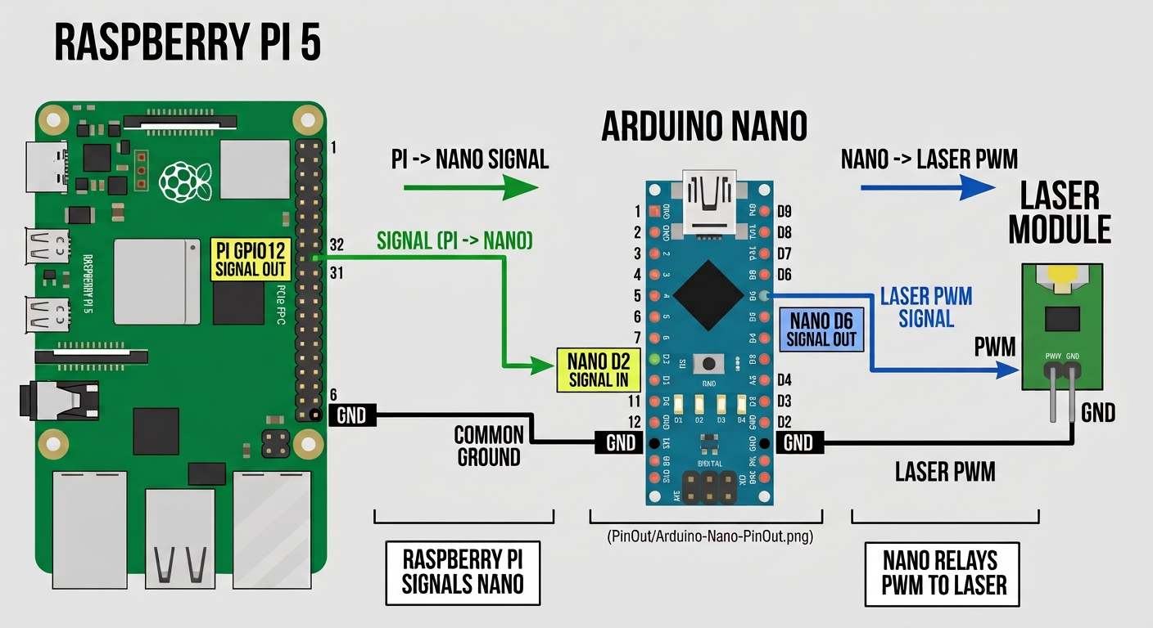
Figure 1. Raspberry Pi GPIO12 (physical pin 32) signals Arduino Nano D2; shared ground (Pi pin 6 → Nano GND) gives the signal a common reference; Nano D6 relays the on/off state directly to the laser module's PWM pin.

Goal
The Raspberry Pi runs a YOLOv8 person-detection model on the live camera feed. When a person is detected in frame, the laser should turn on; when no person has been visible for a few seconds, the laser should turn off. The Nano acts as the relay between the Pi's detection result and the physical laser hardware.

Wiring
From | To | Purpose
Pi GPIO12 (pin 32) | Nano D2 | Signal in
Pi GND (pin 6) | Nano GND | Common ground reference
Nano D6 | Laser PWM pin | Drives the laser directly
Nano GND | Laser GND | Return path

The laser module exposes only two pins — PWM and GND and a separate power pin.

Getting It Working: The Debugging Path
The original plan used an IRF520N MOSFET module so the Pi's GPIO could switch the laser's higher-current 12V supply safely, rather than driving it directly. Two problems surfaced during that build:
1. The MOSFET's signal wire was initially connected to physical pin 28 (GPIO1), which is reserved by the Pi for HAT ID EEPROM detection and cannot be driven reliably as a general-purpose output — confirmed when the pin stayed pinned near 3.3V regardless of commanded state.

2. After moving to a proper GPIO (GPIO12, pin 32), a multimeter check showed only ~0.86V across the MOSFET's load terminals while "on" (expected close to the full 12V) — the Pi's 3.3V logic level was not enough to fully saturate the IRF520N's gate, so the MOSFET never switched cleanly.
Rather than adding a gate-driver stage to fix the MOSFET path, the simpler direct-relay approach was tried instead: the Nano reads the Pi's signal on D2 and mirrors it straight onto a PWM-capable output pin wired to the laser.

Final Working Setup
The Pi's detection script calls the equivalent of pinctrl set 12 op dh when a person is detected, and pinctrl set 12 op dl a few seconds after the person leaves frame — triggered only on state change, not every frame, so the detection loop isn't slowed down by redundant GPIO calls. The Nano relays that state from D2 to D6 in real time, and D6 drives the laser directly. This chain has been tested end-to-end and confirmed working.

Power Requirements
Component | Voltage
Raspberry Pi + Pi HAT | 5V
Arduino Nano | 5V
Laser module | 12V
Total voltage across the setup : 22V (5V + 5V + 12V).

