3.10.8.2 Iterative Design and Translation of the Statistical Workflow
The ProcessWise SPC application was developed iteratively by translating the verified manual analysis into a sequence of user actions. The manual analysis was first performed in two Excel workbooks: an X̄–R calculator for package weight based on 25 subgroups, and a p-chart calculator for the proportion of off-colour samples in each production batch. These workbooks served as the reference against which every stage of the application was checked. At the end of each stage the application outputs were compared with the corresponding workbook values, and the screens and wording were revised before the next stage began.
Three design principles guided the refinements. First, technical wording was reduced so that the interface could be used by packaging personnel without specialist training; for example, the screens refer to “Record a new subgroup”, “Out-of-control points” and “Excluded subgroups — revision history”. Second, the assignable causes offered to the user were restricted to those identified on the cause-and-effect diagram for the packaging operation. Third, the application was designed to prevent unsupported exclusion of data: a subgroup cannot be removed from the control-limit calculations unless a specific cause has been recorded and confirmed. Production dates and subgroup numbers were retained throughout so that every statistical signal could be traced to an actual production event.

Development stages
Development proceeded through eight stages. Each stage added one part of the statistical workflow and was verified against the manual analysis before the next stage was started. Table 3.1 summarizes the purpose of each stage, the functions implemented and the means by which the stage was checked.
Table 3.1: Development stages of the ProcessWise SPC application
Stage | Purpose | Functions implemented | Verification and refinement
1. Manual baseline | Establish verified reference results | X̄–R and p-chart calculations in Excel workbooks using the Tom Brown data | Results checked by hand and used as the reference for later stages
2. Data model and entry | Capture observations in a structured form | Database tables for subgroups and individual package weights; manual entry form with production date, subgroup size and weights | Stored subgroup means and ranges compared with the workbook
3. X̄–R calculation engine | Reproduce the control-limit calculations | Subgroup statistics, grand mean, average range and X̄ and R limits using a controlled table of constants | Centre lines and limits compared with the workbook
4. p-chart module | Monitor the colour attribute | Batch entry, p̄ and batch-specific limits truncated at 0 and 1 | Totals, p̄, limits and out-of-control batches compared with the workbook through automated tests
5. System deployment | Make the application available to users | Separation into data, calculation, alerting and gateway services; cloud database and hosting | Calculations re-checked on the deployed system
6. Signal detection and data import | Apply the tests for special causes and reduce manual entry | Tests 1–8 with user selection; upload of the production workbooks for both charts | Signal locations compared with the workbook and with the Minitab test definitions
7. Usability refinement | Improve readability and data management | Chart axes fitted to the data and limits; production dates on the horizontal axis; side navigation; archiving and restoration of earlier uploads | Screens reviewed against the study workflow and revised
8. Investigation and limit revision | Support evidence-based exclusion of subgroups | Investigation dialog, cause list, whole-subgroup exclusion, trial and revised charts, revision history and reinstatement | Exclusion behaviour checked through automated tests and against the revision sequence of the manual analysis

System architecture
The application was built as a web application so that it could be used from any computer or tablet without installation. Table 3.2 lists the components and the role of each.
Table 3.2: Components of the ProcessWise SPC application
Component | Technology | Role
User interface | Next.js and React, with Recharts for charts and SheetJS for reading Excel files | Data entry, spreadsheet parsing, chart display, signal detection and the investigation dialog
Gateway service | NestJS | Single entry point that validates every request before passing it to the internal services
Data service | NestJS | Stores and retrieves subgroups, package weights, colour batches, archived uploads and investigation records
Calculation service | NestJS | Computes subgroup statistics, centre lines and control limits for the X̄, R and p charts
Alerting service | NestJS | Identifies subgroups beyond the 3σ limits of the revised chart
Database | PostgreSQL (Supabase) | Persistent storage; direct access from the browser is blocked and all access passes through the services
Hosting | Docker container on Render | Runs the services together and restarts them automatically on failure

The use of SMS notifications for out-of-control signals was explored with a stand-alone script but was not incorporated into the application.

Implemented workflow
The application is organized into four sections: Home for entering or uploading package weights, Trends & Charts for the X̄ and R charts and their signals, Records for editing and reviewing subgroups, and Tom Brown p-Chart for colour batch control. The X̄–R analysis follows five ordered stages:
- Enter or upload the original observations; the application validates the subgroup structure and reports any rejected rows.
- Once 25 subgroups have been recorded, construct the trial X̄–R chart from all subgroups and apply the selected tests for special causes.
- Investigate each out-of-control subgroup. Exclude a subgroup only when a specific assignable cause is recorded and confirmed, and recalculate both chart limits from the remaining subgroups.
- Re-test the revised charts and investigate any remaining or newly revealed signals in the same way.
- Report the final revised chart, the retained signals and the overall process status, with the trial chart available for comparison.
The specified method requires the R chart to be investigated before the X̄ chart. In the implemented application, signals from both charts are listed together in subgroup order, and the R-first sequence is followed by the reviewer rather than enforced by the software.

3.10.8.3 Data Inputs and Validation

X̄–R chart inputs
For the X̄–R analysis, each subgroup is stored with its production date, subgroup size n and the individual package weights in grams. A unique identifier is assigned by the database, and subgroups are numbered consecutively in order of production date. Data may be entered in two ways:
- Manual entry, in which the user selects the production date and subgroup size and types each package weight. The subgroup cannot be saved until every weight is a valid number.
- Spreadsheet upload, which accepts two layouts. In the template layout, each row is one subgroup with a production-date column and numbered sample columns (“Sample 1 (g)”, “Sample 2 (g)” and so on); calculated columns in the workbook are ignored. In the long layout, each row is one package with a production date and a weight, and rows sharing a date are grouped into a single subgroup.
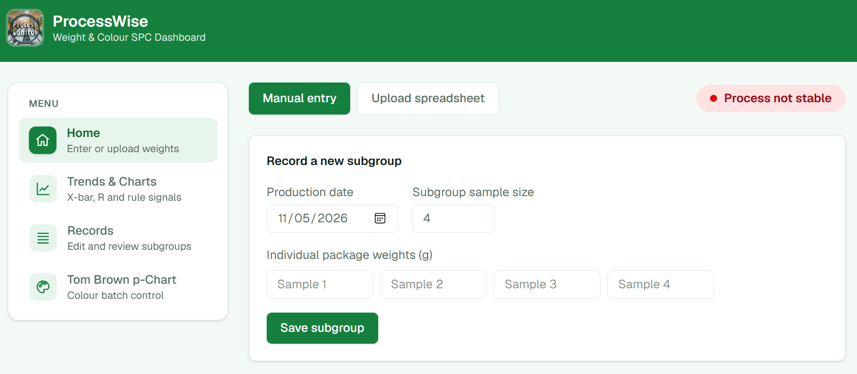
Figure 3.1: Manual entry of a subgroup in the Home section
Figure 3.1 shows the Home section, which opens when the application is started. The side menu on the left gives access to the four sections of the application, and the badge at the top right reports the current process status. In the Manual entry view, the user records a subgroup by selecting the production date, entering the subgroup sample size (four packages in this study) and typing the weight of each package in grams, with one input box for each package. Save subgroup stores the subgroup once every weight is a valid number. The Upload spreadsheet button switches to the workbook upload described above.
The validation rules applied before data are stored are listed in Table 3.3. Each rule is enforced in the user interface, by the gateway service, or by the database, and several are enforced at more than one level.
Table 3.3: Validation rules for X̄–R chart data
Rule | Action when the rule is not met
Subgroup size between 2 and 10 | Subgroup rejected and the reason displayed
Number of weights equal to the subgroup size | Record refused
Every weight numeric | Row rejected and reported with its row number
Production date valid | Row rejected and reported with its row number
Required columns present in an uploaded file | File rejected and the headings found are listed
Upload stored as a single operation | Either all subgroups are stored or none are

Rejected rows are reported to the user before the data are imported and are never replaced with substitute values. When a new workbook is uploaded, the previous set of subgroups is archived rather than deleted, and it can be viewed or restored from the Records section.
In the study dataset, the production-date column contained the subgroup numbers 1 to 25 rather than calendar dates. Because spreadsheet software stores dates as a count of days from 1 January 1900, these numbers were read as dates in January 1900, and the dates shown in the screenshots that follow should be read as subgroup numbers rather than as actual production dates.
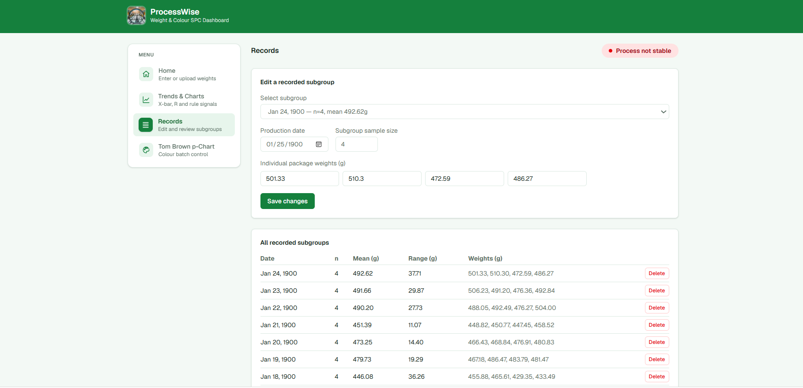
Figure 3.2: Editing and reviewing recorded subgroups in the Records section
Figure 3.2 shows the Records section. The upper panel allows a recorded subgroup to be selected and its production date, subgroup size or individual weights to be corrected; when the changes are saved, the subgroup mean and range are recalculated from the corrected weights. The lower table lists every recorded subgroup with its production date, subgroup size n, mean, range and individual weights, together with a Delete button, so that the original observations remain available for inspection. Earlier uploads, which are archived when a new workbook is imported, are listed further down the same page.
Four aspects of the specified validation were not fully implemented. Weights are required to be numeric but not positive. The subgroup size may differ between subgroups, in which case limits are calculated for each subgroup from its own size rather than the size being fixed for the chart. Several subgroups may share a production date. In the template layout a blank sample cell is treated as an unused position, so a subgroup with a missing value is stored with a smaller subgroup size instead of being marked as incomplete.

p-chart inputs
For the p chart, each production batch is stored with a batch label, a production date, the number of samples inspected nᵢ and the number of samples outside the target colour dᵢ. Batches may be entered manually or uploaded from the colour p-chart workbook, in which case title rows and the totals row are recognized and skipped. The validation rules are given in Table 3.4; they are enforced by the interface, the gateway service and the database.
Table 3.4: Validation rules for p-chart data
Rule | Action when the rule is not met
Batch label entered (1–64 characters) | Entry refused
nᵢ a whole number of at least 1 | Entry refused
dᵢ a whole number of 0 or more | Entry refused
dᵢ not greater than nᵢ | Entry refused
Batch label not repeated within an upload | Row skipped and reported

Unlike the specification, the production date of a colour batch is optional. Clearing the batch list archives the batches, and the most recent clearance can be restored.
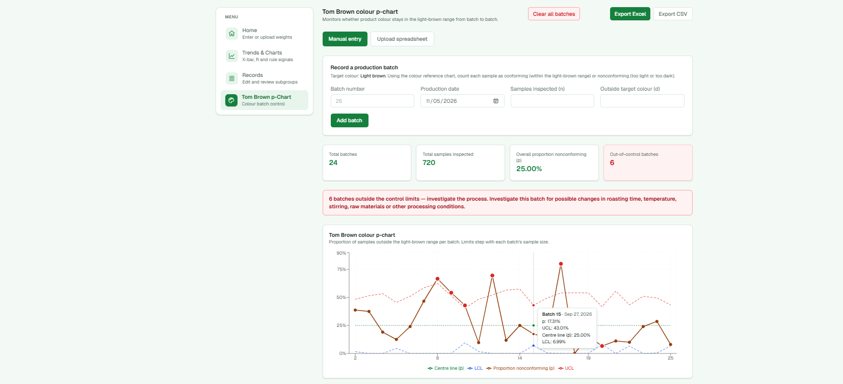
Figure 3.3: Batch entry and summary in the Tom Brown p-Chart section
Figure 3.3 shows the Tom Brown p-Chart section. The form at the top records a production batch: the batch number, production date, number of samples inspected (n) and number of samples outside the target colour (d). The guidance above the form defines the target colour as light brown and explains that, using the colour reference chart, each sample is counted as conforming when it lies within the light-brown range and as nonconforming when it is too light or too dark. Below the form, summary cards report the number of batches (24), the total number of samples inspected (720), the overall proportion nonconforming p̄ (25.00%) and the number of batches out of control (6). Because out-of-control batches are present, a message directs the user to investigate possible changes in roasting time, temperature, stirring, raw materials or other processing conditions. The buttons at the top right export the batch data to Excel or CSV, or clear the batch list.

3.10.8.4 Calculation and Signal Detection

X̄–R chart calculations
For each subgroup i containing nᵢ package weights xᵢⱼ, the subgroup mean and range are calculated directly from the recorded weights:
X̄ᵢ = Σⱼ xᵢⱼ / nᵢ (3.1)
Rᵢ = max(xᵢⱼ) − min(xᵢⱼ) (3.2)
Over the k subgroups used to estimate the limits, the grand mean and average range are:
X̿ = Σᵢ (nᵢ X̄ᵢ) / Σᵢ nᵢ (3.3)
R̄ = Σᵢ Rᵢ / k (3.4)
The X̄- and R-chart limits follow the formulae in Section 3.10.5:
UCL(X̄) = X̿ + A₂R̄, CL(X̄) = X̿, LCL(X̄) = X̿ − A₂R̄ (3.5)
UCL(R) = D₄R̄, CL(R) = R̄, LCL(R) = D₃R̄ (3.6)
The grand mean in Equation 3.3 is weighted by subgroup size; when all subgroups have the same size, as in the present study, it equals the simple average of the subgroup means. The factors A₂, D₃ and D₄ are read from a controlled table (Table 3.5) according to the size of each subgroup and cannot be entered or altered by the user.
Table 3.5: Control chart constants used by the application
n | 2 | 3 | 4 | 5 | 6 | 7 | 8 | 9 | 10
A₂ | 1.880 | 1.023 | 0.729 | 0.577 | 0.483 | 0.419 | 0.373 | 0.337 | 0.308
D₃ | 0 | 0 | 0 | 0 | 0 | 0.076 | 0.136 | 0.184 | 0.223
D₄ | 3.267 | 2.575 | 2.282 | 2.115 | 2.004 | 1.924 | 1.864 | 1.816 | 1.777
Source: NIST/SEMATECH (2012).

Meaning of the control chart constants
The constants A₂, D₃ and D₄ allow 3σ control limits to be set from the average range R̄ without calculating the process standard deviation directly. They rest on the relationship between the range of a subgroup and the standard deviation σ of a normally distributed process. For subgroups of size n, the expected range is d₂σ, so σ can be estimated from the average range as:
σ̂ = R̄ / d₂ (3.7)
where d₂ is the mean of the relative range R/σ for subgroups of size n. Because the range of a larger subgroup tends to be wider, d₂ increases with n; this is why each constant depends on the subgroup size and must be taken from the row of the table that matches n.
A₂ (X̄ chart). The mean of a subgroup of size n varies with a standard deviation of σ/√n. The 3σ limits for the subgroup means are therefore X̿ ± 3σ̂/√n, and substituting Equation 3.7 gives:
A₂ = 3 / (d₂√n) (3.8)
The product A₂R̄ is thus the distance from the centre line to each X̄-chart limit, equal to three standard errors of the subgroup mean. A₂ decreases as n increases, because the means of larger subgroups vary less and the X̄-chart limits become narrower.
D₃ and D₄ (R chart). The subgroup range is itself a random quantity, with a standard deviation of d₃σ, where d₃ is the standard deviation of the relative range. The 3σ limits for the range are R̄ ± 3d₃R̄/d₂, which gives:
D₄ = 1 + 3d₃/d₂, D₃ = max(0, 1 − 3d₃/d₂) (3.9)
D₄ sets the upper limit of the R chart and identifies subgroups whose spread is unusually large. D₃ sets the lower limit and identifies subgroups whose spread is unusually small. For n ≤ 6 the expression 1 − 3d₃/d₂ is negative; since a range cannot be negative, D₃ is set to zero and the lower limit of the R chart is zero, so the chart cannot signal an unusually small range for these subgroup sizes.
The roles of the three constants are summarized in Table 3.6. The values assume that the individual package weights are independent and approximately normally distributed.
Table 3.6: Role of the control chart constants
Constant | Chart | Used in | Meaning
A₂ | X̄ chart | UCL = X̿ + A₂R̄; LCL = X̿ − A₂R̄ | Converts the average range into three standard errors of the subgroup mean
D₃ | R chart | LCL = D₃R̄ | Sets the lower limit for the subgroup range; zero for n ≤ 6
D₄ | R chart | UCL = D₄R̄ | Sets the upper limit for the subgroup range

In the present study each subgroup contained four packages (n = 4), so A₂ = 0.729, D₃ = 0 and D₄ = 2.282. For the trial chart based on all 25 subgroups, X̿ = 461.09 g and R̄ = 38.72 g, which give an X̄-chart UCL of 461.09 + 0.729 × 38.72 = 489.32 g and LCL of 461.09 − 0.729 × 38.72 = 432.86 g, and an R-chart UCL of 2.282 × 38.72 = 88.37 g with an LCL of 0 g. These values can be seen in the calculation breakdown in Figure 3.9.
These calculations are also displayed step by step for each subgroup in the application, as described in Section 3.10.8.7.
The charts are not displayed until 25 subgroups have been recorded, because control limits estimated from fewer subgroups are unreliable. Until that point the application shows the number of subgroups still required.

p-chart calculations
For each batch, the proportion nonconforming, the overall proportion and the batch-specific limits are calculated as:
p̂ᵢ = dᵢ / nᵢ (3.10)
p̄ = Σᵢ dᵢ / Σᵢ nᵢ (3.11)
UCLᵢ = min[1, p̄ + 3√(p̄(1 − p̄)/nᵢ)], LCLᵢ = max[0, p̄ − 3√(p̄(1 − p̄)/nᵢ)] (3.12)
Separate limits are calculated for every batch because the number inspected varies between batches. All values are recalculated from the stored counts whenever the chart is opened, so that editing or deleting a batch immediately updates p̄ and the limits of every batch.
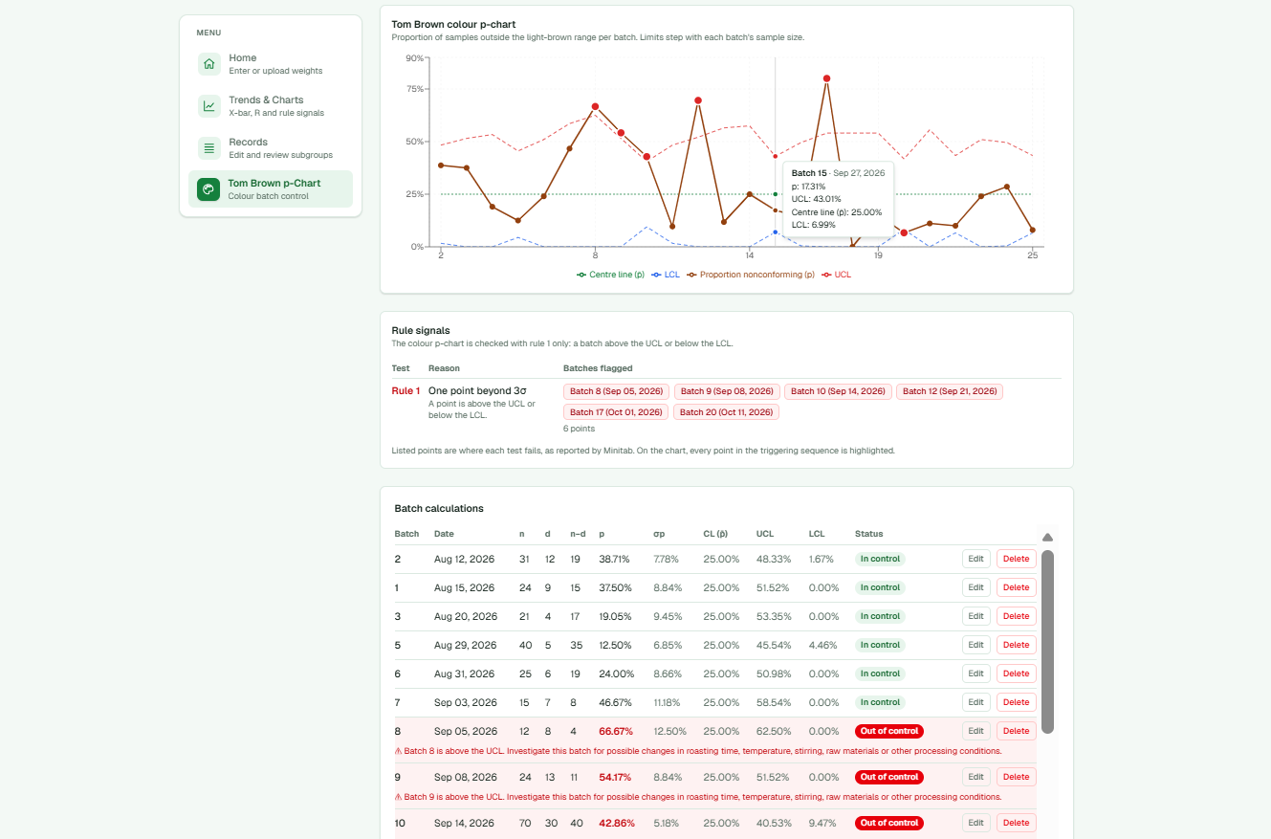
Figure 3.4: The p chart, its rule signals and the batch calculations
Figure 3.4 shows the p chart and the calculations behind it. The brown line plots the proportion nonconforming of each batch; the dotted green line is the centre line p̄; and the dashed red and blue lines are the upper and lower control limits, which step up and down from batch to batch because the number of samples inspected varies. Batches beyond their limits are marked in red. Hovering over a point, as shown for batch 15, displays its proportion nonconforming, its own limits and the centre line. The Rule signals panel lists the six batches that fail Test 1 (batches 8, 9, 10, 12, 17 and 20), and the Batch calculations table gives, for every batch, n, d, n − d, p̂, σp, the centre line, the UCL, the LCL and the batch status, with a warning beneath each out-of-control batch.

Signal detection
The signal engine implements the eight tests for special causes as defined by Minitab (Table 3.7). The user may select which tests are applied. Following Minitab, Tests 5–8 are not applied to the R chart because its σ zones are not symmetric about the centre line. The p chart is assessed with Test 1 only, which differs from the specification of Tests 1–4 for the p chart.
Table 3.7: Tests for special causes implemented in the application
Test | Condition | Charts
1 | One point beyond 3σ from the centre line | X̄, R, p
2 | Nine points in a row on the same side of the centre line | X̄, R
3 | Six points in a row, all increasing or all decreasing | X̄, R
4 | Fourteen points in a row, alternating up and down | X̄, R
5 | Two out of three points more than 2σ from the centre line on the same side | X̄
6 | Four out of five points more than 1σ from the centre line on the same side | X̄
7 | Fifteen points in a row within 1σ of the centre line | X̄
8 | Eight points in a row more than 1σ from the centre line on either side | X̄
Source: Minitab, LLC (2026).
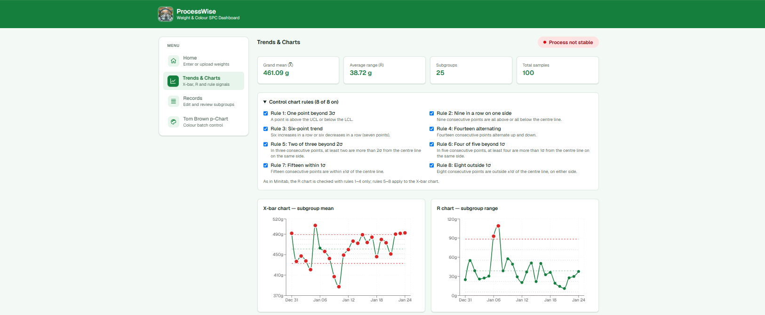
Figure 3.5: Selection of the tests for special causes in the Trends & Charts section
Figure 3.5 shows the Trends & Charts section with the Control chart rules panel expanded. The summary cards at the top report the grand mean X̿ (461.09 g), the average range R̄ (38.72 g), the number of subgroups used to estimate the limits (25) and the total number of packages (100). Each of the eight tests for special causes in Table 3.7 can be switched on or off with its check box, and all eight are selected here. The note beneath the panel records that, as in Minitab, the R chart is checked with Tests 1–4 only. The X̄ and R charts below the panel are redrawn whenever the selection changes.
For the zone tests, σ is taken as one third of the distance between the centre line and the upper control limit. As in Minitab, a run test is reported at the points from the point that completes the run onward, and Tests 5 and 6 are reported at the last point of the window. Each signal identifies the chart, the test number, the production date, the plotted value and the limit against which it was judged, and every point of the signaling sequence is highlighted on the chart. A signal indicates that a subgroup requires investigation; it does not in itself establish a cause.
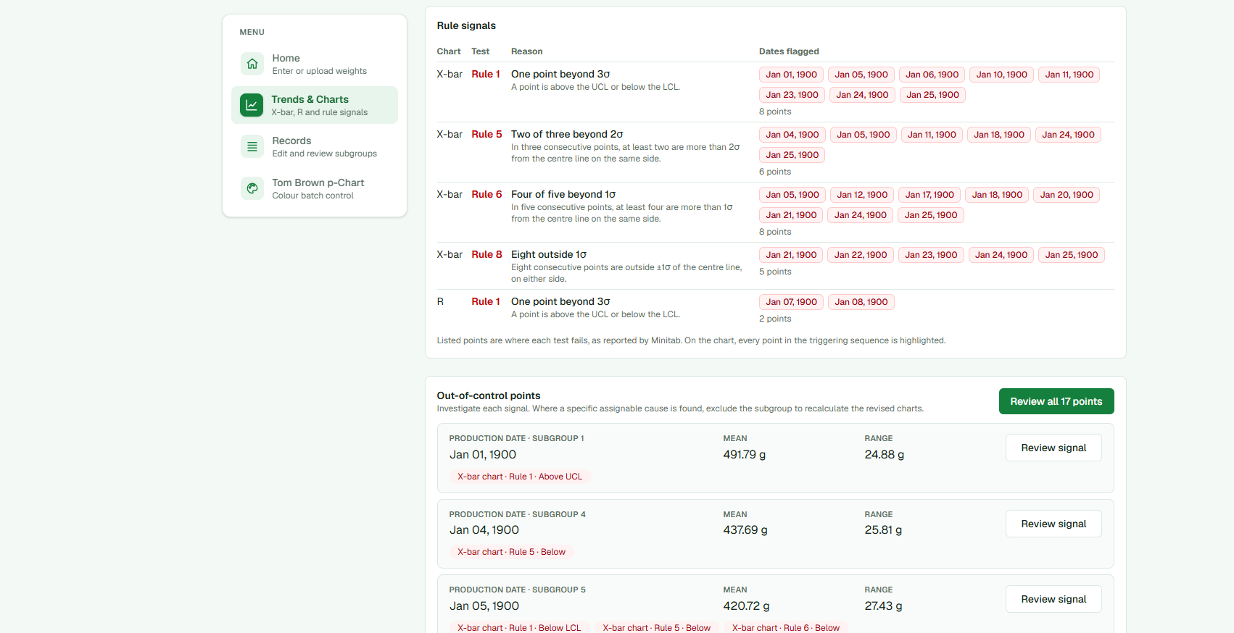
Figure 3.6: Rule signals and out-of-control points on the trial chart
Figure 3.6 shows the Rule signals panel and the start of the Out-of-control points list for the trial chart. For each chart and test, the panel lists the subgroups at which the test fails, in the form used by Minitab: on the X̄ chart, Test 1 fails at eight points, Test 5 at six, Test 6 at eight and Test 8 at five; on the R chart, Test 1 fails at two points, subgroups 7 and 8. The Out-of-control points list below combines these signals by subgroup, showing the subgroup number, production date, mean, range and the tests that fail, with a Review signal button for each subgroup and a Review all 17 points button that steps through them in order.

3.10.8.5 Investigation and Decision Rules
Every subgroup at which a selected test fails on the current chart is listed as an out-of-control point. The user may open a single subgroup or review all listed subgroups in production order; a subgroup may be passed over without any record being made.
When a subgroup is opened, the application displays its number, production date, plotted mean or range, the trial control limit and every test that fails at that point. To exclude the subgroup, the user must complete the fields listed in Table 3.8. The exclusion control remains unavailable until every field has been completed and the confirmation statement has been accepted, and the same requirements are checked again by the gateway service.
Table 3.8: Investigation record required to exclude a subgroup
Field | Content
Assignable cause | One cause from a list grouped by the categories of the cause-and-effect diagram (Table 3.9), or “Other (described in findings)”
Findings | The evidence supporting the cause
Corrective action | The action taken to address the cause
Investigation date | The date on which the investigation was carried out
Confirmation | “I confirm a specific assignable cause was identified and this whole subgroup should be excluded from both revised X-bar and R-chart calculations.”

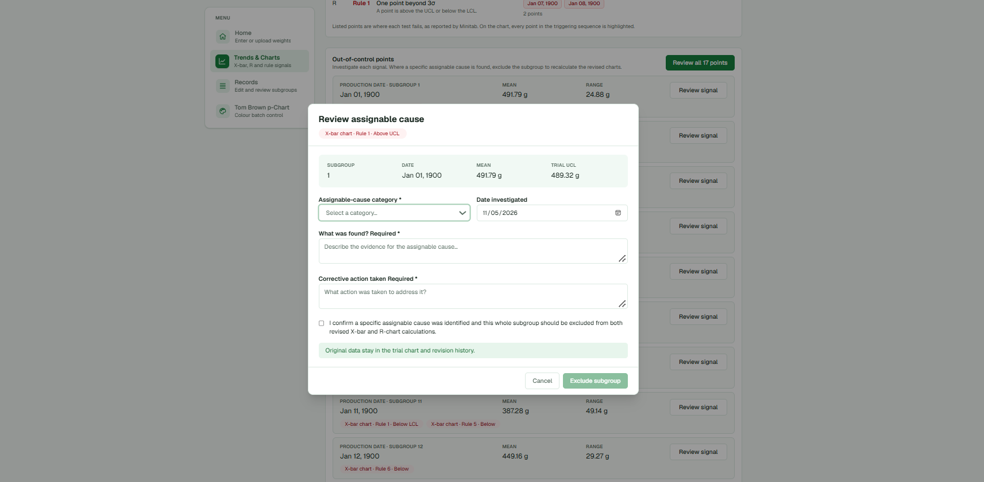
Figure 3.7: Investigation dialog for an out-of-control subgroup
Figure 3.7 shows the investigation dialog opened for subgroup 1, which fails Test 1 above the UCL of the X̄ chart. The label beneath the title identifies the signal, and the panel below it gives the subgroup number, production date, subgroup mean (491.79 g) and the trial UCL against which the mean was judged (489.32 g). The user selects the assignable cause from a list grouped by cause category, records the date of the investigation, describes what was found and the corrective action taken, and confirms that a specific assignable cause was identified and that the whole subgroup should be excluded from both the revised X̄- and R-chart calculations. As shown, the Exclude subgroup button remains disabled until all required fields are complete, and the note above the buttons states that the original data remain in the trial chart and the revision history.
The assignable causes were derived from the cause-and-effect (6M) diagram developed for underweight packages in this study and are listed in Table 3.9. These categories differ from the five categories given in the specification (filling method; personnel and workload; weighing and measurement; packaging and sealing; and other confirmed cause).
Table 3.9: Assignable causes available in the investigation record
Category | Assignable causes
Man | Operator has not been trained in weighing; filling quantity is estimated by judgement; weight is not checked before stapling
Machine | Scale divisions cannot accurately show the 495–505 g range; scale displays pounds and ounces; no controlled filling equipment
Method | Scoop quantity varies between packages; folding and stapling reduce usable package quantity; no standard filling and weighing procedure
Material | Inadequate sachet size for the target weight; sachet capacity does not allow enough closing space
Measurement | No acceptable weight range is used; individual packages are not weighed; package weights are not recorded or reviewed
Environment | Powder loss from uncontrolled airflow; air in powder reduces weight per scoop; trapped air reduces usable sachet capacity
Other | Other (described in findings)

Each exclusion is stored as an investigation record containing the signal that prompted it (chart, test, direction, plotted value and trial limit), together with the category, cause, findings, corrective action, investigation date and the time at which the record was saved. The subgroup and its original weights are never altered, and only one active investigation record is permitted per subgroup. An exclusion can be reversed, in which case the record is marked as reverted rather than deleted, so that every revision remains available for audit.
The implemented application records only one investigation outcome, namely a confirmed assignable cause. Subgroups for which a cause is possible but not confirmed, or for which no cause is identified, are retained by leaving them unexcluded, but the outcome and its reason are not stored. The name of the reviewer, a separate record of the evidence reviewed and follow-up monitoring of retained subgroups are likewise not recorded.

3.10.8.6 Recalculation and Chart Sequence
When a subgroup is excluded, the complete subgroup is omitted from the estimation of X̿ and R̄ and therefore from both the X̄- and R-chart limits. The application maintains two sets of limits at all times, as described in Table 3.10.
Table 3.10: Trial and revised chart views
View | Data used for the limits | Display
Trial chart | All active subgroups | All subgroups, with excluded subgroups shown as hollow grey points
Revised chart | Subgroups without an active exclusion | Retained subgroups, with limits recalculated from them and a statement of the number of subgroups excluded and retained

A summary above the charts reports X̿, R̄, the number of subgroups used to estimate the limits and the total number of samples for the selected view. After each exclusion the revised charts are recalculated and re-tested, so that any signals revealed by the narrower limits are listed for investigation. Each subgroup keeps its original number and production date, and the retained subgroups are not renumbered. A revision history lists every excluded subgroup with its number, date, signal, cause, findings and corrective action.
Applied to the Tom Brown data, the revision sequence of the study is reproduced by excluding subgroups 7 and 8 following the R-chart investigation, giving a revised chart based on 23 subgroups; and then excluding subgroups 10, 11, 23, 24 and 25 following the X̄-chart investigation, giving a final revised chart based on 18 subgroups. Subgroups 1, 2, 5, 6 and 16 are retained because their causes were not confirmed.
The application stores the trial chart and the current revised chart only. Intermediate revisions, such as the 23-subgroup chart, are not saved as separate stages and cannot be displayed side by side with the final revision; they must therefore be captured at the point at which they are reached.

3.10.8.7 Output, Interpretation and Safeguards
Each X̄ and R chart displays the plotted statistic, the centre line, the upper and lower control limits, the 1σ and 2σ zone boundaries and the production date of each point. Points belonging to a signal are highlighted, and selecting a point displays its date, value and the tests that it fails. Below the charts, the signals are listed by chart and by test in the same arrangement as a Minitab report of tests for special causes. The p chart displays the proportion nonconforming of each batch against its own limits and the centre line p̄, together with the number of batches, the total samples inspected, the total nonconforming, p̄ and the number of batches out of control.
The p-chart data, including the calculations for every batch, can also be exported to Excel or CSV for reporting.
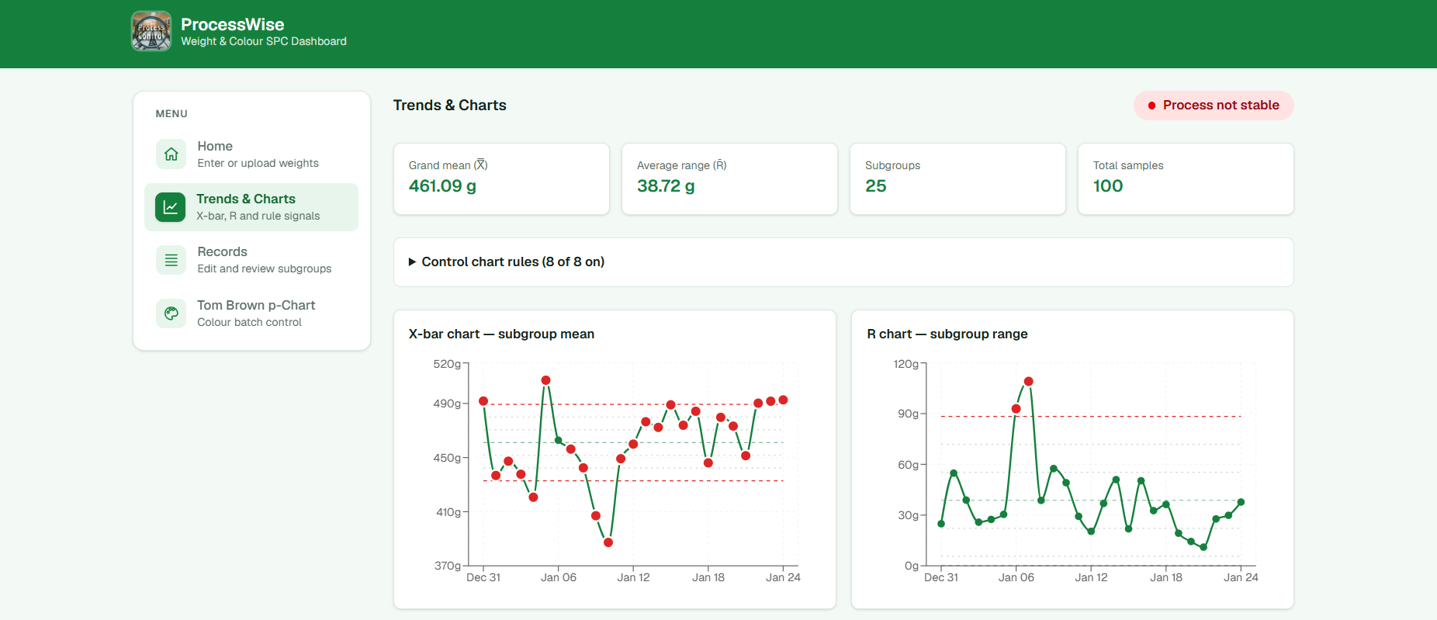
Figure 3.8: Trial X̄ and R charts for the 25 subgroups of the study
Figure 3.8 shows the trial X̄ and R charts for the 25 subgroups of the study, beneath the summary cards for X̿, R̄, the number of subgroups and the total number of packages. On each chart the solid green line joins the plotted subgroup statistics, the dashed green line is the centre line, the dashed red lines are the upper and lower control limits, and the fainter dotted lines mark the 1σ and 2σ zones used by Tests 5–8. Points that belong to a signal are coloured red. The X̄ chart shows signals throughout the series, with subgroup means both above the UCL and below the LCL, whereas the R chart shows two ranges above the UCL, at subgroups 7 and 8, and has a lower limit of zero. The badge at the top right reports that the process is not stable.

Calculation breakdown
To make the calculations transparent to the user, the Home section displays a calculation breakdown after every subgroup is entered or uploaded. By default it shows the most recently entered subgroup, and any other subgroup can be selected from a list identified by subgroup number, production date and subgroup size. The heading of the breakdown states the production date, the subgroup size n and the constants A₂, D₃ and D₄ applied to that subgroup.
Each line of the breakdown shows the formula with the recorded values substituted, followed by the result in grams to two decimal places (Table 3.11). The subgroup range and mean are calculated directly from the recorded package weights, so that every displayed result can be reproduced from the formula beside it. The grand mean, average range and control limits are those of the revised chart, and therefore exclude any subgroup removed following an assignable-cause investigation.
Table 3.11: Contents of the calculation breakdown
Line | Formula displayed | Source of the values
Range | MAX(weights) − MIN(weights) | Recorded weights of the selected subgroup
Mean | (w₁ + w₂ + … + wₙ) ÷ n | Recorded weights of the selected subgroup
X̄ UCL | Grand mean + (A₂ × R̄) | Revised X̿ and R̄; A₂ for the subgroup size
X̄ CL | Grand mean (X̿) | Revised X̿
X̄ LCL | Grand mean − (A₂ × R̄) | Revised X̿ and R̄; A₂ for the subgroup size
R UCL | D₄ × R̄ | Revised R̄; D₄ for the subgroup size
R CL | R̄ (average range) | Revised R̄
R LCL | D₃ × R̄ | Revised R̄; D₃ for the subgroup size

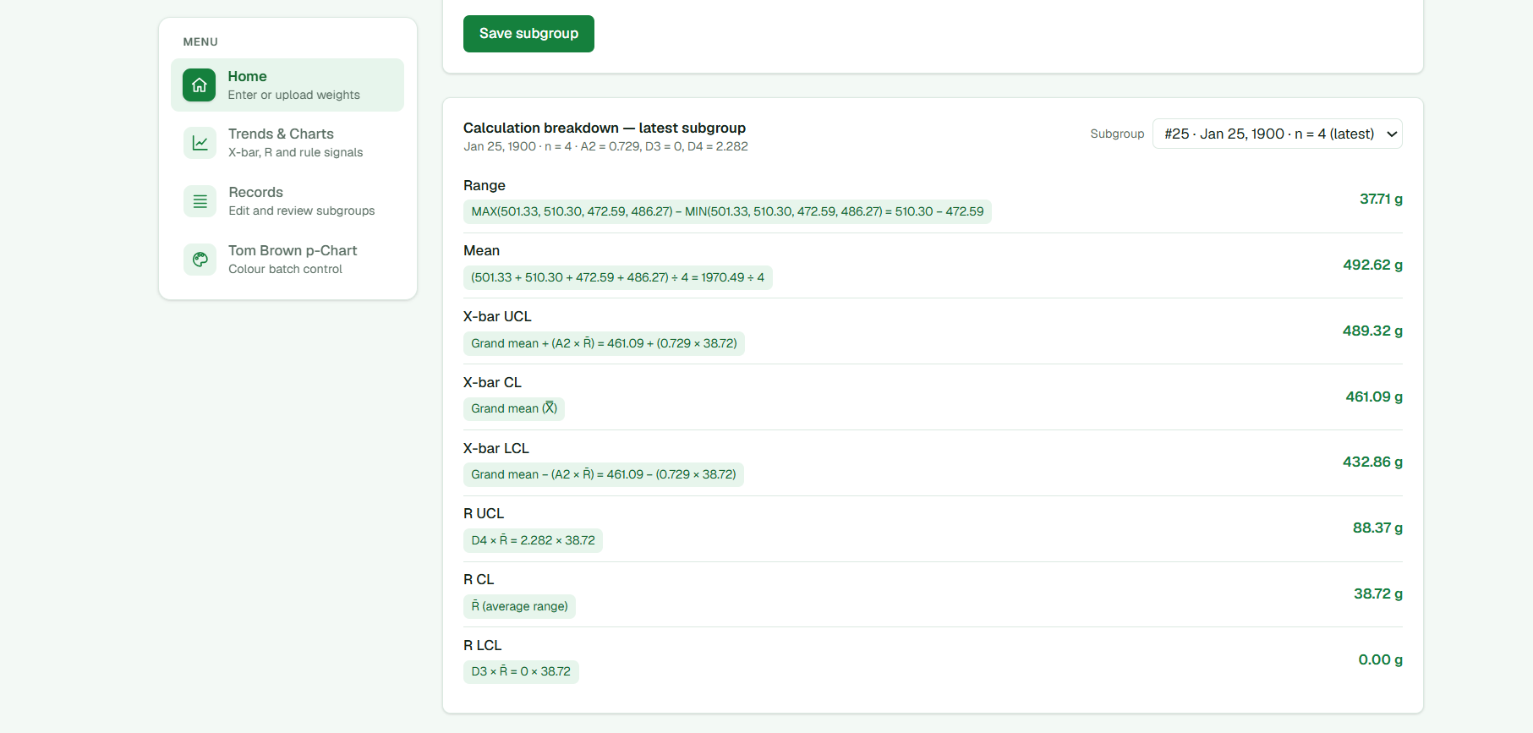
Figure 3.9: Calculation breakdown for the most recently recorded subgroup
Figure 3.9 shows the calculation breakdown for subgroup 25, the most recently recorded subgroup. The heading gives the subgroup size (n = 4) and the constants applied (A₂ = 0.729, D₃ = 0, D₄ = 2.282). Each line shows a formula with the recorded values substituted, followed by its result: the range of the four weights is 510.30 − 472.59 = 37.71 g and their mean is 1970.49 ÷ 4 = 492.62 g; with X̿ = 461.09 g and R̄ = 38.72 g, the X̄-chart limits are 489.32 g and 432.86 g about a centre line of 461.09 g, and the R-chart limits are 88.37 g and 0 g about a centre line of 38.72 g. Any other subgroup can be selected from the list at the top right.
The breakdown allows the user to confirm each step of the calculation and to compare it with a manual or spreadsheet calculation, rather than relying on the chart as an unexplained output.

Status and safeguards
Only control limits are calculated and displayed; specification limits are not entered or plotted, so the two cannot be confused on the charts. The overall status is shown as “Process stable” when no selected test fails on the revised X̄ or R chart and as “Process not stable” otherwise. The status is conveyed by text as well as by colour, and the signals responsible for it are listed on the same page.
Process-capability indices are not calculated by the application, and capability therefore cannot be reported for an unstable process. A revised chart is presented only as the result of the recorded exclusions, and no claim is made about the effectiveness of corrective actions, which would require production data collected after those actions.
The status wording differs from the specification, which calls for “Process in control” or “Process not in control” together with the reason, and for a separate “R chart in control” status once the revised R chart is stable.

3.10.8.8 Verification and User Evaluation
The calculations were verified throughout development by reproducing the Tom Brown workbooks in the application and comparing the outputs. In addition, automated unit tests were written for the calculation service; they are summarized in Table 3.12.
Table 3.12: Automated verification tests
Test | Purpose
Reproduction of the workbook calculations | Confirms that p̂ᵢ, p̄, σᵢ and the limits match the colour p-chart workbook
25-batch totals and p̄ | Confirms that totals and p̄ for the full dataset match the workbook
Out-of-control batches | Confirms that the same seven batches are flagged as in the workbook
Truncation and variable limits | Confirms that limits are truncated at 0 and 1 and vary with nᵢ
Lower-limit signal | Confirms that a batch below its LCL is detected
Invalid batches | Confirms that invalid counts are excluded rather than plotted as zero
Empty dataset | Confirms that no limits are produced without data
Subgroup exclusion | Confirms that an excluded subgroup is omitted from both X̿ and R̄
Limits for excluded subgroups | Confirms that excluded points can still be drawn on the trial chart
Agreement of trial and revised limits | Confirms that both sets of limits agree before any exclusion

Signal locations on the X̄ and R charts were compared with the manual analysis and with the Minitab test definitions while the eight tests were being implemented.
The following activities remain to be completed: an automated check of the X̄–R calculations against the 25-subgroup Tom Brown dataset; verification with at least one additional dataset; tests covering missing or invalid values and retained unexplained signals; and an evaluation of the interface with MSME users or representative packaging personnel. These activities will be reported only once they have been carried out, including the number and type of participants.

Developer Decision Logic
Table 3.13 sets out the decision logic applied by the implemented application.
Table 3.13: Decision logic of the implemented application
Condition | System action | Status
Fewer than 25 subgroups recorded | Charts withheld; number of subgroups still required displayed | No status
Selected test fails on the trial X̄ or R chart | Subgroup listed for investigation | Process not stable
Confirmed assignable cause recorded with all required fields | Whole subgroup excluded from X̿ and R̄; retained on the trial chart and in the revision history; both limits recalculated and re-tested | Reassess
Cause possible or not identified | Subgroup retained and remains listed; outcome not recorded | Signal unresolved
Exclusion reversed | Investigation record marked as reverted; subgroup returned to the limit calculations | Reassess
No selected test fails on the revised X̄ and R charts | Ongoing monitoring; capability not calculated | Process stable
Signal remains on the revised X̄ or R chart | Subgroup remains listed for investigation | Process not stable
p chart: batch beyond its own limits | Batch marked and highlighted | Batch out of control

Alignment With Results and Discussion
The Results and Discussion chapter follows the same order as the application: the initial 25-subgroup X̄–R chart; the interpretation of the R chart; the investigation and recorded causes for subgroups 7 and 8; the 23-subgroup revised chart; the interpretation of the now-stable R chart; the investigation of the X̄-chart signals; the distinction between excluded subgroups with confirmed causes (10, 11, 23, 24 and 25) and retained subgroups with unexplained signals (1, 2, 5, 6 and 16); and the final 18-subgroup revised chart with the conclusion that the process is not in control. The original data remain available in the application, and the discussion states that capability was not estimated because statistical stability was not achieved.
The p-chart results are reported separately, giving p̄, the batch-specific limits, the batches outside their limits and the production evidence considered. Because no batch was excluded and no p-chart limits were revised, this is stated directly rather than repeating the X̄–R exclusion sequence.

Summary of Differences Between the Specified and Implemented Method
Table 3.14 summarizes the points at which the implemented application departs from the specified method. These are acknowledged as limitations of the current version.
Table 3.14: Differences between the specified and implemented method
Specified requirement | Implemented application | Section
R chart investigated before X̄ review is enabled | Both charts reviewed together; order followed by the reviewer | 3.10.8.2
Weights must be positive | Weights must be numeric | 3.10.8.3
Duplicate dates prevented and incomplete subgroups flagged | Shared dates permitted; blank sample cells reduce the subgroup size | 3.10.8.3
Production date required for p-chart batches | Production date optional | 3.10.8.3
Tests 1–4 applied to the p chart | Test 1 applied | 3.10.8.4
Three investigation outcomes recorded | Confirmed cause recorded only | 3.10.8.5
Five cause categories | Six 6M categories and “Other” | 3.10.8.5
Reviewer, evidence and follow-up recorded | Not recorded | 3.10.8.5
Initial and revised charts viewable in stages | Trial and current revised charts only | 3.10.8.6
“Process in control” status with reason; “R chart in control” | “Process stable” or “Process not stable” without reason | 3.10.8.7

References Used to Support the Method
Minitab, LLC. (2026). All statistics and graphs for Xbar-R Chart; Select tests for special causes for P Chart; and Using tests for special causes in control charts. Minitab Support.
Montgomery, D. C. (2020). Introduction to statistical quality control. Wiley.
NIST/SEMATECH. (2012). e-Handbook of statistical methods: Shewhart X-bar and R and S control charts. National Institute of Standards and Technology.

