ProcessWise Review Signal and Revised Chart Developer Design Guide
Complete chart sequence and assignable cause investigation workflow
Purpose. This guide shows the complete ProcessWise sequence from the initial trial X-bar and R chart to the final revised chart. The R chart is investigated first. Only after the R chart is in control is the X-bar chart investigated. The workflow prevents a subgroup from being excluded merely because it produces a statistical signal.
Main decision. Use five cause categories only: Filling method, Personnel and workload, Weighing and measurement, Packaging and sealing, and Other confirmed cause. Exclusion is allowed only when a batch-specific assignable cause is confirmed and supported by evidence. Otherwise, the subgroup remains in the analysis.

Complete control chart sequence
Step | Screen action | Required result
1 | Draw the initial trial X-bar and R chart | Include all 25 production subgroups.
2 | Investigate the R-chart signals first | Exclude only R-chart subgroups with confirmed assignable causes.
3 | Draw the first revised X-bar and R chart | Use 23 retained subgroups; confirm that the revised R chart is in control.
4 | Investigate the X-bar signals | Exclude confirmed causes and retain signals whose causes were not confirmed.
5 | Draw the final revised X-bar and R chart | Use 18 retained subgroups and display “Process not in control.”
Optional public preview. https://processwise-review-signal.astraldace19.chatgpt.site
The Word document is the complete handover and can be sent directly to the developer even if the preview link is unavailable. The screen layouts are design mockups; the implemented charts must use the actual observations and calculated limits stored in ProcessWise.

Control chart 1 Initial trial chart with all 25 subgroups
ProcessWise begins with all 25 production subgroups. The unstable R chart is investigated before the X-bar chart.
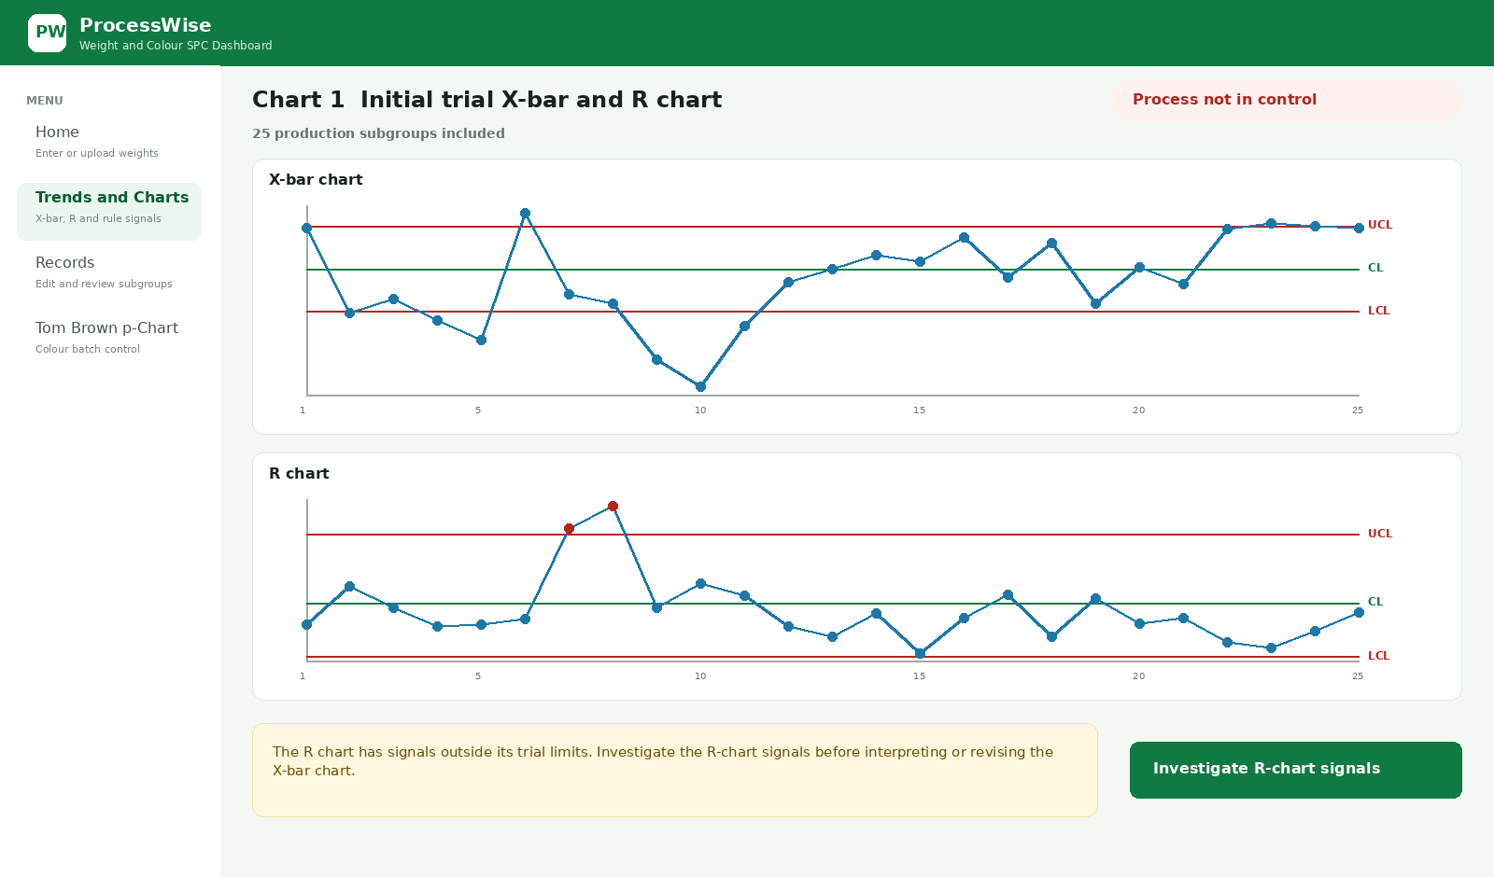
Developer mockup Control chart 1 Initial trial chart with all 25 subgroups

Control chart 2 Revised chart after the R-chart investigation
After confirmed R-chart causes are excluded, the chart is redrawn with 23 retained subgroups. Once the revised R chart is in control, the X-bar signals are investigated.
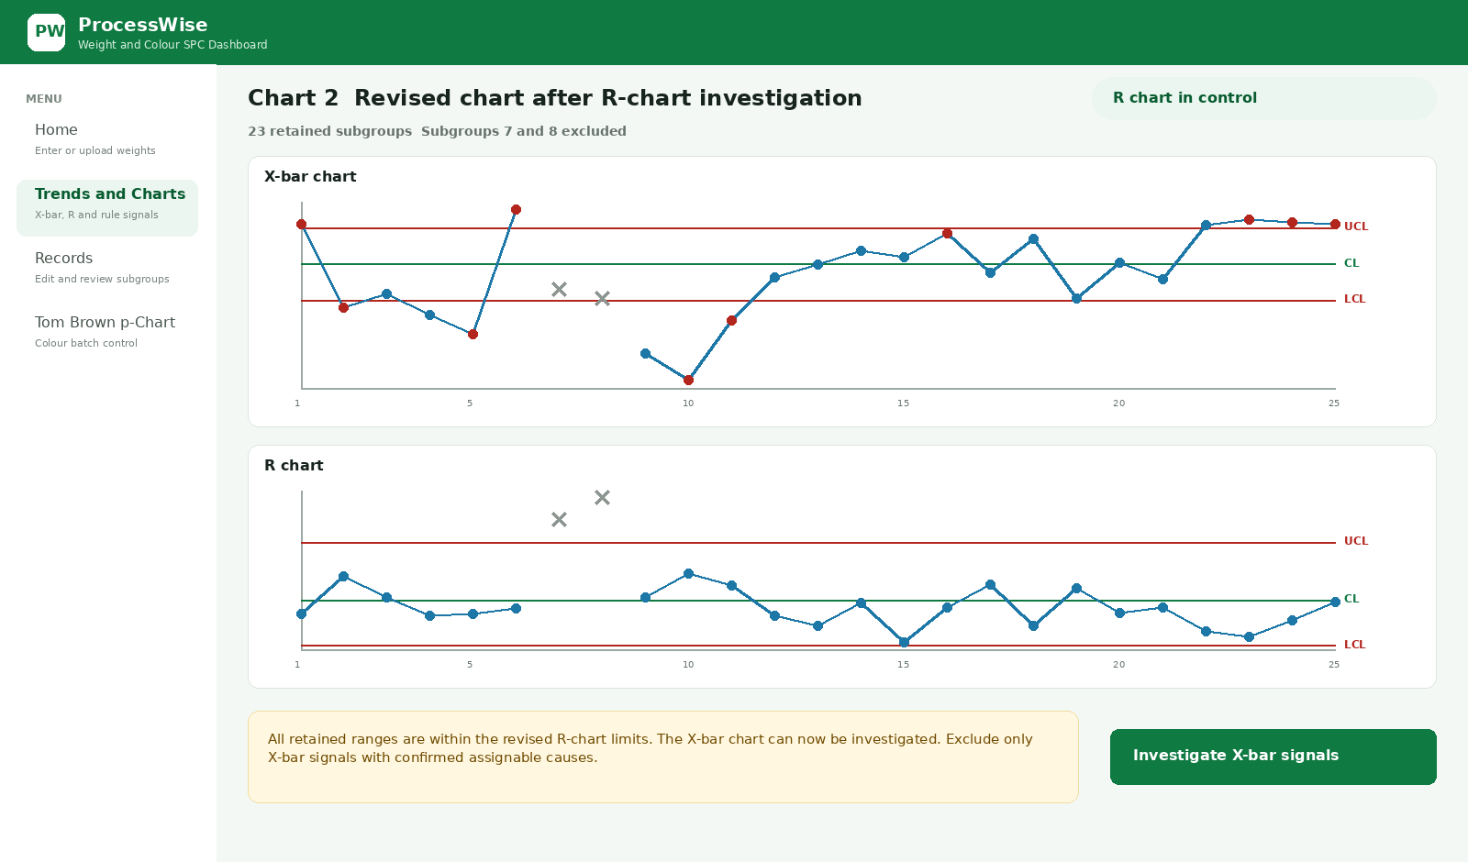
Developer mockup Control chart 2 Revised chart after the R-chart investigation

Investigation screen used for R-chart and X-bar signals
The following Review Signal screens are used twice: first for the R-chart investigation and later for the X-bar investigation. The same evidence and exclusion rules apply at both stages.

Step 1 Signal and investigation outcome
Confirm the signal details and require one investigation outcome before any cause is chosen.
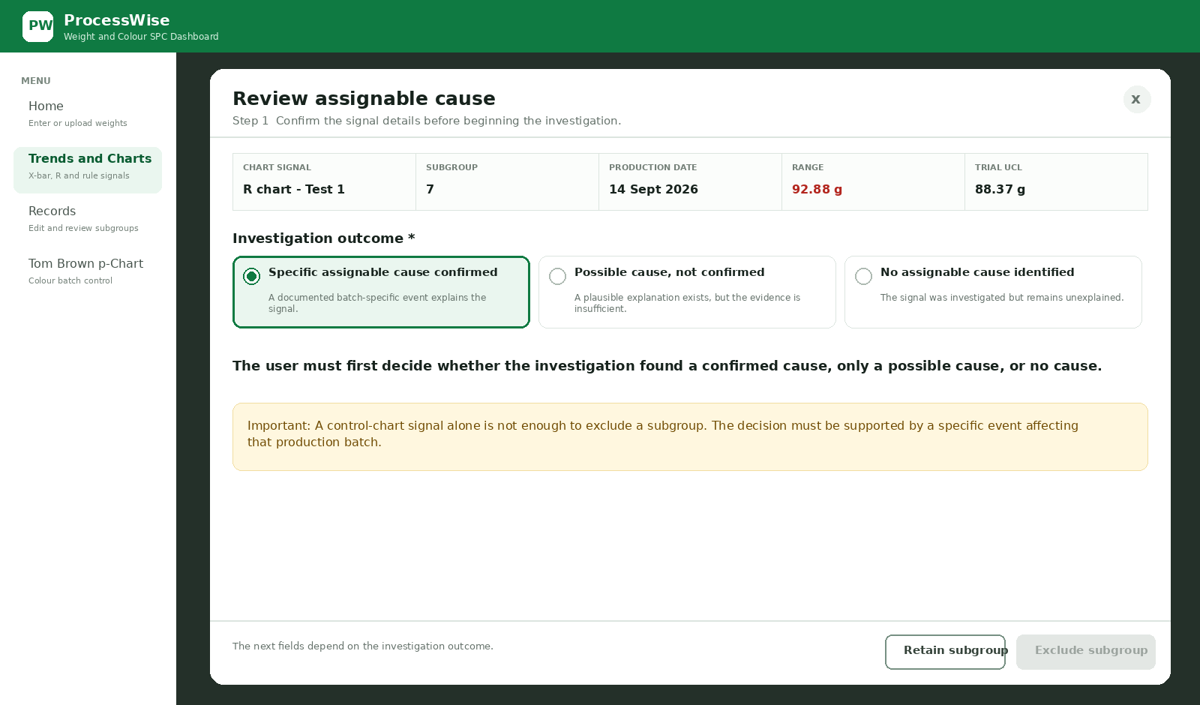

Step 2 Primary cause category
Use the five simplified categories. One is selected as the primary cause category.
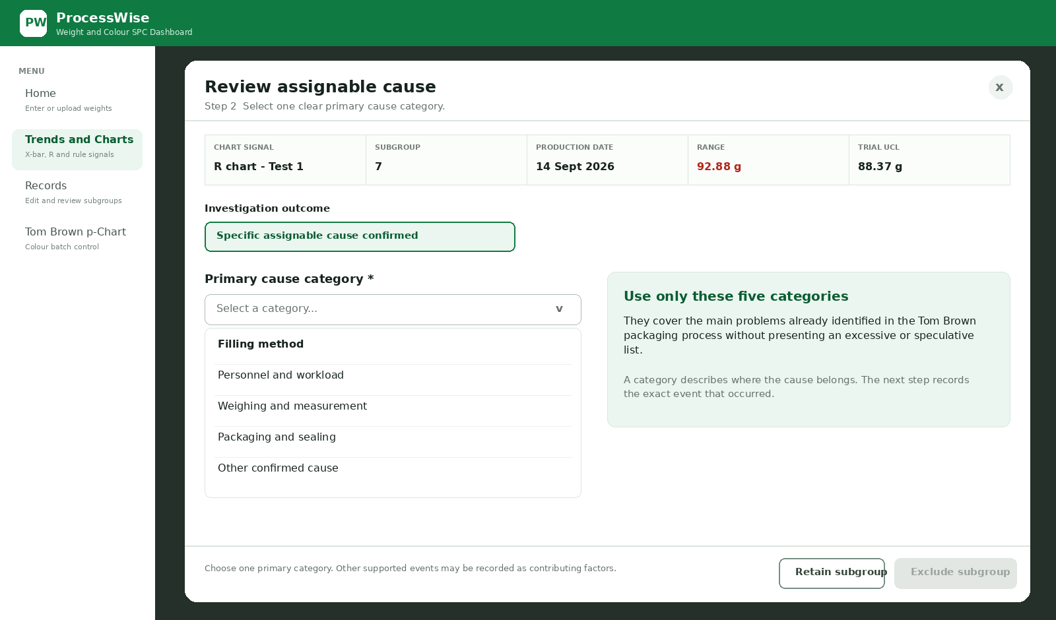

Step 3 Specific supported causes
Show a short list that changes with the category. Allow multiple supported factors.
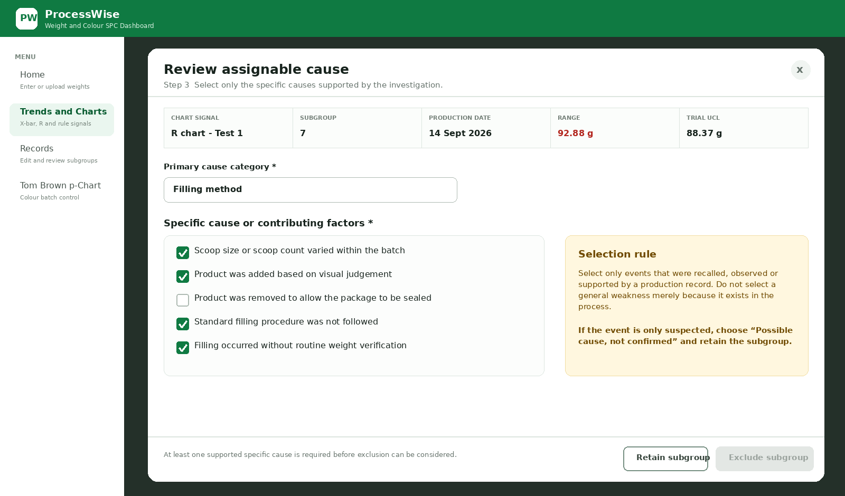

Step 4 Evidence findings and corrective action
Require evidence, a concise finding and the action taken or planned.
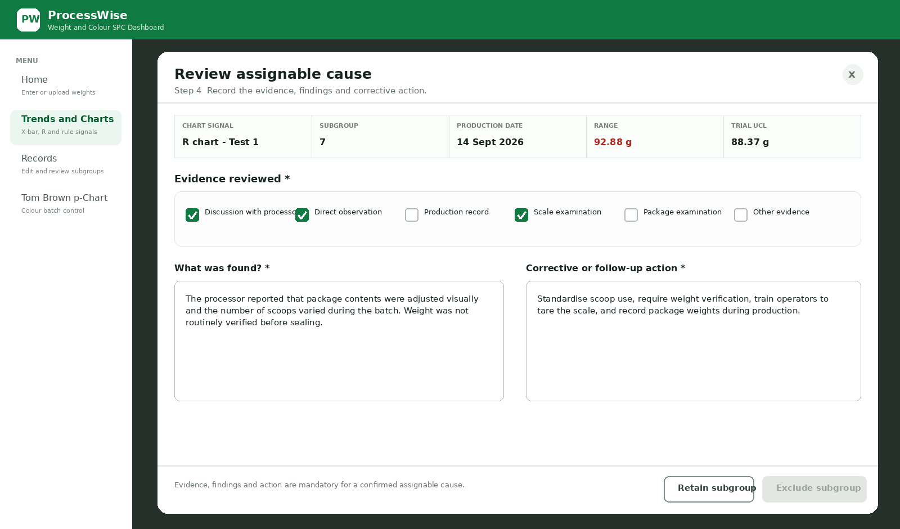

Step 5 Confirmation and exclusion
Enable exclusion only after the cause and evidence requirements are complete.
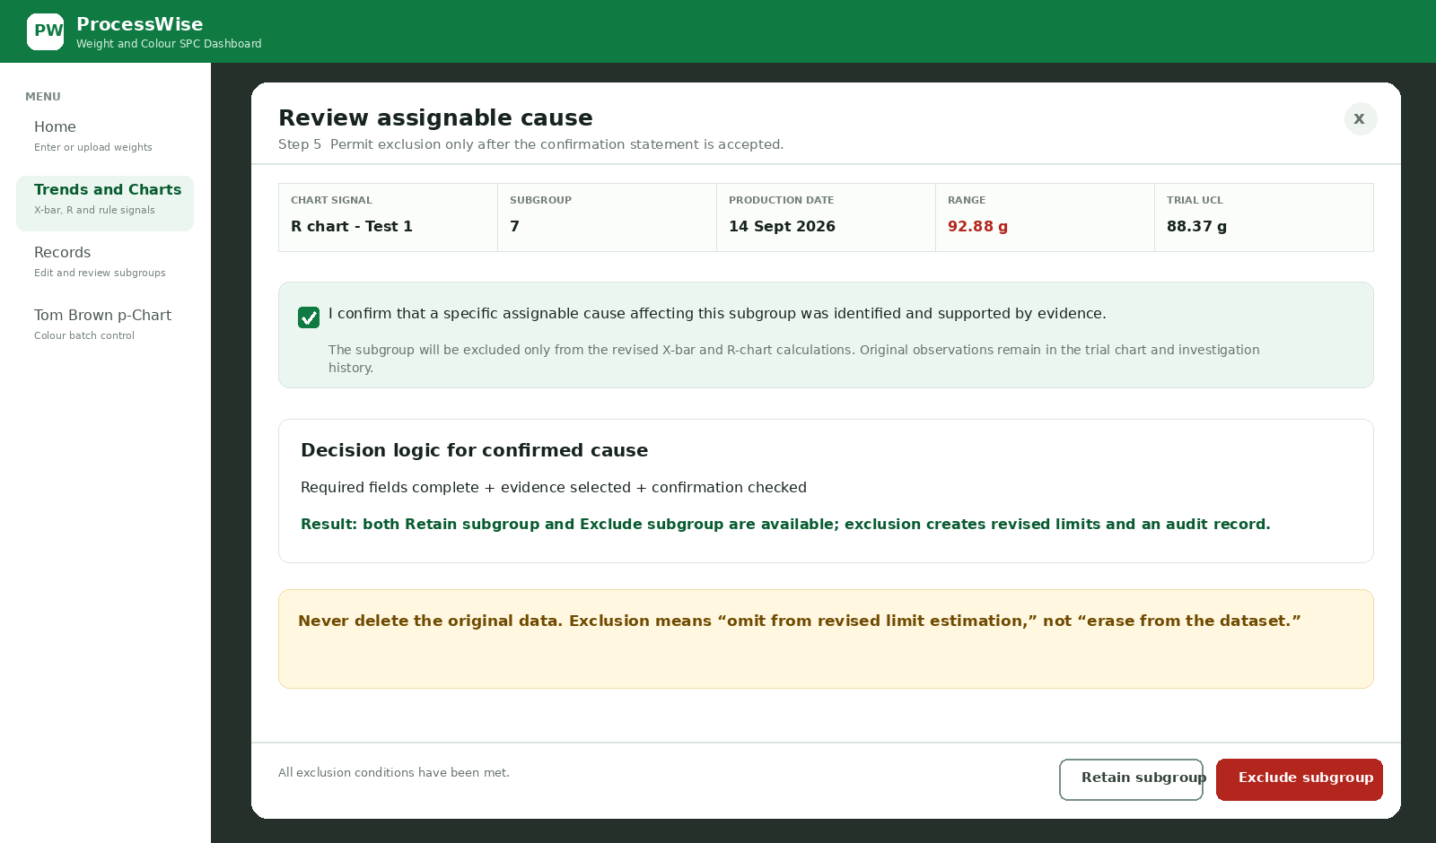

Step 6 Retain when the cause is unconfirmed
Possible or unexplained causes must not be used to remove the subgroup.
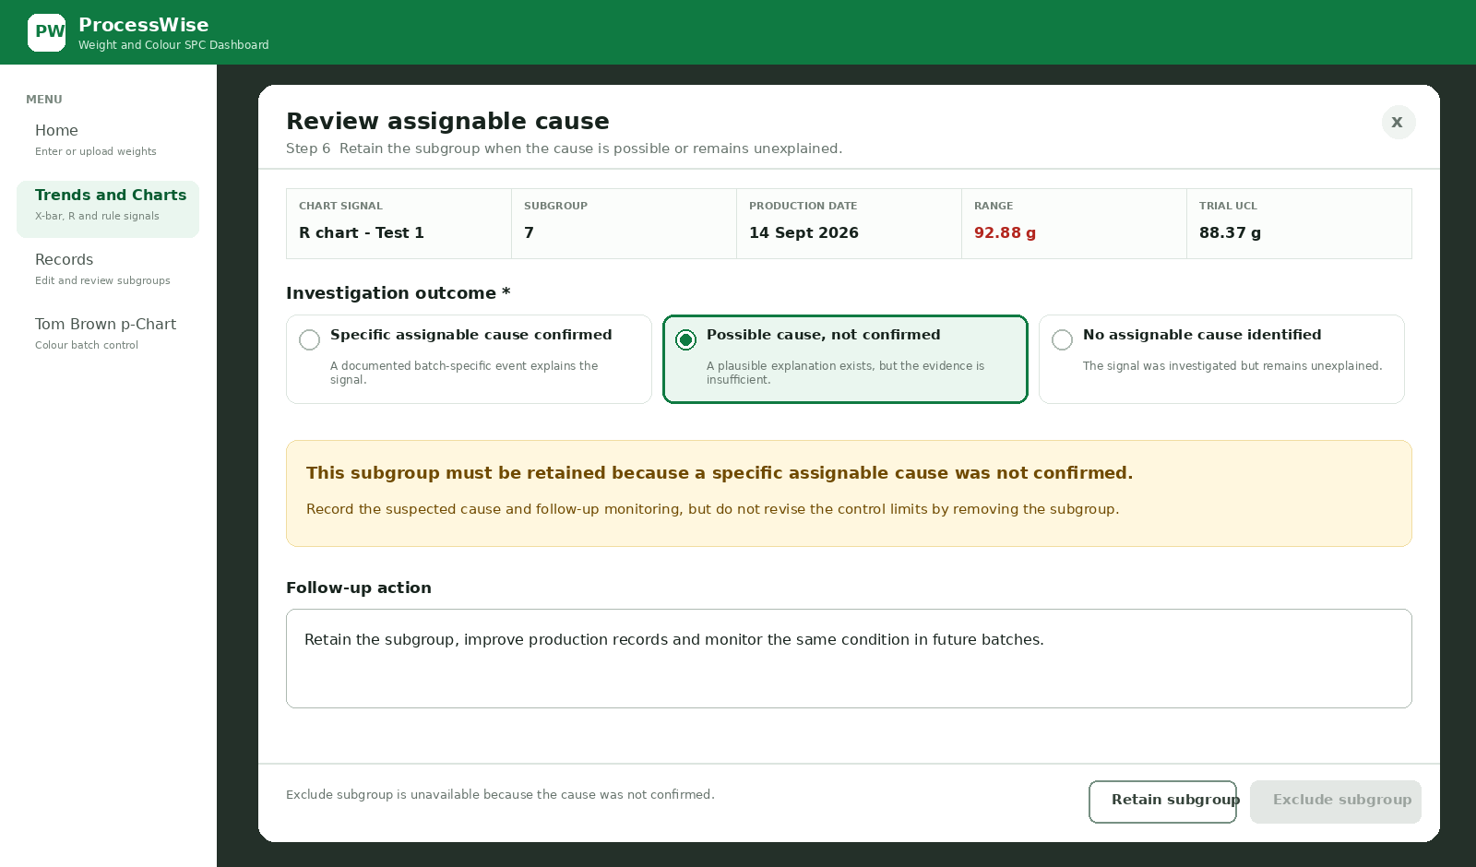

Step 7 Recalculate and redraw
After confirmed exclusions, automatically recalculate both charts and preserve the original subgroup labels.
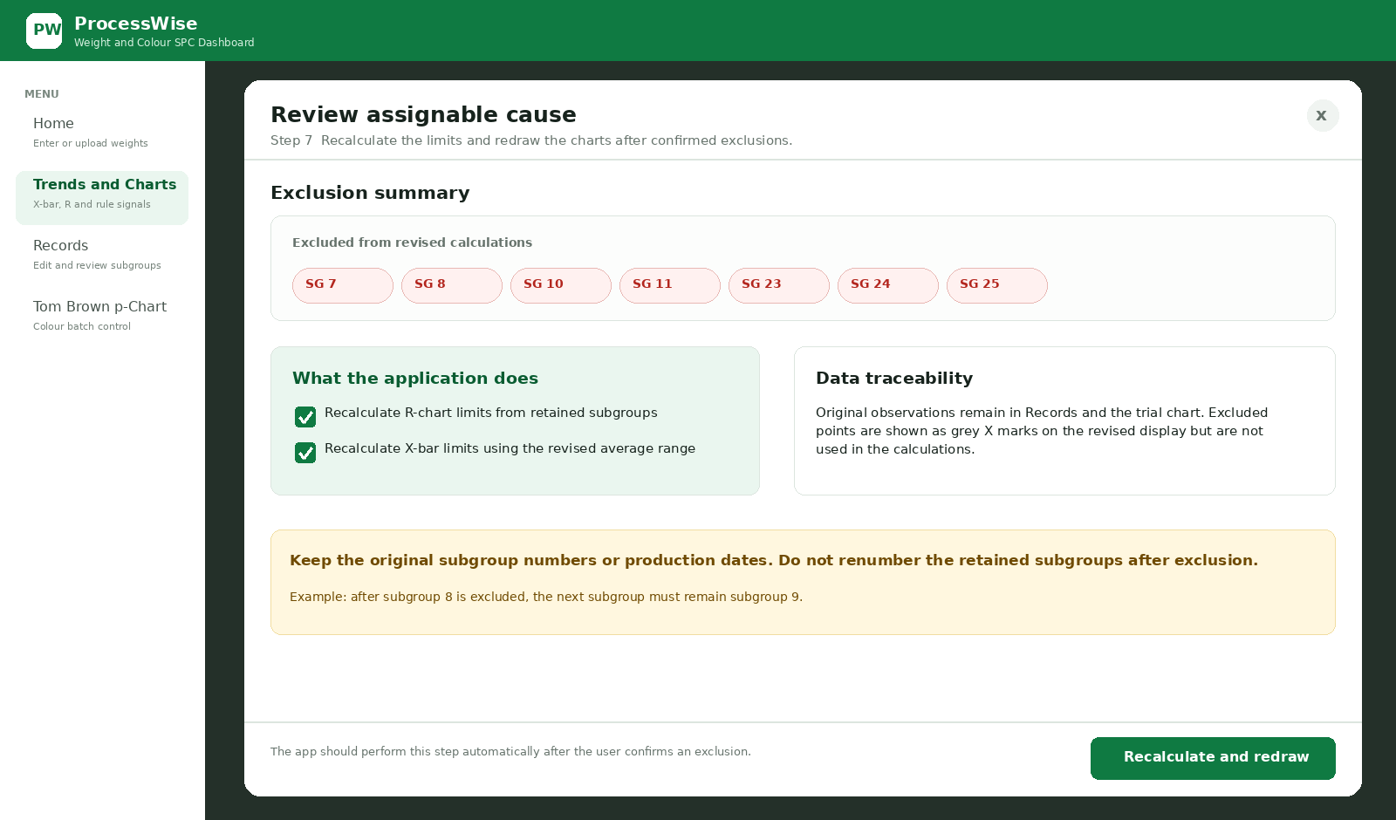

Control chart 3 Final revised chart
After the X-bar investigation, redraw the chart with 18 retained subgroups and display “Process not in control” because unexplained retained X-bar signals remain.
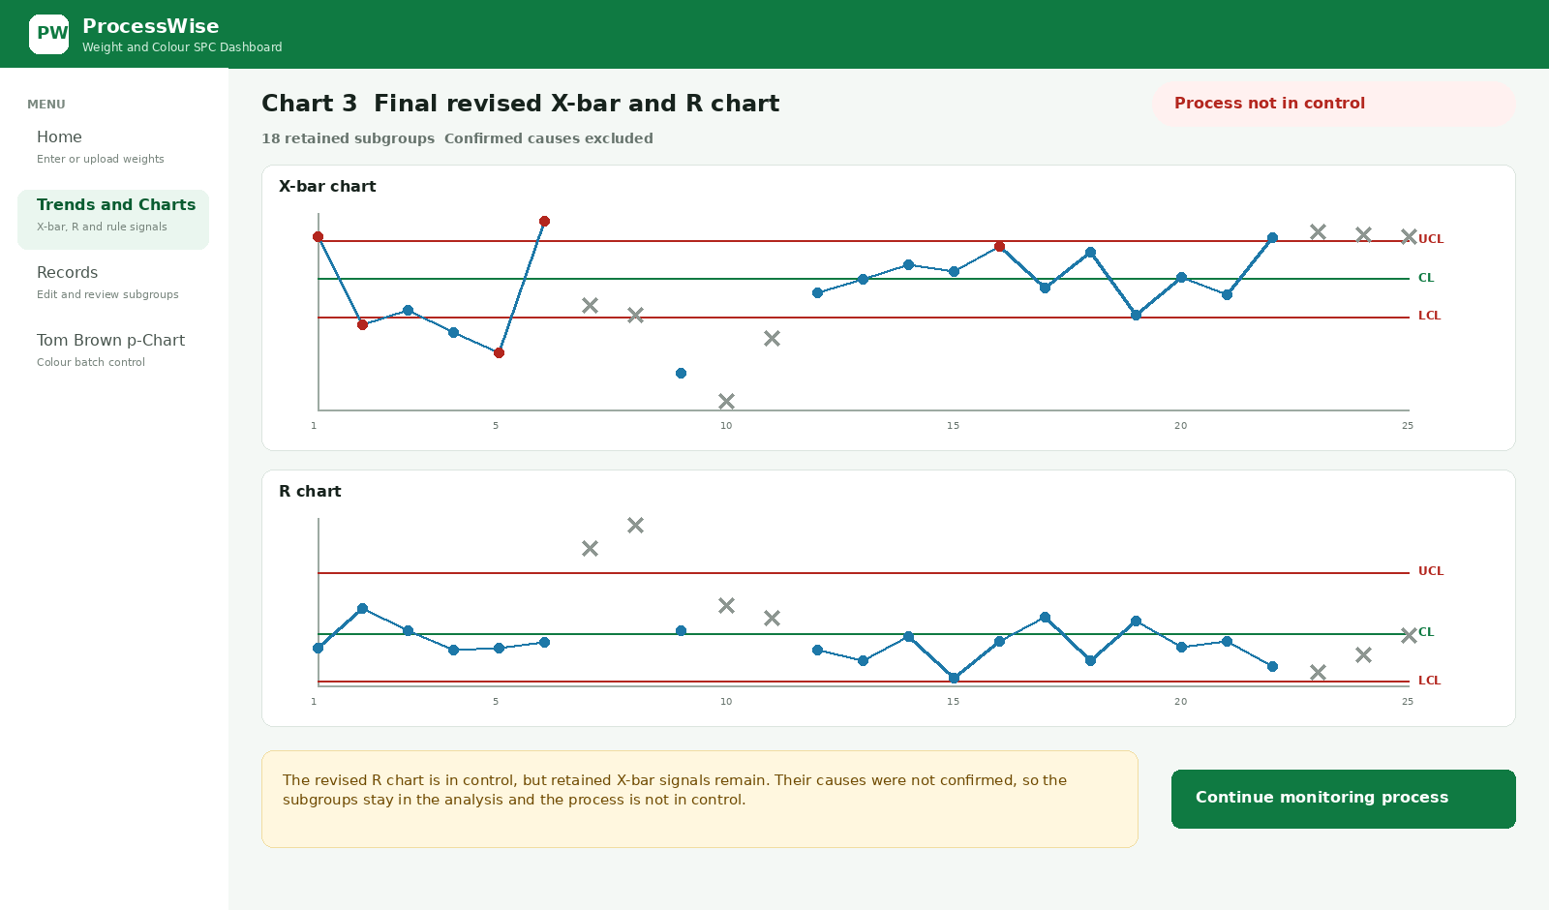

Cause category content
The following options should replace the long mixed dropdown currently used in the application. The wording relates directly to the observed Tom Brown filling and packaging operation.
Primary category | Specific causes shown after selection
Filling method | Scoop size or count varied; product was added by visual judgement; product was removed to allow sealing; the filling sequence was not followed; routine weight verification was omitted.
Personnel and workload | An additional or temporary operator joined; an operator was unfamiliar with the procedure; an urgent order caused rushing; packaging continued overnight; fatigue affected filling.
Weighing and measurement | Packages were not weighed; the scale was not tared; final weight was not verified; the pounds and ounces display made the gram target difficult to interpret; weights were not recorded.
Packaging and sealing | The sachet had insufficient sealing space; product was removed before sealing; a different or smaller sachet was used; the agreed sealing method was not followed.
Other confirmed cause | Another confirmed batch-specific event. Describe the event and supporting evidence in the findings field.

Validation and decision rules
Condition | Application behaviour
Confirmed cause selected | Show category, specific cause, evidence, findings, corrective action and final confirmation.
Possible cause selected | Allow the possible cause and follow-up to be recorded, but hide or disable Exclude subgroup.
No cause identified selected | Record the investigation and retain the subgroup. Do not require the user to invent a cause.
Exclude subgroup selected | Exclude the whole subgroup from both revised X-bar and revised R-chart calculations; retain the original values in the trial chart, Records page and audit history.
Retain subgroup selected | Keep the subgroup in the calculations and store the investigation outcome and follow-up action.

Exact warning text
General process warning. A general process weakness, such as manual filling or the absence of automated filling equipment, does not by itself justify excluding one subgroup. The investigation must identify a specific event affecting that production batch.
Unconfirmed cause message. This subgroup must be retained because a specific assignable cause was not confirmed.
Exclusion confirmation. I confirm that a specific assignable cause affecting this subgroup was identified and supported by evidence. Exclusion applies only to revised X-bar and R-chart calculations; the original observations remain in the trial chart and investigation history.

Recalculation after confirmed exclusions
Required sequence. After an exclusion is saved, ProcessWise must automatically recalculate and redraw the X-bar and R charts using only the retained subgroups. The application should then apply the selected control-chart test to the retained points using the revised limits.
Requirement | Simple application behaviour
Recalculate both charts | First recalculate the R chart. Then calculate the X-bar limits using the revised average range.
Keep original identity | Preserve each subgroup number or production date. Do not renumber the retained subgroups.
Show excluded points | Display excluded points as grey X marks or in a separate excluded list. Do not connect them to the retained data line and do not use them to calculate revised limits.
Retain unexplained signals | A subgroup without a confirmed cause remains in the revised calculation even when it is outside a control limit.
Report stability honestly | If any retained point remains outside the revised limits, display “Process not in control.”
Block capability analysis | Do not calculate process capability while the process remains statistically unstable.

Plain language result for MSME users
Use this message when retained signals remain: “Some production batches still fall outside the revised control limits. The cause could not be confirmed, so these batches were kept in the analysis. The process is not in control. Continue monitoring the process and record what happens during future batches.”
Important interpretation. The process is not unstable merely because the cause could not be investigated. It is unstable because retained points still fall outside the revised control limits or trigger the selected control-chart rule. The lack of a confirmed cause means those points must be retained rather than removed simply to make the chart appear stable.

