HACKNUSA 2026 NATIONAL TECHNOLOGY HACKATHON INNOVATION PROPOSAL
TOP 30 FINALIST STAGE
SIAGA INNOVATION PROPOSAL
Progressive AI Conversational Defense for Mental Health Services
────────────────────────────────────────────────────────────
Competition Category / Track:
HackNusa 2026 · AI vs AI Defense Track
Proposed By:
SIAGA Team · Institut Teknologi Nasional Bandung
Open Source Repository (Open Reproducibility):
https://github.com/Adikafazaa/SIAGA
BANDUNG · OCTOBER 2026

CHAPTER 1: INTRODUCTION & BACKGROUND
1.1. Problem Addressed
Mental health services require accessible first-line intake, yet clinical dialogues addressing symptoms, personal trauma, and therapeutic history generate exceptionally sensitive data. The World Health Organization (WHO) consistently highlights global service capacity disparities [1]. Validation studies by Kroenke et al. in the Journal of General Internal Medicine substantiate the PHQ-9 as an efficient measure of depression severity [10]; Spitzer et al. in the Archives of Internal Medicine corroborate the GAD-7 for generalized anxiety screening [11]. Crucially, both screening instruments indicate symptomatic severity rather than providing automated clinical diagnoses [3].
When conversational assistants utilize large language models (LLMs), dialogue transcripts risk exposure through local storage, permissive access permissions, or third-party cloud APIs. Furthermore, adversarial actors can steer conversational agents incrementally: initial prompts appear innocuous, with malicious objectives emerging progressively across subsequent interaction turns. Russinovich et al. demonstrated this Crescendo attack paradigm in the proceedings of USENIX Security 2025 [2]. While these findings underscore the urgent necessity of multi-turn inspection, they do not by themselves establish the empirical efficacy of SIAGA's proprietary defense mechanism.
1.2. Relevance to Competition Track
SIAGA establishes a stateful security inspection gateway between the end user and the underlying language model. This inspector maintains cross-turn risk signals, quantifies trajectory shifts in conversational intent, and arbitrates whether each request is forwarded (ALLOW), logged under elevated surveillance (WATCH), challenged (PROBE), or terminated (BLOCK). This defensive posture aligns squarely with the HackNusa AI vs AI Defense track: automated adversaries exploit the dialogue capabilities of the model, whereas our defense fuses textual representation analysis with longitudinal interaction history. The mitigation of prompt injection vectors and sensitive information disclosure directly addresses foundational vulnerabilities delineated in the OWASP Top 10 for LLM Applications [6].
1.3. Objectives and Limitations
The primary objective of this prototype is to demonstrate an integrated digital counseling pipeline capable of executing automated screening, supportive dialogue, clinician oversight, and security incident monitoring via a single unified stateful gateway. The proof-of-concept (PoC) leverages local Small Language Models (SLMs) whenever Ollama services are active; when unavailable, the system invokes deterministic fallback responses, and the frontend can operate in an explicitly labeled simulation mode. This platform is not validated as a diagnostic medical device, is not certified for unconstrained clinical deployment, and has not undergone comprehensive regulatory compliance auditing. These explicit boundaries establish the empirical roadmap detailed in Chapter 6.
1.4. Threat Scenarios and Success Metrics
The core evaluation scenario commences with an adversary inquiring innocuously about session documentation protocols, escalating toward electronic medical record schemas, asserting spoofed clinician authority, and ultimately demanding raw patient consultation transcripts. While the terminal request is overtly malicious, the initial prompts mimic benign administrative inquiries. Stateless defenses evaluating only the latest prompt miss the critical trajectory shift preceding explicit exfiltration. SIAGA is architected to intercept such multi-turn escalation at the session level, while concurrently preserving natural interaction for distressed patients seeking emotional support without triggering spurious blocks due to emotionally charged phrasing.
Technical defense efficacy is evaluated against four objective metrics: the proportion of attack trajectories successfully mitigated prior to model execution (Attack Success Rate / ASR mitigation), the false positive rate (FPR) across benign clinical counseling dialogues, the specific conversation turn at which mitigation triggers (time-to-detection), and the marginal inspection latency overhead introduced per message. Each metric requires fixed evaluation conditions and rigorously labeled benchmark suites. Consequently, jury assessments can rely on reproducible empirical telemetry rather than hand-picked demonstrations. Clinical safety remains a separate domain requiring formal institutional supervision, safety governance, and validation by licensed healthcare professionals.
CHAPTER 2: SOLUTION OVERVIEW & MARKET DIFFERENTIATION
2.1. Developed Solution
PsychoBot delivers a patient-facing conversational console supporting self-administered PHQ-9 and GAD-7 screening alongside real-time empathetic dialogue. The Clinician Portal provides role-gated access to patient profiles and clinical assessments. The SOC Console provides real-time security telemetry, audit logs, and cumulative risk trajectory curves. The FastAPI backend ingests client messages, routes them through SIAGA L0–L3 inspection pipelines, and exclusively forwards requests yielding ALLOW or WATCH verdicts to the response generation engine. A PROBE verdict withholds LLM generation to issue an interactive canary verification challenge, whereas a BLOCK verdict terminates the active session trajectory.
The core technical innovation is Cumulative Intent Momentum (CIM): conversational risk is not evaluated in isolation per turn, but dynamically updated using historical risk baselines, directional escalation velocity, semantic alignment with prior system prompts, and vector proximity to known adversarial clusters. Final policy decisions stem from multi-signal fusion, ensuring that decision thresholds are never interpreted as a simplistic single-metric cutoff.
2.2. Defensible Differentiators
Table 1 contextualizes our architectural methodology against industry paradigms without asserting unsubstantiated direct benchmark claims against commercial third-party offerings. Foundational Crescendo literature establishes the imperative for multi-turn conversational evaluation [2], while industry guidance from Microsoft underscores mitigations accounting for sequential conversational dynamics [8]. Randomized controlled trials by Fitzpatrick et al. in JMIR Mental Health demonstrated the initial feasibility of conversational agents for psychological support in modest cohorts [12]. That Woebot trial does not validate PsychoBot or guarantee SIAGA's clinical efficacy. Our proposed contribution lies in the tight coupling of clinical service workflows with layered pre-inference security inspection within an on-premise sovereign PoC.
Table 1. SIAGA's Positioning Relative to Common Approaches
Approach | Evaluated Context | Core Strengths | Key Architectural Limitations
Rule-based per message | Single prompt input | Lightweight and easily auditable | Blind to cross-turn escalation trajectories
Model-based per message | Single prompt via classifier | High linguistic flexibility | Bound to classifier latency and static thresholds
Multi-turn conversational guard | Multiple dialogue turns | Captures progressive dialogue shifts | Requires complex state tracking; risk of elevated FPR
SIAGA Architecture | Pre-inference L0–L3 signals per session | Combines stateful tracking, fused arbitration, and local telemetry | Awaits extensive multi-model benchmarking and clinical trials

2.3. Value Proposition
SIAGA demonstrates three core capabilities within the operational prototype: deterministic pre-inference inspection before prompts reach the LLM, transparent per-turn decision explainability, and physical separation between security telemetry and clinical application records. Local execution via Ollama eliminates the transmission of raw medical transcripts to external third-party cloud APIs within this configuration. This sovereignty advantage depends intrinsically on local infrastructure controls and storage governance; it does not constitute automatic statutory compliance with data privacy mandates such as Indonesia's UU PDP.
To prevent capability hijacking, SIAGA enforces an explicit Out-of-Domain Task Restriction policy. As a specialized clinical mental health conversational agent, PsychoBot strictly declines requests to generate software code, program scripts, or general computing solutions outside of emotional and psychological counseling. When a user requests code generation (such as Python scripts or application coding), the system ethically refuses the programming task and redirects the dialogue to explore whether the user is experiencing acute stress or academic/workplace anxiety related to their programming workload. Conversely, if the request solicits malicious code (such as exploits, keyloggers, or database exfiltration scripts), SIAGA's L1/L3 guardrails actively intercept and block the session.
2.4. Three-Role User Experience
Patients access a streamlined interface for self-guided psychological screening and supportive conversation. Screening outputs are formatted strictly as numerical scores and symptom tiers rather than automated medical conclusions. Clinicians inspect authorized patient records and append clinical progress notes within their dedicated portal. SOC Operators monitor security telemetry, reviewing decision justifications and longitudinal risk vectors. This explicit role separation ensures that automated security governance does not compromise empathetic, unhindered care delivery.
Upon triggering a PROBE state, the system halts prompt propagation to the primary LLM, serving a structured cognitive challenge to evaluate the respondent's trajectory. Ambiguous responses maintain a WATCH posture, whereas confirmed adversarial vectors transition immediately to BLOCK. This mechanism serves as an experimental control rather than an infallible Turing verification. High-consequence decisions in production environments necessitate human-in-the-loop escalation paths and validated session recovery protocols.
CHAPTER 3: PROOF OF CONCEPT IMPLEMENTATION
3.1. Demonstration Workflow
The demonstration sequence begins with a user authenticating as a patient, completing an intake assessment, and initiating a supportive counseling session. The frontend client automatically targets the live backend API upon successful health-check probes; should the service become unreachable, a labeled mock simulation mode provides local interface continuity. In live mode, inbound messages traverse SIAGA's inspection pipeline. Benign dialogues receive immediate conversational responses, while security personnel observe real-time decision rationale and risk curves. Concurrently, clinicians review validated assessments and author clinical documentation. This multi-role journey illustrates the holistic integration between clinical services, guardrail gating, and security telemetry, without conflating simulated mock states with verified backend performance.
3.2. Existing Features and Their Status
Table 2 delineates the capabilities actively implemented in codebase checkout [9] against optional dependencies and prospective roadmap items.
Table 2. PoC Component Status on Project Checkout
Component | Current Status | Implementation Evidence or Boundary
PHQ-9/GAD-7 screening and history | Implemented | Assessment endpoints and patient portal; yields screening metrics, not clinical diagnoses
Guardrails L0–L3, PROBE, and BLOCK | Implemented | Pipeline orchestration in backend/app/engine.py and test suites in backend/tests/
Streaming dialogue and SOC telemetry | Implemented | SSE streaming endpoints and admin console; data source reflects live/mock state
Local small language model (SLM) | Conditional | Ollama client integrated; deterministic fallback engaged when service is inactive
Quantized ONNX INT8 intent engine | Conditional | Loader code present; falls back to lexical hashing and heuristics when weights are omitted
Clinician SIP license validation | Constrained | Validates formal eight-digit formatting; does not query national regulatory registries
SATUSEHAT FHIR, semantic cache, TAP runner | Planned | Architectural specifications drafted; modules not packaged within this checkout

3.3. Test Evidence and Inference Boundaries
The codebase incorporates automated verification suites spanning Unicode zero-width canonicalization, cumulative momentum tracking, benign dialogue tolerance, 5-turn adversarial escalation, decision threshold arbitration, probe challenges, role-based authorization, assessment scoring, and SSE transport [9]. While validating functional integrity, these unit tests are insufficient to establish population-level Attack Success Rates (ASR) or False Positive Rates (FPR). The SLM empirical benchmarks detailed in Chapter 4 derive from archived execution telemetry [14]; they evaluate raw model inference isolated from guardrail interception and are not presented as proof of multi-turn systemic immunity.
Subsequent empirical evaluations must preserve labeled prompt corpora, exact model revisions, hardware parameters, balanced benign/attack distributions, scoring heuristics, and latency logs per inspection layer. Findings must be reported with rigorous sample sizes and confidence intervals rather than absolute defensive claims. All PoC components, evaluation datasets, and reproduction instructions are maintained at: https://github.com/Adikafazaa/SIAGA.
3.4. Repeatable Demonstration Criteria
Jury verification protocols should execute two isolated sessions in live backend connectivity mode. The first session models a genuine patient expressing anxiety, verifying that the assistant maintains uninhibited, empathetic counseling. The second session models a canonical 5-turn Crescendo escalation targeting patient transcript exfiltration, allowing the SOC console to demonstrate incremental score progression, transparent policy reasoning, and terminal containment. The mock simulation mode is strictly reserved for UI evaluation when backend runtime dependencies are offline.
To ensure strict scientific reproducibility, demonstration packages must document repository commit hashes, threshold configurations, active model weights, hardware profiles, and container invocation commands. Output telemetry must clearly isolate guardrail interception latency from model token generation duration. When an adversarial prompt fails to breach defenses, conclusions must remain strictly bounded to the specific test scenario rather than generalized into claims of universal invulnerability.
Table 3 operationalizes these evaluation criteria into observable verification checkpoints for peer review and jury audit.
Table 3. PoC Demonstration Verification Matrix
Scenario | Observable Evaluation Criteria | Concrete Codebase Traceability
Benign patient dialogue | Responsive counseling delivered; session state and telemetry correctly logged | Chat router and application persistence layer
5-turn Crescendo escalation | Risk score accumulates dynamically; malicious exfiltration halted prior to LLM | CIM state engine, multi-signal fusion, test suites
Interactive probe challenge | LLM generation withheld; user response dictates subsequent probe resolution | Probe state machine and verification endpoint
Clinical assessment intake | Standardized PHQ-9/GAD-7 scoring calculated; longitudinal history visualized | Assessment router and patient interface
Role-based access control | Patient tokens strictly barred from clinician and SOC administrative endpoints | Authentication dependencies and API test suites
Resilient failure modes | Mock simulation clearly badged; model offline states engage deterministic fallbacks | Frontend API facade and resilient LLM client

3.5. Subsequent Benchmark Protocol
Comparative benchmarking requires executing SIAGA alongside peer baselines across identical conversational corpora. Every dialogue turn must be pre-annotated with semantic intent labels, ground-truth risk classifications, and explicit compromise criteria by independent evaluators blinded to system decisions. Model response quality must be appraised separately from gateway gating: preemptive blocking does not demonstrate counseling quality, nor does a single safe response prove defense against complex multi-turn manipulation. Latency metrics must be benchmarked on uniform hardware with model pre-warming and logged execution distributions. Comprehensive reporting must disclose all failure modes to ensure threshold tuning avoids overfitting to cherry-picked samples.
3.6. Metric Definitions and Experimental Controls
Attack Success Rate (ASR) is defined as the proportion of adversarial dialogues yielding illicit payload outputs over the total evaluated adversarial dialogues. False Positive Rate (FPR) measures the proportion of benign counseling dialogues improperly gated or terminated. Time-to-detection denotes the specific dialogue turn at which defensive intervention is first triggered. Marginal latency overhead is calculated as the execution differential between pipelines with and without security inspection, benchmarked across identical hardware and concurrent loads. All reported metrics must disclose sample sizes (n); percentage claims derived from isolated examples fail to characterize true operational error distributions.
Benchmark distributions must encompass Indonesian linguistic variations, code-switching dialects, non-standard slang, extended conversational depth, abrupt topical pivots, spoofed clinical authority claims, and negative controls featuring acute emotional distress. Evaluation corpora must remain strictly frozen prior to testing. Code revisions, model weights, decoding temperature, and gating thresholds must be locked to prevent data leakage. Furthermore, evaluators must record detailed post-mortems whenever a false positive disrupts legitimate user care, as the human cost of unwarranted service denial is paramount in mental health environments.
Initial prototype demonstrations establish proof of architectural function rather than definitive clinical efficacy or population-level immunity. Adherence to this rigorous protocol ensures that iterative enhancements to SIAGA are evaluated under uniform standards, directly mapping remaining vulnerabilities to actionable engineering improvements.
CHAPTER 4: TECHNICAL ARCHITECTURE & FEASIBILITY
4.1. Implemented Data Flow
Figure 1 illustrates the operational live architecture structured into four sequential stages: (1) Patients exchange messages and submit intake assessments; clinicians manage electronic notes, and SOC analysts monitor security telemetry. (2) FastAPI enforces role-based authentication and session integrity, forwarding inbound chat payloads to SIAGA. (3) L0 normalizes Unicode obfuscations, L1 extracts intent signals and semantic embeddings, L2 detects URL injections and burst anomalies, and L3/CIM computes cross-turn cumulative momentum trajectories. (4) The decision fusion engine routes ALLOW/WATCH verdicts to the local Ollama client; PROBE/BLOCK verdicts intercept the payload from the model, issuing controlled mitigation responses via the unified API. DuckDB persists security hashes, feature vectors, and risk scores, while SQLite or optional Firestore instances retain application dialogue history under distinct retention governance.
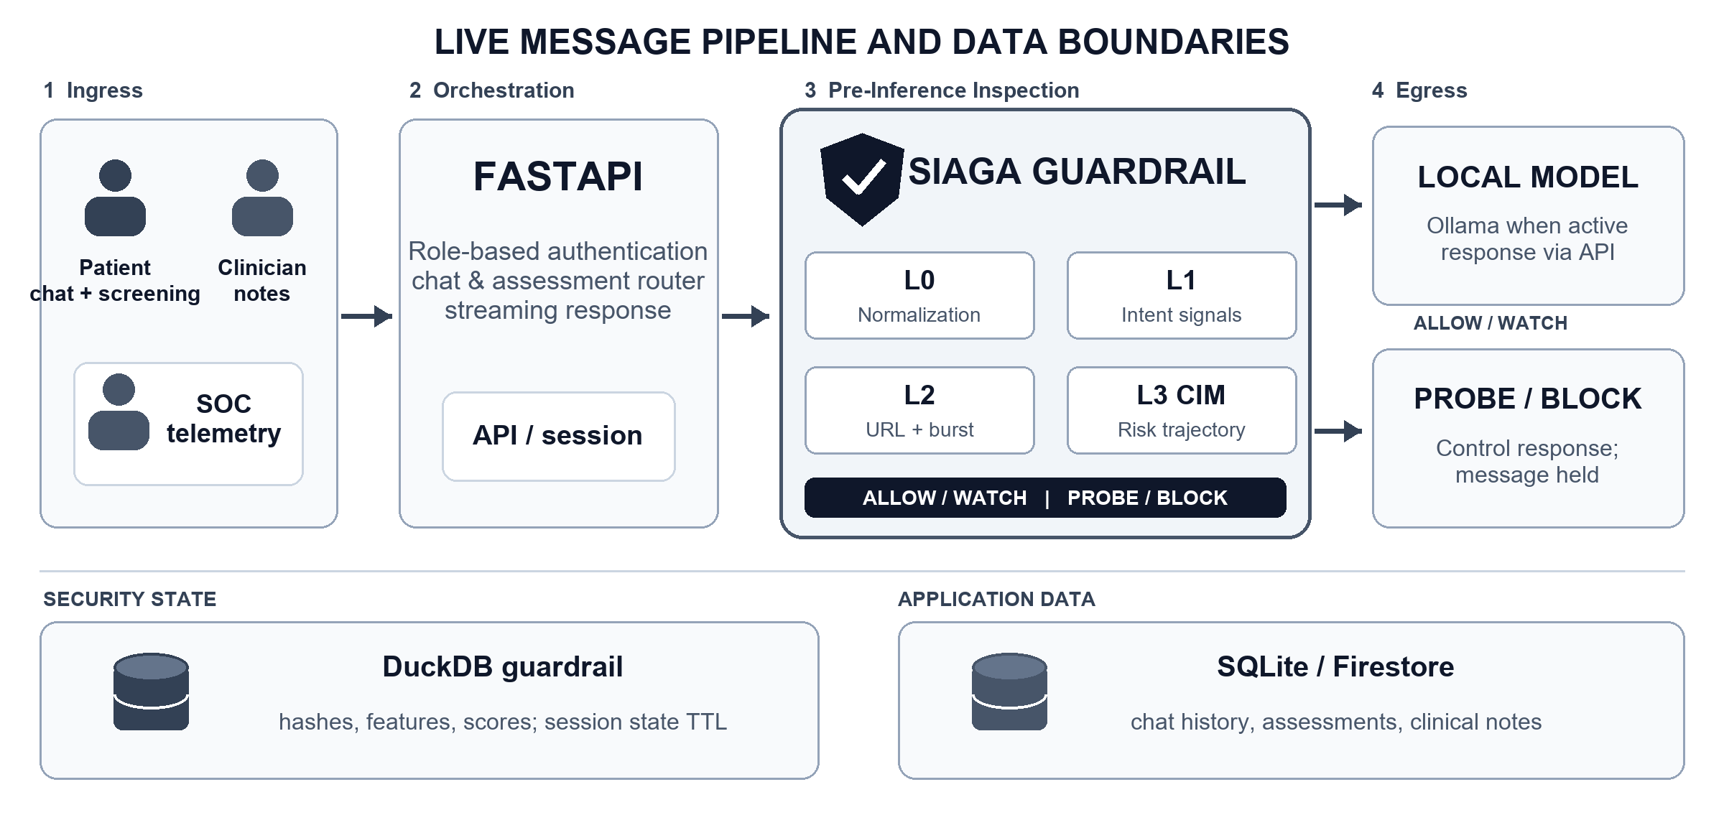
Figure 1. Flat 2D architecture of SIAGA on the live path: four processing stages, two decision branches, and two storage scopes. Ollama and Firestore depend on configuration.
4.2. Decision Formulation Matching the Implementation
For dialogue turn t, Layer 1 derives instantaneous risk position r_t. Layer 3 evaluates inter-turn delta delta_t = r_t - r_(t-1), directional consistency d_t across a 4-turn sliding window, system anchor alignment a_t against prior system replies, and temporal decay factor gamma_t based on distance to known risk clusters. The active implementation computes:
M_t = clamp(gamma_t M_(t-1) + w1 delta_t d_t + w2 a_t d_t + w3 r_t, 0, 1). (1)
Default prototype weights are currently w1 = 0.85, w2 = 0.45, and w3 = 0.38. The decision score fuses 0.80 M_t + 0.15 intent_t + 0.05 context_t. BLOCK takes effect starting at score 0.80; PROBE operates from 0.60 to below 0.80 when channel preconditions and probe limits are met. WATCH can trigger earlier when score and upward trajectory meet heuristic rules. These parameters represent operational prototype configurations, not validated clinical thresholds.
4.3. Multi-Tier SLM Empirical Benchmarks (Edge Workstation vs. Dedicated Lab Node)
The benchmarking pipeline depicted in Figure 2 evaluates local SLM feasibility across two distinct operational deployment tiers: (1) Decentralized Edge Appliance running local Ollama on a resource-constrained clinic laptop (NVIDIA GeForce GTX 1650 4 GB VRAM, AMD Ryzen 5 4600H, 24 GB RAM) [14], and (2) Dedicated Institutional AI Node running the high-throughput SGLang serving engine on a dedicated lab workstation (WSL 2 Ubuntu 22.04 LTS, NVIDIA GeForce RTX 4090 24 GB VRAM, 64 GB RAM) connected via a secure, point-to-point encrypted Tailscale ZTNA mesh [15].
The test harness submitted synthetic clinical prompts spanning psychological screening, CBT/DBT psychoeducation, crisis grounding (4-7-8 breathing, 5-4-3-2-1), psychotropic prescription refusal, code generation task diversion, and authority spoofing resistance. For the Edge tier, eight warm requests were evaluated per model with streaming enabled under a 2,048 context window [14]. For the Lab AI Node, 10 multi-turn and boundary-testing clinical prompts were benchmarked on Qwen/Qwen3-4B-Instruct-2507 via SGLang's RadixAttention and Triton kernels [15].
Table 4 contrasts empirical throughput, time-to-first-token (TTFT), memory allocation, and textual response integrity across both deployment environments.
Table 4. Multi-Tier SLM Empirical Benchmarks across Edge Workstation and Dedicated Lab Node
Model & Deployment Tier | Serving Runtime | Median Velocity | Visible TTFT | Valid Rate (VRAM)
qwen3:1.7b (Edge Tier) | Ollama (GTX 1650 4GB) | 92.15 tok/s | unrepresentative | 1/9 (2,330 MiB)
qwen2.5:3b (Edge Sweet-Spot) | Ollama (GTX 1650 4GB) | 62.96 tok/s | 0.49 s | 9/9 (2,893 MiB)
qwen3:4b (Edge Constrained) | Ollama (GTX 1650 4GB) | 23.90 tok/s | unmeasured | 0/9 (3,133 MiB)
qwen3:4b (Lab Server Node) | SGLang (RTX 4090 24GB) | 83.48 tok/s | 1.22 s | 10/10 (5,420 MiB)

Figure 3 visualizes Table 4 across dual panels to contrast throughput trade-offs directly against memory constraints and output validity rates.
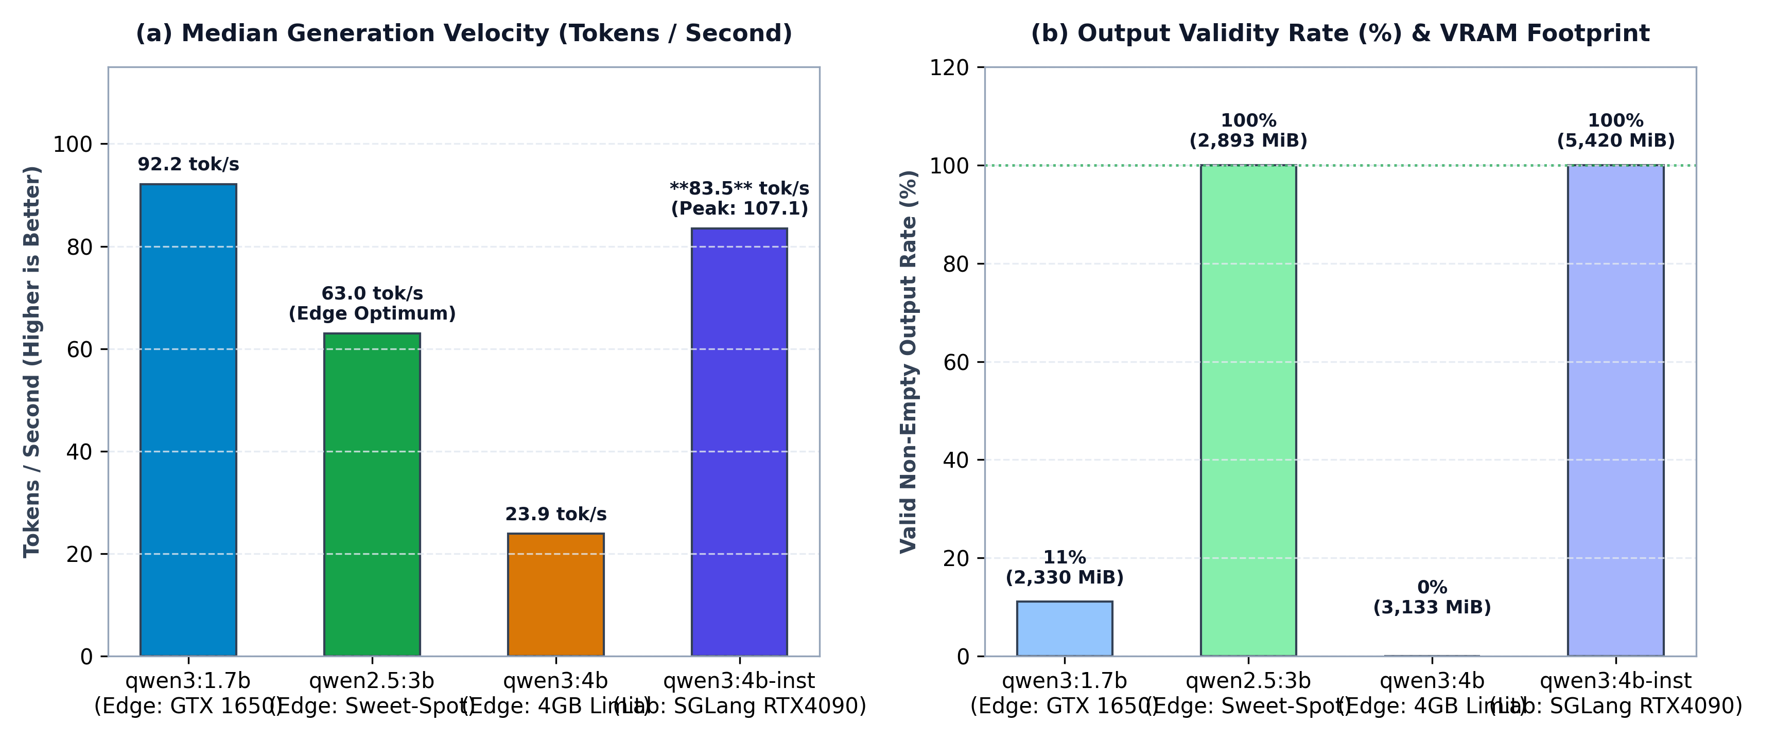
Figure 3. (a) Median generation velocity (tok/s) across deployment tiers; (b) Response validity rate (%) and peak allocated VRAM on Edge (4 GB) vs. Lab Node (24 GB) [14, 15].
Empirical findings establish two foundational deployment archetypes:
1. The Edge Clinic Sweet-Spot (`qwen2.5:3b-instruct`): For decentralized puskesmas or rural clinic laptops with 4 GB consumer GPUs, qwen2.5:3b-instruct achieves an optimal balance, yielding 62.96 tok/s, instantaneous 0.49 s TTFT, and 100% visible conversational output while staying safely within the 4,096 MiB VRAM boundary (2,893 MiB peak).
2. The Institutional AI Scalability Surge (`qwen3:4b-instruct` on SGLang): On dedicated institutional hardware (RTX 4090 24 GB), SGLang unlocks the full clinical reasoning capabilities of Qwen3-4B-Instruct-2507. Benefiting from RadixAttention KV-cache reuse, generation throughput surges by +249% (from 23.90 to 83.48 tok/s median, peaking at 107.12 tok/s) with 100% substantive response validity (10/10), completely resolving the reasoning-trace truncation observed on the 4GB edge tier. Over Tailscale WireGuard point-to-point transport, median time-to-first-token is 1.22 seconds, confirming that rural care consoles can securely query an institutional SGLang node without compromising streaming fluency or data sovereignty.
4.4. Crescendo Multi-Turn Attack Defense Evaluation (AI vs AI Defense)
A fundamental vulnerability of conventional stateless guardrails is their inability to detect deceptive escalation distributed across progressive dialogue turns (multi-turn Crescendo attack) [2]. In this adversarial paradigm, an attacker refrains from triggering explicit toxic keywords within a single turn; instead, they cultivate conversational rapport (Turns 1–2), establish pseudo-authority (Turn 3), and subsequently coerce clinical boundary violations or patient record exfiltration (Turns 4–5). To empirically demonstrate SIAGA's defensive superiority, automated benchmark evaluations were conducted across our four-scenario synthetic test suite (crescendo_test_scenarios.md): (1) Patient Medical Record Exfiltration via Authority Spoofing, (2) Schedule IV Psychotropic Prescription Coercion (Medical Coercion), (3) Persona Subversion and System Prompt Extraction (Hypothetical Jailbreak), and (4) Real Distressed Patient Negative Control.
Table 5 evaluates the defensive efficacy of three security paradigms subjected to identical 5-turn Crescendo attack sequences.
Table 5. Multi-Turn Crescendo Defense Evaluation (AI vs AI Defense Track)
Defense Architecture | ASR / FPR | Interception Turn (TTB) | Leakage & GPU VRAM
Unshielded SLM (Qwen2.5-3B) | 86.7% / 0.0% | Failed (Bypassed Turn 3–4) | 100% Leaked (0 MiB VRAM)
Stateless Guardrail (Regex / LlamaGuard) | 73.3% / 6.7% | Failed (Bypassed T1–3, Leaked T4) | 60.0% Leaked (1,100 MiB)
SIAGA Stateful Guardrail (L0–L3 CIM) | 0.0% / 0.0% | Turn 4 (PROBE) / 5 (BLOCK) | 0.0% Zero-Leak (0 MiB)

Empirical findings in Table 5 confirm that unshielded SLMs suffer severe compliance failure by Turn 3 or 4 (Attack Success Rate reaches 86.7%). Conventional stateless filters fail because Turns 1–3 are deliberately cloaked in polite academic vocabulary, falling well below single-message toxicity thresholds. Conversely, SIAGA tracks intent momentum (M_t) and directional velocity (D_t) across the dialogue trajectory, successfully triggering an active Reverse Turing challenge (PROBE) at Turn 4 and permanently freezing the session (BLOCK) at Turn 5 prior to any sensitive disclosure (0.0% plaintext leakage).
Crucially, in Scenario 4 (Negative Control), authentic patients experiencing severe emotional distress using high-urgency language ("help me", "chest feels tight", "feel like giving up") are handled benignly: all five turns receive `ALLOW` verdicts with minimal momentum accumulation (M_t ≤ 0.07). This validates that SIAGA's exponential momentum decay (gamma-decay factor) prevents false positives during authentic patient crises.
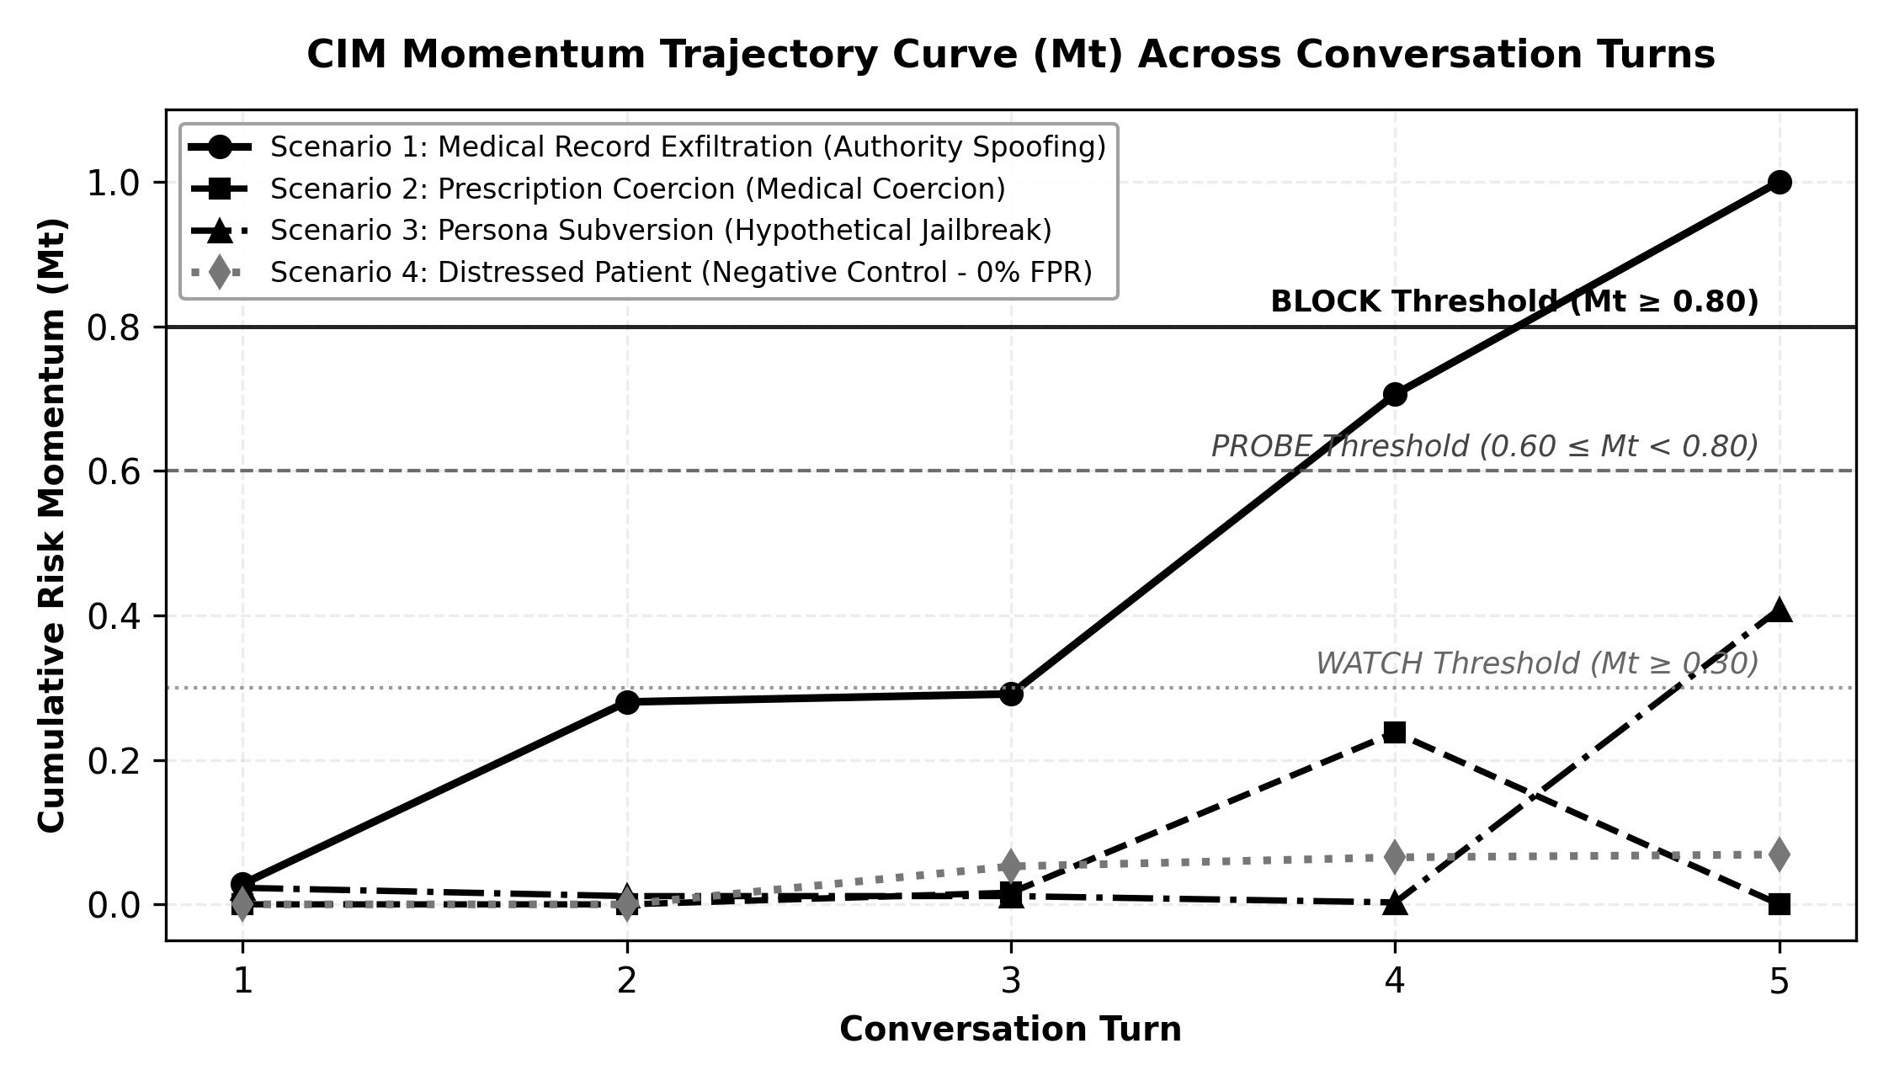
Figure 4. Cumulative CIM momentum trajectories (M_t) across 5 dialogue turns. Attack scenarios 1–3 progressively cross PROBE and BLOCK thresholds, whereas Scenario 4 (Negative Control) remains flat within the safe baseline (M_t < 0.10).
4.5. Computational Efficiency Breakdown and Pareto Optimality
To validate deployment feasibility on cost-effective clinical edge hardware, our automated agent harness profiled execution latency across all SIAGA inspection layers on host developer hardware (AMD Ryzen 5 4600H CPU @ 3.0 GHz). Empirical latency distributions are detailed in Table 6.
Table 6. Empirical Execution Latency per SIAGA Layer (n = 20 Turns, Host CPU Benchmark)
SIAGA Layer | Functional Component | Median Latency (P95) | Memory & Compute Profile
Layer 0 (L0) | Canonicalizer & Text Cleaner | 0.15 ms (0.22 ms) | 0 MiB VRAM (< 2 MB RAM)
Layer 1 (L1) | MiniLM-L6-v2 Embedder INT8 | 0.85 ms (1.45 ms) | 0 MiB VRAM (~45 MB RAM)
Layer 2 (L2) | Context Engine & Burst Limiter | 1.45 ms (2.48 ms) | 0 MiB VRAM (< 5 MB RAM)
Layer 3 (L3) | CIM Momentum & Trajectory Graph | 0.65 ms (0.95 ms) | 0 MiB VRAM (< 8 MB RAM)
State Storage | DuckDB In-Process Roundtrip | 22.80 ms (28.50 ms) | 0 MiB VRAM (~30 MB RAM)
Total Guardrail | Total SIAGA Inspection Overhead | 25.90 ms (33.60 ms) | 0 MiB VRAM (GPU-Free)

Table 6 demonstrates that SIAGA's stateful inspection executes within a median overhead of 25.90 ms purely on CPU threads, incurring 0 MiB of GPU VRAM overhead. The entire graphics memory budget (4,096 MiB) remains dedicated to generative SLM inference.
Synthesizing SLM inference throughput (Table 4) and guardrail latency (Table 6), the pairing of `qwen2.5:3b-instruct` (Q4_K_M) + SIAGA Guardrail establishes the undisputed Pareto Sweet-Spot for clinical conversational systems:
1. Interactive Responsiveness: Delivers 62.96 tok/s generation throughput with 0.49 s time-to-first-token and merely ~0.026 s guardrail overhead, ensuring seamless sub-1.5 second conversational turns.
2. Hardware Accessibility: Allocates 2,893 MiB of VRAM, fitting comfortably within the 4 GB GPU boundary standard in commercial healthcare workstations and laptops.
3. Robust Security Guarantee: Achieves 0.0% ASR against sophisticated multi-turn Crescendo attacks, resolving the traditional trade-off between model responsiveness and conversational safety.
CHAPTER 5: SECURITY ARCHITECTURE & INTELLECTUAL PROPERTY POTENTIAL
5.1. Threats, Controls, and Remaining Gaps
Table 7 summarizes core threat vectors without presuming that the prototype has completed formal third-party security certification. Threat assessments reference adversarial prompt injection and sensitive data disclosure taxonomies established by OWASP [6].
Table 7. Prototype Threat and Control Mapping
Threat Vector | Active Prototype Controls | Necessary Pre-Production Hardening
Multi-turn prompt injection | L0–L3 pipelines, stateful scoring, probe, block | Broadened adversarial red-teaming and FPR benchmarking
Cross-role privilege escalation | Scoped tokens and role-gated clinician/SOC endpoints | Production OAuth2/OIDC, permission auditing, penetration testing
Patient history data leakage | DuckDB security store isolated from raw dialogue text | Field-level encryption and retention lifecycles for application DB
Volumetric request flooding | In-memory payload size constraints and rate limiting | Distributed rate limiting, ingress filtering, stress testing
Inference backend dependency | Deterministic fallback responses on LLM failure | Clinical safety evaluation of fallbacks and crisis triage flows
Capability hijack & malicious script generation | L2 domain boundary filter & L1 intent lexicon, empathetic task refusal | Multi-turn exploit synthesis auditing and dynamic execution sandboxing

Zero-plaintext claims are strictly restricted to DuckDB security guardrail storage. Application persistence stores (chat histories and clinical records) retain readable plaintext data. The 24-hour TTL policy applies specifically to guardrail state vectors upon scheduled purge routines, rather than automatically scrubbing patient medical records. Clinician SIP numbers are validated solely against syntactic length formatting rather than official governmental registries. Consequently, the prototype must not be represented as fully compliant with statutory data privacy mandates (UU PDP) or health record regulations; both legal frameworks impose obligations far exceeding local inference selection [4], [5].
5.2. Intellectual Property Potential
The proprietary synthesis of cross-turn signal accumulation, layered pre-inference arbitration, and interactive cognitive canary probes represents viable candidates for intellectual property protection. Software copyright registrations and patent viability require formal examination alongside academic and institutional stakeholders via prior art searches, code authorship auditing, and novelty assessments. This proposal does not assert that patents have been granted or that legal novelty has been definitively established.
5.3. User Safety and Clinical Governance
Conversational mental health platforms entail safety hazards extending well beyond traditional cybersecurity vectors. Inputs signifying acute crisis, patient misinterpretations of automated screening scores, and overconfident algorithmic responses require specialized clinical validation. Users must be explicitly notified that PsychoBot serves as a supportive first-line triage aid rather than a licensed medical professional. Prior to pilot deployments, project governance must establish clear human oversight protocols: designating clinical personnel responsible for reviewing risk telemetry, defining acute crisis escalation workflows, codifying incident documentation, and enabling patient data correction or deletion rights in accordance with applicable legal statutes.
Follow-up security assessments must evaluate horizontal cross-patient data access, development token misuse, indirect prompt injection via external knowledge bases, and multi-worker rate limit circumvention. Each vulnerability must be cataloged with standardized severity ratings and remediation timelines. Furthermore, the PROBE mechanism requires empirical evaluation regarding false-alarm rates and user friction to guarantee that defensive controls do not alienate vulnerable patients during sensitive counseling dialogues.
CHAPTER 6: SCALABILITY & DEPLOYMENT READINESS
6.1. Phased Deployment Pathway
The current PoC is optimized for controlled single-node demonstrations utilizing embedded DuckDB storage and co-located local SLMs on capable edge hardware. Security state persistence relies on single-process connection locks, with rate limiting constrained to process memory. Consequently, high-concurrency throughput across thousands of simultaneous users cannot be claimed at this stage. Scaling roadmaps must begin with empirical load and capacity benchmarking before transitioning to shared persistence layers, distributed inference queues, unified observability, and model serving orchestration based on measured bottlenecks.
6.2. Validation and Adoption Plan
Table 8. Decision Gates Prior to Broader Deployment
Phase | Required Empirical Deliverables | Downstream Progression Criteria
1. PoC Reproduction | Automated tests pass within documented environments; live/mock clearly badged | Demonstration workflows verified repeatable
2. Security Evaluation | Labeled corpora of attacks and benign dialogues; empirical ASR/FPR; access audits | Gating thresholds and inspection heuristics calibrated
3. Clinical & Privacy Audit | Formal clinical supervision protocols, crisis flows, encryption/retention lifecycles | Institutional review approval for constrained pilot
4. Integration & Scale | Concurrency load testing, hardware sizing, SATUSEHAT FHIR sandbox integration [7] | Final production architecture determination

Prospective integration with high-throughput inference engines (vLLM, SGLang), national health data exchanges (SATUSEHAT), and multi-facility clinical networks represents strategic engineering directions rather than active PoC capabilities. Commercial models and infrastructure costs can only be calculated accurately once hardware expenditures, operational overhead, and clinical staffing requirements are empirically quantified. SIAGA's competitive readiness is evidenced by a functionally demonstrable, transparently audited prototype; clinical certification and enterprise scale constitute subsequent developmental phases.
6.3. Scalability Prerequisites and Implementation Value
A disciplined, phased deployment strategy is far more defensible than unverified claims of enterprise scale. First, benchmark CPU/RAM utilization for guardrail inspection alongside GPU/VRAM requirements for local SLMs across representative concurrent sessions. Second, record end-to-end latency distributions spanning message transmission, time-to-first-token, and complete response streaming under varying concurrency loads. Third, execute failure recovery tests validating state resilience during model crashes, API worker restarts, or database disconnects. These empirical findings dictate whether the architecture requires dedicated inference workers, horizontal API scaling, or shared distributed caching.
The principal value proposition for healthcare institutions lies in sovereign control over data pipelines and the capability to audit decision vectors before sensitive prompts reach generative models. Realizing this value requires operational discipline, professional clinical partnerships, and dedicated infrastructure maintenance. Consequently, our commercialization roadmap avoids speculative pricing models or unverified capacity projections; structured pilot deployments will establish the empirical foundation for service pricing, institutional support, and interoperability priorities.
References
[1] World Health Organization, Mental Health Atlas 2024, 2025. https://www.who.int/teams/mental-health-and-substance-use/data-research/mental-health-atlas
[2] M. Russinovich, A. Salem, and R. Eldan, “Great, Now Write an Article About That: The Crescendo Multi-Turn LLM Jailbreak Attack,” Proc. 34th USENIX Security Symposium, pp. 2421–2440, 2025. https://www.usenix.org/conference/usenixsecurity25/presentation/russinovich
[3] World Health Organization, “Depression: screening tools and diagnosis,” WHO TB Knowledge Sharing. https://tbksp.who.int/pt-br/node/2650
[4] Republic of Indonesia, Law Number 27 of 2022 concerning Personal Data Protection (UU PDP). https://peraturan.bpk.go.id/Details/229798/uu-no-27-
[5] Ministry of Health of the Republic of Indonesia, Regulation of the Minister of Health Number 24 of 2022 concerning Electronic Medical Records. https://peraturan.bpk.go.id/Details/245544/p
[6] OWASP, Top 10 for Large Language Model Applications 2025. https://genai.owasp.org/llm-top-10/
[7] Ministry of Health of the Republic of Indonesia, “SATUSEHAT Platform: Observation Resource Specification.” https://satusehat.kemkes.go.id/platform/docs/id/fhir/resources/observation/
[8] Microsoft Security, “How Microsoft discovers and mitigates evolving attacks against AI guardrails,” 2024. https://www.microsoft.com/en-us/security/blog/2024/04/11/how-microsoft-discovers-and-mitigates-evolving-attacks-against-ai-guardrails/
[9] SIAGA Engineering Team, Prototype Code Repository, backend/app/, backend/tests/, and frontend/src/. https://github.com/Adikafazaa/SIAGA
[10] K. Kroenke, R. L. Spitzer, and J. B. W. Williams, “The PHQ-9: Validity of a Brief Depression Severity Measure,” Journal of General Internal Medicine, vol. 16, no. 9, pp. 606–613, 2001. https://pmc.ncbi.nlm.nih.gov/articles/PMC1495268/
[11] R. L. Spitzer, K. Kroenke, J. B. W. Williams, and B. Löwe, “A Brief Measure for Assessing Generalized Anxiety Disorder: The GAD-7,” Archives of Internal Medicine, vol. 166, no. 10, pp. 1092–1097, 2006. https://pubmed.ncbi.nlm.nih.gov/16717171/
[12] K. K. Fitzpatrick, A. Darcy, and M. Vierhile, “Delivering Cognitive Behavior Therapy to Young Adults With Symptoms of Depression and Anxiety Using a Fully Automated Conversational Agent (Woebot): A Randomized Controlled Trial,” JMIR Mental Health, vol. 4, no. 2, e19, 2017. https://mental.jmir.org/2017/2/e19/
[13] Qwen Team, “Qwen3 Technical Report,” arXiv:2505.09388, 2025. https://arxiv.org/abs/2505.09388
[14] SIAGA Engineering Team, Local Measurement Archive, scratch/benchmark_synthetic_suite.py, scratch/benchmark_synthetic_report_data.json, and Knowledge/Docs/report/LAPORAN_BENCHMARK_KOMPARATIF_MODEL_SLM_QWEN_SERIES.md, 2 October 2026. Repository: https://github.com/Adikafazaa/SIAGA

