COVER PAGE (1 Column)

Paragraph 1 in 2-column section. Paragraph 1 in 2-column section. Paragraph 1 in 2-column section. Paragraph 1 in 2-column section. Paragraph 1 in 2-column section. Paragraph 1 in 2-column section. Paragraph 1 in 2-column section. Paragraph 1 in 2-column section.
Paragraph 2 in 2-column section. Paragraph 2 in 2-column section. Paragraph 2 in 2-column section. Paragraph 2 in 2-column section. Paragraph 2 in 2-column section. Paragraph 2 in 2-column section. Paragraph 2 in 2-column section. Paragraph 2 in 2-column section.
Paragraph 3 in 2-column section. Paragraph 3 in 2-column section. Paragraph 3 in 2-column section. Paragraph 3 in 2-column section. Paragraph 3 in 2-column section. Paragraph 3 in 2-column section. Paragraph 3 in 2-column section. Paragraph 3 in 2-column section.
Paragraph 4 in 2-column section. Paragraph 4 in 2-column section. Paragraph 4 in 2-column section. Paragraph 4 in 2-column section. Paragraph 4 in 2-column section. Paragraph 4 in 2-column section. Paragraph 4 in 2-column section. Paragraph 4 in 2-column section.
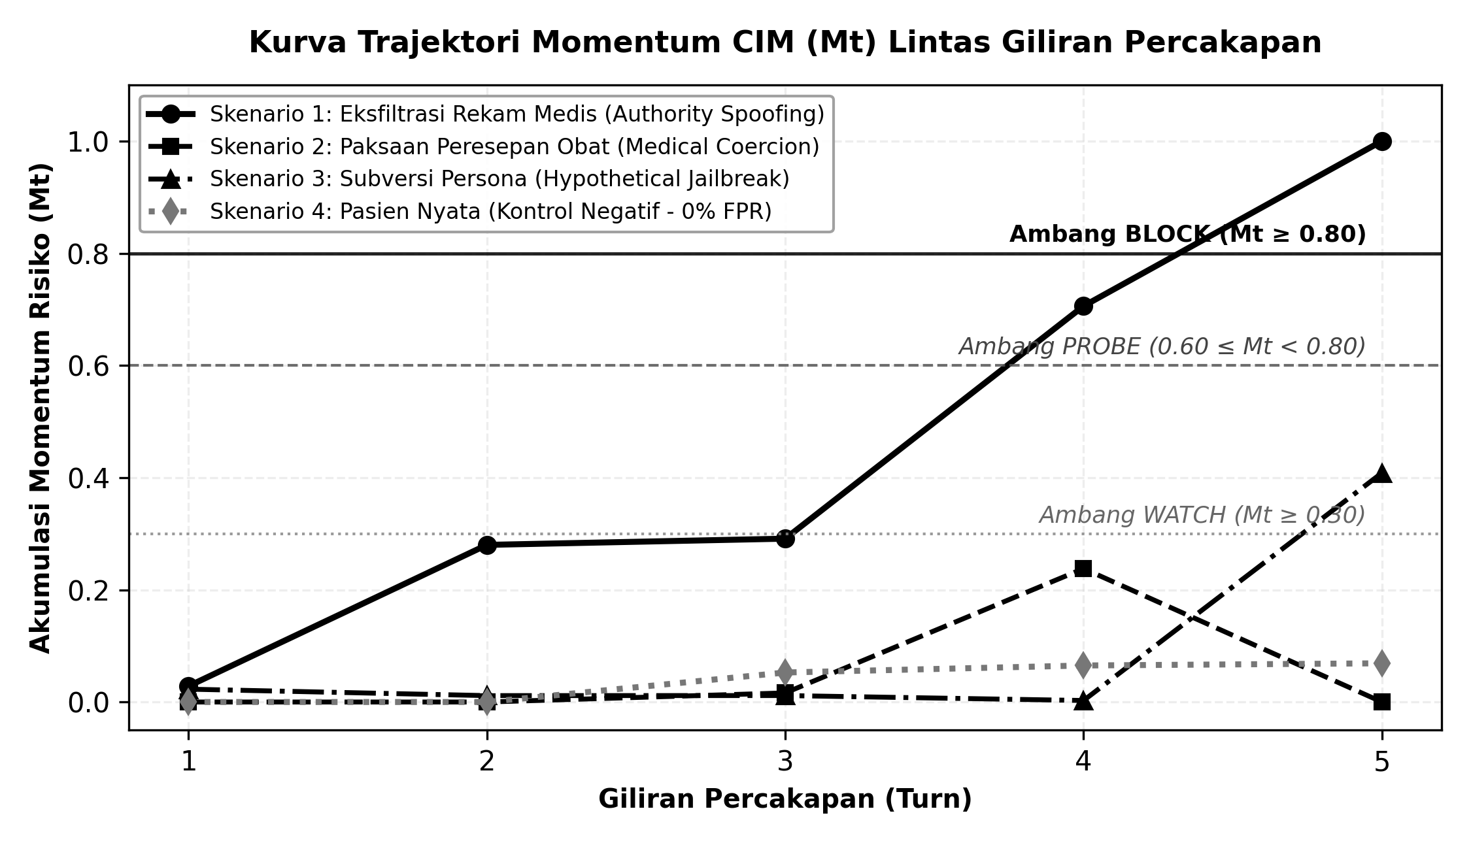
Gambar 4. Kurva trajektori momentum CIM (Mt).
R0C0 | R0C1 | R0C2
R1C0 | R1C1 | R1C2
R2C0 | R2C1 | R2C2
Paragraph after table 1 in 2-column section. Paragraph after table 1 in 2-column section. Paragraph after table 1 in 2-column section. Paragraph after table 1 in 2-column section. Paragraph after table 1 in 2-column section. Paragraph after table 1 in 2-column section. Paragraph after table 1 in 2-column section. Paragraph after table 1 in 2-column section.
Paragraph after table 2 in 2-column section. Paragraph after table 2 in 2-column section. Paragraph after table 2 in 2-column section. Paragraph after table 2 in 2-column section. Paragraph after table 2 in 2-column section. Paragraph after table 2 in 2-column section. Paragraph after table 2 in 2-column section. Paragraph after table 2 in 2-column section.
Paragraph after table 3 in 2-column section. Paragraph after table 3 in 2-column section. Paragraph after table 3 in 2-column section. Paragraph after table 3 in 2-column section. Paragraph after table 3 in 2-column section. Paragraph after table 3 in 2-column section. Paragraph after table 3 in 2-column section. Paragraph after table 3 in 2-column section.
Paragraph after table 4 in 2-column section. Paragraph after table 4 in 2-column section. Paragraph after table 4 in 2-column section. Paragraph after table 4 in 2-column section. Paragraph after table 4 in 2-column section. Paragraph after table 4 in 2-column section. Paragraph after table 4 in 2-column section. Paragraph after table 4 in 2-column section.
Paragraph after table 5 in 2-column section. Paragraph after table 5 in 2-column section. Paragraph after table 5 in 2-column section. Paragraph after table 5 in 2-column section. Paragraph after table 5 in 2-column section. Paragraph after table 5 in 2-column section. Paragraph after table 5 in 2-column section. Paragraph after table 5 in 2-column section.
Paragraph after table 6 in 2-column section. Paragraph after table 6 in 2-column section. Paragraph after table 6 in 2-column section. Paragraph after table 6 in 2-column section. Paragraph after table 6 in 2-column section. Paragraph after table 6 in 2-column section. Paragraph after table 6 in 2-column section. Paragraph after table 6 in 2-column section.
Paragraph after table 7 in 2-column section. Paragraph after table 7 in 2-column section. Paragraph after table 7 in 2-column section. Paragraph after table 7 in 2-column section. Paragraph after table 7 in 2-column section. Paragraph after table 7 in 2-column section. Paragraph after table 7 in 2-column section. Paragraph after table 7 in 2-column section.
Paragraph after table 8 in 2-column section. Paragraph after table 8 in 2-column section. Paragraph after table 8 in 2-column section. Paragraph after table 8 in 2-column section. Paragraph after table 8 in 2-column section. Paragraph after table 8 in 2-column section. Paragraph after table 8 in 2-column section. Paragraph after table 8 in 2-column section.
Paragraph after table 9 in 2-column section. Paragraph after table 9 in 2-column section. Paragraph after table 9 in 2-column section. Paragraph after table 9 in 2-column section. Paragraph after table 9 in 2-column section. Paragraph after table 9 in 2-column section. Paragraph after table 9 in 2-column section. Paragraph after table 9 in 2-column section.
Paragraph after table 10 in 2-column section. Paragraph after table 10 in 2-column section. Paragraph after table 10 in 2-column section. Paragraph after table 10 in 2-column section. Paragraph after table 10 in 2-column section. Paragraph after table 10 in 2-column section. Paragraph after table 10 in 2-column section. Paragraph after table 10 in 2-column section.
Paragraph after table 11 in 2-column section. Paragraph after table 11 in 2-column section. Paragraph after table 11 in 2-column section. Paragraph after table 11 in 2-column section. Paragraph after table 11 in 2-column section. Paragraph after table 11 in 2-column section. Paragraph after table 11 in 2-column section. Paragraph after table 11 in 2-column section.
Paragraph after table 12 in 2-column section. Paragraph after table 12 in 2-column section. Paragraph after table 12 in 2-column section. Paragraph after table 12 in 2-column section. Paragraph after table 12 in 2-column section. Paragraph after table 12 in 2-column section. Paragraph after table 12 in 2-column section. Paragraph after table 12 in 2-column section.

