IBM SkillsBuild – Data Analytics with AI
Academic Internship 2026 · AICTE × BharatCares
Quick-Commerce Sales, Customer & Delivery Analytics with AI
A Blinkit-style dark-store analysis: revenue drivers, customer segmentation, late-delivery prediction and demand forecasting
Project Report

Submitted by: Keshav Kumar
Branch / Specialization: B.Tech CSE
September 2026

Contents
1. Abstract
2. Introduction
3. Dataset Description
4. Tools and Technologies
5. Methodology
6. Data Cleaning and Preparation
7. Exploratory Data Analysis
8. AI and Machine-Learning Models
9. Business Recommendations
10. Limitations and Future Scope
11. Conclusion
12. References
Appendix A: Project Structure and How to Run

1. Abstract
Quick-commerce companies such as Blinkit, Zepto and Swiggy Instamart compete on a promise of delivery within minutes. Their profitability depends on understanding what customers buy, who keeps returning, and whether promised delivery times are met. This project builds an end-to-end data analytics and AI workflow on a year of order-level data (31,960 orders, January–December 2025, six Indian cities).
The workflow covers data cleaning, feature engineering, KPI computation and exploratory analysis, followed by four AI components: (1) RFM-based customer segmentation using K-Means clustering, (2) a late-delivery prediction model (best model: Gradient Boosting, ROC-AUC 0.91), (3) a daily demand-forecasting model that reduces error by 50% compared with a last-week baseline, and (4) an automated insight engine that writes a management summary directly from the data. The report closes with concrete, data-backed business recommendations.
Important note on data: the real Blinkit order-level data is not publicly available, so a seeded, reproducible synthetic dataset that mimics quick-commerce behaviour (peak hours, rain effects, festive spike, churn, and deliberately dirty records) is used. Absolute figures are therefore illustrative; the methodology is what transfers to real data. The notebook can run on a real CSV with the same columns by setting one variable.

2. Introduction

2.1 Background
Quick-commerce (q-commerce) delivers groceries and daily essentials from small neighbourhood "dark stores" in roughly 10–20 minutes. Margins are thin, so small improvements in basket value, repeat purchase and on-time delivery have a large effect on profit. The business generates rich transactional data, but it is only valuable when converted into decisions.

2.2 Problem Statement
A quick-commerce operator has a year of order-level data but no unified view of its revenue drivers, customer value and delivery reliability. The operator needs to know which categories, cities and time slots matter, who its best and at-risk customers are, what causes late deliveries (and whether they can be predicted), how many orders to expect tomorrow, and whether discounts genuinely increase basket size.

2.3 Objectives
- Clean and prepare raw order data, documenting every decision.
- Compute business KPIs and analyse revenue by time, category, city and payment method.
- Identify the drivers and business cost of late deliveries.
- Segment customers with RFM analysis and K-Means to enable targeted retention.
- Build and evaluate machine-learning models for late-delivery prediction and daily demand forecasting.
- Generate automated insights and actionable recommendations.

2.4 Scope
The analysis is limited to order-level records for one calendar year (2025) across six cities. SKU-level baskets, rider-level data and marketing-spend data are outside scope and are listed under future work.

3. Dataset Description
The dataset contains 32,060 raw order records (31,960 after cleaning) from about 2,700 active customers. It was generated with a fixed random seed (42) so every run produces identical results. The generator encodes realistic behaviour: morning and evening demand peaks, weekend uplift, an October–November festive spike with higher discounts, monsoon rain, distance-dependent delivery times, customer churn, and injected data-quality problems.
Column | Description
order_id, customer_id | Unique order and customer identifiers
order_datetime | Timestamp of the order
city, age_group, is_member | Customer city, age band and paid-membership flag
category | Main product category of the basket (11 categories)
items_count, discount_pct, order_value | Basket size, discount percentage, final amount paid (₹)
payment_method | UPI, Credit/Debit Card, Cash on Delivery, Wallet, Pay Later
distance_km | Distance from dark store to customer
is_raining, prep_time_min | Rain flag and order packing time
promised_time_min, delivery_time_min | ETA shown to the customer and actual delivery time
rating, refund_requested | Customer rating (1–5, optional) and refund flag

Source and reproducibility: the data-generation function is included in the notebook (Section 3), and the resulting CSV files are saved in the repository under the data/ folder.

4. Tools and Technologies
Tool | Purpose
Python 3.10+ | Core programming language
Pandas, NumPy | Data cleaning, aggregation, feature engineering
Matplotlib, Seaborn | Visualisation
Scikit-learn | K-Means, Logistic Regression, Random Forest, Gradient Boosting, Ridge, metrics, permutation importance
Jupyter Notebook | Interactive, reproducible analysis
GitHub | Version control and project hosting
AI coding assistant | Used to help design, generate and debug the code, as encouraged in the internship guidelines

5. Methodology
The project follows a standard analytics lifecycle, with each stage implemented as a section of the notebook:
- Data acquisition – generate (or load) the order dataset.
- Data understanding – shape, types, ranges and missing-value profile.
- Data cleaning – remove duplicates, treat missing values, remove implausible delivery times.
- Feature engineering – time features, delay flags and discount economics.
- Exploratory analysis – KPIs and visual analysis by time, category, city, payment, delivery and membership.
- AI modelling – RFM segmentation, late-delivery classification, demand forecasting.
- Insight generation and recommendations – automated narrative plus business actions.

6. Data Cleaning and Preparation
Each issue was detected programmatically and treated with a documented rule so decisions can be defended:
Issue | Detected | Decision
Duplicate rows | 60 rows | Dropped – an order_id cannot occur twice
Missing payment_method | 259 rows | Filled with "Unknown" to retain the order's revenue
Missing rating | 3,775 rows (11.8%) | Kept as missing – customers did not rate; imputing would bias satisfaction metrics
Delivery time outliers | 40 rows > 90 min | Removed – business rule: >90 min is a logging error in quick-commerce

After cleaning, 31,960 of 32,060 rows remain and the maximum delivery time falls from over 400 minutes to about 42 minutes. The only remaining missing values are in the optional rating column.
Engineered features include: order date, month, weekday, hour, day-part, weekend flag, peak-hour flag (8–9 am and 7–9 pm), delay in minutes, late-delivery flag, gross basket value before discount and discount amount.

7. Exploratory Data Analysis

7.1 Business KPIs
KPI | Value
Total revenue | ₹10,945,839
Total orders | 31,960
Unique customers | 2,683
Average order value (AOV) | ₹342
Orders per customer | 11.9
On-time delivery rate | 82.5%
Avg delivery time (min) | 10.2
Avg customer rating (of rated orders) | 4.60 / 5
Refund request rate | 1.7%
Discount given (₹) | ₹608,165
Discount as % of gross sales | 5.3%

7.2 Revenue and order trend
Revenue grew 76% from January to December, with Oct the strongest month, driven by the festive-season promotion window. Growth is visible in both order count and revenue, indicating the increase is volume-led rather than price-led.
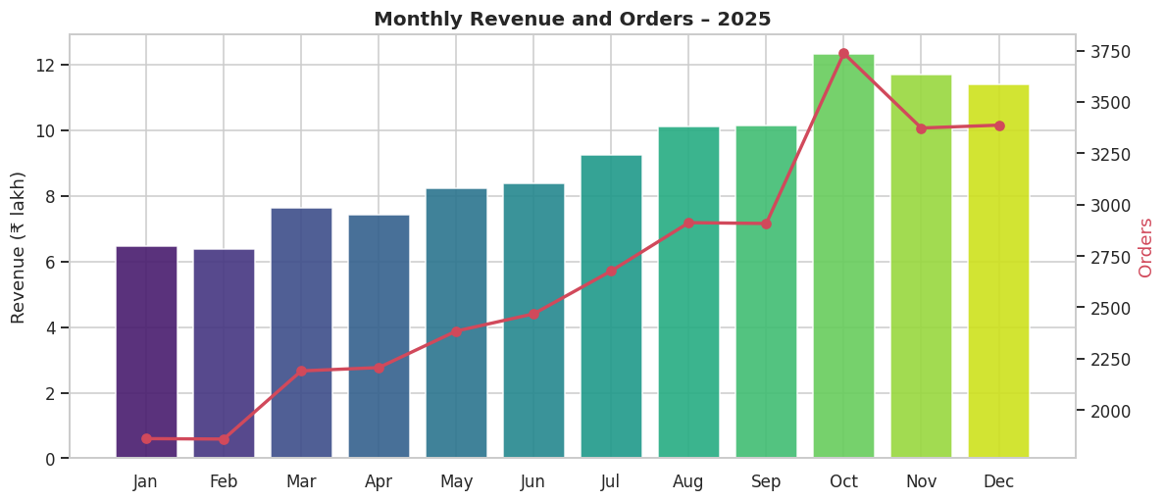
Figure 1: Monthly revenue (bars) and order count (line), 2025

7.3 Category performance
Electronics & Accessories is the top revenue category (18.1% of sales) because of its very high average order value (₹1,077), even though it is not the most frequently ordered. In contrast, high-frequency staples such as Dairy & Bread and Fruits & Vegetables have low basket values (about ₹183 and ₹234), which suggests a cross-sell opportunity: attaching higher-value items to staple baskets.
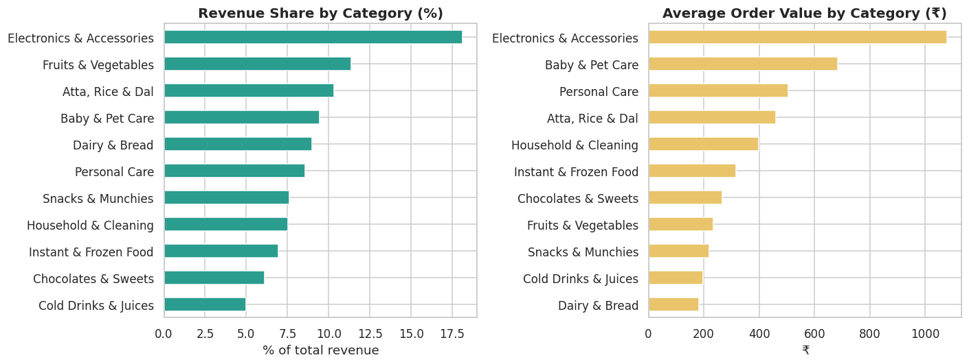
Figure 2: Revenue share and average order value by category

7.4 City performance
Delhi NCR generates the most revenue (₹2,909,266). Delivery reliability differs sharply by city: Pune is the most reliable (90.7% on time) while Bengaluru is the weakest (74.3% on time). Average order value is similar across cities, so the gap is operational rather than commercial.
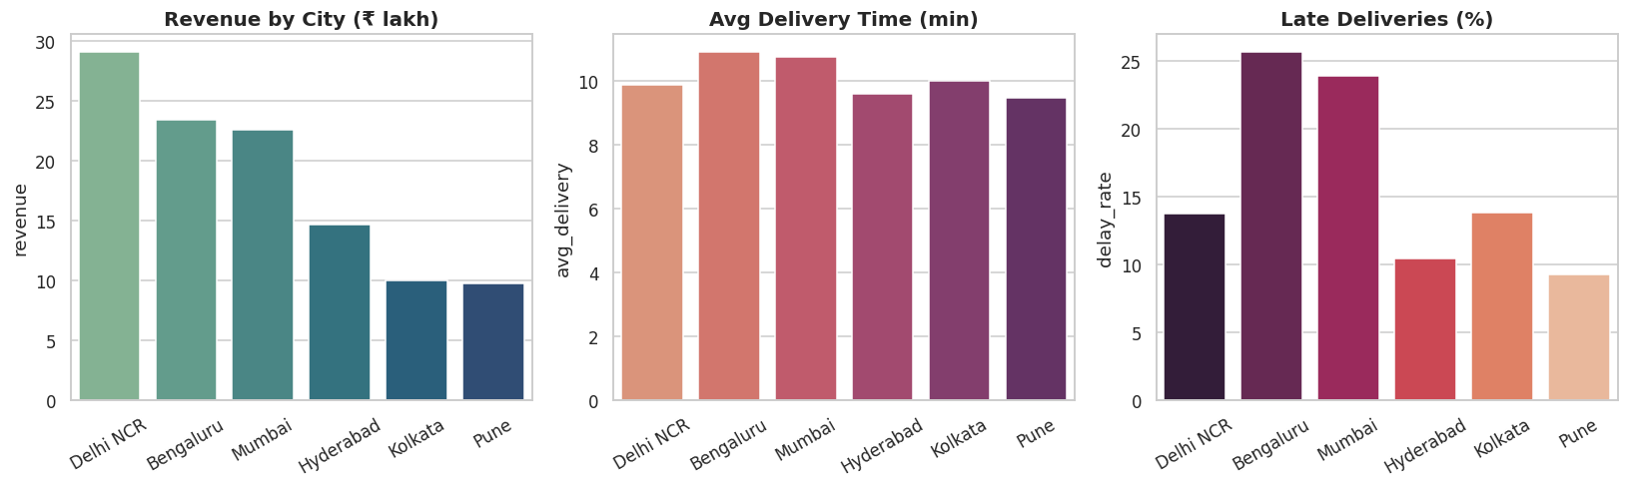
Figure 3: Revenue, average delivery time and late-delivery rate by city

7.5 Demand pattern by weekday and hour
Demand peaks in the evening; the busiest hour is 20:00. The peak windows (8–9 am and 7–9 pm) carry 39% of all orders, and weekends are consistently busier than weekdays. Late-night orders skew towards snacks, cold drinks and sweets, while mornings skew towards dairy and vegetables.
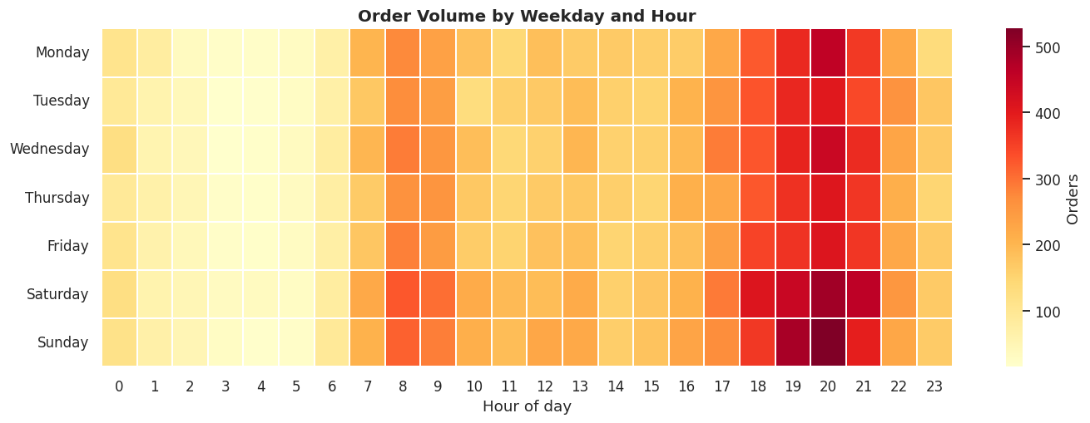
Figure 4: Order volume by weekday and hour of day

7.6 Payments and discount effectiveness
UPI is the dominant payment method. To test whether discounts encourage larger baskets, the basket value before discount was compared across discount levels. The correlation between discount percentage and basket size is +0.002, i.e. effectively zero: customers who receive a bigger discount do not buy more. Total discount given was ₹608,165 (5.3% of gross sales), which reduces net revenue without a measurable basket-size benefit in this data.
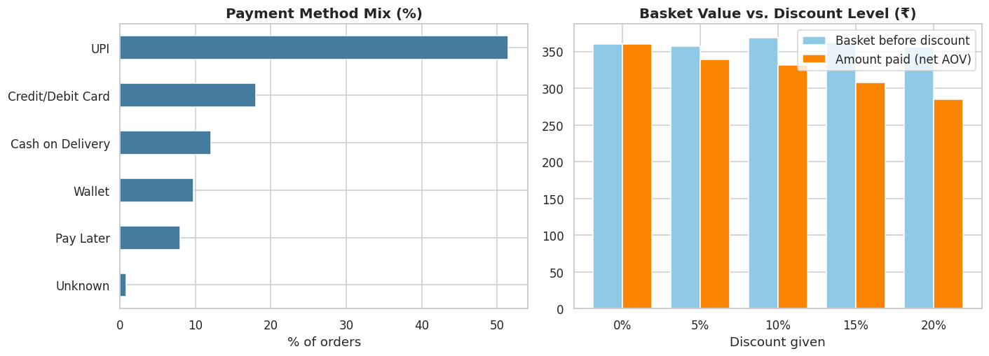
Figure 5: Payment method mix and basket value versus discount level

7.7 Drivers of delivery time and late deliveries
Delivery time rises steadily with distance. Late deliveries are strongly influenced by weather and time of day: the late rate is 32.7% when raining versus 13.3% when dry, and 23.8% in peak hours versus 13.5% off-peak. The combination of rain and peak hours is the worst case.
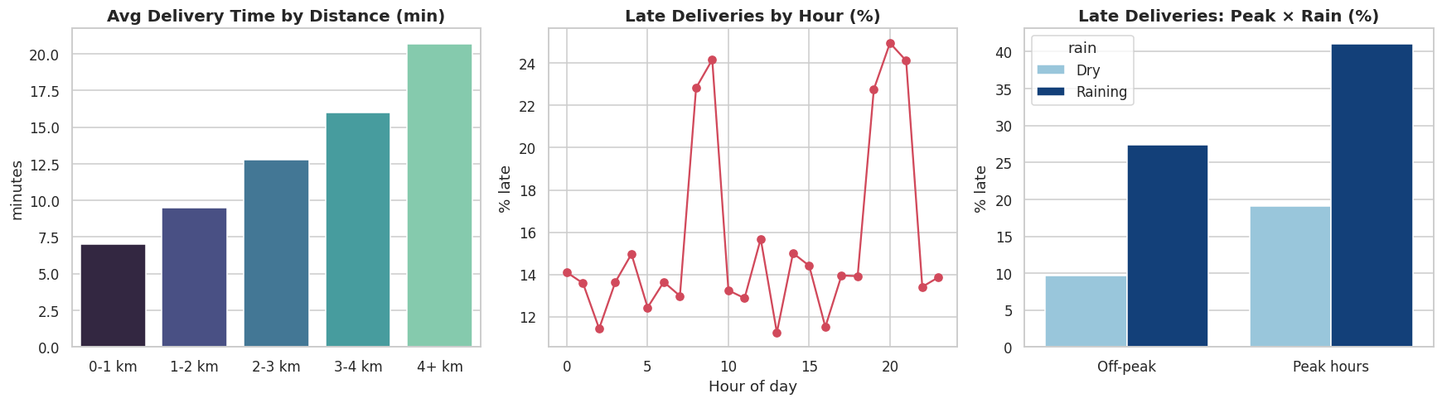
Figure 6: Delivery time by distance, late rate by hour, and late rate by peak/rain condition

7.8 Cost of late deliveries
Lateness directly hurts customer experience. Ratings fall and refund requests rise as the delay grows:
Delay bucket | Orders | Avg rating | Refund rate
On time | 26,361 | 4.66 | 1.5%
1-3 min late | 4,696 | 4.36 | 1.5%
3-6 min late | 762 | 4.11 | 7.6%
6+ min late | 141 | 3.67 | 11.3%

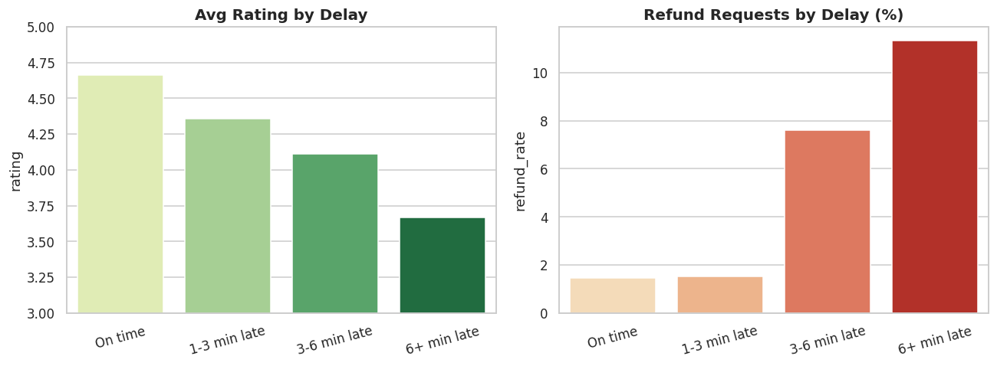
Figure 7: Average rating and refund rate by delay bucket

7.9 Members versus non-members
Members place far more orders per customer (15.6) than non-members (9.9), while average order value is similar (₹346 vs ₹340). Membership therefore drives frequency, not basket size.

8. AI and Machine-Learning Models

8.1 Customer segmentation (RFM + K-Means)
Each customer was summarised by three numbers: Recency (days since last order), Frequency (number of orders) and Monetary value (total spend). The values were log-transformed and standardised, then grouped with K-Means. The elbow curve and silhouette scores were compared for k = 2 to 7. Silhouette is highest at k = 2 (simply active versus inactive), which is too coarse to act on; k = 4 is the smallest solution that separates previously-loyal-but-fading customers from never-engaged customers, and was therefore selected.
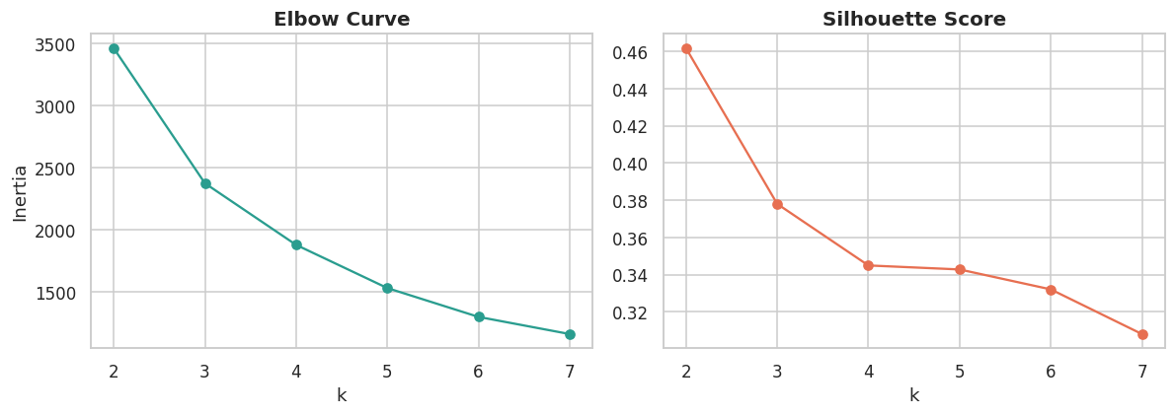
Figure 8: Elbow curve and silhouette score for K-Means
Segment | Customers | Avg recency (days) | Avg orders | Avg spend | Revenue share
Champions | 676 | 12 | 28.7 | ₹10,007 | 61.8%
Active Regulars | 715 | 16 | 9.0 | ₹2,983 | 19.5%
At-Risk (Fading Regulars) | 731 | 126 | 7.0 | ₹2,449 | 16.4%
Lapsed / Low-Value | 561 | 184 | 1.7 | ₹460 | 2.4%

Champions are 25% of customers but generate 62% of revenue. The At-Risk (Fading Regulars) group contains 731 customers with ₹1,790,301 of historical spend: they ordered regularly in the past but have not ordered for months, making them the best win-back target.
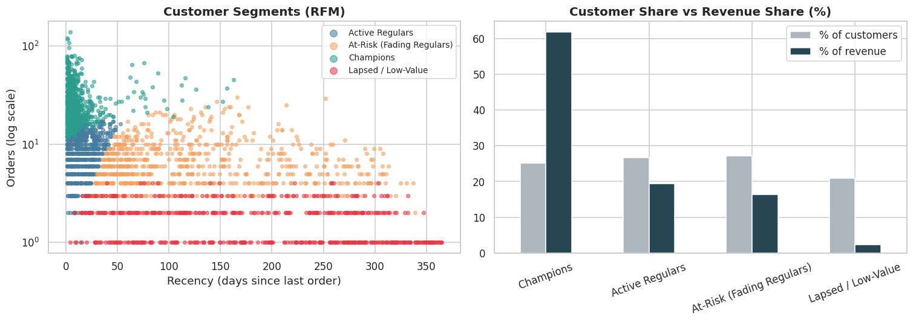
Figure 9: RFM customer segments and their share of customers versus revenue

8.2 Late-delivery prediction (classification)
Goal: predict at order time whether delivery will exceed the promised time so operations can re-route riders or show a more realistic ETA. Features are limited to information known before delivery (distance, items, packing time, hour, peak flag, rain flag, weekend flag, city, day-part); the actual delivery time is deliberately excluded to avoid data leakage. The data was split 75/25 (23,970 training and 7,990 test orders, stratified), and 17.5% of orders are late, so class weighting was used where supported.
Model | Accuracy | Precision | Recall | F1 | ROC-AUC
Logistic Regression | 0.750 | 0.390 | 0.754 | 0.514 | 0.834
Random Forest | 0.838 | 0.529 | 0.710 | 0.606 | 0.883
Gradient Boosting | 0.883 | 0.752 | 0.498 | 0.599 | 0.906

Gradient Boosting achieved the best ROC-AUC (0.906). At the default 0.5 threshold it is precise (75% of predicted-late orders are truly late) but catches 50% of late orders; Random Forest and Logistic Regression have higher recall with lower precision. The threshold can be tuned to the operational cost of a missed late delivery versus a false alarm.
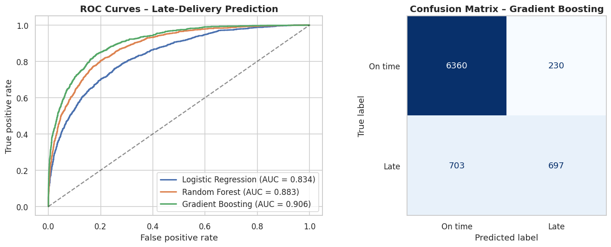
Figure 10: ROC curves and confusion matrix for late-delivery prediction
Permutation importance shows the main drivers of lateness are distance_km, prep_time_min, is_raining, followed by city. In business terms: long distances, slow packing and rain are the levers to manage.
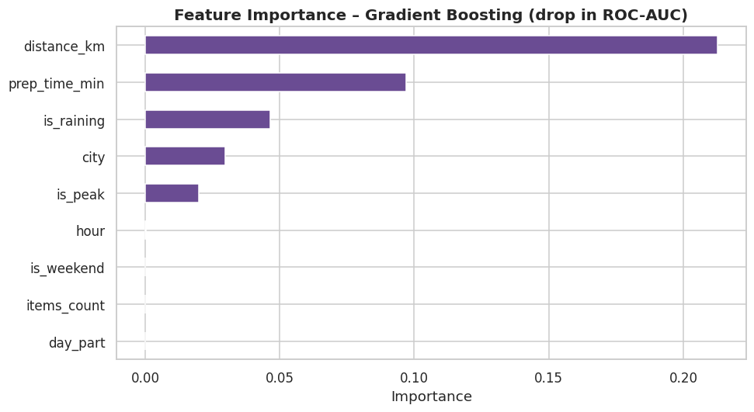
Figure 11: Permutation feature importance (drop in ROC-AUC)

8.3 Daily demand forecasting
Rider rosters and dark-store stock are planned a day ahead, so daily order volume was forecast. The last 20% of days (late October to December, including the festive peak) formed the test set. Four approaches were compared:
Model | MAE (orders/day) | MAPE %
Seasonal naive (last week) | 13.60 | 12.13
7-day moving average | 11.09 | 9.90
Random Forest + lags | 12.99 | 12.26
Ridge (trend + calendar) | 6.76 | 6.03

The Ridge regression with an explicit growth trend, day-of-week and festive-season effect performs best (MAE 6.8 orders/day, 50% lower than the last-week baseline of 13.6). The Random Forest with lag features performed no better than a simple moving average: tree models cannot extrapolate beyond the range seen in training, which is a weakness when the business is growing. This is a useful practical finding – the more complex model is not automatically the better one.
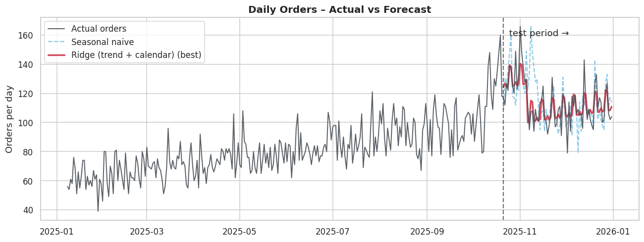
Figure 12: Daily orders: actual versus forecast on the held-out test period

8.4 Automated insight engine
A statistical engine reads the analysed data and writes the management summary automatically, so the narrative refreshes whenever new data is loaded. The output for this dataset:
- REVENUE MIX: 'Electronics & Accessories' and 'Fruits & Vegetables' lead revenue with 18% and 11% of sales; top-3 categories together contribute 40%.
- BASKET VALUE: 'Electronics & Accessories' has the highest AOV (₹1,077) vs. 'Dairy & Bread' (₹183) – cross-sell high-AOV items into low-AOV baskets.
- DEMAND PEAKS: busiest hours are 19:00, 20:00, 21:00; peak windows (8-9 am, 7-9 pm) handle 39% of orders and run a 23.8% late rate vs 13.5% off-peak.
- CITY RELIABILITY: best on-time city is Pune (90.7%); weakest is Bengaluru (74.3%).
- WEATHER: rain lifts the late-delivery rate from 13.3% to 32.7% (2.5x) – add rider buffer & surge ETA on rainy days.
- DELAY COST: late orders get an average rating of 4.31 vs 4.66 on-time, and refund requests jump from 1.5% to 2.6%.
- MEMBERSHIP: members place 15.6 orders/customer vs 9.9 for non-members.
- DISCOUNTS: discount % vs basket size correlation is +0.00; ₹608,165 (5.3% of gross sales) was given away without lifting basket value.
- CUSTOMERS: 25% of customers (Champions) generate 62% of revenue; 731 fading regulars hold ₹1,790,301 of historical spend and should be re-engaged now.
- AI READINESS: the late-delivery model reaches ROC-AUC 0.91; main drivers are distance_km, prep_time_min, is_raining.

9. Business Recommendations
- Fix peak-hour & rain reliability first. Late rate is 23.8% at peak and 32.7% in rain. Use the delay model (Gradient Boosting, AUC 0.91) to add a rider buffer or show a longer ETA for high-risk orders.
- Replace blanket discounts with targeted offers. Discounts show no link to basket size (corr +0.00) and cost ₹608,165. Test targeted alternatives instead (e.g. free-delivery threshold, category bundles) and measure incremental basket size.
- Launch a win-back campaign for 'At-Risk (Fading Regulars)'. 731 customers with ₹1,790,301 historical spend.
- Protect Champions. They are 25% of customers but 62% of revenue – give priority delivery and early access.
- Staff by forecast. The Ridge (trend + calendar) model cuts planning error by 50% vs the last-week baseline (MAE 7 orders/day) – use it for next-day rider rosters and stock.
- Grow the high-AOV categories ('Electronics & Accessories') via cross-sell prompts at checkout.

10. Limitations and Future Scope

10.1 Limitations
- The dataset is synthetic. Relationships such as "discounts do not raise basket size" or the exact size of the rain effect are partly a consequence of how the data was generated, so absolute numbers should be treated as illustrative. The pipeline and methods are what carry over to real data.
- Order-level data only: there is no SKU-level basket, rider, inventory or marketing-cost information.
- The forecast is evaluated as a one-year, one-step-ahead exercise; a longer history would be needed to learn true annual seasonality.

10.2 Future scope
- Run the pipeline on a real quick-commerce dataset (set REAL_DATA_PATH in the notebook).
- Add market-basket analysis at SKU level for cross-sell recommendations.
- Deploy the delay model and insight engine in a Streamlit dashboard with live filters.
- Add a large-language-model layer so managers can ask questions in plain English.
- Tune the delay-classification threshold using real cost of late deliveries and refunds.

11. Conclusion
This project shows how raw order data can be turned into decisions using a complete analytics and AI workflow. Descriptive analysis showed where revenue comes from and where delivery reliability breaks down; predictive models identified late deliveries with ROC-AUC 0.91 and forecast daily demand 50% more accurately than a naive baseline; and customer segmentation revealed that about 25% of customers (the Champions) generate about 62% of revenue while 731 fading regulars represent a clear win-back opportunity. The recommendations translate these results into concrete operational and marketing actions.

12. References
- IBM SkillsBuild – Data Analytics with AI Academic Internship Programme (AICTE × BharatCares), 2026 – course material and live sessions.
- Pedregosa et al., "Scikit-learn: Machine Learning in Python", Journal of Machine Learning Research, 12, 2825–2830, 2011. https://scikit-learn.org
- McKinney, W., "Data Structures for Statistical Computing in Python", Proceedings of the 9th Python in Science Conference, 2010. https://pandas.pydata.org
- Hunter, J. D., "Matplotlib: A 2D Graphics Environment", Computing in Science & Engineering, 9(3), 90–95, 2007. https://matplotlib.org
- Waskom, M., "seaborn: statistical data visualization", Journal of Open Source Software, 6(60), 3021, 2021. https://seaborn.pydata.org

Appendix A: Project Structure and How to Run
Repository layout:
- KeshavKumar_QuickCommerceAnalytics.ipynb – main notebook (all analysis and models)
- requirements.txt – Python dependencies
- README.md – overview and setup instructions
- KeshavKumar_ProjectReport.docx – this report
- data/ – generated raw and clean datasets, customer segments and auto-generated insights
- charts/ – all figures used in this report
To run:
- pip install -r requirements.txt
- jupyter notebook YourName_QuickCommerceAnalytics.ipynb
- Run all cells (Kernel → Restart & Run All). The notebook creates the data/ and charts/ folders automatically.

