MACHINE LEARNING PROJECT REPORT
SmartPrice
Smartphone Price Category Prediction
and Multi-Model Benchmarking
Submission details | Information
Submitted by | ________________________________________
Student ID / Roll No. | ________________________________________
Programme / Department | ________________________________________
Institution | ________________________________________
Course / Supervisor | ________________________________________
Submission date | ________________________________________

Project repository: Mobile-Price-Prediction-ML

Abstract
SmartPrice is an end-to-end supervised machine-learning system that classifies a smartphone into one of four price tiers—Budget, Mid-Range, Premium, or Flagship—from its technical specifications. The project uses 980 smartphone records and evaluates Multinomial Logistic Regression, K-Nearest Neighbors (KNN), an RBF-kernel Support Vector Machine (SVM), and Random Forest. The recorded price is used only to construct the target label and is excluded from the predictor features. A stratified 80/20 train/test partition produces 784 training records and 196 held-out test records. The reported best model is a tuned Random Forest, with 82.65% test accuracy, 79.96% Macro F1, 82.39% Weighted F1, and 0.9613 one-vs-rest ROC-AUC in the tuning summary. A FastAPI backend loads the saved scikit-learn preprocessing and model artifacts; a React/TypeScript frontend provides prediction, model comparison, analytics, and explainability views. The results show useful tier classification but also leave room for improvement, especially on the smaller Premium class.
Keywords: smartphone specifications; price-tier classification; Random Forest; model comparison; FastAPI; React.

Report contents
- 1. Introduction
- 2. Literature Review
- 3. Methodology
- 4. Data Cleaning and Preprocessing
- 5. Results and Discussion
- 6. State-of-the-Art Models Comparison
- 7. User Interface Development and Deployment
- 8. Conclusion and Future Work
- 9. References
- Appendix A. Project workflow

1. Introduction

1.1 Background
Smartphone models differ across processor, memory, display, camera, battery, connectivity, brand, and operating-system characteristics. These features interact, and market prices span a wide range. SmartPrice investigates whether product specifications can be used to classify a phone into a useful market segment. The project treats this as a four-class supervised classification task rather than exact-price regression.

1.2 Problem statement
Given a smartphone's specifications, predict which predefined Indian-rupee price interval contains its recorded price. The system should provide a reproducible model comparison and an interface that accepts a new specification vector and returns the predicted tier and probability-like class scores.
Class | Price interval (INR) | Records | Share
Budget | ≤ ₹15,000 | 337 | 34.39%
Mid-Range | ₹15,001–₹30,000 | 349 | 35.61%
Premium | ₹30,001–₹50,000 | 133 | 13.57%
Flagship | > ₹50,000 | 161 | 16.43%
Total | — | 980 | 100.00%

1.3 Objectives
- Audit the smartphone dataset, missingness, feature types, and target distribution.
- Prepare a reproducible feature pipeline with imputation, scaling, categorical encoding, and domain-derived features.
- Train, tune, and compare four distinct classification approaches.
- Evaluate generalization using held-out test metrics and stratified cross-validation.
- Explain influential features and expose prediction functionality through a web application.

1.4 Scope and assumptions
The target is a category derived from the dataset's recorded price, not a quote for a current retail transaction. Prices can vary by date, retailer, location, offers, storage configuration, and condition. The dataset file is documented in the repository, but its upstream collection source is not identified in the available project documentation; findings should therefore be interpreted within this dataset's scope.

2. Literature Review
Recent tabular-learning research provides context for choosing and evaluating models. The studies below are methodological references on tabular classification and are not claimed to use this project's smartphone dataset. Their numeric scores are not directly comparable to SmartPrice because their datasets, splits, tasks, and metrics differ.
Study | Focus / approach | Relevant insight | Relation / limitation
[1] Gorishniy et al. (2021) | Revisited deep-learning methods for tabular data, including MLP, ResNet, and feature-tokenization Transformer approaches. | Shows that carefully designed deep tabular models can be competitive; supports benchmarking multiple model families rather than assuming one universal winner. | SmartPrice does not implement these neural architectures; its dataset is small and its focus is reproducible classical-model comparison.
[2] Grinsztajn et al. (2022) | Systematically studied why tree-based methods remain strong on typical tabular datasets and identified inductive-bias and robustness differences. | Motivates Random Forest as a candidate for nonlinear feature interactions and mixed tabular inputs. | Evidence comes from benchmark datasets, not the SmartPrice data; it motivates but does not prove this project's winning result.
[3] Shwartz-Ziv & Armon (2022) | Compared deep learning and gradient-boosted tree methods for tabular data and discussed when deep learning is not necessary. | Reinforces the need for a well-tuned tree-based baseline and dataset-specific evaluation. | Their tree-boosting experiments are not identical to the Random Forest used here.
[4] Hollmann et al. (2025) | Presented TabPFN, a Transformer-based prior-data-fitted network; the Nature study evaluates small-data classification, including datasets up to 10,000 samples. | Highly relevant to a 980-row classification problem; suggests a strong future comparator, not a model evaluated in SmartPrice. | The paper evaluates its own benchmarks; its results are not directly comparable with this project?s split or metrics.
[5] Borisov et al. (2024) | Surveyed deep neural network architectures and challenges for tabular data, including preprocessing, categorical variables, and evaluation. | Provides a recent overview of the design space and underscores that data representation and evaluation protocol affect comparisons. | A survey summarizes multiple lines of work; it is not a direct experiment on smartphone price classification.

2.1 Synthesis and research gap
The literature does not support declaring one algorithm best for every tabular dataset. Tree ensembles, kernel methods, linear classifiers, and specialized neural models have different inductive biases. SmartPrice addresses a practical project-level gap by evaluating four established classifiers on the same smartphone dataset, preserving a held-out test partition, reporting multiple class-sensitive metrics, and delivering an interactive inference application. A useful future extension would compare gradient-boosted trees or TabPFN under the same split and leakage controls.

3. Methodology

3.1 End-to-end design
The workflow separates offline model development from online inference. Offline scripts inspect and transform the data, tune models, produce evaluation and explainability outputs, and serialize a preprocessor and classifiers. At runtime, the API loads those artifacts, validates the user's input, applies corresponding feature engineering and transformations, and returns a class prediction.
Stage | Activity | Project implementation
1 | Ingest CSV | 980 records; 25 source columns
2 | Inspect and explore | Quality audit, distributions, feature relationships
3 | Label and engineer | Four tiers; parse resolution; derive hardware features
4 | Split and preprocess | Stratified 80/20; fit transformations on training data
5 | Train and tune | Four classifiers; 5-fold stratified grid search
6 | Evaluate and explain | Held-out metrics, class errors, feature importance
7 | Deploy artifacts | FastAPI inference API and React/TypeScript dashboard

3.2 Target definition
The recorded `price` becomes the label: Budget for price ≤ ₹15,000; Mid-Range for ₹15,000 < price ≤ ₹30,000; Premium for ₹30,000 < price ≤ ₹50,000; and Flagship for price > ₹50,000. Class indices are 0, 1, 2, and 3 respectively. The original `price` and phone `model` columns are not used as predictors.

3.3 Candidate models
Model | Learning principle | Why it is included
Multinomial Logistic Regression | Linear class boundaries; estimates class scores/probabilities. | Interpretable, efficient linear baseline.
K-Nearest Neighbors | Predicts from nearby labeled samples using a distance metric. | Non-parametric, instance-based comparison.
RBF Support Vector Machine | Maximum-margin classifier with nonlinear RBF kernel. | Tests a kernel method for nonlinear boundaries.
Random Forest | Aggregates randomized decision trees. | Captures nonlinear splits and feature interactions.

4. Data Cleaning and Preprocessing

4.1 Dataset audit
The inspection report describes 980 rows, 25 columns, and zero exact duplicate rows. Numeric, categorical, Boolean, and composite-text fields are mixed in the original CSV. Price is strongly right-skewed (reported skewness 6.59; maximum ₹650,000), so robust price segmentation is more suitable for the stated task than interpreting a single mean price.
Data issue | Example from audit | Handling in pipeline
Missing numeric values | Rating: 101; fast charging: 211; extended_upto: 480. | Median imputation in numeric pipeline; selected domain fallbacks for derived fields.
Boolean fields | 5G, NFC, IR blaster represented as Boolean/text variants. | Normalize to integer 1/0.
Resolution stored as text | Example: “1080 x 2400”. | Parse dimensions; derive pixel count, aspect ratio, and PPI.
Rare categories | Infrequent brand and processor names. | Group rare brands/processors; normalize OS categories.
Price target leakage | Price generates the category label. | Exclude price from X; exclude model name as a predictor.

4.2 Feature engineering
Engineered feature | Definition / purpose
resolution_width, resolution_height | Parsed pixel dimensions from the resolution string.
pixel_count | Width × height; approximate total display pixels.
aspect_ratio | Height ÷ width.
ppi | √(width² + height²) ÷ screen diagonal in inches.
total_cameras | Rear camera count + front camera count.
screen_to_battery_ratio | Battery capacity ÷ screen size.
ram_to_storage_ratio | RAM capacity ÷ internal storage.
performance_score | CPU core count × processor speed × RAM capacity.

4.3 Partition and transformations
Partition / stage | Samples | Processing
Training | 784 (80%) | Stratified split; random_state=42.
Testing | 196 (20%) | Held-out stratified partition; not used to fit the scaler/imputers/encoder.
Numeric columns | 28 before encoding | Median imputation followed by StandardScaler.
Categorical columns | 3 grouped columns | Most-frequent imputation followed by one-hot encoding; unknown values ignored.
Transformed feature space | 62 columns | Saved transformer is reused for inference.

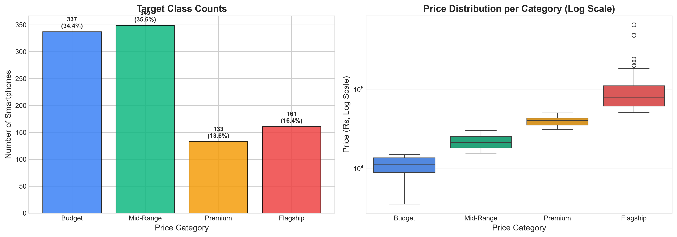
Figure 1. Project-generated price-tier distribution and category plot.

5. Results and Discussion

5.1 Experimental protocol
The baseline and tuning scripts train the four estimators on the 784 training records. Hyperparameters are selected with a five-fold stratified grid search; final reported test metrics are calculated on the 196-row held-out test set. The final estimator is selected using comparative performance, then exported with the preprocessing artifacts for the backend.

5.2 Metric definitions
Metric | Interpretation
Accuracy | Fraction of all test predictions that match the true label.
Macro F1 | Unweighted mean of class-level F1 scores; gives each tier equal importance.
Weighted F1 | Mean class F1 weighted by each class's test support.
ROC-AUC (OvR) | One-vs-rest discrimination, averaged across classes; evaluates ranking across thresholds.
Precision / Recall | Precision: correctness of predicted class members. Recall: fraction of true class members recovered.

5.3 Benchmark results
Model | Test accuracy | Macro F1 | Weighted F1 | ROC-AUC (OvR) | Decision
Random Forest | 82.65% | 79.96% | 82.39% | 0.9613 | Champion
SVM (RBF) | 80.10% | 78.07% | 80.05% | 0.9591 | Runner-up
KNN | 79.59% | 76.38% | 79.50% | 0.9517 | Tuned baseline
Logistic Regression | 78.57% | 76.39% | 78.57% | 0.9451 | Linear baseline

Source: project output `ml/outputs/05_tuning_summary.md`. Model comparison uses the same reported held-out test set. Percentages are rounded as in the project reports.
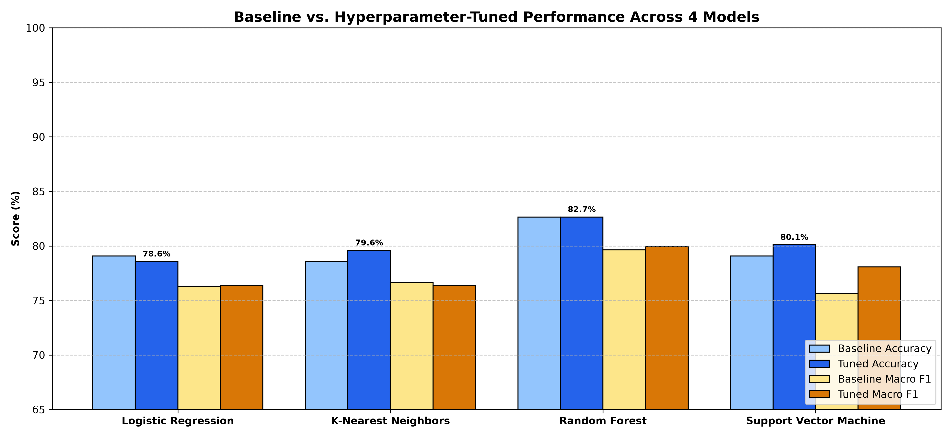
Figure 2. Baseline versus tuned test accuracy and Macro F1 across the four project models.

5.4 Discussion and selected model
Random Forest is the selected model because it has the highest reported test accuracy (82.65%), Macro F1 (79.96%), Weighted F1 (82.39%), and multiclass ROC-AUC (0.9613) among the tuned candidates. The result is consistent with its ability to model nonlinear thresholds and interactions among hardware features. The margin over SVM is moderate, so the conclusion is specific to this dataset, feature pipeline, and split—not a universal claim that Random Forest is always superior.
The tuned Random Forest classification report gives Premium recall of 55.56% (15 of 27 Premium phones correctly found), compared with 80.60% for Budget, 91.43% for Mid-Range, and 90.62% for Flagship. Premium is the smallest category, and overlap near price boundaries likely contributes to errors. This is why Macro F1 and class-level recall are important alongside accuracy.

Random Forest class-level test performance
Price tier | Precision | Recall | F1-score | Test support
Budget | 0.9474 | 0.8060 | 0.8710 | 67
Mid-Range | 0.7711 | 0.9143 | 0.8366 | 70
Premium | 0.7143 | 0.5556 | 0.6250 | 27
Flagship | 0.8286 | 0.9062 | 0.8657 | 32
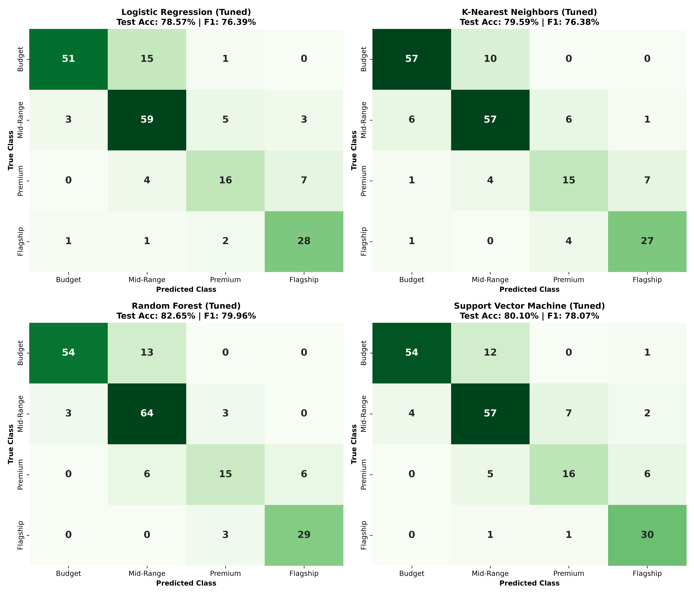
Figure 3. Test-set confusion matrices for all four tuned classifiers (rows: true tier; columns: predicted tier).

5.5 Feature importance
Permutation importance ranks a feature by the decrease in test Macro F1 after shuffling its values. The project reports performance_score as the largest permutation importance (mean decrease 0.0369), followed by processor_speed (0.0298), RAM (0.0242), and rating (0.0242). These are model reliance indicators, not causal effects. Tree impurity importance and permutation importance can rank variables differently because they measure different properties.
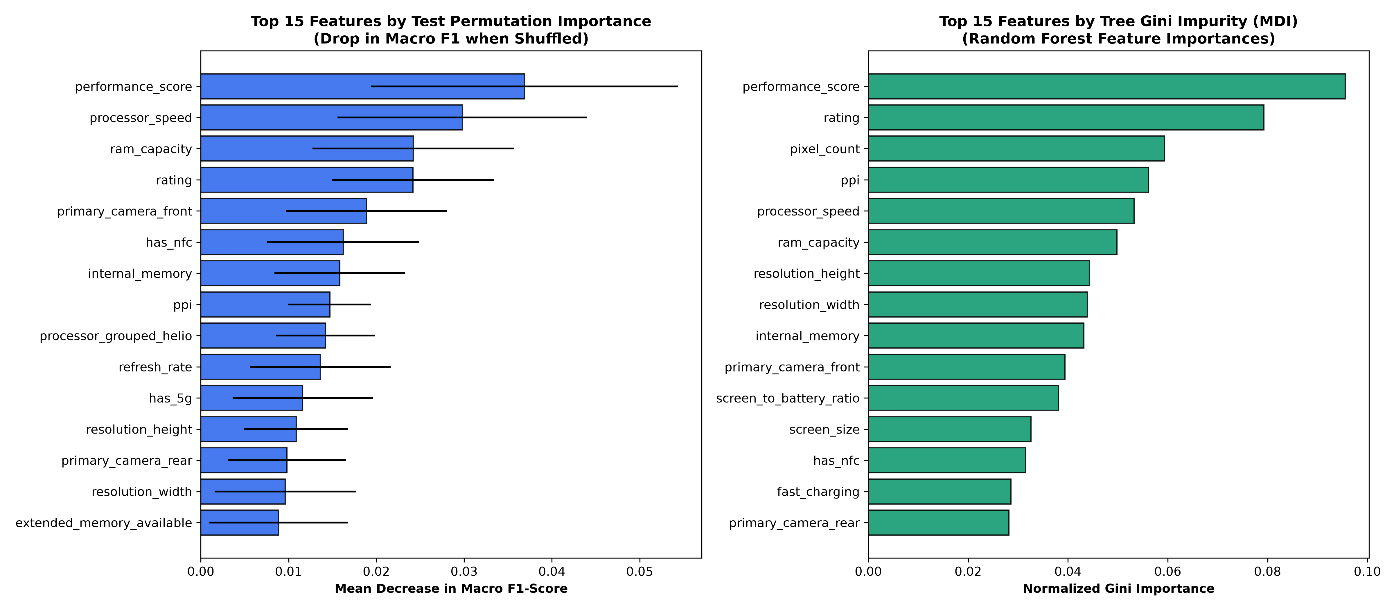
Figure 4. Random Forest permutation importance on the test set and tree impurity importance.

6. State-of-the-Art Models Comparison

6.1 Tuning configurations
Model | Selected settings reported by tuning | Implication
Logistic Regression | C=5.0; L2; lbfgs | Regularized linear multiclass decision surface.
KNN | k=19; Manhattan; distance weighting | Uses local neighbors; nearer records receive more influence.
Random Forest | 300 trees; max_depth=15; max_features=log2; min_samples_leaf=1; min_samples_split=2 | Ensemble of bounded-depth nonlinear trees.
SVM (RBF) | C=5.0; gamma=auto; RBF kernel | Nonlinear maximum-margin classification.

6.2 Comparative interpretation
- Random Forest leads the reported held-out comparison and handles feature interactions without requiring a linear boundary.
- SVM is a close second: its 80.10% accuracy and 0.9591 ROC-AUC indicate strong class separation, but its Macro F1 is 1.89 percentage points below Random Forest.
- KNN reaches 79.59% accuracy after tuning. It is sensitive to distance definition and feature scaling in a 62-column encoded feature space.
- Logistic Regression provides a compact, interpretable baseline. Its 78.57% accuracy is lower, but its model coefficients provide directional associations.
- A high ROC-AUC does not guarantee high recall at a particular class decision threshold; class-specific confusion matrices should be examined as well.

6.3 Validation and reporting caveat
The project files contain small inconsistencies between summary artifacts (for example, alternate cross-validation and ROC-AUC values in the README, Phase 5 tuning summary, and Phase 6 evaluation summary). The comparison table in this report uses the single Phase 5 tuned-results summary for test accuracy, F1, and ROC-AUC. Cross-validation scores are not mixed into the main test table. Before a formal defense, regenerate all reports from one pipeline run and synchronize the README and JSON/Markdown summaries.
A second methodological caveat is that category-frequency grouping is computed during dataset cleaning before the train/test split, and the saved transformed training matrix is then used for cross-validation. The held-out test partition is not used to fit the imputer, scaler, or encoder, but fold-specific preprocessing is not fully refitted inside each cross-validation fold. A stricter follow-up should place all feature cleaning, grouping, imputation, scaling, encoding, and estimator steps inside a scikit-learn Pipeline evaluated within each fold.

7. User Interface Development and Deployment

7.1 Frontend
The frontend is a React and TypeScript single-page application built with Vite. `App.tsx` composes the dashboard, prediction form, model benchmarking, dataset analytics, sidebar, header, and mobile navigation. `api.ts` centralizes typed calls to the backend and includes example device presets. The interface presents a prediction workflow and exposes benchmark and dataset views.

7.2 Backend and inference
FastAPI provides the REST interface and Pydantic request/response schemas. At application startup, `backend/app/main.py` loads the saved inference engine. `predictor.py` normalizes Boolean and category values, derives resolution and interaction features, transforms the request with the saved preprocessor, and calls the selected classifier. Responses include the predicted tier, estimated tier range, class scores, and engineered-feature summary.
Endpoint | Purpose
GET /api/health | Service health and loaded model status.
POST /api/predict | Single smartphone price-tier prediction.
POST /api/predict/batch | Predict categories for multiple smartphones.
POST /api/predict/compare | Compare predictions from all available models.
GET /api/models/metrics | Return model benchmark data.
GET /api/models/roc-curves | Return saved ROC/PR curve data.
GET /api/models/feature-importance | Return saved explainability data.
GET /api/analytics/records | Search, filter, sort, and paginate dataset records.

7.3 Deployment and screenshot evidence
The repository includes Render and Vercel configuration files and a Windows launcher. The frontend can use a configured API base URL; locally, Vite proxies API requests. The figures included as Figures 1–4 are genuine project-generated dataset and model-analysis outputs from `ml/outputs/`, not illustrative or externally sourced charts.
A live capture of the React dashboard and prediction form could not be included in this build: the project environment has no Node.js/npm executable to start the frontend, and the configured hosted preview could not be reached. No fabricated UI screenshots have been inserted. For a final submission that specifically requires interface screenshots, run `start_project.bat` or start the backend and frontend, then capture the Dashboard, Predictor result, Model Benchmarking, and Dataset Analytics views and insert them here.
Recommended UI capture | What to show
Figure 5 — Dashboard | Navigation, health status, overview cards, and application title.
Figure 6 — Prediction | Example phone specifications and resulting tier/probabilities.
Figure 7 — Model lab | Four-model comparison and champion metrics.
Figure 8 — Dataset analytics | Search/filter controls and representative dataset records.

8. Conclusion and Future Work
SmartPrice demonstrates an end-to-end workflow for smartphone price-tier classification: dataset inspection, feature engineering, stratified partitioning, preprocessing, four-model benchmarking, explainability, and a web-based prediction service. Random Forest is the best of the tested models on the reported held-out metrics, with 82.65% accuracy and 79.96% Macro F1. The comparison also shows that class-level results matter: Premium recall is the key weakness, and predictions should be treated as category estimates rather than exact market prices.
- Increase and refresh the dataset, document its original source, date, and collection method, and validate on newer unseen phone models.
- Place all preprocessing inside cross-validation folds and regenerate all benchmark summaries from a single reproducible run.
- Investigate Premium-class errors, consider class weighting or resampling only within training folds, and report per-class precision/recall.
- Compare additional methods such as gradient-boosted trees and TabPFN under the identical validation protocol.
- Calibrate class probabilities and evaluate calibration before presenting returned scores as confidence.
- Capture genuine screenshots of the deployed dashboard and main workflows for the final submission.

9. References
[1] Y. Gorishniy, I. Rubachev, V. Khrulkov, and A. Babenko, “Revisiting Deep Learning Models for Tabular Data,” Advances in Neural Information Processing Systems 34 (NeurIPS 2021). https://proceedings.neurips.cc/paper/2021/hash/9d86d83f925f2149e9edb0ac3b49229c-Abstract.html
[2] L. Grinsztajn, E. Oyallon, and G. Varoquaux, “Why Do Tree-Based Models Still Outperform Deep Learning on Typical Tabular Data?,” Advances in Neural Information Processing Systems 35, pp. 507–520, 2022. https://doi.org/10.52202/068431-0037
[3] R. Shwartz-Ziv and A. Armon, “Tabular data: Deep learning is not all you need,” Information Fusion, vol. 81, pp. 84–90, 2022. https://doi.org/10.1016/j.inffus.2021.11.011
[4] N. Hollmann, S. Müller, L. Purucker, A. Krishnakumar, M. Körfer, S. B. Hoo, R. T. Schirrmeister, and F. Hutter, ?Accurate predictions on small data with a tabular foundation model,? Nature, vol. 637, pp. 319?326, 2025. https://doi.org/10.1038/s41586-024-08328-6
[5] V. Borisov, T. Leemann, K. Seßler, J. Haug, M. Pawelczyk, and G. Kasneci, “Deep Neural Networks and Tabular Data: A Survey,” IEEE Transactions on Neural Networks and Learning Systems, vol. 35, no. 6, pp. 7499–7519, 2024. https://doi.org/10.1109/TNNLS.2022.3229161
[6] SmartPrice project artifacts: `ml/outputs/01_inspection_summary.md`, `03_preprocessing_summary.md`, `04_baseline_models_summary.md`, `05_tuning_summary.md`, `06_evaluation_summary.md`, and `07_explainability_summary.md`.
[7] SmartPrice source repository: `backend/app/`, `frontend/src/`, `ml/src/`, `data/raw/smartphone_cleaned_v5.csv`, and `scripts/verify_system.py`.

Appendix A. Project workflow
The diagram below summarizes how the project moves from source data through model evaluation to real-time application use.
Flow | Component | Output / responsibility
A | Raw smartphone CSV | 980 phones; 25 original columns
↓ | Inspection and EDA | Audit missingness, distributions, and associations
↓ | Label + clean + engineer | Four tiers; normalize fields; derive features
↓ | Stratified split and transform | 784 train / 196 test; train-fitted preprocessing
↓ | Fit and tune four classifiers | 5-fold stratified GridSearchCV
↓ | Evaluate + explain | Metrics, confusion matrices, permutation importance
↓ | Save .joblib artifacts | Preprocessor + selected models
↓ | FastAPI inference | Validate input; engineer and transform; predict
↓ | React + TypeScript interface | Prediction, comparison, analytics, explainability

