Finance manger project  
attached screenshots  
Source code is separated into three files namely   
index.html for html page  
style.css for CSS  
script.js for Javascript  
and below that are

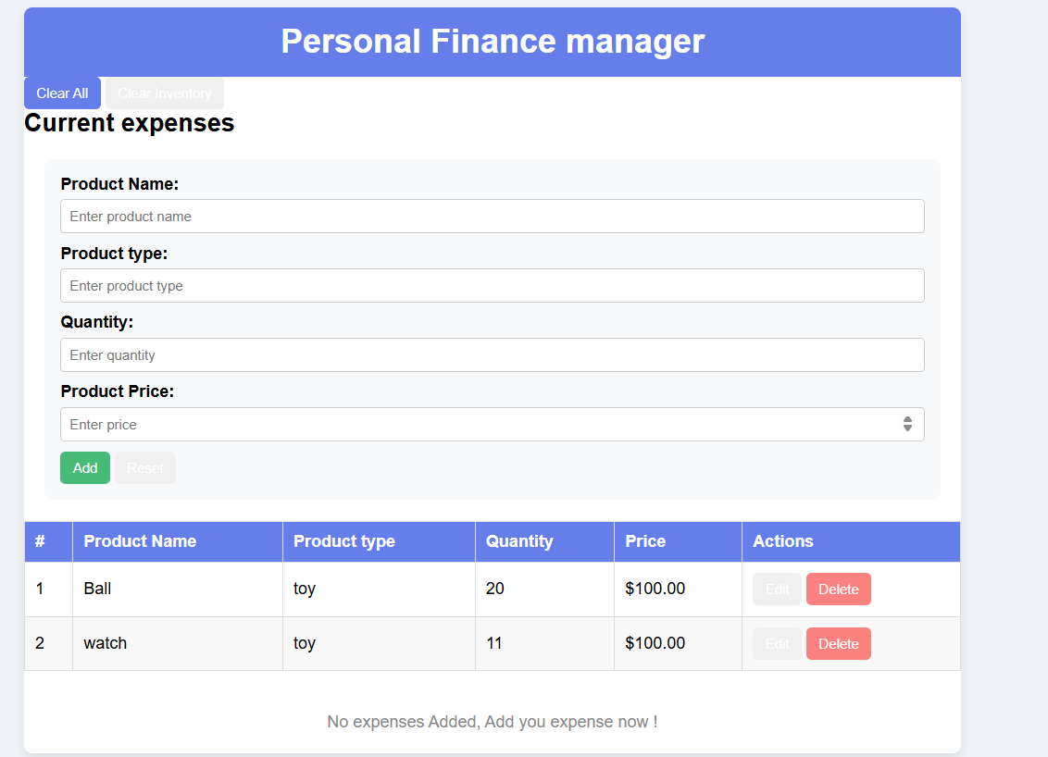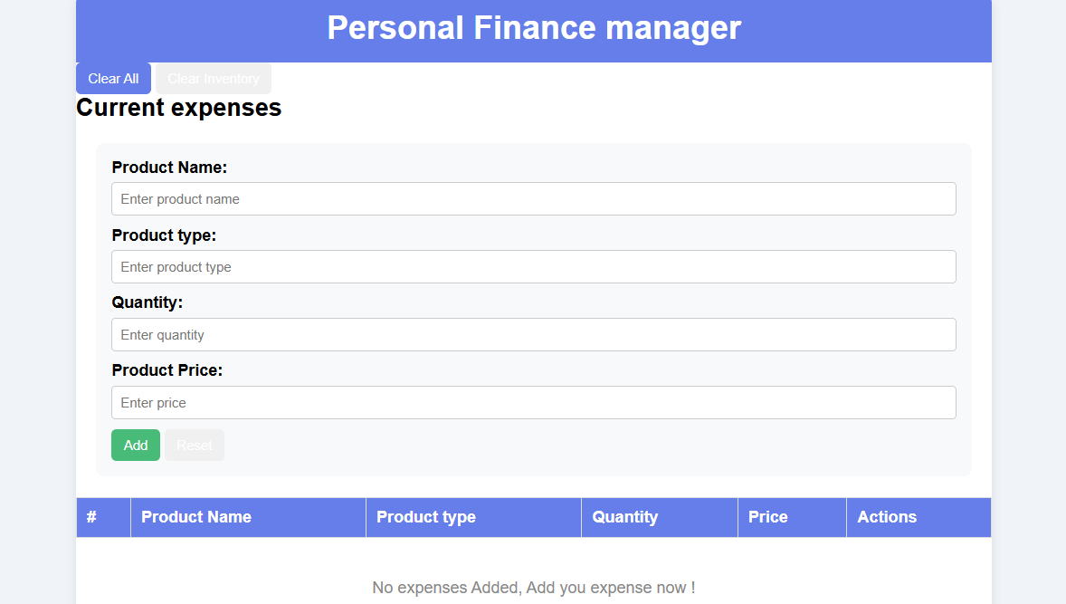

**INDEX.HTML**

<!DOCTYPE html>

<html lang="en">

<head>

    <meta charset="UTF-8">

    <meta name="viewport" content="width=device-width, initial-scale=1.0">

    <title>Personal Finance Manager</title>

    <link rel="stylesheet" href="style.css">

</head>

<body>

    <div class="container">

        <header class="header">

            <h1>Personal Finance manager</h1>

        </header>

        <div class="actions-bar">

            <button id="clearAllBtn" class="btn-clear">Clear All</button>

            <button id="clearInventoryBtn" class="btn-clear-inventory">Clear Inventory</button>

        </div>

        <section class="inventory-section">

            <h2>Current expenses</h2>

            <div class="form-container">

                <div class="form-group">

                    <label for="productName">Product Name:</label>

                    <input type="text" id="productName" placeholder="Enter product name">

                </div>

                <div class="form-group">

                    <label for="producttype">Product type:</label>

                    <input type="text" id="productBrand" placeholder="Enter product type">

                </div>

                <div class="form-group">

                    <label for="productQuantity">Quantity:</label>

                    <input type="number" id="productQuantity" placeholder="Enter quantity" min="0">

                </div>

                <div class="form-group">

                    <label for="productPrice">Product Price:</label>

                    <input type="number" id="productPrice" placeholder="Enter price" min="0" step="0.01">

                </div>

                <div class="form-actions">

                    <button id="addBtn" class="btn-add">Add</button>

                    <button id="updateBtn" class="btn-update" style="display: none;">Update</button>

                    <button id="cancelBtn" class="btn-cancel" style="display: none;">Cancel</button>

                    <button id="resetBtn" class="btn-reset">Reset</button>

                </div>

            </div>

            <div class="table-container">

                <table id="inventoryTable">

                    <thead>

                        <tr>

                            <th>#</th>

                            <th>Product Name</th>

                            <th>Product type</th>

                            <th>Quantity</th>

                            <th>Price</th>

                            <th>Actions</th>

                        </tr>

                    </thead>

                    <tbody id="inventoryBody">

                    </tbody>

                </table>

                <div id="emptyMessage" class="empty-message">No expenses Added, Add you expense now !</div>

            </div>

        </section>

    </div>

    <script src="./main.js"></script>

</body>

</html>  
  
  
  
**STYLE.CSS**

* {

  margin: 0;

  padding: 0;

  box-sizing: border-box;

}

body {

  font-family: Arial, sans-serif;

  background-color: #f0f4f8;

  padding: 20px;

}

.container {

  max-width: 900px;

  margin: 0 auto;

  background-color: white;

  border-radius: 8px;

  box-shadow: 0 4px 10px rgba(0, 0, 0, 0.1);

  overflow: hidden;

}

.header {

  background-color: #667eea;

  color: white;

  padding: 15px;

  text-align: center;

}

.nav {

  text-align: center;

  background-color: #eee;

  padding: 10px;

}

.nav a {

  color: #333;

  text-decoration: none;

  margin: 0 10px;

  font-weight: bold;

}

button {

  padding: 8px 12px;

  border: none;

  border-radius: 5px;

  color: white;

  cursor: pointer;

}

.btn-add { background-color: #48bb78; }

.btn-update { background-color: #4299e1; }

.btn-delete { background-color: #fc8181; }

.btn-clear { background-color: #667eea; }

.form-container {

  background-color: #f8f9fa;

  padding: 15px;

  margin: 20px;

  border-radius: 8px;

}

.form-group {

  margin-bottom: 10px;

}

.form-group label {

  font-weight: bold;

  margin-bottom: 5px;

  display: block;

}

.form-group input {

  width: 100%;

  padding: 8px;

  border: 1px solid #ccc;

  border-radius: 4px;

}

/* Table */

table {

  width: 100%;

  border-collapse: collapse;

  margin: 20px 0;

}

th, td {

  border: 1px solid #ddd;

  padding: 10px;

  text-align: left;

}

th {

  background-color: #667eea;

  color: white;

}

tr:nth-child(even) {

  background-color: #f9f9f9;

}

**SCRIPT.JS**

const STORAGE_KEY = 'Expenses';

let products = loadProducts();

let editingId = null;

function loadProducts() {

    const stored = localStorage.getItem(STORAGE_KEY);

    return stored ? JSON.parse(stored) : [];

}

function saveProducts() {

    localStorage.setItem(STORAGE_KEY, JSON.stringify(products));

}

function generateId() {

    return Date.now().toString(36) + Math.random().toString(36).substr(2);

}

function addProduct() {

    const name = document.getElementById('productName').value.trim();

    const brand = document.getElementById('productBrand').value.trim();

    const quantity = document.getElementById('productQuantity').value.trim();

    const price = document.getElementById('productPrice').value.trim();

    if (!name || !brand || !quantity || !price) {

        alert('Please fill in all fields');

        return;

    }

    if (parseFloat(quantity) < 0 || parseFloat(price) < 0) {

        alert('Quantity and price must be positive numbers');

        return;

    }

    const product = {

        id: generateId(),

        name: name,

        brand: brand,

        quantity: parseInt(quantity),

        price: parseFloat(price).toFixed(2)

    };

    products.push(product);

    saveProducts();

    clearForm();

    renderTable();

}

function updateProduct() {

    const name = document.getElementById('productName').value.trim();

    const brand = document.getElementById('productBrand').value.trim();

    const quantity = document.getElementById('productQuantity').value.trim();

    const price = document.getElementById('productPrice').value.trim();

    if (!name || !brand || !quantity || !price) {

        alert('Please fill in all fields');

        return;

    }

    if (parseFloat(quantity) < 0 || parseFloat(price) < 0) {

        alert('Quantity and price must be positive numbers');

        return;

    }

    const index = products.findIndex(p => p.id === editingId);

    if (index !== -1) {

        products[index] = {

            id: editingId,

            name: name,

            brand: brand,

            quantity: parseInt(quantity),

            price: parseFloat(price).toFixed(2)

        };

        saveProducts();

        cancelEdit();

        renderTable();

    }

}

function editProduct(id) {

    const product = products.find(p => p.id === id);

    if (product) {

        editingId = id;

        document.getElementById('productName').value = product.name;

        document.getElementById('productBrand').value = product.brand;

        document.getElementById('productQuantity').value = product.quantity;

        document.getElementById('productPrice').value = product.price;

        document.getElementById('addBtn').style.display = 'none';

        document.getElementById('updateBtn').style.display = 'inline-block';

        document.getElementById('cancelBtn').style.display = 'inline-block';

    }

}

function deleteProduct(id) {

    if (confirm('Are you sure you want to delete this product?')) {

        products = products.filter(p => p.id !== id);

        saveProducts();

        renderTable();

    }

}

function cancelEdit() {

    editingId = null;

    clearForm();

    document.getElementById('addBtn').style.display = 'inline-block';

    document.getElementById('updateBtn').style.display = 'none';

    document.getElementById('cancelBtn').style.display = 'none';

}

function clearForm() {

    document.getElementById('productName').value = '';

    document.getElementById('productBrand').value = '';

    document.getElementById('productQuantity').value = '';

    document.getElementById('productPrice').value = '';

}

function clearAllProducts() {

    if (confirm('Are you sure you want to clear all products? This action cannot be undone.')) {

        products = [];

        saveProducts();

        renderTable();

    }

}

function renderTable(filteredProducts = null) {

    const tbody = document.getElementById('inventoryBody');

    const emptyMessage = document.getElementById('emptyMessage');

    const displayProducts = filteredProducts !== null ? filteredProducts : products;

    tbody.innerHTML = '';

    if (displayProducts.length === 0) {

        emptyMessage.classList.add('show');

        return;

    }

    emptyMessage.classList.remove('show');

    displayProducts.forEach((product, index) => {

        const row = document.createElement('tr');

        row.innerHTML = `

            <td>${index + 1}</td>

            <td>${escapeHtml(product.name)}</td>

            <td>${escapeHtml(product.brand)}</td>

            <td>${product.quantity}</td>

            <td>$${product.price}</td>

            <td>

                <div class="action-buttons">

                    <button class="btn-edit" onclick="window.editProduct('${product.id}')">Edit</button>

                    <button class="btn-delete" onclick="window.deleteProduct('${product.id}')">Delete</button>

                </div>

            </td>

        `;

        tbody.appendChild(row);

    });

}

function escapeHtml(text) {

    const div = document.createElement('div');

    div.textContent = text;

    return div.innerHTML;

}

function filterProducts(searchTerm) {

    const filtered = products.filter(product =>

        product.name.toLowerCase().includes(searchTerm.toLowerCase())

    );

    renderTable(filtered);

}

window.editProduct = editProduct;

window.deleteProduct = deleteProduct;

document.getElementById('addBtn').addEventListener('click', addProduct);

document.getElementById('updateBtn').addEventListener('click', updateProduct);

document.getElementById('cancelBtn').addEventListener('click', cancelEdit);

document.getElementById('resetBtn').addEventListener('click', clearForm);

document.getElementById('clearAllBtn').addEventListener('click', clearAllProducts);

document.getElementById('clearInventoryBtn').addEventListener('click', clearAllProducts);

});

document.getElementById('productName').addEventListener('keypress', (e) => {

    if (e.key === 'Enter') {

        if (editingId) {

            updateProduct();

        } else {

            addProduct();

        }

    }

});

document.getElementById('productBrand').addEventListener('keypress', (e) => {

    if (e.key === 'Enter') {

        if (editingId) {

            updateProduct();

        } else {

            addProduct();

        }

    }

});

document.getElementById('productQuantity').addEventListener('keypress', (e) => {

    if (e.key === 'Enter') {

        if (editingId) {

            updateProduct();

        } else {

            addProduct();

        }

    }});

document.getElementById('productPrice').addEventListener('keypress', (e) => {

    if (e.key === 'Enter') {

        if (editingId) {

            updateProduct();

        } else {

            addProduct();

        }}});

renderTable();