SOFTWARE REQUIREMENTS SPECIFICATION
Contractor Operations, Job Management & Stock Inventory System
Client Version 1.1 | ASP.NET Core Web Application | Qatar
Document Item | Detail
Purpose | Define the agreed scope for design, development, testing and client acceptance.
Primary Users | Administrator, Department Head, Department User, Read Only
Core Areas | Jobs, departments, contractors, multi-currency reporting, stock inventory, users & permissions
Database | Microsoft SQL Server
Status | Development baseline / client confirmation

1. Project Overview
The application will replace spreadsheet-based contractor operation tracking with a controlled multi-user system. It will keep job information consistent, prevent defined duplicate entries, separate totals by currency, restrict users by permission and department, and provide management visibility from one dashboard.
The system is designed so normal business changes—such as adding a contractor, department, project, currency, unit, stock category or warehouse—can be handled from master data instead of requiring a code change.

2. Main Business Workflow
Step | System Behaviour
1. Login | User signs in with an individual account. Access is calculated from role, user overrides and assigned department(s).
2. Add Job | Job Number is generated automatically. Project, Department and Contractor are selected from active master data.
3. Enter Work | User enters job description and one or more lines with Unit, Qty, Rate and Currency.
4. Validate | System rejects the defined duplicate job and exact duplicate job-line combinations.
5. Track | Status, service dates, invoice information, payment status and processor can be updated.
6. Inventory | Stock can be received, issued, adjusted or transferred between warehouses. Negative stock is blocked.
7. Report | Dashboard and reports show job counts, department quantities, department amounts by currency and stock alerts.

3. Job Management Requirements
Field / Function | Requirement
Job Number | Automatic and unique, format JB-YYYY-####.
Project | Select from active Project master.
Department | Select from permitted active Department master.
Contractor | Select from active Contractor master.
Job Description | Manual text entry.
Job Date / Service Dates | Job date required; service start/end optional; end cannot be before start.
Status | Draft, In Progress, Completed, On Hold, Cancelled.
Job Lines | Multiple lines: Description, Unit, Quantity, Unit Rate, Currency, calculated Total.
Invoice / Payment | Invoice Number, Invoice Date, Payment Status and Processor.
Delete Protection | Authorized delete moves the job to Recycle Bin; authorized user can restore it.

3.1 Duplicate Prevention
- A duplicate job is blocked when Project + Department + Contractor + Job Date + normalized Job Description are the same.
- Exact duplicate lines inside one job are blocked based on Description + Unit + Currency + Quantity + Unit Rate.
- The application also uses database uniqueness controls so duplicate protection is not only a screen-level check.

3.2 Currency Handling
Amounts are not silently converted. QAR, USD and any later currency remain separate in the job, department summary, dashboard and reports unless the client later approves an exchange-rate policy. Example: Accounts may show QAR 6,777 and USD 8,896 as two separate totals.

4. Stock Inventory Requirements
The stock module is included in the same application and follows the same user/security model. It is intended for operational inventory control rather than accounting-ledger valuation.
Function | Requirement
Stock Item | Item Code, Name, Category, Unit, Reorder Level, Unit Cost, Currency, Active/Inactive.
Warehouse | Multiple warehouses/locations can be maintained.
Balance | Quantity on hand is maintained per Item + Warehouse.
Receive | Increase stock with quantity, cost, currency, reference, optional contractor and optional linked job.
Issue | Reduce stock; transaction is rejected if available stock is insufficient.
Adjustment | Authorized Adjustment In / Adjustment Out for controlled corrections.
Transfer | Move stock from one warehouse to another as one controlled operation; source stock cannot become negative.
Duplicate Reference Control | When a reference is entered, the same Item + Warehouse + Movement Type + Reference is rejected.
Low Stock | Item is highlighted when on-hand quantity is at or below reorder level.
Out of Stock | Item is highlighted when total on-hand quantity is zero or below.
Stock Value | Current quantity × item unit cost is summarized by currency without mixing currencies.
History | Transaction history records movement type, user, time, warehouse, quantity, reference and linked records.

5. Users, Roles & Granular Permissions
Each user has a separate ID. Access is enforced on the server, not only by hiding menu items. A user can belong to one role, can be assigned to one or more departments, and can have explicit user-level Allow/Deny overrides.
Security Layer | Behaviour
Role | Administrator, Department Head, Department User or Read Only provides the base permission set.
Department Scope | Non-admin users see only jobs in assigned departments unless All-Department access is granted.
User Override | For each permission: Inherit from Role, Allow, or Deny.
Inactive Account | Cannot sign in.
Password | Strong password rules, login lockout, administrator reset and self-service change password.
Audit | Important changes record user, action, entity, timestamp, details and IP address.

Module | Granular Rights
Dashboard | View
Jobs | View / Create / Edit / Delete / Export
Inventory | View / Create Item / Edit Item / Receive / Issue / Adjust / Transfer / Export
Reports | View / Export
Projects | Manage
Departments | Manage
Contractors | Manage
Master Data | Manage currencies, units, categories, warehouses
Users | View / Manage
Permissions | Manage role grants and user overrides
Audit | View
Settings | Manage
Data Scope | All Departments

6. Dashboard & Reporting
Dashboard Area | Content
KPI Cards | Total Jobs, Completed, In Progress, On Hold/Cancelled.
Jobs by Department | Department job count chart.
Jobs by Status | Status distribution chart.
Department Summary | Department, number of jobs, total quantity, and separate amount columns for each currency.
Recent Jobs | Latest jobs with project, department, contractor, status and date.
Inventory Summary | Active Items, Low Stock, Out of Stock, Warehouses and stock value by currency.
Security Summary | For authorized administrators: role access summary and user count.
Reports | Job/status summary, department currency totals, low-stock report, Job CSV and Inventory CSV.

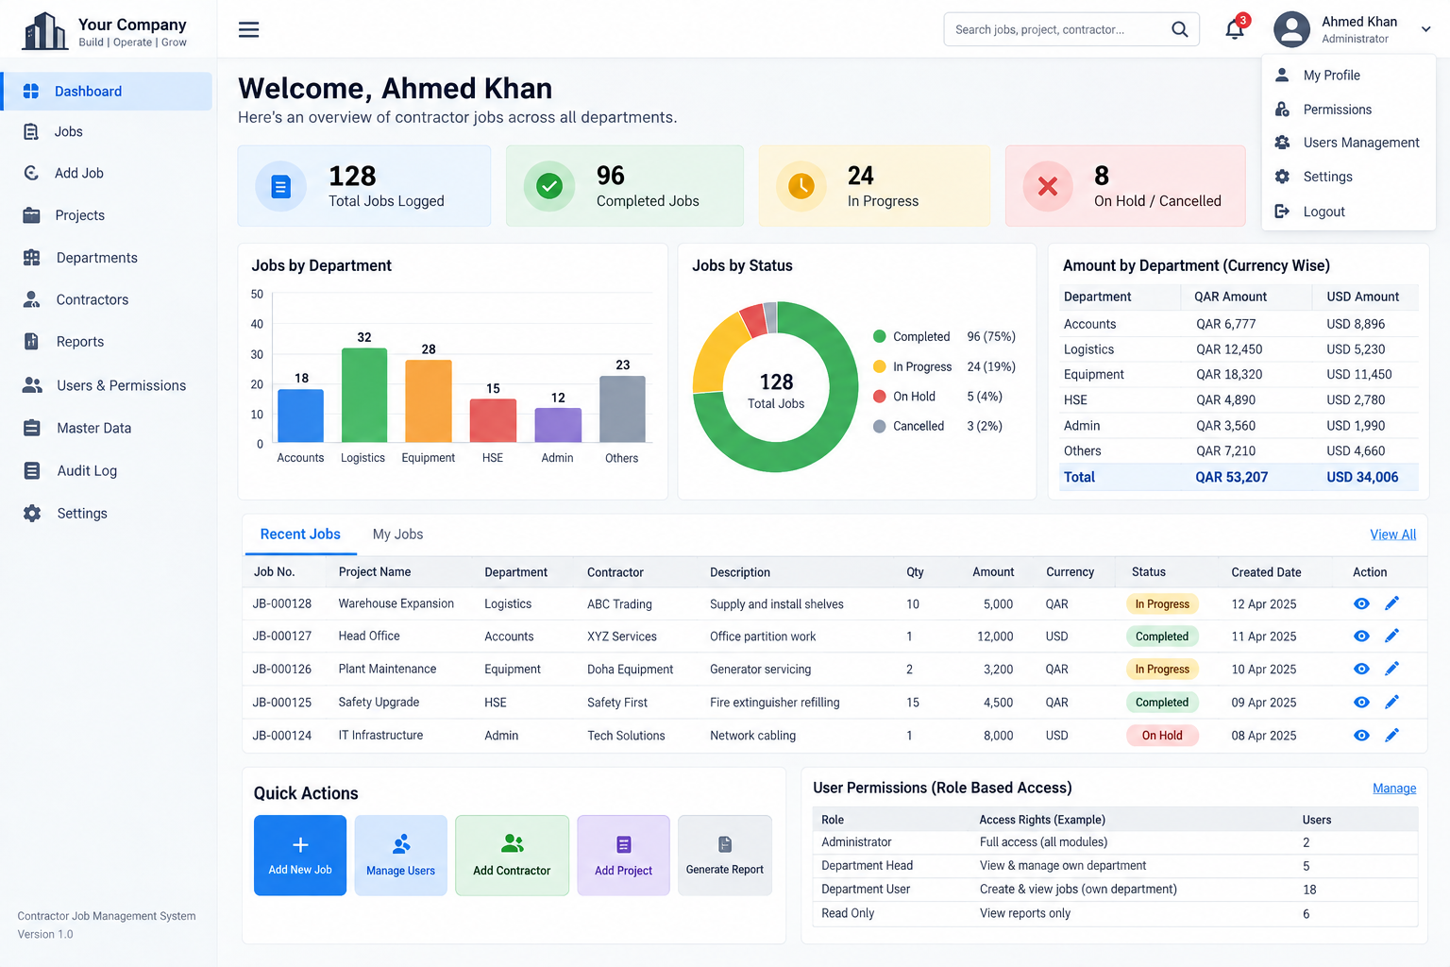
Dashboard UI reference supplied/approved for the project direction.

7. Master Data
Master | Key Information
Projects | Code, Name, Active
Departments | Code, Name, Active
Contractors | Name, Contact Person, Phone, Email, Active
Currencies | 3-letter Code, Name, Symbol, Active
Units | Code, Name, Active
Stock Categories | Name, Active
Warehouses | Name, Location, Active

Inactive master data is removed from new-entry dropdowns while historical records remain readable.

8. System Screens
Area | Screens
Authentication | Login, My Profile, Change Password, Access Denied
Jobs | Jobs List, Add Job, Edit Job, Job Details, Recycle Bin
Inventory | Inventory List, Item Details, Add/Edit Item, Receive, Issue, Adjustment, Transfer, Transaction History
Management | Dashboard, Reports
Administration | Projects, Departments, Contractors, Master Data, Users, Role Permissions, User Permission Overrides, Audit Log, Settings

9. Non-Functional Requirements
Area | Requirement
Security | Authentication, authorization, anti-forgery protection, password policy, account lockout, HTTPS in production.
Data Integrity | Database constraints, controlled dropdown data, duplicate prevention and transactional stock posting.
Usability | Responsive dashboard for desktop/tablet/mobile widths; clear forms, filters and status indicators.
Performance | Normal list pages limited/paged to practical result sizes; database indexes on key lookup/unique fields.
Backup | Production SQL Server must have scheduled backups and a tested restore procedure.
Auditability | Operational/security changes and stock movements remain traceable.
Deployment | ASP.NET Core web application with SQL Server; hosting secrets must be stored outside source code.

10. Client Acceptance Criteria
- Authorized users can log in and unauthorized/inactive users are blocked.
- Job number is created automatically and remains unique.
- Projects, Departments, Contractors, Units and Currencies are selectable from master data.
- Multiple job lines calculate Quantity × Rate correctly.
- Defined duplicate job and exact duplicate job line are rejected.
- Department users cannot see job data outside their allowed department scope.
- QAR and USD totals remain separate and department Job Count + Quantity totals are correct.
- Stock receipt increases balance; stock issue reduces balance; insufficient-stock issue is rejected.
- Warehouse transfer reduces source and increases destination in one controlled operation.
- Low/out-of-stock indicators and stock value by currency are correct.
- Administrator can manage roles, user overrides, user departments and master data.
- Audit log records important business/security changes.
- Job and inventory CSV exports open with expected data.

11. Items for Final Client Confirmation
- Final company name/logo and Qatar hosting environment.
- Final departments, projects, contractors, units, currencies, warehouses and initial stock master.
- Whether a formal approval workflow is required before a job becomes Completed.
- Whether document/PDF attachments are required for invoices or jobs.
- Whether stock requires serial numbers, batch numbers, expiry dates or purchase orders.
- Whether Arabic UI or bilingual reports are required.
- Any approved exchange-rate source if currency conversion is introduced later.

12. Delivery Package
The source package contains the ASP.NET Core solution, SQL Server Entity Framework model, dashboard UI, job and inventory modules, granular permissions, reports/exports, audit log, deployment files, this SRS, UAT checklist, deployment checklist and the dashboard reference image.

