Alimgozha Adil

Lab Functions

1. Create a function that decreases or increases the price of a product by any percentage. If the input is not valid, then print an error message.

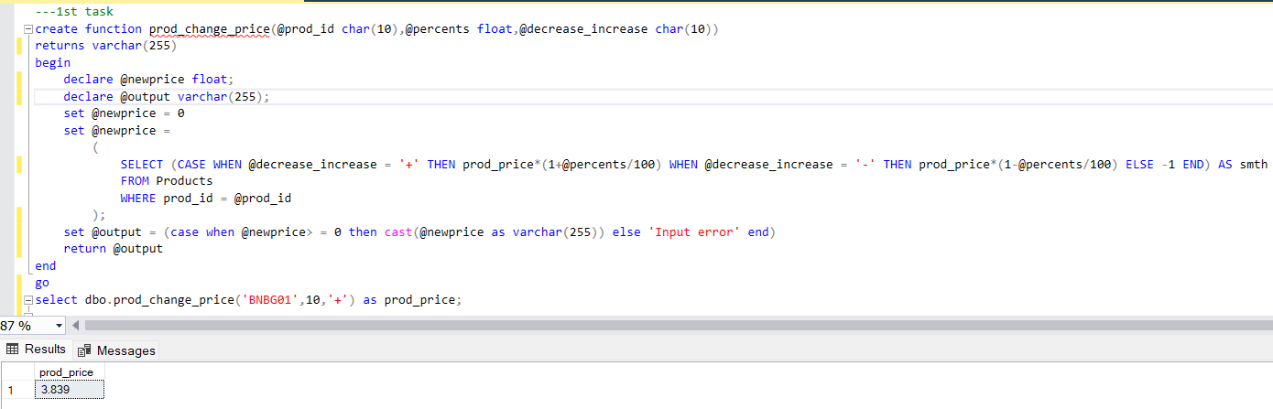

2. Create a function that defines the state of vendor by taking its id. But the main idea is when you get the null value it has to say ‘UNKNOWN’. (u can use IIF function)

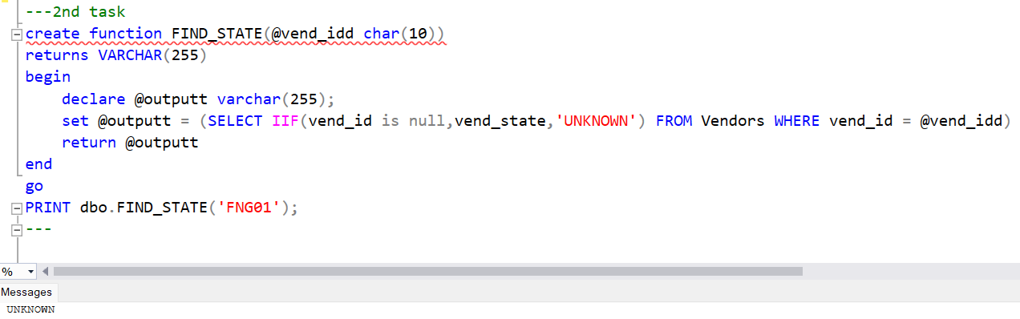

3.Create a function that displays how many vendors and customers in this country. (use table functions)

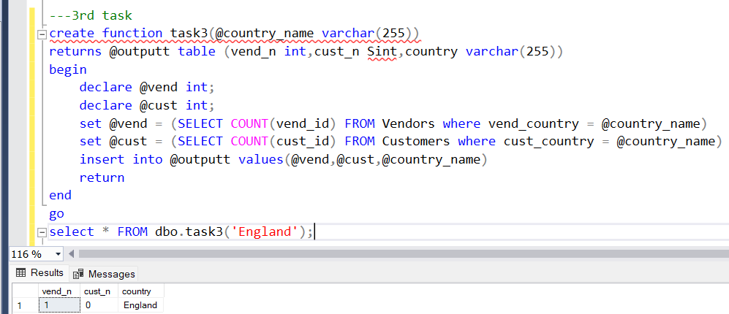

4. Write a function for creating vendor’s email. (u can use lower, concat, left, charindex and substring functions)

5. Get the number of customers by giving the name of month. (u can use DATENAME and MONTH functions)

6. Create a function that shows how many days (from today) have passed since the order date. Input parameter: order_num. (datediff, day and getdate functions)

7. Write a function that would return the total price that person needs to pay. Just multiply the quantity of items by cost of one. Use the type MONEY with dollars sign to make it more realistic

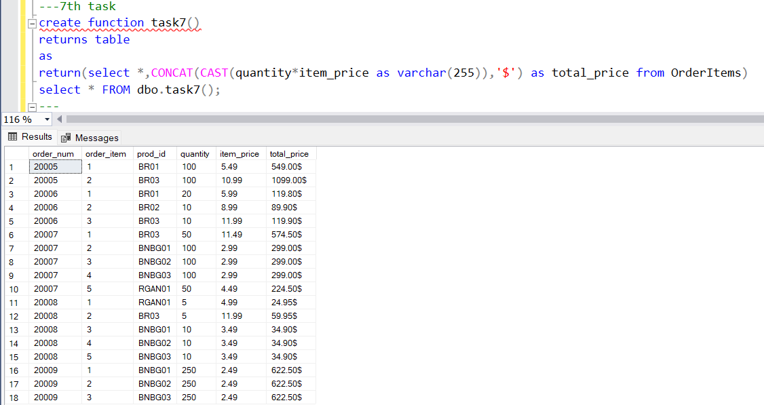

8. Create a function that returns the number in the address. (u can use PATINDEX, STUFF and CONVERT functions)

9. Create a function that checks whether it palindrome or not. (use LEN and SUBSTRING functions)

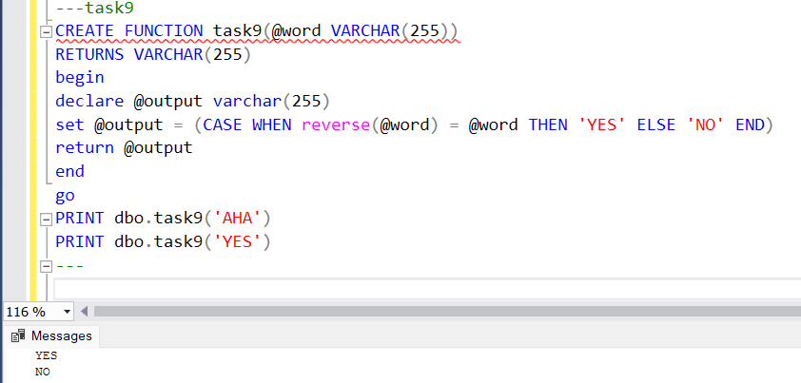

10th task

Returns number of items when given correct product id else retuns error message

