**Assignment LTspice.**

Adil Arystanbek. E2202683

1. **Series resistors**

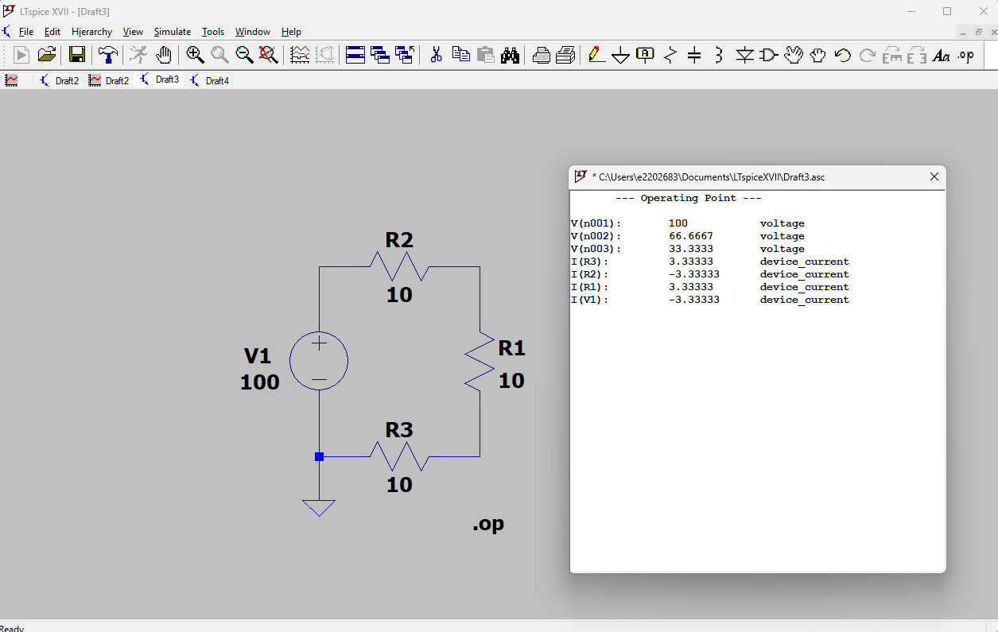

1. **Parallel resistors**

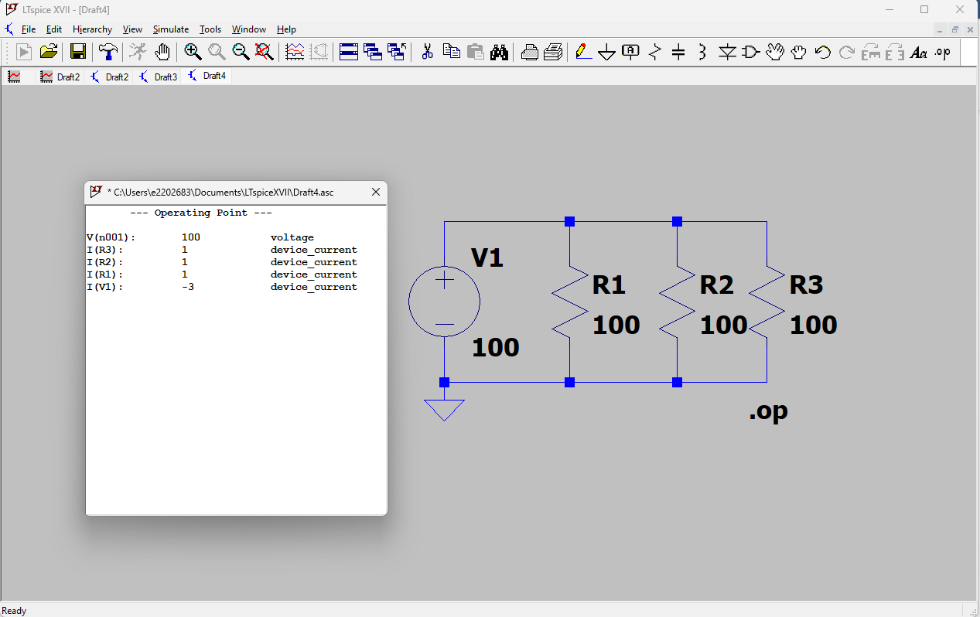

1. **Variable DC-voltage supply (DC-sweep)**
2. **Sinewave source (Transient-sweep)**
3. **Operational amplifier (transient)**



1. **Operational amplifier (dc-sweep)**
2. **Hierarchy design**

