

**National University of Computer and Emerging Sciences**

Software Engineering

**“Salon Management System”**

**STUDENTS NAME and REGISTRATION NUMBERS:**

Hurriya Nasir 18I-0597

Zaynab Batool Reza 18I-0419

M. Adil Fayyaz 18I-0613

**DEGREE PROGRAM:** BS (CS)

**Section:** B

**SUBJECT NAME:** Software Engineering

**DATE OF SUBMISSION:** June 18, 2021

**SUBMITTED TO:**  Dr. Behjat Zuhaira

**STUDENT SIGNATURE:**

__**____________________________________________________________**

**MARKS:**

__**____________________________________________________________**

**REMARKS:**

__**____________________________________________________________**

**TEACHERS SIGNATURE:**

# Introduction

The salon management system which is an Android based application allows customers to explore and book appointments at nearby and highly frequented salons. It also facilitates customers in comparing the different services provided by the salons, to aid them in selecting their best option. Furthermore, the system provides business on the go for salon owners. It allows them to maintain cash drawers and track performances of their employees. Customers can also give reviews to salons which will allow the system to optimize customer experience.

# Software Architecture – Component Based Architecture (CBA) using MVC Architecture

## Rationale

The Component based architecture is considered a good approach due to the reduced time and development cost by reusing existing elements and more reliability with reused components. It provides a hybrid approach between layered and feature-based architecture.

In a CBA, a single component contains the view, business logic and database logic encapsulated together. This provides reusable elements/modules which make the development smoother. With respect to Scissors and Razors, the component based architecture allowed us to develop related functionality as well as interface at the same time. Moreover, it allowed us to create reusable components such as the login page, alert box, and calendar among several others which can be reused not just in this project but also in other management systems. This also ensures reliability of the final product since these individual components have been thoroughly tested.

Within each component the **Model View Controller Architecture** is most suitable for our project. Since it keeps display and data separate it allows us to make changes in either one of the layers without it affecting the other. It also allows multiple views for a model to allow different users to view the same data but with different levels of access/UI. Moreover, it also supports an asynchronous technique that allows developers to load an application swiftly, allowing a better user experience.

However, one major limitation to using the component based architecture is that there is a very extensive process of identifying all possible requirements of a component which may or may not be ambiguous. In the case of ambiguous requirements there is a possibility of extensive rework, thus limiting the reusability of the component. In the case of MVC architecture, the individual development of UI, Business logic and Controllers, can lead to delay in the overall modules development.

## UML Diagrams

**Class Diagram**

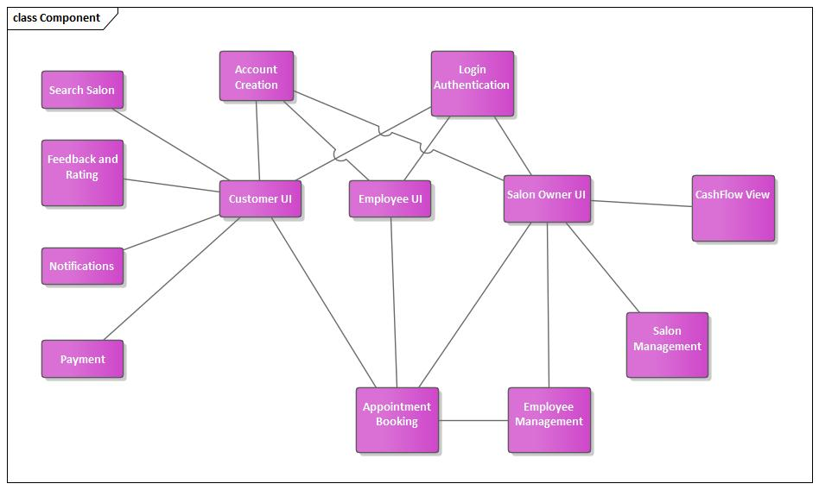

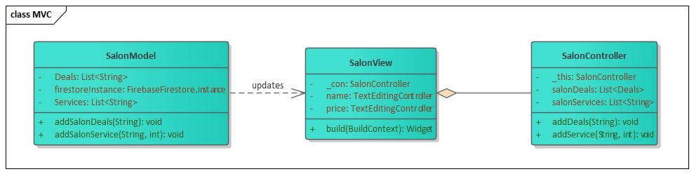

**Sequence Diagram**

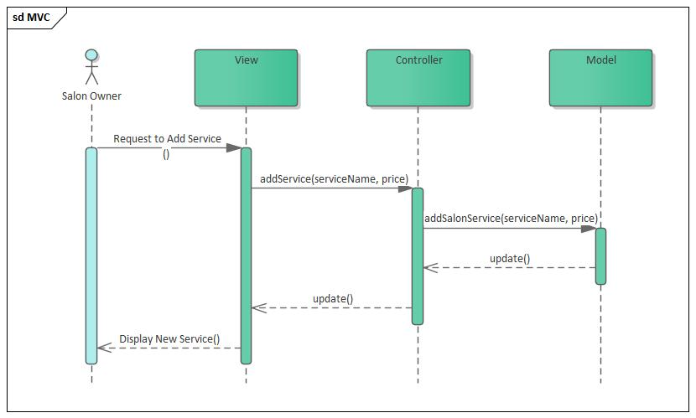

# Burndown Chart

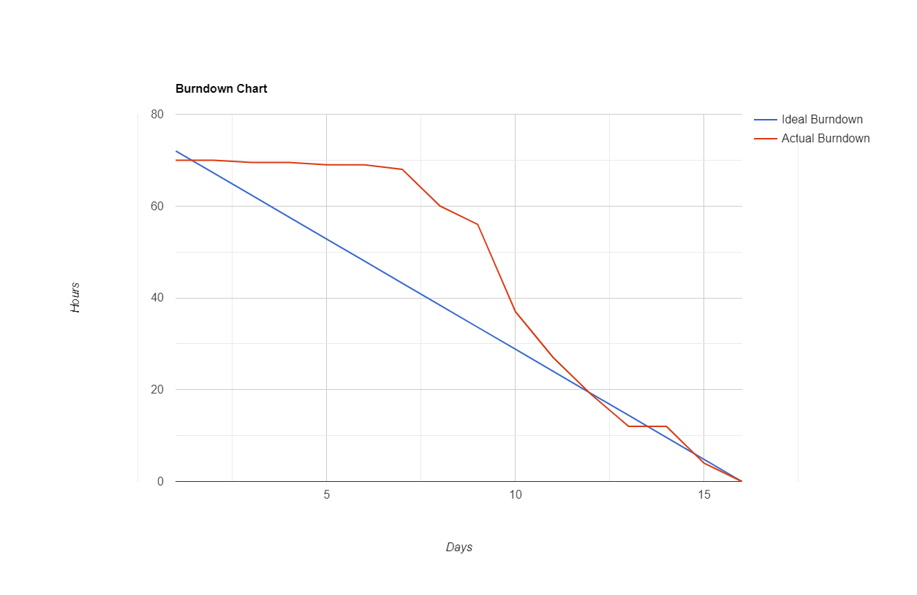

# Complete Product Review

## Possible Improvements

Some of the improvements that can be made to the software are as follows:

1. The UI can be improved for an even better User Experience
2. Push Notifications can be generated for even when app is in background or closed to notify customers in real time
3. More payment gateways can be connected to the app to facilitate advance payments for a broader set of customers

## Limitations of Software

1. In order to utilize the auto-suggest feature, the app has to be on the same network as that where the Elastic Search cluster is hosted as the cloud feature for Elastic Search was not available for free
2. There is a limited amount of data that can be added or read/write actions that can be performed in a day using the free version of Firebase Firestore which is what has been used here
3. Due to limited funds, the Google Maps API could not be utilized in the app

## Product Backlog

|  |  |  |  |  |  |  |  |
| --- | --- | --- | --- | --- | --- | --- | --- |
| **ID** | **User Story** | **Replaced by – user story (if applicable)** | **Reason for change (if applicable)** | **Developed in (sprint 1 / sprint 2 / sprint 3)** | **Developed by [the name of the team member]** | **Time taken for development** | **Comments** |
| 001 | As a customer I want be able to search salons near me so that I can consider my options. | Not changed | - | Sprint 2 | Zaynab Batool Reza + Adil Fayyaz | 8 hours |  |
| 002 | As a customer I want to be able compare rates/services so that I can choose the most feasible option. | Not changed | - | Sprint 1 | Adil Fayyaz + Hurriya Nasir | 3 hours |  |
| 003 | As a customer I want to book an appointment so that I can save my time. | Not changed | - | Sprint 1 | Zaynab Batool Reza + Adil Fayyaz | 1 hour |  |
| 004 | As a customer I want to pay in advance through this application so that I do not have to carry cash. | Not changed | - | Sprint 3 | Hurriya Nasir | 4 hours |  |
| 005 | As a salon owner I want to send out promotional notifications and show my available services so that I can market my business. | Not Changed | - | Sprint 1 | Zaynab Batool Reza + Hurriya Nasir | 2 hours |  |
| 006 | As a salon owner I want to view appointments and be able to manage them so that I can assign duties to my employees efficiently. | Not Changed | - | Sprint 2 | Hurriya Nasir | 8 hours |  |
| 007 | As a customer I want to get recommendations for treatment/service so that I can make an informed decision. | As a customer I want to give feedback/reviews of my appointments so that I can help the Salons grow better. | Original User Story was too time consuming.  It was also decided that feedback/reviews were more of a priority instead. | Sprint 3 | Adil Fayyaz | 4 hours |  |
| 008 | As a salon owner I want to be able to view my profit/loss on a monthly basis so that I can manage the cash flow. | Not Changed | - | Sprint 2 | Zaynab Batool Reza | 5 hours |  |
| 009 | As a salon owner I want to view my employees’ statistics so that I can manage their bonuses and track their performance. | Not Changed | - | Sprint 3 | Zaynab Batool Reza | 3 hours |  |
| 010 | As an employee I want to view appointments assigned to me so that I can manage my daily schedule. | Not Changed | - | Sprint 2 | Hurriya Nasir | 2 hours |  |

## Tasks for User Stories

1. Backlog ID: 0001
   1. As a customer I want to know which Salons are closest to my geographical location so that I can plan my visit accordingly
   2. As a customer I want to know which Salons are visited most frequently so that I can get the best experience
   3. As a customer I want to be able to search for all the Salons so that I can view their services
2. Backlog ID: 0002
   1. UI Design for the app
   2. Implement Sign Up functionality for customer
   3. Implement Login functionality for customer
   4. Access database to get list of services offered by each Salon
   5. Display interactive list of Salons to customer
   6. On selecting a Salon, display all Services offered by it
3. Backlog ID: 0003
   1. Generate an interactive Calendar
   2. Display all items in cart dynamically
   3. Generate an interactive Clock
   4. Add constraint for appointment timings
   5. Save appointment information to database
   6. Initialize calendar with previous appointment by same customer
   7. Make the list of Services interactive such that clicking on them adds them to cart
4. Backlog ID: 0004
   1. Add payment option on appointment booking screen
   2. Take user input of card information
   3. Verify that payment has been made
   4. Update database accordingly
5. Backlog ID: 0005
   1. Design Salon Owner UI
   2. Allow Salon Owner to Sign Up and Add Salon
   3. Implement Login functionality for Salon Owner
   4. Allow Salon Owner CRUD Operations for Services
   5. Allow Salon Owner Add and Delete Operations for Deals
   6. Whenever a new Deal is added by Salon Owner, add it as a notification visible to customer
6. Backlog ID: 0006
   1. As a salon owner I want to view client appointments date and time so that I can manage my schedule
   2. As a salon owner, I want to assign the appointments to employees so that I can ensure efficient running of my Salon
   3. As a salon owner I want to be able to create my employee accounts so that they can log in from their own devices and view the appointments assigned to them
7. Backlog ID: 0007
   1. Allow Customer to view their appointments from their Navigation Bar
   2. Allow customers to use a sliding rating bar to give ratings out of 5
   3. Allow Customers to select their appointments and write reviews
8. Backlog ID: 0008
   1. As a Salon Owner I want to view my income for the current month so that I can track my progress
   2. As a Salon Owner I want to view my annual monthly income for the current year so that I can track my progress
   3. As a Salon Owner I want to view my profit/loss so that I can gain insights into my business’s performance
9. Backlog ID: 0009
   1. Perform statistical analysis of the employees based on ratings
   2. Display animated bar chart showing each employee and their average rating
   3. Take input of employee name from Salon Owner
   4. Fetch information for employee entered by Salon Owner
   5. Perform statistical analysis of employees based on number of appointments
   6. Display animated line chart per employee showing number of appointments in a day for current month
10. Backlog ID: 0010
    1. As an Employee I want to be able to login to my personal account so that I can view the appointments assigned to me

# Scrum Retrospective

## Work Division

In order to divide the work amongst sprints, the user stories with the highest priority were don’t in earlier Sprints, thus the most crucial functionalities of the application were done in Sprint 1 and as the main consumer of this application will be customers, the user stories done then were centered around the customer. Then those stories which were less crucial but still important were done in Sprint 2 and these included tasks revolving around the Salon Owner and the management of the Salon. In the end, the stories with least priority were covered in Sprint 3. The number of user stories per sprint was decided on the basis of how many days were available in each sprint and the complexity as well as time required for each user story.

## Work Process

Before beginning the development, all the developers in the team collectively decided on a UI design and color scheme to follow. Then during each sprint, every developer would initially work on a separate user story. If they faced any difficulties, the other team members would assist them and upon completion of the story, all members would collectively give feedback and work on the UI design. GitHub was used to share the updated source code in real-time along with messaging. Google Meet was used to have regular meetings to discuss the latest progress.

## Possible Improvements to Work Process

1. Due to the Covid-19 pandemic and as a result the imposed lockdown, the meetings could not be held in person and had to be held online. However, in person meetings and code sharing could have been more effective and sped up the process.
2. For the UI, the use of storyboarding could have streamlined the process of improving the GUI better and made it easier for all team members to know which direction to head in beforehand thus also making the process faster.

## Possible Improvements to Team Members’ Work Performance

1. Better time management could have been done in order to better juggle the workload of other assignments along with this project
2. Familiarization with the languages and tools to be used in development beforehand can save a lot of time that is wasted in first understanding and debugging a new platform

## Difficulties Faced

1. Despite repeated efforts, animations could not be added to the GUI

* To solve this, Instead of Animations, 3D images were used to improve GUI.

1. The development team was preoccupied with a number of other assignments

* The development team synchronized which days were allotted to other assignments and which days to this project.

1. Due to Ramadan in Sprint 1, a compatible schedule for working hours was difficult to manage

* To solve this, the entire team worked late hours to ensure timely completion of the tasks.

1. The development team faced issues with synchronizing the application with the database

* In order to solve this, after consulting the dart and firebase documentation, the issue was resolved by one of the developers

1. Addition of one of the GUI widget interfered with the behavior of other GUI elements

* To overcome this, the widget which was causing the problem was added using a slightly different way so that it does not affect other elements

1. The GUI was changing slightly on different devices

* For this, one of the developers was able to solve the problem after consulting the flutter official documents.

## Lessons Learned

1. New languages and platforms were learnt such as Flutter, Firebase and Elastic Search
2. Using GitHub to coordinate development among team members
3. Team coordination and communication

# GUI

# Testing

1. Time for Booking Appointment

Conditions:

Time before Salon’s opening time is invalid

Time between Salon’s opening and closing times is valid

Time after Salon’s closing time is invalid

**Let Salon XYZ’s opening time be 10:00 and closing time be 22:00**

|  |  |  |
| --- | --- | --- |
| **Invalid** | **Valid** | **Invalid** |
| 9:59 | 10:00 22:00 | 23:01 |

**Testing using boundary values**

|  |  |  |
| --- | --- | --- |
| **Test Case #** | **Input** | **Expected Output** |
| 1 | 9:59 | “Invalid” |
| 2 | 10:00 | “Valid” |
| 3 | 22:00 | “Valid” |
| 4 | 23:01 | “Invalid” |

1. Rating for Reviewing Appointment

Conditions:

Rating less than 1 is invalid

Rating between 1 and 3 is valid

Rating greater than 5 is invalid

|  |  |  |
| --- | --- | --- |
| **Invalid** | **Valid** | **Invalid** |
| 0 | 1 5 | 6 |

**Testing using boundary values**

|  |  |  |
| --- | --- | --- |
| **Test Case #** | **Input** | **Expected Output** |
| 1 | 0 | “Invalid” |
| 2 | 1 | “Valid” |
| 3 | 5 | “Valid” |
| 4 | 6 | “Invalid” |

1. Number of Items in Cart for Booking Appointment

Conditions:

Number of items less than 1 is invalid

Number of items between 1 and 3 is valid

Number of items greater than 3 is invalid

|  |  |  |
| --- | --- | --- |
| **Invalid** | **Valid** | **Invalid** |
| 0 | 1 3 | 4 |

**Testing using boundary values**

|  |  |  |
| --- | --- | --- |
| **Test Case #** | **Input** | **Expected Output** |
| 1 | 0 | “Invalid” |
| 2 | 1 | “Valid” |
| 3 | 3 | “Valid” |
| 4 | 4 | “Invalid” |

1. Length of Credit Card Number at Time of Advance Payment

Conditions:

Length of number less than 16 is invalid

Length of number between 16 and 19 is valid

Length of number greater than 19 is invalid

|  |  |  |
| --- | --- | --- |
| **Invalid** | **Valid** | **Invalid** |
| 15 | 16 19 | 20 |

**Testing using boundary values**

|  |  |  |
| --- | --- | --- |
| **Test Case #** | **Input Length** | **Expected Output** |
| 1 | 15 | “Invalid” |
| 2 | 16 | “Valid” |
| 3 | 19 | “Valid” |
| 4 | 20 | “Invalid” |

1. Length of Password at Time of Signup

Conditions:

Length of password less than 3 is invalid

Length of password equal or greater than 4 is valid

|  |  |
| --- | --- |
| **Invalid** | **Valid** |
| 3 | 4 |

**Testing using boundary values**

|  |  |  |
| --- | --- | --- |
| **Test Case #** | **Input Length** | **Expected Output** |
| 1 | 3 | “Invalid” |
| 2 | 4 | “Valid” |