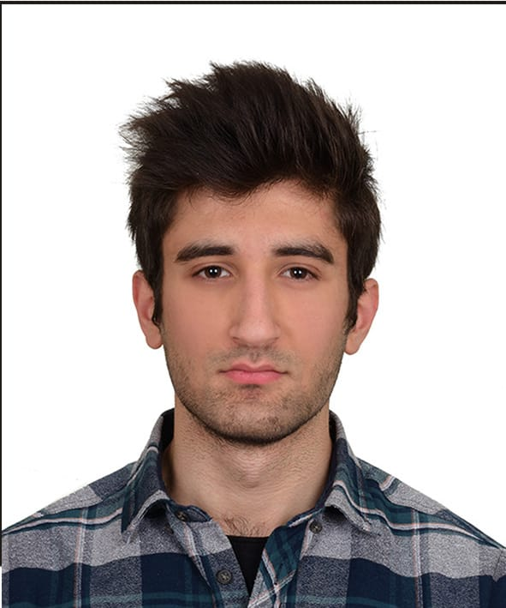

Adil Tuğrul Haydar

Beştelsiz Mahallesi Cahit Bayram Sokak – Zeytinburnu / İSTANBUL

GSM. (531) 738 88 86

[*adilhaydarr@gmail.com*](mailto:adilhaydarr@gmail.com)

[*https://www.linkedin.com/in/adil-haydar-ab941b145/*](https://www.linkedin.com/in/adil-haydar-ab941b145/)

[*https://github.com/AdilHaydar*](https://github.com/AdilHaydar)

# PERSONAL INFORMATION

**Date of Birth :** 25/02/1997

**Nationality :** Turkish

**Marital Status :** Single

**Sex :** Male

**Driving License :** None

# OBJECTIVE

# I am a 4th year student at Istanbul Medeniyet University Physics Engineering department. For more than 3 years, I have been developing projects with Python programming language, mainly Web (Django). I also completed a .Net (C #) course. In addition to the software, I was also interested in Cyber ​​Security and Data science. I think of a software career in the future.

# EDUCATION

**University Istanbul Medeniyet University – İstanbul**

Physics Engineering – 09/2016 –

**High School Zeytinburnu Endüstri Meslek Lisesi – İstanbul**

Electrical and Electronics department / Electrical appliances branch –

2011 - 2015

# WORK EXPERIENCE

**06/2018 – 07/2018**  **EXEDRA E-Business Solutions. / İstanbul**

**Intern Student**

# ADDITIONAL EDUCATION & CERTIFICATES

**11/2020 Ruby on Rails Bootcamp / Kodluyoruz Academy**

Ruby on Rails bootcamp organized by KodluyoruzAcademy I successfully completed the Ruby and Ruby on Rails training organized by instructor Ender Ahmet Yurt between 19 September - 1 November 2020.

**03/2020 Medeniyet Teknoloji Günü 2/ Istanbul Medeniyet University IEEE Student Branch**

A seminar on cyber security and artificial intelligence provided by officials from CyberArts, Turkcell and Alotech companies in the 7-hour program.

**07/2018 Empatik StajOkulu/ Empatik İnsan Kaynakları**

1-month training on cyber security, linux, effective code development, interview techniques.

**07/2018 Strategy Of IT/ UNITS Kariyer Akademesi**

**02/2014 Akümülatör Eğitimi/ AKÜDER**

I have received 45 hours of Accumulator training within the scope of the AYMEP Protocol and I have successfully completed this training.

# LANGUAGE SKILLS

**English** Reading: Intermediate, Writing: Low Intermediate, Speaking: Low Intermediate

**Spanish**  Reading: Beginner, Writing: Beginner, Speaking: Elementary

# COMPUTER SKILLS

Python (Django, Pandas, Numpy, OpenCV and others.): Advanced

Word, Excel, Powerpoint, HTML & CSS (Bootstrap): Good

Fl Studio, GNU/Linux (Debian), SQL (RDBMS): Intermediate  
Matlab, C# (.Net, ASP.NET MVC), Javascript (React), Ruby (Ruby on Rails), Solidworks: Low Intermediate

Java: Beginner

# SOCIAL ACTIVITIES

Chess, Football, Music

# CLUB & ASSOCIATION MEMBERSHIPS

Chamber of Physics Engineers

# REFERENCES