Machine Learning (CS3102) Project – Multi Step Regression-Classification-Attrition

The abstract of this project :-
Most HR analytics projects usually focus only on predicting whether an employee will leave the company or not, and not on how it can impact the company in terms of profit and losses.
In this project, we solve the issues faced by HR analytics regarding the future salary of employees likely to stay and the potential losses faced by the company when certain employees decide to leave, which is a real-world scenario that HR departments around the world strive to quantify.
The methods used to solve this problem are as follows:
1. For predicting whether an employee will leave or not, we use Logistic Regression, Decision Tree and SVM to find the best fitting model in order to lower the chances of overfitting / underfitting.
To check which model works the best, we make use of metrics like F1-score and AUC-ROC.
2. We then simulate future salaries for each employee using a performance-based growth system. This is because it rewards certain employees for working with more efficiency instead of incrementing everyone’s salary with one metric despite the hard work some employees put in compared to the others.
3. Predict future salaries but this time for employees likely to say. For this we use regression models like Random Forest Regressor, Ridge, Lasso and Support Vector Regression (SVR).
4. We then identify employees that are likely to stay by defining a certain threshold and simulate their future salaries.
5. For the employees unlikely to stay, we simply estimate the expected salary loss for each employee and take the aggregate across all employees. This helps a company answer how much value they would be losing if certain employees decided to leave.

Introduction :-
In most companies, the HR analytics department has a fair share of problems to solve regarding the future of the company. One of them is to estimate / predict how much losses they would incur if some employees decided to leave the company on their own accord.
Usually, these companies focus only on predicting whether employees are likely to leave the company or not, and don’t take into considering the potential financial losses they can face.
This project aims to solve that problem by taking attrition, classification and regression, all three at once to model not only who might leave, but also the financial impact of their departure.

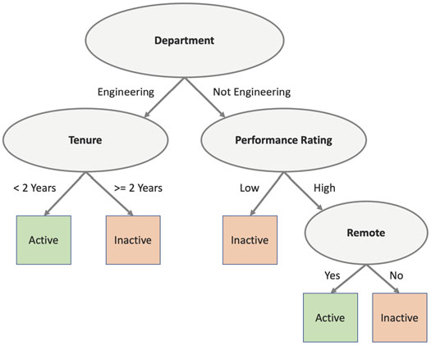

The methodology behind this project :-

To start off, we made use of three models – Logistic Regression, Decision Tree and SVM, to predict whether an employee would leave or not. In the predictions, a ‘1’ meant that the employee would leave, and a ‘0’ meant otherwise.
We did this using the sci-kit learn library and more importantly the pandas library to load our IBM HR Analytics Employee Attrition dataset from Kaggle, in the form of a ‘.csv’ file.
Brief look at the dataset we’ll be working with
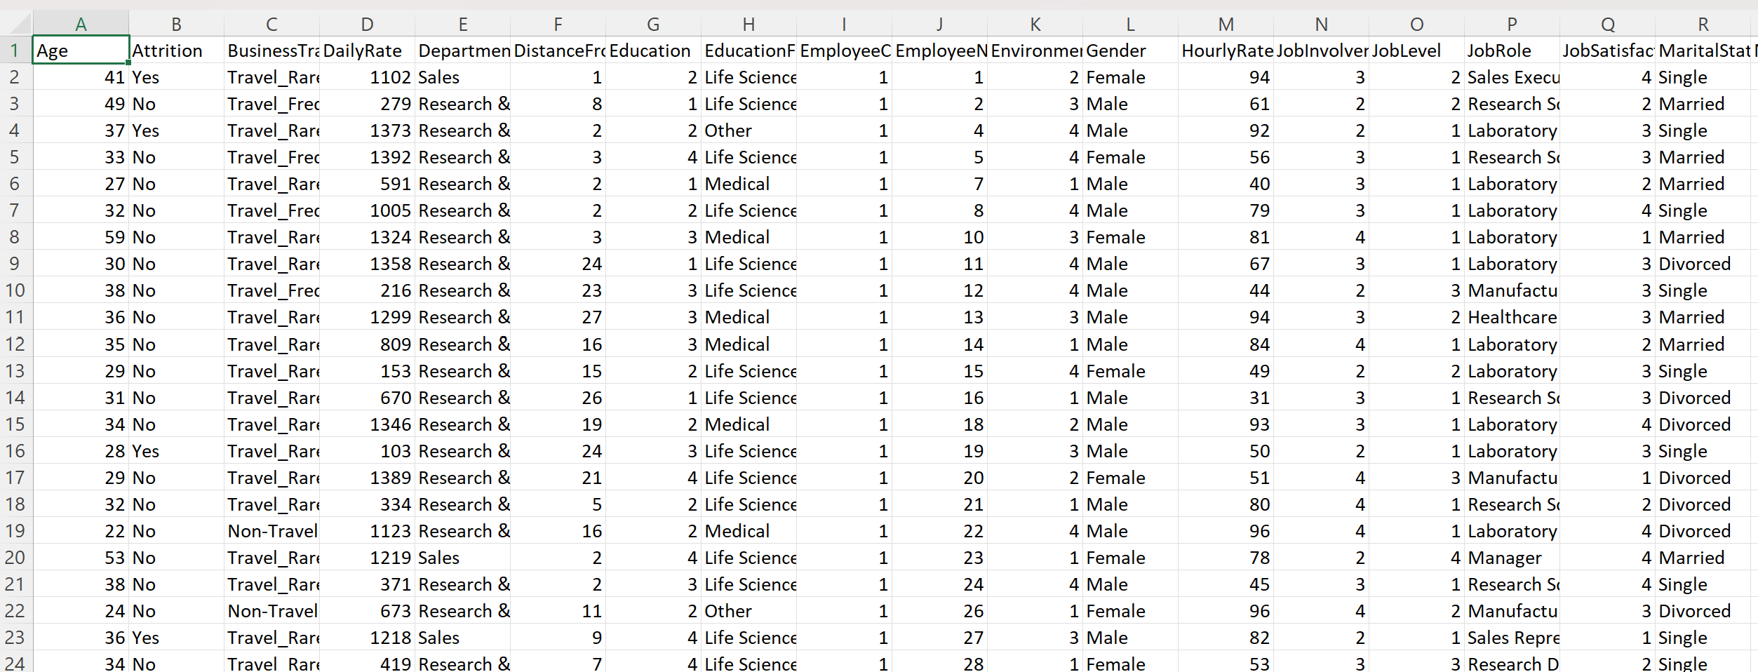
From the sci-kit learn library we imported train_test_split for model selection, LabelEncoder and StandardScaler for pre-processing of the data, our model (Logistic Regression / Decision Tree / SVM), and metrics like f1_score, roc_curve and auc. To add on, we make use of the matplotlib.pyplot library to draw the AUC-ROC curve for our better understanding.
Pre-processing is a crucial step for this project as real-world data is usually not clean, consistent, or immediately usable by models. In this case we encode the variable “Attrition” (Yes/No) as binary (1/0), drop irrelevant columns like EmployeeNumber, EmployeeCount, Over18 and StandardHours, and finish the pre-processing by encoding all the remaining categorical columns numerically using the LabelEncoder function.
Since we are also predicting the future salary of the employees, we add an increment column based on performance. 10% raise for rating 4 and 5% otherwise. We then compute the future salary by applying the raise to the MonthlyIncome column in our dataset. This simulates the income of each employee after they get a raise.
Further, we predict simulated future salary for employees likely to stay by using four models to ensure the best one. The models we use in this part are Random Forest Regressor, Ridge and Lasso regression, and SVR (Support Vector Regression). You might ask why we’re doing this when we already have the model to predict future salary. The reason is, in the previous part we used a fixed formula to generate a ground truth. In this part we train a regression model to learn patterns from those simulated values. This allows us to:
- Avoid using a hardcoded rule for salary prediction;
- Predict future salary flexibly based on features like performance, tenure, job level;
- Generalize to new employees without needing to reapply the simulation formula manually.
This enables downstream steps like estimating potential financial loss when an employee is at risk of leaving.
In the next step, we identify employees that are likely to stay in the company by using the attrition model’s predicted probability :
- P_leave = model.predict_proba(X)[i][1]
- P_stay = 1 – P_leave
We define a threshold, like in this case if P_stay is greater than 0.6, then we say that the employee is likely to stay. We then only predict future salary for these employees in order to understand how valuable they can be to the company.
Finally, we combine both classification and regression to answer the question : "If someone leaves, how much value (in ₹ or $) are we losing?". We make use of the following formulas :
For each employee: Expected loss(i) = P(attrition(i)) * FutureSalary(i)
Aggregate across all employees: Total expected loss = sum of expected loss for each employee
This tells us how valuable each employee that is likely to leave would be to the company and the total expected loss incurred. We finally have our answer.
Results generated :-
Part 1 (Attrition Prediction) :
After running the three models mentioned above, these were the results that showed up…
Logistic Regression :
AUC : 0.7713
F1 Score : 0.4746
AUC-ROC Curve
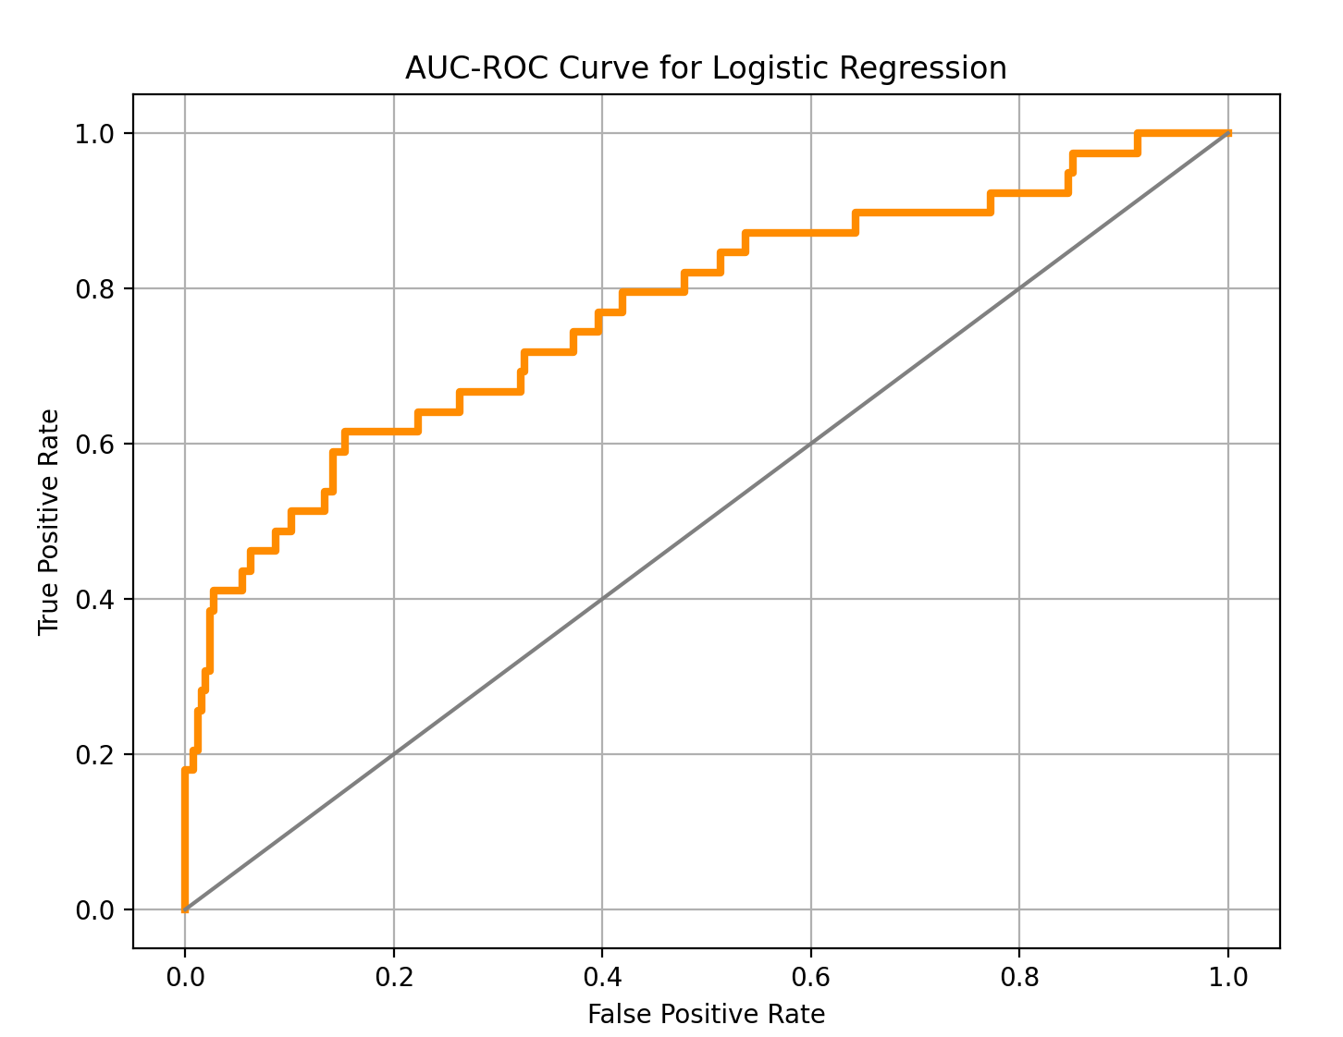

Decision Tree :
AUC : 0.532
F1 score : 0.1928
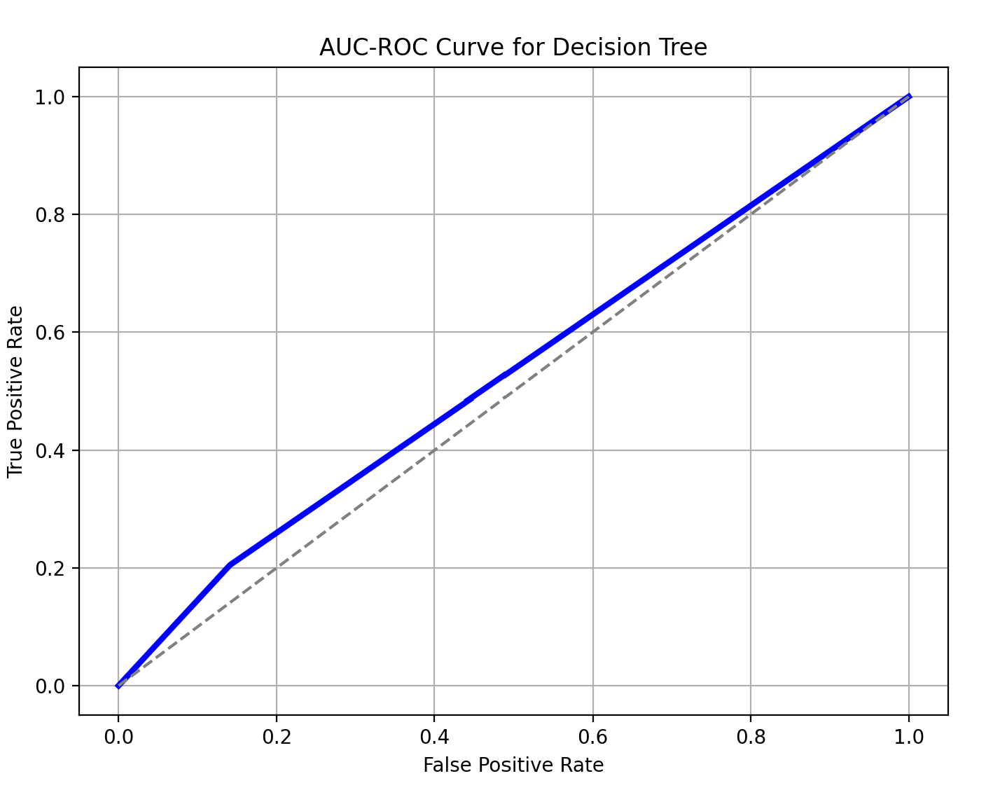
SVM :
AUC : 0.7822
F1 score : 0.4727
Accuracy : 0.9013
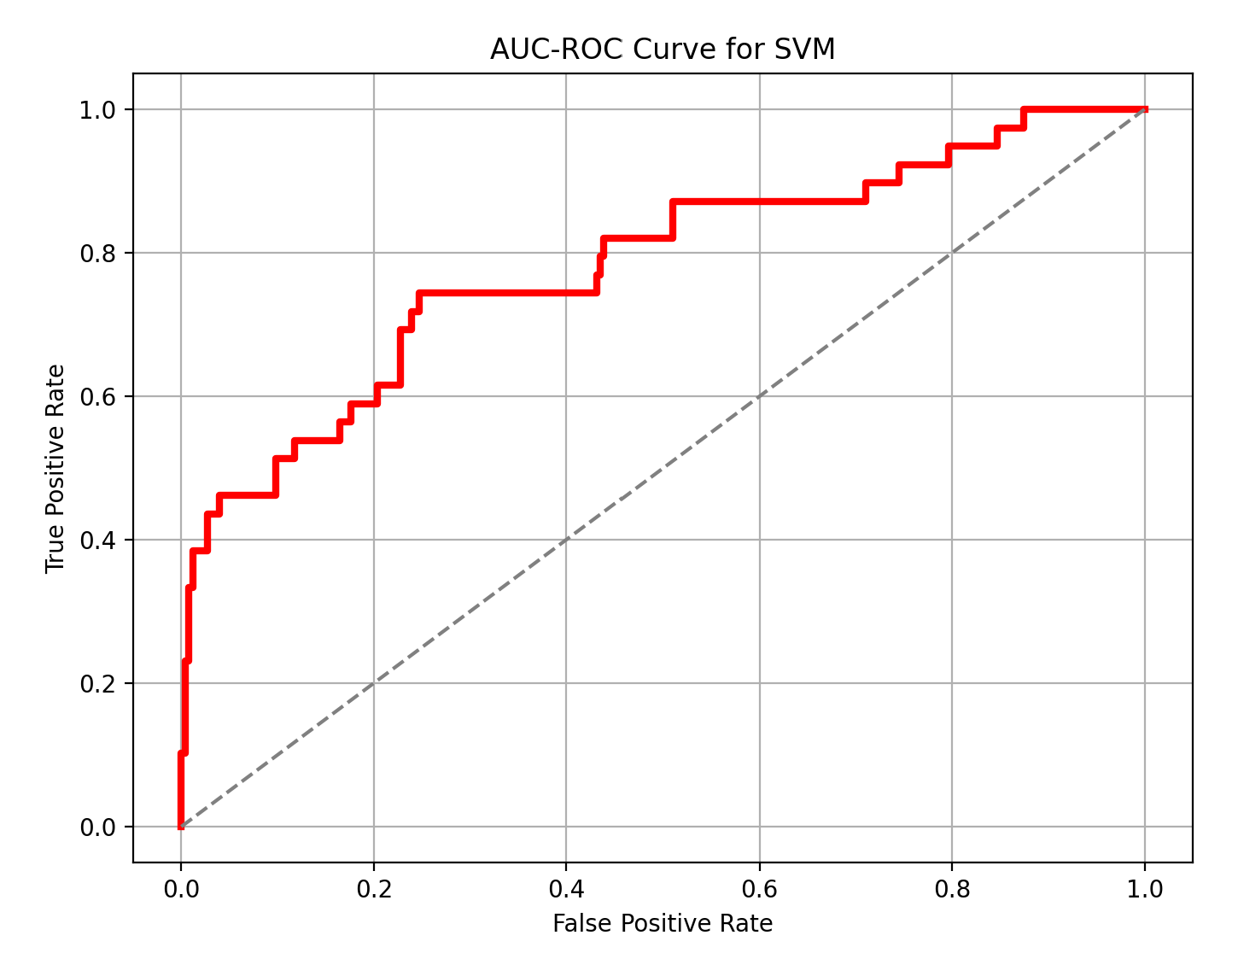
Part 2 :
Future salaries for the employees were generated :-
0 6292.65
1 5643.00
2 2194.50
3 3054.45
4 3641.40
...
1465 2699.55
1466 10490.55
1467 6756.20
1468 5659.50
1469 4624.20
Note : Index 0 is the first person, and there are 1470 employees in total.
Part 3 :
After running the four models mentioned above, these were the results…
Random Forest Regressor :-
R2 score : 0.9399
RMSE : 1239.18396
Lasso Regressor :-
R2 score : 0.9035
RMSE : 1570.3977
Ridge Regressor :-
R2 score : 0.90348
RMSE : 1570.5501
SVR :-
R2 score : -0.10879
RMSE : 5323.24
From Part 3, we concluded that the Random Forest Regressor model worked the best as it had the highest R2 score as well as the lowest RMSE, and so we used it for Part 4 and Part 5 as well, just to achieve better predictions and results.
Part 4 :
In this part, we found out the number of employees likely to stay and predicted their salaries.
There were 1233 employees that were likely to stay.
Part 5 :
The total expected loss, after adding up the expected loss for each employee that is unlikely to stay, was $1378389.14129.

Conclusion :-

As we worked on this project, we found some interesting points regarding it :
1. The SVM model worked the best for classification purposes with regards to accuracy and AUC parameters, however it had a pretty low F1-score which could indicate that many of the positive predictions were actually incorrect, or that the model missed many actual positives. These problems may arise due to factors like imbalanced datasets, model bias, over fitting and under fitting.
2. In terms of regression, the Random Forest Regressor performed the best and hence is a more reliable model than the others for performing regression on a dataset. This is far opposed to the results the Decision Tree model showed us, and it’s ironic how a Random Forest is multiple decision trees at once!
3. Certain limitations exist with these models as evident by the poor F1 score of the classification models despite having a decent AUC and accuracy. These could be fixed by implementing better models like XGBoost or LightGBM, or by tuning the thresholds.
This model was trained on historical data from a single department, which may limit generalizability across the company. Regardless of all the problems faced by the model currently, it remains a crucial step in highlighting the importance of integrating predictive models into HR planning to reduce potential attrition costs and improve workforce stability.

