International Information Technology University JSC

Faculty of Information Technology

Department of Information Systems

**The information system of booking and buying tickets.**

**for discipline «Fundamentals of information systems»**

**Amandyk Adilet**

**(Author)**

**Airline reservation system __________________________________________________________________**

**(TOPIC)**

**Almaty, 2022**

**«** **The information system of booking and buying tickets »**

**Aim of work** – create a system that allow an airline to sell their inventory (seats).

**1 INTRODUCTION**

The name of the program is “Airline reservation system”. Airline plans, fare tariffs, passenger reservations, and ticket data are all stored in the airline reservation system. Direct distribution is a function of an airline's reservation system that also pushes information to the GDS.

Consumers who utilize the Internet or mobile applications to self-book are part of another channel known as direct distribution. All communications are sent using a standardized messaging system that works with two types of messages that are transferred through the SITA high-level network, and travel agencies and other indirect distribution channels get access to the same GDS as airline booking systems (HLN). Type A [typically EDIFACT format] for real-time interactive communication and Type B [TTY] for informative and booking type communications are the two sorts of messages. The IATA and ICAO message building standards are worldwide in scope and apply to all modes of transportation.

Operating your own air ticket booking system is relatively expensive since air ticket booking systems are business-critical programs that are functionally highly complicated.

Prior to deregulation, airlines had their own reservation systems, which travel agents had to subscribe to. GDSs are now run by separate enterprises, with airlines and travel agents as their primary customers.

To accept common codes and interlines, booking systems can support airlines with "no tickets" and "hybrid" airlines that employ electronic tickets in addition to "no tickets."

Some airlines, in addition to these "standardized" GDS, have their own versions that they utilize to conduct their flights. Delta and Deltamatic operating systems, as well as SHARED EDS resources, are two examples. SITA Reservations continues to be the world's biggest neutral airline booking system with numerous hosts, with over 100 airlines now managing inventory.

**2 GENERAL INFORMATION**

**2.1 Full name of IS and its abbreviation**

Airline reservation systems (ARS) are software programs that enable airlines to sell their available tickets (seats). It has timetables and rates information, as well as a database of reservations (or passenger name records) and tickets issued (if applicable). Passenger service systems (PSS) include ARSs, which are apps that facilitate direct communication with passengers.

The Automated Reservation System (ARS) ultimately developed into the computer reservations system (CRS). A computer reservation system is used for a specific airline's bookings, and it interacts with a global distribution system (GDS), which allows travel agents and other distribution channels to make reservations for most major airlines through a single system.

ARS - airline reservation systems (system for booking flights)

PSS - passenger service systems

CRS - computer reservations system

GDS - global distribution system

**2.2 Information about developers and customers**

Developers: Amandyk Adilet

Customer's business: Sakenovich Marat

Contacts: 87766184143

Address: st. Koktem 3/20

**2.3 Project timelines**

11.02.2022 - 12.05.2022

**2.4 Funding**

Sponsor: Sakenovich Marat

**3 PURPOSE OF CREATING INFORMATION SYSTEM**

**3.1 Relevance**

The airline sector has become competitive due to a significant expansion in the number of airline operators. As a result, many businesses are on the lookout for a solution that may assist them in creating significant returns. As a result, the best choice for meeting these firms' dynamic expectations is to use an online airline booking engine.

A Flight Reservation System boosts an airline's revenue and offers it a competitive advantage. The fundamental motivation for using a flight reservation system is to increase the number of flight ticket bookings.

The integration of the Online Flight Reservation System with the website is quite simple. It is also quite simple to have a presence in the Google Play Store and the Apple App Store as a mobile application. As the number of smartphones grows tremendously, mobile apps are becoming increasingly popular.

**3.2 Use**

The areas of activity that use this IP are the aviation industry and websites related to the sale of online air tickets.

**3.3 Ideology**

Our IS will be developed in the form of a website where buyers can purchase/book flights online. The main difference from other IS that buyers will be able to see the status of their tickets.

**3.4 Formulation of the problem**

**Customers may make a mistake when entering their data before departure and have a desire to change this so as not to lose their money.**

**Information systems are designed with the end user in mind, who may or may not have advanced computer skills. As a result, information system client apps should have a clear, convenient, and easy-to-understand interface that gives the end user with all of the functionalities required for operation while also preventing him from performing any superfluous activities.**

**3.5 Formalization of the problem**

**If you make a mistake in at least one letter of your first or last name, you need to contact the airline before departure and eliminate the annoying oversight. We can set a minimum commission for such a problem or a certain period/deadline, after which customers will not be able to change the data and lose money.**

**Redesigning the user interface is essential if the interface is irrelevant and unclear.To resolve this issue, the website must be tested or the developer's credentials must be upgraded.**

**3.6 The goal**

The main goal is create a system that allow an airline to sell their inventory (seats). It contains information on schedules and fares and contains a database of reservations (or passenger name records) and of tickets issued (if applicable).

**3.7** **Objectives**

Are defined by set goal and represent concrete consecutive phases of research problem solution for main aim achievement.

Accordingly, for the creation of IS is necessary to understand the essence of the problem and implement the task of creating such IS.

Example:

* Analysis ….
* Development of model …
* Development of algorithm …
* Development of IS …
* Testing of IS …
* Debug of IS …

**3.8** **Advantages**

* 24/7 booking available for customers
* Increase Accuracy of system
* User-Friendly Interface
* Fully Customized
* Easy Cancellation Process
* Quality Images.
* Calendar.
* Admin panel as feature

**3.9** **Disadvantages**

* You need Internet access necessarily.
* Not all online booking systems are created equal.User-Friendly Interface
* Avoid booking systems that don’t bring you new quality customers.

**4 SOFTWARE REQUIREMENTS**

**4.1 Requirements for the structure and functioning of the IS**

**4.1. 1 Software technology used**

* **HTML5**
* **CSS3**
* **Laravel**
* **MySQL**
* **UI**

**4.1.2 IS model**

Model - a simplified representation of reality. A reduced version of reality is referred to as a model. A model is a representation of the system that might be either a comprehensive blueprint. At this level of abstraction, a good model always contains components that have a major impact on the outcome and excludes those that don't. Each system may be characterized from several points of view, which are then applied to various models, resulting in a closed semantic abstraction system. The model might be structural, focusing on the system's organization, or behavioral, reflecting the system's dynamics.

We may use models to show how the system should be structured and behave. They're also required for visualizing and managing the architecture.

**4.1.2.1 Selection of the model**

Management model - a model is an abstraction of something it represents (some phenomenon), called an entity. For example, if a model represents a firm, then the firm is an entity.

**4.1.2.2 Justification of the model chosen**

* Can be a learning experience.
* Provides predictive power.
* Less expensive than trial and error method.
* Speed allows consideration of more options.

**4.1.2.3 Construction of the general model**

Booking information system

Administrative system

Client system

Timing system

Send message, feedback

Choose,book seats

Manage access system

Search flights

Flight service

**4.1.3 IS Architecture**



Client (pc3)

Client (pc2)

Client (pc1)

**INTERNET**

**Laravel/MySQL**

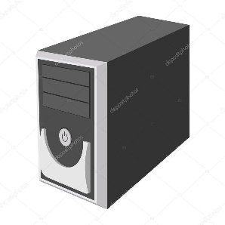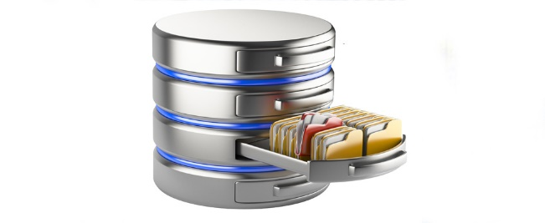

Сhange the destination

Modify flight schedule

Add new seats for booking

Manage access to admin pannel

**4.1.4 Information support requirements**

* The volume of text – 255 symbols.
* The volume of images – 5-10 mb

**4.1.5 Software requirements**

* Microsoft VS 2015
* Sql Server Database Server 2008
* Sql server management studio 2008

**4.1.6 Requirements to the construction of the algorithm**

**4.1.6.1 Structure of databases**

It is necessary to represent the structure of a database as a data logic model. Data logic model (physical model) - a model consisting of tables and relationships between us.

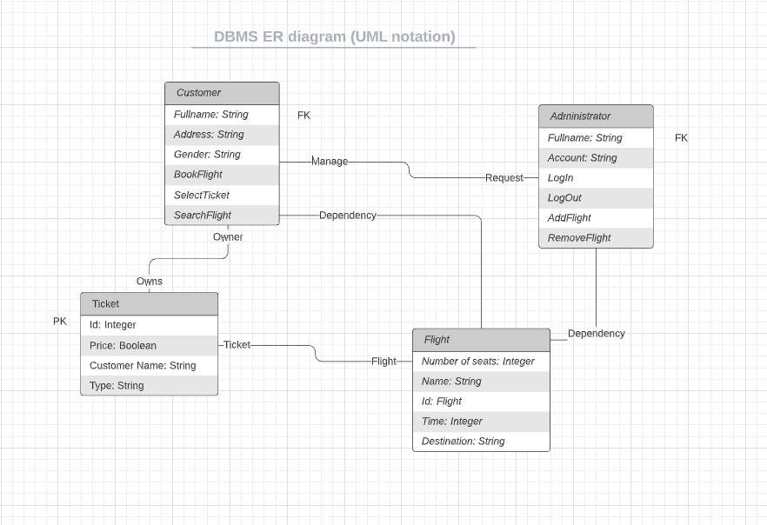

**4.1.6.2 Data Access Technology**

ODBC- This program interfaces (API) in C applications to connect to different databases. When you connect using ODBC application becomes independent of the data source used (and used by the DBMS). Independence implemented using intermediate libraries, which include specific code for a given database, and which provide a uniform interface for ODBC-applications. These libraries are called ODBC-driver, and usually provide database developers themselves.

OLE DB - hybrid ODBC, COM, that is, to access the data it uses no API in the language C, while COM-interfaces. That is, this technology provides an object-oriented interface for any programming language compatible with COM, and not only for the Visual C ++.

RDO- (Remote Data Objects - remote data objects). DAO - this Data Access Objects (Data Access Objects). Initially, this technology was created as a COM-interface to the database Jet, which lets you work with Microsoft Access databases, and any for which there were drivers ODBC. ADO- ActiveX Data Object (ActiveX-objects for data access). It should be noted that this is one of the most popular (after ODBC) technology developed in this field by Microsoft.

ADO- ActiveX Data Object (ActiveX-objects for data access). It should be noted that this is one of the most popular (after ODBC) technology developed in this field by Microsoft. In fact, ADO - it's just another add-on already existing technologies all the same corporation. It uses ActiveX-component is an add-on API OLE DB, which in itself, in general, not so convenient to use. ADO, of course, introduces an additional level that affects the application performance, but it is so well reflected in the design-time, the technology is much more popular than, in fact, OLE DB. Another plus it - the ability to use objects to access data from scripting languages such as VBScript or Jscript. Here an important role is played by the possibility of its use for programming in ASP to develop web-based applications.

ADO.NET - A new generation of facilities for working with data, where instead of ActiveX-components are used components of .NET. MDAC- Microsoft Data Access Components (Data Access Components Corporation Microsoft) - is the common name ODBC, OLE DB and ADO. Or, to be precise, it is a set of libraries that provide job listings technologies.

**4.1.6.3 Requirements to the user data queries from the database**

Show the list of booked/general seats

Show the list of cities

Show the list of arrival / departure time

Show the list of information about us

Show the list of our contacts

**4.1.6.4 Requirements to the source code/programming languages**

* User Interface
* Database about flights, reservations, and user details
* Searching flights for specific dates
* Searching flights multiple destinations
* Manually entering names of destinations (by city, country)
* Specifying number of passengers while searching (adults, children)
* Communication interface with HTTP protocol :
* HTML5
* CSS3
* Laravel
* MySQL
* UI
* VS

**4.1.6.5 Modern theories and methods of IS development**

Select and justify the method of software development. The most important methods of software development - is the PLO and algorithmic (traditional) methods. In the first case, as the basic building block appears or object class. In the most general sense of the object - an entity that is usually extracted from the vocabulary domain or solutions, and the class is a description of the set of similar objects. Each object has its identity (which can be specified or somehow different to distinguish from other objects), state (usually associated with the object are some data) and behavior (with it you can do something or he might have something to do with other objects). In the second case, the basic building block is a procedure or function, and attention is given primarily on the transfer of control and decomposition algorithms larger to smaller. Nothing wrong with that, except for the fact that the system is not too easy to adapt. When requirements change or increase the size of the application (which happens often) to accompany them becomes more difficult.

**4.1.7 OS requirements**

ARS should be a web-based system. It should be possible to open and use the website on the computers with operating systems of Microsoft 7, Microsoft 8, Microsoft 10, Mac Os, Linux, Ubuntu.

**4.1.8. Construction of the algorithm**

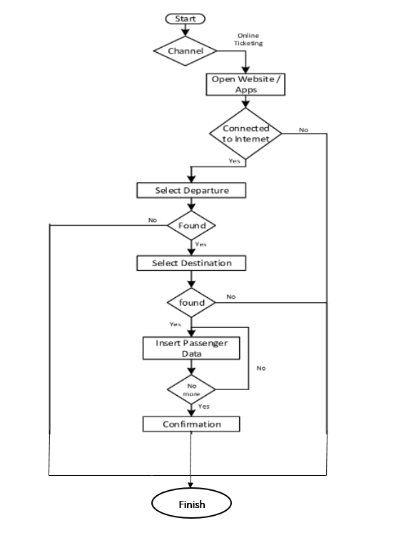

**4.2. Reliability requirements:**

* Use a strong password
* Store user sensitive data in secure database

**4.3. IS Security**

**4.3.1. Copyright protection**

**Copyright certificate and the author’s contact information form.**

1. When making a Reservation, you accept these Terms and any other conditions provided to you during the booking process.

2. If any provision in these Terms is (or becomes) invalid or inapplicable:

It will continue to be applied to the maximum extent permitted by law.;

you will continue to be subject to all other provisions of the Terms.

3. The English version of these Terms is the original. In case of disagreement regarding the Terms or any discrepancy between the Terms in English and other languages, the Terms in English will apply. (You can change the language at the top of this page.)

Contacts: 87766184143

Email: ars_08@gmail.com

Address: st. Koktem 3/20

**4.3.2. Protection of information**

**4.3.2.1. Methods of protection**

* Keep your Software Up-to-Date.
* Enforce a Strong Password Policy.
* Encrypt your Login Pages.
* Use a Secure Host.
* Keep your Website Clean.
* Backup your Data.
* Scan your Website for Vulnerabilities.

**4.3.2.2. Protection algorithm**

* Best way is to take a backup on an external drive and give it for servicing. Else you can create a partition,transfer all data into it and password protect it using BITLOCKER or other Utilities.
* An encryption algorithm is a mathematical procedure used to encrypt data. Through the use of an algorithm and a key, information is encoded into cipher text and requires the use of a 'key' to transform the data back into its original form.
* The IS will initially identify the sort of attack when it detects malware. The threat is then followed by action.

**4.3.2.3. Anti-virus Protection**

Microsoft Defender Antivirus

**4.3.2.4. Protection against attacks**

Installing spam filters and anti-malware software.

Deploying Next-Generation Firewalls (NGFW)

Installing endpoint detection & response (EDR)

**4.3.2.5. Protection against hacking**

Antivirus programs such as Bitdefender, Panda Free Antivirus, Malwarebytes and Avast protect your computer against unauthorized code or software that may threaten your operating system.

**4.4 Requirements for exploitation**

**4.4.1 Exploitation conditions**

**4.4.1.1 Climatic conditions of exploitation**

The direction and strength of the wind most affect the duration of the flight. Because of this, we calculate all possible weather conditions in advance and if the weather is non-flying, we will definitely inform our customers. And in general, our story works in any weather, even if there is a wind outside, even a blizzard.

**4.4.1.2 Requirements to employees qualification and number**

List of minimum requirements to the qualification and number of employees.

* Work experience – at least 2 years
* Skills (communication, accuracy, knowledge of languages python, php, laravel, sql etc)
* Education level and type (bachelor or master degree)
* Professional licenses, accreditations and certifications.(ielts 7+)
* Languages.(kazakh, russian, english, turkish)
* number of employees.= minimum 3 employees

**4.4.2 Help manual development**

##### Identify the users. ...

##### Focus on the problem. ...

##### Use sequential steps in order. ...

##### Map user journey. ...

##### Choose a Template. ...

##### Write simple and easy to follow content. ...

##### Treat all users as laymen. ...

##### Test instructions alongside the product using naive users.

##### 

**4.5 Technical requirements:**

**4.5.1 The recommended monitor resolution range at which software will be viewed is**

1366*768/1920*1080

**4.5.2 The minimal monitor resolution range at which software will be viewed**

640*480/600*800 and less.

**4.5.3 Recommended PC configuration**

2 GHz Processor, 1 GB RAM, 512MB Video Card, 120 GB HDD, a CD-ROM or USB-port

**4.5.4 Minimal PC configuration**

1 GHz Processor, 512MB RAM, 100MB available HDD, 16 MB Video Card, and a CD-ROM or USB-port

**4.6. Non-Technical requirements to IS:**

**4.6.1 Adaptability**

- adaptation of the software system to changing environmental parameters (adaptation of changes)

For example, an information system can adapt to the computer and the user depending on personal needs.

Our website will be adaptive, meaning customers with smaller or larger gadgets will be able to open and view what's inside.

Adaptive works to determine the screen size and load the appropriate layout for it — usually you develop an adaptive site for six common screen widths:

320

480

760

960

1200

1600.

At first glance, it seems that adaptability requires more work, since you need to develop layouts for at least six width values. However, responsiveness can be more difficult, since improper use of media queries (or not using them at all) can lead to display and performance problems.

**4.6.2 Intellectual development**

Any information system that solves an intellectual problem or uses artificial intelligence methods refers to intellectual IS. But our product will not solve some problems which connect with the user knowledge.

**4.6.3 Consistency**

Does the software at the system level? NO Is the software system? NO, IT IS Web-based airline reservations and ticketing system.

**4.6.4 Full functionality**

The functionality of the system is presented in the diagram of use cases

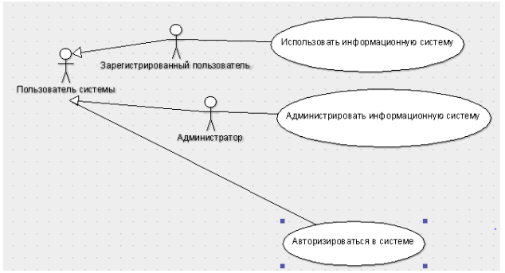

*Use case diagram*

The use case diagram shows the relationship between actors and use cases, describing the system at a conceptual level. In this case, there are three actors: the system user, the registered user and the administrator, and the generalization relation was used to prevent duplication of information. The diagram also shows three use cases - administer the information system, use the information system and log in to the system. They relate to the administrator, the registered user and the system user, respectively.

2nd figure shows the decomposition of the user authorization precedent.

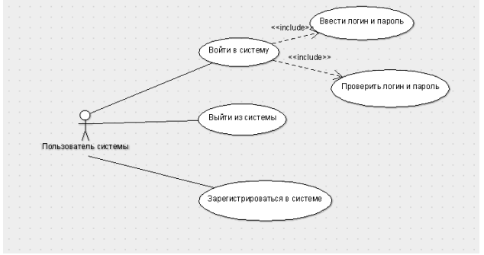

*Log in to the system*

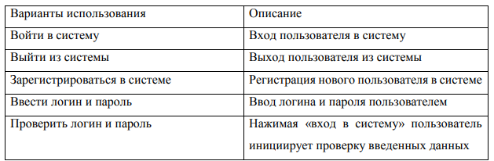

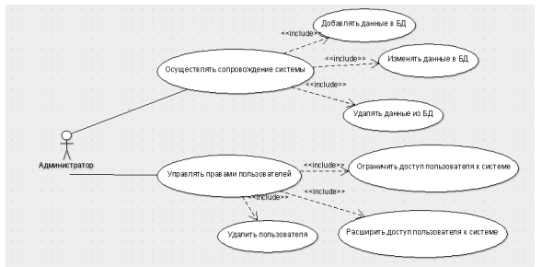

*Decomposition of the use case "Administer the information system"*

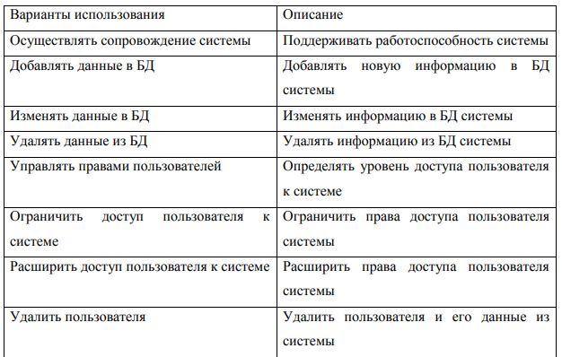

During the analysis of the functionality, a diagram of the use of the information system for the sale of air tickets and its decomposition were presented, as well as the main precedents and actors were described.

**4.6.5 Integrity**

Physical components can be files, libraries, modules, executables, packages, etc. Components are linked through dependencies when the required interface of one component is connected to the existing interface of another component. Thus, the client-source relationship between the two components is illustrated. Dependency shows that one component provides the service needed by another component.

**4.6.6 Quality**

Software quality - the ability of software to confirm its specification, provided that the specification is focused on characteristics that the user wants to receive.

Factor of quality assurance - a non-functional requirements of the program, which is usually not described in the contract with the customer, but, nevertheless, it is desirable requirement, which increases the quality of the program.

**4.6.6.1 Functionality**

Based on the use case diagrams, the following screen forms have been developed:

* authorization form to log in to the system;
* registration form for entering the data of a new user into
* the database;
* flight and ticket information search form;
* form for booking a ticket;
* information system administration form available
* to users of the "Administrator" group;
* the "Personal Account" form, available
* to users of the "Regular User" group.

**4.6.6.2 Reliability**

How to check if our site is secure

1. Secure URL

2. Good appearance of the site

3. Contact information is available

**4.6.6.3 Ease of application**

Our product is fully attractive and easy to use

**4.6.6.4 Effectivity**

A website becomes effective after it recoups the financial costs of its development and becomes a stable source of income. Evaluation of the effectiveness of the site is periodically necessary for any project, because search engine technologies are constantly developing, due to which ranking algorithms and other indicators that affect traffic and other indicators of the quality of the site can vary.

**4.6.6.5 Maintainability**

Оur product is unremountable because in this case it will require a lot of time and costs

**4.6.6.6 Possibility to learn**

Аs we said earlier, the product is fast adaptive

**4.6.6.7 Modifiability**

Extensibility, structuring, modularity.

**4.6.6.8 Mobility**

Adaptive layout helps to do without developing a separate mobile version. This has advantages:

* We don't need a separate page structure to display on mobile devices. It is enough to correct the desktop version of the site using CSS.
* A single URL is used for the desktop and mobile versions. Therefore, the content of the site is not duplicated, the pages do not compete with each other, and the promotion work affects the ranking in desktop and mobile searches.

The mobile version is a more expensive and flexible solution. It can be edited without affecting the main site. This gives advantages:

* A mobile website can be made as easy and faster as possible by removing unnecessary functionality at the code level.
* The interface can be improved for mobile users by adding functionality that was not available on the desktop version of the site.
* The user can always switch to the main version of the site on a mobile device if he wants.

We choose the adaptive one.

**4.6.6.9 Finiteness**

The inverse of the frequency of failures.

**4.6.10 Accuracy**

The ability to give the desired results (e.g., with a certain confidence interval)

**4.6.6.11 Autonomy**

Property that characterizes the ability of the PC to perform intended functions without help or support other software component

Software. In our case It means not always knowing the status of tasks, where difficulties are and when they'll be done. It makes coordination and future planning difficult. Also reporting is affected by that. So currently I'm thinking that high autonomy makes the team lead's job is more difficult with the long-term reward of a faster team

**4.6.6.12 Stability**

We will testing our software system’s stability .Stability Testing is a type of Software Testing to check the quality and behavior of the software in different environmental parameters. It is defined as the ability of the product to continue to function over time without failure.16 мая 2019 г.

**4.6.6.13 Security**

Everything will be secured by appropriate instructions from Oracle Secure Coding

-Denial of Service.

-Confidential Information.

-Injection and Inclusion.

-Accessibility and Extensibility.

-Input Validation.

-Mutability.

-Object Construction.

-Serialization and Deserialization.

**4.6.6.14 P-documentation**

Transform and digitize your file-heavy IP processes with **First to File** – the only document management system designed specifically for the IP industry.

Easy to use, First to File provides administrative relief almost immediately, allowing you to automate the storage, transfer, and management of IP documents worldwide, paperlessly.

1. All IP documentation in one place
2. Increase efficiency and collaboration
3. Paperless and cost friendly

**4.6.6.15 Informational content**

The property is characterized by the presence in the composition according to the information necessary and sufficient for understanding the purpose of the SS, the assumptions made, the existing limitations, the input data and the results of the individual components, as well as the current state of the program in the course of their operation.The information content of the main page will be to book a ticket such as departure, arrival, time, flight class, ticket purchase

**4.6.6.16 Sociability**

It is believed that communication skills are important for the success of social software. Shortly after the opening of the beta versions of the software, we will conduct a study. The purpose of this study is to identify factors influencing users' perceptions of sociability in social software, and to study the effect of sociability on users' attitudes and behavior intentions. The pilot study will survey 35 web users to understand how they use social software to complement their social lives and to explore possible factors influencing users' use of social software.

**4.6.6.17 Time efficiency**

By integrating the time efficiency, software departments become more connected and are able to communicate and share data better. Integrating your company's software applications can save time by improving communication throughout your organization and making workflows and employees more efficient and productive.

**4.6.6.18 The effectiveness of memory**

By attaching memory usage information to static or lightweight program features, compilers and runtime systems can generate fine-grained guidance without additional efforts from users or developers. Recent works have employed this approach with some success, but it is not clear which program features are most useful for guiding data management.

**4.6.6.19 Efficiency devices**

If we want to add even more efficiency we can do it by making small changes to the application code, it can be made suitable for compilation, after which it can be run more (energy-)efficiently. Modern development toolkits make it possible to create astonishing user interfaces, full of graphics, animations, assisted editing, suggestions for further navigation, etc.

**4.6.6.20 C-documentation**

We will use the documentation on all C syntax and built-in functions from https://devdocs.io/c/ for this, which seems to be the definitive official source of knowledge about the C standard.

**4.6.6.21 Intelligibility**

Due to the increased requirements for software intelligibility, there is a huge need for such design software. To do this, we will use Intelligibility Software, powered by EASE's proven professional sound design technology, scaled specifically for life safety professionals, so design is fast and accurate. intuitive.

**4.6.6.22 Structured**

Our structured programming software encourages dividing an application program into a hierarchy of modules or autonomous elements, which may, in turn, contain other such elements. Within each element, code may be further structured using blocks of related logic designed to improve readability and maintainability.

**4.6.6.23 Readability**

Readability in software programming can be defined by the ease with which the software is read and understood. Readability of software can be somewhat objective.

Our readable source code facilitates the reading and understanding of the abstraction phases and as a result, facilitates the evolution of the codebase. Readable code saves future developers' time and effort

**4.6.6.24 Extensibility**

In software engineering, extensibility is defined as “the quality of being designed to allow the addition of new capabilities or functionality.” It is a measure of the ability to extend a system and the level of effort required to implement the extensions. It will be organizing in our project

**4.6.6.25 Modularity**

Software modularity is the decomposition of a program into smaller programs with standardized interfaces. We will use microservices ,Microservices is a hot trend right now, and it's essentially about small modules that are built into a whole software system. **4.6.6.26 Regardless of the device**

Our software system will work on all possible devices above IOS 10.1+ , android 7.0.2+ ,windows 7+ and macOS 12.1

**5 PSYCHOLOGICAL FEATURES**

**5.1.1 Aesthetic look-** It will base on clean, concise, schematic images without unnecessary detail

**5.1.2 Choice of style-** Modern flat-

**5.1.3 Color solution-** The main colors will be 3 pieces - red, black, pink. But there we can use other colors

**5.2 Location of interface elements**

Graphically display will look like a form (window) and thus justify the location of each element on the form in terms of functionality and convenience.

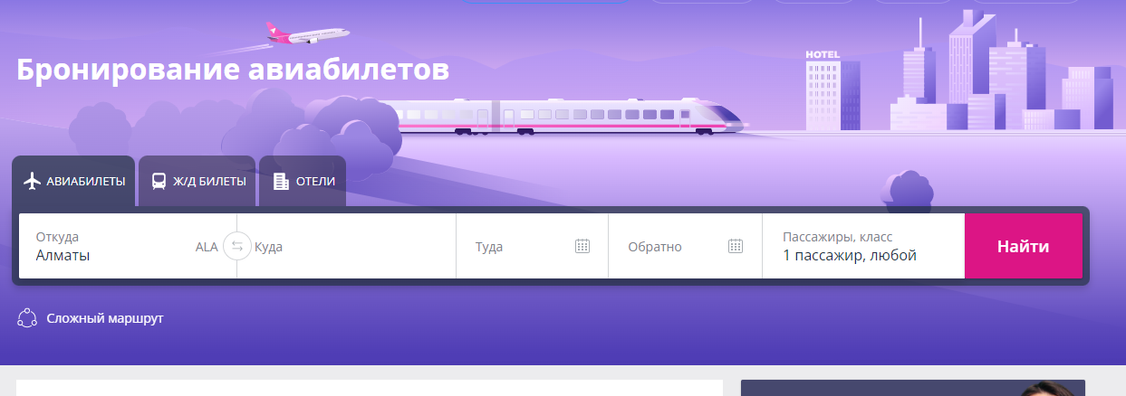

Picture 4 – The system interface ATM

**5.3 Ergonomics**

Friendliness, nice interface, "soft" error messages: "Welcome!", "Are you sure you want to log out?", "Customer support chat" are related to ergonomics.

**5.4 Target audience**

**5.4.1 Age of users-** All except minors or minors with parental permission

**5.4.2 Their mood, temperament, etc.-** Any, except for those who disturb with the environment with their behavior