OS Hardening Practices (Kali Linux)
Operating System hardening refers to the process of securing an operating system by reducing its attack surface and minimizing potential security risks. The following practices were implemented and reviewed on a Kali Linux system.

1. Keep the Operating System Updated
Regular system updates ensure that known vulnerabilities and security flaws are patched.

Implementation:
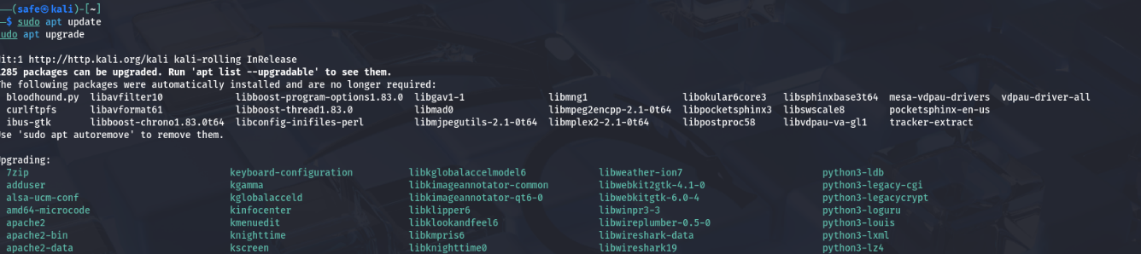

Keeping the operating system up to date helps protect the system from known exploits and improves overall stability.

2. Use Strong Passwords
Strong passwords help protect user accounts from brute-force and credential-based attacks.

Implementation:
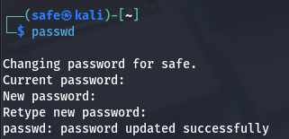

Users should use complex passwords that include a combination of uppercase letters, lowercase letters, numbers, and special characters.

3. Disable Unnecessary Services
Unnecessary services increase the system’s attack surface and may expose unused network ports.

Implementation:
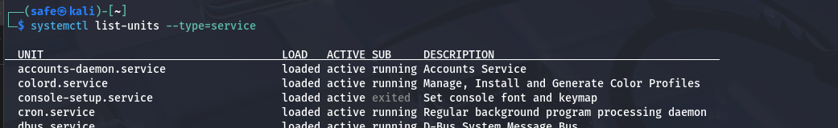

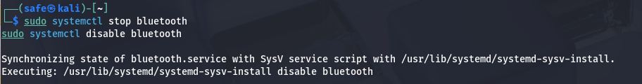

Disabling unused services reduces potential entry points for attackers.

4. Enable Firewall

A firewall controls incoming and outgoing network traffic and blocks unauthorized access.

Implementation:
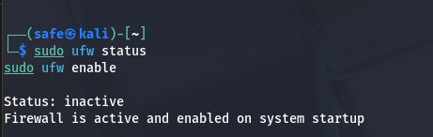

5. Apply the Principle of Least Privilege

The principle of least privilege ensures that users are granted only the minimum permissions required to perform their tasks.

Implementation:
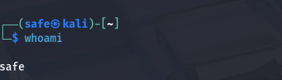

Administrative privileges should be used only when necessary to reduce the impact of potential compromises.

6. Monitor System Logs Regularly

System logs provide valuable information about authentication attempts, system errors, and suspicious activities.

Implementation:

Regular log monitoring helps in early detection of security incidents.

Conclusion

Applying OS hardening practices such as updating the system, enforcing strong passwords, disabling unnecessary services, enabling a firewall, following the least privilege principle, and monitoring logs significantly improves the security posture of the operating system. These measures help reduce risks and protect the system against common threats.

