Network Traffic Analysis Report
Name: Adil Firoz
Internship: Cyber Security Internship
Task: Task 3 – Networking Basics
Tool Used: Wireshark
Date: 19-01-2026

1. Introduction
The objective of this task is to understand basic networking concepts and analyze live network traffic using Wireshark. In this task, different network protocols such as TCP, DNS, HTTP, and HTTPS were captured and analyzed.

The main goals of this analysis were:
- To capture live network traffic
- To filter packets by different protocols
- To observe the TCP three-way handshake
- To identify plain-text and encrypted traffic
- To analyze DNS queries

2. Tools and Environment
The following tools and environment were used in this task:
- Operating System: Kali Linux
- Packet Capturing Tool: Wireshark
- Network Interface: eth0
- Capture File Format: .pcapng

Screenshot
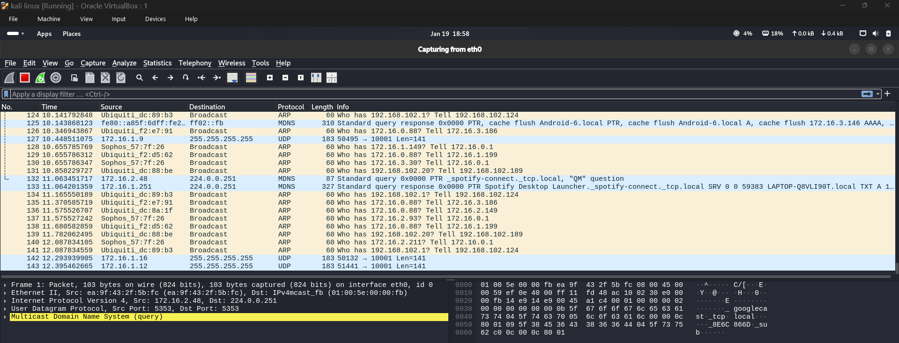
Figure 1: Wireshark interface with eth0 selected for capture
3. Traffic Capture Process
Wireshark was launched and the eth0 network interface was selected. Live packet capture was started and basic browsing activity was performed, such as opening websites in the browser.
The captured packets were then saved for further analysis.
Screenshot
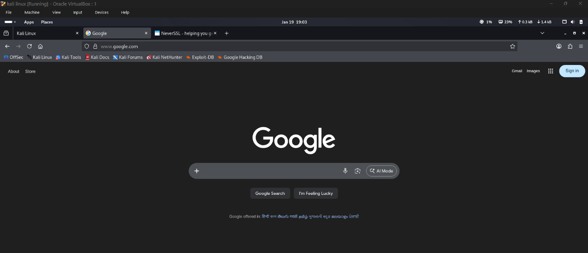

4. TCP Three-Way Handshake Analysis
The TCP three-way handshake was analyzed to understand how a TCP connection is established.

The handshake consists of three steps:
1. The client sends a SYN packet to initiate the connection.
2. The server responds with a SYN-ACK packet.
3. The client sends an ACK packet to confirm the connection.
This process successfully establishes a reliable TCP connection between the client and the server.
Screenshot showing:
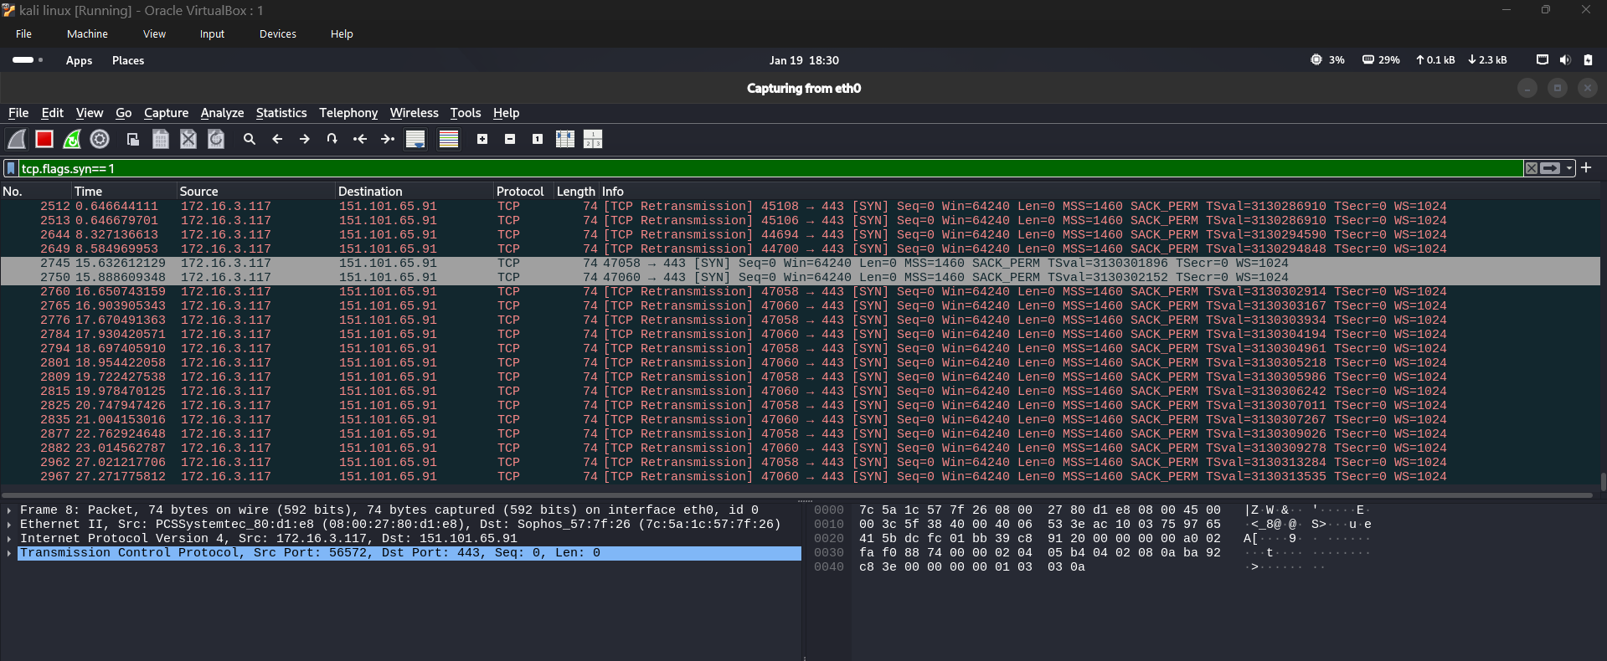
OR
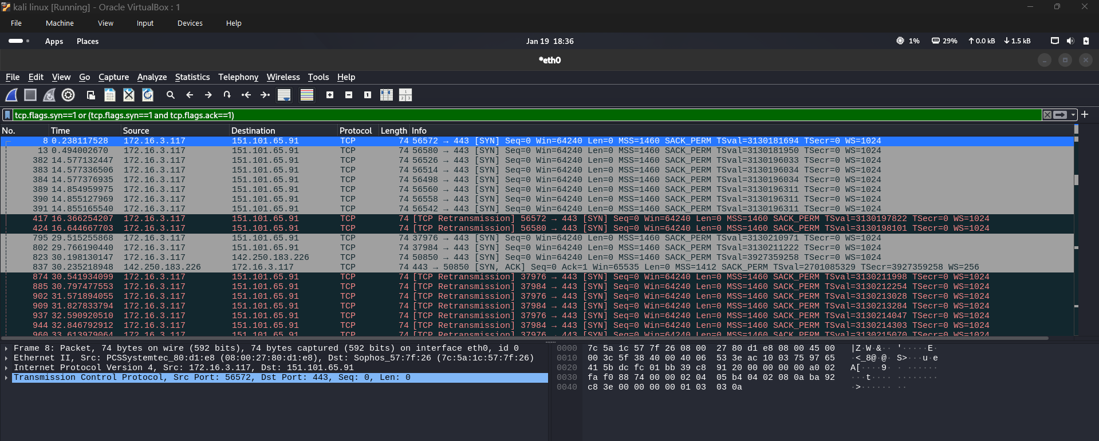
Figure 3: SYN and SYN-ACK packets observed during TCP handshake

5. DNS Analysis:
DNS packets were filtered using the filter "dns". DNS queries and responses were captured to observe how domain names are resolved into IP addresses.
Queries such as ads.mozilla.org and firefox.settings.services.mozilla.com were observed along with their corresponding responses.
Screenshot showing:
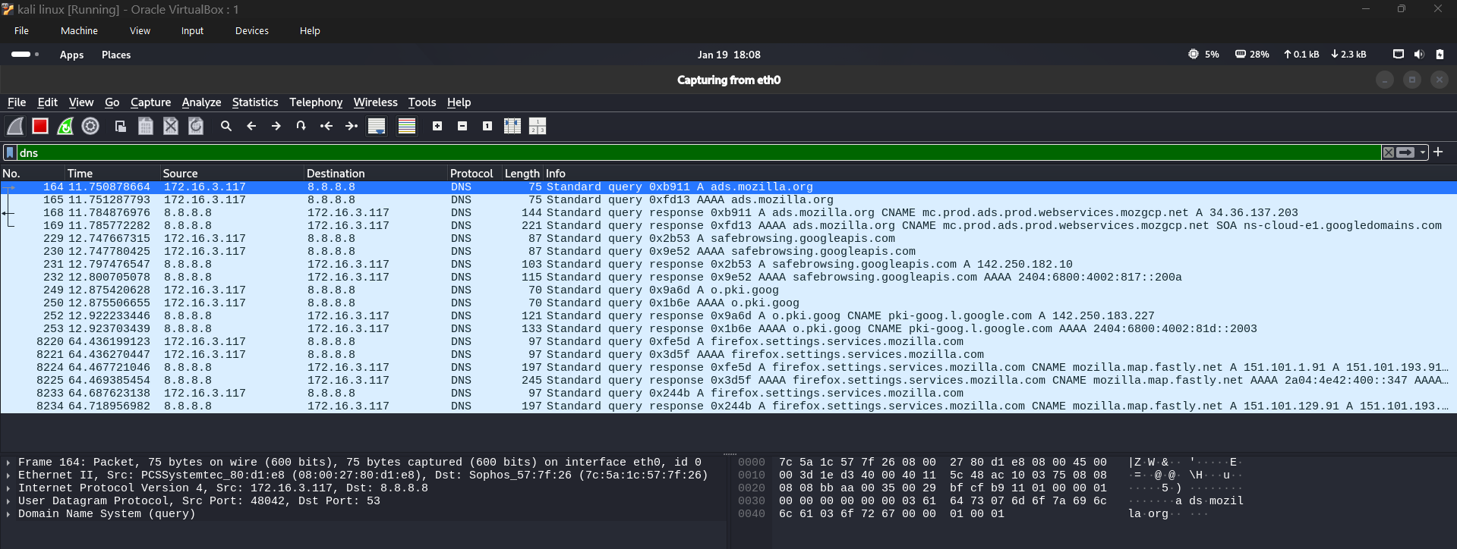
Figure 5: DNS query and response observed in Wireshark
6. HTTP (Plain-text) Traffic Analysis
HTTP traffic was analyzed using the filter "http". It was observed that HTTP transmits data in plain text and the request details were clearly readable.
This demonstrates that HTTP does not provide encryption and is not secure for sensitive communication.
Screenshot showing:
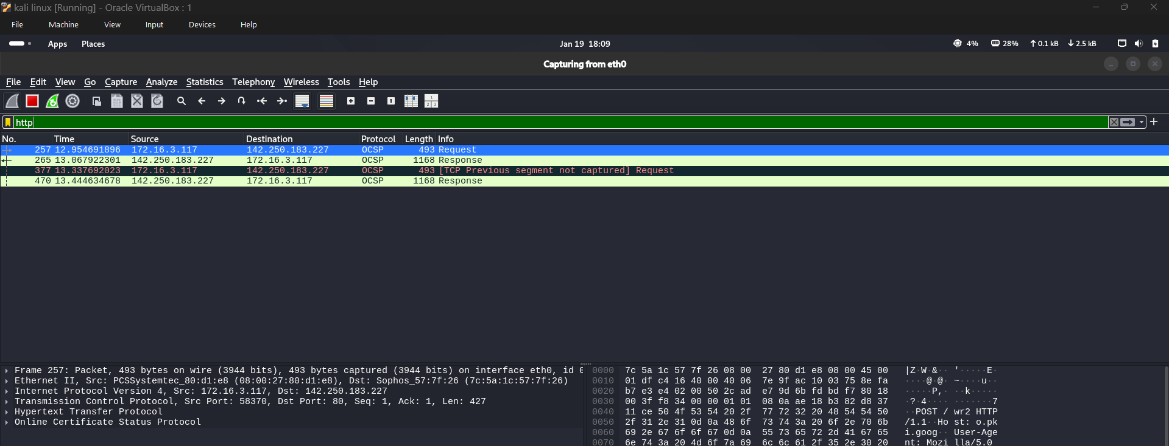
Figure 6: Plain-text HTTP traffic observed in Wireshark

7. TLS (Encrypted Traffic) Analysis
Encrypted traffic was analyzed using the filter "tls". TLSv1.2 and TLSv1.3 packets were observed.
Unlike HTTP, HTTPS encrypts the data, making the content unreadable and protecting it from attackers.
Screenshot showing:
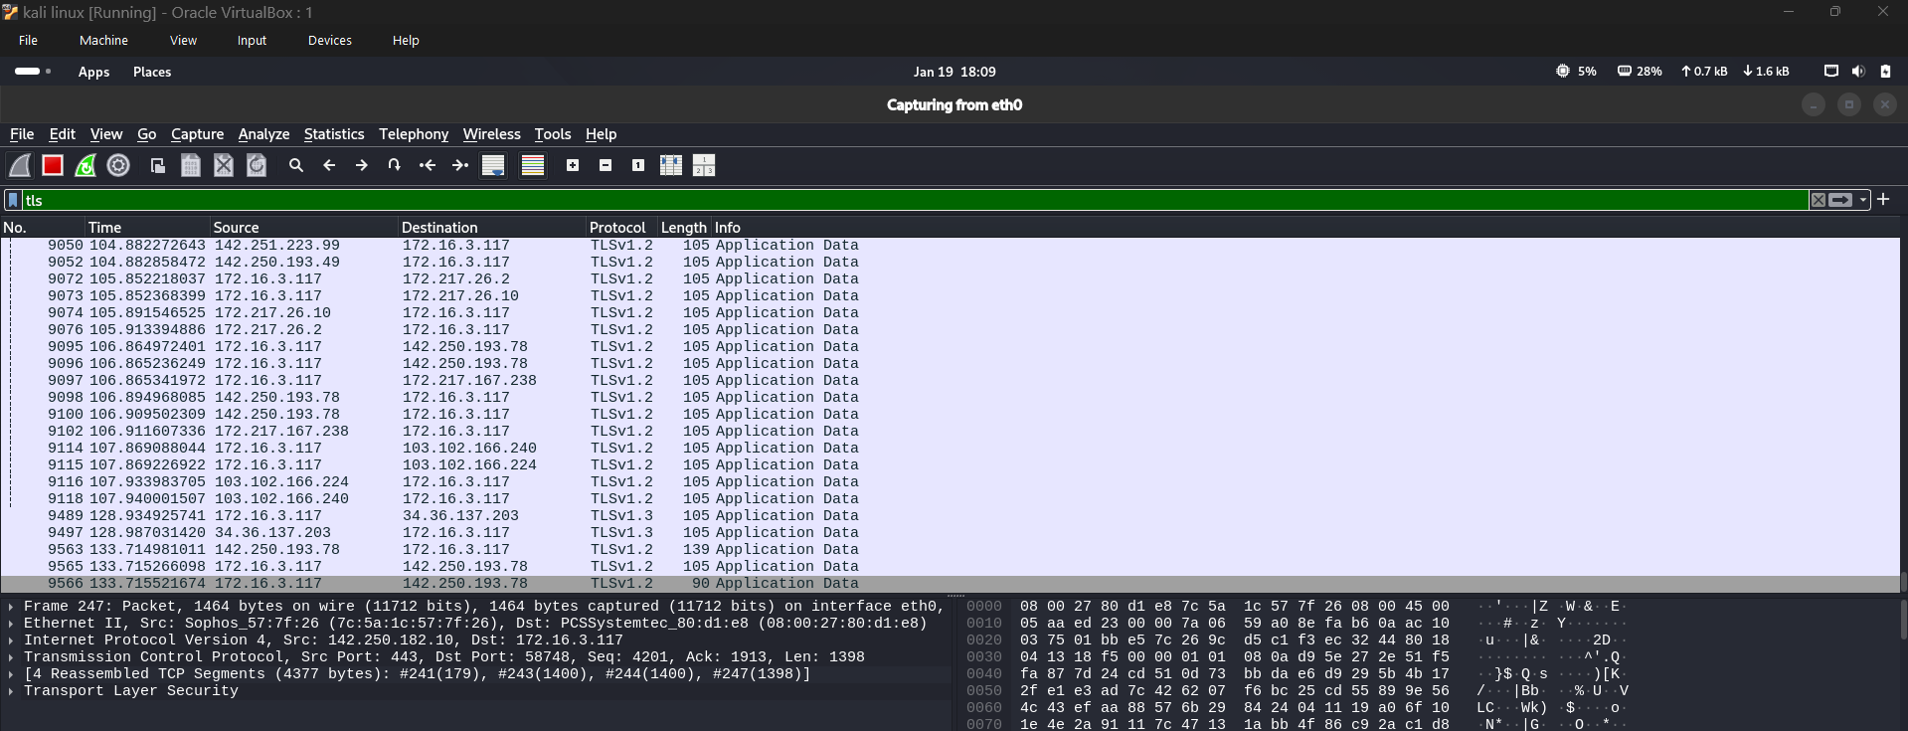
Figure 7: Encrypted HTTPS (TLS) traffic observed in Wireshark
8. Observations
The following key observations were made during the analysis:
- TCP connections are established using a three-way handshake
- DNS resolves domain names into IP addresses
- HTTP transmits data in plain text
- HTTPS encrypts data using TLS
- Packet filtering helps analyze specific protocols efficiently
9. Conclusion
This task provided hands-on experience in capturing and analyzing live network traffic using Wireshark. By analyzing TCP, DNS, HTTP, and HTTPS traffic, a clear understanding of basic networking concepts was developed.
This analysis builds a strong foundation for future network security and traffic monitoring tasks.

