Developer Guidelines 

Here at KentSoft we have specific developer guidelines that we expect all our developers to adhere to. We have implemented these procedures to maximise efficiency, code readability and general correctness within our development process.

## **Developer Environment**

All developers can use any environment they want to suit their needs. We would recommend all developers stay away from Docker as this has proven to create issues in the past, however any use of VM’s is perfectly fine. Since we are a small company we like to leave these decisions up to developer preference. We do however expect everyone to be working on their own git branch and committing to their branch only.

## **Programming Language**

The programming Language of choice we use at KentSoft is heavily impacted by the Client Requirements. As a team we have decided to use Java for our first client (Yuconz), this is because the client requires a software and because of Java’s versatility of working on all operating systems, we think this would best suit their needs.

## **IDE’s**

Since we are programming in Java, we have decided to all work with IntelliJ IDEA Community. There are a couple of reasons for using this IDE instead of Eclipse. However the main reason is the fact that building UI is a lot easier in IDEA than in Eclipse, and we need this as we don’t have any inhouse designers and this would make the product look a lot better for our client.

## **Programming Paradigm**

We will be using Object-Oriented Programming. This means that we will be using concepts like Inheritance, Encapsulation, Polymorphism and Abstraction a lot.

## **Design Pattern**

The chosen Design pattern will be TDD. This stands for Test-Driven Development. We will be using this, because it we want to provide a bug-free and usable software to our client and this agile development pattern is something that has been proven to work within the industry. Be prepared for a lot of specific JUnits to be written!

For those of you that are new to this, this is the process.

1. Start by writing a test
2. Run the test and any other tests. At this point, your newly added test should fail. If it doesn’t fail here, it might not be testing the right thing and thus has a bug in it.
3. Write the minimum amount of code required to make the test pass
4. Run the tests to check the new test passes
5. Optionally refactor your code
6. Repeat from 1

## Coding Style

### **Class Names**

Class Names will be written like this:



### **Method Names**

Method Names should be written like this:

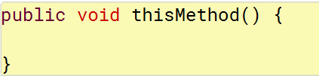

Or a longer name like this:

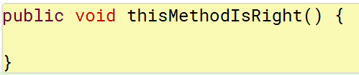

### **Indentation**

We will be using a 4 space tab, and we will not use any spaces.

Indentation should be structured like this:

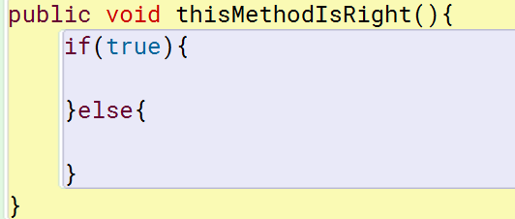

Not like this:

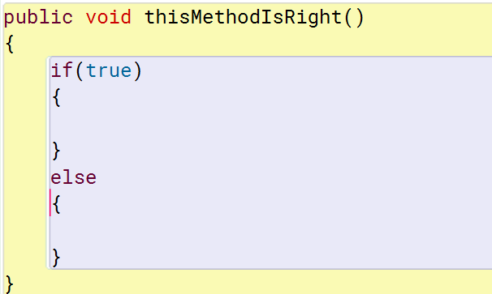

### **Error Handling**

We should use “Try and Catch” in order to ensure Error Handling along with usability via the pre built tests we have created by Use Cases, etc.

### **Variable Declaration**

Local Variables should be declared only when needed and should be declared at the top of the Method only if they are important variables. Temporary, Holder and Counter variables can be declared near where they are used instead.

There should only be one variable per declaration.

Every variable declaration (field or local) declares only one variable: declarations such as int a, b; are not used.

## **Comment Style**

We will use method comments like this:

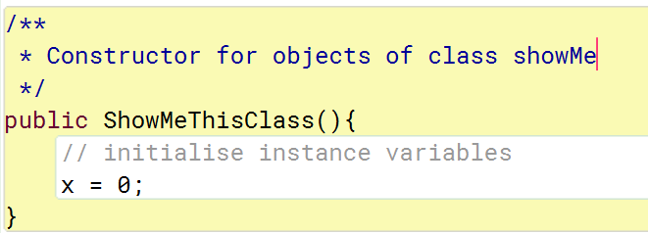

These should be well written and detailed. The only other thing we should comment are the local variables declared at the top of the method or class variables declared at the top of classes. These should be done with inline comments like shown below:

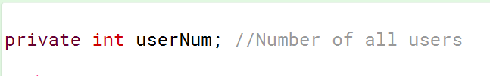

### **Variable Names**

These should be short and meaningful and should leave a detailed explanation for the variable with the inline comment instead. Like the image shown above.