Project Management 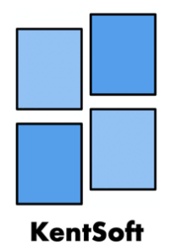

This is the primary document that will give insight as to how the team will manage this project through development all the way to deployment.

As a team we have decided to use an Agile-Waterfall hybrid. We have come to this conclusion because of the fact that our circumstances match up very well with cherry picking Agile and Waterfall components, which will function like an adopted scrum method. This is because we will be organising weekly sprints and hold meetings once these sprints are completed.

We, as a team, believe that taking the following list works best with Agile.

* Since there is no bureaucracy for the team
* With the requirement of fast deployment
* Fast feedback thanks to Miles Roman

And these work best with Waterfall

* The fact that this is a small project
* We know the requirements and they are unlikely to be massive changes
* A specific deadline

In the meetings before the 1-week sprint takes place, we will assign each team member tasks via Trello, through collaboration. We will also document the tasks inside the table in each weekly meeting document and update progress at the start of the next meeting so that we know how much progress has happened. This is in order to work efficiently whilst working remotely. We will also decide which tasks will be shared between members so that large tasks can be divided and worked together on. If a member is struggling with a certain task, other group members can provide support and feedback. We can also assign additional members to a task if need be. Below is a diagram to visually display our Software Development Cycle, showing specifically how our hybrid methodology will function.

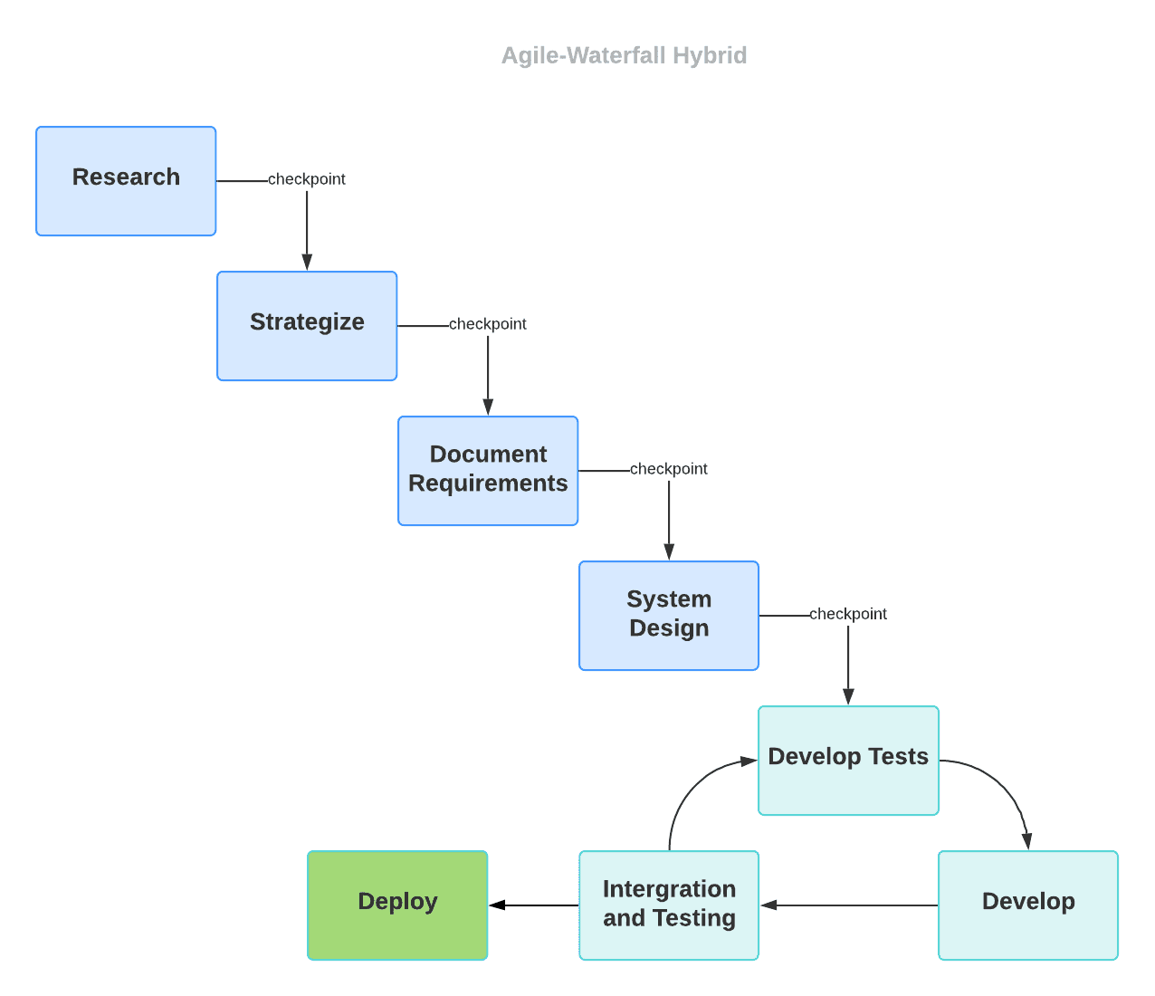

# Planning

In terms of planning our workload, our team will be using a software called Trello which is essentially a virtual notice board, that allows us to prioritise our project in a visual way. On our board we created several categories, such as “Requirements”, “Tasks to do”, “Doing” and “Done”. You can view our board here. The benefits of us adopting this software is that it updates live and keeps a log of who makes changes. In addition to this, you can assign members to a certain task which allows us to easily assign work.

# Managing work with KentSoft Workflow

As a team we will be following the workflow of our Software Development Life Cycle (SDLC) that is shown above.   
When it comes to our team meeting, our group has settled on meeting twice a week which is compulsory: Tuesday 1-2pm and Wednesdays 6-9pm. The meetings will run in the scrum fashion.

Complying with scrum’s best practices we make sure our project management tool, in this case Trello, is visible to the whole team. As such, we will begin with a looking at the Trello board to check the status of where everyone’s at with their workload. Whilst asking every team member these three questions:

* What did you accomplish since the last meeting?
* What are you working on until the next meeting?
* What is getting in your way or keeping you from doing your job?

We will update the Trello board accordingly. These questions aim to cut to the point and minimise procrastination and maximise productivity. Trello has some useful features that we will be utilizing such as allowing us to colour code certain tasks to signify certain things. For example, we used red labels to highlight important documents and blue labels were used for admin work and purple is to represent any problems.

To fulfil our Waterfall documentation requirements, as part of our hybrid methodology, , we will ensure the meeting documents have been filled out and the agenda for the next meeting has been filled out. Within this document is also a tasks table which keeps track of the tasks that have been assigned, the status of them and if they've been completed or not. Essentially creating an fail-safe for our Trello Board. Whilst this will hinder productivity it will ensure reliability and integrity. One member will be responsible to then keep a record of these weekly documents and push them to the Gitlab space.

When working remotely we will ensure that our work is pushed into the branches assigned to each team member by the scrum master. The document folder will contain all our documentation apart from our project, whilst all images or other multimedia should be placed in the assets folder.

# Monitoring Progress

The team will track its progress using the Trello Board, Weekly meeting documents and GitLab commits made. Trello has another function we will be utilizing which is the ability to move thing to different sections, in order to monitor progress we had sections such as a place to put tasks that have been completed or a section to show what tasks were currently being done.

All of this, along with our Software Development Life Cycle will ensure our team functions perfectly remotely, as well as face to face.

# Communication Methods

KentSoft allows members to meet and collaborate via different forms of communication mediums. Our main way to have meetings will be via face to face in which every group member will be present so we can make key decisions together.

Some meetings will happen via conference calls on Facetime. You can find some of the Logs for these here. As all our group members have an Apple device, everyone can use this service. However, we at KentSoft want to make it easier for any new member to seamlessly join our team which led us to keeping Skype as a backup option which all our members can easily transition to if the situation arises. The skype logs can be found here.

To keep in touch with members on the go, we have SMS group chat which, the logs of which can be found here. This along with the fact that we can use the Merge Request commenting among team members, on GitLab, allows KentSoft to be flexible with working remotely or in-house. The logs for this can be found here.

# Updating Project Progress

We at KentSoft will be using an excel sheet to document different metrics for our meetings. These will include total meeting duration (in hours) of every meeting combined in a week and the amount of meetings we have a week. We have a default number of meetings and meeting length (in hours) set for each week. We will set each recorded metric to 0 by default and then after a week has passed, one member who is assigned to updating the graph, will update the figures correctly by adding the recorded time. This will slowly build the chart to see where we met more than what was assigned to us or less so that we can reflect on our default set meeting frequency and duration and maybe change it to what the data says i.e. increase the meeting duration if we are regularly meeting for longer than the set time.

Team members can update each other on their progress on individual tasks in meetings or Trello, as a formal capacity. This could entail answering the 3 fundamental meeting questions, or moving their tasks from “Doing” to “Done”, within Trello. Team members can informally update each other through other means of communication which were listed above.

# Documenting Decisions in Meetings

We will document the actual meeting locations times and dates via Doodle which can be viewed [here](../Assets/Doodle/AllMeetings.png).

However the agenda in the actual meetings will be documented as we go along to via Trello. This is to ensure we stay on schedule and organised whilst in our meetings. Trello will document our decisions in the form of creating tasks, allocating tasks and moving tasks in between the sectioned areas. You can see an example of this [here](../Assets/Trello/TrelloBoardScreenshot.PNG).

We decided to use Trello because it essentially backs-up every decision, as there is an activity section which documents the following:

* When tasks are created, documenting name, description and time.
* When tasks are moved from section to section
* Which users are assigned to which tasks
* Any comments to specific tasks

Along with all that, the time for all of this is recorded. As a way to confirm things decided in the meeting and keep track of tasks, we have also added a Weekly meeting document to fill out at the end of every meeting. This will ensure that everyone on the same page before leaving.

# Processing, record-keeping and reviewing ensure individual accountability for tasks?

The record-keeping and reviewing processes we have in place at KentSoft ensure individual accountability in a number of different ways. For example using Trello allows us to assign certain members to specific tasks so everyone can see what they themselves have been assigned to do as well as what other team members have been assigned to. It also allows us to set due dates and put tasks into separate categories such as what tasks need to be done, what tasks have been completed as well as when they were completed.

A meeting document which is produced for each meeting also includes a table showing what was done during the meeting as well as who did it. It also shows what team members need to do following the meeting.

Lastly, using GitLab allows us to ensure individual accountability as each member is responsible for what goes on in their own branch. It also allows us to review each other's work before merging the changes to the main branch. As a policy we wanted to set up unanimous approval when merging to the master branch, however we realised that when expanding a team this would become time consuming and very inefficient. Hence we agreed that as long as the majority approved the merge, we can merge the changes to the master branch.