Quality Assurance 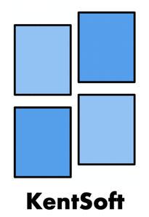

We at KentSoft have created a document style-sheet that sets a guideline of how we will format every document, which includes things such as the size of text that will be used for the body and headings, as well as the fonts that will be used. This ensures consistency across all our documents as every document we produce will conform to these set standards

In addition to this, we also have a developer guideline document that outlines the way we will code and develop software. This includes points on the developer environment, programming language, IDE’s, programming paradigm, design patterns and coding style down to little details such as class names, indentation, variable declaration and comment style.

As part of our weekly meetings, every so often we will also schedule a session where we check all documents that we have produced to ensure they are all following the guidelines. This is an opportunity for us to spot any issues with documents, such as a header being typed in the wrong size by mistake. Furthermore, while working with GitLab before merging individual branches to the master branch, each member will have to approve the merge which will allow members to check for any inconsistencies or errors before adding to the main branch where the final editions of the documents will be kept.