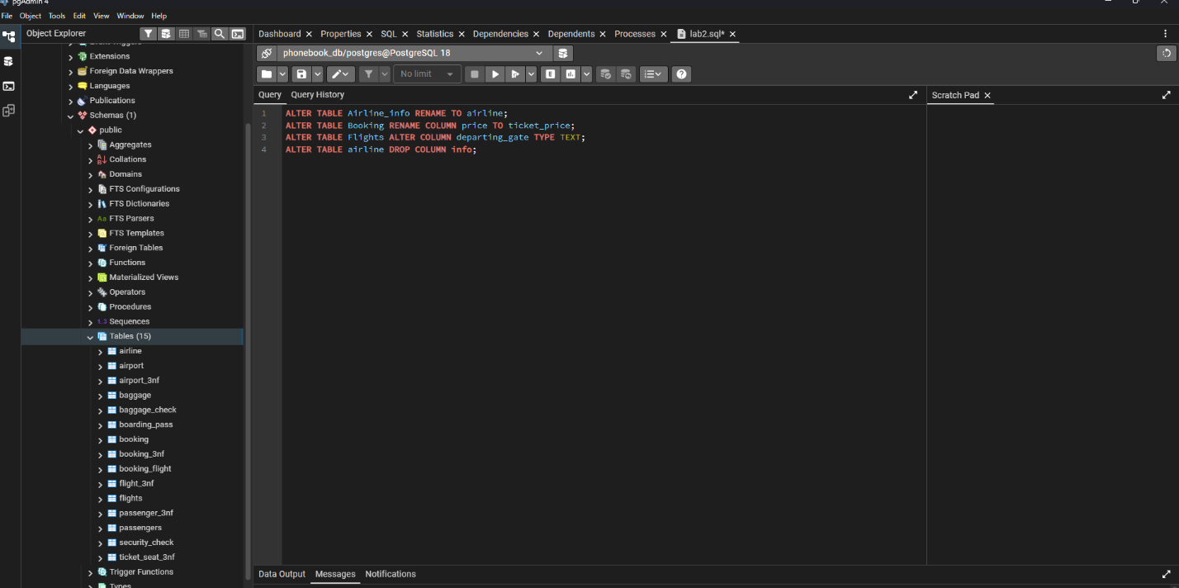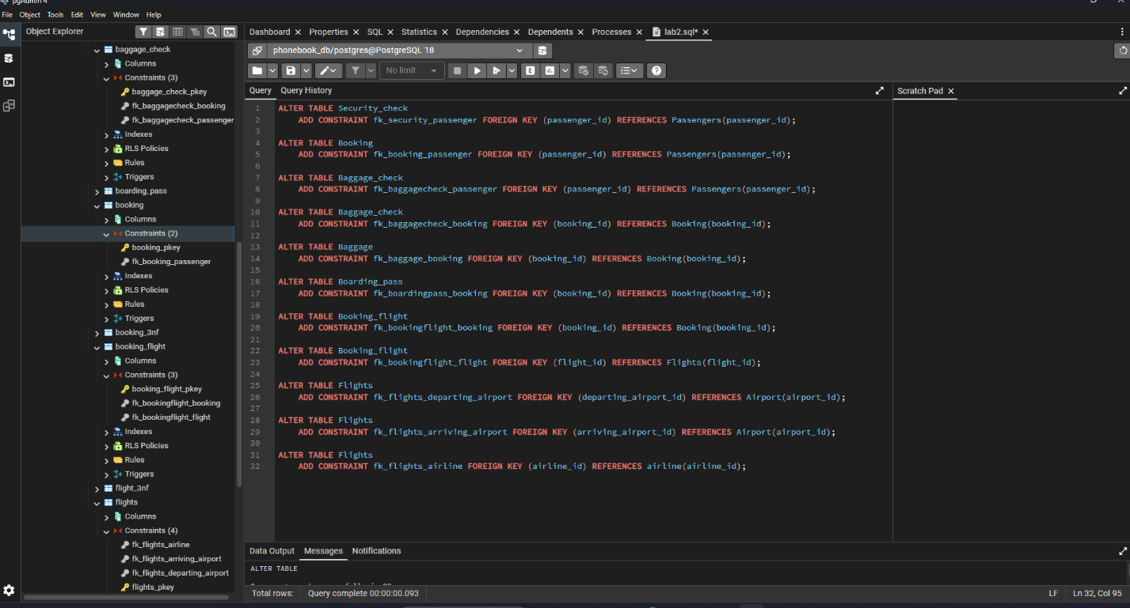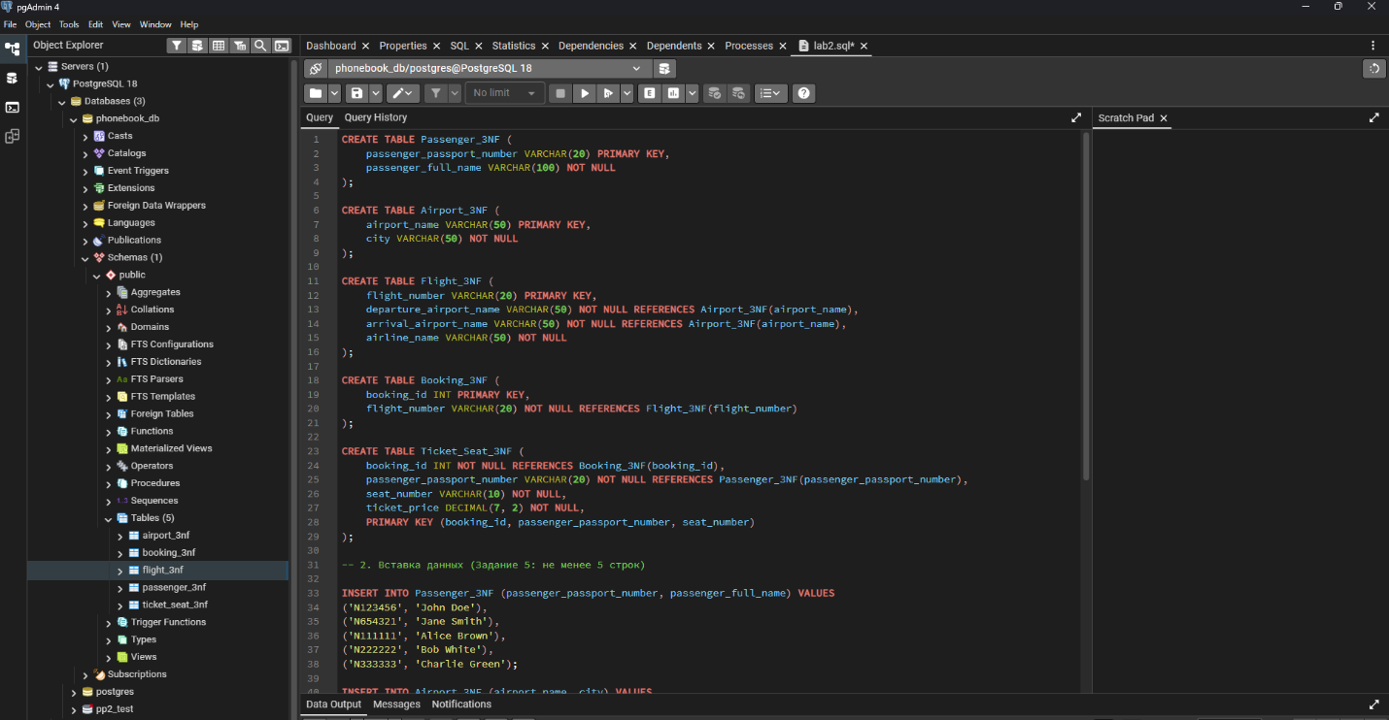

PART 1. Normalization
Task 1. Violation of Normal Forms
The unnormalized table Booking_receipt(booking_id, passenger_full_name, passenger_passport_number, flight_number, departure_airport_name, departure_city, arrival_airport_name, arrival_city, airline_name, seat_numbers, ticket_price) violates First Normal Form (1NF).
Reason: The column seat_numbers contains non-atomic (comma-separated) values (e.g., "12A, 12B") when a booking covers multiple seats. 1NF requires every column to contain atomic (indivisible) values.
Task 2. Step-by-Step Normalization
Step 1: First Normal Form (1NF)
To reach 1NF, we split non-atomic values into separate rows so that each seat has its own record.
- Table: Booking_receipt_1NF
- Attributes: (booking_id, seat_number, passenger_full_name, passenger_passport_number, flight_number, departure_airport_name, departure_city, arrival_airport_name, arrival_city, airline_name, ticket_price)
- Primary Key: (booking_id, seat_number)
Step 2: Second Normal Form (2NF)
2NF requires the table to be in 1NF and have no partial dependencies (all non-key attributes must depend on the whole composite primary key).
We decompose the table into:
- Passenger_3NF
  - Attributes: (passenger_passport_number, passenger_full_name)
  - Primary Key: passenger_passport_number
- Flight_2NF
  - Attributes: (flight_number, departure_airport_name, departure_city, arrival_airport_name, arrival_city, airline_name)
  - Primary Key: flight_number
- Booking_2NF
  - Attributes: (booking_id, passenger_passport_number, flight_number, ticket_price)
  - Primary Key: booking_id
  - Foreign Keys: passenger_passport_number $→$ Passenger_3NF, flight_number $→$ Flight_2NF
- Ticket_Seat_3NF
  - Attributes: (booking_id, seat_number)
  - Primary Key: (booking_id, seat_number)
  - Foreign Key: booking_id $→$ Booking_2NF
Step 3: Third Normal Form (3NF)
3NF requires the tables to be in 2NF and have no transitive dependencies (non-key attributes must not depend on other non-key attributes).
In Flight_2NF, non-key attributes like departure_city depend on departure_airport_name. Thus, we extract airports into a separate entity:
- Airport_3NF
  - Attributes: (airport_name, city)
  - Primary Key: airport_name
- Flight_3NF
  - Attributes: (flight_number, departure_airport_name, arrival_airport_name, airline_name)
  - Primary Key: flight_number
  - Foreign Keys: departure_airport_name $→$ Airport_3NF, arrival_airport_name $→$ Airport_3NF
- Booking_3NF
  - Attributes: (booking_id, passenger_passport_number, flight_number, ticket_price)
  - Primary Key: booking_id
  - Foreign Keys: passenger_passport_number $→$ Passenger_3NF, flight_number $→$ Flight_3NF
Task 3. Functional Dependencies
The following functional dependencies were used:
- booking_id, seat_number $→$ passenger_full_name, passenger_passport_number, flight_number, departure_airport_name, departure_city, arrival_airport_name, arrival_city, airline_name, ticket_price
- booking_id $→$ passenger_passport_number, flight_number, ticket_price
- passenger_passport_number $→$ passenger_full_name
- flight_number $→$ departure_airport_name, arrival_airport_name, airline_name
- departure_airport_name $→$ departure_city
- arrival_airport_name $→$ arrival_city
Task 4. 3NF Verification for Flights Table
In the airport database DDL:
- Primary Key: flight_id
- Functional Dependencies:
  - flight_id $→$ sch_departure_time, sch_arrival_time, departing_airport_id, arriving_airport_id, departing_gate, arriving_gate, airline_id, act_departure_time, act_arrival_time
- Conclusion: The Flights table is in 3NF. All non-key attributes directly depend on flight_id. Information about airports and airlines is stored via foreign keys (departing_airport_id, arriving_airport_id, airline_id), avoiding transitive functional dependencies in this table

PART 2. DDL SQL Commands

