Task 1: Retrieve all airline names in uppercase.
SELECT UPPER(airline_name) AS uppercase_airline_name FROM airline;
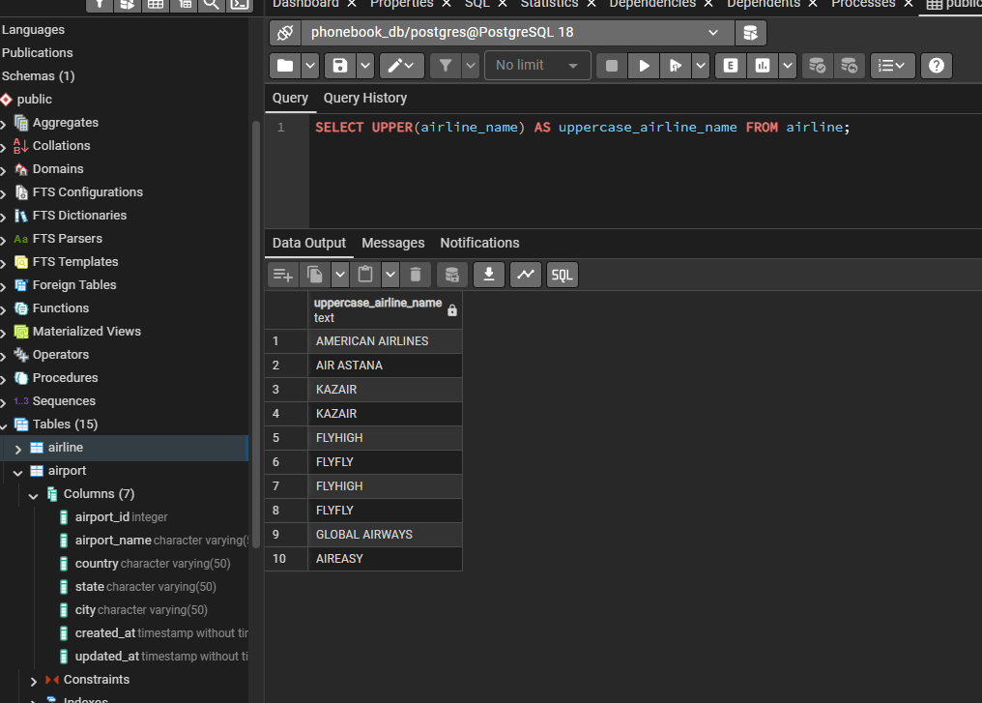

Task 2: Replace any occurrence of the word "Air" in airline names with "Aero".

SELECT REPLACE(airline_name, 'Air', 'Aero') AS modified_airline_name FROM airline;
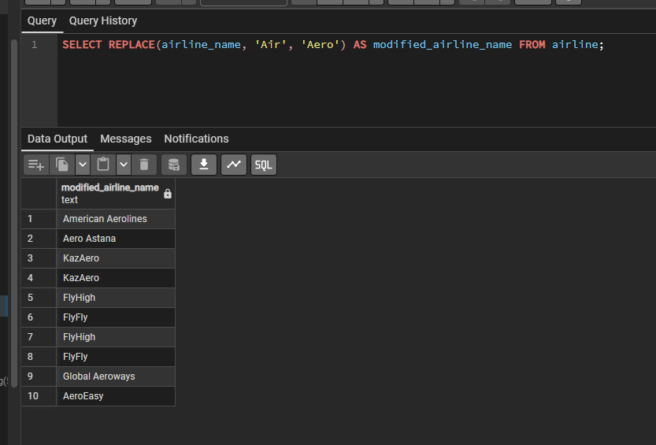

Task 3: Find all flight numbers that coordinate with both airline 1 and airline 2.
SELECT column_name
FROM information_schema.columns
WHERE table_name = 'flight';

SELECT flight_id
FROM flights
WHERE airline_id IN (1, 2)
GROUP BY flight_id
HAVING COUNT(DISTINCT airline_id) = 2;
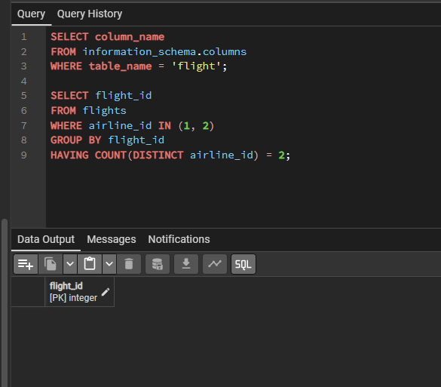

Task 4: Retrieve airports that contain the word "Regional" and "Air" in their names.
SELECT * FROM airport
WHERE airport_name LIKE '%Regional%'
AND airport_name LIKE '%Air%';
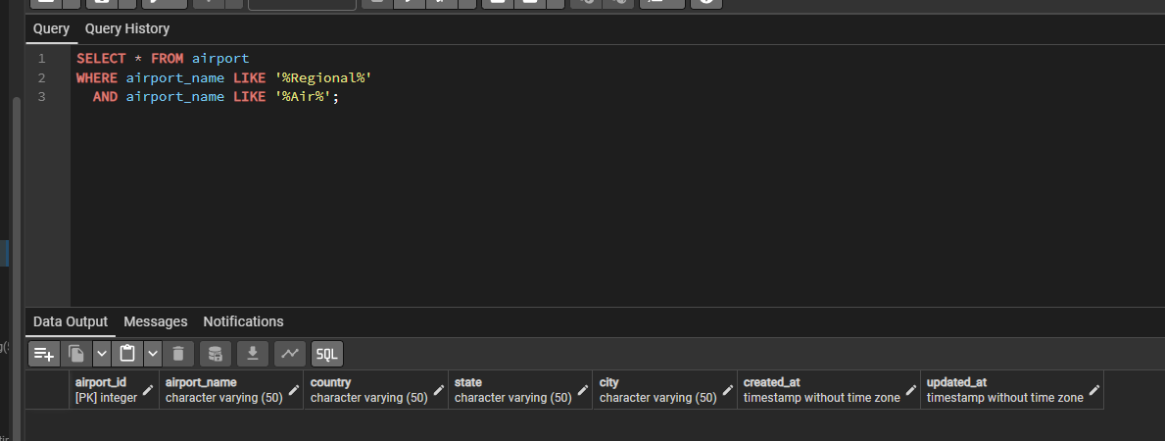
Task 5: Retrieve passenger names and format their birth dates as 'Month DD, YYYY'.
SELECT
CONCAT(first_name, ' ', last_name) AS full_name,
TO_CHAR(date_of_birth, 'Month DD, YYYY') AS formatted_birth_date
FROM passengers;
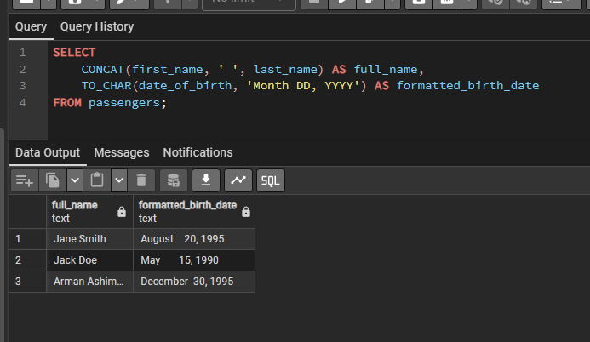

Task 6: Find flight numbers that have been delayed based on the actual arrival time.
SELECT flight_id, act_arrival_time FROM flights WHERE act_arrival_time > sch_arrival_time;
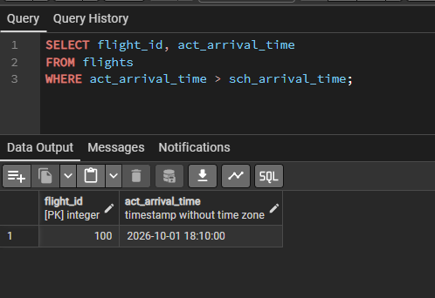
Task 7: Find flights that arrived late according to their actual arrival time compared to the scheduled arrival time.
SELECT flight_id, sch_arrival_time, act_arrival_time
FROM flights
WHERE act_arrival_time > sch_arrival_time;
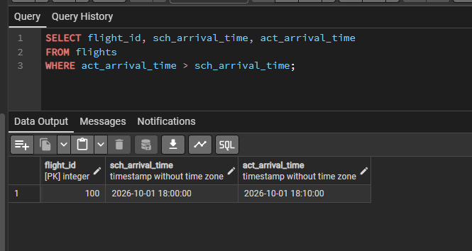

Task 8: Show airlines from any of: ('France','Portugal','Poland') created between '2023-11-01' and '2024-03-31'.

SELECT * FROM airline
WHERE airline_country IN ('France', 'Portugal', 'Poland')
AND created_at BETWEEN '2023-11-01' AND '2024-03-31';

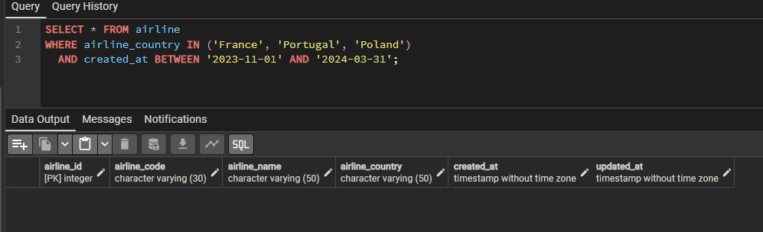

Task 9: Find top 3 overweighted baggage with more than 25kg.
SELECT * FROM baggage WHERE weight_in_kg> 25
ORDER BY weight_in_kg DESC
LIMIT 3;
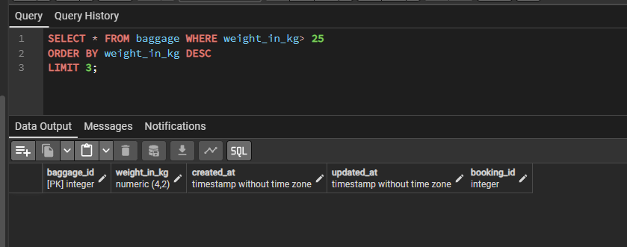

Task 10: Find the youngest passenger's full name.
SELECT CONCAT(first_name, ' ', last_name) AS full_name, date_of_birth
FROM passengers
ORDER BY date_of_birth DESC
LIMIT 1;
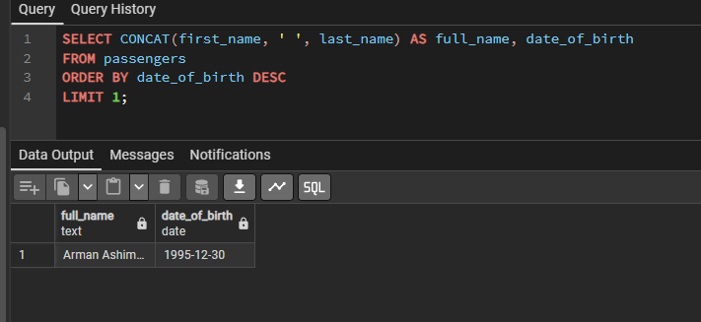

Task 11: Find the cheapest booking price on each booking platform.
SELECT booking_platform, MIN(ticket_price) AS cheapest_price
FROM booking
GROUP BY booking_platform;
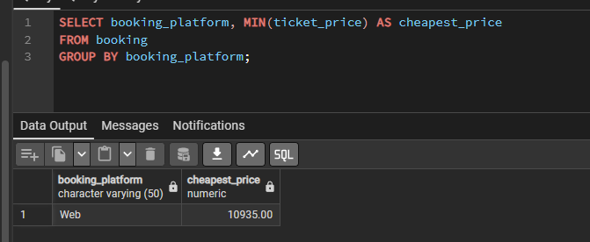

Task 12: Return airlines whose airline_code contains a digit.
SELECT * FROM airline WHERE airline_code ~ '[0-9]';
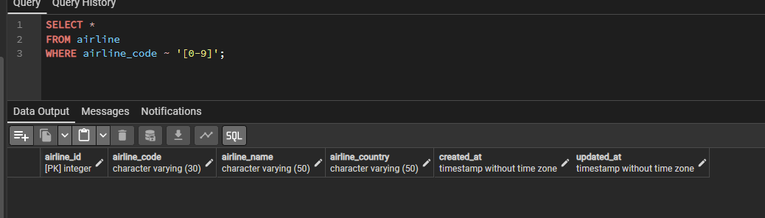

Task 13: List the top 5 most recently created airlines.
SELECT * FROM airline ORDER BY created_at DESC LIMIT 5;
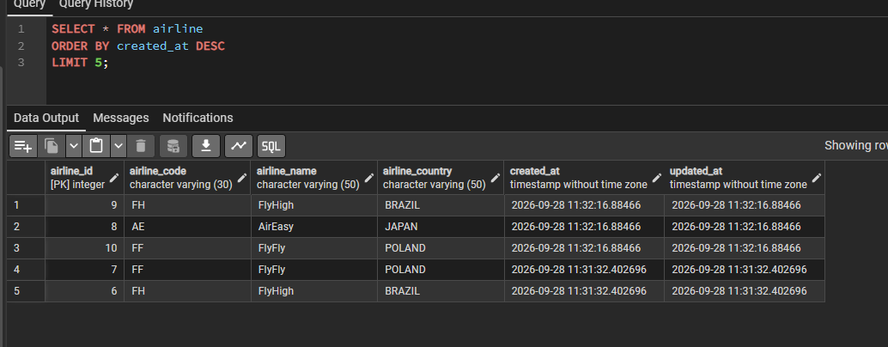
Task 14: Return all rows where booking_id is between 200 and 300 inclusive and check_result <> 'Checked'.
SELECT * FROM baggage_check
WHERE booking_id BETWEEN 200 AND 300
AND check_result <> 'Checked';
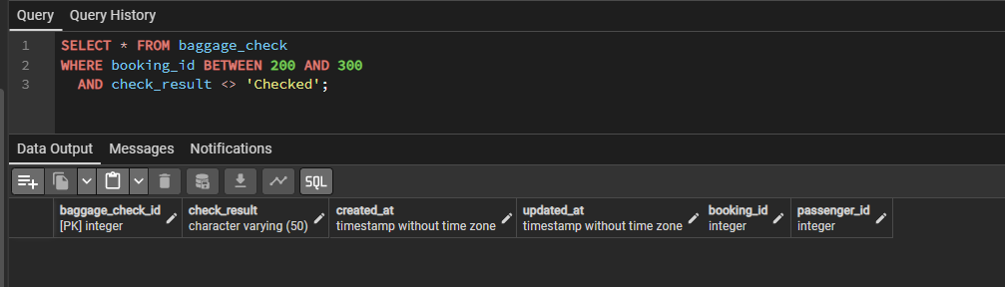

Task 15: Baggage checks where updated_at is in the same month as created_at but occurs earlier than created_at.
SELECT * FROM baggage_check
WHERE EXTRACT(MONTH FROM updated_at) = EXTRACT(MONTH FROM created_at)
AND EXTRACT(YEAR FROM updated_at) = EXTRACT(YEAR FROM created_at)
AND updated_at < created_at
