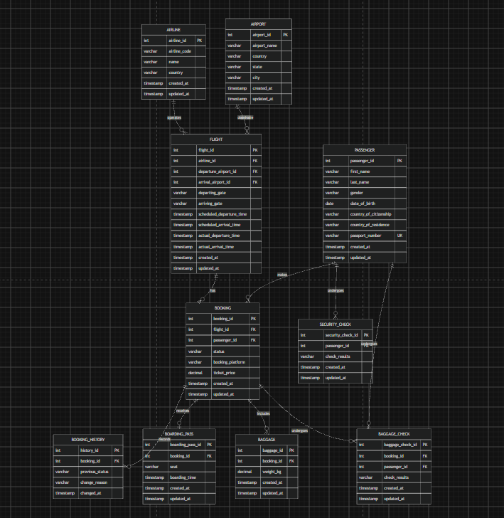

1) AIRPORT: Stores information about airports (airport_id, name, country, state, city, timestamps).
- Relationships: One airport can be the departure point or arrival point for many flights ($1:N$).
2) AIRLINE: Stores airline company details (airline_id, code, name, country, timestamps).
- Relationships: One airline operates multiple scheduled flights ($1:N$).
3) FLIGHT: Contains scheduling and actual flight data (flight_id, gates, scheduled and actual departure/arrival times).
- Relationships: Connected to AIRLINE ($N:1$) and to AIRPORT twice ($N:1$ for departure and arrival airports). One flight can have multiple bookings ($1:N$).
4) PASSENGER: Contains personal profile data for passengers (passenger_id, name, passport number, citizenship, etc.).
- Relationships: One passenger can make multiple bookings ($1:N$) and undergo security checks.
5) BOOKING: Links passengers to specific flights (booking_id, status, platform, price, timestamps).
- Relationships: Relates $N:1$ to FLIGHT and PASSENGER. Relates $1:N$ to BAGGAGE, BAGGAGE_CHECK, and BOOKING_HISTORY.
6) BOOKING_HISTORY: Logs modifications made to bookings over time (history_id, status, change reason).
- Relationships: Connected to BOOKING as $N:1$.
7) BOARDING_PASS: Details of issued boarding passes (boarding_pass_id, seat number, boarding time).
- Relationships: Linked to BOOKING as a $1:1$ or $1:N$ relationship.
8) BAGGAGE: Stores baggage items registered during flight booking (baggage_id, weight).
- Relationships: Belongs to a BOOKING ($N:1$).
9) BAGGAGE_CHECK: Stores security inspection results for registered luggage (baggage_check_id, check results).
- Relationships: Linked to BOOKING and PASSENGER ($N:1$).
10) SECURITY_CHECK: Records airport security checkpoint results for passengers (security_check_id, results).
- Relationships: Linked directly to PASSENGER ($N:1$).

