# BOM (Browser object model)

* Related to browser
* Allow us to talk to browser

Window

This whole is called window

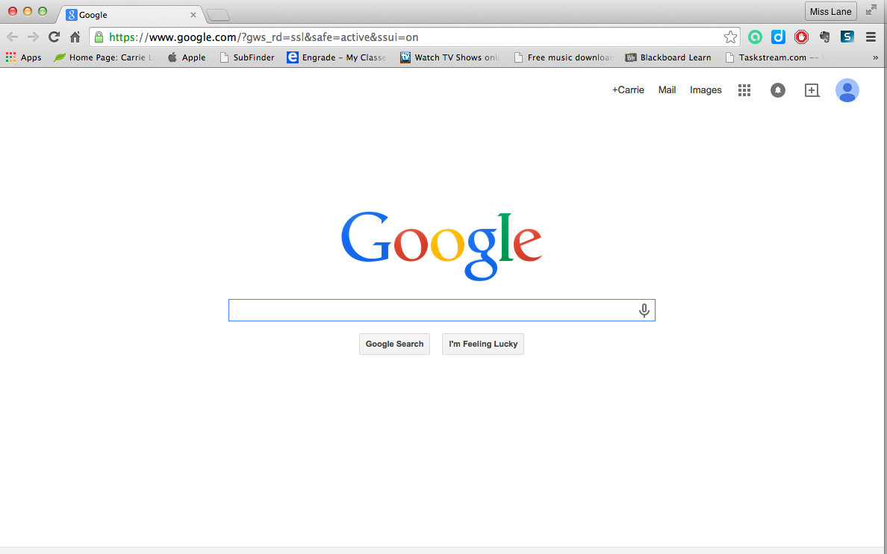

window.document.getElementById("header")

//same as

document.getAnimations("header")

Methods and properties

* innerHeight (browser upper area not count)

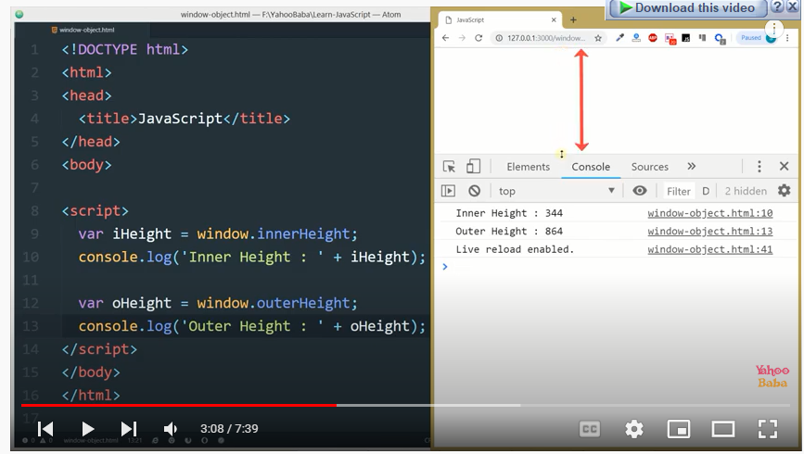

* outerHeight (browser upper area not count)

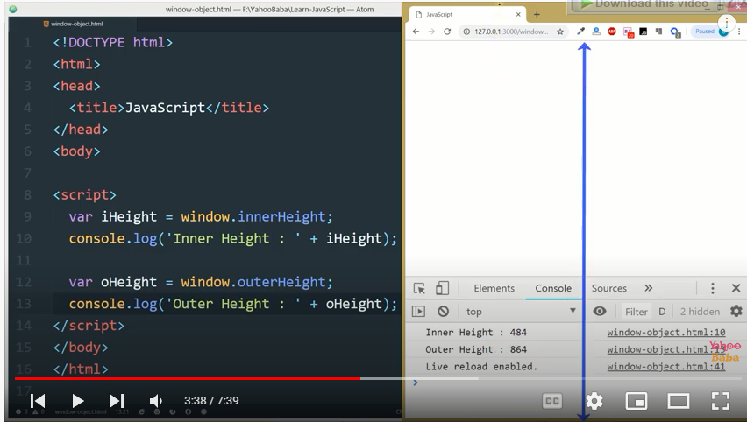

// important example

<body onresize="resize()">

<script>

function resize(){

console.clear()

let ih = window.innerHeight

console.log( "inner Height" + ih);

let oh = window.outerHeight

console.log( "outer Height" + oh);

}

</script>

</body>

* innerWidth (minus scroll bar area)

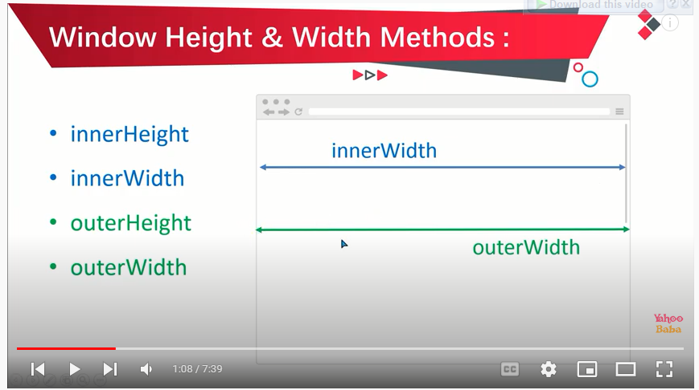

* outerWidth



* window.open() {use to open new tab}

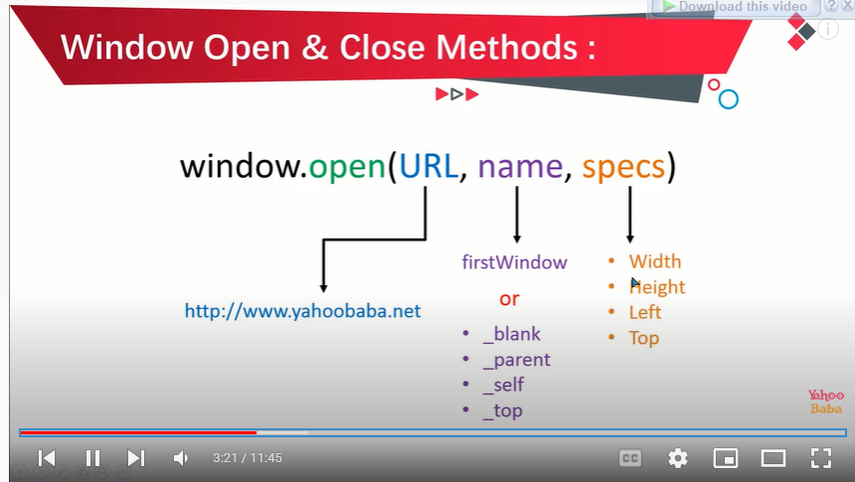

* window.close() {use to close existing tab or new tab}

//example one

<body>

<button onclick="openFunction()">open window</button>

<button onclick="closeFunction()">close window</button>

<script>

let windObject;

function openFunction(){

windObject = window.open("https://www.google.com","_parent","width = 500px, height = 300px , left = 0px top = 100px")

}

function closeFunction(){

windObject.close()

}

</script>

//Example 2

<body>

<button onclick="openFunction()">open window</button>

<button onclick="closeFunction()">close window</button>

<script>

let windObject;

function openFunction(){

windObject = window.open("https://www.google.com","_blank","width = 500px, height = 300px , left = 0px top = 100px")

}

function closeFunction(){

windObject.close()

}

</script>

</body>

* window.moveTo() {count px from the edge of browser window}
* moveBy() {count pixels you gave him open method}

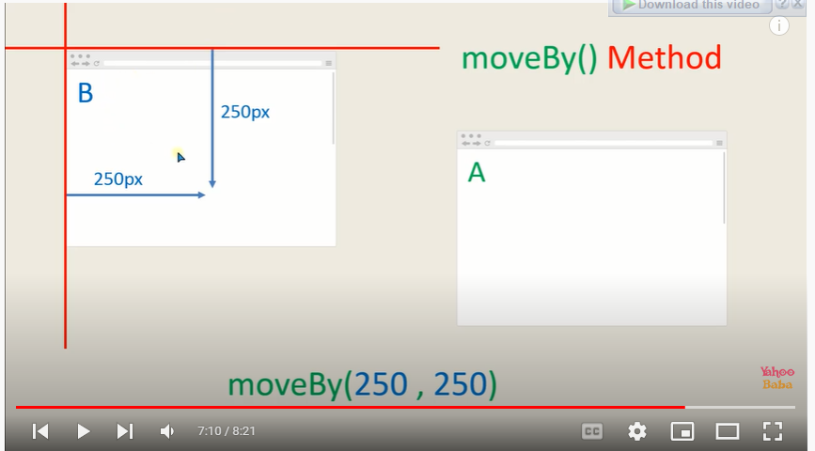

* window.resize() {if you add height and width by open() then this method ignore him}
* window.resizeBy() {if you add height and width by open() then this method add open() pixels him}

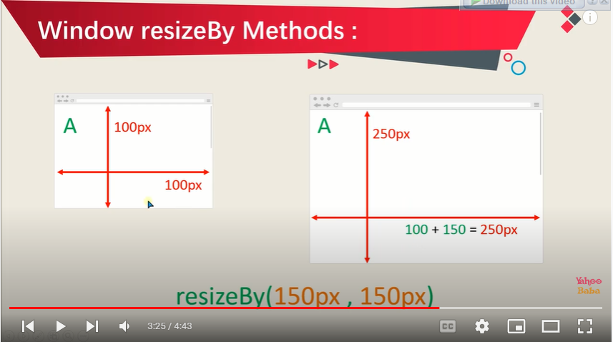

* window.scrollTo() {scroll by absolute poosition}

// take me to this cordinate

<button onclick="upFunciton()" id="on" style="position:fixed; right:100px; top: 500px; ">To up</button>

<script>

function upFunciton(){

    window.scrollTo(0,0)

}

* window.scrollBy() {scroll by relative position and add given pixels}

<button onclick="upFunciton()" id="on" style="position:fixed; right:100px; top: 500px; ">To up</button>

<script>

function upFunciton(){

    window.scrollBy(0,100)

}

Window.Screen

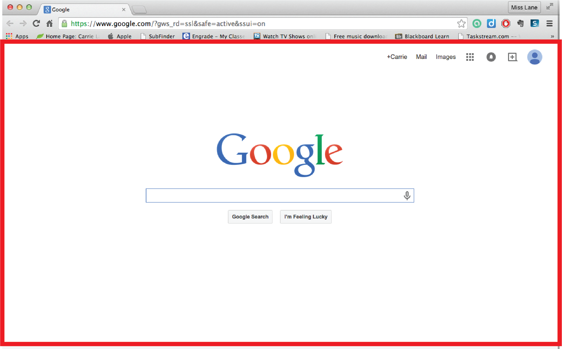

Window.Screen.width = Screen.width

1. Screen.width
2. Screen.height
3. Screen.availWidth (minus taskbar)
4. Screen.availHeight (minus taskbar)

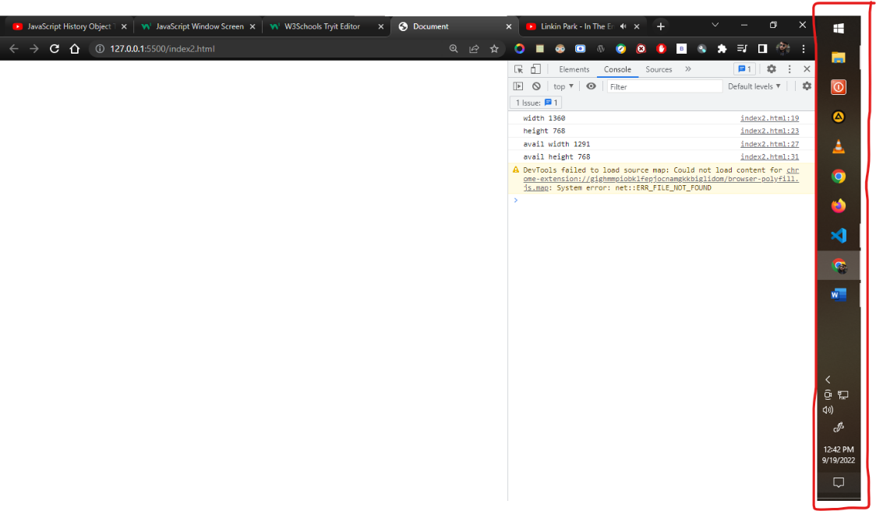

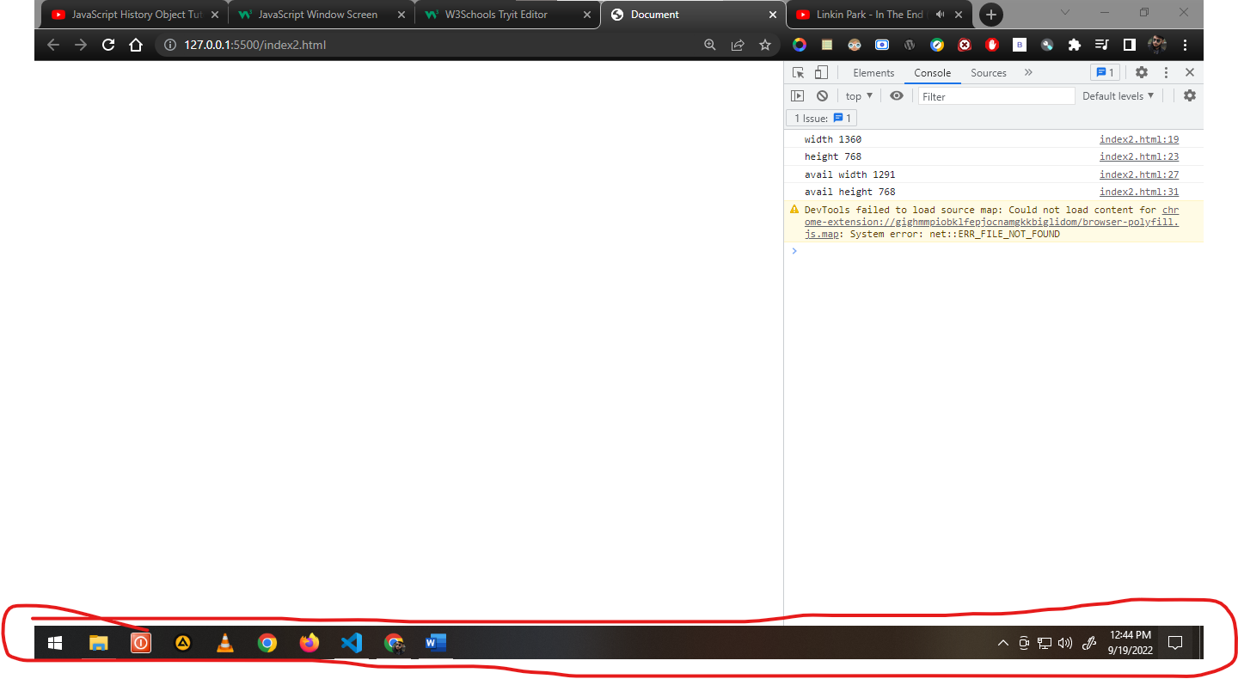

//show the full width of display which browser can take

const width = window.screen.width

console.log( "width " + width);

//show the full height of display which browser can take

const height = window.screen.height

console.log( "height " + height);

//total - taskbar (if place in right or left)

const availWidth = window.screen.availWidth

console.log( "avail width " + availWidth);

//total - taskbar (if place in bottom)

const availheight = window.screen.availHeight

console.log( "avail height " + availheight);

Window.location

Window.location.href = location.href

Use to get the current page URL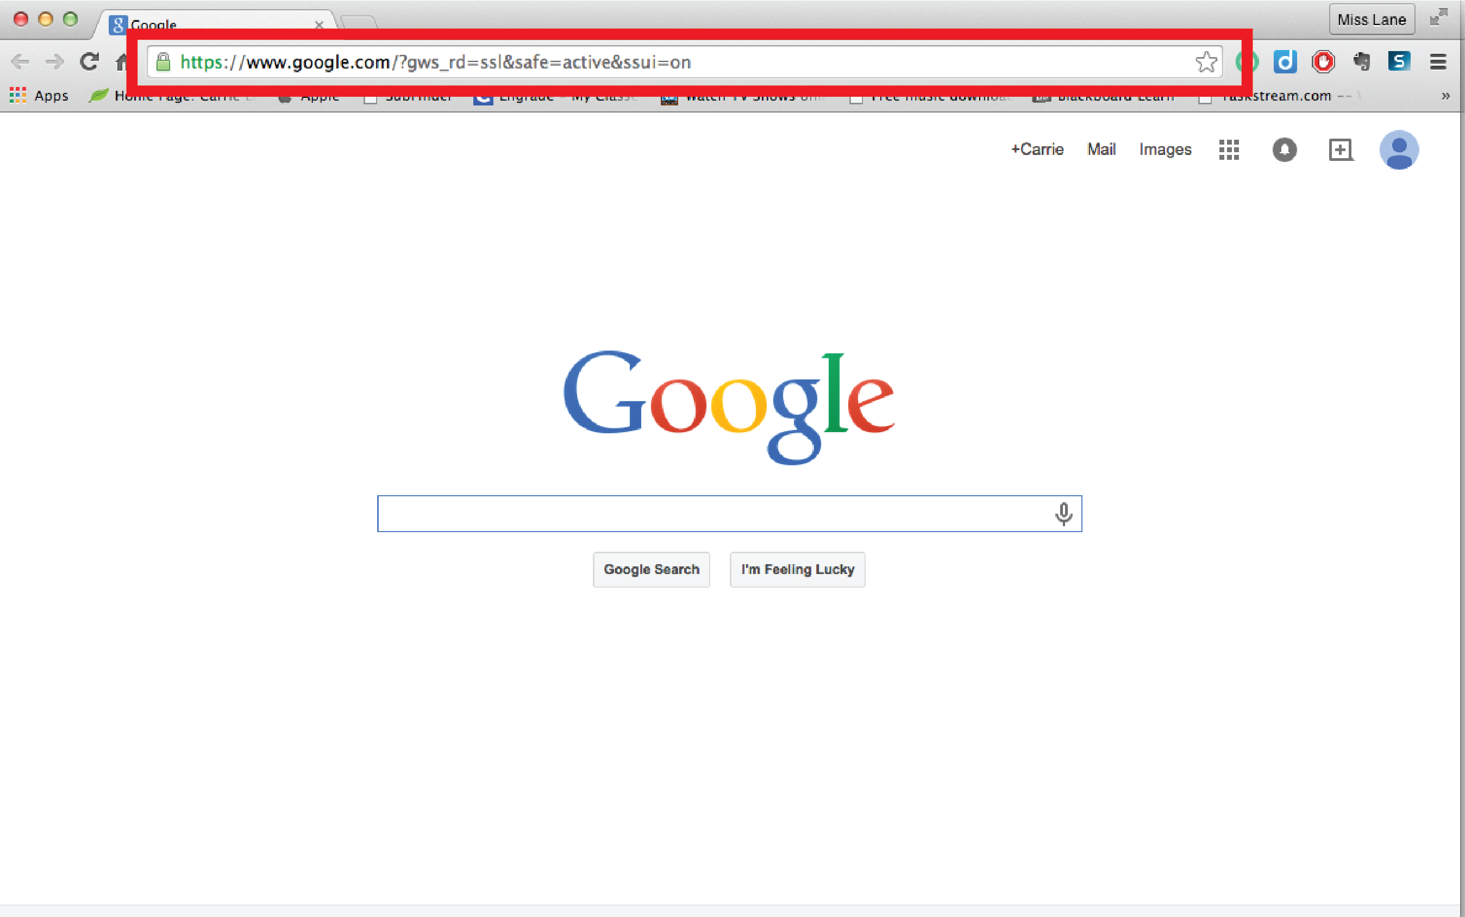

Picture of properties and methods use in location

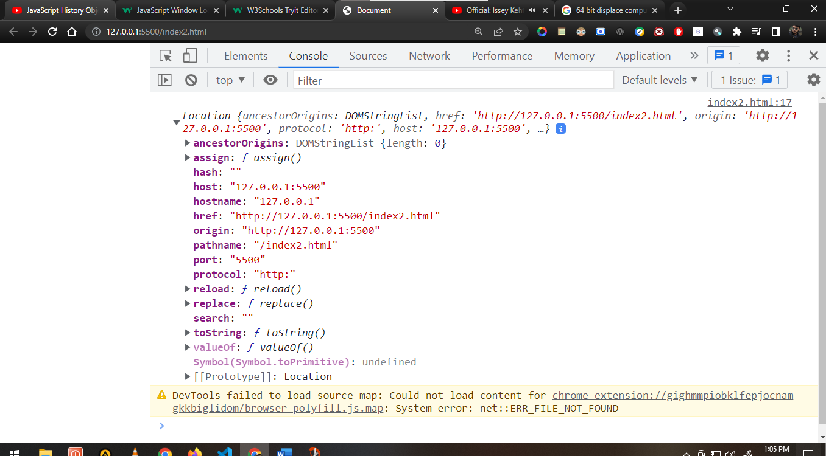

1. Assign()

<button onclick="assign()">click</button>

<script>

function assign(){

const a = window.location.assign("http://www.google.com")

}

1. Reload() {Reload the page}

<button onclick="reload()">click</button>

<script>

function reload(){

const a = window.location.reload()

}

1. Replace() {load the page but kill all the history}

<button onclick="replace()">click</button>

<script>

function replace(){

const a = window.location.replace("http://www.google.com")

}

Window.history

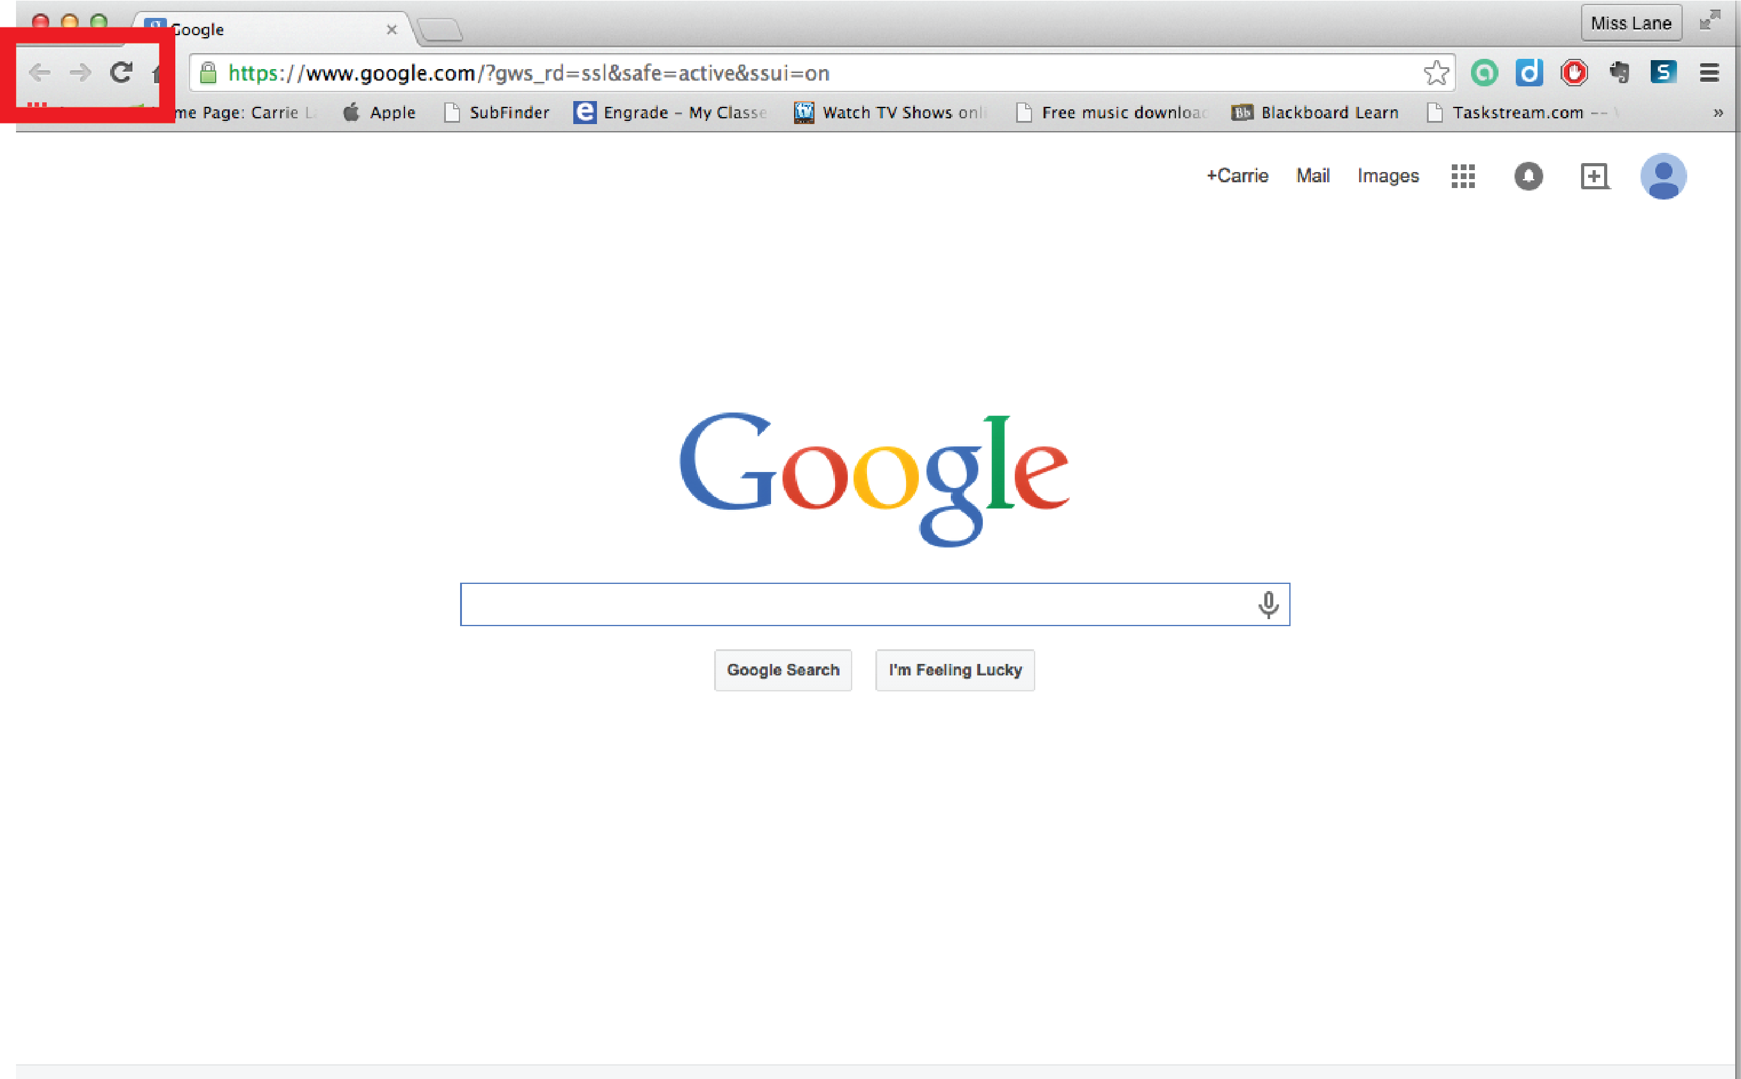

* Browser hold history of tabs
* Means tabs hold the history of current tab

1. Window.history.length
2. Window.history.back()
3. Window.history.forward()
4. Window.history.go() 1 for forward one page and -2 for backward 2 pages

<button onclick="back()">backward</button>

<button onclick="forward()">forward</button>

<button onclick="go()">go</button>

<script>

function back(){

window.history.back()

}

function forward(){

window.history.forward()

}

function go(){

 window.history.go(2)

}

</script>