# Hoisting

1. Definition “raise (something) by means of ropes and pulleys”.

"a white flag was hoisted"

1. Hoisting is **JavaScript's default behavior of moving all declarations to the top of the current scope** (to the top of the current script or the current function).

* Hoisting is JavaScript's default behavior of moving declarations to the top.
* In JavaScript, a variable can be declared after it has been used
* In other words; a variable can be used before it has been declared.
* JS allocate memory to the variable = undefine before initializing in creation phase
* Code runs in JS Execution context

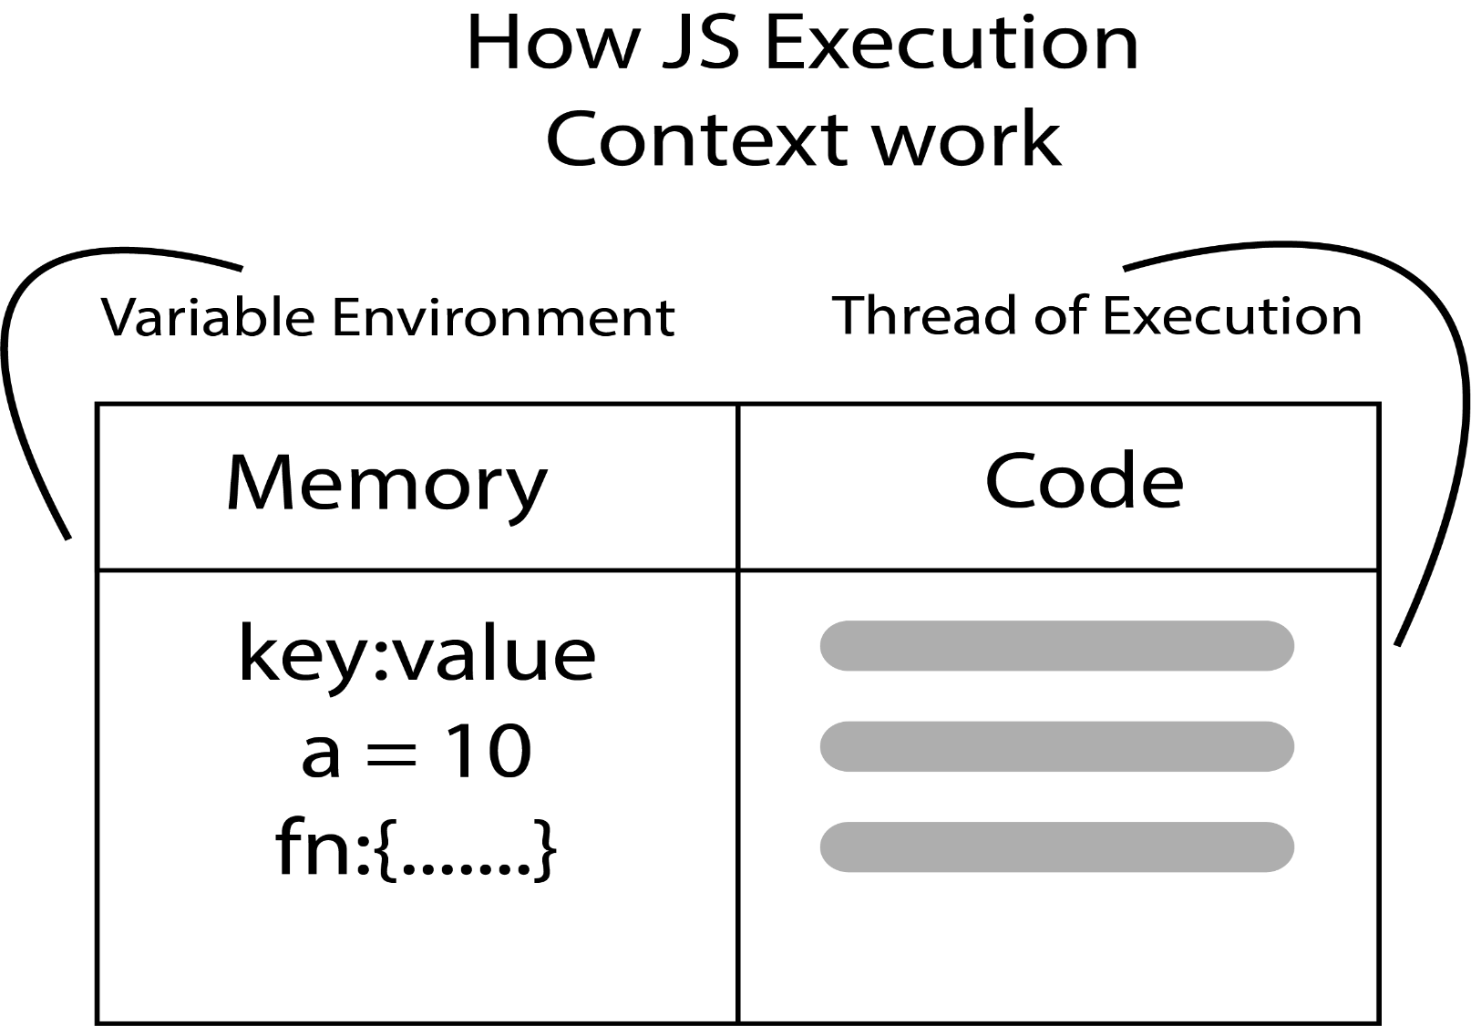

**Variables and second and third type of function show undefine**

test3()

    test2()

    test1();

    console.log(a);

    let a = 2

    const test1 = function (){

      console.log("test1");

    }

    let test2 = ()=>{

      console.log("test2");

    }

    function test3 (){

      console.log("test3");

    } //failed in term of hoisting because it shows the value

**Example for Call Stack (push and pop)**

 let test1 = ()=>{

  debugger;

  let a = "i am test 1"

  console.log(a);

  test2()

 }

 let test2 = ()=>{

  debugger;

  let b = "i am test 2"

  console.log(b);

  test3()

}

let test3 = ()=>{

  debugger;

  let c = "i am test 3"

  console.log(c);

}

debugger;

test1()