Tenses

* “Tenses are the rule which explain time and work”

# Time

* Past
* Present
* Future

# Work

* Continuous ( ho raha hai )
* Perfect ( ho chuka hai )
* Indefinite ( koi pata nai kitna hoa hai )
* Perfect continuous ( not important )

Type of Tenses

|  |  |  |
| --- | --- | --- |
| Present | Past | Future |
| Indefinite | Indefinite | Indefinite |
| Continuous | Continuous | Continuous |
| Perfect | Perfect | Perfect |
| Perfect Continuous | Perfect Continuous | Perfect Continuous |

Concept of Helping Verb

* How to find Time (use helping verb)

|  |  |  |  |
| --- | --- | --- | --- |
| Tense | Present | Past | Future |
| Indefinite | Do, does | Did | Will, shall |
| Continuous | Is, Am, Are | Was, were | Will have, shall have |
| Perfect | Has, have | Had |  |

* How finds work (use forms)

|  |  |  |  |
| --- | --- | --- | --- |
| Indefinite | continuous | Past Indefinite | Perfect |
| Mv1 | Mv1+ing | Mv2  2nd form uses only here | Mv3 |

PRESENT INDEFINATE (Use a lot)

* **You tell me about yourself or I do**
* **Describe Habits**
* **Describe Schedule**
* **Describe Routine**
* **For Interview**
* **WH-FAMILY =>** WHAT, WHEN, WHOME, WHERE, WHICH, WHY
* **Use S / ES** ONLY IF SUBJECT IS THIRD PERSON
* **Use do / does for negative or interrogative**
* **Remember to use** MV1 **and Do, does if Required**

|  |  |
| --- | --- |
| **+ Positive** | Sub + MV1 + S/ES + OBJ |
| **- Negative** | Sub + DO/DOES + NOT + MV1 + OBJ |
| **? Interrogative (Yes or no Condition)** | DO/DOES + Sub + MV1 + OBJ |
| **??Double Interrogative (Detail Answer)** | WH-FAMILY + DO/DOES + Sub + MV1 + OBJ |

Examples

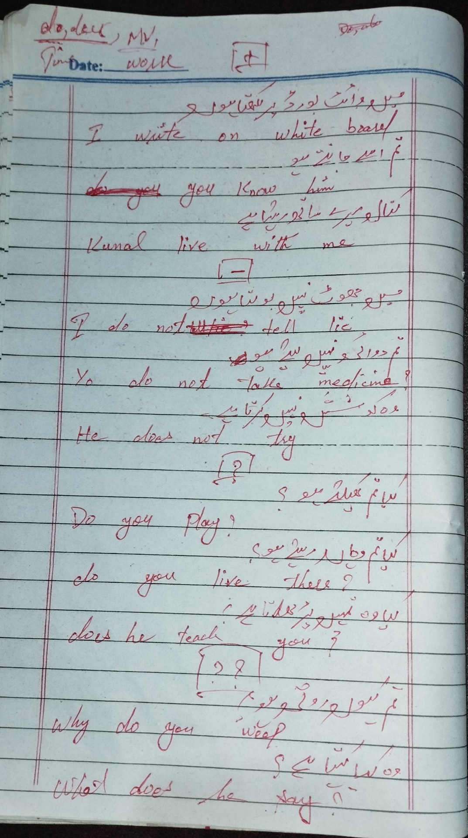

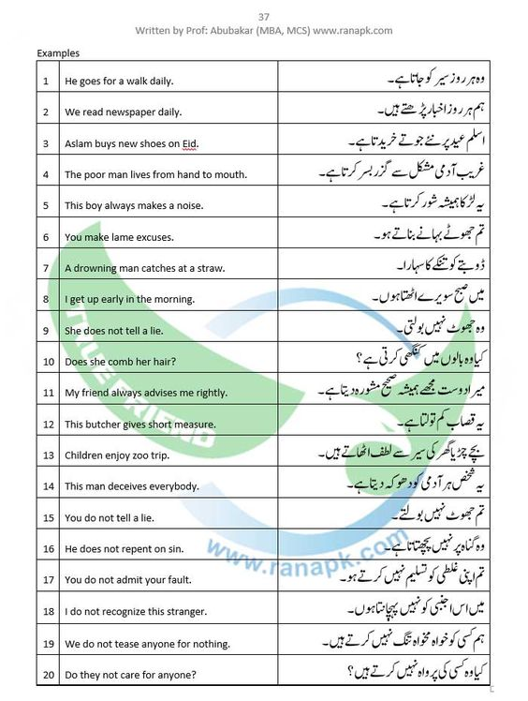

PRESENT CONTINUOUS

|  |  |
| --- | --- |
| **+ Positive** | Sub + IS / AM / ARE + MV1 + ING + OBJ |
| **- Negative** | Sub + IS / AM / ARE + NOT + MV1 + ING + OBJ |
| **? Interrogative (Yes or no Condition)** | IS / AM / ARE + Sub + MV1 + ING + OBJ |
| **??Double Interrogative (Detail Answer)** | WH-FAMILY + IS / AM / ARE + Sub + MV1 + ING + OBJ |

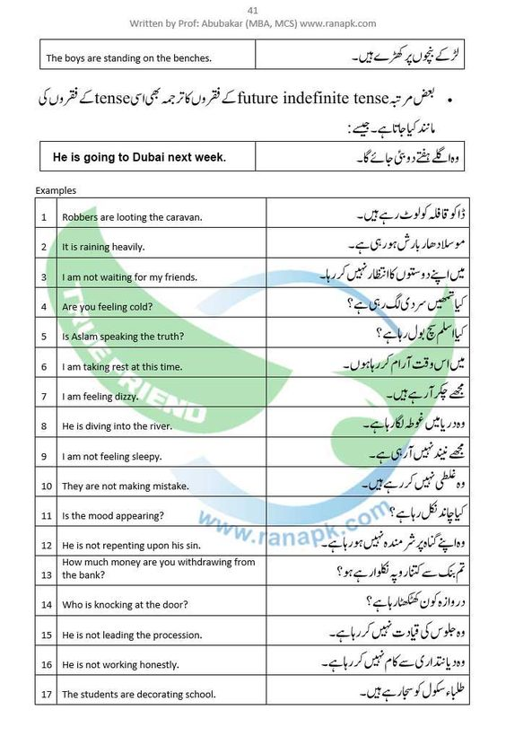

PRESENT PERFECT

* Perfect tense and hain, ha in the end

|  |  |
| --- | --- |
| **+ Positive** | Sub + Has/have + MV3 + OBJ |
| **- Negative** | Sub + Has/have + NOT + MV3 + OBJ |
| **? Interrogative (Yes or no Condition)** | Has/have + Sub + MV3 + OBJ |
| **??Double Interrogative (Detail Answer)** | WH-FAMILY + Has/have + Sub + MV3 + OBJ |

1. میں نے اپنے دوست سے بات کر لی ہے۔ (Main ne apne dost se baat kar li hai.) I have talked to my friend.
2. تم نے کھانا بنا لیا ہے۔ (Tum ne khana bana liya hai.) You have cooked the food.
3. وہ اپنی کار ساف کر لی ہے۔ (Woh apni car saaf kar li hai.) He has cleaned his car.
4. ہم نے اپنے بچوں کو نیند دلوا دی ہے۔ (Hum ne apne bachon ko neend dilwa di hai.) We have put our children to sleep.
5. تم نے پارٹی میں شرکت کر لی ہے۔ (Tum ne party mein shirkat kar li hai.) You have attended the party.
6. میری ماں نے کھانا بنا لیا ہے۔ (Meri maa ne khana bana liya hai.) My mother has cooked the food.
7. وہ لاہور میں رہ چکا ہے۔ (Woh Lahore mein reh chuka hai.) He has stayed in Lahore.
8. ہم نے کمرے کو صاف کر لیا ہے۔ (Hum ne kamre ko saaf kar liya hai.) We have cleaned the room.
9. تم نے اپنی کتاب کو کہاں رکھا ہے؟ (Tum ne apni kitaab ko kahan rakha hai?) Where have you kept your book?
10. میں نے اپنی گاڑی کو دھو لیا ہے۔ (Main ne apni gaadi ko dho liya hai.) I have washed my car.
11. وہ کھانا کھا چکی ہے۔ (Woh khana kha chuki hai.) She has eaten the food.
12. ہم نے اس پرانے گھر کو بیچ دیا ہے۔ (Hum ne us purane ghar ko bech diya hai.) We have sold that old house.
13. تم نے اپنی کتابیں تیار کر لی ہیں۔ (Tum ne apni kitaabein tayyar kar li hain.) You have prepared your books.
14. میری دوست نے فلم دیکھ لی ہے۔ (Meri dost ne film dekh li hai.) My friend has watched the movie

PRESENT PERFECT CONTINUOUS

* “Continuous tense with time given in it sure or not sure”
* Since for perfect date
* For for non-perfect date
* We call it perfect because it contains has/have also
* Positive and negative use mostly

|  |  |
| --- | --- |
| **+ Positive** | Sub + Has/have + been + MV1 + ing + OBJ + Since/for |
| **- Negative** | Sub + Has/have + NOT +been + MV1 +Ing + OBJ + Since/for |
| **? Interrogative (Yes or no Condition)** | Has/have + Sub +been + MV1 + ing + OBJ + Since/for |
| **??Double Interrogative (Detail Answer)** | WH-FAMILY + Has/have + Sub +been + MV1 + Ing + OBJ + Since/for |

