

Team 17

**Architecture for build 2-**

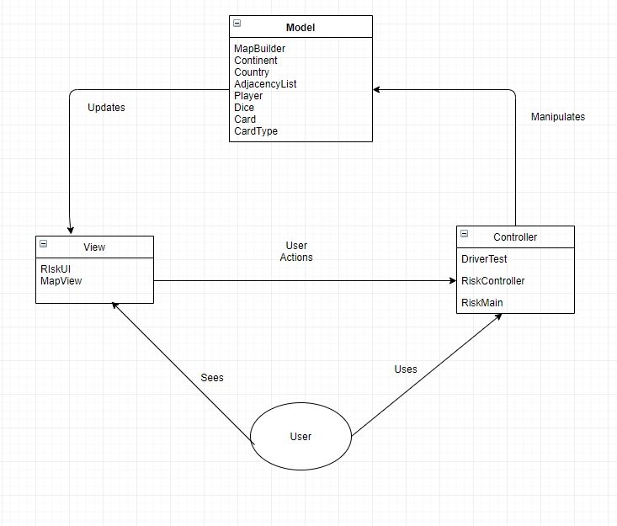

**Model Layer**

* Model layer includes classes that define the game entities, which are embedding their own state and actions.
* Model layer consists of following classes

model.Card

model.Dice

model.AdjacencyList

model.MapBuilder

model.CardType

model.Continent

model.Country

model.Player

**View Layer**

* This layer includes all classes related to visualization of the game or interaction with the user.
* View layer consists of following classes

view.MapView

view.RiskUI

**Controller Layer**

* This layer receives user input and initiate a response by making calls on appropriate model objects.
* Controller layer consists of following classes –

controller.DriverTest

controller.RiskController

Controller.RiskMain

**Design Patterns**

* Observer
* Observer pattern is used when there is one-to-many relationship between objects such as if one object is modified, its dependent objects are to be notified automatically.
* Example: adding or losing territories, exchanging cards, etc.

