

**Team 17**

**Build Architecture 3**

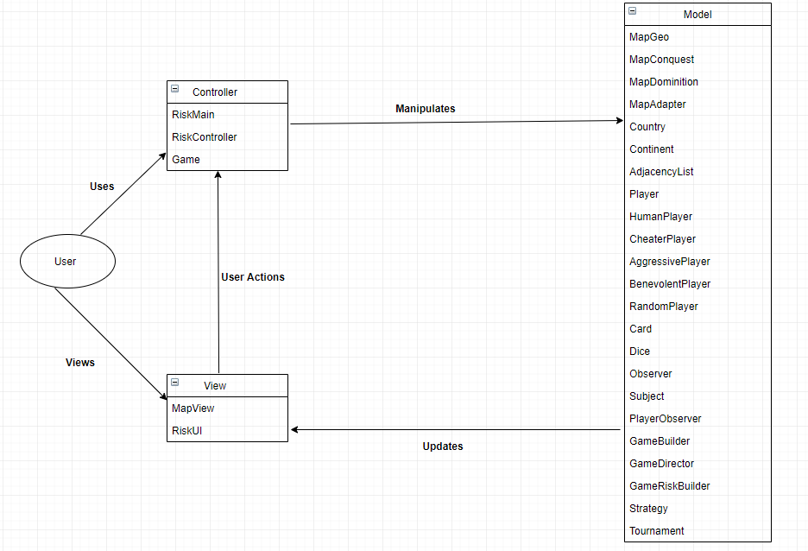

**Model Layer**

* Model layer includes classes that define the game entities, which are embedding their own state and actions.
* Model layer consists of following classes

model.MapGeo

model.MapConquest

model.MapDominition

model.MapAdapter

model.Continent

model.Country

model.AdjacencyList

model.Player

model.HumanPlayer

model.AggressivePlayer

model.BenevolentPlayer

model.CheaterPlayer

model.RandomPlayer

model.Card

model.Dice

model.Observer

model.Subject

model.PlayerObserver

model.GameBuilder

model.GameDirector

model.GameRiskBuilder

model.Strategy

model.Tournamentt

**View Layer**

* This layer includes all classes related to visualization of the game or interaction with the user.
* View layer consists of following classes

view.MapView

view.RiskUI

**Controller Layer**

* This layer receives user input and initiate a response by making calls on appropriate model objects.
* Controller layer consists of following classes –

controller.RiskController

controller.RiskMain

controller.Game

**Design Patterns**

**Observer**

* Observer pattern is used when there is one-to-many relationship between objects such as if one object is modified, its dependent objects are to be notified automatically.
* Example: adding or losing territories, exchanging cards, etc.



**Builder**

* Builder pattern separates the construction of a complex object from its representation so that the same construction process can create different representations.
* Example: saving an ongoing game, loading a saved game etc.



**Adapter**

* Adapter pattern makes classes work together which might not be able to use components from each other due to incompatible interfaces.
* Example: Reading a conquest map file, writing a new map file etc.

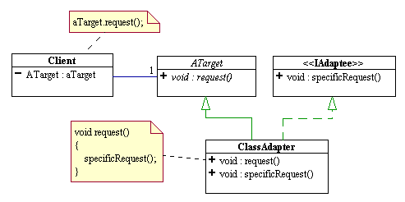

**Strategy**

* Strategy pattern allows some specific algorithm implemented by a method vary without affecting the classes using it.
* Example: Different implementation of different game phases based on type of player

