public static void main(String[] args) {  
      int v=8;  
      System.out.printf("%30d%n",v);  
      System.out.printf("%29d", v);  
      System.out.printf("%1d", v);  
      System.out.printf("%1d%n", v);  
      System.out.printf("%28d", v);  
      System.out.printf("%1d", v);  
      System.out.printf("%1d", v);  
      System.out.printf("%1d", v);  
      System.out.printf("%1d%n", v);  
      System.out.printf("%30d%n", v);  
      System.out.printf("%29d", v);  
      System.out.printf("%1d", v);  
      System.out.printf("%1d%n", v);  
      System.out.printf("%28d", v);  
      System.out.printf("%1d", v);  
      System.out.printf("%1d", v);  
      System.out.printf("%1d", v);  
      System.out.printf("%1d%n", v);  
      System.out.printf("%27d", v);  
      System.out.printf("%1d", v);  
      System.out.printf("%1d", v);  
      System.out.printf("%1d", v);  
      System.out.printf("%1d", v);  
      System.out.printf("%1d", v);  
      System.out.printf("%1d%n", v);  
      System.out.printf("%26d", v);  
      System.out.printf("%1d", v);  
      System.out.printf("%1d", v);  
      System.out.printf("%1d", v);  
      System.out.printf("%1d", v);  
      System.out.printf("%1d", v);  
      System.out.printf("%1d", v);  
      System.out.printf("%1d", v);  
      System.out.printf("%1d%n", v);  
      System.out.printf("%30d%n", v);  
      System.out.printf("%29d", v);  
      System.out.printf("%1d", v);  
      System.out.printf("%1d%n", v);  
      System.out.printf("%28d", v);  
      System.out.printf("%1d", v);  
      System.out.printf("%1d", v);  
      System.out.printf("%1d", v);  
      System.out.printf("%1d%n", v);  
      System.out.printf("%27d", v);  
      System.out.printf("%1d", v);  
      System.out.printf("%1d", v);  
      System.out.printf("%1d", v);  
      System.out.printf("%1d", v);  
      System.out.printf("%1d", v);  
      System.out.printf("%1d%n", v);  
      System.out.printf("%26d", v);  
      System.out.printf("%1d", v);  
      System.out.printf("%1d", v);  
      System.out.printf("%1d", v);  
      System.out.printf("%1d", v);  
      System.out.printf("%1d", v);  
      System.out.printf("%1d", v);  
      System.out.printf("%1d", v);  
      System.out.printf("%1d%n", v);  
      System.out.printf("%25d", v);  
      System.out.printf("%1d", v);  
      System.out.printf("%1d", v);  
      System.out.printf("%1d", v);  
      System.out.printf("%1d", v);  
      System.out.printf("%1d", v);  
      System.out.printf("%1d", v);  
      System.out.printf("%1d", v);  
      System.out.printf("%1d", v);  
      System.out.printf("%1d", v);  
      System.out.printf("%1d%n", v);  
      System.out.printf("%24d", v);  
      System.out.printf("%1d", v);  
      System.out.printf("%1d", v);  
      System.out.printf("%1d", v);  
      System.out.printf("%1d", v);  
      System.out.printf("%1d", v);  
      System.out.printf("%1d", v);  
      System.out.printf("%1d", v);  
      System.out.printf("%1d", v);  
      System.out.printf("%1d", v);  
      System.out.printf("%1d", v);  
      System.out.printf("%1d", v);  
      System.out.printf("%1d%n", v);  
      System.out.printf("%29d", v);  
      System.out.printf("%1d", v);  
      System.out.printf("%1d%n", v);  
      System.out.printf("%29d", v);  
      System.out.printf("%1d", v);  
      System.out.printf("%1d%n", v);  
      System.out.printf("%29d", v);  
      System.out.printf("%1d", v);  
      System.out.printf("%1d%n", v);

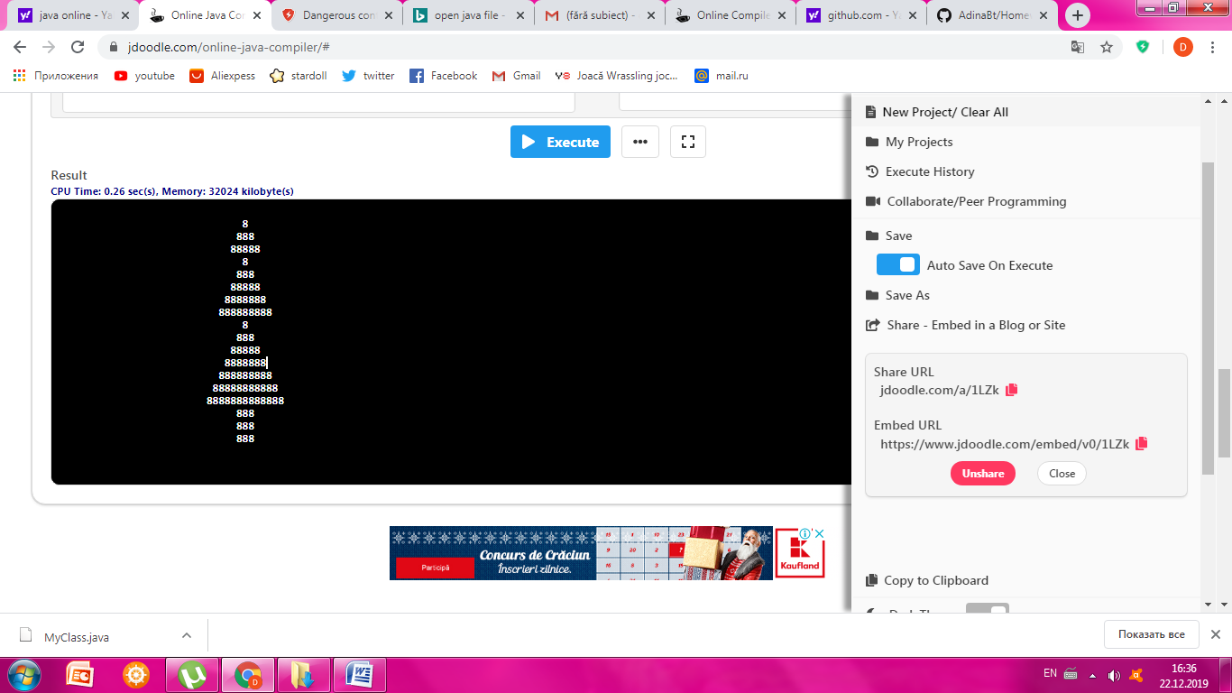

http://jdoodle.com/a/1LZk