# License

The software, data, and stimuli were released under the GNU General Public License v. 3, see

https://www.gnu.org/licenses/gpl-3.0.html

Some of the stimuli have been omitted due to copyright issues.

# Introduction

The data consist of data collected at 500 Hz from the Hi-speed system from SensoMotoric Instruments (SMI). They were collected from participants viewing images, videos, and moving dots. A full description of the data can be found in

Larsson, L., Nystrom, M., & Stridh, M. (2013). Detection of saccades and postsaccadic oscillations in the presence of smooth pursuit. Biomedical Engineering, IEEE Transactions on, 60(9), 2484-2493.

The same database has also been used in

Larsson, L., Nyström, M., Andersson, R., & Stridh, M. (2015). Detection of fixations and smooth pursuit movements in high-speed eye-tracking data. Biomedical Signal Processing and Control, 18, 145-152.

Andersson, R., Larsson, L., Holmqvist, K., Stridh, M., & Nyström, M. (2016). One algorithm to rule them all? An evaluation and discussion of ten eye movement event-detection algorithms. Behavior Research Methods, 1-22.

Please cite these articles when using any of the data provided here.

# Format and description of data

Data are stored in Matlab’s native format, .mat, and each file corresponds to data collected from one participant and one stimulus.

Each .mat-file contains a structure ETdata, which contains the fields

* sampFreq – sampling frequency at which data were recorded
* viewDist – distance eye to screen
* screenDim – physical size of screen in meters.
* screenRes – resolution of screen in pixels
* pos – n x 5 matrix where each row represents a sample, and the columns represent
  + timestamp in microseconds
  + horizontal pupil diameter
  + vertical pupil diameter
  + x-coordinate (gaze)
  + y-coordinate (gaze)

In .mat-files ending with labelled, a sixth column is present that represents the sample label, i.e., the outcome of the manual labeling process. The numbers represent

1. Fixation
2. Saccade
3. Post-saccadic oscillation
4. Smooth pursuit
5. Blink
6. Undefined, i.e., any sample that does not fit any of the other categories.

# Visualization and annotation of data

A simple way to visualize the data is to run the Matlab-GUI EventTag.m (Figure 1). Once the GUI has opened, press the ‘Load mat-file’ button and select the file you want to inspect. Events are represented with colors according to Table 1. The GUI contains five different windows, each showing data selected from the same time window. The windows in the left column show the x-, and y-coordinates of the gaze data in pixels, the sample-to-sample velocity, and the vertical pupil diameter in camera pixels. The x-axis represents time in ms. The right hand side of the GUI shows an (x,y) plot of the gaze-coordinates (top) as well as a zoomed in version of the most recent detected event (bottom).

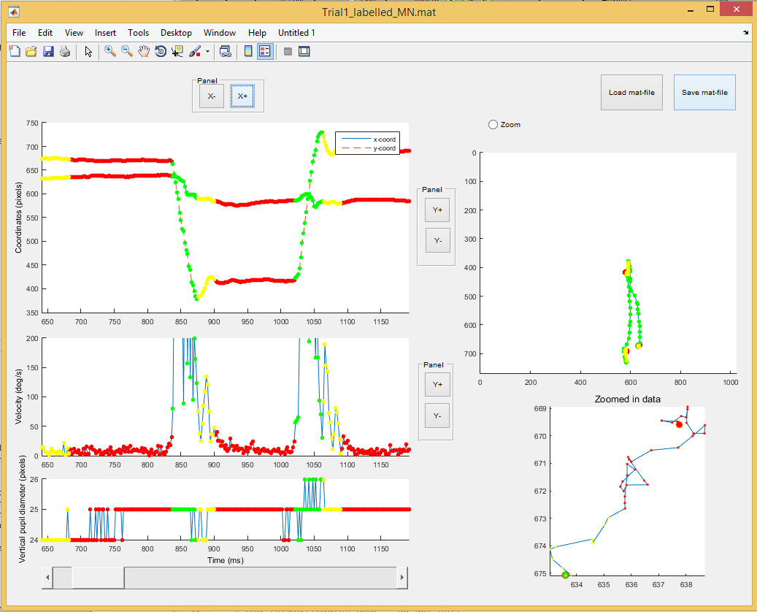

Figure 1. Screenshot from the Matlab-GUI for visualization and tagging of data.

The GUI can also be used for manual annotation of data using the shortcuts in the Table 1. To label any portion of the data, press a key according to the desired event type, and then click at the onset and offset of the event. A successful annotation changes the color of the labeled samples. Once you are done labelling, press the ‘Save mat-file’ button, and save the file using a new name. The name ‘name_labelled.m’ is suggested per default, where ‘name’ is the name of the original file.

Table 1. Color coding and shortcuts for manual labelling of data in the Matlab-GUI EventTag.m.

|  |  |  |
| --- | --- | --- |
| **Color** | **Event** | **Shortcut key** |
| **Red** | Fixation | F |
| **Green** | Saccade | S |
| **Yellow** | Post-saccade oscillation | G |
| **Pink** | Smooth pursuit | P |
| **Black** | Blink | B |
| **Turquoise** | Undefined | U |