IT3091 MACHINE LEARNING
Comprehensive Project Documentation
European Football Match Outcome Prediction Using Team Form,
Starting-XI Positional Strength and Tactical Context
Guided Data Track | Sports Analytics (Code 9) | Group 2026-DS-09
Primary lens: Match Outcome Analysis | Secondary lens: Team Performance and Form Analysis
Prediction point: after the official starting XI is known, before kickoff
Target: Home Win / Draw / Away Win | Primary metric: Macro-F1
Document status
This document combines the assignment brief, prior research literature, the engineered dataset, mathematical foundations, the complete machine-learning implementation, and real, executed results. All figures in Part V and Appendix C come from the executed notebook (seed 42) or from the separately run checks named in the note under Section 18.3; none are estimated or invented.

Prepared for academic implementation and final-group reporting.

Contents
Executive Summary 3
Part I — Assignment Framing and Research Design 5
1. Assignment Alignment and Assessment Strategy 5
2. Business Context, Stakeholder and Decision Need 5
3. Research Questions, Objectives and Hypotheses 6
4. Prediction Boundary and Leakage Contract 7
Part II — Literature Review and Theoretical Foundation 8
5. Football Outcome Modelling Literature 8
6. Literature-to-Design Synthesis and Research Gap 9
7. Mathematical Formulation of the Prediction Problem 10
Part III — Dataset, Data Understanding and Feature Engineering 11
8. Dataset Provenance and Lineage 11
8.2 Independent Verification of the Provenance Claims 11
8.3 Source-Data Notes and Final Data Audit 12
9. Exploratory Data Analysis and Data-Quality Reasoning 12
9.5 Multicollinearity Diagnostic 14
9.6 Descriptive Statistics for Key Numeric Features 15
9.7 Season-by-Season Outcome Table 15
10. Feature Engineering Theory and Formulas 16
11. Feature Sets FS1-FS4 and Ablation Logic 17
Part IV — Machine-Learning Implementation 18
12. Chronological Splitting and Temporal Validation 18
13. Preprocessing Pipeline 19
14. Candidate Models and Mathematical Theory 19
15. Temporal Tuning and Class-Imbalance Experiments 21
Part V — Evaluation and Interpretation (Executed Results) 22
16. Evaluation Metrics and Mathematical Definitions 22
17. FS1-FS4 Ablation Results 22
18. Model Comparison on FS3 23
18.4 Statistical Significance (Paired Bootstrap) 25
18.5 Additional Models Checked After Selection 25
18.6 Other Selection Measures 26
18.7 Overlapping Features 27
18.8 Poisson Goal Model 28
19. Final Test Evaluation (2024-25) 29
20. Explainability and Football Interpretation 32
Part VI — Reproducibility and Project Execution 34
21. Notebook Architecture and Implementation Stages 34
22. Decision Log, AI-Use Transparency and Evidence Package 35
23. Team Responsibilities and Work Allocation 35
Part VII — Stakeholder Value, Limitations and Optional Extension 37
24. Practical Decision-Support Output 37
25. Limitations, Risks and Responsible Use 37
26. Optional Football Simulator and AI Explanation Extension 39
Appendices A-L 40

Executive Summary
This project formulates European football match forecasting as a supervised multiclass classification problem. One row represents one match and the target is H (home win), D (draw) or A (away win). The primary analytical dataset contains 51,201 matches, 62 columns and nine leagues, covering 2008-08-09 to 2026-05-24. The dataset combines a historical European Soccer SQLite stage (2008/09-2015/16) with a modern Transfermarkt-derived stage (2016/17-2025/26), harmonised into one causal, pre-match feature schema.
The central scientific question is not simply which algorithm scores highest. The project tests whether progressively richer pre-match information adds measurable predictive value: recent form (FS1), starting-XI quality (FS2), positional and opponent-relative matchups (FS3), and formation/lineup continuity (FS4). This feature-set ablation is combined with a competition among six models against a Dummy baseline: multinomial Logistic Regression, Gaussian Naive Bayes, k-Nearest Neighbours, a Decision Tree, a Random Forest and Gradient Boosting. Further models (a neural network, HistGradientBoosting, XGBoost, AdaBoost, linear and kernel support vector machines, and ordinal logistic regression) and the classic statistical approach, a Poisson goal model, were checked afterwards on validation data; none beat the Random Forest by the pre-set margin of 0.01 (Sections 18.5 and 18.8).
The evaluation is strictly temporal: seasons up to 2022 form the training period (42,795 matches), 2023 (the 2023/24 season) is the validation period (2,802 matches), and 2024-25 (the 2024/25 and 2025/26 seasons) is the held-out test period (5,604 matches), on which the frozen model is scored exactly once (the robustness checks in Section 18.3 re-score it only to measure sensitivity, never to choose the model). All results below come from the executed notebook; the checks run separately are marked in Section 18.3.

Key results
- FS1 → FS4 ablation on validation (all six models): adding starting-XI quality (FS2) raises Macro-F1 for every model, by 0.050 to 0.072. The best feature set, FS3, reaches 0.473 against a Dummy baseline of 0.201. Positional detail (FS3) adds little beyond FS2, and formation/continuity (FS4) adds nothing.
- Class weighting is the decisive modelling choice. With class_weight = balanced, Random Forest, Gradient Boosting, the Decision Tree and Logistic Regression raise Draw F1 from about 0.00-0.01 to 0.27-0.34 and validation Macro-F1 by 0.08-0.09, at a small log-loss cost. The tuned, class-weighted Random Forest on FS3 has the highest validation Macro-F1 (0.492, log loss 0.983) and was frozen as the final model.
- On the untouched 2024-25 test set (5,604 matches) the final model reaches Macro-F1 0.473 (95% bootstrap CI 0.460-0.486), accuracy 48.9%, log loss 1.008 and Brier score 0.603, against 0.202, 43.4%, 1.075 and 0.651 for the Dummy baseline. For context, a one-feature rule that predicts the most common result for each tenth of the XI strength gap reaches 51.4% accuracy on the same test seasons but Macro-F1 only 0.379, because it never predicts a draw (Section 19.5).
- Draw remains the hardest class (test Draw F1 0.326, against 0.579 for Home and 0.513 for Away). Results are stable across leagues (Macro-F1 0.42-0.52), seasons, training on the modern era only (0.471), and the data-quality variants tested (test Macro-F1 changes between −0.006 and +0.001; none is better than the official model).
Core contribution
The final contribution is evidence about whether recent team form plus actual starting-XI, positional and opponent-relative information improves pre-match H/D/A prediction on unseen future matches, while maintaining strict leakage control, interpretable probability outputs, and an honest account of the trade-off between Macro-F1, draw recognition and probability quality (log loss).

How this document should be used
- Use Parts I-III as the final-report foundation: assignment alignment, literature review, and dataset methodology.
- Use Parts IV-VI as the implementation specification and the executed results for the notebook and final model-selection process.
- Use Part VII as the interpretation, stakeholder-value, limitations and responsible-AI section.
- Use the appendices for the dataset snapshot and data dictionary, the populated results tables, the full decision log, the reproducibility settings, the inventory of code and evidence files (Appendix I), and the EDA insight log, the feature and preprocessing log and the problem-framing canvas (Appendices J to L).

Part I — Assignment Framing and Research Design

1. Assignment Alignment and Assessment Strategy
The assignment descriptor places this group in the Guided Data Track under Sports Analytics (Code 9). The assessment rewards defensible decisions rather than recipe-following: clear problem framing, coherent workflow and decision logging, EDA/data-quality reasoning, justified preprocessing and feature engineering, model comparison, honest validation, practical recommendation, and reproducibility/AI-use transparency.
Decision lenses. The primary lens is match outcome analysis: before kickoff, the stakeholder needs to know how likely a home win, a draw and an away win are, so the task is a three-class prediction with probabilities (Sections 2–3). The secondary lens, team performance and form analysis, is used only where it strengthens that decision. Home advantage and recent form are the first patterns examined in the EDA (Section 9), recent form is the baseline feature set (FS1), and FS1 is the reference against which the value of starting-XI information is tested (RQ2). No separate analysis is run for the secondary lens on its own.
Data source. The dataset that the descriptor links for Code 9 (labelled Football-Data: the Kaggle European Soccer Database, https://www.kaggle.com/datasets/hugomathien/soccer) is the controlled source and forms Stage 1 of the project (2008/09–2015/16). It ends in 2016, so, as proposed in the initial submission, Transfermarkt data (transfermarkt-datasets) is added as a declared supplementary source for 2016/17–2025/26. Both stages are converted to the same 62-column pre-match schema (Section 8); on the 2012–2015 seasons covered by both sources, 99.83% of Stage 1 matches have the same league, date and score in Transfermarkt (Appendix I).
The core analytical deliverable is the reproducible machine-learning study, not any optional web application or simulator. The submission therefore foregrounds the evidence chain from business question to data, leakage control, feature-set experiments, model competition, validation, interpretation and recommendation.
Assessment area | How this project answers it | Where the evidence is
Problem framing | Pre-kickoff H/D/A decision-support for football analysts | Problem-framing canvas (Appendix L); prediction cut-off (Section 4)
Workflow and decisions | Staged, leakage-aware analytical pipeline | Workflow figure (Section 21); decision log (Appendix D)
EDA and data quality | Target balance, coverage, missingness, league/season/source transitions | QA tables and EDA figures (Sections 8–9); insight log (Appendix J)
Preprocessing/features | Past-only form, causal player strength, positional aggregation, opponent-relative features | Feature, preprocessing and leakage logs (Appendix K); pipeline code (Appendix I)
Model strategy | Baseline + multiple statistical/ML alternatives + FS1-FS4 ablation | Model comparison tables (Sections 17–18)
Evaluation | Chronological validation, Macro-F1 plus probability and class-wise metrics | Split (Section 12); metric tables and confusion matrix (Sections 16–19)
Recommendation/value | Probability output with interpretable pre-match context | Recommendation and limitations (Sections 24–25)
Reproducibility/AI | Executable pipeline, dataset fingerprint, explicit AI-assistance declaration | Code and settings (Appendices E and I); AI-use statement (Section 22)

2. Business Context, Stakeholder and Decision Need
The intended stakeholder is a football club performance-analysis team, coaching/technical staff, or a sports organisation seeking a consistent quantitative summary of pre-match conditions. The model is not intended to replace football judgement and is not framed as a betting recommendation system.
The practical decision need arises after the official starting lineups are available but before kickoff. At that point a coach or analyst knows the actual XI, formation, recent form and opponent. The system converts those inputs into a probability distribution over the three possible results and provides enough context to understand which pre-match factors are associated with the prediction.
P(Result) = f(Form, Starting XI, Positional Strength, Formation, Opponent Matchups, League Context)
A probability output is preferable to a single hard label because it preserves uncertainty. For example, Home = 0.57, Draw = 0.25, Away = 0.18 communicates a substantially different risk profile from Home = 0.36, Draw = 0.32, Away = 0.32, even though both might return “Home” as the arg-max class.

3. Research Questions, Objectives and Hypotheses
Primary research question: can recent team form, starting-XI player quality, squad composition, positional strengths and league context be used to predict European football match outcomes before kickoff?
Supporting research question: does adding player-aware and positional information improve predictive performance compared with using team-level form and match context alone?
ID | Question / hypothesis | How it was tested | Result (this run)
RQ1 | How accurately can H/D/A outcomes be estimated on unseen future-period matches? | Final chronological test metrics: Macro-F1, class-wise F1, balanced accuracy, log loss | Test Macro-F1 0.473 (95% CI 0.460-0.486), accuracy 48.9%, log loss 1.008 (final Random Forest) vs Dummy baseline 0.202 / 43.4% / 1.075
RQ2 | Does starting-XI information improve prediction beyond team form? | FS1 vs FS2 ablation, all six models, same match sample | Every model gains 0.050-0.072 Macro-F1; best 0.392 → 0.464 (+0.072, 95% CI 0.055-0.089)
RQ3 | Do positional and opponent-relative features add further information? | FS2 vs FS3 comparison | Small: best model 0.464 → 0.473 (+0.009); other models −0.015 to +0.001; positional group importance 0.036
RQ4 | Does formation/lineup continuity add further value? | FS3 vs FS4 comparison | No: best FS4 score 0.416 (kNN); no model gains more than 0.003, Naive Bayes collapses (0.373); continuity LR test p = 0.19 (0.38 after Holm adjustment)
RQ5 | Which classifier generalises best under time-aware validation? | Common validation protocol across six candidate models on FS3, tuned with temporal cross-validation | Class-weighted Random Forest leads (0.492, log loss 0.983), Gradient Boosting 0.491, Logistic Regression 0.485; Naive Bayes 0.473 but log loss 2.35
RQ6 | How difficult is the Draw class, and can weighting/calibration improve useful performance? | Class-wise Draw precision/recall/F1; weighted vs unweighted experiment | Unweighted LR/DT/RF/GB: Draw F1 0.00-0.01; balanced class weights: Draw F1 0.27-0.34 and Macro-F1 +0.08 to +0.09 at about +0.02 log loss; test Draw F1 0.326. Calibration was checked on test but not corrected: P(Home) is on average 8.6 points too low and P(Draw) 7.3 points too high (Section 19.6)
RQ7 | Does the player-quality signal remain useful across the historical-to-modern source transition? | Full-history vs modern-only robustness experiment, identical future test period | Yes: modern-only training gives test Macro-F1 0.471 vs 0.473 for full history; the XI-strength effect does not differ between sources (p = 0.44)

4. Prediction Boundary and Leakage Contract
The single most important design rule is that every predictor must exist before kickoff. This turns the project from retrospective description into a valid forecasting study. The target is created from final home/away goals, but those goals and all same-match event statistics are excluded from the predictor matrix.
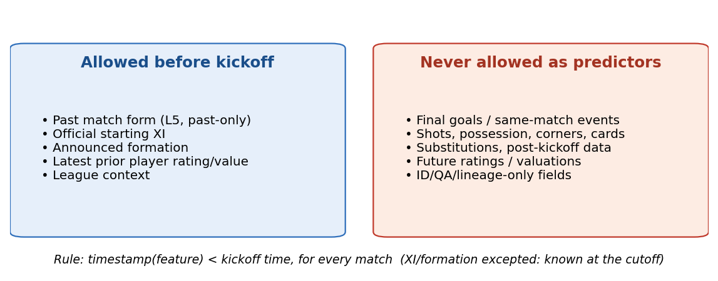
Figure 1. Prediction cut-off and leakage contract: only information available before kickoff may enter the feature matrix X.
Formal leakage rule
For every feature observation x used for match i, the evidence timestamp must satisfy timestamp(x) < kickoff_i, except the announced XI/formation, which is allowed because the prediction cutoff is explicitly after lineups are known and before kickoff.
This rule was verified programmatically, not just asserted: recent-form values were independently recomputed using an earlier-matches-only window and compared against the values shipped in the dataset (100% agreement across 99,509 team-match rows), and a unit test confirmed that changing a match's own recorded goals does not alter that match's own feature values. See Section 8.2 for the full verification table.

Part II — Literature Review and Theoretical Foundation

5. Football Outcome Modelling Literature

5.1 Carpita, Ciavolino and Pasca (2019): role-based team indicators from the Kaggle European Soccer database
Using the Kaggle European Soccer database (10 leagues, 2009/10-2015/16), Carpita et al. average FIFA-derived player attributes by line-up role (forward, midfielder, defender, goalkeeper), linking each player's most recent rating before the match, and use home-minus-away role differences to predict home win versus no-win. Binomial logistic regression, extended with an Elo rating and random effects, is compared with Random Forest, a neural network, k-NN and Naive Bayes; all reach about 64% accuracy, roughly ten points above the majority class, and defenders' defending has the largest role effect. Results are reported separately for 2009-2011 and 2012-2015, because FIFA ratings were updated only twice a year until January 2013 and more often afterwards.
Strength: the role aggregation and the pre-match rating join transfer directly to Sections 10.2, 10.3 and 10.5, and the two-period reporting is a precedent for this project's source-transition check (RQ7). Limitation: draws are merged with losses, models are evaluated on random 70/30 bootstrap splits rather than on later matches, and prediction is judged by accuracy, sensitivity and specificity only. This project keeps three classes, splits chronologically (Section 12) and adds probability metrics (Section 16).

5.2 Hucaljuk and Rakipović (2011): classifier comparison with later-round testing
Despite its title, this study predicts the three-class outcome (home win, draw, away win) of the 96 group-stage matches of one UEFA Champions League season. Six Weka classifiers (Naive Bayes, Bayesian network, LogitBoost, k-NN, Random Forest and a neural network) are compared on a 20-feature basic set (form over the last six games, goals scored and conceded, injuries, league position, previous meeting) and on the same set plus expert team ratings. Models are trained on the first three, four or five rounds and tested only on later rounds; the best result is 68.8% accuracy (F1 0.692), by a neural network.
Strength: test matches always follow training matches, the principle behind Section 12, and F1 is reported alongside accuracy. Limitation: the test sets are very small (16-48 matches), the best model is chosen from test results, and no probability scores are reported; this project selects on a separate validation season, scores the frozen model once (Section 12) and reports log loss and Brier score (Section 16). The authors' own suggestion to model the form of each player is the direction taken by the starting-XI features of FS2 (Section 11).

5.3 Cattelan, Varin and Firth (2013): dynamic team abilities and forward forecasting
Cattelan et al. extend the Bradley-Terry paired-comparison model so that each team's home and away abilities evolve as exponentially weighted moving averages of its past results; for football, a cumulative logit version handles draws. For Serie A 2008-09 (380 matches) and the NBA 2009-10 season, the model is refitted from mid-season after each match day and used to forecast only the next day's matches, scored with the Brier score (NBA) and the rank probability score (football). In football it matched a static team-specific model (mean rank probability score 0.451 vs 0.450) and beat empirical proportions (0.468).
Strength: its results-based abilities parallel the form features of Section 10.1, and its strictly forward forecasting and probability scoring support Sections 12 and 16. Limitation: abilities use only past results, with no player information, which is the gap that FS2 and FS3 address (Section 11).

5.4 Karlis and Ntzoufras (2009): Skellam model for the goal difference
Karlis and Ntzoufras model the goal difference with a Skellam (Poisson-difference) distribution: the home scoring rate combines a home effect, the home team's net attacking parameter and the visitor's defensive parameter, and the away rate combines the visitor's attack with the home defence. Parameters are estimated by Bayesian MCMC on one English Premier League season (2006-07). Because Poisson goal-count models tend to underestimate draws, they propose a zero-inflated variant, but find it unnecessary, since their model slightly overestimates draws. Section 18.8 tests this family of goal-count models on the project's data, with each team's expected goals predicted from the pre-match features.
Strength: the attack-against-opponent-defence structure parallels the matchup features of Section 10.5, and the model yields Home/Draw/Away probabilities. Limitation: team strengths are static and are evaluated only by goodness of fit on the same season, with no future-match test or classification metric, so per-match draw recognition, studied in Sections 16-18, is outside its scope.

5.5 Hewitt and Karakuş (2023): position-adjusted expected goals
Hewitt and Karakuş build an expected-goals (xG) model, a shot-level goal/no-goal classifier (a logistic-regression baseline, then gradient-boosted trees) trained on 15,575 open-play StatsBomb shots, mostly from La Liga; it correlates 0.902 with StatsBomb's own xG. For position-adjusted xG they retrain it on forwards', midfielders' or defenders' shots only: across all shots, the forward-trained model gives 86 more xG and the defender-trained model 473 fewer.
Strength: evidence that finishing efficiency differs by positional group supports ranking players within their role (Sections 10.2-10.3). Limitation: it does not predict match results, and xG is computed from in-match shots, so under the leakage contract (Section 4) it could enter this project only as a lagged pre-match average.

5.6 Link and Hoernig (2017): in-match ball possession as a boundary case
Link and Hoernig detect individual and team ball possession automatically from 25 Hz player-and-ball tracking data, using distance and ball-acceleration thresholds plus a Bayesian network for ball control. Against manually annotated matches they reach F = .88 for individual ball actions and κ = .67 for ball control, and then profile possession in 60 Bundesliga matches.
Strength: careful validation against human-coded ground truth. Limitation: it does not address match-outcome prediction. It is cited as a boundary case: possession, and the passes and shots derivable from it, are measured during play, and the authors note, citing earlier work, that possession is “the consequence of a process of interaction” shaped partly by “the current score”. Such variables would leak outcome information, so Section 4 excludes them.

5.7 Snoek, Larochelle and Adams (2012): Bayesian optimisation of hyperparameters (methodological source)
Snoek et al. treat hyperparameter tuning as optimising an expensive black-box function: a Gaussian-process model of validation performance, with an expected-improvement criterion, chooses each next configuration. On online LDA it beat a 288-setting grid search with a fraction of the experiments, and on CIFAR-10 it surpassed expert tuning (14.98% vs 18% test error).
Strength: a principled, sample-efficient alternative to grid search. Limitation: its benchmarks are costly, non-tabular models, so gains for small, cheap grids are not shown. This project's small grids made exhaustive GridSearchCV over a TimeSeriesSplit affordable (Section 12); Bayesian optimisation would suit larger search spaces, for example for XGBoost or neural networks (Section 18.5), and is noted as future work.

6. Literature-to-Design Synthesis and Research Gap
Individually, the literature supports role-aware aggregation of player quality (Carpita et al.; Hewitt and Karakuş), opponent-relative comparison (Karlis and Ntzoufras; Cattelan et al.), testing only on later matches (Hucaljuk and Rakipović; Cattelan et al.), probability scoring (Cattelan et al.) and attention to draws (Carpita et al.; Karlis and Ntzoufras). No reviewed study combines them: Carpita et al. use role-based player ratings but random splits and a binary target; Cattelan et al. forecast forward and score probabilities but use no player information; Hucaljuk and Rakipović test on later rounds but on 16-48 matches. Few accessible open studies combine all of these inside one auditable, leakage-tested, publicly reproducible pipeline spanning both a historical FIFA-rating era and a modern market-value era within the same nine-league panel.
The research gap this project addresses is therefore not a new algorithm, but a disciplined synthesis: harmonising two structurally different player-quality signals onto one causal scale, testing their incremental value through an explicit FS1-FS4 ladder, and reporting honestly where a single “best” metric (Macro-F1) and probability quality (log loss) disagree — a tension that is common in imbalanced multiclass sports prediction but rarely discussed openly in student-level work.

6.1 A methodological critique the literature does not fully resolve
Classifier-comparison studies in this space rank models by classification metrics alone: Carpita et al. (2019) by accuracy, sensitivity and specificity, and Hucaljuk and Rakipović (2011) by accuracy and F1, choosing the best model from test results; neither reports a probability score. The results in Sections 17-18 show why that is risky. Without class weighting, Gaussian Naive Bayes leads the feature-set ablation on Macro-F1 (0.473 on FS3), yet its validation log loss (2.36) is more than twice that of every tree-based or linear model (0.96-0.99), and it collapses on FS4 (Macro-F1 0.373, log loss 5.80) once one-hot formation columns are added. A Macro-F1 leaderboard alone would have picked a model whose probabilities are unusable, which is why this project, like Cattelan et al. (2013, Section 5.3), also scores the predicted probabilities.
A second gap concerns draw prediction specifically. Carpita et al. (2019) merge draws with losses, and Karlis and Ntzoufras (2009, Section 5.4) treat draws as a question of matching the overall draw rate; neither evaluates whether individual draws can be recognised. Sections 15 and 18 show this directly on an identical feature matrix and split: without class weighting, Logistic Regression, the Decision Tree, Random Forest and Gradient Boosting effectively abandon the Draw class (Draw F1 0.00-0.01), while balanced class weights raise Draw F1 to 0.27-0.34 and Macro-F1 by 0.08-0.09 at a log-loss cost of about 0.02. The decisive factor is the loss weighting, not the model family, and with weighting the Macro-F1 leader (Random Forest, 0.492) also has near-best log loss (0.983, against 0.964 for the best unweighted model). This is a reportable, falsifiable finding about this problem, not a restatement of the literature's general observation.

7. Mathematical Formulation of the Prediction Problem
Let match i have kickoff time t_i. The predictor vector x_i is constructed entirely from evidence with timestamp strictly before t_i (Section 4). The target y_i ∈ {H, D, A} is defined from full-time goals:
y_i = H if goals_home > goals_away; D if goals_home = goals_away; A if goals_home < goals_away
A classifier f_θ is fitted to estimate the conditional class probabilities:
p̂_i = f_θ(x_i) = (P̂(H|x_i), P̂(D|x_i), P̂(A|x_i)), Σ_k p̂_{i,k} = 1
Model parameters θ are estimated on the training period only. Hyperparameters are selected using the validation period (2023). The final, frozen model is evaluated exactly once on the test period (2024-25). This sequence — fit → tune → freeze → evaluate once — is the temporal analogue of standard supervised-learning practice and is what prevents information from the evaluation period influencing any modelling decision.

Part III — Dataset, Data Understanding and Feature Engineering

8. Dataset Provenance and Lineage
The primary analytical file is European_Football_PlayerAware_Primary_9Leagues_2008_2026.csv: 51,201 matches, 62 columns, nine leagues, seasons 2008/09 through 2025/26. It was engineered in two stages from two public sources, harmonised onto one causal, pre-match schema.
Stage | Seasons | Source | Player-quality basis
1 (european_soccer_sqlite_stage1) | 2008/09 - 2015/16 | European Soccer SQLite: matches, team/player IDs, lineups, formations, final scores, historical player attributes | Latest pre-match FIFA overall_rating
2 (transfermarkt_stage2) | 2016/17 - 2025/26 | Transfermarkt: matches, lineups, players, positions, historical market valuations | log1p(latest pre-match market value)

Pipeline: clean matches → strictly pre-match joins → L5 form features (past same-season matches only) → starting-XI / positional / continuity features → causal 0-100 strength harmonisation → opponent-relative features → identical 62-column schema for both stages → row-wise union → coverage filtering → primary 9-league CSV.
- Causal harmonisation: each player value becomes a 0-100 index using only same-league, same-role observations from strictly earlier dates; same-date matches are scored before the reference set is updated (Section 10.2).
- Prediction cutoff: after the announced XI, before kickoff — lineup, formation and strength features are legitimate predictors only once team sheets are public.
- Goals are audit-only: the H/D/A target is created from final goals, kept for auditing and never used as a predictor.
- Missing values are left as NaN, never filled with 0, and reserved for train-only imputation (Section 13).
- Eleven leagues were reduced to nine: Switzerland (C1) and Poland (PL1) had only partial modern-era coverage and were dropped to keep one continuous panel.
Builder QA checks (independently re-verified in Section 8.2): identical schema across stages, zero duplicate match_uid, zero null targets, only valid H/D/A values, zero target-versus-goals mismatch, no source-date overlap, no strength value outside 0-100.

8.2 Independent Verification of the Provenance Claims
Because this dataset feeds a graded assignment, its construction claims were checked programmatically rather than taken on trust.
Claim | Check performed | Result
Target matches final goals | Recompute H/D/A from audit_home_goals/audit_away_goals and compare to target_result | 0 mismatches across 51,201 rows
No duplicate matches | Duplicate check on match_uid and game_id | 0 duplicates on either key
Form features are causal (past-only) | Recompute L5 goals-for using an earlier-matches-only window; compare to the shipped column | 100% agreement (99,509 team-match rows); only 25.2% would match if the current match were wrongly included
Derived difference columns are internally consistent | Recompute xi_strength_diff, midfield/gk diffs, attack-vs-defence diffs from their component columns | Max absolute error ≈ 0 (floating-point rounding only)
Strength scale within 0-100 | Range check on all *_strength columns | Confirmed
Two eras have non-overlapping team-id systems | Set intersection of home_team_id between the two data_source values | Empty intersection — Elo/team-history-style features would need to restart at the 2016 boundary

8.3 Source-Data Notes and Final Data Audit
A final audit compared the number of matches in every league-season with the fixtures each league actually plays, and traced every anomaly back to the raw files. None was introduced by the build pipeline: each is either a gap in the source data or a real-world event. They are documented rather than corrected, and Section 18.3 shows that the related data-quality fixes do not change the results.
Source-data note | Evidence | Treatment
Belgium 2013/14 almost missing; 2009/10 short | 12 of 240 and 210 of 240 matches in the raw SQLite Match table | Kept; source gap; test seasons unaffected
Serie A raw gaps | 2011/12 missing 22 matches; 2014/15 missing 1 | Kept; negligible
Belgian play-offs not included | Both sources hold the regular season only (240 matches with 16 teams, 306 with 18 teams; seasons end in March or April) | Consistent across sources; no action
Scottish league split | Stage 1 (2008/09-2015/16) and the first Stage 2 season (2016/17) include the post-split rounds (228 matches per season); from 2017/18 Stage 2 holds the 198-match regular season only | Kept; removing the 238 Stage 1 post-split matches changes test Macro-F1 by +0.001 (Section 18.3)
COVID-shortened 2019/20 season | France 279 of 380, Netherlands 232 of 306, Belgium 232 of 240, Scotland 179 of 198 matches; restart matches from May to August 2020 | Kept with correct season labels; the following empty-stadium season (2020/21) shows the home-advantage dip discussed in Section 9.7
League size changes | France 20 → 18 teams, Portugal 16 → 18, Belgium 16 / 18 | No action; all features are per match
Matches without any recorded lineup | 662 matches (517 in 2008/09, 129 in 2018/19, 14 in other 2016-2022 seasons, 2 in the test period); in 659 of them neither side has a recorded lineup | Kept; player features imputed inside the pipeline; dropping them changes test Macro-F1 by −0.003 (Section 18.3)
The full list of 26 issues found during the project, with evidence, treatment and status, is kept in the accompanying Data Issues Register (Data_Issues_Register.xlsx).

9. Exploratory Data Analysis and Data-Quality Reasoning

9.1 Target balance and home advantage
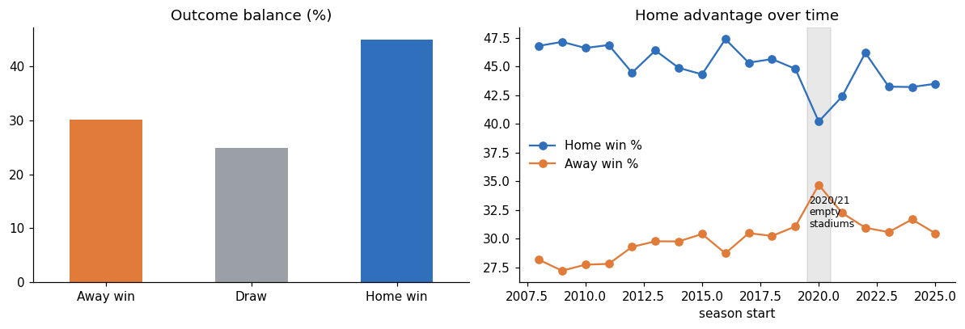
Figure 2. Left: overall H/D/A balance (Home 45.0%, Draw 24.9%, Away 30.1%). Right: home-advantage drift by season, with the 2020/21 empty-stadium season visibly suppressing the home edge.

9.2 Data-quality and heterogeneity
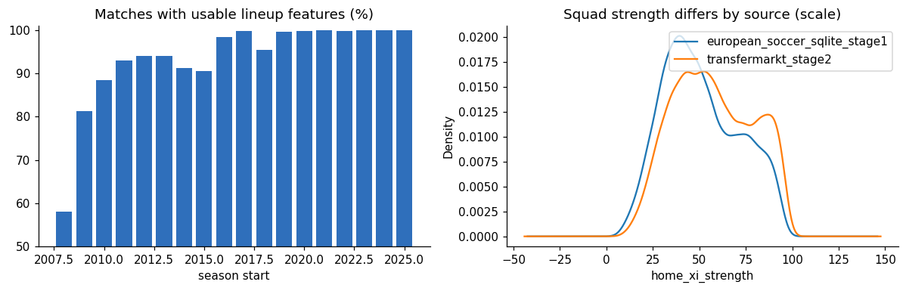
Figure 3. Left: share of matches with usable lineup-strength features by season (worst in 2008, the first season, where prior player evidence is thinnest). Right: squad-strength distributions differ between the FIFA-rating era and the market-value era, which is why each player value is ranked within league and role before it enters the model (Section 10.2).

9.3 Does squad strength relate to the result?
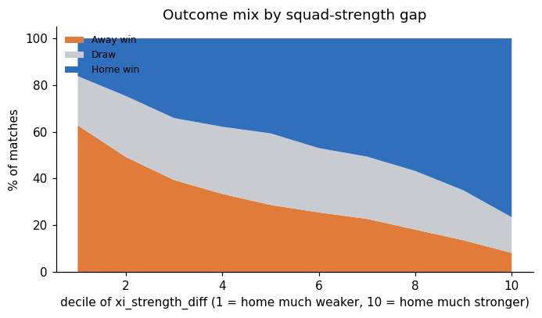
Figure 4. Outcome mix by decile of xi_strength_diff. Home win share rises monotonically with the strength gap; draw share is fairly stable across deciles, consistent with the literature's observation that draws resist strength-based prediction (Section 5.4).

9.4 Missing-data reasoning
About 11% of matches have at least one missing field. Three distinct causes were identified and are treated differently:
Source of missingness | Typical % | Cause | Handling
Recent-form columns (*_L5) | ~2.8% | Structural: the L5 window resets each season, so a team's first match of a season has no prior-season history to draw on | Kept as NaN; form_n_L5 tells the model how many prior matches exist; train-only median imputation for scale-sensitive models
Squad-strength columns | 1.5%-2.7% overall, 20%-26% in 2008 | Coverage gap: the causal percentile needs prior same-league, same-role history, which is thinnest at the very start of the panel | Kept as NaN; a percentile is issued only when at least 30 earlier same-league, same-role values exist, and XI strength needs at least 8 rated starters (Section 10.3)
Lineup continuity | ~7.4% | Undefined for a team's first match of a season (no previous-match XI to compare against) | Kept as NaN; included in FS4 only, where its incremental value is tested directly
No row was dropped for missingness. Dropping would disproportionately remove the first weeks of every season — exactly the situation a deployed model must still handle. The robustness checks in Section 18.3 confirm that dropping incomplete rows would not help: test Macro-F1 changes by −0.003 to −0.005.

9.5 Multicollinearity Diagnostic: Why FS3 Adds Little Beyond FS2
Section 17.1 reports only a small Macro-F1 gain from FS2 to FS3 (+0.009 for the best model, and between −0.015 and +0.001 for the other models), despite FS3 adding positional detail that football reasoning would expect to matter. Before accepting that as a genuine null result, the feature correlation structure was inspected directly, because a model cannot use two variables independently if they move together almost perfectly.
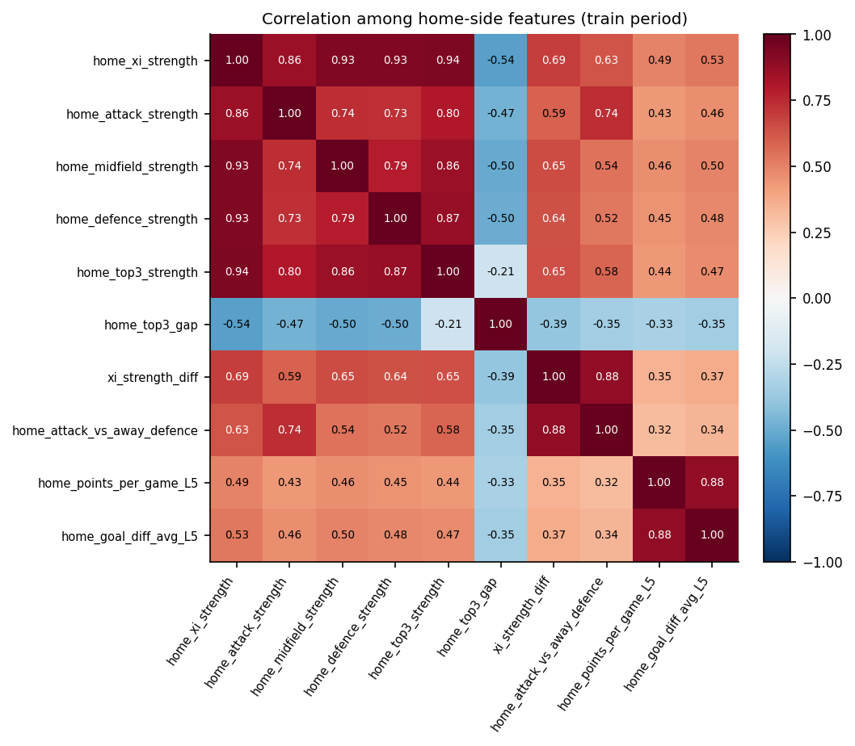
Figure 4b. Pearson correlation among home-side squad-quality features, computed on the training period. Positional strengths are strongly correlated with the overall XI strength they help compute.
The diagnosis confirms multicollinearity, not absence of signal: home_xi_strength correlates 0.94 with home_top3_strength, 0.93 with home_defence_strength, 0.86 with home_attack_strength, and 0.88 between xi_strength_diff and home_attack_vs_away_defence. Because home_xi_strength is itself the mean of the attack/midfield/defence/goalkeeper strengths introduced in FS3, a large share of FS3's variance is mechanically redundant with information FS2 already supplies. A linear model distributes near-identical predictive credit across correlated inputs rather than gaining new separating power from them, which is the standard consequence of near-collinear predictors in a linear decision boundary.
Variance inflation factors computed on the training period (R script 04) confirm the scale of the overlap: the four exact identities (for example xi_strength_diff = home minus away XI strength) and the other difference and gap columns are left out because their VIF is infinite by construction; of the remaining 26 features, 14 have a VIF above 10, led by home and away XI strength (about 196). Overlap of this size does not harm a Random Forest's predictions, but it means single-feature importances and linear coefficients cannot be read one by one, which is why Section 20 reports importance by feature group. Carpita et al. (2019), who used only home-minus-away role differences, report VIF values of at most 5.1; the overlap here comes from keeping the overall XI strength alongside its unit components. Even so, the FS3 positional block carries real information for the final model: shuffling it as a group lowers validation Macro-F1 by 0.036 (Section 20.2).
Correlated pair | r (training period, seasons up to 2022)
home_xi_strength ↔ home_top3_strength | 0.936
home_xi_strength ↔ home_defence_strength | 0.929
home_xi_strength ↔ home_midfield_strength | 0.928
home_xi_strength ↔ home_attack_strength | 0.855
xi_strength_diff ↔ home_attack_vs_away_defence | 0.883
home_points_per_game_L5 ↔ home_goal_diff_avg_L5 | 0.885

9.6 Descriptive Statistics for Key Numeric Features
Full-sample descriptive statistics (mean, standard deviation and quartiles) for the ten most decision-relevant numeric features, reported here to characterise scale and spread before any scaling is applied in the pipeline (Section 13).
Feature | Mean | Std | Min | Q1 | Median | Q3 | Max
home_xi_strength | 54.56 | 21.02 | 3.80 | 37.93 | 52.25 | 71.57 | 99.65
away_xi_strength | 54.27 | 21.09 | 3.84 | 37.47 | 51.91 | 71.21 | 99.68
xi_strength_diff | 0.29 | 29.30 | -86.93 | -20.23 | 0.20 | 21.03 | 86.46
home_top3_strength | 75.04 | 18.12 | 8.36 | 62.39 | 77.18 | 90.67 | 100.00
home_top3_gap | 20.57 | 7.62 | 0.31 | 15.42 | 20.77 | 25.79 | 48.89
home_points_per_game_L5 | 1.35 | 0.72 | 0.00 | 0.80 | 1.40 | 1.80 | 3.00
away_points_per_game_L5 | 1.40 | 0.73 | 0.00 | 0.80 | 1.40 | 2.00 | 3.00
home_goal_diff_avg_L5 | -0.04 | 1.05 | -8.00 | -0.80 | 0.00 | 0.60 | 6.00
home_attack_strength | 53.79 | 25.15 | 0.00 | 33.82 | 52.84 | 74.61 | 100.00
home_lineup_continuity | 0.78 | 0.14 | 0.00 | 0.73 | 0.82 | 0.91 | 1.00
Two points are worth noting for modelling: xi_strength_diff is approximately symmetric around zero (mean 0.29, median 0.20), consistent with home and away XI quality being drawn from the same underlying rating pool rather than one side being systematically stronger; and home_lineup_continuity is left-skewed with a median of 0.82, meaning most teams retain most of their previous XI, which is why the feature adds little marginal information once form and strength are already known (Section 17.1).

9.7 Season-by-Season Outcome Table
The season-level breakdown underlying Figure 2 (right panel) is reproduced in full below, including average total goals per match, to support independent verification of the home-advantage drift discussed in Section 9.1.
Season | Matches | Home win % | Draw % | Away win % | Avg. total goals
2008 | 2906 | 46.8 | 25.0 | 28.2 | 2.62
2009 | 2810 | 47.2 | 25.6 | 27.2 | 2.67
2010 | 2840 | 46.6 | 25.6 | 27.7 | 2.69
2011 | 2818 | 46.9 | 25.3 | 27.8 | 2.77
2012 | 2840 | 44.5 | 26.2 | 29.3 | 2.81
2013 | 2612 | 46.4 | 23.8 | 29.8 | 2.77
2014 | 2905 | 44.9 | 25.3 | 29.8 | 2.67
2015 | 2906 | 44.3 | 25.3 | 30.4 | 2.74
2016 | 2906 | 47.4 | 23.9 | 28.7 | 2.78
2017 | 2876 | 45.3 | 24.2 | 30.5 | 2.76
2018 | 2876 | 45.7 | 24.1 | 30.3 | 2.82
2019 | 2674 | 44.8 | 24.1 | 31.1 | 2.78
2020 | 2942 | 40.2 | 25.1 | 34.7 | 2.78
2021 | 2942 | 42.4 | 25.4 | 32.3 | 2.79
2022 | 2942 | 46.2 | 22.8 | 31.0 | 2.81
2023 | 2802 | 43.3 | 26.2 | 30.6 | 2.90
2024 | 2802 | 43.2 | 25.1 | 31.7 | 2.81
2025 | 2802 | 43.5 | 26.0 | 30.5 | 2.79
The 2020 season (2020/21, the empty-stadium period) is the clearest outlier: home win share drops to 40.2%, 5.4 percentage points below the other training seasons combined (45.7%; two-proportion test p < 0.001, R script 04), 4.6 points below 2019 and 2.2 points below 2021, while away win share rises to 34.7%, its highest value in the panel. Home advantage recovers by 2022 (46.2%) before settling near 43-44% in 2023-25, slightly below the pre-2020 level of about 44-47%.

10. Feature Engineering Theory and Formulas

10.1 Recent form using past-only rolling windows
For team t before match i, let M_t(i) be the set of up to five immediately preceding same-season league matches (current match never included):
- PPG_L5(t,i) = (1/|M_t(i)|) Σ Points_{t,j} WinRate_L5(t,i) = (1/|M_t(i)|) Σ I(t won j)
- GF_L5(t,i) = (1/|M_t(i)|) Σ GoalsFor_{t,j} GA_L5(t,i) = (1/|M_t(i)|) Σ GoalsAgainst_{t,j} GD_L5 = GF_L5 − GA_L5
Implementation: group by team/season, shift the match result one position back, then apply a rolling window. The shift is the leakage barrier — without it the current match's own result would contaminate its own predictors.

10.2 Player-quality harmonisation
Using the latest valid pre-match evidence q_{p,t*} for player p at time t* strictly before kickoff t_i (t* < t_i):
- strength_{p,i} = 100 × PercentileRank(q_{p,t*} | prior same-league, same-role evidence)
For the modern period, raw market value is compressed with log(1+value) before percentile ranking, to reduce extreme right-skew. Percentile ranking creates a comparable 0-100 scale but does not claim FIFA ratings and market values measure identical constructs.

10.3 Starting-XI and role aggregation
- XI_Strength = mean(strength_p for p in valid starters), requiring ≥ 8 valid starters
- Attack / Midfield / Defence_Strength = mean(strength_p) within that role group; GK_Strength = strength of the starting goalkeeper
- Top3_Strength = mean(three highest valid starter strengths), requiring ≥ 3 valid starters; Top3_Gap = Top3_Strength − XI_Strength
Top3_Gap is read as star-dependence: two XIs can share the same average strength while one leans on a few elite players and the other is balanced.

10.4 Lineup continuity
- Continuity(t,i) = |XI_{t,i} ∩ XI_{t,i−1}| / |XI_{t,i}|, relative to the immediately previous same-season league-match XI

10.5 Opponent-relative features
- XI_Diff = Home_XI_Strength − Away_XI_Strength
- HomeAttack_vs_AwayDefence = Home_Attack_Strength − Away_Defence_Strength; AwayAttack_vs_HomeDefence = Away_Attack_Strength − Home_Defence_Strength
- Midfield_Diff = Home_Midfield_Strength − Away_Midfield_Strength; GK_Diff = Home_GK_Strength − Away_GK_Strength
These paired-comparison variables encode football as a matchup: a home attack of 75 means something different against a defence of 80 than against a defence of 55, which absolute strength alone cannot represent.

11. Feature Sets FS1-FS4 and Ablation Logic
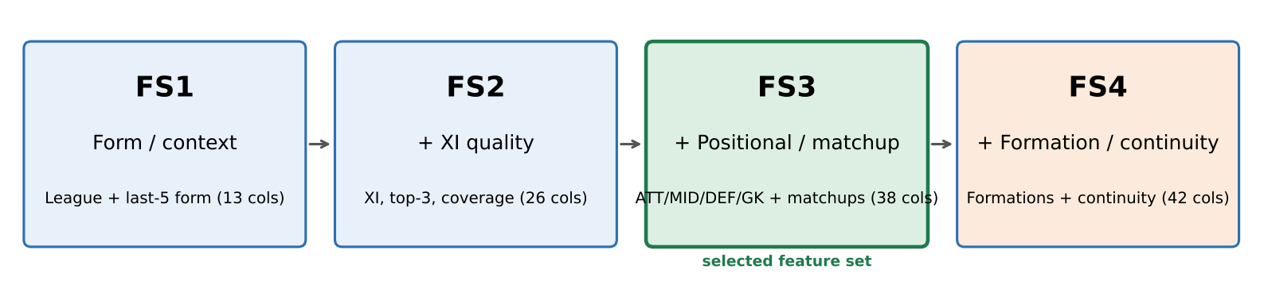
Figure 5. Progressive feature-set ladder used for ablation testing, with column counts from the executed schema.
Feature set | Contents | Research purpose | Columns
FS1 — Form/context | League + last-5 points per game, win rate, goals for, goals against, goal difference and number of form matches (12 numeric + league) | Establish a team-level pre-match baseline | 13
FS2 — + XI quality | FS1 + XI strength, Top-3 strength, Top-3 gap, XI difference, starter counts and strength coverage | Test incremental value of the announced starting XI | 26
FS3 — + positional/matchups | FS2 + ATT/MID/DEF/GK strengths + attack-vs-defence + midfield/GK differences | Test whether positional composition and opponent-relative structure add value | 38
FS4 — + tactical/continuity | FS3 + home/away formation + lineup continuity | Test whether tactical structure and selection stability add value | 42
Ablation is more informative than automatic feature selection alone because it directly answers the research questions in Section 3: if FS2 improves over FS1 on future validation data, player-aware information has incremental predictive value; if FS3 improves further, positional information matters beyond a simple XI average; if FS4 adds little, that negative result is itself useful and is reported as such in Section 17.

Part IV — Machine-Learning Implementation

12. Chronological Splitting and Temporal Validation
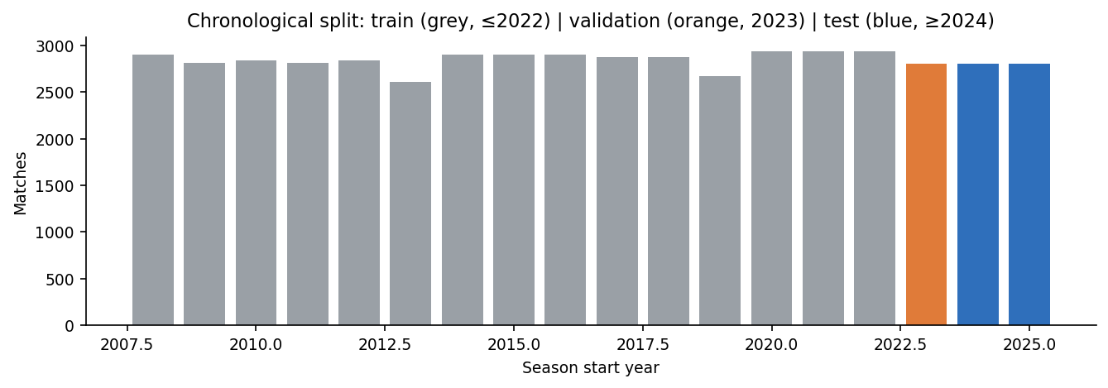
Figure 6. Matches per season, coloured by split assignment. Grey = train (≤2022), orange = validation (2023), blue = test (≥2024).
The executed split contains 42,795 training matches (season_start ≤ 2022), 2,802 validation matches (season_start = 2023), and 5,604 final-test matches (season_start ≥ 2024). Train period < Validation period < Test period is enforced throughout: every modelling decision (feature-set choice, hyperparameters, model family and class weighting) is made using training and validation evidence only, and the frozen model is scored on the test period exactly once, after every decision is made. Later robustness checks re-score the test period only to measure sensitivity (Section 18.3), never to choose.
Part | Seasons | First and last match | Matches | Share | Home / Draw / Away
Train | 2008/09–2022/23 | 2008-08-09 to 2023-06-04 | 42,795 | 83.6% | 45.3% / 24.8% / 29.9%
Validation | 2023/24 | 2023-07-28 to 2024-06-02 | 2,802 | 5.5% | 43.3% / 26.2% / 30.6%
Test | 2024/25–2025/26 | 2024-07-26 to 2026-05-24 | 5,604 | 10.9% | 43.4% / 25.6% / 31.1%
The shares (84%, 5% and 11%) follow from splitting by whole seasons rather than from a target percentage. The two most recent complete seasons form the test period, so the test is as close as possible to how the model would be used, and the season before them is the validation period, used only to choose between candidates. Hyperparameters were tuned by time-series cross-validation inside the training seasons, as described at the end of this section. Splitting by whole seasons also keeps each league's season together in one part.
All nine leagues appear in all three parts, in almost the same proportions: a league's share of the training and test matches differs by at most 2.2 percentage points (France, whose top division went from 20 to 18 teams in 2023/24). Different counts per league reflect league size (380 matches a season with 20 teams, 306 with 18, 240 in Belgium's regular season and 198 in Scotland's), not missing data; the two leagues that did miss whole seasons, Switzerland and Poland, were removed for that reason (D06). Giving every league the same total weight in training changed validation Macro-F1 from 0.4916 to 0.4919 (each league between −0.007 and +0.006), and a league's test Macro-F1 is unrelated to how many of its matches were in training (correlation 0.03 across the nine leagues), so the natural league mix was kept (extra_experiments/11_league_balance_check.py).
Inside the training period, hyperparameters were tuned with GridSearchCV over a three-fold TimeSeriesSplit (expanding-window folds: train on earlier matches, score the next block), with Macro-F1 as the score. The 2023 validation season and the test period play no role in the search, and every fold preserves the deployment direction. Small explicit grids made exhaustive search affordable; Bayesian optimisation (Snoek et al., 2012; Section 5.7) is a more sample-efficient alternative for larger search spaces.

13. Preprocessing Pipeline
Variable type | Transformation | Rationale
Numeric | Median imputation; StandardScaler for scale-sensitive models (Logistic Regression, Naive Bayes, kNN) | Median is robust to skew/outliers; scaling is required for distance- and gradient-based linear models and is harmless when applied consistently
Categorical (league, formation) | One-hot encoding, unseen-category safe | Avoids false ordinal assumptions; handles categories not seen in training
Tree models (Decision Tree, Random Forest, Gradient Boosting) | Same encoded matrix; scaling not required | Keeps the comparison reproducible across a common pipeline
QA / IDs / outcome columns | Excluded from X entirely | Prevents leakage, memorisation and source-artifact learning
Train-only rule
Imputer medians, scaler means/standard deviations and the one-hot category vocabulary are fitted on training data only (on the training part of each fold during tuning), never on validation or test rows. No resampling, calibration model or learned feature selector is used.
The rubric also asks for justified handling of missing values, outliers, duplicates and class imbalance. Categories, scaling and leakage are covered by the table above and Section 4; the other four are handled as follows.
Data issue | How it was handled | Evidence
Missing values | Kept as missing in the dataset, because they mean "not observed yet" (for example, a team has no recent form before its first match of a season). Filled with the training-set median inside the pipeline. Missing shares are small: 2.8% for recent form, 1.8% for starting-XI strength and at most 7.4% overall (lineup continuity, FS4 only). Dropping incomplete rows was tested and did not improve the model. | Sections 9 and 18.3; EDA log E13 (Appendix J); issues register D04
Outliers | No values were removed or clipped. The most extreme results are real matches (4 matches with 10 or more goals for one side, such as Ajax 13–0 at VVV-Venlo), and a match's own goals are used only to build its target. Strength features are percentiles between 0 and 100 by construction, form features are averages over at most five earlier matches, the imputer uses the median, and the final model is a tree ensemble, which is not sensitive to extreme values. | Issues register D17; data-engineering check (strength columns within 0–100)
Duplicates | None found: match_uid and game_id are unique, and no match repeats the same date, teams and league, so no rows were removed. | Section 8.2; data-engineering checks
Class imbalance | Home 45.0%, draw 24.9%, away 30.1%. Macro-F1 is the main metric, so the smaller draw class counts equally. class_weight = balanced was compared with no weighting and kept because it raised validation Macro-F1 by 0.08–0.09 and draw F1 from about 0 to 0.27–0.34. No resampling such as SMOTE is used, so the training data stay unchanged. | Sections 15 and 18.3; preprocessing log P07 (Appendix K)

14. Candidate Models and Mathematical Theory

14.1 Dummy baseline
Predicts the training-period class prior for every match: P̂(k) = n_k / N_train. This is the minimum bar every informative model must clear.

14.2 Multinomial Logistic Regression
Models log-odds as a linear function of standardised features for each class relative to a reference: log(P(k)/P(A)) = β_{k0} + β_kᵀx. Equivalently, class probabilities are produced by the softmax function P(k|x) = exp(β_kᵀx) / Σ_j exp(β_jᵀx), fitted by maximising the multinomial log-likelihood with L2 regularisation (inverse strength C, Appendix E). Chosen as the interpretable linear baseline — coefficients translate directly into direction and magnitude of association with each outcome. Its core limitation, demonstrated concretely in Section 9.5, is that it cannot exploit near-collinear inputs independently, which caps its ability to use FS3's positional detail beyond what FS2 already supplies.

14.3 Gaussian Naive Bayes
Applies Bayes' rule assuming conditional independence of features given the class: P(k|x) ∝ P(k) Π_j P(x_j|k), with each P(x_j|k) modelled as a univariate Gaussian N(μ_{jk}, σ_{jk}²) estimated per class from the training data. The independence assumption is almost certainly violated here (e.g. XI strength and Top-3 strength are correlated by construction, Section 9.5), which is the most likely explanation for its strong Macro-F1 but very poor log loss (2.36 on FS3, and 5.80 on FS4 where it collapses; Sections 17 and 18.1): the product-of-marginals approximation over-multiplies redundant evidence, systematically pushing posteriors toward 0 or 1.

14.4 k-Nearest Neighbours
Predicts P(k|x) as the class frequency among the k nearest training matches under a distance metric (Euclidean, on standardised features): P̂(k|x) = (1/k) Σ_{i ∈ N_k(x)} I(y_i = k), optionally distance-weighted. Provides a non-parametric, instance-based contrast to the parametric models: it makes no assumption about the functional form of the decision boundary, at the cost of being sensitive to the curse of dimensionality on FS4's 42 input columns.

14.5 Decision Tree
Recursively splits the feature space to reduce class impurity, measured at each candidate split by the Gini index G = 1 − Σ_k p_k², choosing the split that maximises the weighted impurity reduction between parent and child nodes. Depth and leaf size are constrained (Appendix E) to control overfitting; used mainly as a transparent, if weaker, contrast to its ensemble descendants.

14.6 Random Forest
An ensemble of B decision trees, each trained on a bootstrap sample of the training rows with random feature subsampling at each split (typically √p candidate features out of p), with predictions averaged: P̂(k|x) = (1/B) Σ_{b=1}^{B} P̂_b(k|x). Bootstrap aggregation reduces the variance of a single tree while remaining scale-invariant, since only feature order (not magnitude) determines splits. Selected as the final model (Section 18.2): 200 trees, max_depth 6, min_samples_leaf 5, class_weight = balanced.

14.7 Gradient Boosting
Builds shallow trees sequentially, each new tree h_m fitted to the negative gradient of the multiclass log-loss with respect to the current ensemble's predictions: F_m(x) = F_{m-1}(x) + η·h_m(x), where η is the learning rate. The scikit-learn GradientBoostingClassifier is used (100 trees, learning rate 0.1, depth 3, 80% row subsampling; Appendix E). Missing values are median-imputed in the pipeline first. Typically one of the strongest tabular methods; here it is effectively tied with Random Forest once class weighting is applied (Section 18).

14.8 Multi-Layer Perceptron (checked in Section 18.5)
The brief lists a small neural network as optional. It was not part of the original six-model comparison and was checked afterwards (Section 18.5): a network with two hidden layers (64 and 32 units), standardised inputs, balanced sample weights and early stopping, tuned with the same temporal cross-validation. It reached validation Macro-F1 0.485, about 0.01 below the Random Forest retrained in the same run, because a 38-feature table with a smooth main signal leaves little for hidden layers to discover.

14.9 Poisson goal model (checked in Section 18.8)
The classic statistical model for football results. Instead of the result, it predicts each team's goals: log λ = β₀ + βᵀx for the home team and for the away team (L2-regularised Poisson regression), P(k goals) = λᵏ e^(−λ) / k!, and the result probabilities are sums over the grid of scorelines. It assumes the two teams' goals are independent given the inputs, which spreads the chance of a draw thinly; Section 18.8 compares it with the Random Forest.

15. Temporal Tuning and Class-Imbalance Experiments
The feature set with the highest validation Macro-F1 in the ablation (FS3) was carried forward, and the three strongest model families at that set (Naive Bayes, kNN and Random Forest) were tuned with temporal cross-validation inside the training period (Section 12); final settings are listed in Appendix E. Two further experiments were run:
- Weighted vs unweighted classes: class_weight = balanced (balanced sample weights for Gradient Boosting) was compared with no weighting for Logistic Regression, the Decision Tree, Random Forest and Gradient Boosting, using the same settings with and without weighting (the tuned settings for Random Forest and the defaults in Appendix E for the others). Weighting was not assumed to be better; it was kept only because it raised validation Macro-F1 (Section 18.3 reports the trade-off).
- Full-history vs modern-only training: training on the modern (Transfermarkt) era alone was compared against training on the full historical panel, both evaluated on the same 2024-25 test set, to check whether the FIFA-rating-to-market-value source transition harms signal consistency (Section 18.3).

Part V — Evaluation and Interpretation (Executed Results)

16. Evaluation Metrics and Mathematical Definitions

16.1 Confusion matrix and class-wise precision/recall/F1
- Precision_k = TP_k / (TP_k + FP_k) Recall_k = TP_k / (TP_k + FN_k) F1_k = 2×Precision_k×Recall_k / (Precision_k+Recall_k)
- Macro-F1 = (F1_H + F1_D + F1_A) / 3 — the project's primary metric, because it weights Home, Draw and Away equally and prevents the largest class from dominating the score.
- Weighted-F1 = Σ_k (n_k / N) × F1_k weights each class by its number of matches, so home wins dominate it; Micro-F1 pools every decision and, when each match has exactly one result, equals accuracy. Both reward a model that rarely predicts draws. All three are compared in Section 18.6.

16.2 Accuracy and balanced accuracy
- Accuracy = correct predictions / N; Balanced Accuracy = (Recall_H + Recall_D + Recall_A) / 3
Accuracy remains a useful intuitive summary but is not sufficient for model selection on its own, because the classes are imbalanced and Draw needs separate inspection.

16.3-16.5 Probability-quality metrics
- Multiclass log loss = −(1/N) Σ_i Σ_k y_{ik} log(p_{ik}) — penalises confident wrong predictions heavily; appropriate for probability-based decision support.
- Multiclass Brier score = (1/N) Σ_i Σ_k (p_{ik} − y_{ik})² — squared error of the probability vector; lower is better.
- Rank Probability Score (results ordered A < D < H by goal difference): RPS = ½ Σ_{j=1}^{2} (cumulative predicted − cumulative observed)², averaged over matches; used by Cattelan et al. (2013) for football forecasts and reported in Section 18.6, together with balanced accuracy, Cohen's kappa, the Matthews correlation coefficient and one-vs-rest ROC-AUC.

17. FS1-FS4 Ablation Results (Validation, 2023)
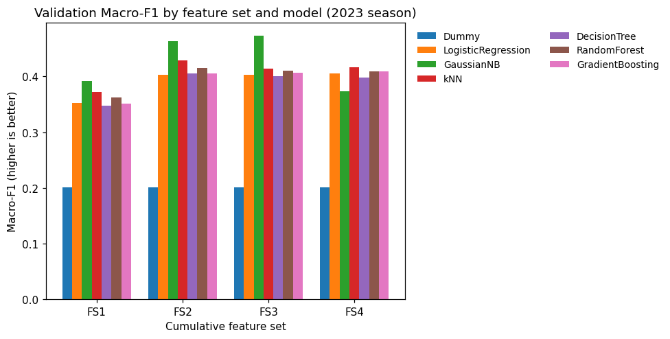
Figure 7. Validation Macro-F1 by feature set for all six models and the Dummy baseline (2023 season).
Feature set (best model) | Columns | Macro-F1 | Accuracy | Balanced acc. | Log loss
FS1 (Naive Bayes) | 13 | 0.392 | 47.9% | 0.428 | 1.250
FS2 (Naive Bayes) | 26 | 0.464 | 52.4% | 0.484 | 1.467
FS3 (Naive Bayes) | 38 | 0.473 | 52.0% | 0.487 | 2.356
FS4 (kNN) | 42 | 0.416 | 52.6% | 0.462 | 0.984
Dummy baseline (training-period class frequencies): Macro-F1 0.201, accuracy 43.3%, log loss 1.077. Every model gains from FS1 to FS2: Logistic Regression +0.050, Naive Bayes +0.072, kNN +0.057, Decision Tree +0.059, Random Forest +0.053, Gradient Boosting +0.054.

17.1 Interpretation
- FS1 → FS2 (adding starting-XI quality): the best Macro-F1 rises from 0.392 to 0.464 (+0.072, paired-bootstrap 95% CI 0.055 to 0.089), and every one of the six models gains between 0.050 and 0.072. This is the largest jump in the ladder and directly answers RQ2: the announced starting XI carries real information beyond team-level recent form. The nested multinomial regressions in R script 04 agree (likelihood-ratio test p < 2.2e-16; McFadden R² 0.039 → 0.080).
- FS2 → FS3 (adding positional/opponent-relative structure): the best model gains a further 0.009 (0.464 → 0.473; CI of FS3 against FS1: 0.063 to 0.101), but the other models change by −0.015 to +0.001. Positional detail adds little once overall XI quality is known (RQ3), consistent with the multicollinearity in Section 9.5. FS3 is still the best set and was carried forward.
- FS3 → FS4 (adding formation/continuity): no model improves by more than 0.003, and Naive Bayes collapses (0.473 → 0.373, log loss 5.80) when the one-hot formation columns are added, so the best FS4 score falls to 0.416 (kNN). Formation and lineup continuity add nothing (RQ4), which the likelihood-ratio test for continuity confirms (p = 0.19; 0.38 after Holm adjustment).
- Every feature set clears the Dummy baseline by a wide margin (best FS3 0.473 against 0.201), confirming the pre-match signal is real, not an artefact of the evaluation protocol.

18. Model Comparison on FS3 (Validation, 2023)
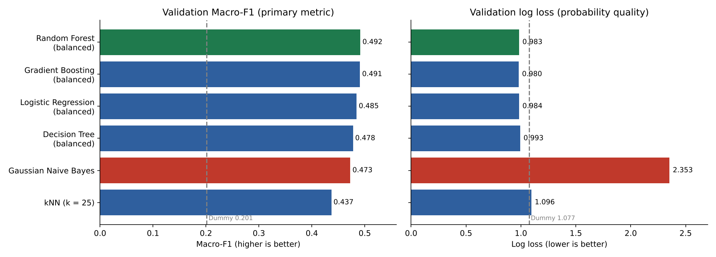
Figure 8. Left: best validation Macro-F1 per model family on FS3 (primary metric). Right: validation log loss of the same candidates (probability quality). Naive Bayes (red) is competitive on Macro-F1 but far worse on log loss; the selected Random Forest is shown in green.
Model | Macro-F1 | Accuracy | Class weight | Draw F1 | Log loss
Random Forest (tuned) | 0.492 | 50.6% | balanced | 0.334 | 0.983
Gradient Boosting | 0.491 | 50.7% | balanced | 0.324 | 0.980
Logistic Regression | 0.485 | 52.4% | balanced | 0.267 | 0.984
Decision Tree | 0.478 | 48.7% | balanced | 0.337 | 0.993
Gaussian Naive Bayes (tuned) | 0.473 | 52.0% | none | 0.236 | 2.353
kNN (tuned, k = 25) | 0.437 | 51.8% | none | 0.150 | 1.096
Gradient Boosting (unweighted) | 0.407 | 54.0% | none | 0.011 | 0.964

18.1 Reading the comparison
With balanced class weights, four model families finish within 0.015 Macro-F1 of each other: the tuned Random Forest (0.492), Gradient Boosting (0.491), Logistic Regression (0.485) and the Decision Tree (0.478). Gaussian Naive Bayes (0.473) and kNN (0.437) follow. Without weighting the same tree and linear models score only 0.40-0.41, because they almost never predict a draw (Draw F1 0.00-0.01); weighting raises Draw F1 to 0.27-0.34. This answers RQ5 and RQ6 together: class weighting, not the choice of model family, is what recovers the Draw class and lifts Macro-F1.
Gaussian Naive Bayes shows why Macro-F1 cannot be read alone. Its validation log loss (2.35) is more than twice that of every weighted tree or linear model (0.98-0.99). Its conditional-independence assumption (Section 14.3) is violated by construction, since XI strength, Top-3 strength and the positional strengths are strongly correlated, and violating independence pushes its posteriors toward 0 or 1, which a hard-label metric does not penalise but log loss does.

18.2 Final model selection
Model-selection decision
The frozen configuration is the candidate with the highest validation Macro-F1: Random Forest on FS3 (200 trees, max_depth 6, min_samples_leaf 5, class_weight = balanced), trained on seasons up to 2022 only, with median imputation and one-hot league encoding fitted on training data. Its validation Macro-F1 is 0.492 and its log loss 0.983, close to the best log loss of any candidate (0.964, unweighted Gradient Boosting, which almost never predicts a draw). With class weighting the Macro-F1-versus-log-loss conflict therefore largely disappears: one model is both the Macro-F1 leader and within 0.02 of the best probability quality. Gradient Boosting with balanced weights (0.491, log loss 0.980) is a near-equivalent alternative. Log loss was used only as a tie-breaker and secondary diagnostic, and the test set was not touched until this configuration was frozen.

18.3 Robustness checks
Robustness check | Setting A | Setting B | What changed
Full-history vs modern-only training (frozen Random Forest, same 2024-25 test set) | Full history (2008-2022, n = 42,795): test Macro-F1 0.473, log loss 1.008 | Modern era only (2016-2022, n = 20,158): test Macro-F1 0.471, log loss 1.011 | Practically identical: the FIFA-to-market-value source change does not harm generalisation to 2024-25
Weighted vs unweighted (Random Forest, FS3, validation) | Unweighted: Macro-F1 0.397, Draw F1 0.000, log loss 0.966 | class_weight = balanced: Macro-F1 0.492, Draw F1 0.334, log loss 0.983 | Weighting raises Macro-F1 by 0.094 and recovers the Draw class at a log-loss cost of 0.018; adopted
Data-quality variants (frozen configuration retrained, test; notebook Section 25) | Official data: Macro-F1 0.472 (retrained) | Without no-lineup matches −0.003; complete player data only −0.005; without 2008/09 −0.002; without Scottish post-split +0.001; same-season player ranking −0.005; all fixes −0.006 | Five of six differences are within bootstrap noise; 'complete player data only' is slightly worse (95% CI −0.009 to −0.001). No variant met the decision rule (validation gain above 0.01; largest gain +0.001), so the official data and model stay
Extra pre-match information (2016-2022 training, test) | FS3: validation 0.492, test 0.470 | + rest days, discipline and player form from previous matches only: validation −0.001 to +0.004, test +0.001 to +0.004 | Within noise (all 95% CIs include 0); starting-XI strength already captures this information; not added
Rows 3 and 4 retrain the frozen configuration on changed training data. They were run separately with a newer scikit-learn release (1.9), so their baselines differ slightly from the notebook run (full history 0.472 instead of 0.473; modern-only 0.470 instead of 0.471). Every comparison within a row uses the same release. Row 3 is notebook Section 25 (ml_outputs/data_issue_robustness.csv); row 4 was produced by the script in ML_Pipeline/extra_experiments/ (ml_outputs/new_feature_experiment.csv).

18.4 Statistical Significance (Paired Bootstrap)
Point estimates alone cannot show whether the differences reported above reflect a genuine effect or sampling noise. Percentile bootstraps (1,000 resamples with replacement, seed 42) were therefore computed for the comparisons that matter most: the feature-set gains on the 2,802 validation matches (paired: the same resampled matches for both sets) and the final model on the 5,604 test matches.
Comparison | Estimate | 95% confidence interval | Interpretation
FS2 − FS1, best model, validation Macro-F1 | +0.072 | [0.055, 0.089] | Excludes zero: starting-XI quality adds real information (RQ2)
FS3 − FS1, best model, validation Macro-F1 | +0.081 | [0.063, 0.101] | Excludes zero; the extra +0.009 over FS2 is small relative to the interval width (RQ3)
FS4 − FS1, best model, validation Macro-F1 | +0.024 | [0.007, 0.043] | Excludes zero but well below FS2 and FS3: FS4 loses ground (RQ4)
Final model, test Macro-F1 | 0.473 | [0.460, 0.486] | The whole interval lies far above the Dummy baseline (0.202), confirming RQ1
The paired intervals are indicative rather than formal tests, because the best model per feature set was chosen on the same validation data (a mild winner's-curse effect). The test interval for the final model is not affected by this, since the test set was used only once.
Why this matters academically
A difference that merely looks large in a single point estimate could be sampling noise. Reporting intervals shows which conclusions are robust: the gain from adding the starting XI is, while the further steps from FS2 to FS3 and FS4 are not clearly beneficial, and no data-quality variant in Section 18.3 improves on the official model.

18.5 Additional Models Checked After Selection
After the final model was frozen, further models from four families (a neural network, gradient boosting, support vector machines and ordinal regression) were trained on the same data (FS3, seasons up to 2022) and compared on the validation season only, to answer whether another family would fit this problem better (notebook Section 26). The MLP, HistGradientBoosting and XGBoost were tuned with the same temporal cross-validation; the support vector machines used standard settings and the ordinal model has no settings to tune. Class weighting was used wherever the model supports it. Because this run used a newer scikit-learn release, the frozen Random Forest was retrained in the same run as the reference (validation Macro-F1 0.495). The decision rule was fixed in advance: a new model would be considered only if it beat the reference by more than 0.01.
Model (validation 2023/24) | Macro-F1 | Gap to Random Forest | Draw F1 | Log loss | Train time (s)
Random Forest (frozen configuration, reference) | 0.495 | — | 0.339 | 0.983 | 6
HistGradientBoosting (balanced) | 0.495 | +0.000 | 0.327 | 0.981 | 41
RBF-kernel SVM (balanced) | 0.494 | −0.001 | 0.329 | — | 195
XGBoost (balanced) | 0.493 | −0.002 | 0.322 | 0.980 | 16
MLP neural network (balanced) | 0.485 | −0.010 | 0.305 | 0.980 | 17
Logistic Regression (balanced, reference) | 0.483 | −0.012 | 0.265 | 0.984 | 4
AdaBoost (balanced, script 05) | 0.482 | −0.013 | 0.320 | 1.059 | 343
Ordinal logistic regression, prior-corrected decision | 0.475 | −0.020 | 0.271 | 0.967 | 61
Ordinal logistic regression, most probable class | 0.402 | −0.093 | 0.000 | 0.967 | 61
Linear SVM (balanced, calibrated) | 0.403 | −0.092 | 0.000 | 0.970 | 5
No model met the rule. HistGradientBoosting (0.495), the RBF-kernel SVM (0.494) and XGBoost (0.493) tie with the Random Forest, and the MLP (0.485) and logistic regression (0.483) are about 0.01 lower. When bagging, boosting and kernel models reach the same level and the neural network comes close, the limit is the information available before kickoff rather than the algorithm. Two results are informative for theory. The ordinal model, which matches the A < D < H order of the outcome, gives good probabilities (log loss 0.967) but treats Draw as a narrow middle band (with the fitted thresholds P(Draw) never exceeds 0.29), so Draw is never the most probable class (Draw F1 0.000) unless the decision is corrected for class shares (0.475). The kernel SVM ties, but needs an extra calibration step to give probabilities and took about 195 seconds to train against about 6 for the Random Forest on the same machine. Train times include the tuning grid where one was used. The Random Forest therefore remains the final model; a model-by-model justification is given in the accompanying Model_Choice_Justification document.
AdaBoost, the original boosting method (each round gives more weight to the matches the previous trees got wrong), was checked afterwards with the same data, tuning, class weighting and rule, and the same library versions as Section 26 (extra_experiments/05_adaboost_and_boosting_rounds.py). It reached validation Macro-F1 0.482, 0.013 below the reference Random Forest, with the weakest probabilities of the tree models (log loss 1.059). The same script shows why boosting does not help on this problem. For Gradient Boosting (depth 3, learning rate 0.1), going from 100 to 300 rounds raises training Macro-F1 from 0.496 to 0.540 while validation Macro-F1 stays between 0.495 and 0.499, so the extra rounds fit the training seasons rather than new matches. For AdaBoost, validation log loss rises with every extra round (1.032 after 10 rounds, 1.060 after 300), because each round adds weight to the matches it got wrong, and in football many of those are upsets that no pre-match information can predict.

18.6 Other Selection Measures: Is Macro-F1 a Fair Choice?
Choosing a model by one measure could favour one model unfairly, so the six candidates were re-scored on the same validation season with every F1 type and seven further measures (extra_experiments/07 to 09). The configurations are exactly those ranked in Section 18; five of the six reproduce the saved Macro-F1 exactly, and Logistic Regression, refitted, differs by 0.002.
Model (validation, rank) | Macro-F1 | Weighted-F1 | Micro-F1 (= accuracy) | Home F1 | Draw F1 | Away F1
Random Forest | 0.492 (1) | 0.511 (3) | 0.506 (5) | 0.592 | 0.334 | 0.548
Gradient Boosting | 0.491 (2) | 0.512 (2) | 0.507 (4) | 0.595 | 0.324 | 0.554
Logistic Regression | 0.486 (3) | 0.514 (1) | 0.526 (1) | 0.628 | 0.268 | 0.562
Decision Tree | 0.478 (4) | 0.497 (5) | 0.487 (6) | 0.580 | 0.337 | 0.517
Naive Bayes | 0.473 (5) | 0.503 (4) | 0.520 (2) | 0.626 | 0.236 | 0.555
kNN | 0.437 (6) | 0.475 (6) | 0.518 (3) | 0.635 | 0.150 | 0.526
The ranking depends on the F1 type. The Random Forest is first on Macro-F1 but third on Weighted-F1 and fifth on Micro-F1; Logistic Regression leads both size-weighted measures because it recognises home wins best of the weighted models (Home F1 0.628) while recognising draws less well (Draw F1 0.268). kNN has the best Home F1 (0.635) and the worst Draw F1 (0.150). Macro-F1 was fixed as the primary measure before modelling (D03) because the stakeholder needs all three results recognised; Weighted- and Micro-F1 would favour a model that seldom predicts draws.
Model (validation) | Balanced accuracy | Cohen's kappa | MCC | ROC-AUC | Log loss | Brier | RPS
Random Forest | 0.493 | 0.252 | 0.253 | 0.685 | 0.983 | 0.587 | 0.196
Gradient Boosting | 0.492 | 0.253 | 0.254 | 0.685 | 0.980 | 0.585 | 0.195
Logistic Regression | 0.496 | 0.266 | 0.269 | 0.684 | 0.984 | 0.587 | 0.196
Decision Tree | 0.476 | 0.227 | 0.230 | 0.669 | 0.993 | 0.595 | 0.198
Naive Bayes | 0.487 | 0.254 | 0.258 | 0.685 | 2.353 | 0.763 | 0.265
kNN | 0.464 | 0.224 | 0.237 | 0.657 | 1.096 | 0.596 | 0.199
Dummy baseline | 0.333 | 0.000 | 0.000 | 0.500 | 1.077 | 0.652 | 0.229
No model wins every measure. Gradient Boosting has the best probability measures (log loss 0.980, Brier 0.585, RPS 0.195, against 0.983, 0.587 and 0.196 for the Random Forest); Logistic Regression has the best balanced accuracy (0.496), kappa (0.266) and MCC (0.269); the Random Forest leads on Macro-F1. The differences among these three are small on every measure, while the Decision Tree, kNN and Naive Bayes are clearly behind on the probability measures. ROC-AUC (0.66 to 0.69 for all six) shows that every model ranks matches in a similar order; what separates them is how they turn that order into probabilities and decisions.
A Bayesian way to compare models is to ask how much probability each gave to what actually happened. Summed over the 2,802 validation matches, the log of the probability given to the actual result (the log-likelihood on new data, the practical counterpart of a Bayes factor) is 9.2 units higher for Gradient Boosting than for the Random Forest, with a standard error of 5.0 (z = 1.86): Gradient Boosting is slightly favoured on probability quality, but not decisively. Logistic Regression is level with the Random Forest (−0.4, z = −0.05); the Decision Tree (−27.9), the Dummy baseline (−260.7), kNN (−303.7) and Naive Bayes (−3,837) are clearly worse. This agrees with Section 18.2: the Random Forest and Gradient Boosting are near-equivalent, and the choice between them rests on the measure fixed in advance.

18.7 Overlapping Features: Does Removing Them Help?
Nine of the 38 features are exact combinations of others (for example xi_strength_diff = home_xi_strength − away_xi_strength), and several others are strongly correlated (Section 9.5). This matters most for Naive Bayes, which assumes the features are independent and so counts the same evidence several times: its average top probability on validation is 0.85 and its log loss 2.35. Three remedies were tested on the validation season, and the Random Forest was given the same changes (extra_experiments/10_feature_overlap_check.py).
Variant (validation) | Features | Macro-F1 | Draw F1 | Log loss | Average top probability
Naive Bayes, all 38 features (official) | 38 | 0.473 | 0.236 | 2.353 | 0.848
Naive Bayes, duplicates removed (29) | 29 | 0.471 | 0.212 | 1.551 | 0.785
Naive Bayes, PCA (decorrelated) | 38 → 17 components | 0.415 | 0.036 | 0.968 | 0.541
Naive Bayes, calibrated (sigmoid, time-series CV) | 38 | 0.412 | 0.023 | 0.990 | 0.525
Naive Bayes, PCA + calibrated | 38 | 0.408 | 0.013 | 0.971 | 0.530
Random Forest, all 38 features (official) | 38 | 0.492 | 0.334 | 0.983 | 0.470
Random Forest, duplicates removed (29) | 29 | 0.498 | 0.356 | 0.983 | 0.467
Random Forest, PCA (decorrelated) | 38 → 17 components | 0.482 | 0.275 | 0.999 | 0.441
For Naive Bayes, decorrelating the features with PCA or calibrating its probabilities removes the over-confidence (log loss 0.97 to 0.99, average top probability about 0.53), but Macro-F1 falls to about 0.41 because the corrected model almost stops predicting draws (Draw F1 0.01 to 0.04). Removing the nine derived features reduces the over-confidence (log loss 1.55) at a small Macro-F1 cost (0.471). The Random Forest is hardly affected: without the derived features it scores 0.498 (+0.006, below the 0.01 rule, so the frozen 38-feature model is kept), and with PCA 0.482, probably because PCA mixes the strongest single feature with weaker ones, which the trees' one-feature-at-a-time splits use less efficiently. Overlap therefore explains Naive Bayes' poor probabilities, but fixing it does not produce a better model than the Random Forest.

18.8 Poisson Goal Model: the Classic Statistical Approach
Before machine learning, football results were modelled through goals (Maher, 1982; Dixon and Coles, 1997; Karlis and Ntzoufras, 2009, Section 5.4). Each team's goals in a match are treated as a Poisson count with an expected value λ, so P(k goals) = λᵏ e^(−λ) / k!. Treating the two counts as independent gives the chance of every scoreline, P(i–j) = P_home(i) × P_away(j), and adding up the scorelines gives P(H) (i > j), P(D) (i = j) and P(A) (i < j). Figure 9 shows the idea on an average training match: with home teams scoring 1.55 goals and away teams 1.20 on average, the grid gives H 45.4%, D 25.1% and A 29.5%, against the actual 45.3%, 24.8% and 29.9%. Goal counts are close to Poisson (variance/mean 1.11 for home goals and 1.13 for away goals; exactly Poisson would be 1.00).
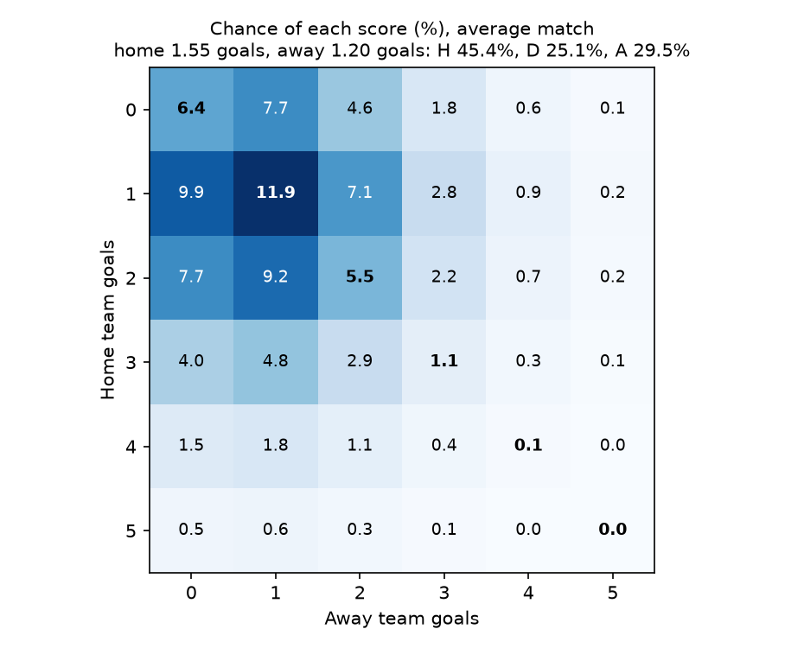
Figure 9. Chance of each scoreline (%) for an average training match (expected goals: home 1.55, away 1.20). Diagonal cells (bold) are draws; cells below the diagonal are home wins and cells above it away wins. Source: extra_experiments/06.
For each match, λ_home and λ_away were predicted from the same 38 pre-match features with Poisson regression (log λ = β₀ + βᵀx), fitted on the training seasons with the notebook's preprocessing and the regularisation strength tuned by the same time-series cross-validation. The goals are used only as training targets, like the result itself, and never as inputs. The model was compared with the Random Forest on the validation season only, under the same 0.01 rule (notebook Section 27; extra_experiments/06_poisson_goal_model.py). Two decisions were taken from the same probabilities: the most probable result, and the prior-corrected decision of Section 18.5 (each probability divided by its class's training share).
Model (validation 2023/24) | Macro-F1 | Accuracy | Draw F1 | Log loss | Brier | RPS | Draws predicted
Random Forest (final model, retrained in the same run) | 0.492 | 50.6% | 0.334 | 0.983 | 0.587 | 0.196 | 29.8%
Poisson goal model, most probable result | 0.405 | 54.0% | 0.000 | 0.969 | 0.576 | 0.192 | 0.0%
Poisson goal model, prior-corrected decision | 0.453 | 52.0% | 0.169 | 0.969 | 0.576 | 0.192 | 10.1%
Dummy baseline (training class shares) | 0.201 | 43.3% | 0.000 | 1.077 | 0.652 | 0.229 | 0.0%
The Poisson model gives slightly better probabilities than the Random Forest (log loss 0.969 against 0.983, Brier 0.576 against 0.587, RPS 0.192 against 0.196), close to the unweighted models compared in Section 18 (log loss 0.964 to 0.971), but it cannot recognise draws on its own. The highest draw probability it gives any validation match is 0.292, so the most probable result is never a draw (Draw F1 0.000, Macro-F1 0.405). Two independent goal counts spread the chance of a draw thinly over 0–0, 1–1, 2–2 and so on, and the model also under-predicts draws overall (23.0% against 26.2%), the weakness Dixon and Coles (1997) addressed with a low-score adjustment. The prior-corrected decision predicts a draw for 10.1% of matches (the Random Forest: 29.8%) and reaches Macro-F1 0.453, still 0.039 below the Random Forest (paired bootstrap 95% CI −0.054 to −0.024), so the rule is not met and the Random Forest stays the final model. What only a goal model offers is expected goals for each team and a most likely exact score, which was right for 13.2% of validation matches. The comparison confirms Section 18.2 from a different angle: the best model depends on whether the user needs all three results recognised (Macro-F1) or the most accurate probabilities (log loss).

19. Final Test Evaluation (2024-25, Evaluated Once)
The frozen configuration (Section 18.2), trained on seasons up to 2022, was evaluated exactly once on the untouched 2024-25 test period, per the frozen-decision protocol in Section 12. The validation season was not added to the training data before testing, so the test score reflects exactly the model that was selected.

19.1 Random Forest (frozen final model)
Metric | Value
Macro-F1 | 0.473 (95% bootstrap CI 0.460-0.486)
Accuracy | 48.9%
Balanced accuracy | 0.474
Draw F1 | 0.326
Log loss | 1.008
Brier score | 0.603
Dummy baseline on the same test set | Macro-F1 0.202, accuracy 43.4%, log loss 1.075, Brier 0.651
Class | Precision | Recall | F1 | Support
Away win | 0.496 | 0.530 | 0.513 | 1742
Draw | 0.306 | 0.350 | 0.326 | 1432
Home win | 0.624 | 0.540 | 0.579 | 2430

19.2 Confusion matrix (final model, test)
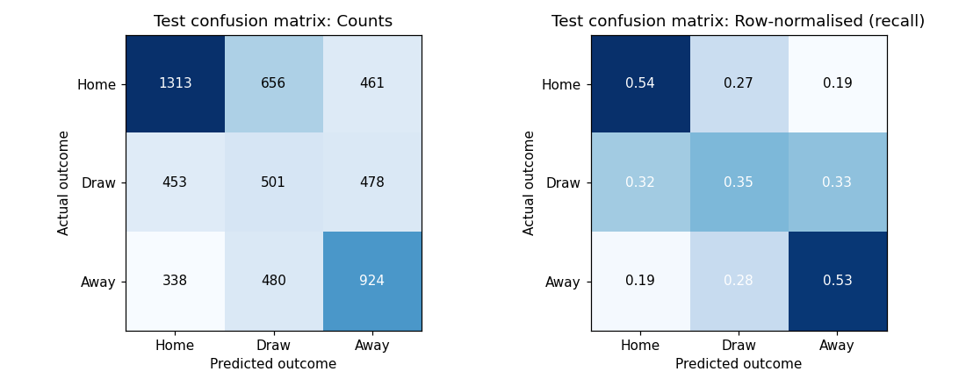
Figure 10. Confusion matrix of the final Random Forest on the test period 2024-25 (left: counts; right: share of each actual outcome).
Actual \ predicted | Home | Draw | Away | Total
Away win | 338 | 480 | 924 | 1742
Draw | 453 | 501 | 478 | 1432
Home win | 1313 | 656 | 461 | 2430
The confusion matrix shows the effect of class weighting. The model predicts a draw in 1,637 of the 5,604 test matches (29.2%), close to the true draw share (25.6%), and recognises 501 of the 1,432 actual draws. The price is that only 1,313 of the 2,430 home wins (54%) are recognised, because some home wins are now predicted as draws (656). Most errors are between neighbouring outcomes: true draws are split almost evenly between predicted home (453) and away (478) wins, while confusion between the two extremes is smaller (461 home wins predicted as away wins, 338 away wins as home wins).

19.3 Per-league diagnostics (final model, test)
League | Matches | Macro-F1 | Accuracy
Belgium | 480 | 0.451 | 47.1%
England | 760 | 0.422 | 44.2%
France | 612 | 0.477 | 50.3%
Germany | 612 | 0.477 | 50.2%
Italy | 760 | 0.519 | 52.9%
Netherlands | 612 | 0.474 | 49.7%
Portugal | 612 | 0.517 | 52.1%
Scotland | 396 | 0.452 | 47.2%
Spain | 760 | 0.449 | 45.9%
Performance is broadly consistent across leagues (Macro-F1 0.42-0.52, highest in Italy and Portugal and lowest in England), with no league collapsing to baseline-level performance, which is evidence against a single-league artefact driving the overall result. The two test seasons are equally stable (2024/25: 0.475; 2025/26: 0.471). Per Section 18 of the governing protocol, this is diagnostic only and was not used to re-select the model.

19.4 Training, validation and test compared
Part (final model) | Matches | Accuracy | Macro-F1 | Draw F1 | Log loss | Brier
Train | 42,795 | 49.2% | 0.483 | 0.358 | 0.997 | 0.595
Validation | 2,802 | 50.6% | 0.492 | 0.334 | 0.983 | 0.587
Test | 5,604 | 48.9% | 0.473 | 0.326 | 1.008 | 0.603
Accuracy and Macro-F1 differ by less than 0.02 across the three parts: the training score is only 0.010 above the test score (Macro-F1 0.483 against 0.473) and below the validation score (0.492). The model is therefore not overfitting; 200 trees of depth at most 6, with at least 5 matches in every leaf, cannot memorise individual matches. Overfitting would show as a large gap between the training and test rows, as it did when Gradient Boosting was given more rounds (training 0.540, validation 0.495 to 0.499; Section 18.5). Scores near 0.5 reflect how uncertain football results are before kickoff, not a failure to learn, and the validation season happened to be slightly easier than the test seasons. The training row is computed with the saved model (extra_experiments/12); the test row is the single evaluation of Section 19.1.

19.5 How good is 48.9%?
Accuracy of 48.9% sounds low next to the 80% to 95% often quoted for other classification tasks, so the model is compared below with simple rules on the same kind of data (extra_experiments/12).
Rule or model | Seasons | Matches | Accuracy | Macro-F1 | Draw predictions
Always predict a home win | 2024/25–2025/26 (test) | 5,604 | 43.4% | 0.202 | 0.0%
Most common result for each tenth of the XI strength gap | 2008/09–2022/23 (training) | 42,795 | 52.5% | 0.382 | 0.0%
Most common result for each tenth of the XI strength gap | 2024/25–2025/26 (test) | 5,604 | 51.4% | 0.379 | 0.0%
Bookmaker favourite (Bet365, margin removed) | 2008/09–2015/16 (only seasons with odds) | 22,592 | 53.3% | 0.389 | 0.1%
Final Random Forest | 2024/25–2025/26 (test) | 5,604 | 48.9% | 0.473 | 29.2%
The final model's accuracy is below two rules that never predict a draw: the XI-gap rule (51.4% on the same test seasons) and the bookmaker's favourite (53.3%, on the 2008/09–2015/16 seasons, the only ones with odds in the data, so that comparison is indicative). The gap is the price of recognising draws: the model predicts a draw for 29.2% of test matches and gets 501 of the 1,432 actual draws right, while the rules get none. On Macro-F1, which counts the three results equally, the final model (0.473) is well ahead of the XI-gap rule (0.379) and the bookmaker's favourite (0.389). A user who only wants the most frequent correct pick should use an unweighted model (validation accuracy up to 54.0%, Section 18); this project chose Macro-F1 in advance (D03). How sure a single prediction is matters more than the average: when the highest of the three probabilities is 0.60 or more (15.0% of test matches) the pick is right 73.8% of the time, and when it is below 0.40 (42.3% of matches) only 34.8% of the time.

19.6 Are the probabilities calibrated?
A probability is calibrated if, among matches given 40%, about 40% end that way. The test matches were split into five equal groups by each predicted probability, and the average prediction in each group was compared with how often that result happened (extra_experiments/12; ml_outputs/calibration_test.csv).
Group (by that probability) | Home: predicted / happened | Draw: predicted / happened | Away: predicted / happened
Lowest fifth | 15.2% / 19.4% | 24.0% / 18.0% | 13.7% / 12.2%
Second fifth | 25.8% / 32.7% | 31.3% / 22.5% | 23.7% / 19.8%
Middle fifth | 32.6% / 41.5% | 34.6% / 28.4% | 30.0% / 29.6%
Fourth fifth | 40.8% / 51.6% | 36.5% / 27.2% | 38.4% / 37.4%
Highest fifth | 59.5% / 71.6% | 37.8% / 31.7% | 56.1% / 56.5%
All test matches | 34.8% / 43.4% | 32.9% / 25.6% | 32.4% / 31.1%
P(Away) is close to calibrated (gaps −3.9 to +0.4 points). P(Home) is too low in every group, by 4.1 to 12.2 points, and P(Draw) too high, by 6.0 to 9.3 points: on average the model gives P(Home) 34.8% while 43.4% of test matches were home wins, and P(Draw) 32.9% against 25.6% draws. This is the expected side-effect of class weighting, which gives draws and away wins more weight in training than their share of matches. The probabilities put matches in a sensible order (ROC-AUC 0.69 on validation, Section 18.6) but should not be read as exact chances unless they are recalibrated on a later season (Section 25).

20. Explainability and Football Interpretation
Interpretation here answers “what predictive information did the model use?” rather than “what caused the result?” — observational football data cannot establish causal effects without a stronger design, so every finding below is described as predictive association, following Section 19 of the governing methodology.

20.1 Most important single inputs (final model)
Feature | Introduced in | Macro-F1 drop (permutation) | Std. dev. | Impurity importance
xi_strength_diff | FS2 | 0.0070 | 0.0050 | 0.163
away_top3_strength | FS2 | 0.0037 | 0.0032 | 0.059
home_top3_strength | FS2 | 0.0031 | 0.0029 | 0.060
away_attack_strength | FS3 | 0.0022 | 0.0013 | 0.025
home_attack_strength | FS3 | 0.0014 | 0.0017 | 0.023
away_attack_vs_home_defence | FS3 | 0.0009 | 0.0024 | 0.079
away_goals_for_avg_L5 | FS1 | 0.0007 | 0.0007 | 0.005
home_attack_vs_away_defence | FS3 | 0.0005 | 0.0039 | 0.075
Starting-XI strength dominates both measures. Shuffling xi_strength_diff alone lowers validation Macro-F1 by 0.007, and it carries 16% of the forest's impurity importance. The two measures disagree on the next places: midfield_strength_diff has the second-highest impurity importance (0.115) but almost no permutation effect, because the correlated XI and Top-3 strengths carry the same information (Section 9.5). Single-column results are therefore read with caution, and the group view in Section 20.2 is the more reliable summary. This is consistent with the FS1 → FS2 jump in Section 17.

20.2 Group-level importance (final model, permutation on validation Macro-F1)
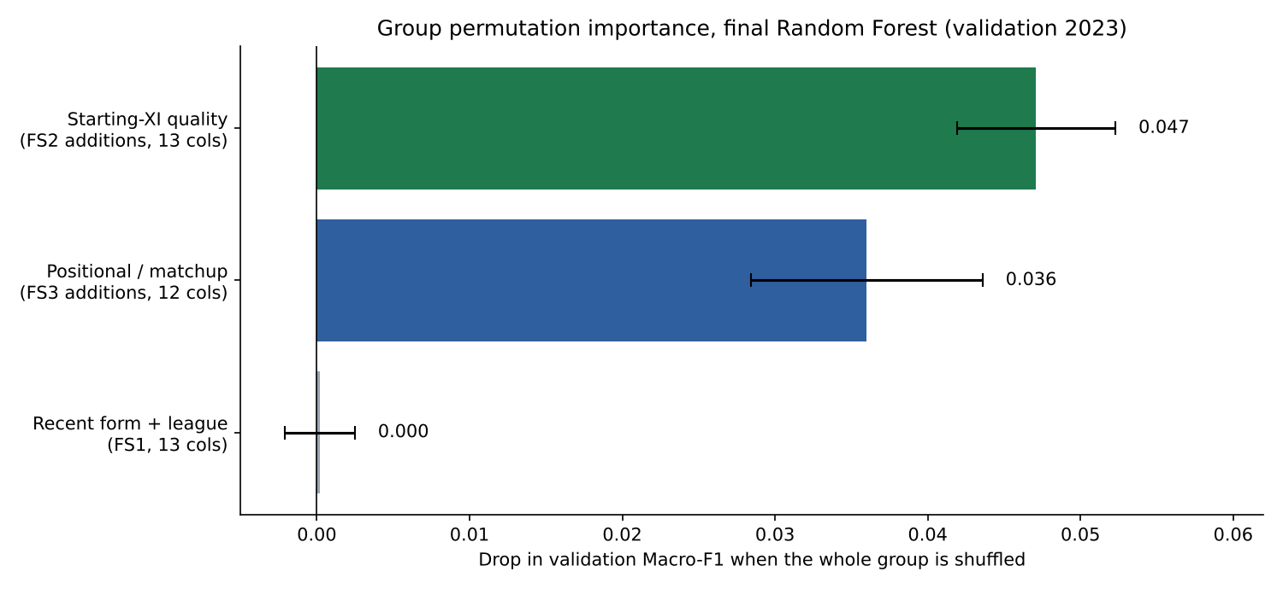
Figure 11. Drop in validation Macro-F1 when all columns of one feature group are shuffled together, final Random Forest (mean of repeated shuffles; error bars show one standard deviation).
Shuffling the starting-XI quality block (13 columns) lowers validation Macro-F1 by 0.047 and the positional/matchup block (12 columns) by 0.036, while the form-and-league block changes it by less than 0.001. Recent form is not useless on its own (it explains part of the outcome in the nested regressions of R script 04), but once XI strength is known it adds almost nothing new, because strong XIs are usually also in good form. The final model therefore rests on who actually plays, which is the central claim of the project.

20.3 Illustrative match-level explanation format
For a single unseen match, the deployed explanation should show the probability vector plus a small set of supporting and opposing drivers, for example: “strong home recent PPG and a positive midfield difference support the Home probability, while a strong away defence and a negative Top-3 gap reduce it.” This structured output is what a natural-language layer (Section 26) would narrate — it should receive these numbers rather than invent its own reasoning.

Part VI — Reproducibility and Project Execution

21. Notebook Architecture and Implementation Stages
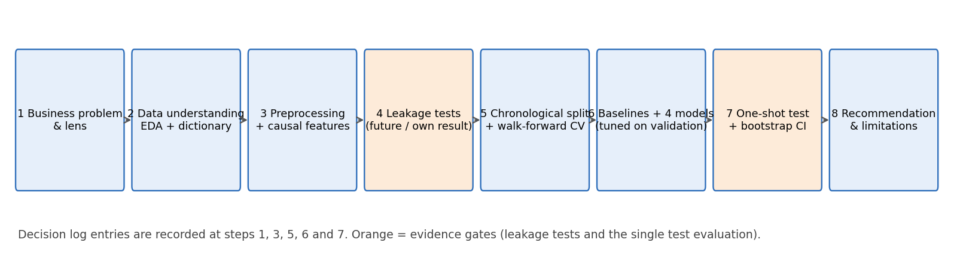
Figure 12. End-to-end assignment workflow from framing to final evidence package.
Stage | Required implementation | Saved evidence
01 Setup | Imports, versions, random seed (42), paths, configuration | Environment/version block
02 Load & audit | Load CSV, parse dates, shape/schema, target/duplicate checks | QA table
03 EDA | Target/league/season/source/missingness/form/strength plots | EDA insight log + Figures 2-4
04 Leakage audit | Explicit excluded columns and timestamp rules | Leakage log; Section 8.2 verification
05 Feature sets | Define FS1-FS4 exactly | Feature registry; Section 11
06 Split | Chronological Train/Val/Test with counts | Split figure/table; Section 12
07 Preprocessing | ColumnTransformer and train-only pipeline | Preprocessing log; Section 13
08 Baseline | Dummy prior benchmark | Baseline metrics; Section 17
09 Ablation | All six models + Dummy on FS1-FS4; paired bootstrap | Ablation table; Section 17
10 Candidate models | Logistic Regression / Naive Bayes / kNN / Decision Tree / Random Forest / Gradient Boosting | Validation leaderboard; Section 18
11 Temporal tuning | GridSearchCV with TimeSeriesSplit (3 folds) inside the training period | Tuning table (tuned_validation_results.csv)
12 Imbalance | Weighted vs unweighted class experiment (no calibration applied) | Trade-off table; Section 18.3
13 Freeze model | Write final configuration before touching test | Decision-log entry; Section 22
14 Final test | One evaluation on 2024+ | Final metrics/confusion matrix; Section 19
15 Robustness | Modern-only, per-league, per-season, coverage and data-quality variants | Robustness tables; Sections 18.3, 19.3
16 Explainability | Permutation importance (single columns and groups) + impurity importance | Interpretation figures; Section 20
17 Export | Save pipeline, feature schema, predictions, metrics | ml_outputs/ (model .joblib + CSV tables + figures)
18 What-if analysis | Scenario changes applied to the frozen model (notebook Section 24) | What-if tables; Section 26
19 Additional models | MLP, HistGradientBoosting, XGBoost, support vector machines and ordinal logistic regression, on validation only, after the model was frozen | additional_models_validation.csv; Section 18.5
20 Statistical goal model | Poisson regression for each team's goals; the scoreline grid gives H/D/A probabilities (notebook Section 27) | poisson_validation.csv; Section 18.8
Most stages are implemented in Machine_Learning_Pipeline.ipynb (Sections 1–27); the EDA stage is also covered by the R scripts and the pattern-exploration notebook. Appendix I lists every notebook and script in the evidence package and how to run it.

22. Decision Log, AI-Use Transparency and Evidence Package
Decision | Options considered | Rationale / evidence
Prediction cutoff | Before lineups; after lineups before kickoff; in-match | After lineups, before kickoff — enables actual XI/formation while preserving pre-match forecasting (Section 4)
Target | Exact score; binary win/no-win; H/D/A | H/D/A aligns with the assignment's decision lens and preserves outcome uncertainty
Main metric | Accuracy; Macro-F1; log loss | Macro-F1 primary because Draw is the smaller class and class balance matters; log loss and Brier score retained as probability-quality support (Section 16, resolved explicitly in Section 18.2)
Split | Random split; chronological holdout | Chronological — represents future deployment and prevents future-to-past contamination (Section 12)
Player quality | No player signal; raw values; causal relative index | Latest prior evidence with a causal 0-100 relative index; source transition documented and stress-tested (Sections 10.2, 18.3)
Feature strategy | All features at once; automated filter; FS1-FS4 ablation | Ablation directly answers the incremental-value research questions (Section 11, 17)
Model selection | Trust Macro-F1 alone; trust log loss alone; Macro-F1 with log loss as a secondary check | Highest validation Macro-F1 (class-weighted Random Forest, 0.492) with near-best log loss (0.983); Naive Bayes ranked lower on Macro-F1 (0.473) and its log loss (2.35) also showed unreliable probabilities (Section 18.2)
AI assistance | Undeclared code generation; transparent assisted workflow | Declared below; all reported numbers are reproducible programmatic outputs, not AI-estimated values
The table summarises the main decisions. The complete log of 20 decisions, with the evidence and owner of each, is in Appendix D, and Appendix I lists the notebooks, code and logs submitted with this report.
AI-use statement
Generative AI tools (Claude, Anthropic) were used to support pipeline drafting, code review, documentation structuring and report writing. Dataset transformations, model training, evaluation metrics and every numerical result reported in Parts V and Appendix C were executed programmatically from the submitted code (seed 42) and are reproducible. AI-generated text and suggestions were reviewed by the group and were not treated as empirical evidence unless verified against the executed data.

23. Team Responsibilities and Work Allocation
Member | Core responsibility | Evidence
Kumara D.G.K.R.D. — IT24103972 | Problem framing, source validation and integration | Problem-framing canvas; source log; integration checks; decision-log entries
Jayamuni J T S J — IT24300329 | EDA and data-quality analysis | EDA notebook; missingness/coverage audit; visualisations; EDA insight log
Jayawardana D. I. A. — IT24103756 | Feature engineering and preprocessing | Feature code; leakage checks; preprocessing pipeline; feature log
Bandara H. M. T. A. — IT24103675 | Modelling, evaluation and interpretation | Temporal tuning; comparison tables; confusion matrices; explainability and final-model evidence
All members reviewed the final modelling decisions, verified notebook-to-report consistency, agreed on limitations and recommendation wording, and will participate in the demonstration.

Part VII — Stakeholder Value, Limitations and Optional Extension

24. Practical Decision-Support Output
Item | Example display (illustrative)
Match | Team A vs Team B
Recent form | Home PPG L5 / Away PPG L5
XI quality | Home XI / Away XI / difference
Positional matchup | Home ATT vs Away DEF; midfield difference; GK difference
Continuity | Home and Away lineup continuity
Model output | P(Home), P(Draw), P(Away) from the frozen Random Forest (Section 18.2)
Explanation | Top supporting and opposing predictive factors (Section 20.3)
Uncertainty note | Probability estimates are not guarantees
What-if | Change venue, unit strength or rival absences and show the new probabilities (Section 26)

24.1 Reading a prediction: real examples from the test seasons
The table shows five real test-season predictions of the frozen model (ml_outputs/prediction_examples_test.csv, selected by rule in extra_experiments/12). They show how the output should, and should not, be read.
Match | P(Home) | P(Draw) | P(Away) | Pick → score | What it shows
FC Porto v Avs Futebol  (29 Dec 2025, Portugal) | 0.804 | 0.137 | 0.059 | Home → 2–0 | The most confident prediction in two seasons still leaves about 20% for a draw or an away win.
Sporting CP v CD Santa Clara  (30 Nov 2024, Portugal) | 0.775 | 0.159 | 0.066 | Home → 0–1 | A confident prediction can still be wrong: upsets are part of football.
Avs Futebol v SL Benfica  (15 Dec 2024, Portugal) | 0.072 | 0.170 | 0.758 | Away → 1–1 | The most confident away-win pick ended level.
Leeds United v Fulham FC  (17 Jan 2026, England) | 0.304 | 0.396 | 0.300 | Draw → 1–0 | The highest draw probability in two test seasons is 0.40; a draw pick means the three results are close.
Chelsea FC v Manchester City  (12 Apr 2026, England) | 0.328 | 0.335 | 0.337 | Away → 0–3 | Almost a three-way tie: the pick was right, but it was close to a guess.
- Read all three probabilities, not only the pick: the pick is right 73.8% of the time when its probability is 0.60 or more, but only 34.8% of the time when it is below 0.40 (Section 19.5).
- Allow for calibration: on average P(Home) is about 9 points too low and P(Draw) about 7 points too high (Section 19.6), so a draw pick means the match is close rather than that a draw is likely.
- The probabilities describe what usually happened in similar past matches; in-match events (injuries, red cards, refereeing) are outside the model (Section 25), and the output is not a betting recommendation.

25. Limitations, Risks and Responsible Use
Limitation | Impact on the model | Mitigation applied or recommended
In-match events (cards, injuries, substitutions) are unknowable at the prediction cutoff | Sets a hard ceiling on achievable accuracy regardless of model quality; not a modelling failure | Communicate probabilities, not certainties (Section 24); do not claim event-level accuracy
Historical lineup/strength coverage varies by league and era (Section 9.4) | Slightly noisier training signal in 2008 and low-coverage leagues | NaN retained + train-only imputation; dropping incomplete matches changes test Macro-F1 by −0.003 to −0.005, i.e. it does not help (Section 18.3)
FIFA ratings and market values measure related but different constructs (Section 10.2); market value also reflects club wealth, age and contract length | Player-quality scale is not perfectly homogeneous across the 2016 boundary | Causal percentile within league and role; on 2012-2015 matches present in both sources the two versions of xi_strength_diff correlate at r = 0.94; the XI-strength effect does not differ between sources (p = 0.44); modern-only training gives the same test score (Section 18.3)
Recent form is sparse at season openers | Form-based features default toward the population mean early in each season | form_n_L5 retained so the model knows how many form matches exist; at season openers the model relies on squad strength instead
Class weighting trades some probability quality for draw recognition (Section 18.2) | Validation log loss rises from 0.966 to 0.983 with weighting; on the test seasons P(Home) is on average 8.6 points too low and P(Draw) 7.3 points too high (Section 19.6) | Log loss, Brier score and a calibration table reported alongside Macro-F1; recalibration on a later season recommended before probabilities are shown to users; reading guidance in Section 24.1
Feature importance is associative, not causal (Section 20) | “What predicted this” must not be read as “what caused this” | Explanation language restricted to “supporting/opposing factors”, never “causes”
Bookmaker odds exist only in the 2008-2016 source and are not used | Cannot state whether the model beats the market on the 2024-25 test period, only that it beats naive baselines | Odds are not part of the engineered dataset, so inputs are lineup and form information only. For context, the Bet365 favourite on the 2008/09–2015/16 seasons reaches 53.3% accuracy and Macro-F1 0.389 (Section 19.5); a test-period market benchmark needs odds for recent seasons
Model must not be positioned as a betting recommendation engine | Misuse risk if deployed without this framing | Explicit statement here and in Section 24's stakeholder output design
Performance can drift as tactics, transfer markets and data-generation processes evolve | A model frozen at submission time will degrade silently without monitoring | Periodic revalidation recommended, particularly around the source-era boundary documented in Section 8
Only 9 of Europe's leagues are covered; Switzerland and Poland were excluded (Section 8) | Findings may not transfer to leagues with different tactical or competitive characteristics | Per-league diagnostics reported (Section 19.3) to bound generalisation claims to the covered leagues
Source-data gaps and league-format differences (Section 8.3) | Some seasons are incomplete (Belgium 2013/14, COVID 2019/20); Scottish post-split rounds are missing from Stage 2 after 2016/17 | Documented; the related robustness variants change test Macro-F1 by at most 0.006 (Section 18.3)
Richer pre-match information (rest days, discipline, player form) exists only from 2016 | Cannot be used across the full 2008-2026 panel | Tested on 2016-2022 training: no gain beyond noise (Section 18.3); left as future work
Accuracy (48.9%) is below simple rules that never predict a draw (Section 19.5) | A one-feature XI-gap rule reaches 51.4% on the same test seasons, so a user who judges by accuracy alone may see the model as weak | Deliberate trade-off fixed in D03: Macro-F1 0.473 against 0.379 for the rule; both measures reported; an accuracy-first user should use an unweighted model
Model selection rests on one validation season (2,802 matches) | Differences of about 0.01 between the best candidates are within noise (Sections 18.4 and 18.6) | Pre-set 0.01 decision rule; tuning by time-series cross-validation inside the training seasons; test used once; bootstrap intervals reported
Draws remain the hardest result (test Draw F1 0.326) | The model's highest draw probability in two test seasons is 0.40, and a statistical goal model never makes a draw the most likely result (Section 18.8) | Class weighting; all three probabilities shown, with reading guidance (Section 24.1)
Nine features are exact combinations of others (Section 18.7) | Inflates Naive Bayes' confidence (log loss 2.35) and splits importance among correlated features (Section 20.1) | Tested: removing them changes the Random Forest by +0.006, within the rule; group-level importance reported (Section 20.2)

26. Optional Football Simulator and AI Explanation Extension — Future Work
The following extension is proposed as a natural next step for the stakeholder identified in Section 2. The web application is not built in this submission and is not required by the rubric. A first, model-based what-if analysis has been run in Section 24 of the notebook to show the direction a production system could take.
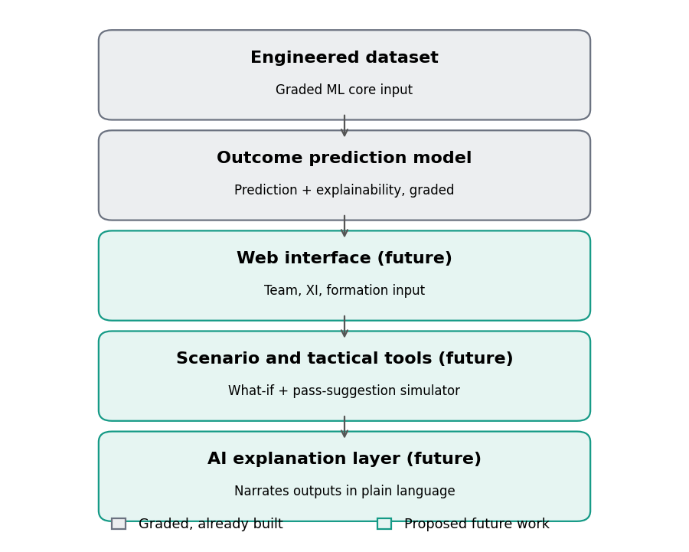
Figure 13. Recommended extension of the graded ML core into a decision-support system. Grey = graded and already built; teal = proposed future work.
The graded outcome-prediction model and its explainability output (Sections 18-20) would sit behind a web interface where a coach selects the team, starting XI and formation. That interface would drive a what-if simulator (re-running the same model on an edited lineup) and a tactical pass-suggestion tool, with an AI layer narrating the model's numbers in plain football language.
The notebook's what-if analysis applies such scenario changes to the frozen model. Across the 1,425 test matches where the away XI was at least 20 points weaker and player data were complete, a 10-point improvement across the away XI raised the away-win probability by 2.4 percentage points on average, playing at home instead by 1.5, and a 15-point weaker rival attack by 1.2, while single-unit improvements added 0.2-0.9 points. These are associations learned from past matches, not causal effects of selection decisions, and formation itself carried no predictive value (Section 17).
Boundary the future-work extension must respect
Because the current match-level dataset contains no pass-by-pass event or XY tracking data, any “best pass” hint in a future prototype must be clearly labelled as simulator logic, not as something learned from the H/D/A dataset. A natural-language layer should receive structured model outputs (probabilities, drivers) and must not invent its own numerical reasoning — the correct architecture is Model/Simulator → structured output → language explanation, never the reverse.

Appendices

Appendix A — Dataset Snapshot
Property | Value
File | European_Football_PlayerAware_Primary_9Leagues_2008_2026.csv
Rows | 51,201 matches
Columns | 62
Date range | 2008-08-09 to 2026-05-24
Leagues | 9: Belgium, England, France, Germany, Italy, Netherlands, Portugal, Scotland, Spain
Data sources | european_soccer_sqlite_stage1 (2008/09-2015/16); transfermarkt_stage2 (2016/17-2025/26)
Target balance | Home 45.0%, Draw 24.9%, Away 30.1%
Train / Validation / Test | 42,795 (≤2022) / 2,802 (2023) / 5,604 (≥2024)
Duplicate match_uid / game_id | 0 / 0
Target vs audit-goals mismatch | 0 rows

Appendix B — Full Data Dictionary (62 columns)
Column descriptions follow the dataset builder's own documentation (Section 8) and were independently verified where checkable (Section 8.2).
Column | Type | Group | % missing | Description
match_uid | str | identifier / label | 0.0% | Unique match key (stage prefix + game_id).
data_source | str | context | 0.0% | Origin stage of the row: european_soccer_sqlite_stage1 (seasons 2008-2015) ...
strength_method | str | context | 0.0% | How player strength was built: Stage 1 = latest pre-match FIFA overall_rati...
game_id | int64 | identifier / label | 0.0% | Match id within its source.
date | datetime64[us] | context | 0.0% | Match date.
season_start | int64 | context | 0.0% | Calendar year the season starts (2025 = 2025/26).
season | str | identifier / label | 0.0% | Season label, e.g. 2008/2009.
league_code | str | identifier / label | 0.0% | League code, harmonised across both sources (BE1, ES1, FR1, GB1, IT1, L1, NL1, PO1, SC1).
league_name | str | identifier / label | 0.0% | League name (differs between the two sources).
country | str | context | 0.0% | Country of the league (consistent across sources, 9 values).
league_coverage_flag | str | identifier / label | 0.0% | Which era the league rows belong to (full_2008_2015 or full_2016_2025).
home_team_id | int64 | identifier / label | 0.0% | Home team id (id systems of the two sources do NOT overlap).
away_team_id | int64 | identifier / label | 0.0% | Away team id.
home_team | str | identifier / label | 0.0% | Home team name.
away_team | str | identifier / label | 0.0% | Away team name.
home_formation | str | formation | 1.32% | Home starting formation label (30 distinct labels).
away_formation | str | formation | 1.33% | Away starting formation label.
home_form_n_L5 | int64 | recent form | 0.0% | Home team: Number of earlier matches (0-5) in the last-5 window. The window...
away_form_n_L5 | int64 | recent form | 0.0% | Away team: Number of earlier matches (0-5) in the last-5 window. The window...
home_points_per_game_L5 | float64 | recent form | 2.82% | Home team: Points per game over the last (up to) 5 earlier matches of this ...
away_points_per_game_L5 | float64 | recent form | 2.83% | Away team: Points per game over the last (up to) 5 earlier matches of this ...
home_win_rate_L5 | float64 | recent form | 2.82% | Home team: Share of wins in the last (up to) 5 earlier matches.
away_win_rate_L5 | float64 | recent form | 2.83% | Away team: Share of wins in the last (up to) 5 earlier matches.
home_goals_for_avg_L5 | float64 | recent form | 2.82% | Home team: Average goals scored in the last (up to) 5 earlier matches (veri...
away_goals_for_avg_L5 | float64 | recent form | 2.83% | Away team: Average goals scored in the last (up to) 5 earlier matches (veri...
home_goals_against_avg_L5 | float64 | recent form | 2.82% | Home team: Average goals conceded in the last (up to) 5 earlier matches.
away_goals_against_avg_L5 | float64 | recent form | 2.83% | Away team: Average goals conceded in the last (up to) 5 earlier matches.
home_goal_diff_avg_L5 | float64 | recent form | 2.82% | Home team: Average goal difference in the last (up to) 5 earlier matches.
away_goal_diff_avg_L5 | float64 | recent form | 2.83% | Away team: Average goal difference in the last (up to) 5 earlier matches.
home_starter_count | int64 | lineup quality | 0.0% | Home team: Number of starters recorded for the team (11 expected).
away_starter_count | int64 | lineup quality | 0.0% | Away team: Number of starters recorded for the team (11 expected).
home_strength_known_n | int64 | lineup quality | 0.0% | Home team: Number of starters that have a strength value.
away_strength_known_n | int64 | lineup quality | 0.0% | Away team: Number of starters that have a strength value.
home_strength_coverage | float64 | lineup quality | 1.29% | Home team: Share of starters with a strength value (0-1).
away_strength_coverage | float64 | lineup quality | 1.29% | Away team: Share of starters with a strength value (0-1).
home_strength_age_mean_days | float64 | lineup quality | 1.29% | Home team: Mean age in days of the strength values used (staleness).
away_strength_age_mean_days | float64 | lineup quality | 1.31% | Away team: Mean age in days of the strength values used (staleness).
home_xi_strength | float64 | squad strength | 1.81% | Home team: Starting-XI overall strength, 0-100 percentile scale.
away_xi_strength | float64 | squad strength | 1.82% | Away team: Starting-XI overall strength, 0-100 percentile scale.
home_attack_strength | float64 | squad strength | 1.81% | Home team: Mean strength of starting attackers.
away_attack_strength | float64 | squad strength | 1.82% | Away team: Mean strength of starting attackers.
home_midfield_strength | float64 | squad strength | 1.47% | Home team: Mean strength of starting midfielders.
away_midfield_strength | float64 | squad strength | 1.49% | Away team: Mean strength of starting midfielders.
home_defence_strength | float64 | squad strength | 1.46% | Home team: Mean strength of starting defenders.
away_defence_strength | float64 | squad strength | 1.47% | Away team: Mean strength of starting defenders.
home_gk_strength | float64 | squad strength | 2.14% | Home team: Strength of the starting goalkeeper.
away_gk_strength | float64 | squad strength | 2.19% | Away team: Strength of the starting goalkeeper.
home_top3_strength | float64 | squad strength | 1.46% | Home team: Mean strength of the 3 strongest starters.
away_top3_strength | float64 | squad strength | 1.47% | Away team: Mean strength of the 3 strongest starters.
home_top3_gap | float64 | squad strength | 1.81% | Home team: top3_strength - xi_strength (star dependence; verified).
away_top3_gap | float64 | squad strength | 1.82% | Away team: top3_strength - xi_strength (star dependence; verified).
home_lineup_continuity | float64 | lineup quality | 7.44% | Home team: Share of current starters who also started the team's previous s...
away_lineup_continuity | float64 | lineup quality | 7.43% | Away team: Share of current starters who also started the team's previous s...
xi_strength_diff | float64 | squad strength | 2.15% | home_xi_strength - away_xi_strength (verified).
home_attack_vs_away_defence | float64 | squad strength | 1.84% | home_attack_strength - away_defence_strength (verified).
away_attack_vs_home_defence | float64 | squad strength | 1.84% | away_attack_strength - home_defence_strength (verified).
midfield_strength_diff | float64 | squad strength | 1.52% | home_midfield_strength - away_midfield_strength (verified).
gk_strength_diff | float64 | squad strength | 2.7% | home_gk_strength - away_gk_strength (verified).
player_feature_ready | int64 | lineup quality | 0.0% | 1 if lineup-strength features are usable for the match, else 0.
audit_home_goals | int64 | leakage (never a feature) | 0.0% | Full-time home goals. AUDIT ONLY: never a model input (it defines the target).
audit_away_goals | int64 | leakage (never a feature) | 0.0% | Full-time away goals. AUDIT ONLY.
target_result | str | target | 0.0% | TARGET: full-time result from the home team's view (H / D / A).

Appendix C — Populated Results Tables (Executed Run)
This appendix consolidates every numeric result referenced in Part V into one place for quick marking reference. All values come from the executed notebook with random seed 42; the last row of C.4 and of Appendix G come from the data-quality checks described in the note under Section 18.3.

C.1 FS1-FS4 ablation (validation, 2023, best model per feature set)
Feature set | Macro-F1 | Accuracy | Balanced acc. | Draw F1 | Log loss
FS1 (Naive Bayes) | 0.392 | 47.9% | 0.428 | 0.090 | 1.250
FS2 (Naive Bayes) | 0.464 | 52.4% | 0.484 | 0.204 | 1.467
FS3 (Naive Bayes) | 0.473 | 52.0% | 0.487 | 0.236 | 2.356
FS4 (kNN) | 0.416 | 52.6% | 0.462 | 0.066 | 0.984

C.2 Model comparison (validation, 2023, FS3)
Model | Macro-F1 | Accuracy | Class weight | Draw F1 | Log loss
Random Forest (tuned) | 0.492 | 50.6% | balanced | 0.334 | 0.983
Gradient Boosting | 0.491 | 50.7% | balanced | 0.324 | 0.980
Logistic Regression | 0.485 | 52.4% | balanced | 0.267 | 0.984
Decision Tree | 0.478 | 48.7% | balanced | 0.337 | 0.993
Gaussian Naive Bayes (tuned) | 0.473 | 52.0% | none | 0.236 | 2.353
kNN (tuned, k = 25) | 0.437 | 51.8% | none | 0.150 | 1.096
Gradient Boosting (unweighted) | 0.407 | 54.0% | none | 0.011 | 0.964

C.3 Final test (2024-25, evaluated once)
Model | Macro-F1 | Accuracy | Log loss | Brier | Macro-F1 95% CI
Random Forest (frozen final model) | 0.473 | 48.9% | 1.008 | 0.603 | [0.460, 0.486]
Dummy baseline (reference) | 0.202 | 43.4% | 1.075 | 0.651 | —

C.4 Robustness checks
Check | Macro-F1 | Log loss | Draw F1
Full-history training (final Random Forest, test) | 0.473 | 1.008 | 0.326
Modern-only training (Random Forest, test) | 0.471 | 1.011 | —
Unweighted Random Forest (validation) | 0.397 | 0.966 | 0.000
Weighted Random Forest, balanced (validation) | 0.492 | 0.983 | 0.334
All data-quality fixes (retrained, test) | 0.467 | 1.012 | 0.345

C.5 Per-league diagnostics (final model, test)
League | Matches | Macro-F1 | Accuracy
Belgium | 480 | 0.451 | 47.1%
England | 760 | 0.422 | 44.2%
France | 612 | 0.477 | 50.3%
Germany | 612 | 0.477 | 50.2%
Italy | 760 | 0.519 | 52.9%
Netherlands | 612 | 0.474 | 49.7%
Portugal | 612 | 0.517 | 52.1%
Scotland | 396 | 0.452 | 47.2%
Spain | 760 | 0.449 | 45.9%

Appendix D — Decision Log (Full Entries)
The complete project decision log (Decision_Log.xlsx in folder 1, maintained by Kumara D.G.K.R.D.) is reproduced below: 20 decisions, each with the options considered, the choice and the reason, the evidence and the owner. D01–D03 concern problem framing, D04–D07 the data, D08–D11 the features, D12–D13 the EDA, D14–D18 and D20 modelling, and D19 the project as a whole. Every decision was reviewed by the group; "All" marks decisions taken jointly.
ID | Decision | Options considered | Chosen option and reason | Evidence | Owner
D01 | Prediction cut-off | Before lineups / after lineups, before kickoff / in-match | After lineups, before kickoff: uses the real XI while staying a pre-match forecast. | Section 4; canvas box 3 | Kumara
D02 | Target definition | Exact score / win vs not-win / H-D-A | H / D / A, built from the final score. | Sections 2 and 7 | Kumara
D03 | Primary metric | Accuracy / Macro-F1 / log loss | Macro-F1, so the smaller Draw class counts equally; log loss and Brier as support. | Sections 16 and 18.2 | All
D04 | Data sources | Football-Data.co.uk results and odds only / Kaggle European Soccer Database (the descriptor's Code 9 dataset) + Transfermarkt | Kaggle European Soccer Database (2008-2016; the dataset the descriptor links for Code 9) + Transfermarkt (2016-2026) as a declared supplementary source: only these have lineups and dated player values. | Source notes §1 | Kumara
D05 | How to combine the sources | Join rows / stack rows | Stack: each match comes from one source; same 62-column schema; no time overlap. | Source notes §3; data-engineering notebook Part C | Kumara
D06 | Leagues kept | 11 leagues / 9 leagues | 9 leagues: Switzerland and Poland miss 2016-2023 and Poland lacks player data for 62.6% of matches. | R script 01: C_​why_​C1_​PL1_​removed.csv | Kumara
D07 | Which raw tables | All tables / pre-match tables only | Pre-match tables only; appearances and game_events excluded from the dataset (in-match information). | Source notes §2 | Kumara
D08 | Player-quality signal | None / raw values / causal relative index | Causal 0-100 percentile within league and role, from values dated before the match. | Feature log F03; Section 10.2 | Jayawardana
D09 | Missing values | Zero-fill / drop rows / NaN + train-only imputation | Keep NaN, median-impute inside the pipeline on training data only; dropping rows tested and did not help. | Preprocessing log P03; Section 18.3 | Jayawardana
D10 | Feature strategy | All at once / automatic filter / staged ablation | FS1 → FS4 ablation to answer the research questions directly. | Sections 11 and 17 | Jayawardana
D11 | Extra features from appearances | Add rest days, discipline, player form / keep FS3 | Keep FS3: best gain +0.004, within noise, and data exist only from 2016. | new_​feature_​experiment.csv | Jayawardana
D12 | Train / validation / test split | Random / chronological | Chronological (≤ 2022 / 2023 / ≥ 2024): outcomes drift over seasons (EDA E02-E04). | Section 12; EDA log | Jayamuni
D13 | Source-data gaps (Belgium 2013/14, Scottish split, COVID season) | Correct / remove / keep and document | Keep and document; robustness variants change test Macro-F1 by at most 0.006. | Sections 8.3 and 18.3 | Jayamuni
D14 | Final feature set | FS1 / FS2 / FS3 / FS4 | FS3: highest validation Macro-F1 (0.473 best model in the ablation); FS4 added nothing. | ablation_​validation_​results.csv | Bandara
D15 | Class imbalance | Resampling / class weights / none | class_weight = balanced: Macro-F1 +0.08 to +0.09 and Draw F1 from about 0 to 0.27-0.34. | candidate_​ranking_​validation.csv; Section 18.3 | Bandara
D16 | Final model | 6 models compared on validation | Random Forest (200 trees, max_depth 6, min_samples_leaf 5, balanced): validation Macro-F1 0.492, log loss 0.983. Naive Bayes ranked lower on Macro-F1 (0.473); its log loss of 2.35 also shows unreliable probabilities. | final_​model_​selection.csv; Section 18.2 | Bandara
D17 | Use of the test set | Test repeatedly / test once | Frozen model scored once on 2024/25-2025/26: Macro-F1 0.473 (95% CI 0.460-0.486). | final_​test_​metrics.csv | Bandara
D18 | Other model families | Stop at six models / also check MLP, HistGradientBoosting, XGBoost, AdaBoost, SVM and ordinal logistic regression | Checked after selection, on validation only: best was HistGradientBoosting at +0.00005 vs Random Forest, far below the 0.01 rule, and AdaBoost was 0.013 lower, so Random Forest stays. | additional_​models_​validation.csv; adaboost_​validation.csv; Section 18.5; Model_​Choice_​Justification.docx | Bandara
D19 | AI assistance | Undeclared / declared and verified | Declared; every number comes from executed code. | Section 22 | All
D20 | Classic statistical model | Machine-learning models only / also a Poisson goal model | Checked after selection, on validation only: Macro-F1 0.405 (most probable result; never predicts a draw) and 0.453 (prior-corrected) against 0.492; probabilities slightly better (log loss 0.969 against 0.983). Random Forest kept; Poisson reported as the statistical baseline. | poisson_​validation.csv; Section 18.8; notebook Section 27 | Kumara, Bandara

Appendix E — Reproducibility Settings
Setting | Value
Random seed | 42 (all models)
Software | Python, pandas, NumPy, scikit-learn 1.8 (LogisticRegression, GaussianNB, KNeighborsClassifier, DecisionTreeClassifier, RandomForestClassifier, GradientBoostingClassifier, DummyClassifier)
Dataset fingerprint | MD5 f3cee88490552a994e4d4608fedcf938 (European_Football_PlayerAware_Primary_9Leagues_2008_2026.csv; listed in the Official_Dataset_Files README)
Train / Validation / Test sizes | 42,795 / 2,802 / 5,604
Logistic Regression | C = 1.0, max_iter = 2000 (not tuned: only the three strongest families on FS3 were tuned); class_weight = balanced in the weighting experiment; median imputation + standard scaling
Gaussian Naive Bayes | var_smoothing tuned over {1e-9, 1e-6, 1e-3, 1e-1}: 0.001 selected; median imputation + standard scaling
k-Nearest Neighbours | k = 50 by default; tuned over k ∈ {25, 50, 100, 200} × uniform/distance weights: k = 25, uniform selected; median imputation + standard scaling
Decision Tree | max_depth = 6, min_samples_leaf = 50; class_weight = balanced in the weighting experiment
Random Forest (final) | 200 trees; tuned over max_depth {6, 12} × min_samples_leaf {5, 20} × class_weight {none, balanced}: 6, 5, balanced selected
Gradient Boosting | 100 trees, learning_rate = 0.1, max_depth = 3, subsample = 0.8; balanced sample weights in the weighting experiment
Tuning | GridSearchCV with TimeSeriesSplit (3 folds) inside the training period, scoring = Macro-F1

Appendix F — Glossary
Term | Meaning
Causal feature | A feature whose evidence timestamp is strictly before the match kickoff it is used to predict
FS1-FS4 | The four progressively richer feature sets used for ablation (Section 11)
Macro-F1 | The unweighted average of per-class F1 scores; the project's primary metric
Log loss / Brier score | Probability-quality metrics; lower is better for both
L5 | Rolling window over the team's previous five same-season league matches, current match excluded
XI strength / Top-3 strength / Top-3 gap | Mean starting-XI quality; mean of the three strongest starters; their difference (star-dependence)
Player-feature-ready | Indicator that both teams' starting-XI strengths were computable for a given match
Data source stage 1 / stage 2 | The FIFA-rating era (2008/09-2015/16) and the market-value era (2016/17-2025/26) of the dataset
Weighted-F1 / Micro-F1 | F1 averaged with class-size weights / F1 pooled over all decisions (equals accuracy when each match has one result); Section 18.6
Calibration | Whether predicted probabilities match observed frequencies: matches given 40% should end that way about 40% of the time (Section 19.6)
Poisson goal model | Predicts each team's expected goals; the two goal counts give the chance of every scoreline, which are added up into P(H), P(D) and P(A) (Section 18.8)

Appendix G — Statistical Significance (Paired Bootstrap, Full Detail)
Method: 1,000 bootstrap resamples with replacement, seed 42. Intervals are the 2.5th-97.5th percentile of the resampled statistic (a percentile bootstrap). Feature-set comparisons are paired on the 2,802 validation matches; the final-model interval uses the 5,604 test matches.
Model | Macro-F1 95% CI | Note
Random Forest (final model, test) | [0.460, 0.486] | Test set used once
Dummy baseline (test) | Point estimate 0.202 | Far below the final model's interval
Paired comparison | Mean diff. | 95% CI of difference
FS2 − FS1, best model (validation) | +0.072 | [0.055, 0.089]
FS3 − FS1, best model (validation) | +0.081 | [0.063, 0.101]
FS4 − FS1, best model (validation) | +0.024 | [0.007, 0.043]
All data-quality fixes − official (test, retrained) | −0.006 | [−0.012, 0.000]

Appendix H — Reference List
- Carpita, M., Ciavolino, E., & Pasca, P. (2019). Exploring and modelling team performances of the Kaggle European Soccer database. Statistical Modelling, 19(1), 1-28. https://doi.org/10.1177/1471082X18810971
- Cattelan, M., Varin, C., & Firth, D. (2013). Dynamic Bradley-Terry modelling of sports tournaments. Journal of the Royal Statistical Society: Series C (Applied Statistics), 62(1), 135-150.
- Dixon, M. J., & Coles, S. G. (1997). Modelling association football scores and inefficiencies in the football betting market. Journal of the Royal Statistical Society: Series C (Applied Statistics), 46(2), 265-280.
- Hewitt, J. H., & Karakuş, O. (2023). A machine learning approach for player and position adjusted expected goals in football (soccer). Franklin Open, 4, Article 100034. https://doi.org/10.1016/j.fraope.2023.100034
- Hucaljuk, J., & Rakipović, A. (2011). Predicting football scores using machine learning techniques. In 2011 Proceedings of the 34th International Convention MIPRO (pp. 1623-1627). Opatija, Croatia.
- Karlis, D., & Ntzoufras, I. (2009). Bayesian modelling of football outcomes: Using the Skellam's distribution for the goal difference. IMA Journal of Management Mathematics, 20(2), 133-145. https://doi.org/10.1093/imaman/dpn026
- Link, D., & Hoernig, M. (2017). Individual ball possession in soccer. PLoS ONE, 12(7), Article e0179953. https://doi.org/10.1371/journal.pone.0179953
- Maher, M. J. (1982). Modelling association football scores. Statistica Neerlandica, 36(3), 109-118. https://doi.org/10.1111/j.1467-9574.1982.tb00782.x
- Snoek, J., Larochelle, H., & Adams, R. P. (2012). Practical Bayesian optimization of machine learning algorithms. In Advances in Neural Information Processing Systems 25 (pp. 2951-2959). Copy consulted: arXiv:1206.2944v2.
Data sources: European Soccer Database, Kaggle (hugomathien), https://www.kaggle.com/datasets/hugomathien/soccer; transfermarkt-datasets, GitHub (dcaribou), https://github.com/dcaribou/transfermarkt-datasets, also published on Kaggle as “player-scores” (davidcariboo).

Appendix I — Code, Notebooks and Evidence Files
This appendix lists the code, notebooks and logs submitted with this report. The evidence package has one folder per member, numbered as in Section 23 (1 Kumara: problem framing and integration; 2 Jayamuni: EDA and data quality; 3 Jayawardana: feature engineering and preprocessing; 4 Bandara: modelling and evaluation), and a shared folder (0_Shared) with this report and the official dataset files. The final dataset (MD5 f3cee88490552a994e4d4608fedcf938) is included in folders 1, 2 and 4, so each runs on its own. The raw source tables are not included because of their size; only the steps marked below need them. Each folder also has a README.md with its files, how to run them and a short demonstration script.

I.1 Notebooks and scripts
Notebook or script (folder) | What it does | How to run it and what it writes
Data_​Engineering_​Build_​Dataset.ipynb  (folder 1, Data_​Engineering) | Builds Stage 1 (2008/09–2015/16) and Stage 2 (2016/17–2025/26) from the raw tables, stacks them into the Master dataset (55,585 matches) and keeps nine leagues for the Primary dataset (51,201 matches). Runs 14 verification checks; all 14 pass. | Needs the raw csv/​stage_​1 and csv/​stage_​2 folders, pandas and numpy; about 2 minutes. Writes the Stage 1, Stage 2, Master and Primary files, verification_​checks.csv and comparison_​with_​ML_​dataset.csv to output/​.
Cross_​Source_​Consistency_​Check.ipynb  (folder 1, Cross_​Source_​Check) | Checks that the two sources describe the same real matches: 99.83% of Stage 1 matches from 2012–2015 have the same league, date and score in Transfermarkt. Team IDs are never joined across sources. | Needs the Stage 1 and Stage 2 Causal_​v2 files (Official_​Dataset_​Files.zip) and csv/​stage_​2/​games.csv. Writes cross_​source_​outputs/​team_​id_​crosswalk.csv.
Build_​Master_​Dataset.py and .ipynb, selftest_​build.py  (folder 3, Build_​Pipeline) | The feature code: last-5 form, causal 0–100 player percentiles, starting-XI, top-3 and unit strengths, matchups, formation and lineup continuity. Run on the real raw files, it rebuilds the same 51,201 matches with the same H/D/A counts. | python Build_​Master_​Dataset.py --stage1-dir csv/​stage_​1 --stage2-dir csv/​stage_​2 --output-dir output. Agreement with the engineered files: validation_​stage1_​real_​raw_​data.csv and validation_​stage2_​real_​raw_​data.csv.
01_​Data_​Journey.R to 04_​Time_​and_​Model_​Inference.R  (folder 2) | 01 data journey (raw tables to the Primary dataset, rows removed, coverage, missing values); 02 descriptive analysis; 03 statistical inference (Welch ANOVA, Kruskal-Wallis with effect sizes, post-hoc tests, chi-square, Holm correction); 04 time dependence, multicollinearity (VIF) and nested multinomial regressions testing RQ2. | RStudio with tidyverse, data.table, scales, corrplot, car and nnet. Script 01 also needs the Stage 1, Stage 2 and Master files. Results are in the R_​results_​from_​verification_​run folder.
Pattern_​Exploration.ipynb  (folder 2) | Descriptive patterns: player nationality, transfers, time trends, cards and goal timing. The red-card result is kept as an example of in-match information that can never be a feature. | Needs the raw csv/​stage_​2 folder. Figures in pattern_​figures/​ (11 files).
Machine_​Learning_​Pipeline.ipynb  (folder 4, ML_​Pipeline) | Sections 1–27: leakage audit, chronological split, feature sets FS1–FS4, train-only preprocessing, Dummy baseline and six models, ablation with bootstrap intervals, temporal tuning, draw-class experiment, model selection on validation, single test evaluation, confusion matrix, probability evaluation, explainability, robustness, what-if analysis, data-issue checks (Section 25) additional models (Section 26) and the Poisson goal model (Section 27). | pip install -r requirements.txt, then Run All; reads the Primary CSV in the same folder. Writes ml_​outputs/​: the result tables (CSV), the figures, final_​model.joblib and final_​preprocessor.joblib.
extra_​experiments/​01 to 12  (folder 4, ML_​Pipeline) | 01 builds rest-day, card-discipline and player-form features from earlier matches only; 02 tests them on the frozen configuration, with a 200-starter leakage check (best gain +0.004, within noise); 03 compares FIFA ratings and market values on 9,046 matches present in both sources (r = 0.937); 04 ranks Stage 2 strength within each season (inflation check); 05 checks AdaBoost and tracks training and validation Macro-F1 as boosting adds rounds (validation only). 06 the Poisson goal model (also notebook Section 27); 07 to 09 every F1 type, seven further selection measures and the log-likelihood comparison; 10 the feature-overlap check; 11 the league-balance check; 12 split shares, training/validation/test scores, benchmarks, calibration and real examples. | Scripts 01–04 run from the extra_​experiments folder with --stage2-dir pointing to csv/​stage_​2; script 02 needs the output of script 01. Scripts 05–12 run from the ML_​Pipeline folder and need no raw files (12 uses the raw Match.csv only for the Bet365 benchmark). Results in ml_​outputs/​ and in the folder's README.md.
All five notebooks are saved with their outputs and ran without errors, so they can be read without re-running. Sections 1–24 of the ML notebook were executed in one run (Python 3.12.3, pandas 3.0.2, NumPy 2.4.4, scikit-learn 1.8.0, matplotlib 3.10.8, seed 42); this run trained and saved the frozen model and produced the main results in this report. Sections 25 and 26 were added after the model was frozen and retrain its configuration with scikit-learn 1.9, so their reference Random Forest scores slightly differently (validation Macro-F1 0.495 instead of 0.492; test 0.472 instead of 0.473), and each compares models within its own run. Section 26 was executed separately (with XGBoost 3.4.1 and statsmodels 0.15.0), which is why its cell numbers restart at 1. Section 27 (the Poisson goal model) was added last and executed separately with scikit-learn 1.8.0, the same version as Sections 1–24, so its reference Random Forest reproduces the main run's validation Macro-F1 (0.492); its cell numbers also restart at 1. Extra experiments 06–12 were run with the same version.

I.2 Logs and supporting documents
File (folder) | Contents | Used in this report
Decision_​Log.xlsx (folder 1) | 20 decisions with the options considered, the choice and reason, the evidence and the owner | Appendix D; Section 22
Data_​Issues_​Register.xlsx (folder 1) | 26 data issues with evidence, treatment and result; all 26 resolved | Sections 8.3, 18.3 and 25
Problem_​Framing_​Canvas.docx and .pdf (folder 1) | One-page canvas: stakeholder, decision need, prediction moment, data, target, output, inputs, success criteria, validation design, leakage rule, risks and result | Sections 2–4; Appendix L
Source_​Notes.docx (folder 1) | Sources used and not used, inventory of every raw table, how the sources were combined, checks, known gaps in the source data and MD5 checksums | Section 8
Dataset_​Choice_​Comparison.xlsx (folder 1) | Why the nine-league Primary dataset was chosen over the eleven-league Master dataset | Section 8
Dataset_​Files_​and_​Checksums.md (folder 1) | Rows, columns and MD5 checksum of each of the four official dataset files | Section 8; Appendix E
EDA_​Insight_​Log.xlsx (folder 2) | 20 insights, each with the question, the finding, the evidence file and what it means for the model | Section 9; Appendix J
Preprocessing_​Feature_​Log.xlsx (folder 3) | 12 feature families, 8 preprocessing steps, 7 leakage checks and the role of all 62 columns | Sections 4, 8.2, 10, 11 and 13; Appendix K
Model_​Choice_​Justification.docx and .pdf (folder 4) | Model by model: the theory, why it fits or does not fit this problem, and the evidence from our runs | Sections 14 and 18.5
Official_​Dataset_​Files.zip (0_​Shared) | Stage 1, Stage 2, Master and Primary CSV files with a README | Section 8
Literature_​Check.xlsx (0_​Shared) | Each literature summary checked against its paper, and a list of further papers to download | Section 5; Appendix H

Appendix J — EDA Insight Log
The EDA insight log (EDA_Insight_Log.xlsx in folder 2, owner Jayamuni J T S J) is reproduced below without its status column. Statistical tests use the training period (season_start ≤ 2022); counts and shares use all 51,201 matches unless stated.
ID | Area | Question | Finding | Evidence | Meaning for the model
E01 | Target | How balanced are the three outcomes? | Home 45.0% (23,020) · Draw 24.9% (12,773) · Away 30.1% (15,408) of 51,201 matches. | R 02 · target_​distribution.csv; ML notebook figure 01 | Classes are unbalanced: Macro-F1 is the main metric and class weighting is tested.
E02 | Home advantage | Is there a home advantage, and is it stable over time? | Home-win share 46.8% in 2008 and 43.5% in 2025. Small long-term decline: odds ratio 0.993 per season (p = 0.0047; Holm-adjusted 0.014; COVID season excluded). | R 04 · summary_​time_​and_​model_​inference.csv; Pattern notebook 3.2 | Patterns drift over time, so the split is chronological, never random.
E03 | Home advantage | Did empty stadiums (2020/21) change home advantage? | Home-win share 40.2% vs 45.7% in the other training seasons (two-proportion test p < 0.001); away wins 34.7%, the highest in the panel. | R 04 · A1_​outcome_​shares_​by_​season.csv; report Section 9.7 | Kept as a real event; the model is tested across seasons.
E04 | Time | Do outcome shares differ between seasons? | Yes, but weakly: chi-square 98.3, df 28, p < 0.001, Cramér's V 0.034. | R 04 · summary_​time_​and_​model_​inference.csv | Supports the time-ordered train / validation / test design.
E05 | League | Do leagues differ in outcomes and goals? | Outcome mix differs slightly (chi-square 59.5, p < 0.001, Cramér's V 0.026). Goals per match from 2.57 (Portugal) to 3.09 (Netherlands); draws from 23.6% (Netherlands) to 26.7% (France). | R 03 · statistical_​inference_​summary.csv; Pattern notebook 3.3 | league_code is kept as a one-hot feature (FS1).
E06 | Source change | Do the two data sources show different outcome patterns? | Small difference overall (chi-square 30.6, p < 0.001, V = 0.027). Around the 2016 handover: home wins 45.0% vs 45.8%, draws 25.2% vs 24.1%. | R 01 · D_​outcome_​shares_​around_​handover.csv; R 04 | Source change documented; modern-only training tested (test Macro-F1 0.471 vs 0.473).
E07 | Starting-XI strength | Is the XI strength difference related to the result? | Strongest single signal: Kruskal-Wallis epsilon-squared 0.145 (p < 0.001). One standard deviation more in xi_strength_diff multiplies the odds of a home win vs a draw by 1.53 (95% CI 1.48-1.58). | R 03 · statistical_​effect_​sizes.csv; R 04 · C2_​odds_​ratios_​xi_​strength.csv | Core feature of the model (FS2); later confirmed as the top feature in importance.
E08 | Positional strength | Do unit-level matchups relate to the result? | Midfield difference epsilon-squared 0.127, home attack vs away defence 0.113, goalkeeper difference 0.058 (all p < 0.001). | R 03 · statistical_​effect_​sizes.csv | Included as FS3; expected to add less than FS2 because they overlap with XI strength.
E09 | Recent form | Is last-5 form related to the result? | Yes, but weaker than XI strength: goal difference epsilon-squared 0.075, points-per-game difference 0.063, win-rate difference 0.057. | R 03 · statistical_​effect_​sizes.csv | Kept as FS1 baseline features.
E10 | Lineup continuity | Does keeping the same XI relate to the result? | No: epsilon-squared 0.00003, p = 0.57. | R 03 · statistical_​inference_​summary.csv | Formation and continuity (FS4) tested in the ablation; not kept.
E11 | Stability | Is the XI-strength effect stable across seasons and sources? | Epsilon-squared between 0.11 and 0.18 in every season 2008-2022; no difference between sources (likelihood-ratio p = 0.44). | R 04 · A5_​xi_​effect_​by_​season.csv | Pooling both sources in one model is justified.
E12 | Stronger XI | How often does the stronger XI win when the match is not a draw? | 65.5% (Belgium) to 70.8% (Portugal) of decided matches. | Pattern notebook 3.3 | Confirms XI strength as the main signal; also shows the ceiling: about 3 in 10 decided matches go to the weaker XI.
E13 | Missing values | Where are values missing, and why? | At most 7.4% (lineup continuity: needs two complete XIs); form 2.8% (first match of a season); XI strength 1.8% (fewer than 8 rated starters). | R 01 · E_​missing_​value_​reasons.csv | Missing values kept as NaN; median imputation fitted on training data only; no rows dropped.
E14 | Player coverage | How complete is player data by season? | Only 58.1% of 2008/09 matches have complete player data; 81-94% in 2009-2015; 95-100% from 2016. | R 01 · E_​player_​coverage_​by_​season.csv | Tested dropping incomplete rows and 2008/09: test Macro-F1 −0.002 to −0.005, so they are kept.
E15 | Feature overlap | Are the strength features correlated? | home_xi_strength vs home_top3_strength r = 0.94 (training period); 14 of 26 features have VIF above 10. | R 02 · pearson_​correlation_​matrix.csv; R 04 · B2_​vif_​table.csv | Importance is reported by feature group; tree models handle the overlap.
E16 | Within season | Do results change during a season? | Home-win share lowest in August (42.6%); draws lowest in May (23.2%); goals highest in May (2.95 per match). | Pattern notebook 3.4 | Descriptive only; no feature added.
E17 | Squad change | How much does a club's XI change between seasons? | Median 59.1% of last season's starters start again. | Pattern notebook 2.4 | Strength must be measured per match from the actual XI, not per club.
E18 | Nationality | Do clubs with more home-country players do better? | Home-country share of starts ranges from 30.2% (England) to 57.0% (Spain); correlation with points per match is weak and negative (Spearman −0.16 overall). | Pattern notebook 1.1-1.4 | Descriptive only; not used as a feature.
E19 | Red cards (in-match) | What happens after a red card? | Teams with a red card lose 57.1% of matches vs 36.7% without. | Pattern notebook 4.4 | Example of leakage: a red card happens during the match, so it can never be a pre-match feature.
E20 | League selection | Why are Switzerland and Poland not in the final data? | Both miss 2016-2023 entirely; Poland has no player data for 62.6% of its matches. | R 01 · C_​why_​C1_​PL1_​removed.csv | Removed; the Primary dataset keeps 9 leagues and 51,201 matches.

Appendix K — Feature, Preprocessing and Leakage-Check Log
The feature engineering and preprocessing log (Preprocessing_Feature_Log.xlsx in folder 3, owner Jayawardana D. I. A.) is reproduced below. The feature log is shown without its column-list and code columns (the columns are listed in Appendix B and the code in Appendix I), and the preprocessing log without its applied-to and location columns. The workbook's data-dictionary sheet covers the same 62 columns as Appendix B.

K.1 Feature log
ID | Feature family | How it is computed | Leakage control | Check / evidence | Status
F01 | Recent form (last 5) | Up to 5 earlier league matches of the same team in the same season; form_n counts how many exist (0-5). NaN when there is no earlier match. | Window shifted by one match: the current match is never included. | 1,000 of 1,000 random team-matches recomputed identically. Across all 99,509 team-match rows, a window that wrongly included the current match would agree only 25.2% of the time. | FS1 · kept
F02 | League | Harmonised code (BE1, ES1, FR1, GB1, IT1, L1, NL1, PO1, SC1). | Fixed before the season. | 9 values in both sources. | FS1 · kept
F03 | Player strength (0-100) | Stage 1: latest FIFA overall rating; Stage 2: log of latest market value. Each turned into a percentile among earlier players of the same league and role. | Value dated strictly before the match, at most 730 days old; reference uses earlier dates only and needs at least 30 values. | 300 random starters per stage recomputed (max difference 0); 1,366,594 values all dated before the match. | Input to F04-F07
F04 | Starting-XI quality | Mean percentile of the starters; needs at least 8 rated starters. | Uses only F03 values. | Differences recomputed from components: error ≈ 0. | FS2 · kept
F05 | Star quality | Mean of the 3 strongest starters; gap = top-3 minus XI strength (star dependence). | Uses only F03 values. | Identity checked in R 04 (max error 0.0001). | FS2 · kept
F06 | Data coverage | How many starters are recorded and how many have a strength value. | Known when the lineup is announced. | Range checks in the data-engineering notebook. | FS2 · kept
F07 | Positional units | Mean percentile per unit. Roles: Stage 1 from pitch Y coordinate (GK 1, DEF 2-4, MID 5-8, ATT 9+); Stage 2 from position text. | Uses only F03 values and the announced XI. | Strength columns within 0-100. | FS3 · kept
F08 | Matchups | Differences between the two teams' units. | Uses only F07. | Recomputed from components: error ≈ 0. | FS3 · kept
F09 | Formation | Stage 1: count of DEF-MID-ATT from the coordinates; Stage 2: source formation label. | Known when the lineup is announced. | Missing for 1.3% of matches. | FS4 · tested, not kept (no gain)
F10 | Lineup continuity | Share of starters who also started the team's previous same-season match; needs two complete XIs. | Compares with an earlier match only. | Missing for 7.4%; no link with the result (p = 0.57). | FS4 · tested, not kept
F11 | Quality flags | Flag for usable player features; average age of the values used. | Used for checks only. | player_​feature_​ready used in robustness variant V2 (only complete player data). | Not a feature
F12 | Extra features tested | From games and appearances, previous matches only (Stage 2 only). | shift(1) before each rolling window. | 200 of 200 identical in a brute-force leakage check; best gain +0.004, within noise. | Tested, not kept

K.2 Preprocessing steps (in pipeline order)
ID | Step | What is done | Fitted on | Why
P01 | Select columns | Only the 38 FS3 features go into X. Identifiers, dates, names, source labels, QA flags and the final goals are excluded. | - | Prevents leakage and memorising team names or IDs.
P02 | Chronological split | Train season_​start ≤ 2022 (42,795), validation 2023 (2,802), test ≥ 2024 (5,604). | - | Simulates real use: learn from the past, predict the future.
P03 | Numeric imputation | SimpleImputer(strategy='median') for every numeric feature. | Training rows only | Median is robust to skew; NaN means 'not observed yet', not zero.
P04 | Categorical encoding | league_​code: most-frequent imputation + OneHotEncoder(handle_​unknown='ignore'). | Training rows only | No false order between leagues; unseen categories are handled safely.
P05 | Scaling | StandardScaler only for scale-sensitive models (Logistic Regression, Naive Bayes, kNN). Tree models use unscaled values. | Training rows only | Distance and linear models need comparable scales; trees do not.
P06 | Pipelines | Preprocessing and model are one scikit-learn Pipeline, so tuning refits the preprocessing inside every TimeSeriesSplit fold. | Each fold's training part | Stops validation information leaking into the imputer or scaler during tuning.
P07 | Class imbalance | No SMOTE or resampling. class_​weight='balanced' is compared with no weighting and kept because it raised validation Macro-F1. | Model training | Keeps the training data untouched; recovers the Draw class (Draw F1 0.00 → 0.33).
P08 | Save | Fitted preprocessor and final model saved (final_​preprocessor.joblib, final_​model.joblib) with the feature list. | - | Reproducible predictions and what-if analysis.

K.3 Leakage checks
ID | Check | Method | Result | Evidence
L01 | Target equals the result of the goals | Recompute H/D/A from the final goals | 0 mismatches in 51,201 rows | Data-engineering notebook E4
L02 | Form uses earlier matches only | Recompute last-5 form from earlier matches for 1,000 random team-matches | 1,000 of 1,000 identical | Data-engineering notebook E1
L03 | Player values dated before the match | Compare every value date with the match date | 1,366,594 values, all before the match day; oldest 730 days | Data-engineering notebook E3
L04 | Percentiles use earlier values only | Recompute 300 random starters per stage from scratch | Maximum difference 0 | Data-engineering notebook E2
L05 | No outcome column in the inputs | Column-level leakage audit table | 42 candidate features (FS1-FS4) kept; IDs, labels, QA flags and the final goals excluded from X. The final model uses the 38 FS3 features | ML notebook §5.2, §16
L06 | Extra features from appearances are past-only | Brute-force recompute for 200 random starters | 200 of 200 identical | extra_​experiments/​02_​test_​new_​features.py
L07 | Preprocessing fitted on training data only | Pipeline + TimeSeriesSplit; test set scored once with the frozen model | Confirmed by design | ML notebook §9, §14, §17

Appendix L — Problem-Framing Canvas
The one-page problem-framing canvas (Problem_Framing_Canvas.docx and .pdf in folder 1, owner Kumara D.G.K.R.D.) is reproduced below.
