* A typical remedy in these circumstances is called fine-tuning when only a part of the pre-trained neural network is being fitted to a new dataset. However, in our experiments, fine-tuning approach did not demonstrate good performance on this task. Therefore, we employed a different approach known as deep convolutional feature representation [18]
* In this study, breast histology images are encoded with the state-of-the-art, general purpose networks to obtain sparse descriptors of low dimensionality (1408 or 2048). This unsupervised dimensionality reduction step significantly reduces the risk of overfitting on the next stage of supervised learning. We use LightGBM as a fast, distributed, high performance implementation of gradient boosted trees for supervised classification [20]. Gradient boosting models are being extensively used in machine learning due to their speed, accuracy, and robustness against overfitting [21].
* Data pre-processing and augmentation To bring the microscopy images into a common space to enable improved quantitative analysis, we normalize the amount of H&E stained on the tissue as described in [22]. For each image, we perform 50 random color augmentations. Following [23] the amount of H&E is adjusted by decomposing the RGB color of the tissue into H&E color space, followed by multiplying the magnitude of H&E of every pixel by two random uniform variables from the range [0.7, 1.3]. Furthermore, in our initial experiments, we used different image scales, the original 2048 × 1536 pixels and downscaled in half to 1024 × 768 pixels. From the images of the original size we extract random crops of two sizes 800 × 800 and 1300×1300. From the downscaled images we extract crops of 400×400 pixels and 650 × 650 pixels. Lately, we found downscaled images is enough. Thereby, each image is represented by 20 crops. The crops are then encoded into 20 descriptors.

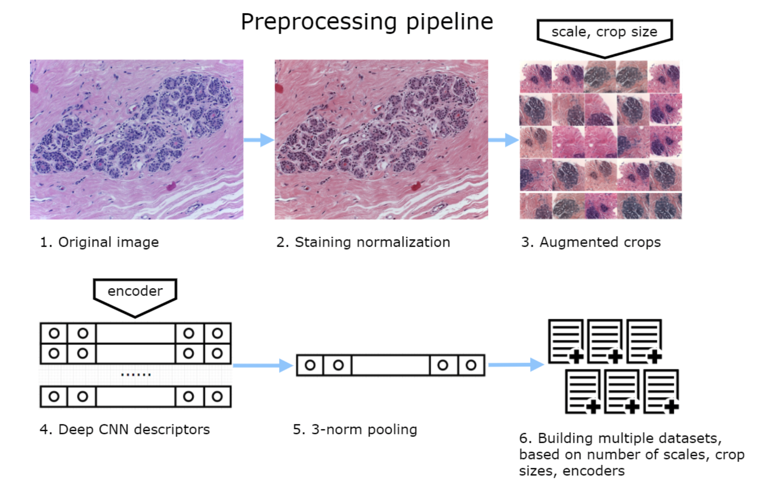

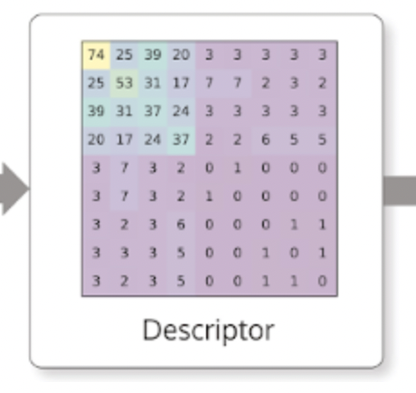

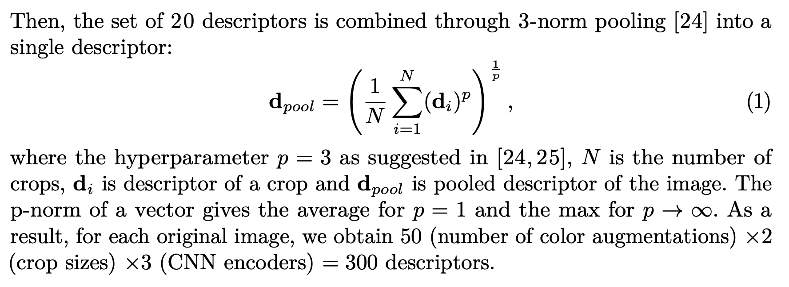

דאטה סט - <https://www.kaggle.com/code/paultimothymooney/predict-idc-in-breast-cancer-histology-images/data>